uOttawa
UNIVERSITÉ D'OTTAWA · UNIVERSITY OF OTTAWA

SRR — EOSAT-1 Multispectral Imager
  - System Requirements Review
SpaceCDF
2026

Faculty of Engineering · School of Engineering Design and Teaching Innovation (SEDTI)
SCDF-SRR-001 · 6U EO CubeSat · Issue 1.0 · 2026-05-12
Classification: Internal · Demo

Document Information
Document code | SCDF-SRR-001
Title | System Requirements Review — EOSAT-1 Multispectral Imager
Study / Mission | 6U EO CubeSat
Issue | 1.0
Date | 2026-05-12
Prepared by | SpaceCDF AI Concurrent Design Facility
Reviewed by | [TBD]
Approved by | [TBD]
Classification | Internal · Demo
Applies to | EOSAT-1 Multispectral Imager

Change Record
Issue | Date | By | Summary of changes
1.0 | 2026-05-12 | SpaceCDF | Initial SRR issue generated from converged design loop.

Acknowledgement — Generative AI (AIG)
This document was produced with the assistance of generative AI as part of the SpaceCDF Concurrent Design Facility workflow. The design-loop convergence, agent rationales, embedded figures and document rendering are generated by the SpaceCDF backend (Python · matplotlib · python-docx) guided by ECSS, NASA SEH and SMAD-4 references. Editorial framing, worked examples and pedagogical commentary remain owned by the SpaceCDF teaching team.
Attribution follows the AIG (Assisted by Generative AI) framework — Peters (2023), Logos IA-EN, CC BY-NC-SA 4.0 — https://mpeters.uqo.ca/en/logos-ia-en-peters-2023/
Any course deliverable that incorporates content from this document, or from any document exported by SpaceCDF, must in turn carry the AIG badge and a short note describing how generative AI was used.

Acronyms & Abbreviations
Acronym | Definition
AIT | Assembly, Integration and Test
AOCS | Attitude and Orbit Control Subsystem
BoL | Beginning of Life
CDF | Concurrent Design Facility
CDR | Critical Design Review
ConOps | Concept of Operations
DDT&E | Design, Development, Test and Evaluation
EPS | Electrical Power Subsystem
EoL | End of Life
FMECA | Failure Mode, Effects and Criticality Analysis
GS | Ground Station
IADC | Inter-Agency Space Debris Coordination Committee
ITU | International Telecommunication Union
MLI | Multi-Layer Insulation
MRD | Mission Requirements Document
MTBF | Mean Time Between Failures
OBDH | On-Board Data Handling
PDR | Preliminary Design Review
RPN | Risk Priority Number
RW | Reaction Wheel
SA | Solar Array
SCDF | SpaceCDF Concurrent Design Facility
SRR | System Requirements Review
SSO | Sun-Synchronous Orbit
TCS | Thermal Control Subsystem
TRL | Technology Readiness Level
TT&C | Telemetry, Tracking and Command
VP | Verification Plan
WBS | Work Breakdown Structure

Applicable Documents
ID | Reference | Title
AD-01 | ECSS-M-ST-10C Rev.1 | Space project management
AD-02 | ECSS-E-ST-10C Rev.1 | System engineering general requirements
AD-03 | ECSS-E-ST-10-02C | Verification requirements
AD-04 | ECSS-E-ST-10-06C | Technical requirements specification
AD-05 | ECSS-Q-ST-30C | Dependability
AD-06 | ECSS-Q-ST-40C Rev.1 | Safety

Reference Documents
ID | Reference | Title
RD-01 | NASA SP-2016-6105 | NASA Systems Engineering Handbook Rev. 2
RD-02 | NPR 7123.1D | NASA Systems Engineering Processes and Requirements
RD-03 | SMAD-4 | Space Mission Analysis and Design (4th ed.)
RD-04 | ECSS-U-AS-10C Rev.2 | Space debris mitigation requirements
RD-05 | ISO 24113:2023 | Space debris mitigation requirements
RD-06 | ITU-R P.618-13 | Propagation data for Earth-space links
RD-07 | ITU-R P.676-13 | Attenuation by atmospheric gases

Table of Contents
Right-click and select 'Update Field' to populate.

1. Scope

1.1 Purpose
This document is the System Requirements Review for the EOSAT-1 Multispectral Imager. It captures the converged engineering baseline produced by the SpaceCDF AI Concurrent Design Facility and provides the evidence required for the SRR review gate per ECSS-M-ST-10C Rev.1.

1.2 Applicability
The contents are applicable to all engineering disciplines, project management, product assurance and operations. Subsystem-level data items inherit applicability from the parent applicable documents listed above.

1.3 Conventions
All units are SI unless otherwise stated. Margins are quoted relative to the nominal value (i.e. with-margin = nominal × (1 + margin%)). Status colours follow the SpaceCDF / ECSS convention: green = compliant, amber = marginal, red = non-compliant or exceeded.

2. Mission Overview
Mission 'EOSAT-1 Multispectral Imager' is a Earth Observation mission carried out by 1 nano-class spacecraft over a design life of 3.0 years. Top-level mission targets are 12.0 kg launch mass and 5.0 MEUR total programme cost.
Mission attribute | Value
Mission name | EOSAT-1 Multispectral Imager
Mission type | Earth Observation
Spacecraft class | nano
Number of spacecraft | 1
Design lifetime (yr) | 3.00
Reliability target | 0.90
Cost target (MEUR) | 5.00
Mass target (kg) | 12.00
Ground stations | KSAT Svalbard, KSAT Troll
Table 1 — Top-level mission descriptor.

2.1 Payload complement
Name | Type | Mass (kg) | Power (W) | Rate (Mbps) | Pointing (°) | Duty
Multispectral Imager | optical_imager | 1.50 | 20.0 | 100.0 | 0.100 | 25%
Table 2 — Payload complement.

3. Concept of Operations & Orbit
Parameter | Value
Orbit type | SSO
Altitude (km) | 450
Inclination (deg) | 97.40
Period (min) | 93.4
Orbits per day | 15.41
Velocity (m/s) | 7644.4
Eclipse fraction | 0.384
Footprint radius (km) | 2327
Contact time / day (s) | 2055
Mission duration (yr) | 3.0
Table 3 — Orbital parameters.
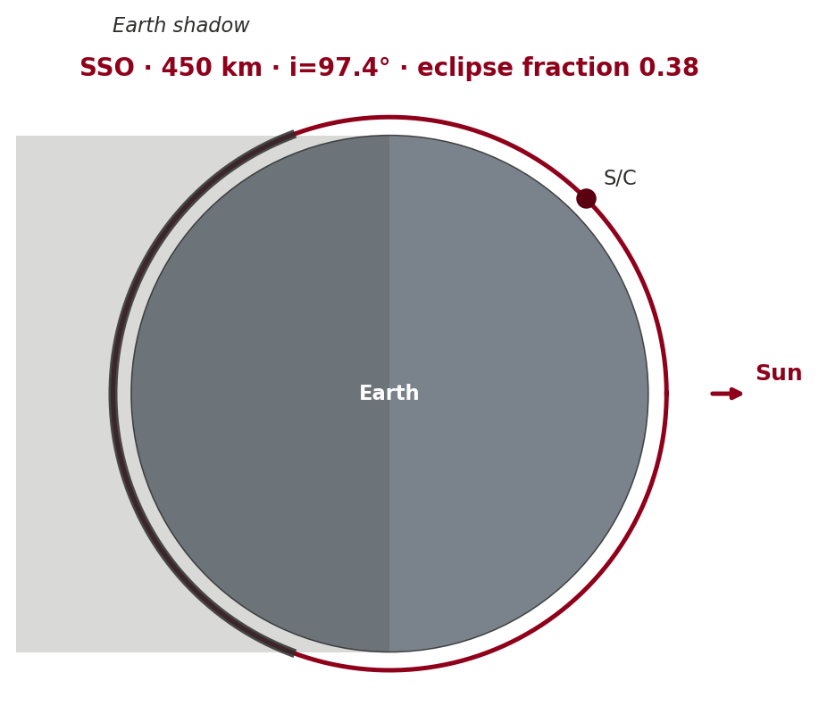
Figure 1 — SSO orbit geometry with shaded eclipse arc.
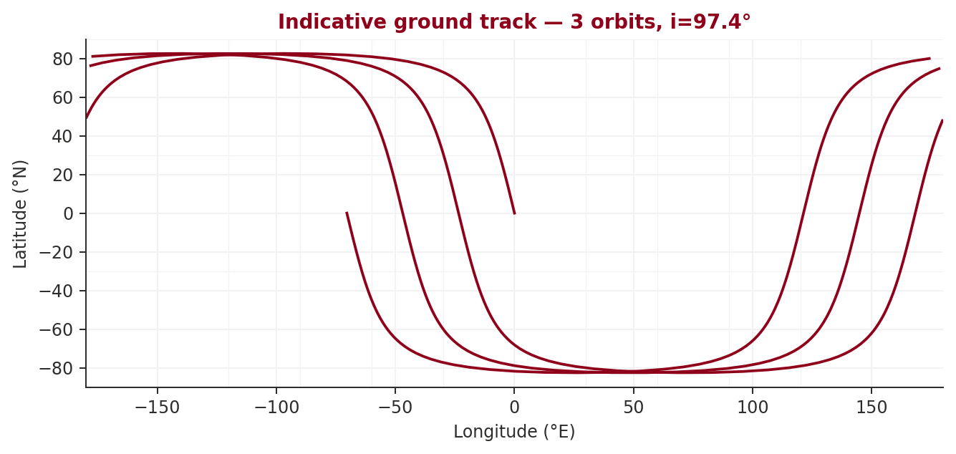
Figure 2 — Indicative ground track over three consecutive orbits.

Rationale
Orbit chosen as SSO at 450 km altitude and inclination 97.40°. The Keplerian period is 93.4 min (15.4 orbits / day) with an eclipse fraction of 0.38 (cylindrical shadow). A high-latitude ground station near 78° provides ≈34.2 min of contact / day.

Assumptions
- Cylindrical Earth-shadow eclipse model (no penumbra).
- Ground-station latitude assumed 78° (Svalbard-class).
- Station-keeping ΔV from JR-1971 drag model over 3-yr life.

3.1 ΔV breakdown
Component | ΔV (m/s) | Rationale
Station-keeping | 4.6 | Drag makeup over 3 yr design life.
Collision avoidance | 3.0 | Allowance of ~1 m/s per year for collision-avoidance burns.
Deorbit / EOL | 71.7 | Lower perigee for ≤25-yr re-entry (IADC compliance).
Table 4 — ΔV budget breakdown.

4. System Architecture
The spacecraft system architecture follows the canonical CubeSat-class topology with a payload routing data through the OBDH to the TT&C subsystem, while the EPS distributes regulated power to all platform subsystems. AOCS drives propulsion (when fitted) and the thermal subsystem couples conductively to the structure.
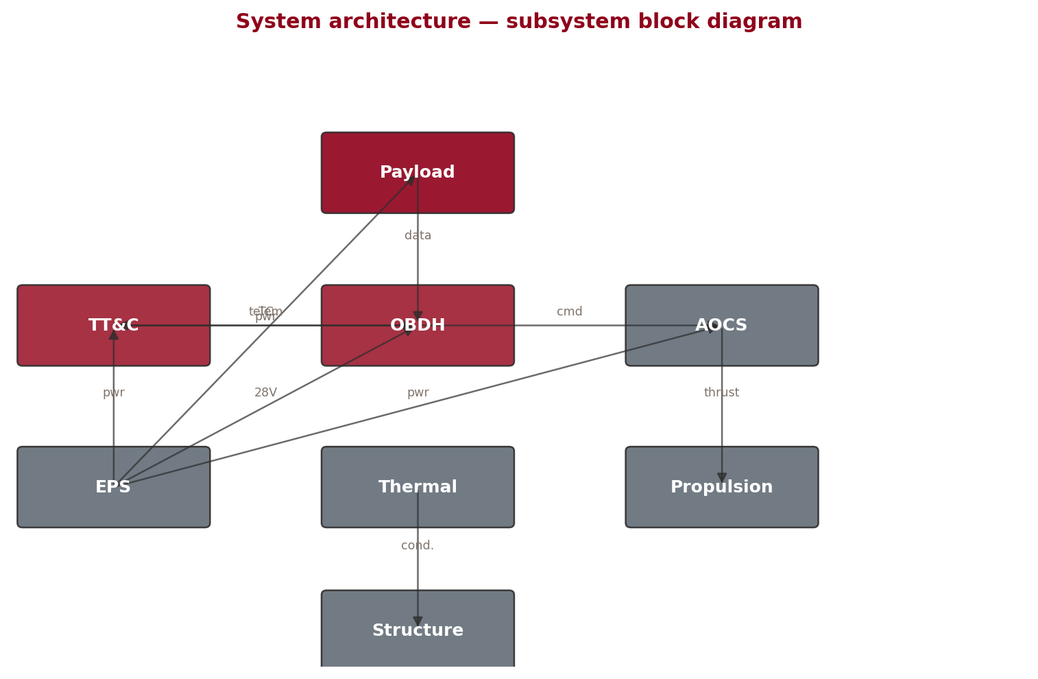
Figure 3 — Spacecraft system architecture — block diagram.

5. Payload

5.1 Multispectral Imager
4-band ocean colour imager (443, 560, 665, 865 nm)
Attribute | Value
Type | optical_imager
Mass (kg) | 1.50
Power, mean (W) | 20.0
Power, peak (W) | 45.0
Data rate (Mbps) | 100.00
Data volume / day (GB) | 2.00
Pointing accuracy (°) | 0.100
Duty cycle (%) | 25

6. Electrical Power Subsystem

Rationale
Electrical power system sized for a worst-case sunlight load of 31.0 W and worst-case eclipse load of 36.0 W. Solar array delivers 76.5 W BoL / 70.9 W EoL after 3.0 yr of degradation, covering 0.216 m² of 29.5%-efficient cells. Battery capacity 71.7 Wh chosen for 30.0% depth-of-discharge over the eclipse duration.

Assumptions
- Solar cell efficiency 29.5% (class-appropriate triple-junction GaAs / KB-resolved cell).
- Specific power 80 W/kg.
- Mode profile estimated from payload duty cycles.
- Heater allocation 10.0 W during eclipse.
- Battery DoD limit 30% (ECSS Li-ion practice).
Parameter | Value | Unit | Margin
Battery Capacity | 71.7 | Wh | 20%
Battery DOD | 30 | % | 20%
Battery Mass | 0.48 | kg | 20%
EPS Cost | 12 | kEUR | 20%
EPS Total Mass | 1.57 | kg | 20%
Solar Array Area | 0.216 | m² | 20%
Solar Array Mass | 0.89 | kg | 20%
SA Power BOL | 76.5 | W | 20%
SA Power EOL | 70.9 | W | 20%
Total Power (Eclipse) | 36 | W | 20%
Total Power (Sunlight) | 31 | W | 20%
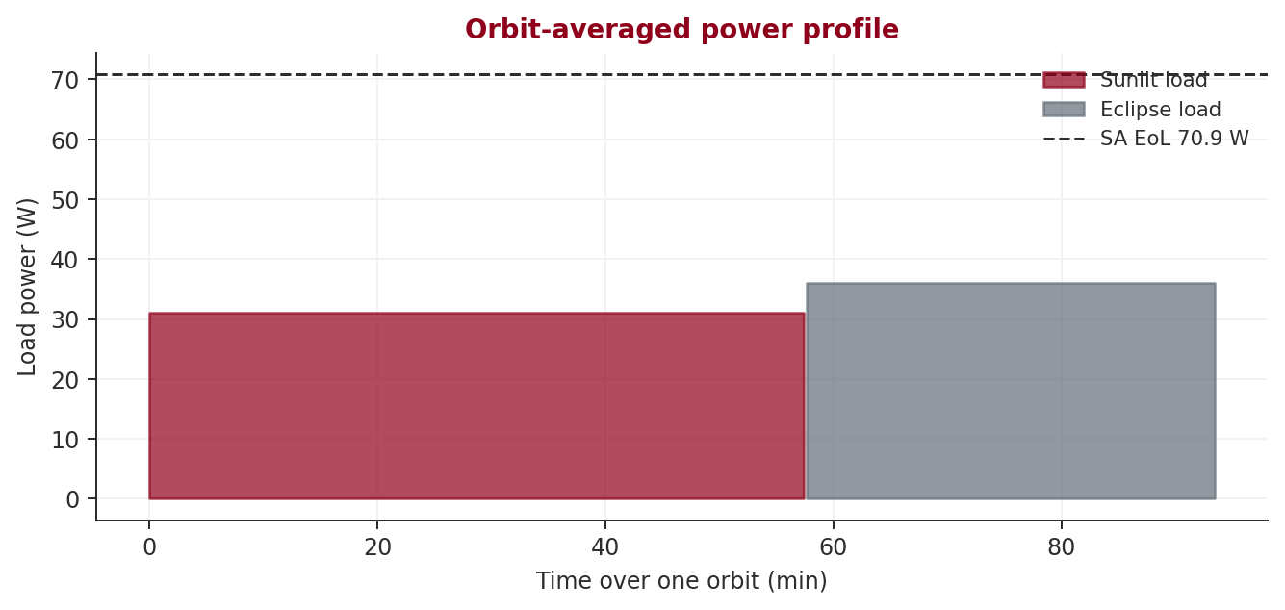
Figure 4 — Orbit-averaged power profile (sunlit / eclipse, SA EoL line).

6.2 Battery
Parameter | Value
Capacity (Wh) | 71.7
Depth of discharge (%) | 30.0
Mass (kg) | 0.48
Chemistry | Li-ion (assumed)

7. Thermal Control Subsystem

Rationale
Thermal control sized for a hot-case internal dissipation of 31.0 W on a 0.22 m² external surface (cubesat). The radiator area is 0.113 m² (ε=0.85, α=0.15) and rejects to space at T_max=50 °C. In the cold case (eclipse, 30 % standby load) heaters supply 0.0 W to hold the platform above T_min=-20 °C.

Assumptions
- Stefan–Boltzmann steady-state energy balance, no transient analysis.
- Solar flux 1361 W/m², Earth IR 237 W/m², albedo 0.30.
- Radiator: ε=0.85, α=0.15 (white paint / OSR).
- MLI effective emissivity 0.01 (15-layer blanket).
- Platform allowable range −20 °C to +50 °C; payload limits set separately.

Warnings & open issues
- Radiator area 0.11m² exceeds 50% of S/C area — consider active cooling
Parameter | Value | Unit | Margin
Eclipse Heater Power | 0 | W | 20%
Radiator Area | 0.113 | m² | 20%
Radiator Mass | 0 | kg | 20%
TCS Cost | 5 | kEUR | 20%
TCS Total Mass | 0.35 | kg | 20%
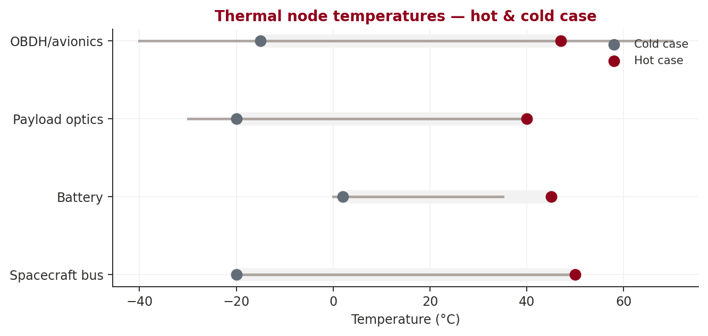
Figure 5 — Hot and cold case temperatures across the principal thermal nodes.
Node | Cold (°C) | Hot (°C) | Min limit | Max limit
Spacecraft bus | -20.0 | 50.0 | -20.0 | 50.0
Battery | 2.0 | 45.0 | 0.0 | 35.0
Payload optics | -20.0 | 40.0 | -30.0 | 40.0
OBDH/avionics | -15.0 | 47.0 | -40.0 | 70.0

7.1 Surface treatments
Surface | α | ε | Area (m²)
Radiator (OSR) | 0.15 | 0.85 | 0.113
MLI (15-layer) | 0.10 | 0.01 | 0.107

8. AOCS

Rationale
AOCS sized for a pointing requirement of 0.100° around a earth central body. Disturbance torque budget is dominated by gravity gradient (9.94e-09 Nm), with solar pressure (6.13e-09), aerodynamic (2.20e-08) and magnetic (2.44e-06) contributions over one orbit summing to 2.48e-06 Nm. Reaction wheel momentum capacity 0.003 Nms provides one-orbit absorption before desaturation.

Assumptions
- Spacecraft maximum dimension 0.30 m (class-typical).
- Wet area assumed 0.09 m² (cubical bus).
- Worst-case attitude offsets: 5° from nadir for gravity gradient; 0.05 m solar CoP offset; 0.05 m aero CoP offset.
- Magnetorquer dipole desaturation effective at mid-latitudes (Earth orbits only).
Parameter | Value | Unit | Margin
AOCS Cost | 204 | kEUR | 20%
AOCS Mass | 2.04 | kg | 20%
Pointing Accuracy | 0.1 | deg | 20%
AOCS Power | 15 | W | 20%
Aerodynamic Torque | 0 | Nm | 20%
Gravity Gradient Torque | 0 | Nm | 20%
Magnetic Torque | 2e-06 | Nm | 20%
Solar Pressure Torque | 0 | Nm | 20%
Total Disturbance Torque | 2e-06 | Nm | 20%
Wheel Momentum | 0.003 | Nms | 20%

8.1 Disturbance torque budget
Source | Torque (Nm)
Gravity gradient | 9.94e-09
Solar pressure | 6.13e-09
Aerodynamic | 2.20e-08
Magnetic | 2.44e-06

8.2 Pointing error budget
Contributor | 1σ (arcsec)
Sensor noise (star tracker) | 10.0
Actuator quantisation (RW) | 30.0
Disturbance reject. residual | 60.0
Alignment | 36.0
Achieved (RSS) | 76.8

9. Propulsion

Rationale
No propulsion required — the spacecraft is a nano class at 450 km altitude, where natural atmospheric drag completes deorbit within the IADC 25-year window without active manoeuvres.

Assumptions
- Natural-decay regime (low-LEO nano/micro-class).
- No collision-avoidance budget; mission-dependent JCA on-orbit.
Parameter | Value | Unit | Margin
Propulsion Cost | 0 | kEUR | 20%
Total Delta-V | 0 | m/s | 20%
Specific Impulse | 0 | s | 20%
Propellant Mass | 0 | kg | 20%
Total Impulse | 0 | Ns | 20%
Propulsion System Mass | 0 | kg | 20%
Propulsion Type | none |  | 20%

10. Telemetry, Tracking & Command

Rationale
Communications architecture is a dual link: an always-on UHF TT&C channel for command and housekeeping (margin 29.4 dB) and a higher-rate X payload downlink at 8.2 GHz (margin 7.7 dB). EIRP is 8.0 dBW; free-space loss is 176.5 dB at the worst-case slant range of 1944 km.

Assumptions
- 5° minimum elevation; ITU-R P.676/P.618 atmospheric model.
- GS antenna 13.0 m, efficiency 0.55, system noise temperature 200 K.
- Modulation coding rate 0.5, protocol overhead 10%, implementation loss 2 dB.
- Required Eb/N0 10 dB for BER 10⁻⁶ at the assumed modulation.
Parameter | Value | Unit | Margin
Data Downlinked/Day | 2.4 | GB | 20%
Downlink Margin (worst) | 7.7 | dB | 20%
Downlink Data Rate | 9.34e+06 | bps | 20%
Payload DL Margin | 7.7 | dB | 20%
TTC Cost | 32 | kEUR | 20%
TTC Margin | 29.4 | dB | 20%
TTC Mass | 0.42 | kg | 10%
TTC Power | 11 | W | 20%
Uplink Margin | 39.4 | dB | 20%
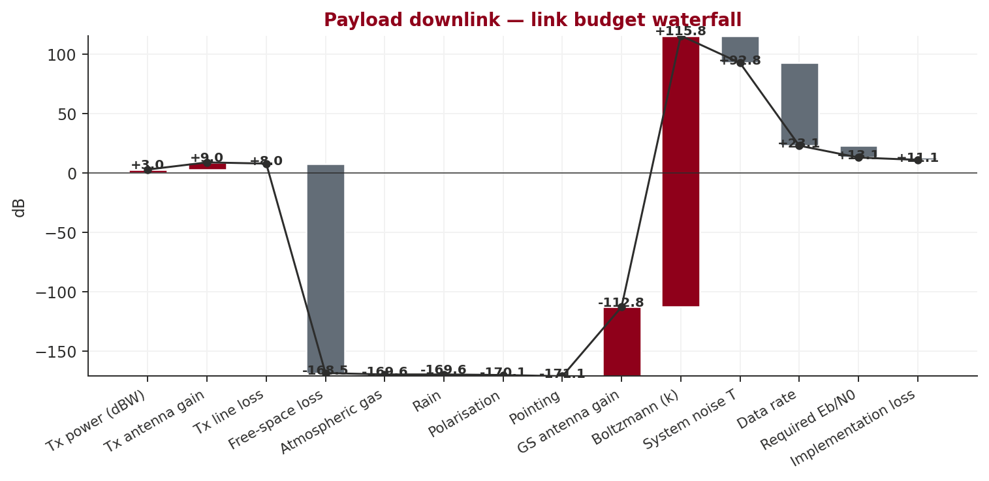
Figure 6 — Payload downlink link budget waterfall (positive = gain, negative = loss).
Term | Δ (dB)
Tx power (dBW) | +3.01
Tx antenna gain | +6.00
Tx line loss | -1.00
Free-space loss | -176.50
Atmospheric gas | -1.14
Rain | -0.00
Polarisation | -0.50
Pointing | -1.00
GS antenna gain | +58.37
Boltzmann (k) | +228.60
System noise T | -23.01
Data rate | -69.71
Required Eb/N0 | -10.00
Implementation loss | -2.00

10.1 Link summary
Parameter | Value
Band | X
Frequency (GHz) | 8.200
S/C Tx power (W) | 2.0
S/C antenna gain (dBi) | 6.0
GS antenna Ø (m) | 13.00
GS antenna gain (dBi) | 58.4
Slant range (km) | 1944
User data rate (bps) | 9,344,907
Data downlinked / day (GB) | 2.40
Downlink margin (dB) | 7.7
TT&C margin (dB) | 29.4
Uplink margin (dB) | 39.4

11. Data Handling

Rationale
Data architecture sized for 2.0 GB/day generated (2.4 GB/day downlinked). Onboard storage 4.0 GB provides 2-orbit redundancy. OBDH mass 0.16 kg from class factor × storage demand.

Assumptions
- 2:1 lossless compression when payload data rate is used as input (explicit per-day volume overrides this).
- Storage = 2 × daily generation (operational buffer).
- OBDH mass scales with class baseline × (1 + storage/100 GB).
Parameter | Value | Unit | Margin
Data Downlinked/Day | 2.4 | GB | 20%
Data Generated/Day | 2 | GB | 20%
OBDH Cost | 16 | kEUR | 20%
OBDH Mass | 0.16 | kg | 10%
Storage Required | 4 | GB | 20%

12. Structure & Mechanisms

Rationale
Structure mass is taken from the heritage class-fraction database with Phase-A margin of 20%. Detailed FEM, modal analysis, and mechanism qualification are deferred to PDR/CDR.
Parameter | Value | Unit | Margin
Structure Cost | 8 | kEUR | 20%
Structure Fraction | 0.141 |  | 20%
Structure Mass | 0.99 | kg | 20%

13. System Budgets
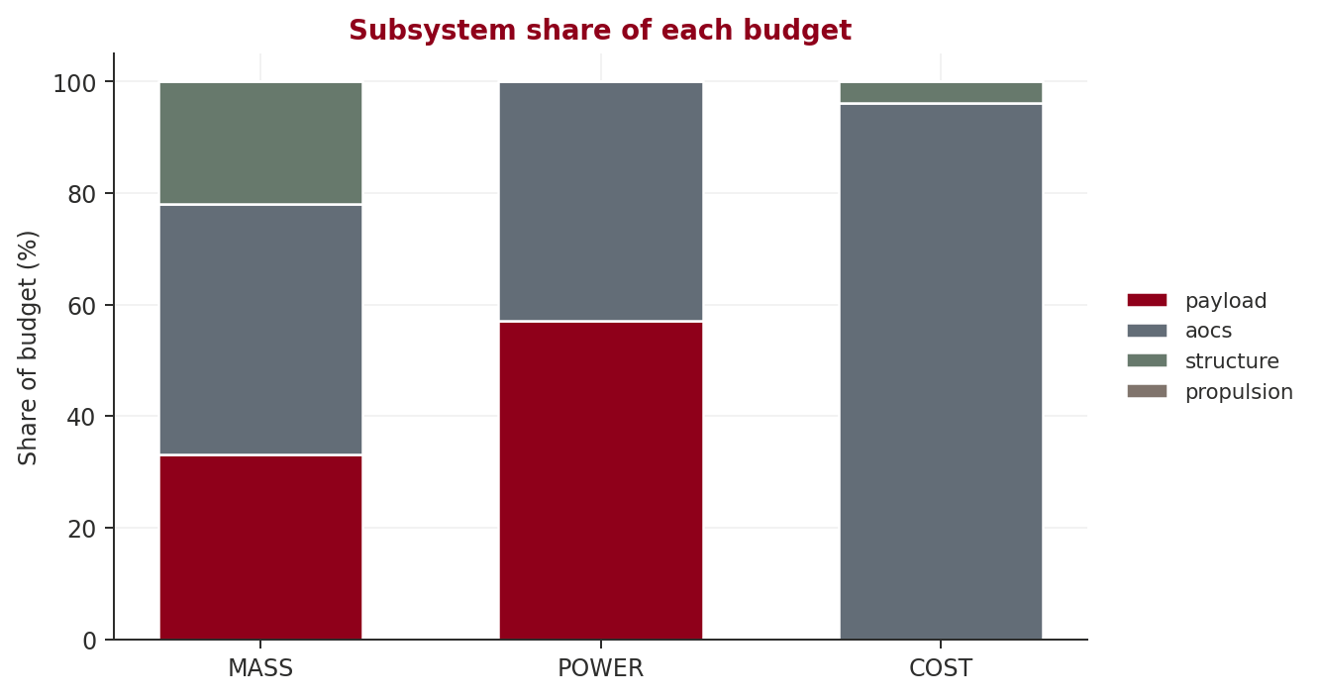
Figure 7 — Normalised share of each system budget by subsystem.

13.1 Mass budget
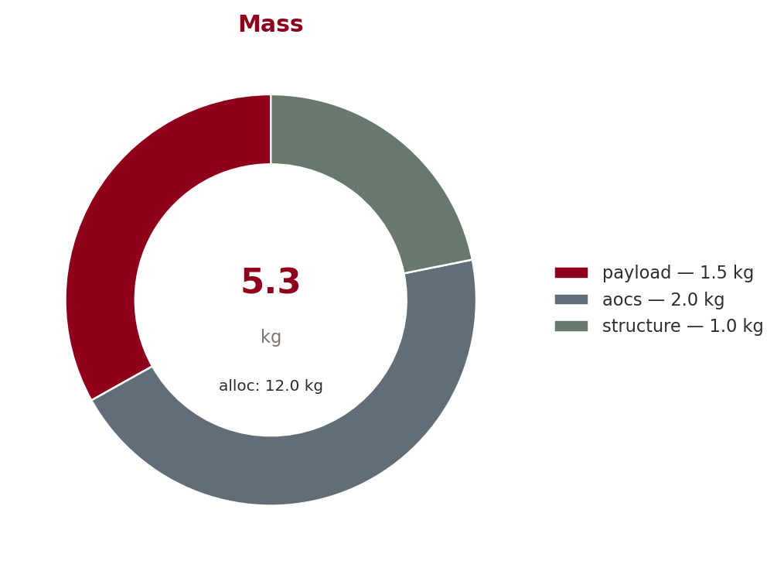
Figure 8 — Mass budget contributions and total (kg).
Subsystem | Equipment | Nominal (kg) | Margin (%) | With margin (kg)
payload | Payload Multispectral Imager Mass | 1.5 | 10 | 1.65
aocs | AOCS Mass | 2.04 | 20 | 2.45
structure | Structure Mass | 0.99 | 20 | 1.19
TOTAL |  | 4.53 | 56 | 5.29
Allocation: 12.00 kg — margin 55.9% — status GREEN

13.2 Power budget
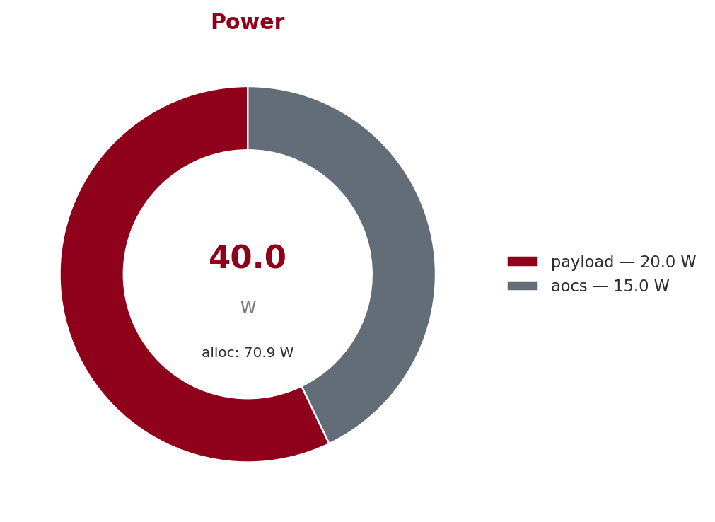
Figure 9 — Power budget contributions and total (W).
Subsystem | Equipment | Nominal (W) | Margin (%) | With margin (W)
payload | Payload Multispectral Imager Power | 20 | 10 | 22
aocs | AOCS Power | 15 | 20 | 18
TOTAL |  | 35 | 44 | 40
Allocation: 70.90 W — margin 43.6% — status GREEN

13.4 Cost budget
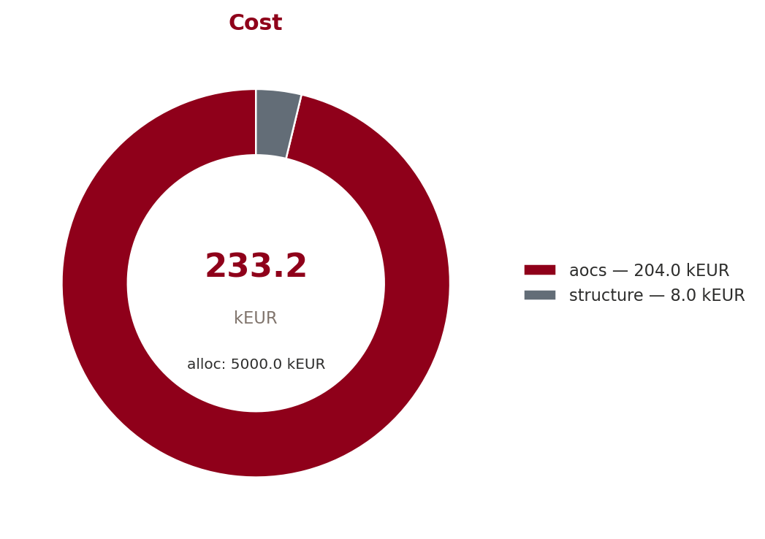
Figure 10 — Cost budget contributions and total (kEUR).
Subsystem | Equipment | Nominal (kEUR) | Margin (%) | With margin (kEUR)
aocs | AOCS Cost | 204 | 10 | 224
propulsion | Propulsion Cost | 0 | 10 | 0
structure | Structure Cost | 8 | 10 | 8.8
TOTAL |  | 212 | 95 | 233
Allocation: 5.00 MEUR — margin 95.3% — status GREEN

14. Equipment List
No KB-selected equipment recorded in the design state.

15. Compliance & Verification
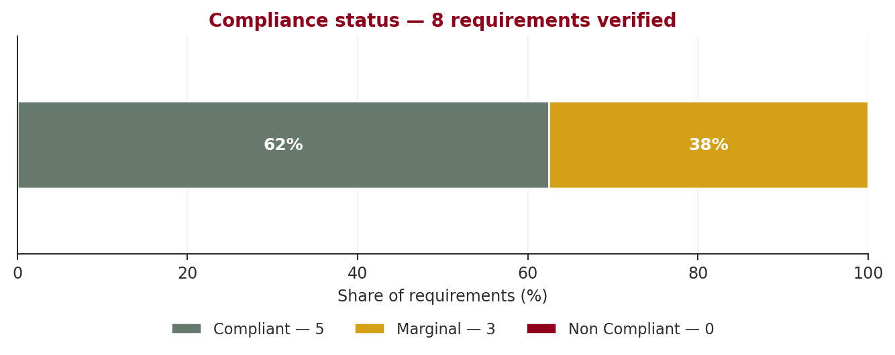
Figure 11 — Compliance status across all requirements.
Req ID | Description | Achieved | Margin % | Status
REQ-SYS-001 | The spacecraft shall have a design lifetime of at least 3.0 years | 3.00 | 0.0 | marginal
REQ-SYS-002 | The spacecraft wet mass shall not exceed 12.0 kg | 7.03 | 41.4 | compliant
REQ-SYS-003 | The total mission cost shall not exceed 5.0 MEUR | 0.70 | 86.0 | compliant
REQ-AOCS-001 | The spacecraft shall provide pointing accuracy of 0.1° or better for Multispectral Imager | 0.10 | 0.0 | marginal
REQ-DATA-001 | The communication system shall support downlink of Multispectral Imager data at 100.0 Mbps | 2.00 | 20.0 | marginal
REQ-PWR-001 | The EPS shall provide positive power margin in all operating modes including eclipse | 70.90 | 100.0 | compliant
REQ-TTC-001 | The communication link shall close with at least 3 dB margin at minimum elevation | 7.70 | 156.7 | compliant
REQ-SYS-004 | The spacecraft shall be capable of deorbiting within 25 years of end-of-mission per space | 71.69 | 100.0 | compliant
Total 8 requirements: 5 compliant · 3 marginal · 0 non-compliant (62.5%).

16. Technology Readiness
Subsystem | Baseline (TRL) | Innovation (TRL) | Recommendation
eps | Triple-junction GaAs (Azur Space 3G30C) (9) | Perovskite-silicon tandem solar cells (5) | baseline
eps | Li-ion battery (SAFT VES16) (9) | Solid-state lithium battery (4) | carry_both
aocs | Reaction wheels + star tracker (9) | MEMS gyroscope + AI-based attitude determination (5) | carry_both
ttc | X-band transponder (conventional) (9) | Optical inter-satellite link (OISL) terminal (6) | baseline
propulsion | Monoprop hydrazine (9) | Water electrolysis green propulsion (5) | baseline
propulsion | Hall-effect thruster (8) | Electrospray (ionic liquid) thruster (6) | carry_both
structure | Aluminium honeycomb panels (9) | 3D-printed titanium lattice structure (6) | carry_both
thermal | MLI + radiator panels (9) | Phase-change material thermal buffer (5) | baseline
obdh | RAD750 / GR740 radiation-hardened processor (9) | COTS RISC-V with radiation-tolerant design (5) | baseline

17. Reliability & FMECA

Rationale
Series reliability model R_sys=∏R_i. Over 3.0 yr (26298 h) the mission reliability is 0.718 against a target of 0.90. Weakest contributor: aocs (R=0.924). System MTBF is 60241 h.

Assumptions
- Constant failure-rate (exponential) model R(t) = e^{-λt}.
- Series model: all subsystems must function; no parallel redundancy modelled here.
- Failure rates from heritage (SMAD4 Table 19-5, MIL-HDBK-217F).

Warnings & open issues
- Mission reliability 0.718 < target 0.90; weakest: aocs (R=0.924). Consider redundancy.
- Single-point failures: eps (R=0.936), aocs (R=0.924), obdh (R=0.949), payload (R=0.924)

17.1 Per-subsystem failure rates
Subsystem | λ (1/h) | R(mission) | Redundancy
EPS | 2.50e-06 | 0.9364 | single string
AOCS | 3.00e-06 | 0.9241 | single string
TTC | 1.50e-06 | 0.9613 | single string
OBDH | 2.00e-06 | 0.9488 | single string
TCS | 5.00e-07 | 0.9869 | single string
PROPULSION | 4.00e-06 | 1.0000 | single string
STRUCTURE | 1.00e-07 | 0.9974 | single string
PAYLOAD | 3.00e-06 | 0.9241 | single string

17.2 FMECA (top items)
Item | Failure mode | Effect | S | O | D | RPN | Mitigation
EPS | Battery cell short | Loss of bus voltage; depleted battery | 4 | 3 | 2 | 24 | Cold/hot redundancy; safe-mode handoff; ground-commanded res
AOCS | Reaction-wheel bearing seizure | Loss of fine pointing; switch to coarse mode | 4 | 3 | 2 | 24 | Cold/hot redundancy; safe-mode handoff; ground-commanded res
OBDH | OBC SEU latch-up | Reset cycle; loss of telemetry window | 4 | 3 | 2 | 24 | Cold/hot redundancy; safe-mode handoff; ground-commanded res
PAYLOAD | Detector dark current rise | Image SNR degradation; calibration drift | 4 | 3 | 2 | 24 | Cold/hot redundancy; safe-mode handoff; ground-commanded res
TTC | Transmitter PA failure | Loss of downlink; use backup transmitter | 3 | 2 | 2 | 12 | Cold/hot redundancy; safe-mode handoff; ground-commanded res
TCS | Heater string open | Component temperature excursion below limit | 3 | 2 | 2 | 12 | Cold/hot redundancy; safe-mode handoff; ground-commanded res
STRUCTURE | Bolt back-out | Loss of deployable, latched structure | 3 | 2 | 2 | 12 | Cold/hot redundancy; safe-mode handoff; ground-commanded res

18. Risk Register
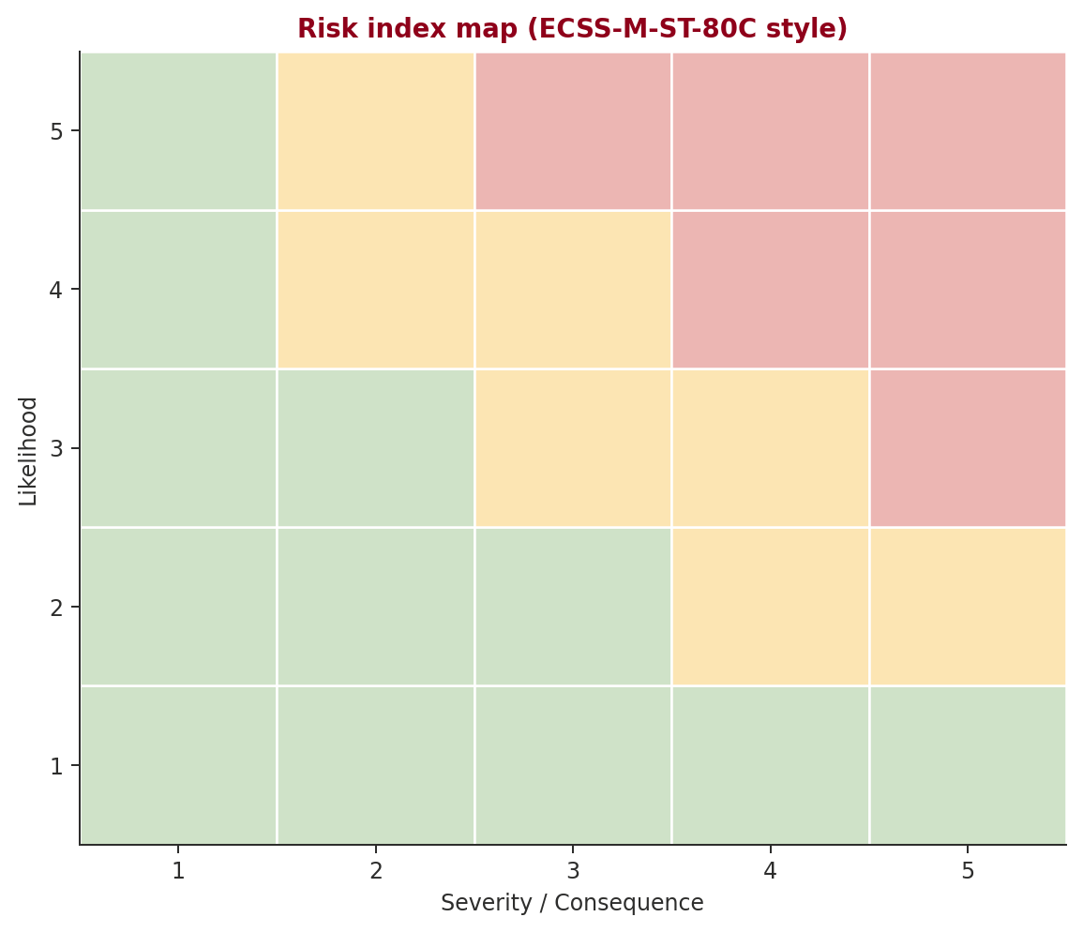
Figure 12 — 5×5 risk index map (ECSS-M-ST-80C).
Risk register pending — no risks identified at this stage.

19. Space Debris Compliance

Rationale
Post-mission disposal: orbital lifetime 2.7 yr with deorbit method 'natural'. Casualty risk Ec=1.10e-08 (compliant against 1e-4 threshold). Passivation score 1.00 covers stored-energy depletion of battery and propellant tanks per ISO 24113. 25-yr rule satisfied; 5-yr rule satisfied.

Assumptions
- Atmospheric drag lifetime per NRLMSISE-00 / JR-1971 (mean solar flux).
- Casualty risk per NASA-STD-8719.14 demise model.
- Passivation score weighted by battery + propellant tank stored energy.
- Collision-avoidance ΔV budget assumed ~1 m/s per year in LEO.
Parameter | Value
Orbital lifetime (yr) | 2.7
25-yr rule (IADC) | Compliant
5-yr rule (FCC) | Compliant
Casualty risk Ec | 1.10e-08
Casualty risk compliance | Compliant
Passivation score | 1.00
Compliance score (0–100) | 92
Deorbit method | natural
CA ΔV per year (m/s) | 2.5

20. Cost & Schedule

Rationale
Parametric life-cycle cost estimate using the CubeSat COTS model. Hardware 151 kEUR + AIT 18 kEUR + NRE 45 kEUR (30% of HW) + launch 200 kEUR + operations 300 kEUR over 3.0 yr. Total 0.7 MEUR with ±40% confidence interval at Phase A.

Assumptions
- Spacecraft class 'nano' → COTS pricing table.
- AIT 12% of HW; NRE 30% of HW; ops €100k/yr.
- Launch cost from rideshare/dedicated-launcher market reference.
- All costs in 2025-EUR; no inflation escalation applied.
- Phase-A P-curve: P50≈total, P70≈+15%, P80≈+25%, P90≈+50% per ECSS-M-ST-60C cost-uncertainty practice.
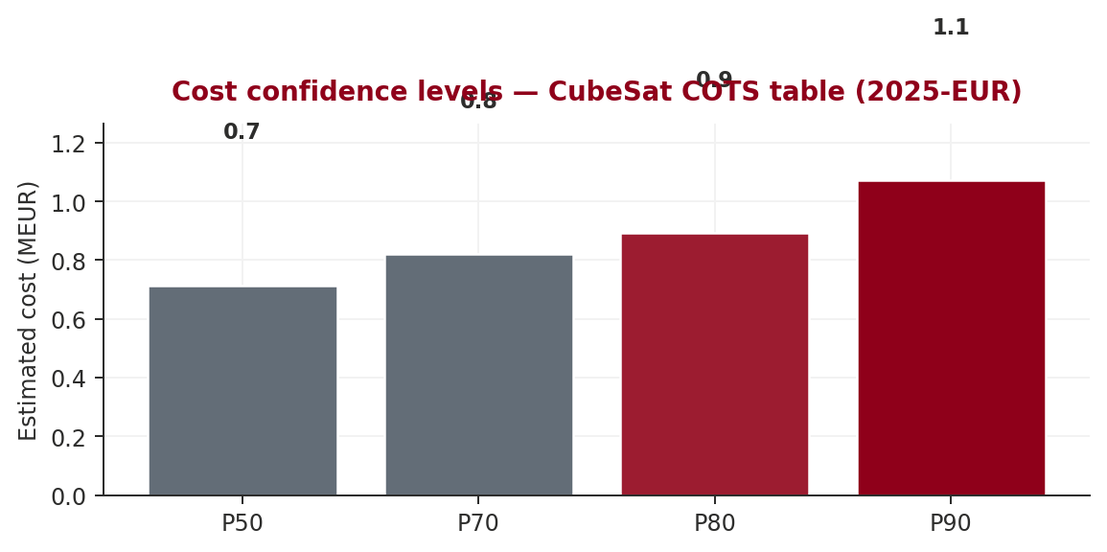
Figure 13 — Cost estimate at P50/P70/P80/P90 confidence levels.
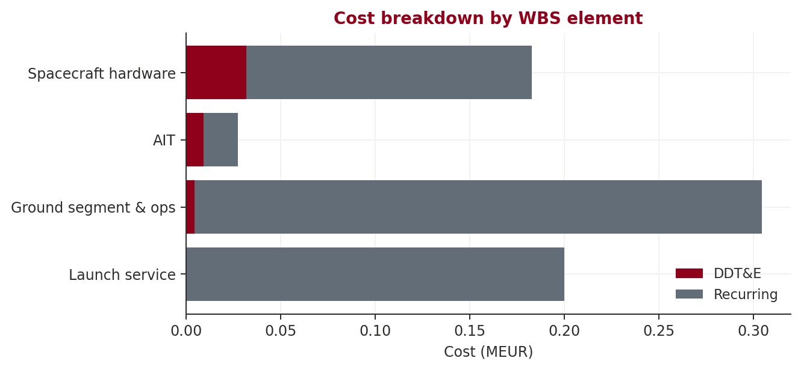
Figure 14 — Cost breakdown by WBS element (DDT&E + recurring).
WBS | Element | DDT&E (MEUR) | Recurring (MEUR) | Total (MEUR)
1.1 | Spacecraft hardware | 0.03 | 0.15 | 0.18
1.2 | AIT | 0.01 | 0.02 | 0.03
1.3 | Ground segment & ops | 0.00 | 0.30 | 0.30
1.4 | Launch service | 0.00 | 0.20 | 0.20

21. Design Loop Convergence
Metric | Value
Converged | Yes
Iterations | 16
Wall-clock time (s) | 0.02

22. Conclusions & Recommendations
The SRR baseline is now established. Key engineering observations follow.

22.1 Open warnings
- Link margin -2.6 dB < 3 dB minimum (required rate 100.0 Mbps vs max 54.4 Mbps)
- Radiator area 0.11m² exceeds 50% of S/C area — consider active cooling
- Mission reliability 0.718 < target 0.90; weakest: aocs (R=0.924). Consider redundancy.
- Single-point failures: eps (R=0.936), aocs (R=0.924), obdh (R=0.949), payload (R=0.924)

22.2 Recommendations
- [INNOVATION] STRUCTURE: Consider 3D-printed titanium lattice structure (TRL 6) as tech demo alongside baseline Aluminium honeycomb panels. Benefit: 30% mass reduction, integrated thermal paths. Risk: Qualification for flight loads ongoing
- [INNOVATION] PROPULSION: Consider Electrospray (ionic liquid) thruster (TRL 6) as tech demo alongside baseline Hall-effect thruster. Benefit: Ultra-precise thrust, no moving parts. Risk: Limited total impulse for large dV

22.3 Next steps
- Lock the Mission Requirements Document and Concept of Operations.
- Prepare the system architecture trade space for the PDR.
- Mature low-TRL components and update the technology development plan.

