**Worksheet 4**

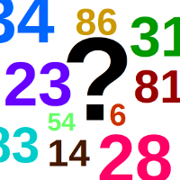

**Objective:**

To create an interactive guessing game in C# where the user attempts to guess a randomly generated number using a while (true) loop and the break statement. This exercise will help reinforce the concepts of loops, conditionals, and user input.

**Concepts Covered:**

1. Variables
2. User Input
3. Relational Operators
4. while(true) loops and break

**Requirements**

1. The program will generate a random number between 1 and 100.
2. It will prompt the user to guess the number and provide feedback (too high or too low) until the user guesses correctly.
3. Make use of while(true) loop and break command

**Further improvements**

* **Guess Count**:

Modify the program to count the number of guesses the user makes and display this count when they guess correctly.

* **Replay Option**:

Add functionality that allows the user to play multiple rounds of the game without restarting the program. Use a loop to ask if they want to play again.