Adv Robocup

Tiago Web-manager: http://tiago-46c:8080

MAP, SSH
rosservice call /pal_map_manager/change_map "input: '2025-01-30_124458'"
useful command:
# 终止进程 sudo kill <pid>
rosnode cleanup

ifconfig

Ethernet
export ROS_MASTER_URI=http://192.168.1.200:11311 \
export ROS_IP=10.68.0.131

WLAN
export ROS_MASTER_URI=http://192.168.1.200:11311 \
export ROS_IP=192.168.1.84
rosrun rviz rviz -d'rospack find tiago_2dnav'/config/rviz/navigation.rviz

roslaunch tiago_moveit_config moveit_rviz.launch config:=true
rosservice call /parallel_gripper_controller/grasp
roslaunch carry_moveit arm_prepare.launch
rosrun carry_moveit arm_torso 0.2 -0.5 1.4 0 -1.57 0
rosrun carry_moveit arm 0.2 -0.5 1.4 0 -1.57 0
rosrun tiago_moveit_tutorial plan_arm_torso_ik 0.2 -0.5 1.4 0 -1.57 0
rosrun tiago_moveit_tutorial plan_arm_torso_ik 0.2 -0.5 1.2 0 -1.57 0

rosrun smach_viewer smach_viewer.py
rosservice list
rostopic list

rqt & rosbag:
rqt_topic
rqt_graph
rqt_bag
rosbag play -l <filename.bag>

communication test:
ping: tiago-46c
ssh: ping host IP

rostopic pub /test_topic std_msgs/String "data: 'start_grasp'"
rostopic pub /test_topic std_msgs/String "data: 'stop_follow'"
rostopic echo /test_topic

Procedure
------------------------------------------------------------------------------------------------------------------------
roslaunch carry_navi simulation.launch

roslaunch carry_navi grasp_drop_simulation.launch

rosrun carry_task_manager task_manager.py

roslaunch carry_perception object_detection.launch

roslaunch carry_perception plane_segmentation.launch

roslaunch carry_perception object_labeling.launch

Person following:
roslaunch carry_navi simulation.launch
roslaunch carry_navi localization.launch
yolov3
roslaunch preprocessing_pointcloud preprocessing_pointcloud.launch
roslaunch object_labeling object_labeling.launch
roslaunch navigation_to_person navigation_to_person.launch
roslaunch tiago_2dnav_gazebo tiago_nav_wrs.launch public_sim:=true lost:=true world:=person_following map:=$HOME/.pal/tiago_maps/configurations/wrs2020
roslaunch tiago_localization tiago_localization.launch
roslaunch object_detection_world find_person.launch
roslaunch navigation_to_person navigation_to_person.launch
------------------------------------------------------------------------------------------------------------------------

Terminator
新实例 |  | Super+I
新窗口 |  | Shift+Ctrl+I
新标签页 |  | Shift+Ctrl+T
分体式端子 | 水平、垂直 | Shift+Ctrl+O/E
关闭终端 |  | Shift+Ctrl+W
调整终端大小 | 上、下、左、右 | Shift+Ctrl+<Arrow>
移动标签 | 左, 右 | Shift+Ctrl+PgUp/PgDn
搜索 |  | Sshift+Ctrl+F
移动焦点 | 上、下、左、右 | Alt+<Arrow>
聚焦终端 | 下一页, 上一页 | Shift+Ctrl+N/P
切换标签 | 上一页 下一页 | Ctrl+PgUp/PgDn

ssh pal@tiago-46c
Tiago Robot sudo password: palroot

ping host IP (host name?)

video record:
topics to be recorded: Tutorial4_ws2425.pdf
video record: please note, record the bag in /tmp
pal@tiago-46c:/tmp$ rosbag record \
/tf \
/tf_static \
/xtion/rgb/image_raw\
/xtion/depth_registered/image \
/xtion/rgb/camera_info \

Host command, copy the file from remote back to host
scp pal@tiago-46c:/tmp/2024-12-18-15-59-40.bag ~/Documents

example:
zby@ub2004:~$ scp pal@tiago-46c:/tmp/2024-12-18-15-52-52.bag ~/Documents
pal@tiago-46c's password:
2024-12-18-15-52-52.bag 100% 390MB 2.0MB/s 03:18

rostopic:

speaking
rostopic echo /tts/goal
rostopic pub /tts/goal pal_interaction_msgs/TtsActionGoal "header:
seq: 0
stamp:
secs: 0
nsecs: 0
frame_id: ''
goal_id:
stamp:
secs: 0
nsecs: 0
id: ''
goal:
text:
section: ''
key: ''
lang_id: ''
arguments:
- section: ''
key: ''
expanded: ''
rawtext:
text: 'test'
lang_id: 'en_GB'
speakerName: ''
wait_before_speaking: 0.0"

torso
rostopic pub /torso_controller/increment/goal teleop_tools_msgs/IncrementActionGoal "header:
seq: 0
stamp:
secs: 0
nsecs: 0
frame_id: ''
goal_id:
stamp:
secs: 0
nsecs: 0
id: ''
goal:
increment_by:
- 0.3"

head control
rostopic pub /head_controller/command trajectory_msgs/JointTrajectory "header:
seq: 0
stamp:
secs: 0
nsecs: 0
frame_id: ''
joint_names:
- 'head_1_joint'
- 'head_2_joint'
points:
- positions: [0.0, -1.0]
velocities: []
accelerations: []
effort: []
time_from_start: {secs: 1, nsecs: 0}"

base control
rostopic pub /mobile_base_controller/cmd_vel geometry_msgs/Twist "linear:
x: 0.0
y: 0.0
z: 0.0
angular:
x: 0.0
y: 0.0
z: -2.0"

tiago_move_base
rostopic echo /mobile_base_controller/cmd_vel

rosrun map_server map_server src/carry_my_luggage/ics_map/map.yaml

rosrun rviz rviz -d'rospack find tiago_2dnav'/config/rviz/navigation.rviz

rostopic echo /move_base_simple/goal
rostopic pub /move_base_simple/goal geometry_msgs/PoseStamped "header:
frame_id: 'map'
stamp:
secs: 0
nsecs: 0
pose:
position:
x: 0.0
y: 0.0
z: 0.0
orientation:
x: 0.0
y: 0.0
z: 0.0
w: 1.0"

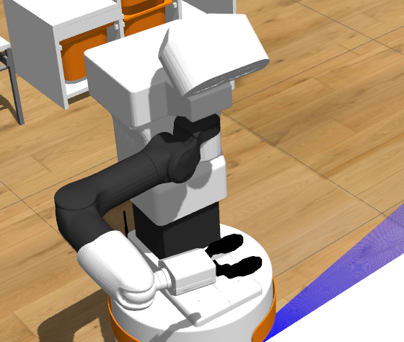
arm_control
rostopic pub /arm_controller/command trajectory_msgs/JointTrajectory "header:
seq: 0
stamp:
secs: 0
nsecs: 0
frame_id: ''
joint_names:
- 'arm_1_joint'
- 'arm_2_joint'
- 'arm_3_joint'
- 'arm_4_joint'
- 'arm_5_joint'
- 'arm_6_joint'
- 'arm_7_joint'
points:
- positions: [0.1, 0.0, -1.5, 1.5, -1.6, 1.4, 1.5]
time_from_start: {secs: 5, nsecs: 0}"

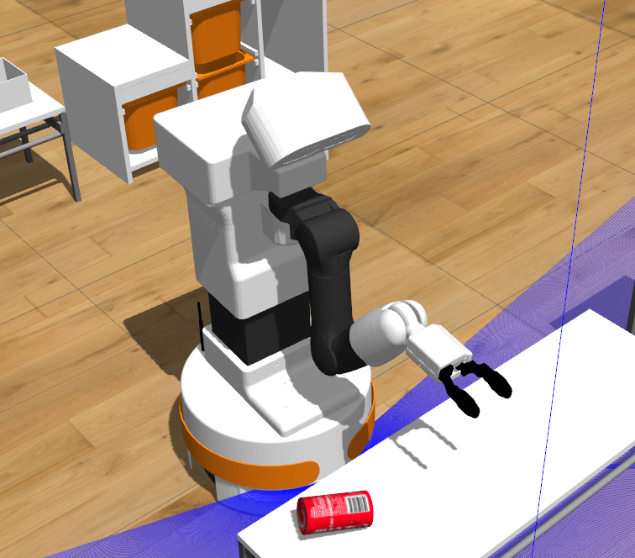
rostopic pub /arm_controller/command trajectory_msgs/JointTrajectory "header:
seq: 0
stamp:
secs: 0
nsecs: 0
frame_id: ''
joint_names:
- 'arm_1_joint'
- 'arm_2_joint'
- 'arm_3_joint'
- 'arm_4_joint'
- 'arm_5_joint'
- 'arm_6_joint'
- 'arm_7_joint'
points:
- positions: [1.5, -1.5, -3.0, 2.5, -1.6, -1.0, 0.0]
time_from_start: {secs: 1, nsecs: 0}"

