Pre-start checks for the MMU
Do these checks at the depot before every shift. Do not leave the depot if any check fails.

Walk-around
- Check the AN tank level on the gauge.
- Inspect the auger hoses for cracks and leaks.
- Run the emulsion pump for 30 seconds and read the pressure.
- Check the gassing solution flow at the test port.

Limits
Check | Limit | If outside the limit
AN tank level | at least 20% | refill at the depot
Emulsion pump pressure | 8 to 12 bar | stop and report to the supervisor
Auger hoses | no cracks, no leaks | replace before leaving
Gassing solution flow | 0.8 to 1.2 L/min | recalibrate the gassing pump

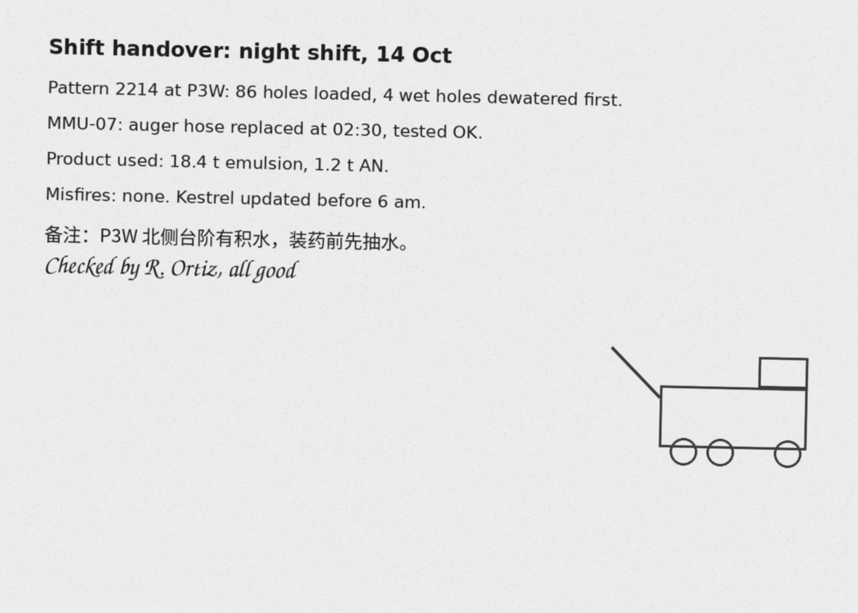
Sign the MMU logbook when all checks pass.

