LANDIS-II Net Ecosystem Carbon and Nitrogen (NECN) Hydrology Succession v1.0

Extension User Guide

Robert M. Scheller1

Melissa S. Lucash2

Alec Kretchun2

1. North Carolina State University

2. Portland State University

Last Revised: January 21, 2018

Table of Contents

1 Introduction

1.1 Cohort Reproduction – Probability of Establishment

1.2 Cohort Growth

1.3 Soil and Dead Biomass Decay

1.4 Initializing Biomass and Soil Properties

1.5 Interactions with Disturbances

1.6 Available Light

1.7 Cohort Reproduction – Disturbance Interactions

1.8 Cohort Reproduction – Initial Biomass

1.9 Cohort Senescence and Mortality

1.10 Major Releases

1.10.1 Version 1.0

1.11 References

1.12 Acknowledgments

2 Succession Input File

2.1 LandisData

2.2 Timestep

2.3 SeedingAlgorithm

2.4 InitialCommunities

2.5 InitialCommunitiesMap

2.6 ClimateConfigFile

2.7 AgeOnlyDisturbances:BiomassParameters

2.8 SoilDepthMapName

2.9 SoilDrainMapName, SoilBaseFlowMapName, SoilStormFlowMapName

2.10 SoilFieldCapacityMapName, SoilWiltingPointMapName

2.11 SoilPercentClayMapName, SoilPercentSandMapName

2.12 InitialSOM1CsurfMapName

2.13 InitialSOM1NsurfMapName

2.14 InitialSOM1CsoilMapName

2.15 InitialSOM1NsoilMapName

2.16 InitialSOM2CMapName

2.17 InitialSOM2NMapName

2.18 InitialSOM3CMapName

2.19 InitialSOM3NMapName

2.20 InitialDeadWoodSurfaceMapName

2.21 InitialDeadWoodSoilMapName

2.22 CalibrateMode

2.23 Water Decay Function

2.24 Probability of Establishment Adjustment

2.25 InitialMineralN

2.26 Nitrogen Inputs- Slope, Intercept

2.27 Latitude

2.28 DenitrificationRate

2.29 DecayRateSurf

2.30 DecayRateSOM1

2.31 DecayRateSOM2

2.32 DecayRateSOM3 MaximumLAI

2.33 LightEstablishmentTable

2.34 SpeciesParameters Table

2.34.1 Species

2.34.2 Functional Type

2.34.3 Nitrogen Fixers

2.34.4 GDD minimum/maximum

2.34.5 Minimum January Temperature

2.34.6 Maximum Allowable Drought

2.34.7 Leaf Longevity

2.34.8 Epicormic resprouting

2.34.9 Lignin: Leaf, Fine Root, Wood, Coarse Root

2.34.10 CN Ratios: Leaf, Fine Root, Wood, Coarse Root, Litter

2.35 Functional Group Parameters

2.35.1 Name

2.35.2 Functional Type

2.35.3 PPDF: 1, 2, 3, 4

2.35.4 FRACleaf

2.35.5 BTOLAI, KLAI, MAXLAI

2.35.6 PPRPTS2, PPRPTS3

2.35.7 Woody Decay Rate

2.35.8 Monthly Wood Mortality

2.35.9 Mortality Curve – Shape Parameter

2.35.10 Leaf Drop Month

2.35.11 Coarse Root Fraction and Fine Root Fraction

2.36 Initial Ecoregion Parameters

2.36.1 Ecoregion Names

2.36.2 SOM1–3 Carbon and Nitrogen

2.36.3 Mineral Nitrogen

2.37 Ecoregion Parameters

2.37.1 Ecoregion Names

2.37.2 Latitude

2.37.3 Decay Rates of SOM1 surface, SOM1 soil, SOM2 and SOM3

2.37.4 N volatilization and Denitrification

2.38 Fire Reduction Parameters

2.38.1 Fire Severity

2.38.2 Wood Reduction

2.38.3 Litter Reduction

2.39 Harvest Reduction Parameters

2.39.1 Prescription Name

2.39.2 Wood Reduction

2.39.3 Litter Reduction

2.40 Ecoregion-dependent Species Parameters

2.40.1 First Row – Ecoregions

2.40.2 Other Rows – Species Parameters

2.40.3 MaximumMonthlyANPP Table

2.40.4 MaximumBiomass Table

2.41 AgeOnlyDisturbances:BiomassParameters

3 Output Files

4 Initial Communities Input File

4.1 Example File

4.2 LandisData

4.3 Initial Community Class Definitions

4.3.1 MapCode

4.3.2 Species Present

4.3.3 Grouping Species Ages into Cohorts

5 Input File – Age-only Disturbances

5.1 LandisData

5.2 CohortBiomassReductions Table

5.2.1 Disturbance

5.2.2 Woody

5.2.3 Non-Woody

5.3 DeadPoolReductions Table

5.3.1 Disturbance

5.3.2 Woody

5.3.3 Non-Woody

6 Example Inputs

6.1 Main Parameter File

6.2 Age-only Disturbances

# Introduction

This document describes the **Net Ecosystem Carbon and Nitrogen Hydrology (NECN_Hydro) Succession** extension for the LANDIS-II model. For information about the LANDIS-II model and its core concepts including succession, see the *LANDIS-II Conceptual Model Description* and the LANDIS-II website (www.landis-ii.org)*.*

The NECN_Hydro Succession Extension is a hybrid between the Century soil model (Parton et al. 1993, Schimel et al. 1994, Parton et al. 1994, Pan et al. 1998) and the LANDIS-II Biomass Succession extension (Scheller and Mladenoff 2004). NECN Succession calculates how cohorts grow, reproduce, age, and die (Scheller et al. 2011). Dead biomass is tracked over time, divided into four pools: surface wood, soil wood (dead coarse roots), surface litter (dead leaves), and soil litter (dead fine roots). In addition, three principal soil pools: fast (soil organic matter (SOM) 1), slow (SOM2), and passive (SOM3) are simulated.

For a schematic drawing of the NECN extension, see Scheller et al 2011.

NECN_Hydro departs from standard NECN in several important ways:

* Ecoregions are no longer used to define abiotic conditions. This extension is essentially ‘ecoregion free’. Soils vary site-to-site. Climate is grouped into climate regions.
* The extension does not ‘spin up’. All initial parameters, including species biomass, are provided at time zero. This eliminates the initial processing time required during spin-up and initial conditions reflect available data.
* Data regarding water availability are written as output maps, hence the ‘hydro’ moniker. One of our goals was to incorporate site-scale variation in slope into water availability equations and therefore more accurately represent local hydrological conditions.

## Cohort Reproduction – Probability of Establishment

The probability of establishment (PEST) is internally calculated at an annual time step and is dependent upon input weather data. Although calculated annually, establishment can only occur following a disturbance or at a succession time step. PEST is based on the minimum of three limiting factors: 1) growing degree days (GDD), 2) drought tolerance, 3) minimum January temperature. These represent **site-scale** limits to species establishment in that the requisite parameters vary by ecoregion. Available light is calculated as a function of LAI and is included as a part of the **site scale** limits to establishment.

## Cohort Growth

At each time step, cohort growth is determined by estimated leaf area index (LAI), water availability, temperature, growing space capacity and nitrogen availability. Cohort growth generally follows the algorithms found in Century, except for N uptake. In the spring, the amount of resorbed N is calculated (leaf N - litter N), which can be “used” by the cohort when conditions are conducive to growth. In hardwoods, resorbed N is used primarily in the spring; resorbed N can be utilized throughout the year in conifers. After the pool of resorbed N is depleted, the cohort takes up N from the mineral N pool. Uptake of N is proportional to above-ground net primary productivity (ANPP), with greater N uptake by faster growing cohorts. When mineral N is limiting, competition for N between cohorts is determined by the relative amount of their coarse root biomass.

## Soil and Dead Biomass Decay

All soil processes follow the algorithm and science from Century v4.5 whereby there are four litter pools (structural and metabolic material either on the surface or within the soil) and three soil organic matter (SOM) pools (SOM 1,2,3). SOM1 is further subdivided into SOM1 surface and SOM1 soil.

Decay rates of SOMsurf, SOM1soil, SOM 2 and SOM 3 are user inputs at the **ecoregion** scale.

## Initializing Biomass and Soil Properties

The initial biomass is provided by the user and therefore there is no model “spin-up”.

**Note:** *An initial (time zero) climate stream is still required for initialization (see the climate library user’s manual- LANDIS-II Climate Library v1.0 User Guide). This is an artifact of the Climate Library and this data is not used.*

## Interactions with Disturbances

NECN Succession was written to allow disturbances (e.g. wind and harvest) that operate on age-only cohorts to interact with the two dead biomass pools. For example, a User is able to run the wind extension with NECN Succession. Although the wind disturbance extension is not ‘biomass aware’, a simple interface was created that enables the biomass of cohorts killed by the disturbance to be allocated to the proper dead biomass pools. The interface allows a user to indicate a) whether and how much leaf or woody **live biomass** is transferred to their respective dead pools by a disturbance type and b) whether and how much of the leaf or woody **dead biomass *aboveground* pools** are removed by a disturbance type.

**Note**: *Do not list fire in the age-only disturbance table*. Fire effects vary by severity and are indicated in the separate **FireReductionParameters** table (below).

This interface does not allow dynamic changes in the transfer rates into and out of the dead pools. Rather, the interface was designed to allow existing age-cohort disturbances to be used with NECN Succession.

The interface is specified in a separate LandisData parameter file: "Age-only Disturbances - Biomass Parameters". See Chapter 4.

## Available Light

Available light (the conceptual inverse of shade) calculations follow the shade algorithms in Biomass Succession (v2).

## Cohort Reproduction – Disturbance Interactions

See the rules and algorithm outlined for Biomass Succession (v4).

## Cohort Reproduction – Initial Biomass

See the rules and algorithm outlined for Biomass Succession (v4).

## Cohort Senescence and Mortality

See the rules and algorithm outlined for Biomass Succession (v4).

## Major Releases

### Version 1.0

NECN Hydrology introduced including site-scale reproduction and no spin-up.

## References

Aber, J.D., D.B. Botkin, and J.M. Melillo. 1979. Predicting the effects of different harvesting regimes on productivity and yield in northern hardwoods. Canadian Journal of Forest Research **9**: 10-14.

Albaugh, T., H. Allen, and L. Kress. 2006. Root and stem partitioning of *Pinus taeda*. Trees - Structure and Function 20:176-185.

Botkin, D.B., J.F. Janak, and J.R. Wallis. 1973. Some ecological consequences of a computer model of forest growth. Journal of Ecology **60**: 849-872

Covelo, F., J. Duran, and A. Gallardo. 2008. Leaf resorption efficiency and proficiency in a *Quercus robur* population following forest harvest. Forest Ecology and Management.

Johnson, D. W., M. E. Fenn, W. W. Miller, and C. T. Hunsaker. 2009. Fire effects on carbon and nitrogen cycling in forests of the Sierra Nevada. Pages 405-423 in A. Bytnerowicz, M. Arbaugh, C. Andersen, and A. Riebau, editors. Wildland Fires and Air Pollution. Developments in Environmental Science 8. Elsevier, The Netherlands.

Killingbeck, K. T. 1996. Nutrients in senesced leaves: Keys to the search for potential resorption and resorption proficiency. Ecology 77:1716-1727.

Lovett, G. M., L. M. Christenson, P. M. Groffman, C. G. Jones, J. E. Hart, and M. J. Mitchell. 2002. Insect defoliation and nitrogen cycling in forests. BioScience 52:335-341.

Lovett, G. M. and A. E. Ruesink. 1995. Carbon and nitrogen mineralization from decomposing gypsy moth frass. Oecologia 104:133-138.

Kimmins, J. P., D. Mailly, and B. Seely. 1999. Modelling forest ecosystem net primary production: the hybrid simulation approach used in FORECAST. Ecological Modelling 122:195-224.

Pan, Y., J.M. Melillo, A.D. McGuire, D.W. Kicklighter, L.F. Pitelka, K. Hibbard, L.L. Pierce, S.W. Running, D.S. Ojima, W.J. Parton, D.S. Schimel, and VEMAP Members. 1998. Modeled responses of terrestrial ecosystems to elevated atmospheric CO2: a comparison of simulations by the biogeochemistry models of the Vegetation /Ecosystem Modeling and Analysis Project (VEMAP). Oecologia 114: 389-404.

Park, B., R. Yanai, T. Fahey, S. Bailey, T. Siccama, J. Shanley, and N. Cleavitt. 2008. Fine root dynamics and forest production across a calcium gradient in northern hardwood and conifer ecosystems. Ecosystems 11:325-341.

Parton, W. J., D. S. Ojima, C. V. Cole, and D. S. Schimel. 1994. "A General Model for Soil Organic Matters Dynamics: Sensitivity to Litter Chemistry, Texture and Management." Pp. 147-67 in Quantitative Modeling of Soil Forming Processes: Proceedings of a Symposium Sponsored by Divisions S-5 and S-9 of the Soil Science Society of America Minneapolis, Minnesota, USA, editors R. B. Bryant and R. W. Arnold. Madison, Wisconsin, USA: Soil Science Society of America.

Parton, W.J., J.M.O. Scurlock, D.S. Ojima, T.G. Gilmanov, R.J. Scholes, D.S. Schimel, T. Kirchner, J.C. Menaut, T. Seastedt, E. Garcia Moya, A. Kamnalrut, and J.I. Kinyamario. 1993. Observations and modeling of biomass and soil organic matter dynamics for the grassland biome worldwide. Global Biogeochemical Cycles 7: 785-809.

Ryan, D. F. and F. H. Bormann. 1982. Nutrient resorption in northern hardwood forests. BioScience 32:29-32.

Scheller, R. M., D. Hua, P. V. Bolstad, R. A. Birdsey, and D. J. Mladenoff. 2011. The effects of forest harvest intensity in combination with wind disturbance on carbon dynamics in Lake States mesic forests. Ecological Modelling 222:144-153.

Scheller, R.M., S. Van Tuyl, K. Clark, J. Hom, I. La Puma. 2011. Carbon sequestration in the in the New Jersey pine barrens under different scenarios of fire management. Ecosystems. DOI: 10.1007/s10021-011-9462-6

Scheller, R. M. and Mladenoff, D. J. A forest growth and biomass module for a landscape simulation model, LANDIS: Design, validation, and application. Ecological Modelling. 2004; 180(1):211-229.

Schimel, D.S., B.H. Braswell, E.A. Holland, R. McKeown, D.S. Ojima, T.H. Painter, W.J. Parton, and A.R. Townsend. 1994. Climatic, edaphic, and biotic controls over storage and turnover of carbon in soils. Global Biogeochemical Cycles 8: 279-293.

Seitzinger, S., J. A. Harrison, J. K. Böhlke, A. F. Bouwman, R. Lowrance, B. Peterson, C. Tobias, and G. V. Drecht. 2006. Denitrification across landscapes and waterscapes: A synthesis. Ecological Applications 16:2064-2090.

Schlesinger, W. H. and A. E. Hartley. 1992. A global budget for atmospheric NH3. Biogeochemistry 15:191-211.

## Acknowledgments

Funding for the development of LANDIS-II has been provided by the Climate Change Program (New Town Square, Pennsylvania) of the U.S. Forest Service. Funding for versions 3.2 – 4.1 has been provided by USDA AFRI.

# Succession Input File

Nearly all the input parameters for this extension are specified in one main input file. This text file must comply with the general format requirements described in section 3.1 *Text Input Files* in the *LANDIS-II Model User Guide*.

## LandisData

This parameter’s value must be "NECN-H Succession".

## Timestep

This parameter is the time step of the extension. Value: integer > 0. Units: years.

**Note**: When changing the timestep of this extension (e.g., from a 5-year time step to a 1-year time step), you may need to adjust the probability of establishment adjustment factor (ProbEstablishAdjust) to retain the same regeneration rates (see section 2.13 below).

## SeedingAlgorithm

This parameter is the seeding algorithm to be used. Valid values are "WardSeedDispersal", "NoDispersal" or "UniversalDispersal". The algorithms are described in section 4.5.1 *Seeding* of the *LANDIS-II Conceptual Model Description*.

## InitialCommunities

This parameter is the file with the definitions of the initial communities at the active sites on the landscape (see section 4).

## InitialCommunitiesMap

This parameter is the input map indicating the initial communities at the active sites on the landscape. Each cell value for an active site on the landscape must be one of the map codes listed in the initial communities input file (see section 4).

## ClimateConfigFile

The climate configuration file contains required climatic inputs. The format of that file and its contents are described in the climate library user’s manual (LANDIS-II Climate Library v1.0 User Guide).

## AgeOnlyDisturbances:BiomassParameters

## SoilDepthMapName

The depth of the soil simulated, cm.

**User Tip:** The depth specified here will influence other ecoregion parameters in the table (e.g. % sand, % clay, field capacity). For example, if you choose a soil depth of 50cm, you might have lower % sand, than if you select a soil depth of 100cm.

## SoilDrainMapName, SoilBaseFlowMapName, SoilStormFlowMapName

Determines the amount of water runoff and leaching. This affects the amount of N leaching (N loss) which, in turn, affects the amount of mineral N.

* drain - the fraction of excess water lost by drainage. The soil drainage factor allows a soil to have differing degrees of wetness (e.g., [DRAIN](http://www.nrel.colostate.edu/projects/century/manual4/man96.html#DRAIN)=1 for well drained sandy soils and [DRAIN](http://www.nrel.colostate.edu/projects/century/manual4/man96.html#DRAIN)=0 for a poorly drained clay soil).
* basef - fraction per month of subsoil water going into stream flow
* stormf - the fraction of the soil water content lost as fast stream flow

## SoilFieldCapacityMapName, SoilWiltingPointMapName

Field capacity and wilting point expressed as a fraction of the soil depth. In the model, field capacity and wilting point are calculated as this fraction multiplied by soil depth.

## SoilPercentClayMapName, SoilPercentSandMapName

Units: fraction of soil (0.0 – 1.0).

## InitialSOM1CsurfMapName

## InitialSOM1NsurfMapName

## InitialSOM1CsoilMapName

## InitialSOM1NsoilMapName

## InitialSOM2CMapName

## InitialSOM2NMapName

## InitialSOM3CMapName

## InitialSOM3NMapName

## InitialDeadWoodSurfaceMapName

## InitialDeadWoodSoilMapName

## CalibrateMode

Determines whether the model is run in calibrate mode whereby additional parameters are added to a log file (“NECN-calibrate-log.csv”). **The calibrate mode should only be used when simulating a single site due to the volume of screen output.** The intention is to view output of additional parameters, such as what factors are limiting growth at each time step.

## Water Decay Function

The WaterDecayFunction parameter determines the effect of moisture on decay rate can be either linear or based on a ratio. The Century 4.0 Help file states that linear option is to be when only the relative water content in the top 15 cm affects decay rates. If ratio, the ratio of rainfall to potential evaporation rate determines the effect of moisture on decay rates.

Options: “Linear” or “Ratio”

***User Tip:*** Linear is generally appropriate for sandy soils; ratio for more mesic soils.

## Probability of Establishment Adjustment

This optional parameter adjusts the probability of establishment. The default value is one.

***User Tip:*** This value can be reduced (<1) if regeneration rates are too high. This is particularly useful when changing the successional time step- e.g. changing from a 5-year time step to a 1-year time step. For example, if you want regeneration at a 1-year successional time step to be equivalent to 5-year time step values, a value of 0.2 (1/5) would be most appropriate when using a 1-year time step.

## InitialMineralN

## Nitrogen Inputs- Slope, Intercept

Determines N deposition rates (including wet deposition, dry deposition, non-symbiotic fixation and N fertilization) using simple regression:

Total N deposition = (AtmosNslope*precipitation) + AtmosNinter

The AtmosNslope parameter controls how the amount of wet deposition, i.e. how much N is deposited during rain events, with higher slopes generating more N deposition. Dry deposition is controlled by the N intercept parameter, which is constant and is not a function of precipitation.

**User Tip:** *Adjust the slope and intercept until the monthly or annual N deposition in the NECN-succession-monthly-log.csv is similar to literature values.*

## Latitude

## DenitrificationRate

## DecayRateSurf

## DecayRateSOM1

## DecayRateSOM2

## DecayRateSOM3

## MaximumLAI

## LightEstablishmentTable

This table allows the user to control site-scale PEST dependent upon species light requirements (i.e., shade class) and available light. For example, if a species is mid-tolerant of low light (light requirement = 3) and the available light class is 5 (very low light), the probability may be low but not zero. If the user indicates a low probability, then there would still some small chance that a mid-tolerant can become established as may be the case in small gaps.

## SpeciesParameters Table

This table contains species’ physiological parameters. Each row in the table has the parameters for one species. Every active species must have an entry.

### Species

The species must be defined in the species input file (see chapter 5 in the *LANDIS-II Model User Guide*). Species may appear in any order.

### Functional Type

This is an index into the FunctionalTypeParameters table, below.

### Nitrogen Fixers

This should be either yes (Y) or no (N), depending on whether the species can fix N.

### GDD minimum/maximum

Growing Degree Day (GDD) maximum and minimum are used to define a species climatic envelope following the algorithm by Botkin (1973). GDD is calculated on a 5°C base.

### Minimum January Temperature

A species has a minimum tolerable January temperature (the mean of January nights). If the stochastically generated January minimum temperature is below the minimum, a species cannot establish. Units: degrees Celsius.

### Maximum Allowable Drought

If available water falls below zero for a percent of the growing season greater than this value, a species cannot establish. Units: fraction of the growing season (0.0 – 1.0). Lower values indicate species whose establishment is more sensitive to drought.

### Leaf Longevity

This parameter is the average longevity of a leaf or needle. Value: 1.0 ≤ decimal number ≤ 10.0. Units: years.

### Epicormic resprouting

Does the species resprout via epicormic branching following a fire? Value: Y/N; yes, no.

### Lignin: Leaf, Fine Root, Wood, Coarse Root

The fraction of lignin in each plant component (leaf, fine root, wood, and coarse root) per species. Value: 0.0 ≤ decimal number ≤ 1.0.

### CN Ratios: Leaf, Fine Root, Wood, Coarse Root, Litter

The carbon to nitrogen ratios for leaf, fine root, wood, coarse root, and litter components. The difference between leaf and litter CN ratios represents the amount of N that is resorbed (i.e. retranslocated) prior to leaf mortality.

**Note**: *For retranslocation to work properly, litter CN* ***must be*** *higher than leaf CN for each species.*

## Functional Group Parameters

These parameters are either not generally resolved to the level of species or are similar across genera. **The number of functional groups cannot exceed 25.**

### Name

The name is for display purposes only to help users organize the inputs.

### Functional Type

An index to the species table.

### PPDF: 1, 2, 3, 4

* These four parameters define a temperature growth curve. ppdf(1)- optimum temperature for production for parameterization of a Poisson Density Function curve to simulate temperature effect on growth
* ppdf(2) - maximum temperature for production for parameterization of a Poisson Density Function curve to simulate temperature effect on growth
* ppdf(3) - left curve shape for parameterization of a Poisson Density Function curve to simulate temperature effect on growth
* ppdf(4) - right curve shape for parameterization of a Poisson Density Function curve to simulate temperature effect on growth

**Note that these parameters affect growth only, not establishment**

For a more detailed explanation of these parameters, see the CENTURY 4.5 manual and help files (<http://www.nrel.colostate.edu/projects/century/manual4/man96.html>).

### FRACleaf

The fraction of aboveground net primary productivity that is allocated to leaves. Units: fraction of ANPP (0.0 – 1.0).

### BTOLAI, KLAI, MAXLAI

These three parameters determine how LAI is calculated which subsequently limits growth. Therefore these parameters help determine the initial rate of growth in the landscape. BTOLAI - biomass to leaf area index (LAI) conversion factor for trees

* KLAI - large wood mass (g C/m2) at which half of theoretical maximum leaf area [(maxlai)](http://www.nrel.colostate.edu/projects/century/manual4/man96.html#MAXLAI) is achieved
* MAXLAI - theoretical maximum leaf area index achieved in a mature forest and is additive within a cell

For definitions, see the Century 4.5 on-line manual (http://www.nrel.colostate.edu/projects/century/manual4/man96.html). BTOLAI determines LAI as a function of leaf biomass. KLAI and MAXLAI determine LAI as a function of wood biomass. If MAXLAI = 0.0, then only leaf biomass determines LAI and the growth limits.

For a more detailed explanation of these parameters, see the CENTURY 4.5 manual and help files (<http://www.nrel.colostate.edu/projects/century/manual4/man96.html>).

### PPRPTS2, PPRPTS3

* These two parameters determine growth sensitivity to low available water, e.g., drought conditions. pprpts(2) - the effect of water content on the intercept
* pprpts(3)- the lowest ratio of available water to [potential](http://www.nrel.colostate.edu/projects/century/manual4/man96.html#PET) evapotranspiration at which there is no restriction on production

**Note that these parameters affect growth only, not establishment**

For a more detailed explanation of these parameters, see the CENTURY 4.5 manual and help files (<http://www.nrel.colostate.edu/projects/century/manual4/man96.html>).

### Woody Decay Rate

This parameter defines the maximum fraction of the species’ dead wood that decomposes in the ecoregion. Value: 0.0 ≤ number ≤ 1.0. Unitless.

### Monthly Wood Mortality

A monthly fraction of wood mortality. This replaces the algorithm in Biomass Succession v2 where growth-related mortality was a function of ANPP. Units: fraction of wood biomass (0.0 – 1.0).

**User Tip**: *This parameter can have large effects. If set too high, a site can remain in a permanent ‘juvenile’ state and dead woody biomass and SOM will increase very quickly and reach overly high levels. If too low, the site will reach maximum biomass too quickly and SOM may actually decline.*

### Mortality Curve – Shape Parameter

This parameter determines how quickly age-related mortality begins and operates as in Biomass Succession v1 and v2. Value: 5.0 ≤ decimal number ≤ 25.0. If the parameter = 5, then age-related mortality will begin at 10% of life span. If the parameter = 25, then age-related mortality will begin at 85% of life span.

### Leaf Drop Month

This parameter determines when the leaves will drop and become part of the litter pool.

**Note:** *Note that LeafDropMonth=9 means that half the leaves will drop in October (one month offset) and the other half drop in November.*

### Coarse Root Fraction and Fine Root Fraction

The fraction of aboveground net primary productivity that is allocated to coarse roots and fine roots. Units: fraction of ANPP (0.0 – 1.0).

## Initial Ecoregion Parameters

The initial ecoregion parameters allow soils to begin with some C and N. However, SOM C and N at time zero will also reflect the initial communities and ecoregion parameters (e.g., soil depth, field capacity, wilting point).

**Note**: *Dead biomass (wood, structural, and metabolic) is estimated from the growth and mortality of cohorts during initialization.*

### Ecoregion Names

The first column in the table is a list of one or more active ecoregions defined in the ecoregions input file (see chapter 6 in the *LANDIS-II Model User Guide*). The ecoregions can appear in any order; they do not need to appear in the same order as in the ecoregions input file.

### SOM1–3 Carbon and Nitrogen

The initial amount of C and N in the four principle soil pools: SOM1-surface, SOM1-soil, SOM2 and SOM3. Units: g C m-2 and g N m-2.

### Mineral Nitrogen

The initial amount of mineral N. This N is available to plants for growth. Units: g m-2.

## Ecoregion Parameters

### Ecoregion Names

The first column in the table is a list of one or more active ecoregions defined in the ecoregions input file (see chapter 6 in the *LANDIS-II Model User Guide*). The ecoregions can appear in any order; they do not need to appear in the same order as in the ecoregions input file.

### Latitude

The latitude of the study site (°)

### Decay Rates of SOM1 surface, SOM1 soil, SOM2 and SOM3

The decay rates for SOM1-surface, SOM1-soil, SOM2, and SOM3 determine the **maximum** decomposition rate (k) of the four soil organic matter pools.

**User Tip:** *The decay rates should be adjusted to so that the changes in each of the soil pools between year 0 (input file) and year 1 are realistic. In most landscapes, the relative changes in the soil pools are higher in the upper than the lower horizons. Therefore, the maximum decay rates should be higher in the surficial than the deeper pools (i.e. DecayRateSurf>DecayRateSOM1> DecayRateSOM2>DecayRateSOM3). Also, the total amount of C in soil should slowly increase over time in the absence of disturbance.*

### N volatilization and Denitrification

The fraction of mineral N lost through ammonia volatilization and denitrification **per month**. This fraction is not fire related; fire related volatilization is modeled separately). Units: dimensionless.

**User Tip:** *This parameter should be adjusted so that Nvol (output parameter of N volatilization) ranges from 0 to ~0.3 for uplands and 0.3 to 1 g m-2 year-1 for wetlands (Seitzinger et al. 2006).*

## Fire Reduction Parameters

The FireReductionParameters table allows users to specify how much dead wood and litter will be removed as a function of fire severity. The reduction of wood and litter will occur **after** fire induced mortality of cohorts. After a fire kills a cohort, the dead biomass is deposited on the forest floor and is then subsequently volatilized in the same time step.

**Note**: This table is needed even if fire extensions are not being used.

### Fire Severity

The first column is fire severity, classes 1 – 5. Severity should be listed in ascending order.

### Wood Reduction

The second column is the proportion (0.0 – 1.0) of dead wood biomass that is volatilized. The proportion will be applied to both C and N components.

### Litter Reduction

The third column is the proportion (0.0 – 1.0) of dead litter biomass that is volatilized. The proportion will be applied to both C and N components.

## Harvest Reduction Parameters

The **optional** HarvestReductionParameters table allows users to specify how much dead wood and litter will be removed as a function of harvest activity. The reduction of wood and litter will occur **after** harvest induced mortality of cohorts. After a harvest event kills a cohort, the dead biomass is removed from the forest. **If this table is not used, the harvested cohorts will follow the parameters in the age-only-disturbance file (see below).** *If the table is used be sure to remove harvesting from the age-only-disturbance file.*

### Prescription Name

The first column is prescription name. Each prescription name must be identical to the prescription names in the Leaf Biomass Harvest file (see “LANDIS-II Base Harvest v2.0 User Guide”). Prescriptions can be in any order; they do *not* need to appear in the same order as in the Leaf Biomass Harvest input file.

### Wood Reduction

The second column is the proportion (0.0 – 1.0) of dead wood biomass that is removed. The proportion will be applied to both C and N components.

### Litter Reduction

The third column is the proportion (0.0 – 1.0) of dead litter biomass that is removed. The proportion will be applied to both C and N components.

## Ecoregion-dependent Species Parameters

The NECN Succession extension uses some species parameters that vary by ecoregion:

* Maximum monthly aboveground net primary production (ANPP). Note this parameter is in units of biomass, not carbon (C). C generally comprises roughly 50% of biomass.
* Maximum above ground biomass (AGB). Note this parameter is in units of biomass, not carbon (C). C generally comprises roughly 50% of biomass.

Each parameter has its own table.

### First Row – Ecoregions

The first row in a table is a list of one or more active ecoregions defined in the ecoregions input file (see chapter 6 in the *LANDIS-II Model User Guide*). The ecoregions can appear in any order; they do not need to appear in the same order as in the ecoregions input file.

Every active ecoregion that is not in a table’s first row will have default parameter values assigned to all the species (given below). The sections below which describe the individual parameter tables also specify the default value for each table.

### Other Rows – Species Parameters

All other rows in a table after the initial row contain species parameter values. Each row contains the parameter values for one species. The species name comes first, followed by one or more parameter values. The name and values are separated by whitespace. There must be one parameter value for each of the ecoregions listed in the table’s first row.

The species can be listed in any order in a table. A species can be omitted. If so, it will be assigned the default parameter value for all active ecoregions.

### MaximumMonthlyANPP Table

This parameter is the maximum possible aboveground net primary productivity (ANPP) for each cohort of each species in the ecoregion. The value is specified as the ANPP in the month of the year with maximum growth (e.g., June). Value: 0 ≤ integer ≤ 100,000. Units: g biomass m-2 month-1. Default value: 0

**Note:** This parameter is in units of biomass but output from Landis-NECN is in units of C (C generally comprises roughly 50% of biomass. Also, remember that this is the maximum monthly ANPP during peak growing season, not the annual ANPP often reported in the literature.

### MaximumBiomass Table

This parameter defines the maximum allowable aboveground biomass (AGB) for the species in the ecoregion. This parameter interacts with KLAI and ANPP to determine the growth rate and maximum biomass of each species. Value: 0 ≤ integer. Units: g biomass m-2. Default value: 0

## AgeOnlyDisturbances:BiomassParameters

This optional file parameter is the path of a text file with the biomass parameters to be used with age-cohort disturbances (e.g., Base Wind, Base Fire, Base BDA). The format of that file is described in chapter 4.

# Output Files

The NECN Succession extension produces a number of outputs, both maps (.img) and output log files and summary log files (.csvs).

Maps

Output maps for NECN_Hydro primarily contain information on nutrient cycling and hydrology.

1. Annual Water Budget: Excess soil moisture after evapotranspiration. Defined as water inputs (precipitation + irract) – actual evapotranspiration (AET)
2. Available water: amount of water available to trees

In addition to the maps, there are three primary log files and one optional log files. These are all comma delimited (*.csv) files that are typically read using Excel.

**Note**: *When you run NECN, xml files are created for the NECN-succession-log and NECN-succession-monthly-log files in the folder called Metadata****. These xml files can be opened in any internet browser (e.g. Internet Explorer) and will list all the output parameters, their description and units.***

1. NECN-succession-log: The primary log file that outputs a snapshot of data at every successional time step. These data are averaged by ecoregion and are most useful for analyzing variation over time and across ecoregions.

2. NECN-succession-monthly-log: This log file contains an abbreviated set of data that are useful at a monthly time step. These include NPP, heterotrophic respiration, N deposition and NEE. These data can be compared to monthly flux tower data. Also included are monthly temperature and precipitation and soil temperature. These allow a quick cross-reference to your input data.

3. NECN-prob-establish-log: This log file contains the data used to calculate the probability of establishment for each ecoregion at each succession time step. The probability of establishment is the minimum of all limiting factors. However, these values do not take shade and presence of seed sources into account and therefore do not reflect the actual probability of establishment in a given site. The metadata file for this log file is located in the folder: C:\Program Files\LANDIS-II\v6\docs

***Note:*** *The probability of establishment is calculated annually and averaged over the succession time step.*

4. NECN-calibrate-log: A detailed monthly output for **every cohort at each month**. Due to the volume of data, this file should only be used with single cell runs.

The metadata file for the calibrate log file is located in the folder: C:\Program Files\LANDIS-II\v6\docs. In the calibrate log file, BTOLAI is labelled as rLAI and KLAI as tLAI to make it consistent with the original Century code.

# Initial Communities Input File

This file contains the definitions of the initial community classes. Each active site on the landscape is assigned to an initial community class. The class specifies the tree species that are present along with the particular age classes and biomass that are present for each of those species.

## Example File

LandisData "Initial Communities"

>>Old jackpine oak

MapCode 7

acerrubr 30 (240)

pinubank 80 90

pinuresi 110 140

querelli 40 120 240

>> young jackpine oak

MapCode 0

pinubank 30 50

querelli 10 40 70

>> young aspen

MapCode 2

poputrem 10 20

>> old maple hardwoods

MapCode 55

abiebals 10 60 120

acerrubr 90 120

acersacc 20 50 150 200

betualle 40 140 200

fraxamer 10 100 130 180

piceglau 180

querrubr 100 160 180

thujocci 200 240 260

tiliamer 20 80 110 150

tsugcana 30 80 120 220 320 340

>> old pine - spruce - fir

MapCode 6

abiebals 10 50 80

piceglau 100 140 180 200 220

pinuresi 140 160 180

pinustro 200 280 350

## LandisData

This parameter’s value must be "Initial Communities".

## Initial Community Class Definitions

Each class has an associated map code and a list of species present at sites in the class.

### MapCode

This parameter is the code used for the class in the input map (see section 2.5). Value: 0 ≤ integer ≤ 65,535. Each class’ map code must be unique. Map codes do not have to appear in any order, and do not need to be consecutive.

### Species Present and Biomass

A list of species present at the class’ sites comes after the map code. Each species is listed on a separate data line.

*species age (biomass) age (biomass) age* *(biomass)* ...

The species name comes first, followed by one or more ages. The name and ages are separated by whitespace. An age is an integer and must be between 1 and the species’ Longevity parameter. The ages do not have to appear in any order.

Following each age is the aboveground woody biomass (g Biomass m-2)

acersacc 10 (240) 5 (16) 21 (112) 60 (1968) 100 (2103)

The list may be empty, which will result in the sites in the class being initialized with no species cohorts.

### Grouping Species Ages into Cohorts

The list of ages for each species is grouped into cohorts based on the succession extension’s timestep. This timestep determines the size of each cohort. For example, if the timestep is 20, then the cohorts are ages 1 to 20, 21 to 40, 41 to 60, etc.

Suppose an initial community class has this species in its list (biomass left out for simplicity):

acersacc 10 25 30 40 183 200

If the succession timestep is 10, then the cohorts for this species initially at each site in this class should be:

acersacc 10 20 30 40 190 200

If the succession timestep is 20, then the cohorts for this species initially at each site in this class will be:

acersacc 20 40 200

# Input File – Age-only Disturbances

This auxiliary input file contains the biomass parameters used when age-only disturbances kill biomass cohorts (see section 2.24 *AgeOnlyDisturbances:BiomassParameters*). This text file must comply with the general format requirements described in section 3.1 *Text Input Files* in the *LANDIS-II Model User Guide*.

**Note**: *Fire is not allowed as a disturbance type*. Fire effects vary by severity and are indicated in the FireReductionParameters table.

## LandisData

This parameter’s value must be "Age-only Disturbances - Biomass Parameters".

## CohortBiomassReductions Table

This table describes **how much a dead cohort’s biomass is removed by a disturbance** before the biomass is added to the corresponding dead pool. For example with harvesting, the harvest extension specifies the amount of biomass that is killed, while the cohort biomass table determines the amount that gets removed (e.g. removed for use as lumber). The table also determines how much of the material that is removed is wood vs. leaves. Each row describes the reductions associated with a particular type of disturbance.

### Disturbance

This text parameter is the type of the disturbance. The disturbance name must be consistent with the LandisData name given in the disturbance extension. The keyword "(default)" specifies the reductions for all disturbance types not listed in the table. The row with the default reductions must be present in the table.

### Woody

This parameter is the percentage by which the disturbance reduces a dead cohort’s woody biomass. Value: 0% ≤ integer percentage ≤ 100%. The biomass remaining after the reduction is added to the dead woody pool at the site where the cohort was killed.

### Non-Woody

This parameter is the percentage by which the disturbance reduces a dead cohort’s non-woody biomass. Value: 0% ≤ integer percentage ≤ 100%. The biomass remaining after the reduction is added to the dead non-woody pool at the site where the cohort was killed.

## DeadPoolReductions Table

This table describes how much a disturbance reduces the dead biomass pools at the sites it disturbs. Each row describes the reductions associated with a particular type of disturbance.

### Disturbance

This text parameter is the type of the disturbance. The disturbance name must be consistent with the LandisData name given in the disturbance extension. The keyword "(default)" specifies the reductions for all disturbance types not listed in the table. The row with the default reductions must be present in the table.

### Woody

This parameter is the percentage by which the disturbance reduces a site’s dead woody biomass. Value: 0% ≤ integer percentage ≤ 100%.

### Non-Woody

This parameter is the percentage by which the disturbance reduces a site’s dead non-woody biomass. Value: 0% ≤ integer percentage ≤ 100%.

# 

# Example Inputs

## Main Parameter File

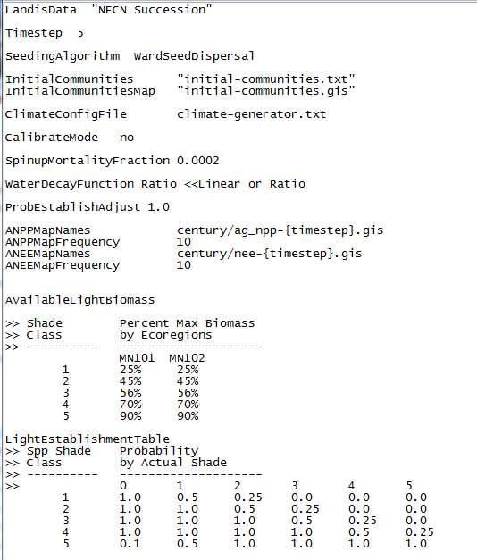

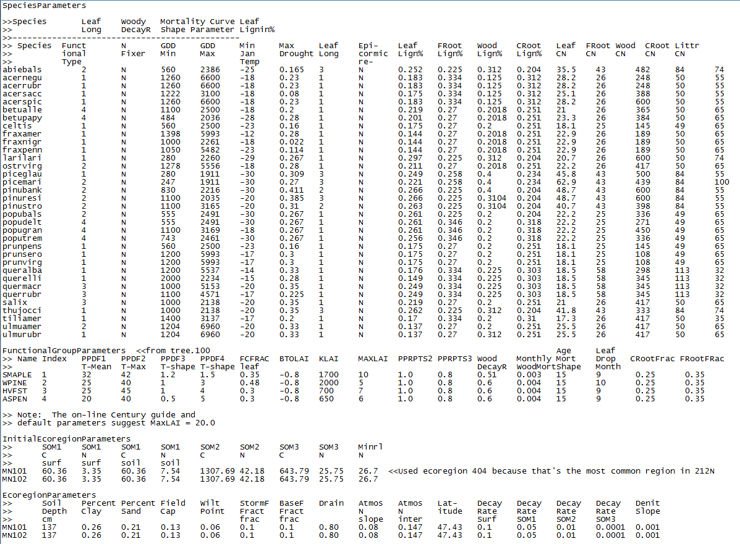

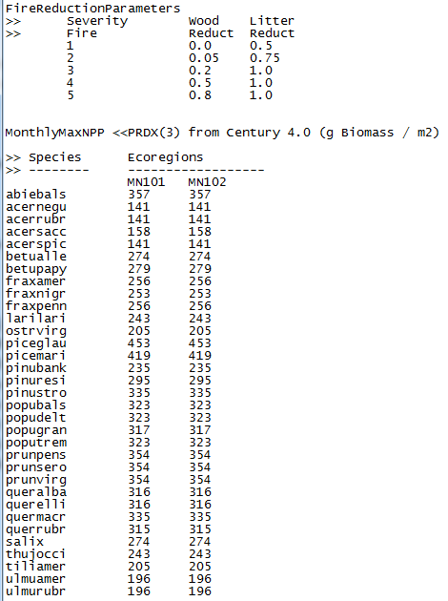

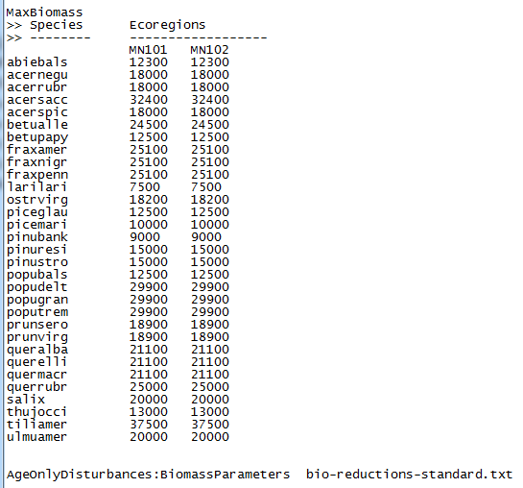

## Age-only Disturbances

