Manual for the spatio-temporal explicit earthworm model “FORESEE”

Version 1.1
29.08.2024

Purpose of the model
The FORESEE model was developed to simulate earthworm populations in the field and to predict possible effects on the populations due to exposure to plant protection products.
The model can simulate separate populations of the three ecological earthworm types epigeic, endogeic, or anecic, which describe the movement of the worm in the soil or at the surface:
- Epigeic worms, here represented by Eisenia fetida, move solely on the surface,
- Endogeic worms, here represented by Aporrectodea caliginosa, move only in the soil in non-permanent burrows, and
- Anecic worms, here represented by Lumbricus terrestris, stay in a permanent burrow during daytime and forage on the surface at night.
Their movement is driven by environmental factors, such as food (represented by organic matter content), soil moisture, soil temperature, and soil bulk density. These parameters must therefore be provided with spatial and, for moisture and temperature, temporal resolution to run simulations with the model.

Model version and data structure
The model is implemented in NetLogo Version 6.3.0. Its working directory is set to the folder, the .netlogo-file is opened from. In this folder, the sub-folder “input” needs to be placed, which contains all relevant data as .txt-files and must be provided in the following structure:

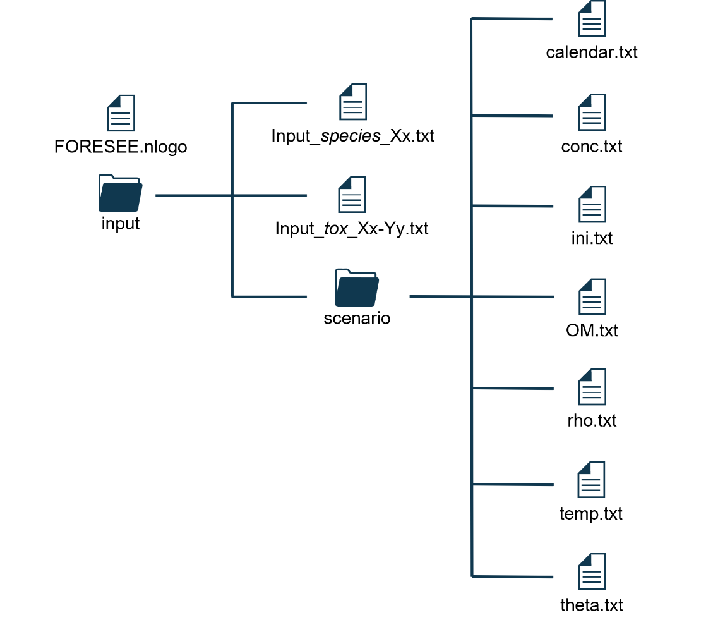

In case a new earthworm species or substance is simulated, new input files for the species’ biological and ecological data or the species’ toxicity parameters for the substance must be provided in the “input”-folder with any desired name.
If a new scenario is supposed to be simulated, a new folder with any desired name can be created in the “input”-folder. All sub-files containing the abiotic data, calendar, and initial set-up need to be named as indicated above. The continuous data on temperature, moisture, and concentration of the substance and the calendar must all begin and end on the same day.

Species’ parameters
The file “input_species_Xx.txt” with Xx standing for the initials of the species (Ac = Aporrectodea caliginosa, Ef = Eisenia fetida, Lt = Lumbricus terrestris) contains all relevant data on biology and ecology of the species in the following order:
Table 1: Structure of species-specific parameter file.
Row | Parameter | Unit | Name in code | Comments
1 | ecological type | - | eco-type | "anecic", "endogeic" or "epigeic"
Diapause
2 | diapause existent | - | undergoes-diapause | true or false
3 | minimal length of diapause | d | min-days-diapause | for worms with facultative diapause
4 | distribution width for diapause | 1/% | b_diapause | see Gergs et al. 2022; is ignored, if worm does not go into diapause
Moisture-dependent movement
5 | maximum specific searching rate | g d⁻¹ cm⁻² | F_m0
6 | moisture threshold for movement | w/w% | m_0 | see Gergs et al. 2022
7 | Maximum moisture dependent specific movement rate | cm d⁻¹ %⁻¹ cm⁻² | b_max | see Gergs et al. 2022
8 | Moisture-dependent specific movement rate | cm d⁻¹ %⁻¹ cm⁻² | k_b | see Gergs et al. 2022
Dynamic energy budget for individual development
9 | κ_{X} | - | kap_X
10 | X_{K} | J/g | HSK
11 | p_{M} | J d⁻¹ cm⁻³ | p_M0
12 | v | cm/d | v0
13 | k_{J} | 1/d | k_J0
14 | p_{Am} | J d⁻¹ cm⁻² | p_Am0
15 | κ | - | kap
16 | E_{G} | J/cm³ | E_G
17 | $${\text{E}}_{\text{H}}^{\text{p}}$$ | J | E_Hp
18 | $${\text{E}}_{\text{H}}^{\text{b}}$$ | J | E_Hb
19 | κ_{R} | - | kap_R0
20 | U_{E0} | d cm² | U_E0
21 | δM | - | del_M
22 | d_{V} | g/cm³ | d_V
23 | w_{E} | g/mol | w_E
24 | µ_{E} | J/mol | mu_E
25 | s_{g} | - | s_g
26 | h_{a} | 1/d² | h_a0
27 | t₀ | d | t_0
28 | T_{A} | K | T_A
29 | T_{H} | K | T_H
30 | T_{AH} | K | T_AH
31 | T_{ref} | K | T_ref
32 | L₀ | cm | L_0
Ecological parameters
33 | Average eggs per cocoon |  | ave_eggs
34 | minimal vision distance | cm | cone-distance
35 | angle of cone of vision in burrow | ° | cone-angle-burrow
36 | angle of cone of vision in litter | ° | cone-angle-litter | only relevant for anecic worms, value is ignored if not anecic
37 | minimal distance between burrows | cm | min-distance-between-burrows | only relevant for anecic worms, value is ignored if not anecic
38 | desiccation rate | 1/d | rate-desic

Toxicity parameters
The file “input_tox_Xx-Yyyy.txt” with Xx standing for the initials of the species (Ac = Aporrectodea caliginosa, Ef = Eisenia fetida, Lt = Lumbricus terrestris) and Yyyy for the compound (Carb = Carbendazim) contains all available information on the toxicity of the substance to the species in the following order:
Row | Parameter | Unit | Name in code | Comments
GUTS-RED-IT
1 | k_{d} | mg g-1 d-1 | k_d_IT
2 | h_{b} | 1/d | h_b_IT
3 | m_{w} | mg/g | m_w_IT
4 | β |  | beta
GUTS-RED-SD
5 | k_{d} | mg g-1 d-1 | k_d_SD
6 | h_{b} | 1/d | h_b_SD
7 | b_{w} | 1/d | b_w
8 | m_{w} | mg/g | m_w_SD
DEB-TKTD pMoA
9 | c₀ feeding | mg/g | c01
10 | c_{T} feeding | mg/g | cT1 | if 0 pMoA is turned off
11 | c₀ somatic maintenance | mg/g | c02
12 | c_{T} somatic maintenance | mg/g | cT2 | if 0 pMoA is turned off
13 | c₀ maturity maintenance | mg/g | c03
14 | c_{T} maturity maintenance | mg/g | cT3 | if 0 pMoA is turned off
15 | c₀ cost on egg | mg/g | c04
16 | c_{T} cost on egg | mg/g | cT4 | if 0 pMoA is turned off
17 | c₀ hazard during oogenesis | mg/g | c05
18 | c_{T} hazard during oogenesis | mg/g | cT5 | if 0 pMoA is turned off

Scenario data

Initial data
The information for the initial setup of the scenario is provided in the “ini.txt”-file based on the following structure:
- Row 1: Location
- Row 2: Latitude of the location in decimal degrees
- Row 3: The day of the year that the data and calendar start on with January 1st ≙ 1
- Row 4: The days after initial day from row 3, that plots should start. For example, if the model should run a pre-year to establish a stabilized population set to 365.

Calendar
The “calendar.txt”-file contains the dates of the simulation days in one of the following formats:
- “d/m/YYYY” or “m/d/YYYY”
- “dd/mm/YYYY” or “mm/dd/YYYY”
- “dd.mm.YYYY”
The data must be enclosed by one opening square bracket (“[“) and one final closing square bracket (“]”).

Constant abiotic parameters
The two parameters organic matter (“OM.txt”) and soil bulk density (“rho.txt”) do not change during the simulation and are constant across the horizontal soil section. Therefore, only data for the vertical soil layers are provided representing the different depths with a resolution of 1 cm up to 1 m depth (100 values in total). Organic matter content uses the unit [g OM / g soil], soil bulk density is given in the unit [kg soil / m³ soil]. The numerical data must be enclosed by one opening square bracket (“[“) and one final closing square bracket (“]”).

Dynamic abiotic parameters
The two parameters soil moisture (“theta.txt”) and soil temperature (“temp.txt”) must be provided with a daily resolution and across depth with a resolution of 1 cm down to 1 m depth (100 values per day). The same resolution is needed for the compound concentration data (“conc.txt”). If this file is missing, the model can still be run by turning off the substance. All values are assumed to be constant across the horizontal. Soil moisture must be provided in the unit [m³ water / m³ soil], soil temperature in [°C] and substance concentration in [kg substance / m³ soil]. The data must be enclosed by one opening square bracket (“[“) and one final closing square bracket (“]”).

Graphical user interface
The interface is separated into 3 parts. On the left-hand site, the settings can be chosen, the middle panel contains all relevant graphs and outputs to get an insight into the predictions, and the right-hand site includes some additional expert settings and plots.
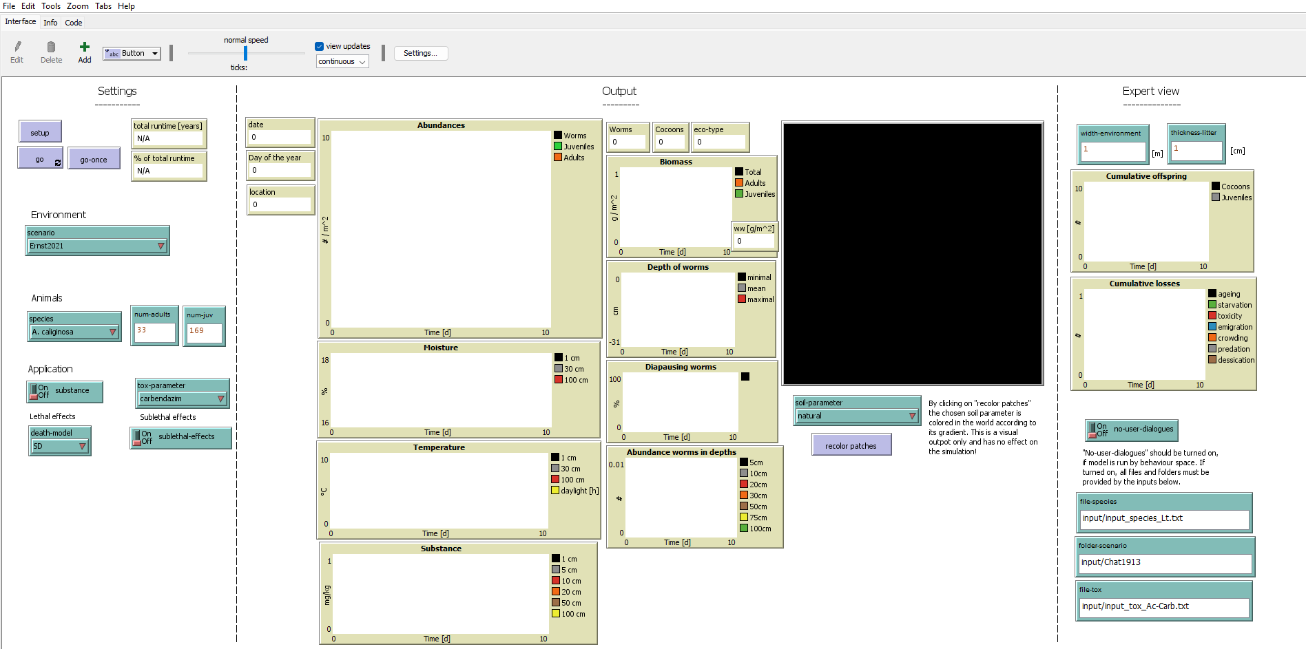

Section “Settings”
For overview, this section is shown in figure 1 and the possible configurations described in the following.
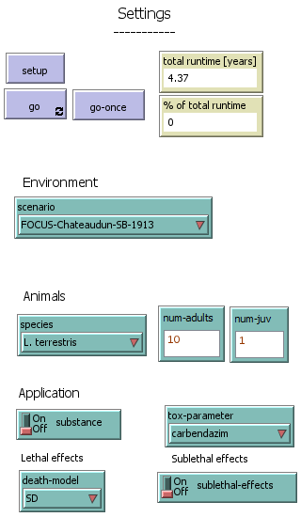
First, the environment is set via the chooser “scenario”. The scenario can be one of the pre-defined scenarios:
- “FOCUS-Chateaudun-SB-1913”: the standard FOCUS in Chateaudun with sugar beet (1913-1914)
- “Ernst2021”: the validation study in Wurzen (2016-2019)
- “Johnston2014”: the available study data of the preceeding model for A. caliginosa in Bodelshausen (2008)
If the scenario is set to “Ernst2021”, the input numbers for adults and juveniles are ignored and the values based on the study used.
If unrealistically high numbers of L. terrestris are set, they are set to more realistic ones (# adults = 10, # juveniles = 50).
If numbers are set to 0, default values are used by the model.
- “Johnston2018”: the available study data of the preceeding model for A. caliginosa (EEEworm) in Rothamsted (1974-1978)
If a new scenario is supposed to be run, the input files must be provided as described in 2.3 and the chooser “scenario” is set to “choose folder”.

Secondly, the worm population is set up by selecting one of the default species “L. terrestris”, “A. caliginosa” or “E. fetida”, or a new species by setting “choose file” with the chooser “species” and providing the initial number of adults (“num-adults”) and juveniles (“num-juv”). For special cases, see info box.

The application of a substance is optional. If the switch “substance” is turned off, the scenario folder must contain a “conc.txt” file, which is the case for all default scenarios except for the two Johnston scenarios. All scenarios with application used carbendazim, which is why it is set as default in the chooser “tox-parameter”. If a new scenario with a different substance and/or worm species is meant to be run, the chooser must be set to “choose file”. For effects on the worm, the chooser “death-model” describes the lethal death model based on a reduced GUTS model, which is always needed, while sublethal effects are optional and can be turned off or on via the switch “sublethal-effects”. Sublethal effects are based on the 5 standard DEB-TKTD physiological modes of action:
- effect on feeding
- effect on somatic maintenance
- effect on maturity maintenance
- effect on cost of egg
- hazard during oogenesis
Once all desired settings are chosen, the model must be initiated with the button “setup”. This setup might take a short while and the interface does not react to new inputs until the button turns off automatically after the setup. After initialization, the model can be run, either by clicking the “go-once” button, which simulates one day each time it is clicked, or by clicking the button “go”, which simulates the entire scenario time. If the “go”-button is pressed during simulation, the model pauses where it is and can resume the simulation by clicking the button again. To get an impression, how many days are left for simulation, the monitor “% of total runtime” can be observed.

Section “Output”
This section shows all relevant plots and outputs of the simulation. The monitors “date”, “day of the year”, “location” and “eco-type”, as well as the plots “moisture”, “temperature” and “substance” can be checked to ensure, that the scenario was chosen properly and runs as expected. The remaining monitors and plots show population traits and behavior of the worms. The “world” panel shows the worms and their movement through the soil or at the surface. The permanent burrows of anecic worms are colored in yellow. By default, the soil is brown and the litter green. These color settings may be changed via the chooser “soil-parameter” to one of the 5 abiotic soil properties “OM”, “Bulkdensity”, “Moisture”, “Temperature”, or “Concentration” and pressing the button “recolor patches”. This way, the set parameter is colored according to its gradient. If the model is run via one of the “go” buttons, the latter three change their coloring each day to the gradient based on the running day.
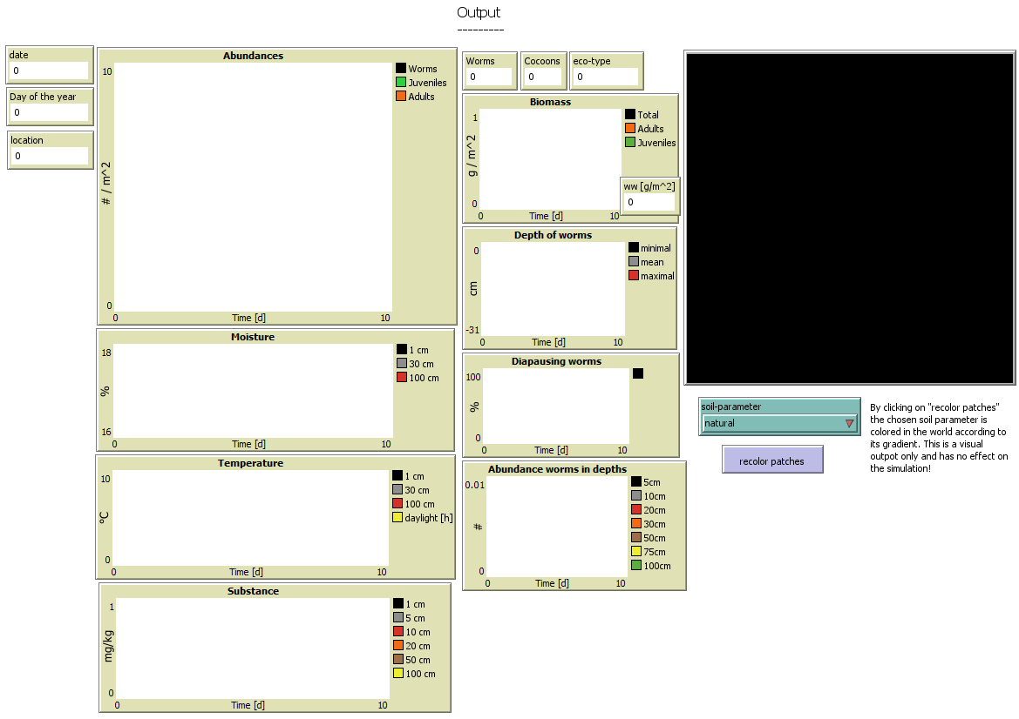

Section “Expert view”
This section contains some additional graphs to get more insight into the population about death mechanisms and depth distribution of the population. Also, if it is of interest, the litter thickness and the world width can be adapted.
The switch “no-user-dialogues” and the path inputs are meant for more advanced NetLogo users. These options are of interest, if the user does not want to choose scenario or species parameters manually every time the model is started or if a behavior space is supposed to be run. In case the switch “no-user-dialogues” is turned on, the paths for scenario folder, species and/or toxic parameter-files must be provided in the corresponding inputs.
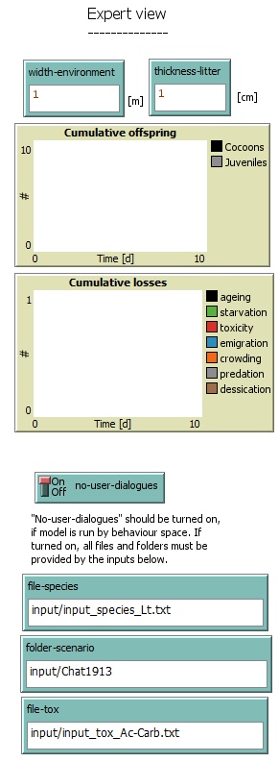

BehaviorSpace analysis tool
If the model is run via NetLogo’s BehaviorSpace, the results are saved in a .csv-file. For a quick first analysis, the model repository includes an R-skript that summarizes the single runs by creating tables with mean, standard deviation, and other statistical measures as well as graphs of the means of absolute abundances of total, juvenile, and adult worms for the control and graphs of the treatments relative to control. In the first 7 rows of the script, the user needs to provide information on the name for the result files (“name_res”), the number of MonteCarlo runs, that were used in the behavior space (“num_MC”), the start date of the simulation (“start_Date”) and if field data exist (“exists_fielddata”). In case field data are available, a vector with the sampling dates must be defined (“c_dateField”). Once all these settings have been adjusted, the script can be run via Alt + Strg + R. For testing purposes, 2 BehaviorSpace experiments are provided, replicating the validation studies of the FORESEE model based on the field study by Ernst et al. (2021) both for A. caliginosa and L. terrestris.

