FORNUTS - FOREST NUTRIENT SIMULATION Model

Version 2.1

Instructions for running FORNUTS Conceptual description of FORNUTS

Designed by Dan Binkley and Steve Hart Programmed by Steve Hart Substantially revised by John Pye

Department of Forest and Wood Sciences Colorado State University Ft. Collins, CO 80523 303-491-6519

October 1988

FORNUTS is designed as a educational tool with two objectives:

1. To reinforce students understanding of nutrient cycling, stand management and site productivity;
2. To provide an opportunity to critique a simple simulation model, and gain insights about the strengths and limitations of models.

The model runs on DBM compatible microcomputers, and simulates production in loblolly pine plantations as affected by changes in nitrogen (N) availability. Stand growth is modeled as a simple function of site index (Figure 1), and the effects of N availability are included by calculating the N content of each year’s potential growth. If N availability in the soil is too low to meet the baseline requirements, stand growth is reduced.

FORNUTS simulates forest growth for up to 5 rotations, and provides tables summarizing the N fluxes and biomass harvested for each rotation, along with a summary table for all the entire run. Users specify general site conditions (including site index in feet at 25 years, soil C and N contents, N contents of biomass, and annual N inputs and outputs), choose among a suite of stand treatments (varying levels of fire, fertilization, and biomass harvest) and rotation lengths.

RUNNING FORNUTS

1. Turn on the microcomputer.
2. Load MS-DOS.
3. Insert disk with FORNUTS into the appropriate disk drive, and type FORNUTS.
4. Answer the questions appearing on the screen (hitting RETURN key when the prompted on the screen). Table 1 lists these questions, along with reasonable ranges of values. Values outside these ranges may give aberrant results.
5. Read over the echo of the input data. If any changes are needed, the entire set of parameters needs to be re-entered.
6. The program will list the years of the simulation as it calculates; rapid passing of the years indicates little feedback of N availability on growth; slow periods indicate the model is scaling back growth to account for N limitations.
7. After the model has computed the run, it pauses and asks you to turn on the printer if you want a hard copy of the run. Again, hit the RETURN button when the printout pauses.
8. The model automatically returns the computer to the MS-DOS operating system after the run. Another run can be started by typing in FORNUTS.

BASIC STRUCTURE OF FORNUTS

Potential Versus Actual Growth. Four site indexes are available in FORNUTS, with the growth trajectories illustrated in Figure 1. Stem biomass accumulates along these trajectories if N does not limit growth; an overabundance of N cannot result in growth greater than these curves. Nitrogen availability only affects the progress of stand development along a given growth curve, and does not affect which growth curve is followed. Speed of growth is regulated by use of a "physiological age" (PHSAGE). Although true age (AGE) is incremented each simulation year, progress along the growth curve is tracked by physiologic age. When N availability does not limit growth, the stand progresses along the curve at a rate of 1 "physiologic" year for each real year. If N limits growth, the movement along the curve will be somewhat than 1 physiologic year for each real year. On a site that is very limited in N, a stand may take an extra decade to reach maturity relative to a stand with an abundant supply of N.

The effects of prescribed burning and fertilization are simulated by allowing the stand to grow at a rate of physiological years that is greater than real years. For example, a cool prescribed fire increases N availability and allows the stand to grow at a rate of 1.25 physiologic years for each real year, assuming N supplies are sufficient. Hotter fires stimulate growth for a longer period, but also remove more N from the site and may reduce N availability. This might give a net decrease in productivity despite the allowance of greater potential growth. Fertilization also increases potential physiologic age, from 1.20 to 1.25 physiologic year per real year, for 3 to 5 years, depending on the rate of fertilization.

Nitrogen and Carbon Pools- In each simulation year, nitrogen additions and losses are calculated. Fluxes of nitrogen calculated in the model include natural inputs (precipitation plus fixation), leaching, harvesting, fertilization, and prescribed and slash burning. The amount of soil carbon (= 50% of organic matter) is specified at the beginning of a run and remains constant. Any N not taken up by trees is simply returned to the soil N pool. In real forests, this N would leach from the system; in FORNUTS, leaching losses are a constant specified at the beginning of each run. Changes in N pools are totalled and reported by rotation.

Nitrogen availability is a function of the C/N ratio of the soil, and the total N content of the soil. High rates of N availability occur in soils with a low C/N and a high N content (Figure 2).

KEY EQUATIONS

mineralization: MINRL=SOILN(ROTNUM)*0.012* (2.7-ALOG(0.2*CNRATO)

Net mineralization in the model is determined by the soil C:N ratio. This rate is then multiplied by the current soil nitrogen to yield total mineralized N. The equation used was selected to reflect our perception of the relationship between mineralization and C:N, including reduced mineralization observed at high C:N ratios, while providing sufficient curvature to provide a realistic amount of negative feedback.

Fertilizer N is added to mineralized N in the year it is applied. Fertilizer N not taken up by trees in the first year is added to the total N pool in the soil, providing very small increases in N availability in subsequent years. In real forests, N availability is probably stimulated for a longer period.

nitrogen demand: NREQ = (LBMAS-LBN)*(LEAFNF/100.0) + (BBMAS-BBN)*0.0033+(FRBMAS- FRBN)*(ROOTNF/100.0) + ((CRBMAS-CRBN) + (SBMAS-SBN))*0.001+0.5*LBN*

(LEAFNF /100.0) +FRBN*(ROOTNF/100.0)-TRANS

Nitrogen required for growth is calculated for each biomass compartment as the difference between this year’s calculated biomass and last year’s biomass, times the percent nitrogen in that compartment. Nitrogen lost through leaf and fine root litterfall is added to this, subtracting for retranslocated N. Litterfall is assumed to consist of one half of leaves (= 2 year retention) and all the fine root biomass. Retranslocated N is calculated as nitrogen in foliage and fine root litterfall multiplied by percent retranslocation for these two fluxes (input variables).

burning:

Warm prescribed burns reduce soil N by 20 kg-N, hot bums by 40. Warm slash burns volatilize 75 kg-N, hot volatilize 150.

harvesting:

Harvesting can be of two types: stem only and whole tree. In stem only, biomass and nitrogen in stems is removed; remaining stand nitrogen is transferred to soil N. In whole tree harvesting, nitrogen in branch, foliage, and coarse roots is removed from the system, rather than returned to soil N.

stem growth: SBMAS= a*(l-EXP(b*PHSAGE))**c

Four sets of coefficients for the Chapman-Richards curve are used, one for each site index:

|  |  |  |  |
| --- | --- | --- | --- |
| SI | a | b | c |
| 45 | 102000 | -0.088 | 4.7 |
| 55 | 122400 | -0.120 | 6.2 |
| 65 | 171788 | -0.1253 | 5.3 |
| 75 | 244800 | -0.114 | 4.3 |

These curves were supplied by Tom Fox, North Carolina State Forest Nutrition Co-operative, and were also used in the loblolly pine version of the FORCYTE model originally developed by J.P. Kimmins and K. Scoullar.

growth of other compartments:

Other compartments are assumed to grow as a linear function of physiologic age to some maximum level, then remain constant at that biomass until harvested. Real forests would probably show sigmoid trajectories rather than this simplified, 2-step trajectory. The maximums (kg/ha) are shown below, along with the physiological age at which the maximum is reached.

|  |  |  |  |
| --- | --- | --- | --- |
| compartment | SI | PHSAGE | max. |
| foliage | 45 | 30 | 6000 |
|  | 55 | 25 | 7000 |
|  | 65 | 25 | 8500 |
|  | 75 | 20 | 9000 |
| branch | 45 | 60 | 15000 |
|  | 55 | 60 | 20000 |
|  | 65 | 60 | 25000 |
|  | 75 | 60 | 30000 |

Fine root biomass is based on foliage biomass times an input factor. Coarse root biomass equals 0.2 times stem biomass.

A complete listing of the program can be printed from the disk. Values that are "hardwired" in the model can be changed by editing the program-assuming you have a FORTRAN compiler that recognizes the FORTRAN dialect used in the model.

FORNUTS was not designed for use outside of courses at Duke University and Colorado State University, and some glitches may still exist. We would like to hear of any problems (or other experiences) you have-but don’t be surprised if the model is not perfect.

**Table 1. FORNUTS questions and recommended ranges.**

|  |  |
| --- | --- |
| Question | Recommended range |
| ENTER THE INITIAL AGE | 0-50 |
| SITE INDEX | 45, 55, 65 or 75 (must be one of 4) |
| ROTATION LENGTH | 25-75 |
| NUMBER OF ROTATIONS | 1-5 |
| AGE FOR FERTILIZATION | anytime, but only once each rotation |
| RATE OF FERTILIZATION | Enter 0 if not fertilizing; or 100, 200 or 300 kg/ha |
| AGE OF FIRST PRESCRIBED BURN | Enter 0 if never; or anything beyond 10 is reasonable |
| FREQUENCY OF BURN | Between 4 and 20 years |
| BURN INTENSITY | 1. = no burn 2. = warm burn 3. = hot burn |
| HARVEST METHOD | 1. = whole tree 2. = stem only |
| SLASH BURN | 1. = no burn 2. = burn |
| SLASH FIRE INTENSITY | 1. = no burn 2. = warm burn 3. = hot burn |
| PERCENT OF LEAF N RESORBED | 0. to 40. |
| PERCENT OF ROOT N RESORBED | 0. to 40. |
| RATIO ROOT BIOMASS : LEAF BIOMASS | 50. to 200. |
| TOTAL SOIL CARBON | 15000 to 35000 |
| TOTAL SOIL NITROGEN  (note C/N should be in the range of 10-20) | 1500 to 5000 |
| PERCENT N IN FOLIAGE | 0.8 to 2.0 |
| PERCENT N IN FINE ROOTS | 0.5 to 1.2 |
| ANNUAL N INPUTS | 5 to 20 |
| ANNUAL N LOSSES | 1 to 5 |

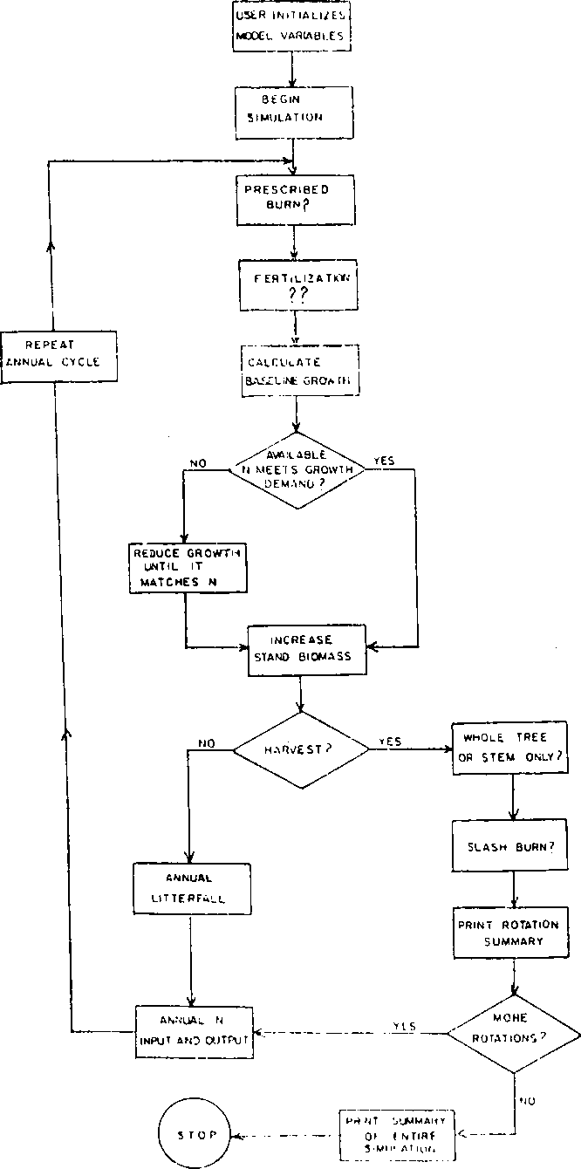

**Figure 2. Flow­chart for FORNUTS.**

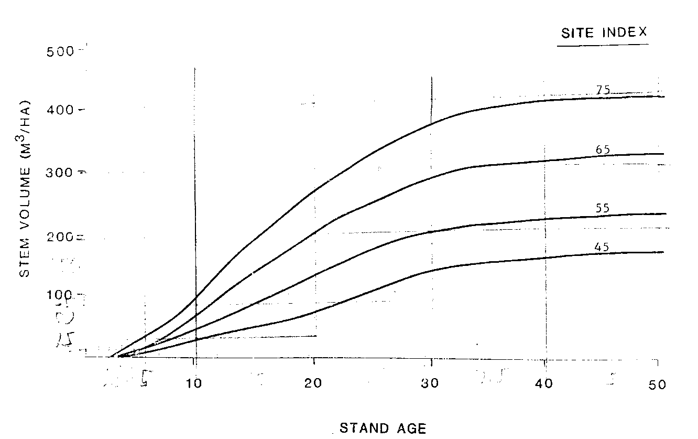

**Figure 1. Site Index growth curves for FORNUTS.**

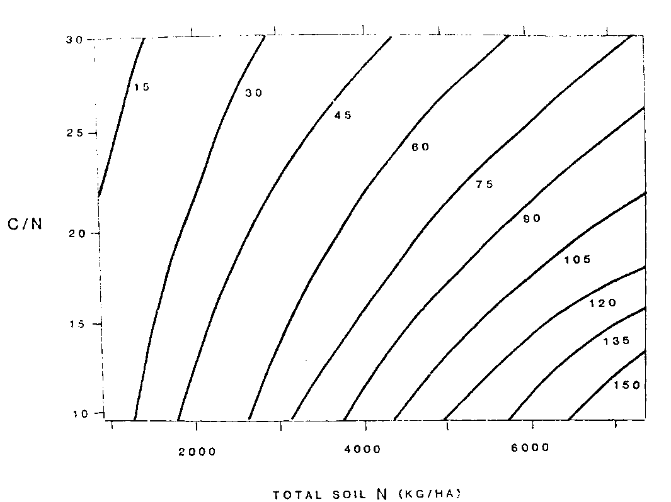

**Figure 3. Nitrogen mineralization (kg/ha annually) is very low for sites with low total soil N and high C/N. Nitrogen mineralization is greatest** **on sites with high total soil N and low C/N.**