Xueyang (Sean) Wang

XW1154

02/12/2017

CS4793

Homework - Program 01

#import socket module

from socket import *

serverSocket = socket(AF_INET, SOCK_STREAM)

#Prepare a sever socket

serverPort = 5000

serverSocket.bind(('', serverPort))

serverSocket.listen(1)

while True:

#Establish the connection

print("Ready to serve...")

connectionSocket, addr = serverSocket.accept()

try:

message = connectionSocket.recv(1024)

filename = message.split()[1]

f = open(filename[1:])

outputdata = f.read()

#Send one HTTP header line into socket

connectionSocket.send('\nHTTP/1.1 200 OK\n\n')

connectionSocket.send(outputdata)

#Send the content of the requested file to the client

for i in range(0, len(outputdata)):

connectionSocket.send(outputdata[i])

connectionSocket.close()

except IOError:

#Send response message for file not found

connectionSocket.send('\nHTTP/1.1 404 Not Found\n\n')

#Close client socket

connectionSocket.close()

serverSocket.close()

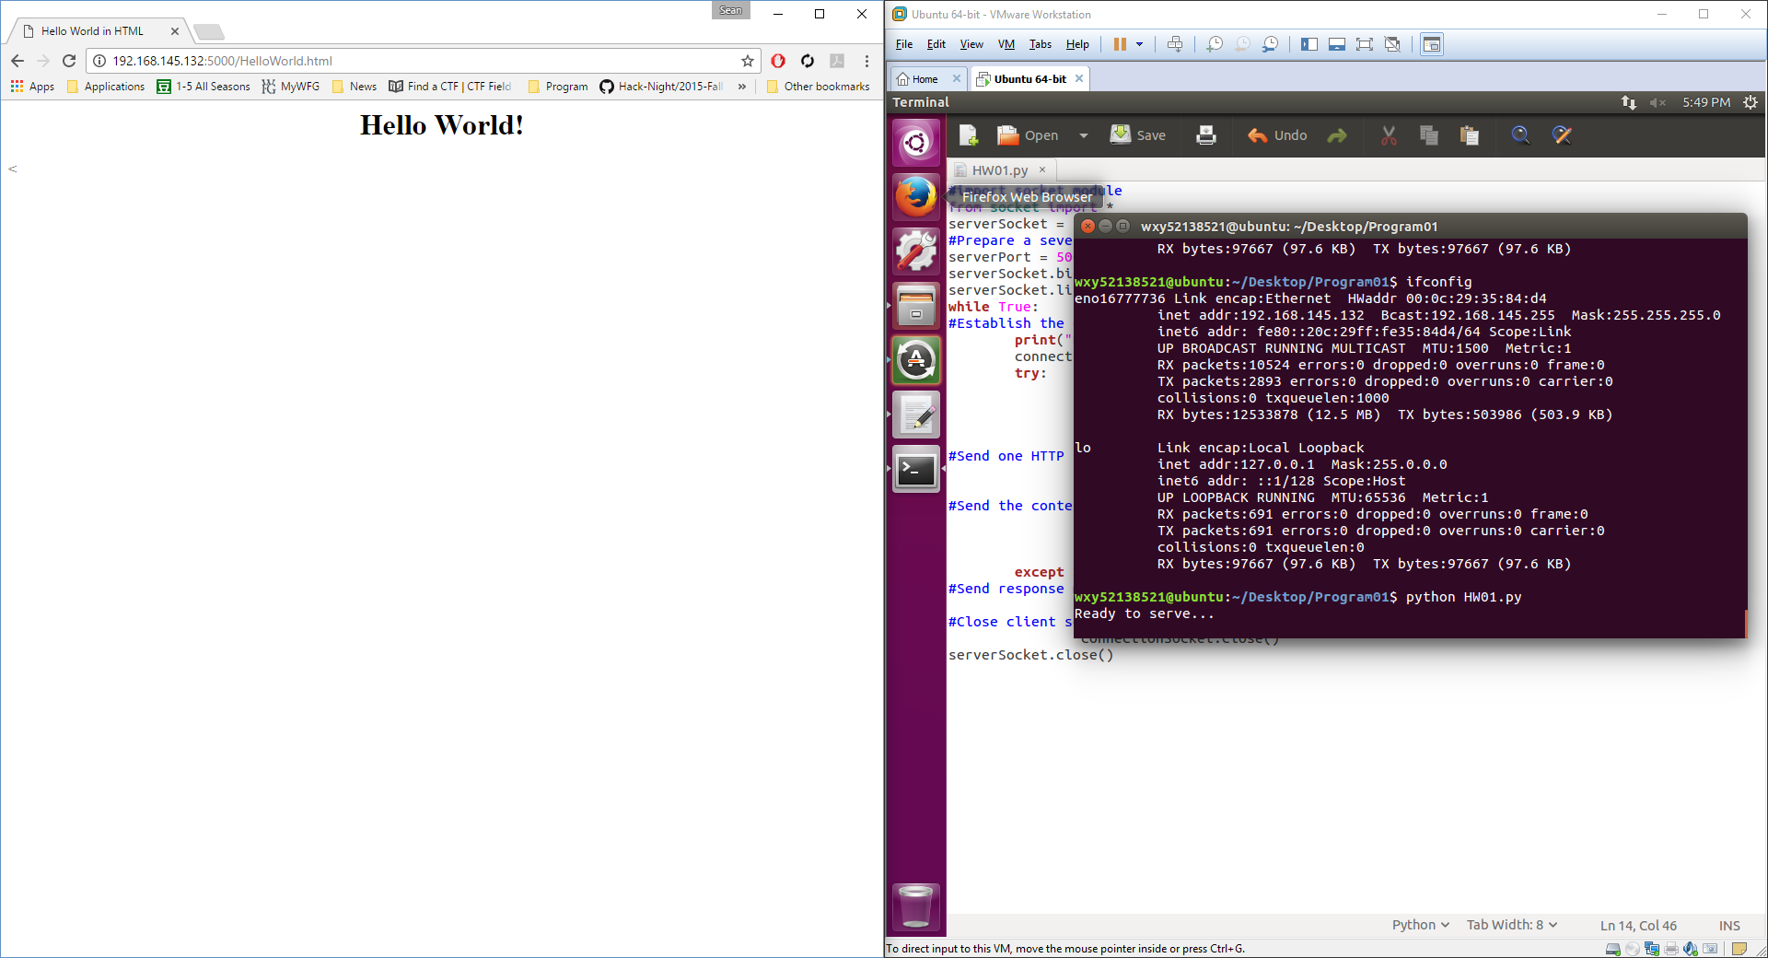

Figure 1: Complete Screen shot.