Xueyang (Sean) Wang

XW1154

03/26/2017

CS4793

Homework - Program 02

*I used smtp4dev to set up a fake SMTP server to send and receive message

Python Code:

from socket import *

msg = "\r\n I love computer networks!"

endmsg = "\r\n.\r\n"

mailserver = 'localhost'

serverport = 25

# Create socket called clientSocket and establish a TCP connection with mailserver

clientSocket = socket(AF_INET, SOCK_STREAM)

clientSocket.connect((mailserver, serverport))

recv = clientSocket.recv(1024).decode()

print(recv)

if (recv[:3] != '220'):

print('220 reply not received from server.')

# Send HELO command and print server response.

heloCommand= 'HELO Localhost\r\n'

clientSocket.send(heloCommand.encode())

recv1 = clientSocket.recv(1024).decode()

print(recv1)

if (recv1[:3] != '250'):

print('250 reply not received from server.')

# Send MAIL FROM command and print server response.

mailFromCommand = 'MAIL FROM: <rob@rnwood.co.uk>\r\n'

clientSocket.send(mailFromCommand.encode())

recv1 = clientSocket.recv(1024).decode()

print(recv1)

if (recv1[:3] != '250'):

print('250 reply not received from server.')

# Send RCPT TO command and print server response.

rcptToCommand = 'RCPT TO: <rob@rnwood.co.uk>\r\n'

clientSocket.send(rcptToCommand.encode())

recv1 = clientSocket.recv(1024).decode()

print(recv1)

if (recv1[:3] != '250'):

print('250 reply not received from server.')

# Send DATA command and print server response.

dataCommand = 'DATA\r\n'

clientSocket.send(dataCommand.encode())

recv1 = clientSocket.recv(1024).decode()

print(recv1)

if (recv1[:3] != '354'):

print('354 reply not received from server.')

# Send message data.

print("Send message data")

clientSocket.send(msg.encode())

# Message ends with a single period.

print(endmsg)

clientSocket.send(endmsg.encode())

recv1 = clientSocket.recv(1024).decode()

print(recv1)

if (recv1[:3] != '250'):

print('250 reply not received from server.')

# Send QUIT command and get server response.

quitCommand = 'QUIT\r\n'

clientSocket.send(quitCommand.encode())

recv1 = clientSocket.recv(1024).decode()

print(recv1)

if(recv1[:3] != '221'):

print('221 reply not received from server')

clientSocket.close()

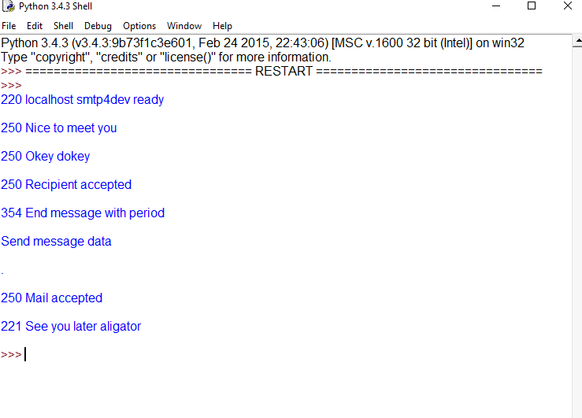

Figure 1: Complete Screen shot.

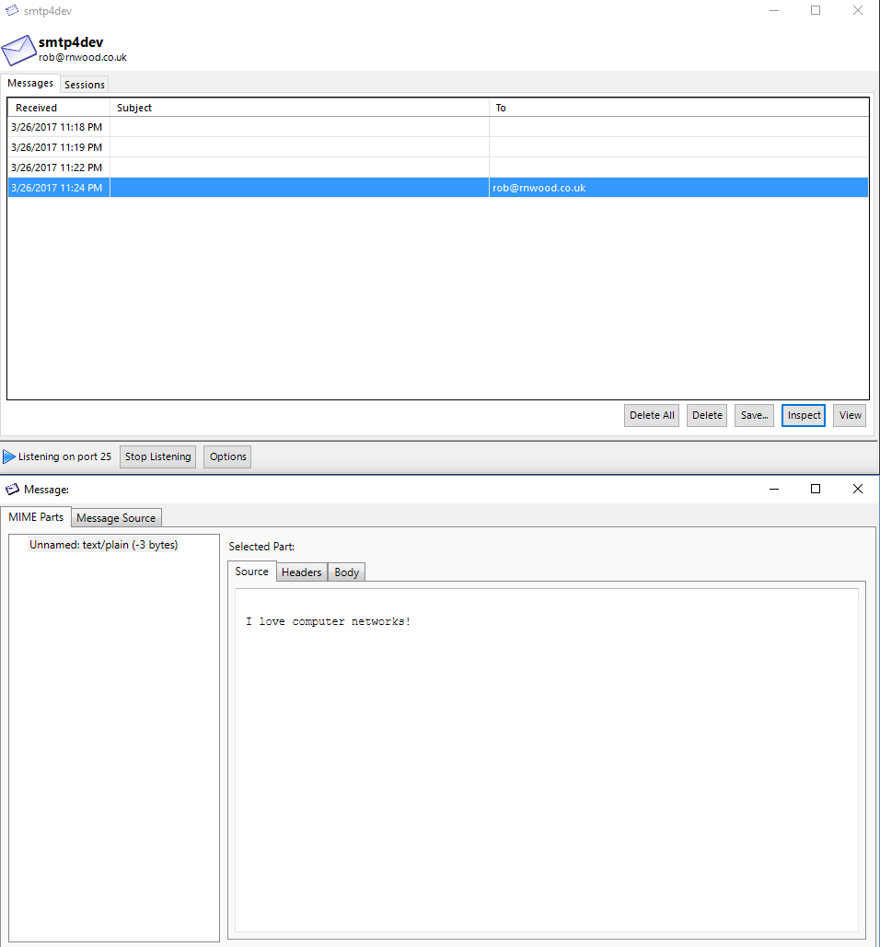

Figure 2: Message sent