Xueyang (Sean) Wang

XW1154

02/24/2017

CS4793

Homework 03

\*For this homework, I used the .zip file (http-ethereal-trace-5) downloaded from the website

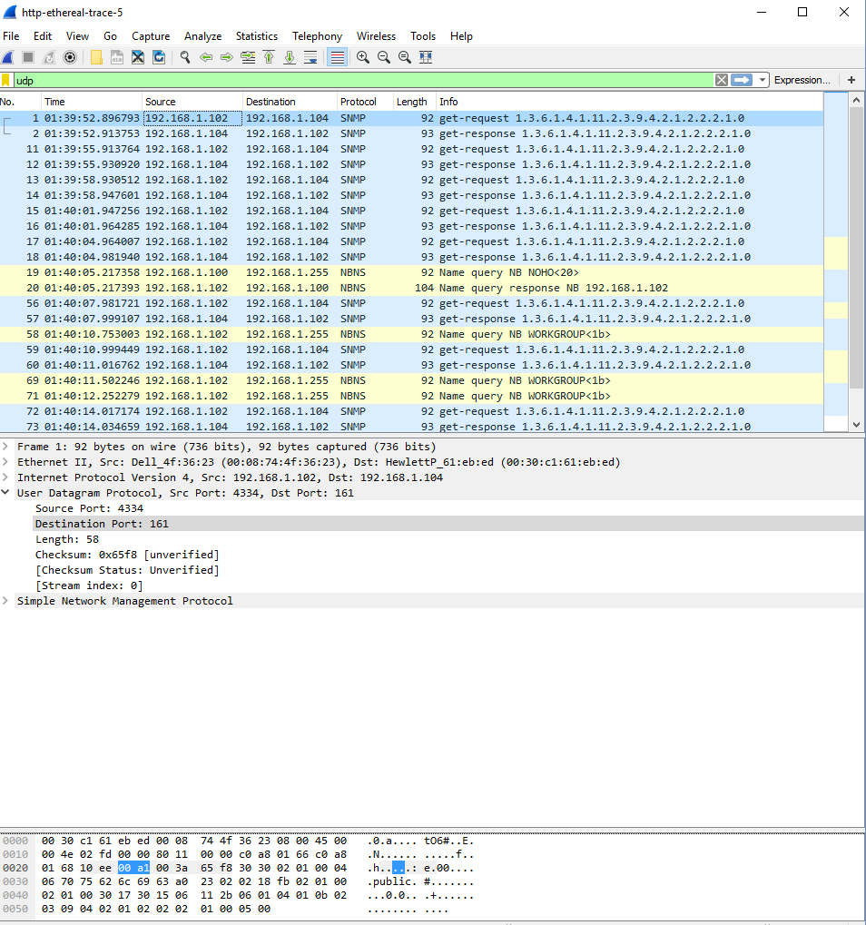

Figure 1. Wireshark UDP file

1. The UDP header contains 4 fields: source port, destination port, length, and checksum.
2. Each of the UDP header fields is 2 bytes long.
3. The value in the length field is the sum of the 8 header bytes. In the example, the length is 58.
4. The maximum number of bytes in a UDP payload is 2^(16) – 1 less the header bytes, which equals to 65535 – 8 = 65527 bytes.
5. The largest possible port number is 2^16 – 1 = 65535.

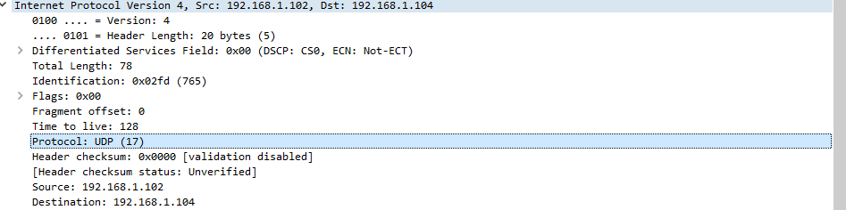

Figure 2. UDP protocol

1. The UDP protocol is 0x11(hex), which is 17 in decimal value.

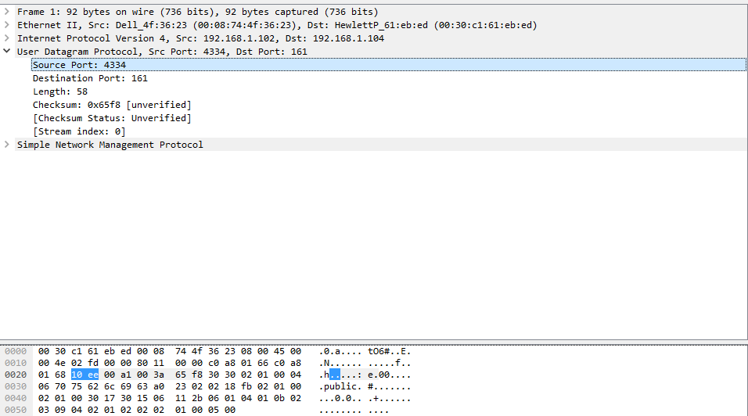

Figure 3. Sending

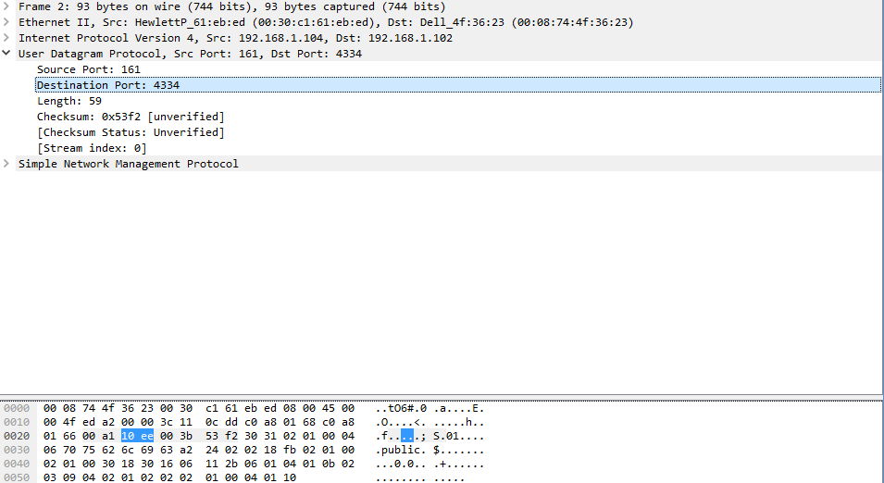

Figure 4. Receiving

1. The source port of the UDP packet sent is the same as the destination port of the reply packet, and the destination port of the UDP packet sent is the same as the source port of the reply packet.