Xueyang (Sean) Wang

XW1154

02/24/2017

CS4793

Homework 04

Based on downloaded file:

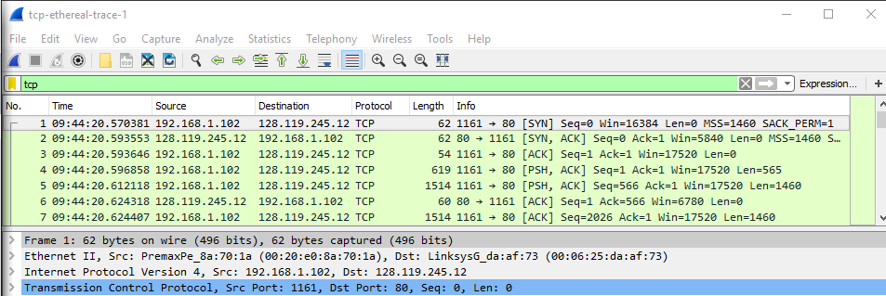

Figure 1. Given TCP capture

1. The client computer IP address is: 192.168.1.102; My client computer port number is 1161.
2. Destination computer IP address is 128.119.245.12; Its computer port number is 80.

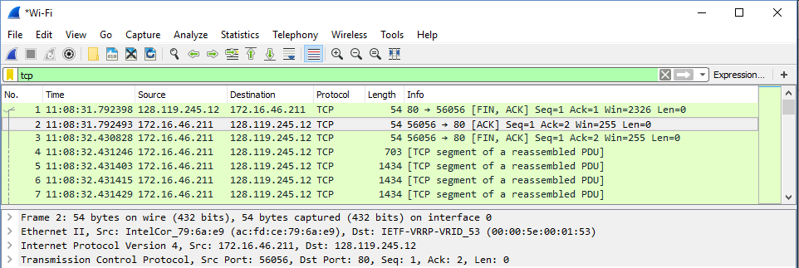

Figure 2. My TCP capture

1. My client computer IP address is: 172.16.26.211; My client computer port number is 56056.

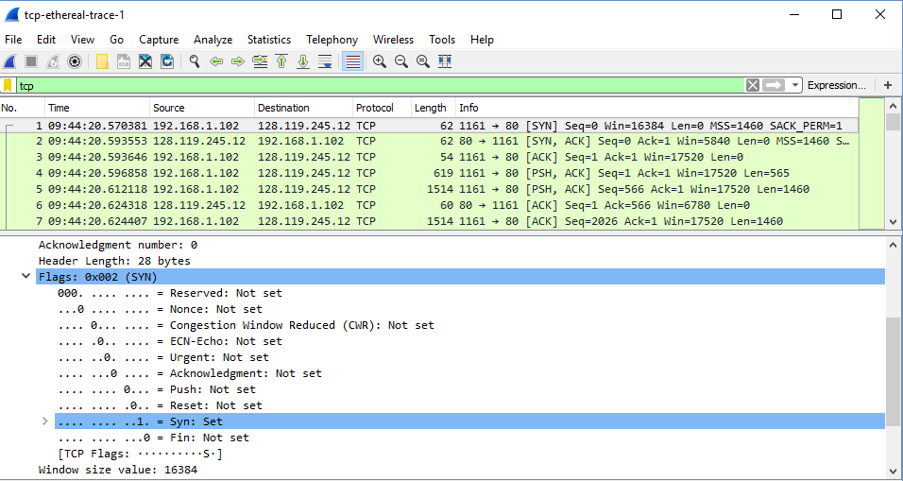

Figure 3. Seq number and indication

1. The initial sequence number is 0 (Seq=0). The SYN flag is set to 1 ([SYN]) which indicates a SYN segment.

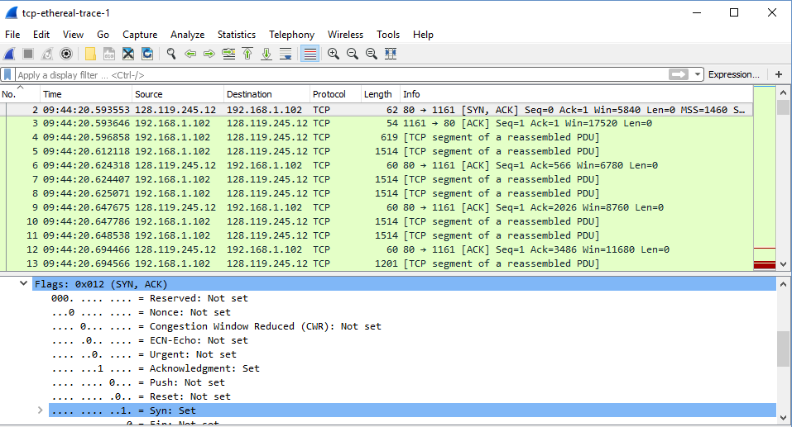

Figure 4. SYNACK pack

1. The sequence number of the SYNACK segment has the value of 0 in this trace. The value of ACK in the SYNACK is 1. The value is determined by the destination by adding 1 to the initial sequence number of SYN segment from the client computer. The SYN flag and ACK flag are set to 1. They indicate that this segment is a SYNACK segment.

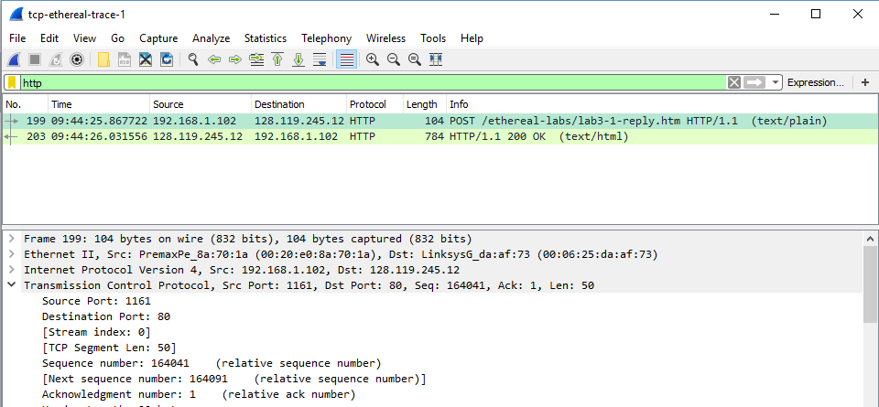

Figure 5.HTTP POST command

1. The sequence number is 164041.

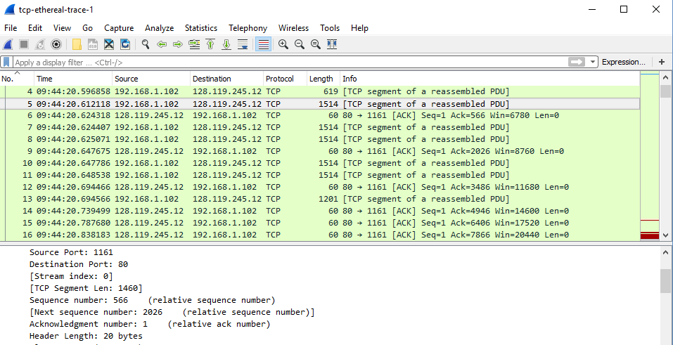

Figure 6. HTTP POST segments

1. If the HTTP POST segment is considered as the first segment, segment 1-6 are NO. 4,5,7,8,10,and 11in this trace. The ACKs are 6,9,12,14,15,and 16. By examining each TCP segment, the sequence numbers is the following:



Segment 1: 1

Segment 2: 566



Segment 3:2026

Segment 4: 3486



Segment 5:4946

Segment 6:6406

Raw send/received time data:

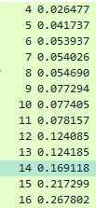

RTT data is obtained under: Transmission Control Protocol -> [SEQ/ACL analysis]

|  |  |  |  |  |
| --- | --- | --- | --- | --- |
| Segment Number | Sent Time | Received Time | Sample RTT(seconds) | Estimated RTT(seconds) |
| 1(first) | 0.026477 | 0.053937 | 0.02746 | 0.02746 |
| 2 | 0.041737 | 0.077294 | 0.035557 | 0.0285 |
| 3 | 0.054026 | 0.124085 | 0.070059 | 0.0337 |
| 4 | 0.054690 | 0.169118 | 0.11443 | 0.0438 |
| 5 | 0.077405 | 0.217299 | 0.13989 | 0.0558 |
| 6 | 0.078157 | 0.267802 | 0.18964 | 0.0725 |

Calculation for Estimated RTT: 0.875 * Estimated + 0.125 * Sample

#1: Segment 1 = 0.02746 secs

#2: Estimated = (0.875) * (above from above) + (0.125) * Sample RTT = 0.0285

#3: Estimated = (0.875) * (above from above) + (0.125) * Sample RTT = 0.0337

#4: Estimated = (0.875) * (above from above) + (0.125) * Sample RTT = 0.0438

#5: Estimated = (0.875) * (above from above) + (0.125) * Sample RTT = 0.0558

#6: Estimated = (0.875) * (above from above) + (0.125) * Sample RTT = 0.0725

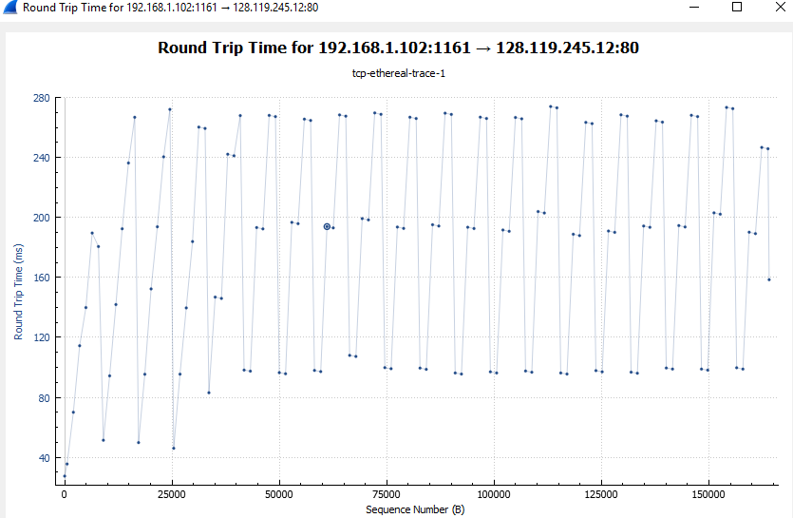

Figure 7. Round Trip Time Graph

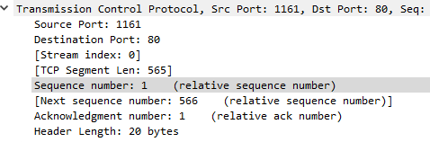

Figure 8. First TCP

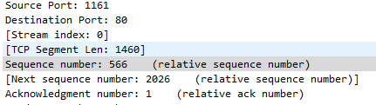

Figure 9. 2-6 TCP

1. The first TCP segment is 565 bytes, and the rest five TCP segments are 1460 bytes.



Figure 10. Min. buffer space



Figure .11. Max. buffer space

1. The minimum amount of buffer space is 5840 bytes, which is the first ACK. The maximum amount of buffer space is 62780 bytes. The send is never throttled due to lacking of receiver buffer space.

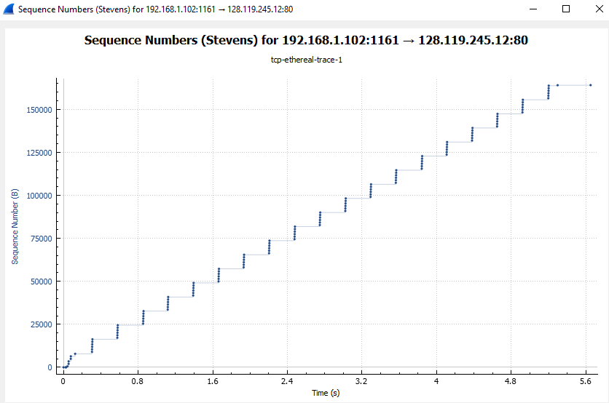

Figure 11. Time Sequence Graph

1. There are no re-transmitted segments in this file. Based on Fig. 11, all sequence is grow steadily and accordingly. If there was a re-transmission, the sequence should be smaller than previous.

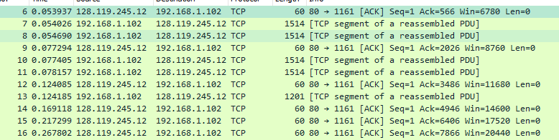

Figure 12. Typical ACK data

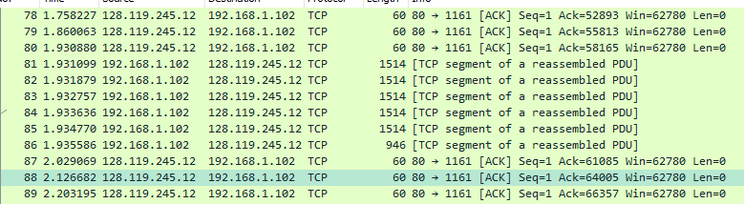

Figure 13. Example of every other received segment.

Simple calculation:

|  |  |  |
| --- | --- | --- |
| ACKs | Data | Different |
| 1 | 566 | 566 |
| 2 | 2026 | 1460 |
| 2 | 3486 | 1460 |

…

11. Typical ACKs data is 1460 bytes. Through observing the files, there are cases where the receiver is ACKing ever other segment. For example, in Fig. 13, No. 80 with 2920 byes.

12. First: Find total data; Second: find total time; Third: use total time divide total data to find speed (throughput)

The last ACK is 164091 bytes; then, the total data is 164091 - 1 = 164090 byes. The whole transmission time is the difference of the time instant of the first TCP segment (0.026477 secs) and last ACK (5.455830 SECS); then, the total time is 5.455830 - 0.026477 = 5.4294 secs. Then the total speed is 164090 / 5.4294 = 30.222Kbyes/sec.