Xueyang (Sean) Wang

XW1154

04/02/2017

CS4793

Homework 05

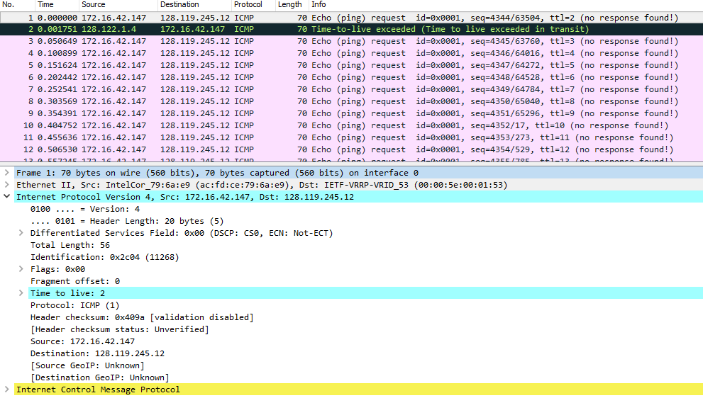

Figure 1. ICMP Echo Request Message

1. The IP address of my computer is 172.16.42.147.
2. Within the header, the value in the upper layer protocol field is ICMP (0x01)
3. There are 20 bytes in the IP header, and 56 bytes in total length. 56-20 = 36byes in the payload of the IP data-gram.
4. The more fragments bit = 0, so the data is not fragmented.
5. Identification, time to live (TTL), and Header checksum always change.

6.

Constant across the IP datagram:

|  |  |
| --- | --- |
| Version | IPV4 |
| Header Length | ICMP |
| Source IP | Same source |
| Destination IP | Same destination |
| Differentiated Services | ICMP, same service class |
| Upper Layer Protocol | ICMP |

Must stay constant:

|  |  |
| --- | --- |
| Version | IPV4 |
| Header Length | ICMP |
| Source IP | Same source |
| Destination IP | Same destination |
| Differentiated Services | ICMP, same service class |
| Upper Layer Protocol | ICMP |

Must change:

|  |  |
| --- | --- |
| Identification | IDs for IP must be different |
| Time to live | Traceroute increments with each packet |
| Header Checksum | Header changes, checksum changes as well |

1. The IP header identification fields increase with each ICMP Echo(ping) request.

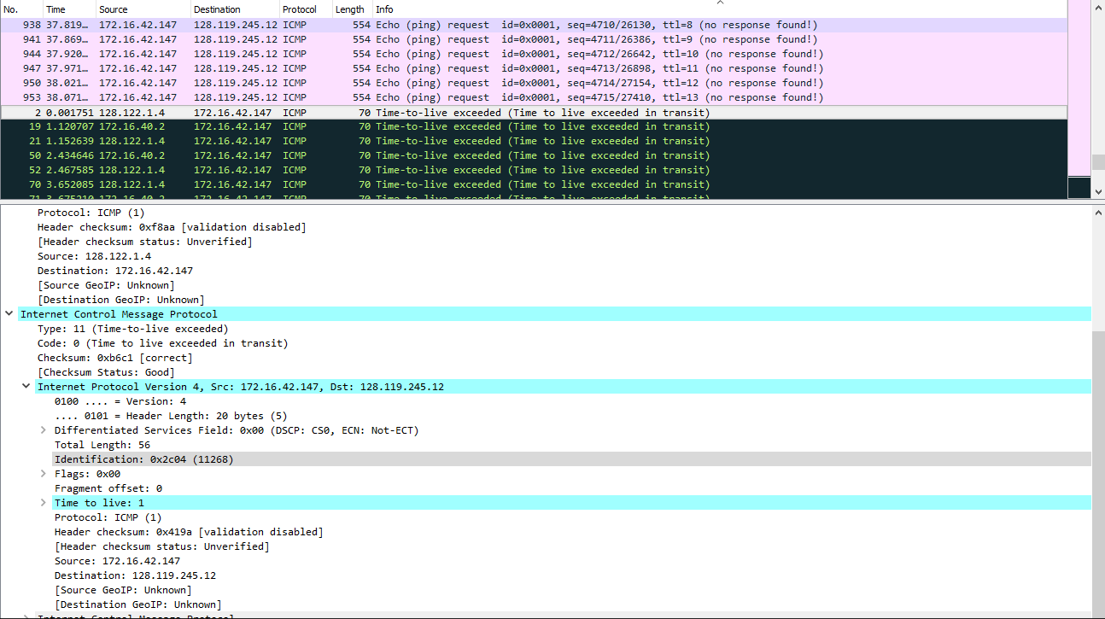

Figure 2. ICMP TTL exceed reply

1. Identification is 11268; and time to live(TTL) is 1.

The identification field changes for all the ICMP TTL exceed replies because it is a unique value. If two more IP have the same ID value, then they are fragments of a single larger IP datagram.

The TTL field remains unchanged because the TTL for the first hop router is always the same.

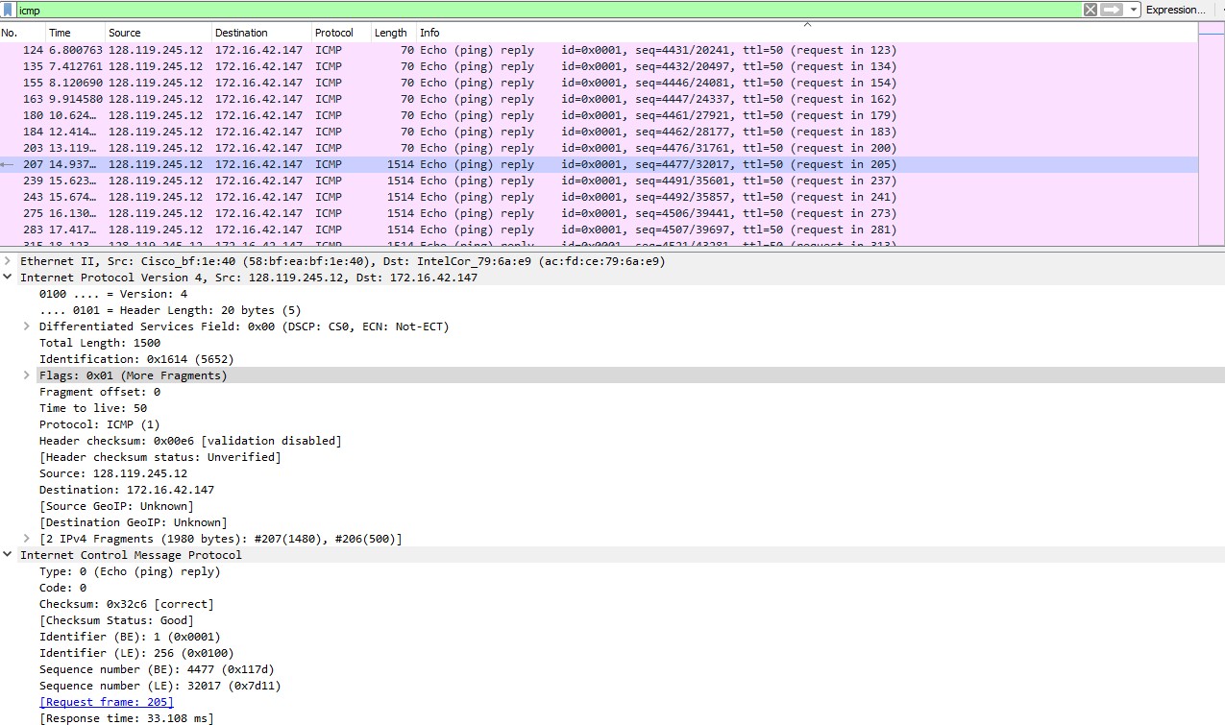

Figure 3. ICMP Echo Request, packet size = 2000, first

1. The message has been fragmented across more than one IP datagram.
2. The Flags is 0x01 (More Fragments), indicating that there is more. Since the offset is 0, therefore this is the first fragment in the sequence. This first datagram has a total length of 1500, including the header.

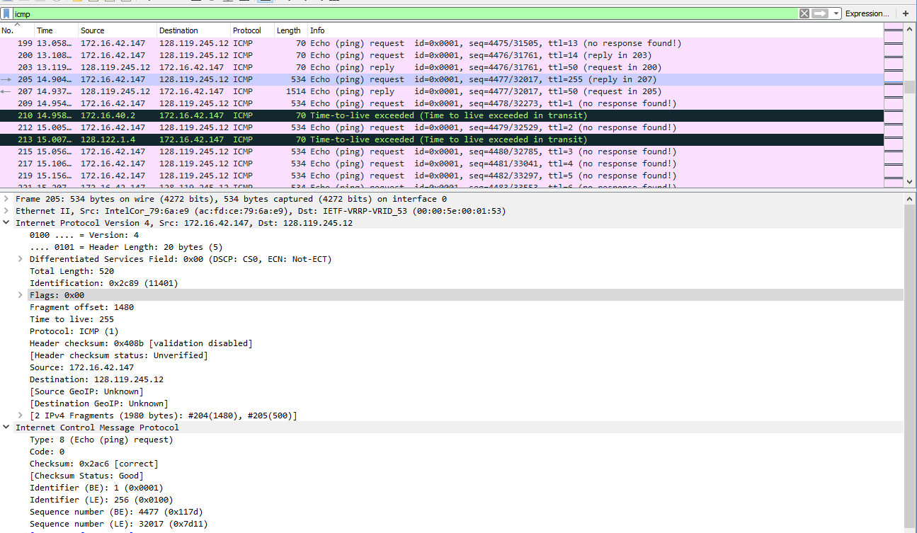

Figure 4. ICMP Echo Request packet size = 2000, second

1. The fragment offset is 1480,so this is not the first fragment. And there is no more fragment flag, therefore, this is the last fragment.
2. The IP header fields that changed are: total length, flags, fragment offset, and checksum.

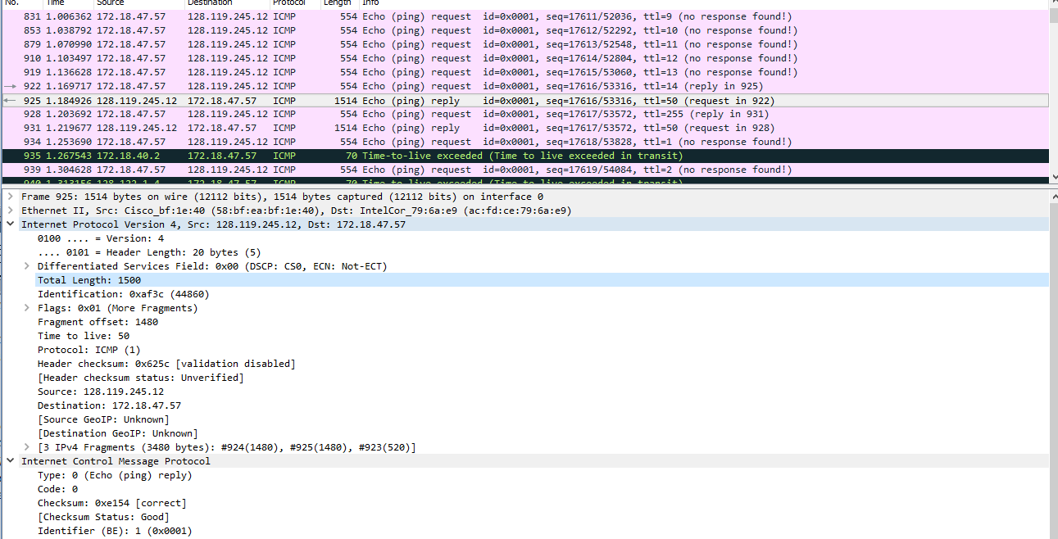

Figure 5. ICMP Echo Request packet size = 3500, first

1. There are three packets(fragments) after switching to 3500.
2. The changes are: fragment offset and checksum. A change in total length and in the flags when looking at the first two packets and the last packet. The first two have 1500, and the last one have 540, including header, with the more fragment bit set to 0 at the end.