Xueyang (Sean) Wang

XW1154

04/12/2017

CS4793

Homework 06

\*For this particular homework, I used the file provided by the lab, because NYU WiFi prevents me from accessing additional information.

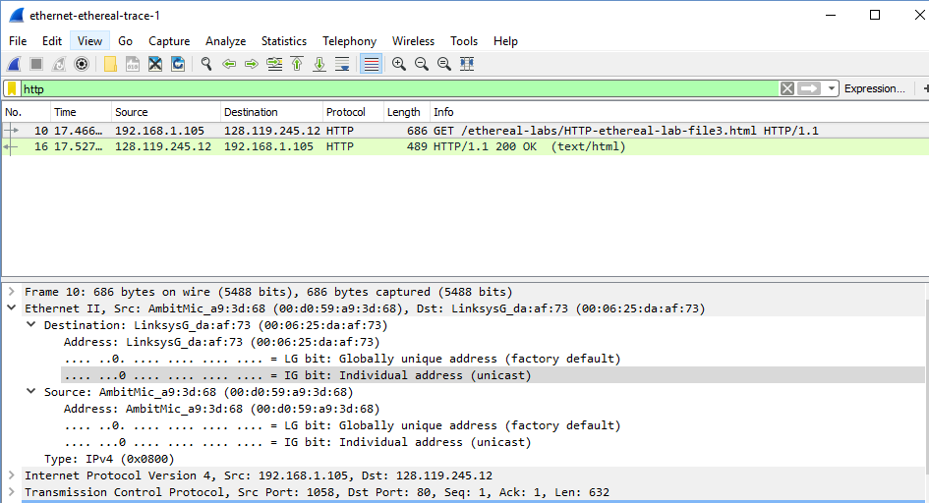

Figure 1. GET response Ethernet information

1. The Ethernet address of my computer is 00:d0:59:a9:3d:68
2. The destination address is 00:06:25:da:af:73. This address is not the Ethernet address of the actual website. It is the address of my router used to get off the subnet, or in case, NYU WiFi.
3. The hex value for the frame type field is 0x0800, it corresponds to the IP protocol.
4. The ASCII “G” appears 52 bytes from the start of the Ethernet frame. There are 14B Ethernet frame, and then 20 bytes of IP header followed by 20 bytes of TCP header before the HTTP data is encountered.

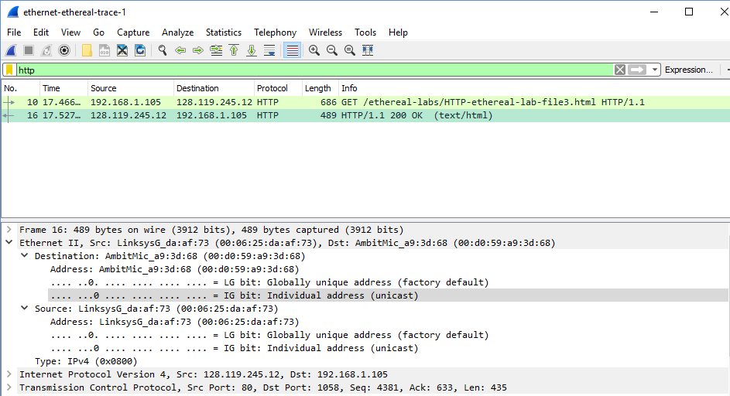

Figure 2. OK response Ethernet information

1. The source address 00:06:25:da:af:73 is neither the Ethernet address of the website nor the address of my computer. It is the address of NYU WiFi.
2. The destination address is 00:d0:59:a9:3d:68 is the address of computer
3. The hex value for the Frame type field is 0x0800, which corresponds to the IP protocol
4. The ASCII “O” appears 52 bytes from the start of the ethernet frame. Again, there are 14 bytes of Ethernet frame, and then 20 bytes of IP header followed by 20 bytes of TCP header before the HTTP data is encountered.

\*My actual computer data

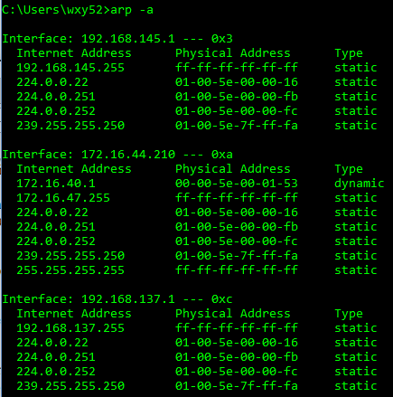

Figure 3. Command prompt ARP

1. The Internet Address column contains the IP address, the Physical Address column contains the MAC address, and the type indicates the protocol type.

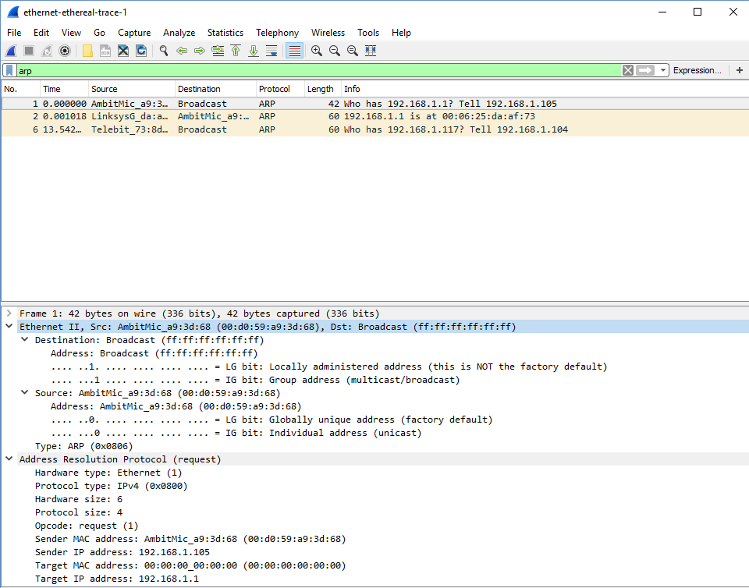

Figure 4. ARP request message

1. The source address is 00:d059:a9:3d:68. The destination address is ff:ff:ff:ff:ff:ff, the broadcast address.
2. The Ethernet frame type field is 0x0806, which corresponds to ARP.
3. The field beings 20 bytes from the very beginning.
4. The hex value of opcode is 0x0001 (request).
5. Yes, the ARP message containing the P address 192.168.1.105 for the sender.
6. The field “Target MAC address” is set to 00:00:00:00:00:00 to question the machine whose corresponding IP address (192.168.1.1) is being queried.

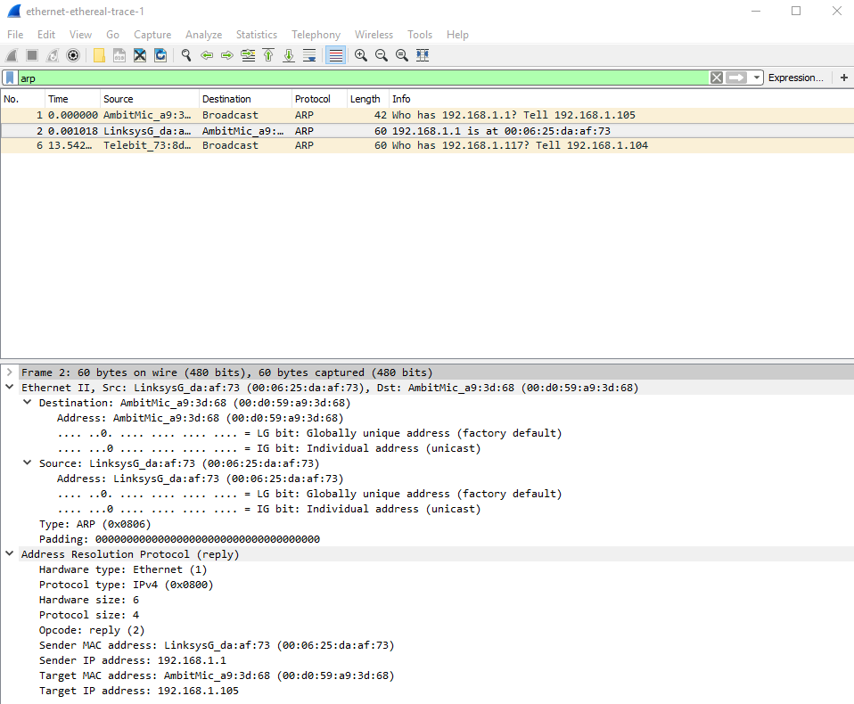

Figure 5. ARP reply message

13.

1. The field beings 20 bytes from the very beginning.
2. The hex value of opcode is 0x0002 (reply).
3. The answer that contains the Ethernet address 00:06:25:da:af:73 appears in the “Sender MAC address”.
4. The source address is 00:06:25:da:af:73 and for the destination is 00:d0:59:a9:3d:68.
5. There is no reply in this trace, because we are not the machine that sent the original request. The ARP reply is sent back directly to the sender’s Ethernet address.

Extra Credit:

EX-1. If the router/adapter received the destination IP address, the router/adapter would still remove the IP address from the Ethernet frame and then using ARP would get the correct MAC address of the destination.

Ex-2. The default time is 20mins. For every 20mins, the ARP table will be refreshed, because the neighboring device can be out of the network so the ARP table should be updated according to the network states. When the table gets refreshed, the content will get erased and when the chance comes to resolve the MAC address to the known UP address, the ARP request will be sent in broadcast mode where the reply will be in Unicast mode.