Xueyang (Sean) Wang

XW1154

04/26/2017

CS4793

Homework 07

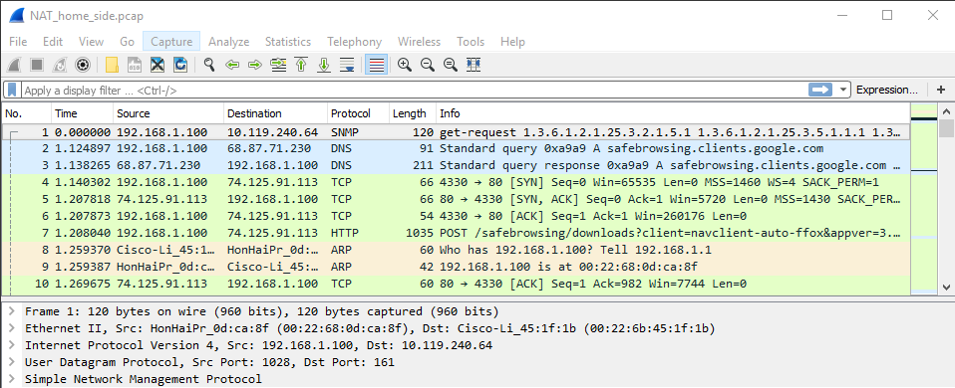

Figure 1. NAT_Home

1. The IP address of the client is 192.168.1.100

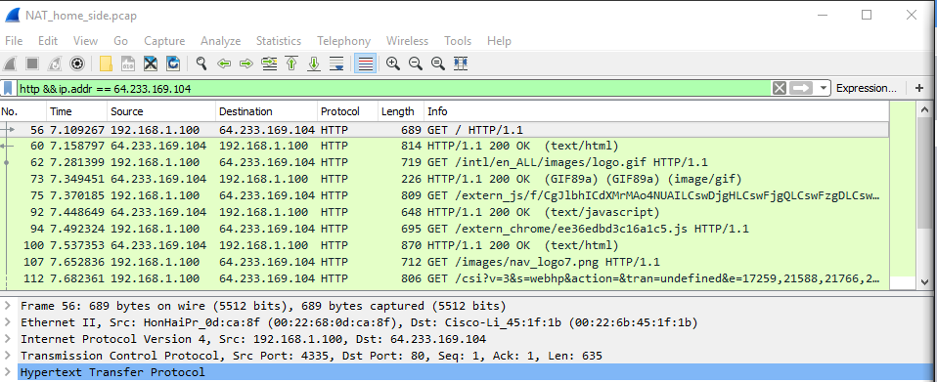

Figure 2. Filtered NAT

1. The source IP address is 192.168.1.100, port: 4335 and the destination IP address is 64.233.169.104, port: 80
2. At 7.158798 is the corresponding 200 OK HTTP message received from the Google server. The source IP address is 64.233.169.104, port: 80 and the destination IP address is 192.168.1.100, port: 4335.

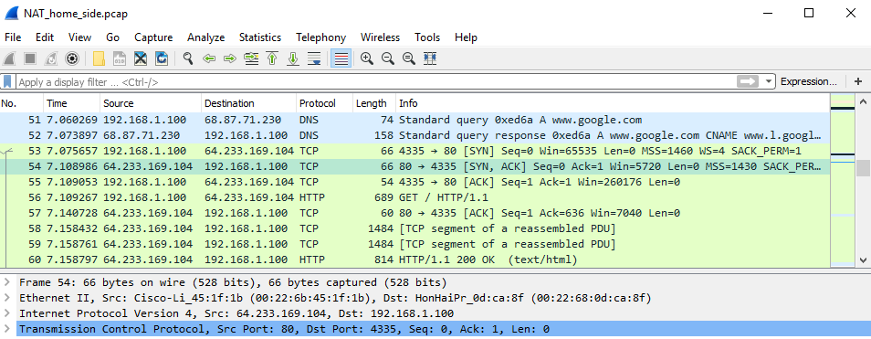

Figure 3. TCP SYN/ACK segment

1. At 7.075657, the client-to-server TCP SYN segment was sent. The source IP address is 192.168.1.100, port: 4335. The destination IP address is 64.233.169.104, port: 80. For the ACK sent to response to the SYN: the source IP address is 64.233.169.104, port: 80, and the destination IP address is 192.168.1.100, port: 4335. At 7.108986, the ACK is received at the client.

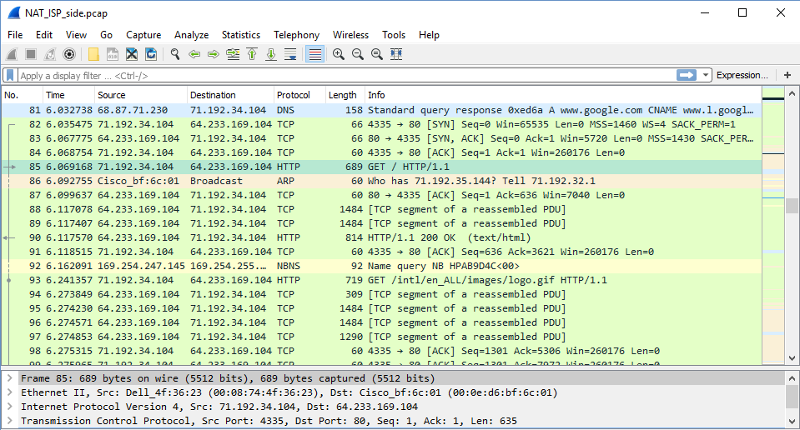

Figure 4. NAT_ISP

1. At 6.069168, the message appears in the file. The source IP address is 71.192.34.104, port: 4335, and the destination IP address is 64.233.169.104, port: 80. Only the source IP address has changed, everything else is the same.
2. No change in GET message: NO change in Version, Header Length, Flags. Checksum is changed. Since the IP source address has change, and the checksum includes the value of the source IP address, the checksum has changed.

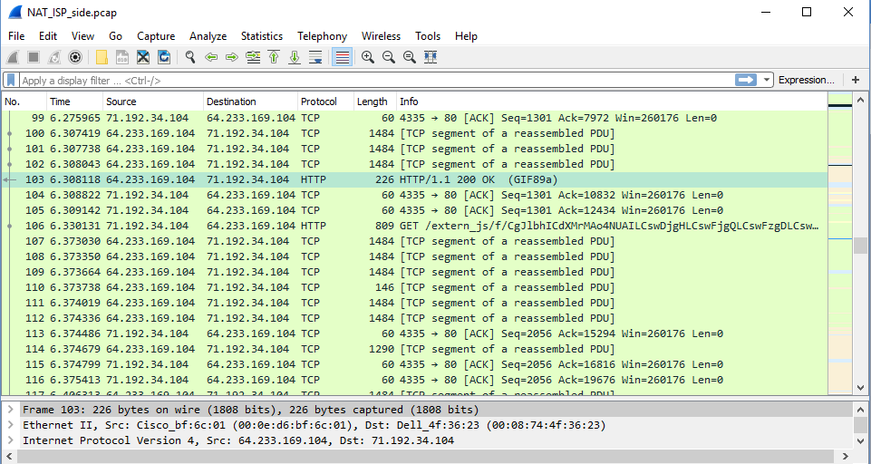

Figure 5. First 200 OK

1. At 6.308118, the first 200 OK HTTP message is received. The source IP address 64.233.169.104, port: 80, and the destination IP address is 71.192.34.104, port: 4335. Only the destination IP address has changed.
2. At time 6.035475 and at time 6.067775, respectively. For SYN: the source IP address is 71.192.34.104, port: 4335, and the destination IP address is 64.233.169.104, port: 80. For ACK: the source IP address 64.233.169.104, port: 80, and the destination IP address is 71.192.34.104, port: 4335. For SYN, the source IP address has changed. For ACK, the destination IP address has changed. The port numbers are unchanged.

|  |  |
| --- | --- |
| NAT translate table | |
| WAN side | LAN side |
| 71.192.34.104, 4335 | 192.168.1.100, 4335 |

Extra Credit: No time for research. EMPTY