 PARAKRAM 2018



Robotics club

presents

MANEUVER

(the gripper manual robotics competition)

“THERE ARE NO EXTRA PIECES IN UNIVERSE. EVERYONE IS HERE BEACAUSE HE OR SHE HAS A PLACE TO FILL, AND EVERY PIECE MUST FIT ITSELF INTO A BIG JIGSAW PUZZLE”

**ABOUT**

A puzzle is a game, problem, or toy that tests a person's ingenuity or knowledge. In a puzzle, the solver is expected to put pieces together in a logical way, in order to arrive at the correct solution of the puzzle. There are different genres of puzzles, such as crossword puzzles, word-search puzzles, number puzzles, or logic puzzles.

**Problem statement**

Bot has to complete the track by crossing all the hurdles and finding the treasure.

**Rounds and details**

There will be asingle round which contain three stages. As you clear stage, next stage get unlocked.

* Stage 1: Stage 1 is the puzzle solving level. The participants have to use their bot for solving puzzle by rearranging the boxes.
* Stage 2: Stage 2 is about picking up a block and dropping it into the basket.
* Final stage: Stage 3 involves making of patterns using gripper.

**RULES:**

* Each team can have maximum 5 participants.
* Certificates of excellence will be awarded to the teams.
* If the organizers doubt the safety of viewers due to a particular bot, the then team might be denied participation.
* The bot is not allowed to leave anything behind during the run. It should not leave any mark on the arena.
* The time measured by the organizers will be highlighted on the website and notified to the teams.
* In case of any disputes/discrepancies, the organizer’s decision shall be final and binding. The organizers reserve the right to any of the above rules , if any will be highlighted on the website and notified to the teams.
* Participants are advised to bring their own extensions for power supply.
* Team to be present at the arena 10 minutes before game starts. Absence will result to direct disqualification of the team.
* No extra time will be given in case of wire entanglement. Participants are suggested to use wireless power supply for bots.
* Participants should not disassemble their bots until results are announced.
* Judges decision will be final.

**Game play:**

* The bot should fit in the dimensions 30cmx30cmx35cm.
* The bot should be designed efficiently along with a gripper to clear all the checkpoints.
* All the checkpoints of the previous stage have to be cleared in order to unlock the next stage.
* This will be a time based task. Maximum time for completing the task is 20 minutes. If team completed their task before time their remaining time get added into their point.
* The boxes to be lifted by the gripper are of the dimensions 7cmx7cmx7cm.
* The points distribution is as follows
  + For clearing each checkpoint team will be awarded +50 points.
  + In case of manhandling team will be awarded -10 point.

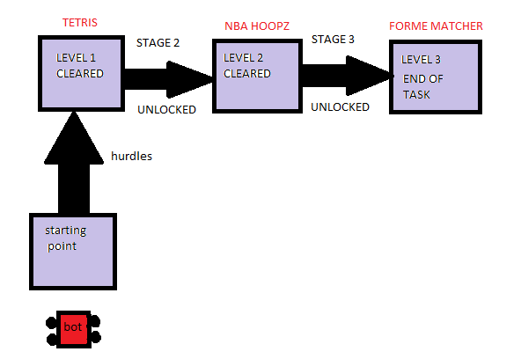

**Frequently asked questions**

Q1: Is any registration required?

Ans: Onspot as well as online registration is there.

Q2: If our bot breaks amidst the round can we get another chance?

Ans: No, you can take a time out of about 5 min only once.

**Contacts:-**

Asheesh Raikwar (E.C.E 3rd yr) (+91-9151479272)

Shretika Jain (E.C.E 3rd yr)

Ankur Singh (E.C.E 3rd yr) (+91-7985349172)

Chandan Jaiswal (E.C.E 3rd yr) (+91-7786040495)

**PRIZE**

1st – 3,000

2nd – 2,000

3rd – 1,000