**AEROTRIX**

(An AeromodellingCompetition)

**Introduction:**

*To invent an airplane is nothing. To build one is something. But to fly is everything! -- Otto Lilienthal*

“It's only when you're flying above it that you realize how incredible the Earth really is.This event requires the participants to design and fabricate an RC plane and perform a set of maneuvers.The event provides the opportunity to boast the flying skill, and help students learn the basics of aerodynamics.”

**Event Structure:**

There will be two rounds of the competition.

### **Qualifier Round:**

This round consists of flying the RC-Plane to certain specified height then make the throttle zero and then hover it for maximum time till it reaches the ground. This task is to see your basic flying skill. Total time and safe landing of RC-Plane are the key-point taken into consideration for qualification of team.

### **Maneuver Round:**

### In this round each team must complete given tasks.

1. Teams must make their RC-Plane travel through given waypoints or between given bars and land it at specific location.
2. Selected team will undergo RC-Plane racing.

**Plane Specification:**

1. T/W < 0.75 (if excess thrust is found, it will be neutralized by adding weightbelow the plane at center of gravity).

2. Propeller diameter should not be greater than 10 inches.

3. Battery weight should not be more than 150 gm.

4. Only electrical motors are allowed. The use of IC engines or any other means of providing thrust is prohibited.

5. Use of gyroscopes (gyros) and programming assistance in receivers is prohibited.

6. Only one of the team members can fly the aircraft.

**7. Readymade planes are not allowed.**

8. Plane should not be of advance type; they should resemble the basic trainer craftas shown in the image:

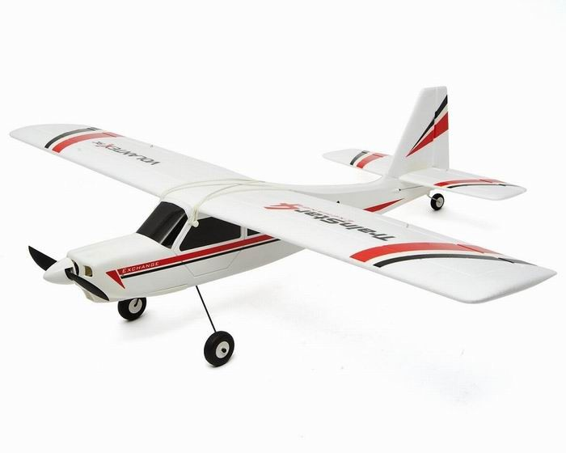

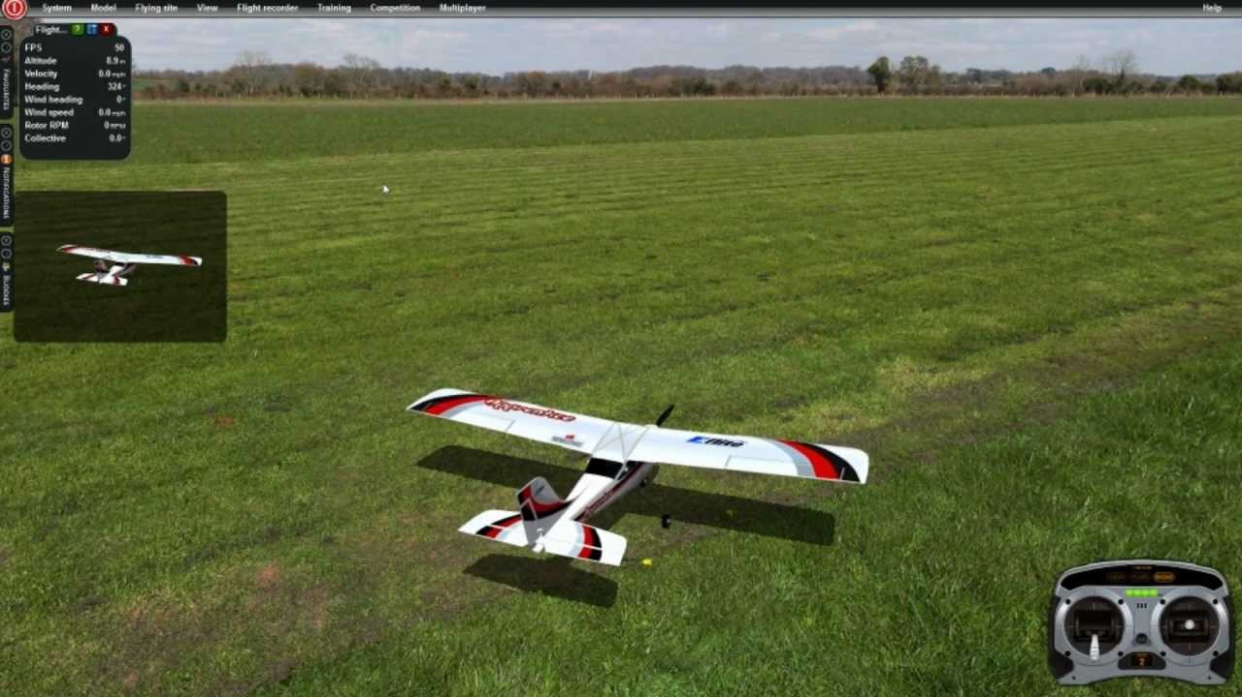

**Team structure:**

1. Maximum of 5 members in a team.

2. Members of a team may be from same college/school or different (K-12/UG/PG).

3. Any number of teams can participate from one college/school

4. Professionals are not allowed. Only students can participate.

5. Participants are required to have their school/college ID Card.

**General Rules:**

1. Each team would be given 2 chances for each of the rounds and the best score is considered as per the scoring procedure mentioned above for each round.
2. The timer will start from the moment the aircraft is in the air for both the rounds.
3. Awards will be announced based on the performance of the teams in the Maneuver Round.

**Prize Money:**

**1st – 4,000**

**2nd- 2,000**

**3rd- 1,000**

**General Guidelines for the Competition:**

1. The use of 2.4 GHz radio is required for all aircraft competing in the competition. If the participants want to use any other frequency, they will have to inform the organizers in advance.
2. A limited number of 2.4 GHz radios will be available with the organizers for use by the teams. Teams who do not have access to radios can inform the organizers in advance to request use of these radios.
3. Receivers installed in the aircraft have to be in 'receiver mode only'.
4. All the systems (Servos, motor, etc.) will be checked by organizers for functionality before the competition. If found not working, teams will be dismissed from the competition.
5. Pilot can position himself at any point in the arena to fly the aircraft during the rounds.
6. Metal propellers are not allowed.
7. The models can have powered take-off with a landing gear or can be launched manually by a person standing at ground level.
8. Plane should be built from scratch and not purchased models.
9. A team member can’t be a part of more than one team.
10. Bring your college/student I-Card at the time of competition.
11. Any of the above-mentioned rules, if found violated, teams would not be allowed to participate in the competition.
12. Decisions of the coordinators will be final and binding.

**Contacts:-**

Asheesh Raikwar (E.C.E 3rd yr) (+91-9151479272)

Shretika Jain (E.C.E 3rd yr)

Ankur Singh (E.C.E 3rd yr) (+91-7985349172)

Chandan Jaiswal (E.C.E 3rd yr) (+91-7786040495)