TRIBHUWAN UNIVERSITY
INSTITUTE OF ENGINEERING
CENTRAL CAMPUS,PULCHOWK


PROJECT REPORT OF
OBJECT ORIENTED PROGRAMMING
(C++)

Socket-Chat

Submitted By:- Submitted To:-
Team Members:- Department of
Sailesh Shrestha(074BEX437) Electronics&Computer
Ranjan Shrestha(074BEX435) Engineering
Ujjwal Pokhrel(074BEX447)

Acknowlegement

We accept wholeheartedly that the concept of object oriented programming is a revolution in the field of software development taking over the procedure oriented programming in many aspects. And, C++ was one of the primary languages to implement this brilliant technique and as it was created to be the extended version of C, we could blend the powerful programming features provided by C with the OOP technique to make it arguably better in many ways for larger application development.

With the inclusion of object oriented programming through C++ in our curriculum, we received the opportunity to learn about these modern concepts of programming under the mentorship of our sir Mr. Daya Sagar Baral. So, to explore deeper real-world knowledge on C++ and OOP and actually make something out of it, we make ourselves ready to do this project and develop our own application.

We attempted to a multi-featured socket chat, which we’ll be describing thoroughly in this document. We would like to express our gratitude and thanks to our respected sir Mr. Daya Sagar Baral who had guided us to accomplish this project. We would also like to thank Mrs. Bibha Sthapit and Mr. Arjun Upadhaya for the valuable guidance for our project.

Despite consulting many reference materials, we were unable to complete some of the features we’d mentioned in our proposal due to the time constraint. So, we apologize in this regard and hope to keep receiving further help from your side.

Abstract

Socket Chat is a multi-featured chat server intended to have efficient communication between users .User can communicate in a pair or in a group( through chat rooms). It allows file transfer along with Morse Code Communication.
. An inbuilt converter will be able to encode plain text into Morse Code and decode Morse Code into plain text. It also has inbuilt feature of tic-tac-toe game as a fun feature. User can play with computer or against each other. Its goal is to provide a platform to chat and learn Morse Code with fun.

Table of Content

1.INTRODUCTION 5
2.OBJECTIVE 5-6
3.APPLICATION 6
4.LITERATURE SYSTEM 6-8
5.EXISTING SYSTEM 8
6.METHODOLOGY 9
7.IMPLEMENTATION 10
8.RESULTS 11-13
9.PROBLEMS FACED AND SOLUTION 14
10.LIMITATION AND FUTURE ENHANCEMENT 14-15
11.CONCLUSION AND RECOMMENDATION 15
12.REFERENCE 15-16

1. INTRODUCTION TO OUR PROJECT

Our project is a Multi-featured Socket Chat, that creates a network for authenticated users to communicate in a group( through chat rooms) and allows file transfer along with Morse Code Converter Communication Feature. A registration feature is also available for the first-time users. Only the registered users will be able to access the features inside it. We have included Morse Code Communication feature as a fun and educational feature. An inbuilt converter will be able to encode plain text into Morse Code and decode Morse Code into plain text. As another fun feature of our project, the users communicating with each other can challenge each other at simple good-old Tic-Tac-Toe game(under development). When no other users are available, the lone user can play Tic-Tac-Toe with the AI . That’s our proposed program overview.

2. OBJECTIVES OF OUR PROJECT
For the Users
- To provide a secure well featured communication interface for users communicating over a network(local)
- To allow users to communicate in Morse Code Format along with the encoding and decoding features
- To provide users with the fun feature of playing a simple mind game against each other or with the AI

For us:
- To understand the essence of object oriented programming and powerful features of C++
- To get familiar with network programming using sockets (UNIX)
- To get familiar with GUI programming
- To get familiar with Morse Code Communication and learn as we build upon it
- To implement the algorithms for game development and auto game play by the computer

3. APPLICATION
This Socket Chat can be used in following fields.
- Secure and efficient communication between user over locally connected network.
- Efficient file sharing between user.
- Learn and get used to with MORSE Code in a fun way
- Play Tic Tac Toe in different platform.
4. LITERATURE SURVEY
It took some significant amount of research to complete this project so far(some parts are unser ). So we have researched the internet and books to gain enough knowledge for our project.
As the name specifies, our project has been priorily focused on network programming. To become familiar with networking, we have taken the reference of book Beej’s Guide to Network Programming @ Beej.us. From this, we gain the deep knowledge of networking. Related topics like socket, client-server communication and many more were cleared to us. On the other hand, the proper illustration(diagrams) and codes written on Tutorial by Eleftherios Kosmas had helped us to broaden our knowledge on networking. On further researching regarding it, Geeks For Geeks also helped in getting some additional ideas.
For the GUI, we have implemented the gtkmm library. The official documentation on https://developer.gnome.org/gtkmm-tutorial/stable/index-info.html.en helped us to develop a proper GUI for this project. We have used this library because it is the official C++ interface for the popular GUI library GTK+ and also it is open source library. It use the common OOP techniques such as inheritance, and C++ specific facilities such as STL.

Main features of gtkmm are listed as follows:
- Use inheritance to derive custom widgets.
- Type-safe signal handlers in standard C++.
- Polymorphism
- Use of Standard C++ Library, including strings, containers and iterators.
- Full internationalisation with UTF8.
- Complete C++ memory management.
  - Object composition.
  - Automatic deallocation of dynamically allocated widgets.
- Full use of C++ namespace.
- No macros.
- Cross-platform: Linux (gcc, LLVM), FreeBSD (gcc, LLVM), NetBSD(gcc), Solaris (gcc, Forte), Win32 (gcc, MSVC++), macOS (gcc), others.

For the Morse Code, we had browsed the wikipedia to gain enough knowledge. The websites like http://www.learnmorsecode.com/, https://morsecode.scphillips.com/translator.html, https://www.wikihow.com/Learn-Morse-Code had been our tutor to learn Morse Code.

5. EXISTING SYSTEM
As far as we’ve seen, chat software in C++ exist but with the rise of other modern languages, those software don’t quite come into the light. Also, chatting, morse code conversion and gaming are implemented within our application. And,since some of our features are quite unique in our program, it’s going to be newer than the existing in many ways. Mostly, we worked on our project just to get a better idea about the object oriented programming and network programming as well as to have fun with implementation of a simple game in our network and Morse Code.

6.METHODOLOGY
For the implementation of our project, as required, we will be using the following resources.
- C++ for entire coding
- GTKMM( A C++ Interface of GTK+) for the Graphical User Interface
- TCP/IP Sockets for Networking
- Linux System Tools

7.IMPLEMENTATION
Send Message

Authentication
System
Text message

Morse
Converter
Receive
Message
Chat room
Upload file
Morse To
Character

Registration
Character To
Morse
Play Morse
Sound
8. RESULTS
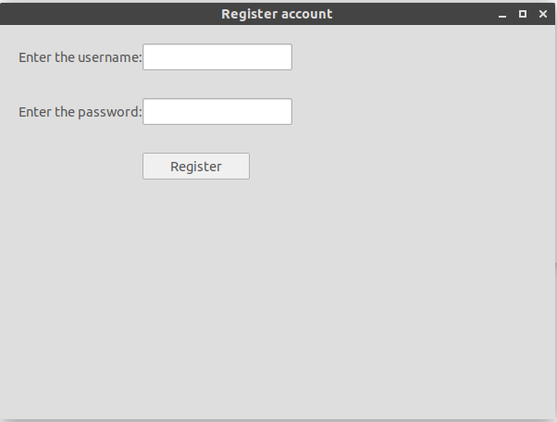
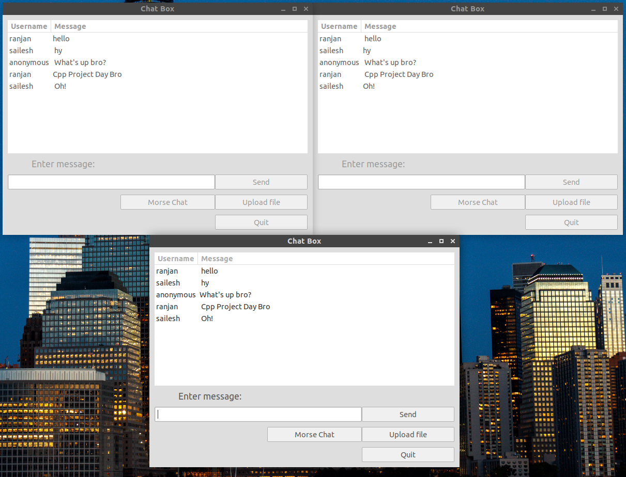

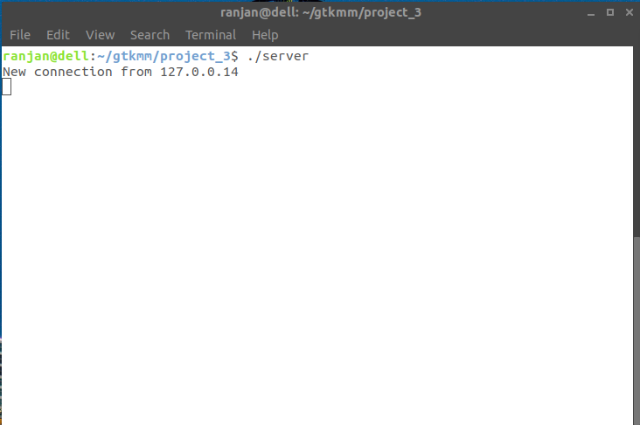

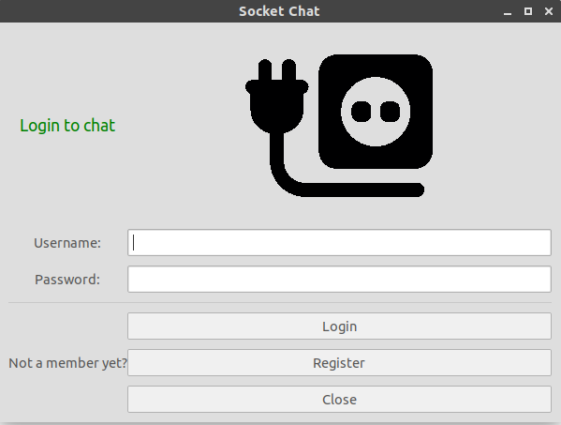

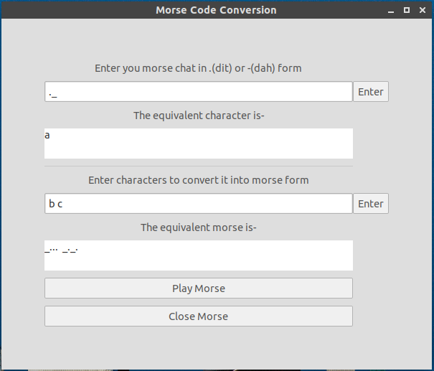

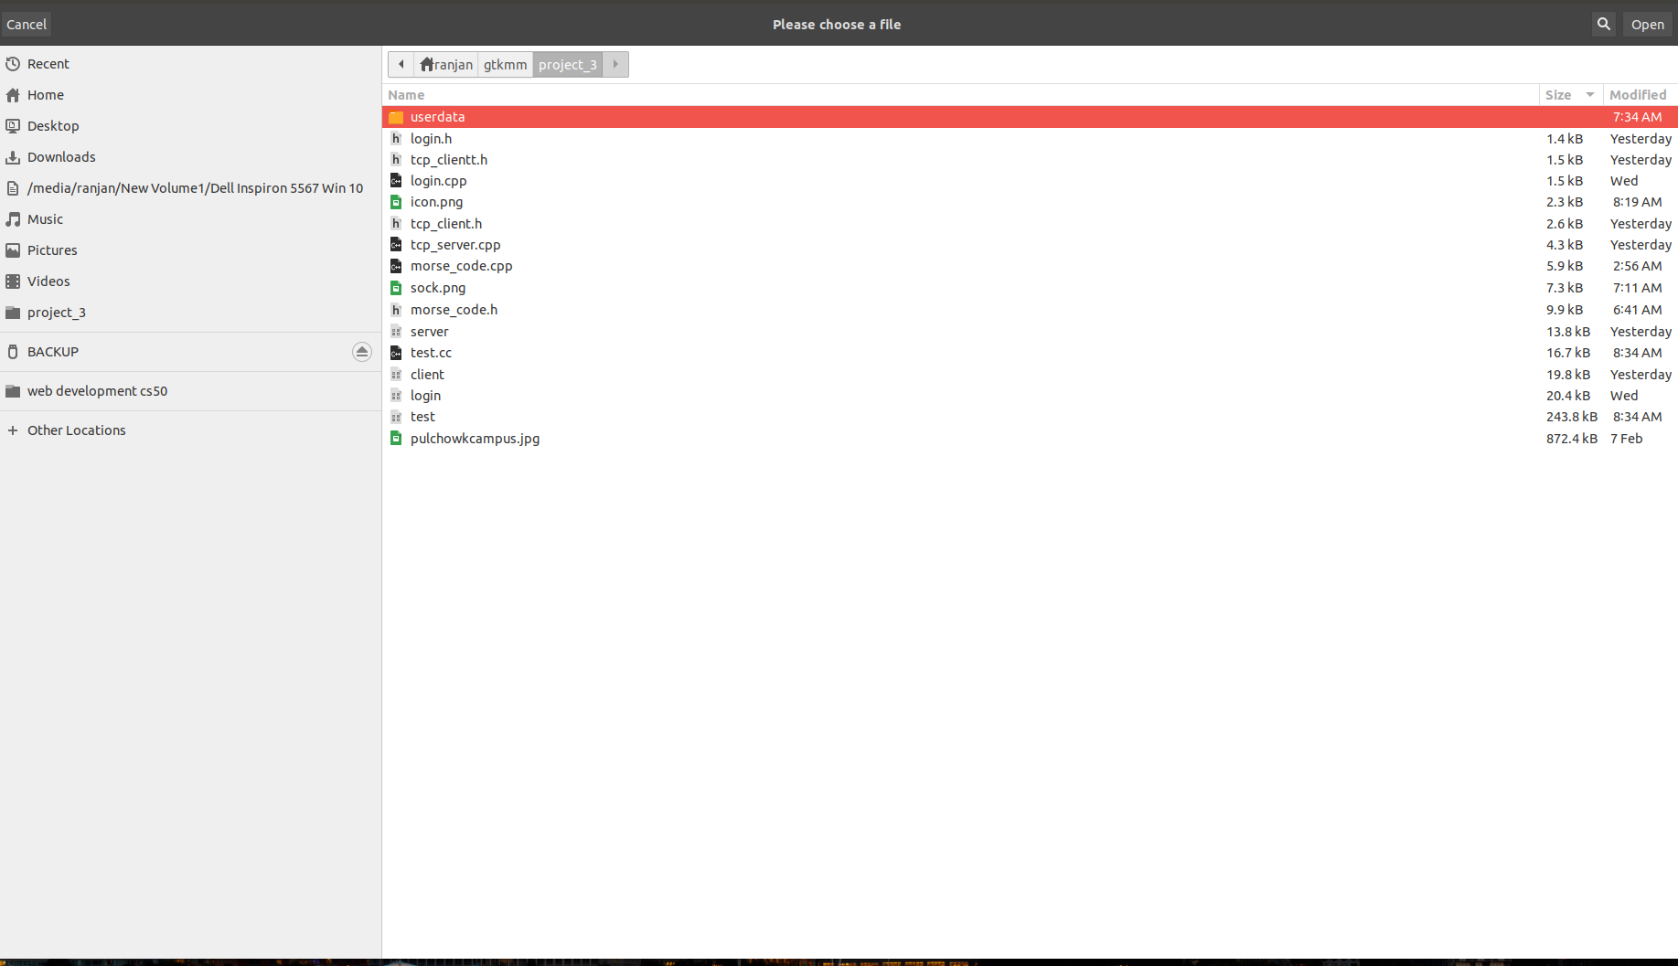
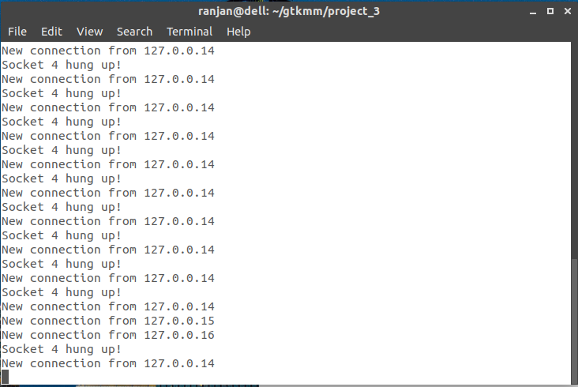

9. PROBLEMS FACED AND SOLUTIONS
- We were unable to implement asynchronous chat system but to make the connection somewhat simultaneous, we used the timer functions and other non-blocking functions. Asynchronous chatting will be further updated.
- Due to lack of updated learning resources on gtkmm, sophisticated GUI could not be made at the moment.
- Due to lack of time, security features could not be implemented but later we will be able to implement encoding and most secured authentication in this project. Also, due to the limited time, a lot of features missed out which we’ll be working on the future.

10. LIMITATIONS AND FUTURE ENHANCEMENT
- Doesn’t have audio library for audio chatting. In future, we can include it.
- Code redundancy can be found at some places so we will be working to improve the code to make more object oriented and make the code efficient.
- Binary data transfer will be implemented soon.

11. CONCLUSION AND RECOMMENDATION
We have attempted to make this project more user-friendly. From this project, we were able to consult a lot of references and learn about network programming, object-oriented feature of C++, gtkmm library and many more. During the project, many errors were encountered but we attempted to minimize them as much as possible.

12. REFERENCES:
- Beej’s Guide To Network Programming
- A presentation on Network Programming by Eleftherios Kosmas
- Geeks For Geeks
- Youtube Playlists From Sloan Kelly and Learning X
- gtkmm documentation by GNOME
- Object Oriented Programming with C++ by E Balagurusamy
- Linux Man Pages
- http://www.learnmorsecode.com/, https://morsecode.scphillips.com/translator.html, https://www.wikihow.com/Learn-Morse-Code

