

**CodeBlockers**

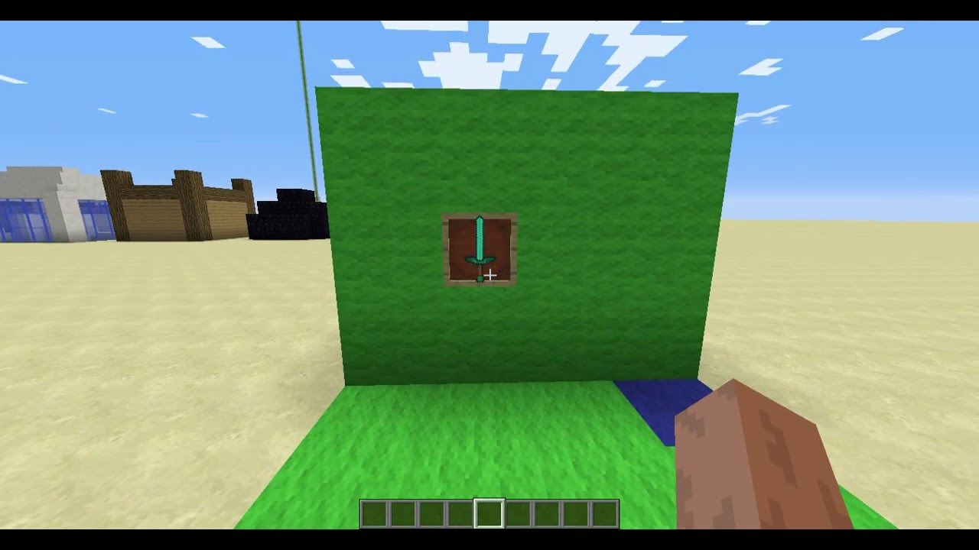

**CodeBlockers Team**



CodeBlockers Team

##### 1. Adam T (Testing) - [Github](https://github.com/Add-man)

2. Fongoh LOKNJINU (Research) - [Github](https://github.com/loknjinu13)

3. Vangx033 (Testing) -[Github](https://github.com/vangx033)

4. Glanel Houenouvi (Documentation) - [Github](https://github.com/grenack)

5. Kasia Lor (Support) - [Github](https://github.com/klor0610)