2.1.2 Arduino

Arduino is an open source microcontroller board and a software development environment. Arduino language is a ‘C’ like programming language which is easy to learn and understand.
Arduino has two components, open source hardware and open source software.

[copied text starts here]
Open source hardware(OSHW):
“Open source hardware is hardware whose design is made publicly available so that anyone can study, modify, distribute, make, and sell the design or hardware based on that design”.

If the licensed design requires software, embedded or otherwise, to operate properly and fulfill its essential functions, then the license may require that one of the following conditions are met:
a) The interfaces are sufficiently documented such that it could reasonably be considered straightforward to write open source software that allows the device to operate properly and fulfill its essential functions. For example, this may include the use of detailed signal timing diagrams or pseudocode to clearly illustrate the interface in operation.
b) The necessary software is released under an OSI-approved open source license.

OSHW gives people the freedom to control their technology while sharing knowledge and encouraging commerce through the open exchange of designs.
OSHW is used for physical objects, such as, printed circuit boards, buildings, machines, 3D printers etc.

[copied text END here: source: http://www.oshwa.org/definition/ License: CC-BY-SA ]

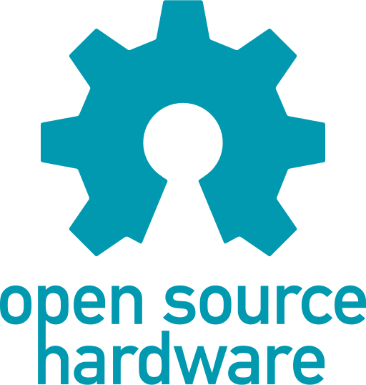
[source in public domain: https://en.wikipedia.org/wiki/Open-source_hardware#/media/File:Open-source-hardware-logo.svg ]

Examples of open hardware projects:
The open hardware initiative is popular in electronic, computing hardware and automation industry.
- The ‘open compute project’ at Facebook shares the design of data center products.
- Beagle board, Panda board, OLinuXino are ARM based development boards.
- ‘Open Graphics Project’ (OGP) releases the designs of graphics card.
- ‘ArduCopter’ is a UAV(unmanned aerial vehicle) created by ‘DIY Drones’ community.
- ‘NetFPGA’ is a prototyping of computer network devices.
- ‘OpenROV’ project (Open source remotely operated vehicle) aims at affordable underwater exploration.
- ‘OpenMoko’ project set foundation for open source mobile phones. ‘Neo 1973’ was the first smartphone released in 2007 with Linux based operating system, it had 128MB RAM and 64MB ROM.

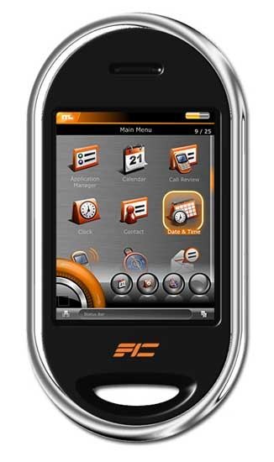
[NEO 1973 Smartphone, source with CC BY-SA 3.0: https://upload.wikimedia.org/wikipedia/commons/f/fd/Neo_1973_smartphone.jpg]

Use of OSHW in industry:
Companies like Adafruit Industries, Texas Instruments, Solarbotics, Sparkfun electronics, MakerBot industries, DIY Drones have proven the power of OSHW with their revenues.
Collaborative innovation using OSHW is yet to establish itself in mainstream. Trend is certainly started and is going strong. There are many startups working with robotics today taking full use of OSHW.

Brief history of Arduino:
Arduino project was started at the ‘Interaction Design Institute Ivrea’ in Ivrea, Italy. The aim was to create a low cost microcontroller board that anyone with little or no background on domain can design and develop. Arduino uses expansion circuit boards known as ‘shields’. Shields can provide GPS, GSM, Bluetooth, Zigbee, motor and other functionality.
The Arduino within its first two years sold more than 50, 000 boards. In 2011, Google has announced ‘The Android Open Accessory Development Kit (ADK)’, which enables Arduino boards to interface with Android mobile platform.
Today Arduino is first choice for electronic designers and hobbyists. There are more than 13 official variants of Arduino, and many more third party Arduino software compatible boards.

Arduino boards:

There are different boards for different requirements. All original Arduino boards are based on ATMEL microcontrollers.

List of popular Arduino boards:
- Arduino Uno:
Based on ATmega328, it has 14 digital input/output pins, 6 analog inputs, 6 PWM pins, a 16 MHz ceramic resonator, a power jack, an ICSP(In-Circuit Serial Programming) header, and a reset button. It has on board USB to serial converter, and can be connected to PC using USB cable.

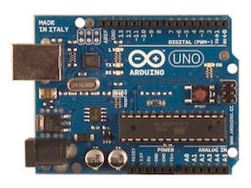
[source (cc by-sa): https://www.arduino.cc/en/uploads/Main/ArduinoUnoFront240.jpg]

- Arduino Mega:
Based on ATmega2560, it has almost double the size of program memory(ROM) compared to Arduino Uno, it also has extra serial ports, digital and PWM pins.
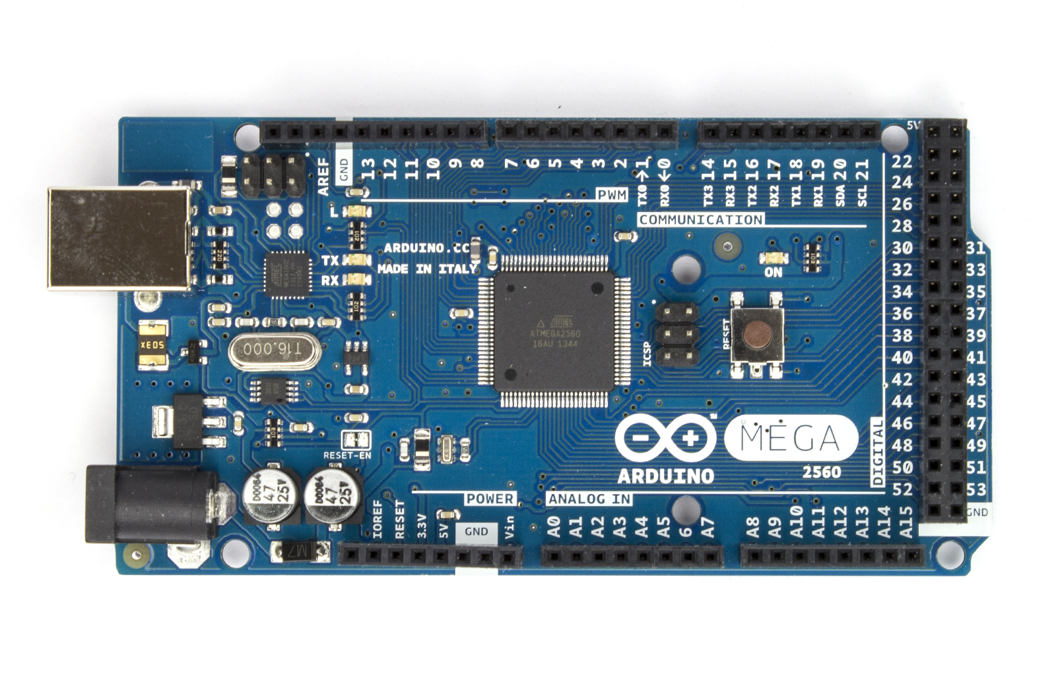
[source (cc by-sa):https://www.arduino.cc/en/uploads/Main/ArduinoMega2560_R3_Fronte.jpg]

- LilyPad Arduino:
A small circular board for fabric designers. It can be stitched with conductive thread and supports sensors, actuators.
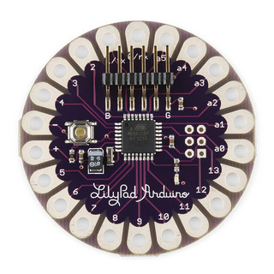
[source (cc by-sa): https://www.arduino.cc/en/uploads/Main/LilyPad_5.jpg]

There are other similar configuration boards with different form factors, such as Arduino Fio, Arduino mini, Arduino nano, Arduino Duemilanove, Arduino serial and so on.

arduino projects:

People around the globe are using Arduino in innovative ways. Its ease to setup and use, intuitive, simple software and low cost. Here are the few interesting applications with Arduino.

- Arduino phone: An Arduino connected with graphic LCD and a GSM shield. This low tech phone can be built in few hours. More details at http://www.instructables.com/id/ArduinoPhone/

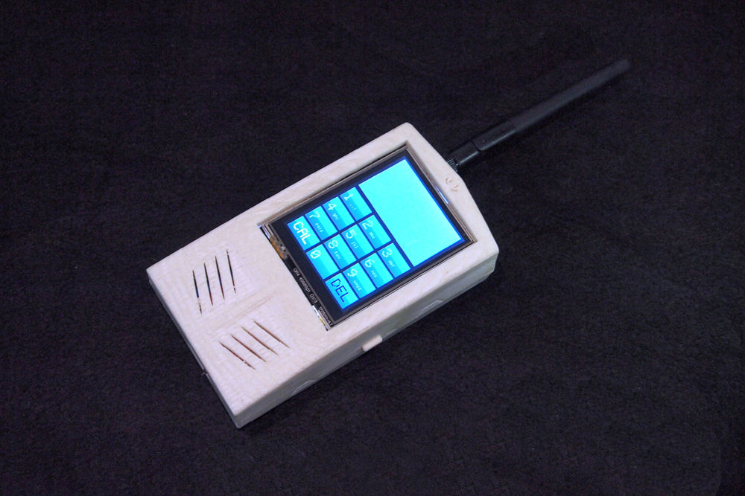

[source (by-nc-sa): http://cdn.instructables.com/FB8/OHIG/HJ6053CU/FB8OHIGHJ6053CU.LARGE.jpg]

2) Candy sorting machine: As the name suggest this machine can sort candy based on its color to separate jars. [http://beta.ivc.no/wiki/index.php/Skittles_M%26M%27s_Sorting_Machine]

3) 3D printers: There are open source 3D printers based on Arduino and Raspberry-pi. Although 3D printers are relatively slow and lack precision, but they can be ideal for building prototypes by hobbyists.
More details at http://www.instructables.com/id/Arduino-Controlled-CNC-3D-Printer/

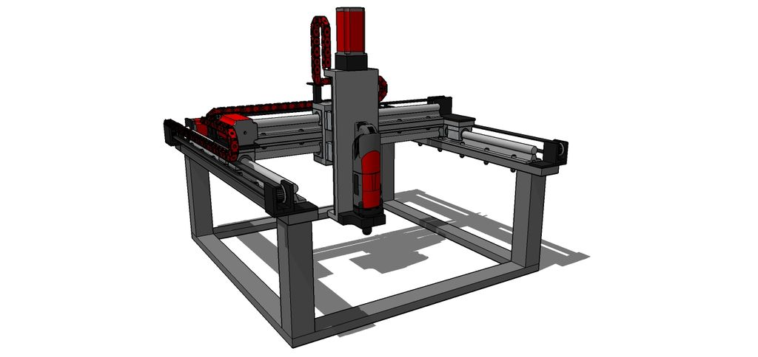

[source (by-nc-sa):
http://cdn.instructables.com/FI8/81D5/HQDLZ0Z5/FI881D5HQDLZ0Z5.LARGE.jpg]

