**Contributor name:** ANSARI MUHAMMAD SALEEM ABUL HASAN

**Book Proposed:** ELECTRONIC DEVICES AND CIRCUITS

**Total Chapters:**7

**Total Examples:** 122

**Codable Examples:**110

**Chapter 1: Electron Dynamics and CRO**

Example 1.1 – Codable

Example 1.2 – Codable

Example 1.3 – Codable

Example 1.4 – Codable

Example 1.5 – Codable

Example 1.6 – Codable

Example 1.7 – Codable

Example 1.8 – Codable

Example 1.9 – Codable

Example 1.10 – Codable

Example 1.11 – Codable

Example 1.12 – Codable

Example 1.13 – Codable

Example 1.14 – Codable

**Chapter 2: Junction Diode Characteristics**

Example 2.1 – Codable

Example 2.2 – Codable

Example 2.3 – Codable

Example 2.4 – Codable

Example 2.5 – Codable

Example 2.6 – Codable

Example 2.7 – Non-Codable (Reason: Theoretical example with the purpose of proving a concept)

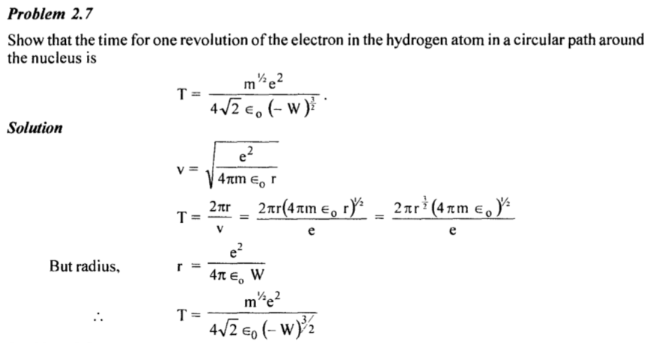

Example 2.8 – Codable

Example 2.9 – Codable

Example 2.10 – Codable

Example 2.11 – Codable

Example 2.12 – Codable

Example 2.13 – Codable

Example 2.14 – Codable

Example 2.15 – Codable

Example 2.16 – Codable

Example 2.17 – Codable

Example 2.18 – Codable

Example 2.19 – Codable

Example 2.20 – Codable

Example 2.21 – Codable

Example 2.22 – Codable

Example 2.23 – Codable

Example 2.24 – Codable

Example 2.25 – Codable

Example 2.26 – Codable

Example 2.27 – Codable

Example 2.28 – Codable

Example 2.29 – Codable

Example 2.30 – Codable

Example 2.31 – Codable

Example 2.32 – Codable

Example 2.33 – Codable

Example 2.34 – Codable

Example 2.35 – Codable

Example 2.36 – Codable

Example 2.37 – Codable

Example 2.38 – Non-Codable (Reason: Theoretical example with the purpose of proving a concept)

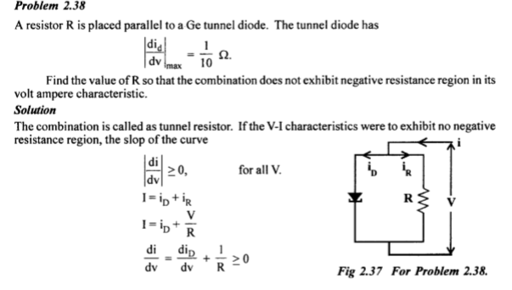

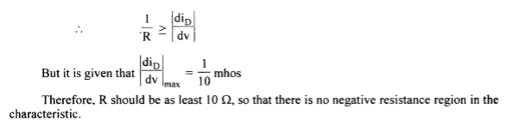

Example 2.39 – Codable

Example 2.40 – Codable

Example 2.41 – Codable

Example 2.42 – Codable

**Chapter 3: Rectifier Filters and Regulator**

Example 3.1 – Codable

Example 3.2 – Codable

Example 3.3 – Non-Codable (Reason: Theoretical example with the purpose of proving a concept)

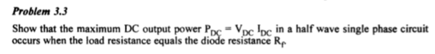

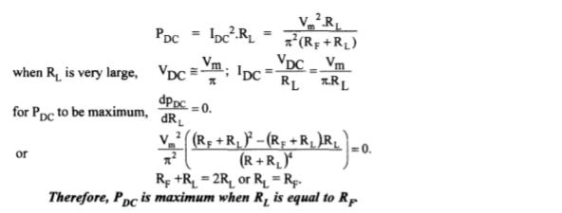

Example 3.4 – Codable

Example 3.5 – Codable

Example 3.6 – Codable

Example 3.7 – Codable

Example 3.8 – Codable

Example 3.9 – Codable

Example 3.10 – Codable

Example 3.11 – Codable

Example 3.12 – Codable

Example 3.13 – Codable

**Chapter 4: Transistors Characteristics**

Example 4.1 – Codable

Example 4.2 – Non-Codable (Reason: Theoretical example with the purpose of proving a concept)

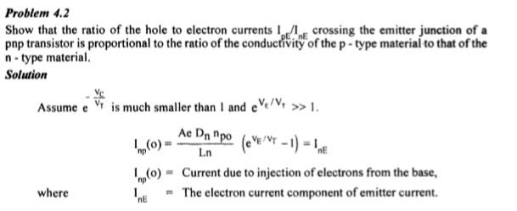

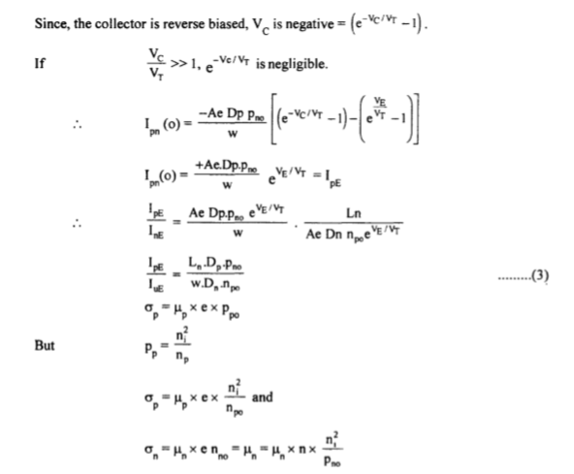

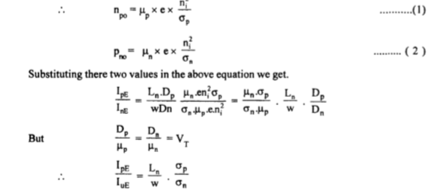

Example 4.3 – Non-Codable (Reason: Theoretical example with the purpose of proving a concept)

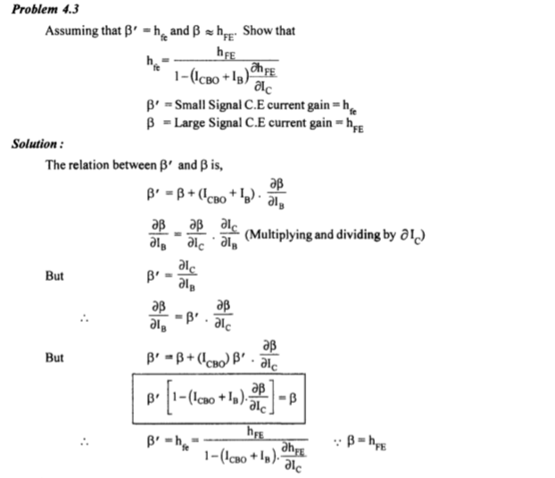

Example 4.4 – Non-Codable (Reason: Theoretical example with the purpose of proving a concept)

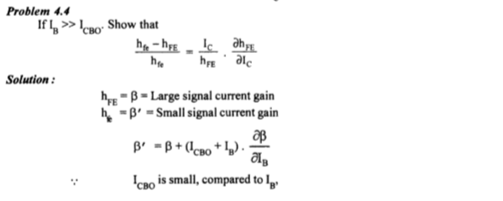

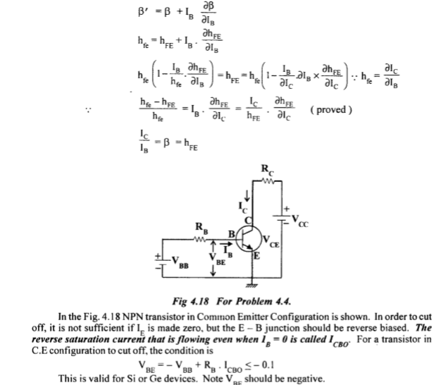

Example 4.5 – Codable

Example 4.6 – Codable

Example 4.7 – Codable

Example 4.8 – Codable

Example 4.9 – Codable

Example 4.10 – Codable

Example 4.11 – Codable

Example 4.12 – Codable

Example 4.13 – Codable

Example 4.14 – Codable

Example 4.15 – Codable

Example 4.16 – Codable

Example 4.17 – Codable

Example 4.18 – Non-Codable (Reason: Theoretical example with the purpose of proving a concept)

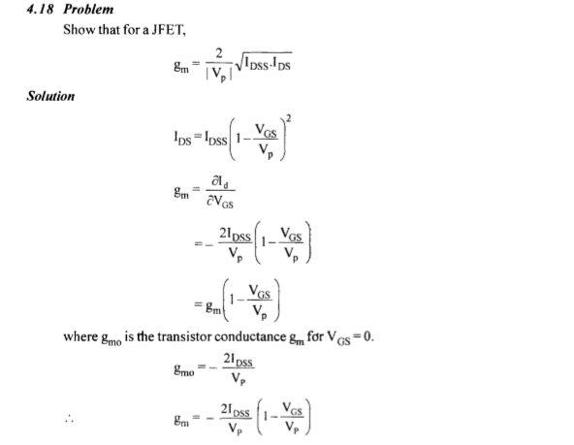

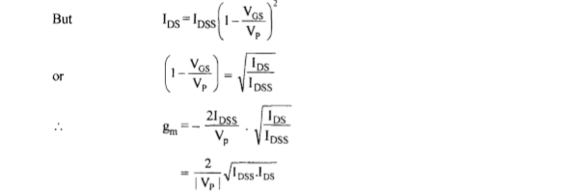

Example 4.19 – Non-Codable (Reason: Theoretical example with the purpose of proving a concept)

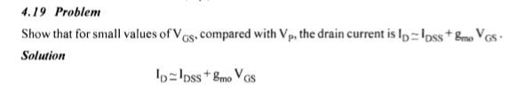

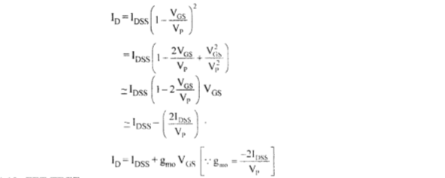

Example 4.20 – Codable

Example 4.21 – Codable

Example 4.22 – Codable

**Chapter 5: Transistor Biasing and Stabilization**

Example 5.1 – Codable

Example 5.2 – Codable

Example 5.3 – Codable

Example 5.4 – Non-Codable (Reason: Theoretical example with the purpose of proving a concept)

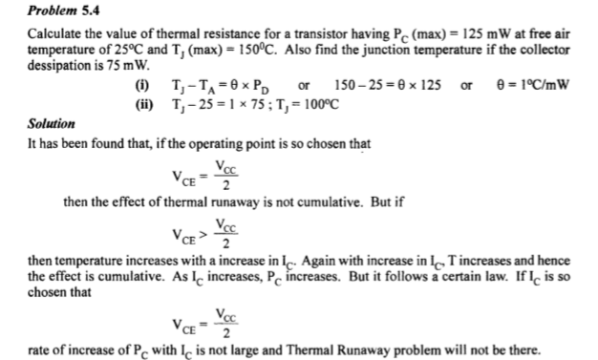

Example 5.5 – Codable

Example 5.6 – Codable

Example 5.7 – Codable

Example 5.8 – Codable

Example 5.9 – Codable

Example 5.10 – Codable

Example 5.11 – Codable

Example 5.12 – Codable

Example 5.13 – Codable

Example 5.14 – Codable

**Chapter 6: Amplifiers**

Example 6.1 – Codable

Example 6.2 – Codable

Example 6.3 – Non-Codable (Reason: Theoretical example with the purpose of proving a concept)

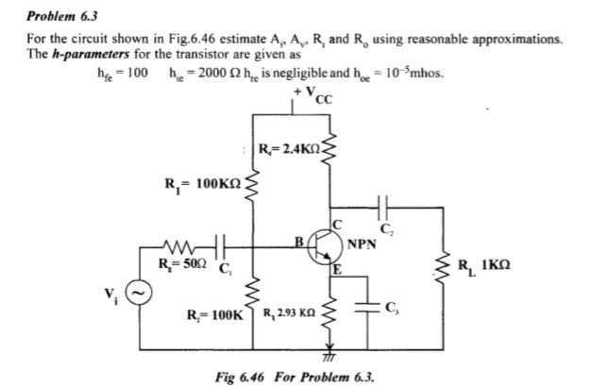

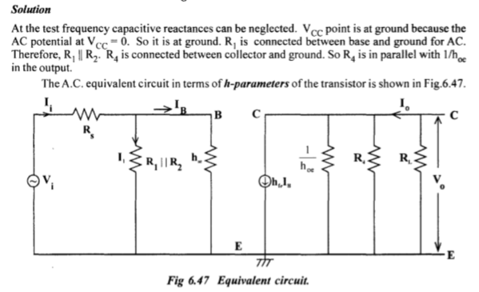

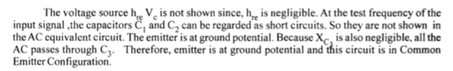

Example 6.4 – Codable

Example 6.5 – Codable

Example 6.6 – Non-Codable (Reason: Theoretical example with the purpose of proving a concept)

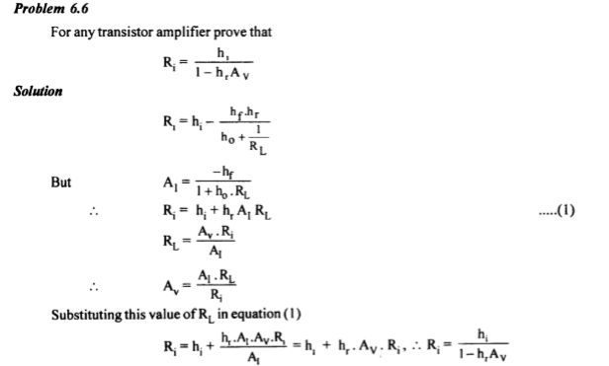

Example 6.7 – Codable

Example 6.8 – Codable

**Chapter 7: Feedback Amplifiers**

Example 7.1 – Codable

Example 7.2 – Codable

Example 7.3 – Codable

Example 7.4 – Codable

Example 7.5 – Codable

Example 7.6 – Codable

Example 7.7 – Non-Codable(Reason: Integration of variables has been performed resulting in a variable expression as the final solution)

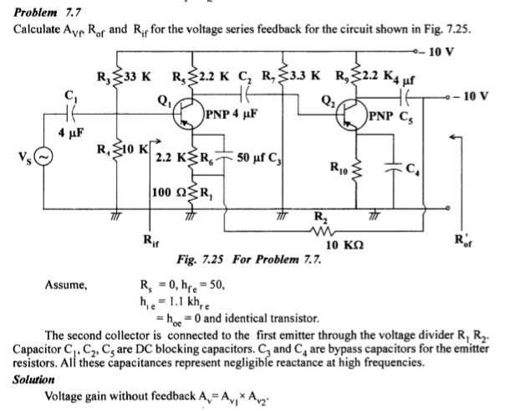

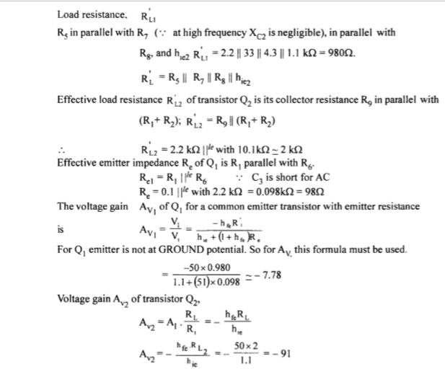

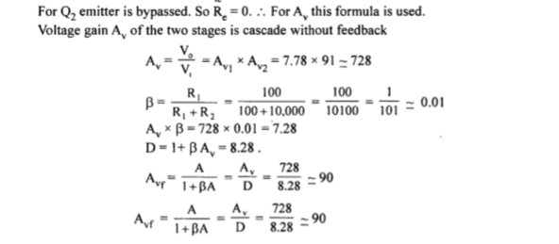

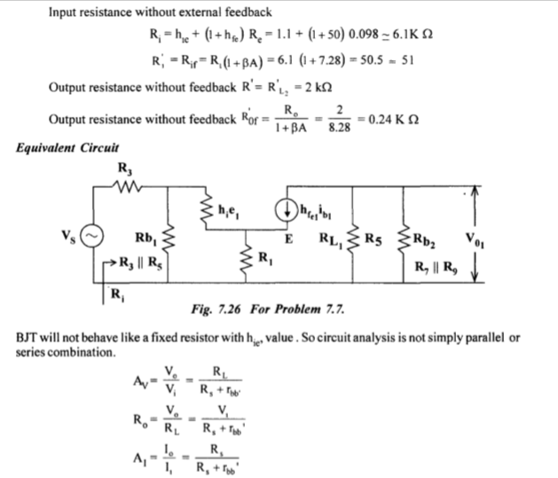

Example 7.8 – Codable

Example 7.9 – Codable