**Contributor name:** Sneha Ranjeet Sonaye

**Book Proposed:** Elementary Number Theory by David M. Burton

**Total Chapters:** 16

**Total Examples:** 73

**Codable Examples:** 64

**Chapter 1: Preliminaries**

Example 1.1 – Codable

**Chapter 2: Divisibilty Theory in the integers**

Example 2.1 – Non-Codable (Reason: Theoretical example with the purpose of proving a concept)

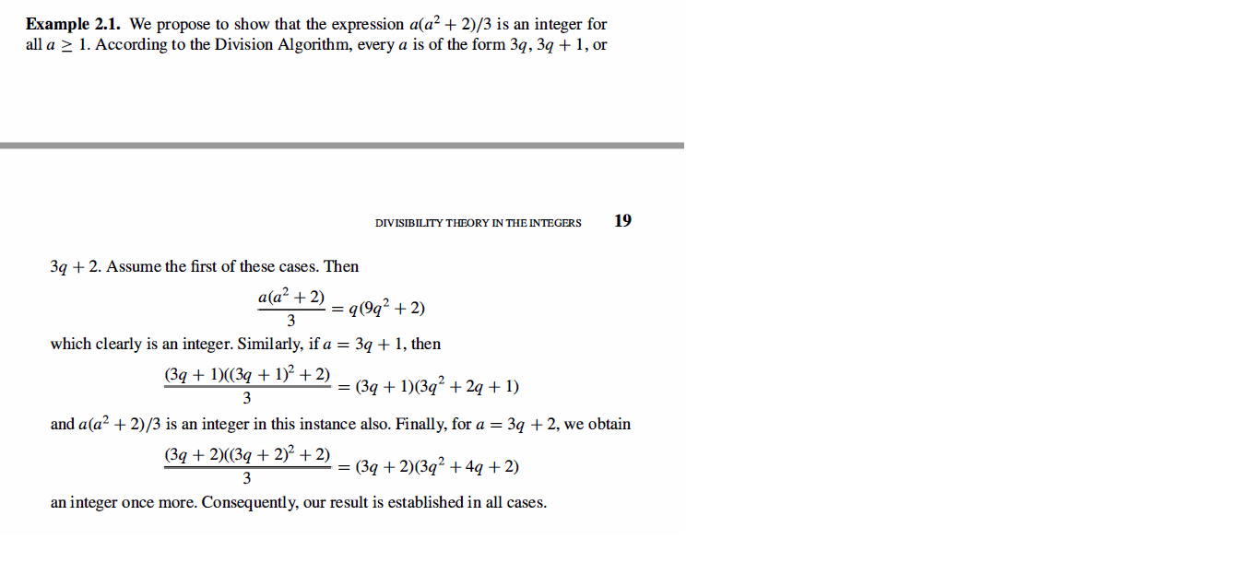

Example 2.2 – Codable

Example 2.3 – Codable

Example 2.4 – Codable

Example 2.5 – Non- Codable (Reason: Integration of variables has been performed resulting in a variable expression as the final solution)

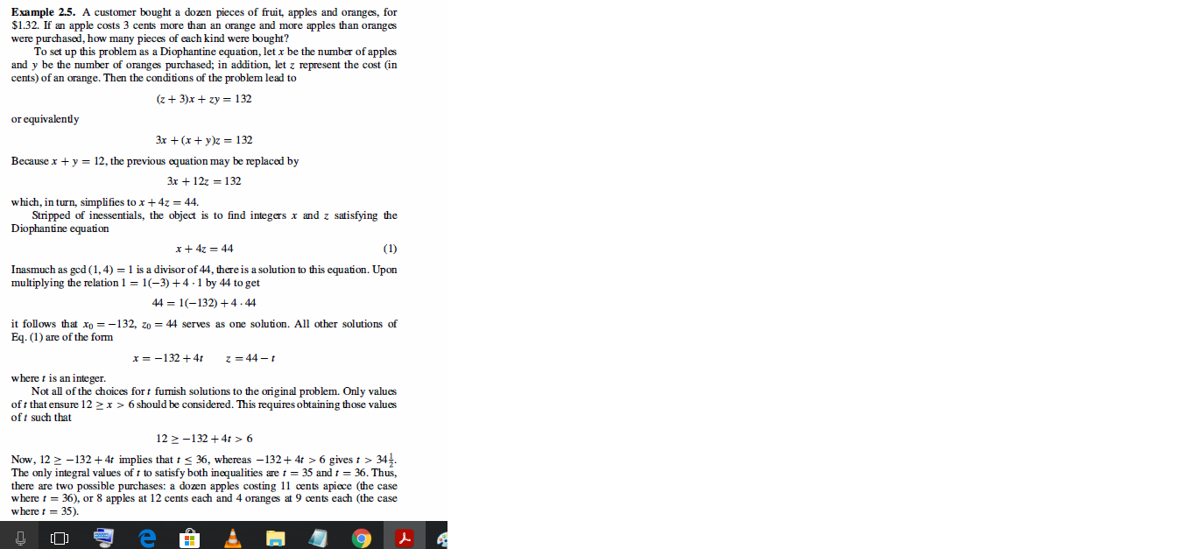

**Chapter 3: Primes and their distribution**

Example 3.1 – Codable

**Chapter 4: The theory of congruences**

Example 4.1 – Codable

Example 4.2 – Codable

Example 4.3 – Codable

Example 4.4 – Codable

Example 4.5 – Codable

Example 4.6 – Codable

Example 4.7 – Codable

Example 4.8 – Codable

Example 4.9 – Codable

Example 4.10 – Non-Codable (Reason: Integration of variables has been performed resulting in a variable expression as the final solution)

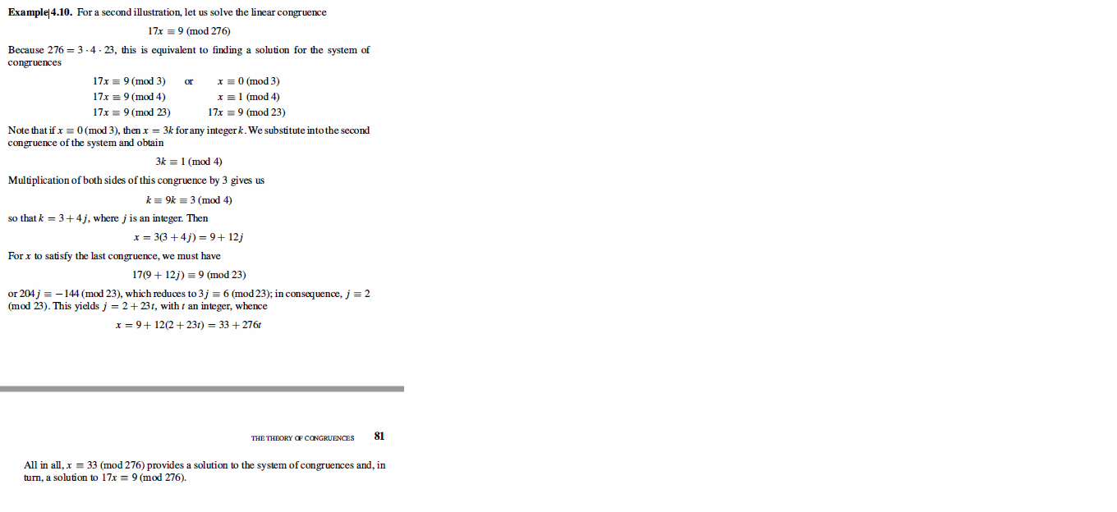

Example 4.11 – Non-Codable (Reason: Integration of variables has been performed resulting in a variable expression as the final solution)

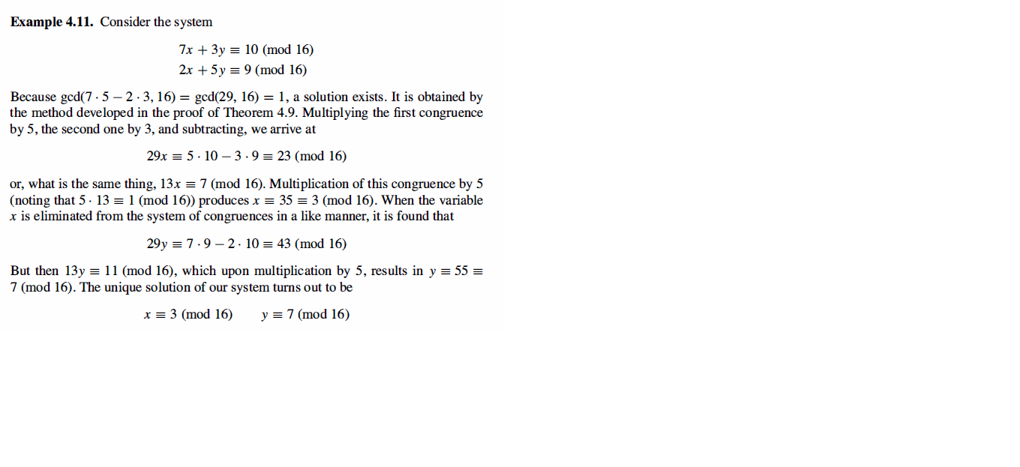

**Chapter 5: Fermat’s theorem**

Example 5.1 – Codable

Example 5.2 – Codable

Example 5.3 – Codable

Example 5.4 – Codable

**Chapter 6: Number-theoretic functions**

Example 6.1 – Codable

Example 6.2 – Codable

Example 6.3 – Codable

Example 6.4 – Codable

Example 6.5 – Codable

**Chapter 7: Euler’s generalization of fermat’s theorem**

Example 7.1 – Codable

Example 7.2 – Codable

Example 7.3 – Codable

Example 7.4 – Codable

**Chapter 8: Primitive roots and indices**

Example 8.1 – Codable

Example 8.2 – Non-Codable (Reason: Theoretical example with the purpose of proving a concept)

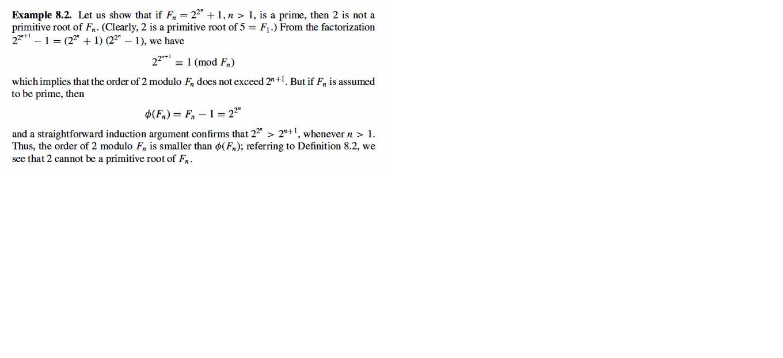

Example 8.3 – Codable

Example 8.4 – Codable

Example 8.5 – Codable

**Chapter 9: The quadratic reciprocity law**

Example 9.1 – Codable

Example 9.2 – Codable

Example 9.3 – Codable

Example 9.4 – Codable

Example 9.5 – Codable

Example 9.6 – Codable

Example 9.7 – Non-Codable (Reason: Theoretical example with the purpose of proving a concept)

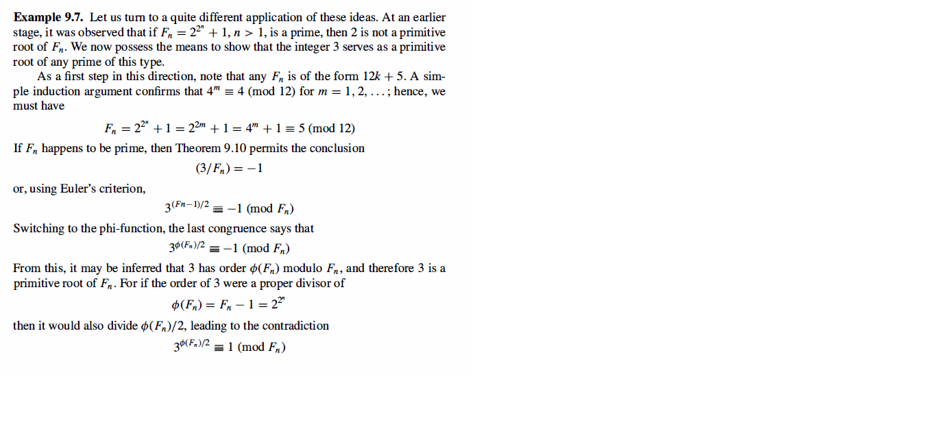

**Chapter 10: Introduction to cryptography**

Example 10.1 – Codable

Example 10.2 – Codable

Example 10.3 – Codable

Example 10.4 – Codable

Example 10.5 – Codable

Example 10.6 – Codable

Example 10.7 – Codable

Example 10.8 – Codable

Example 10.9 – Codable

Example 10.10 – Codable

**Chapter 11: Numbers of special form**

No Examples

**Chapter 12: Certain nonlinear diophantine equations**

No Examples

**Chapter 13: Representation of integers as sums of squares**

Example 13.1 – Codable

Example 13.2 – Codable

Example 13.3 – Codable

**Chapter 14: Fibonacci numbers**

No Examples

**Chapter 15: Continued fractions**

Example 15.1 – Non-Codable (Reason: Theoretical example with the purpose of proving a concept)

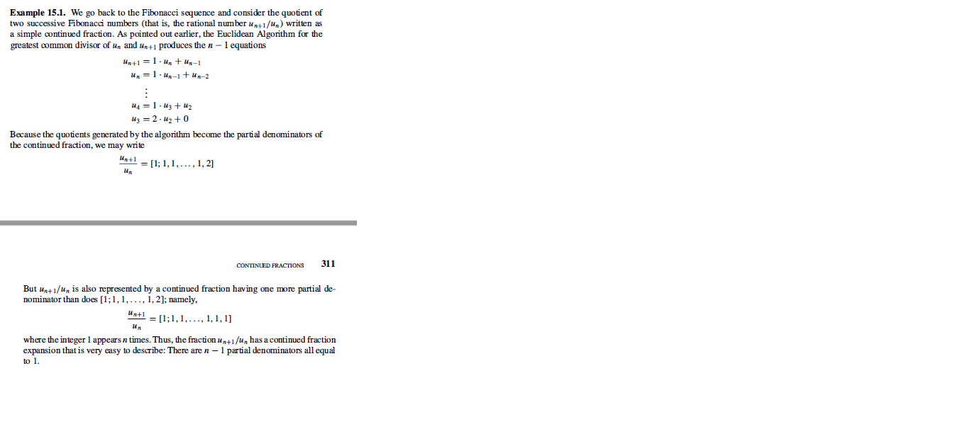

Example 15.2 – Non-Codable (Reason: Theoretical example with the purpose of proving a concept)

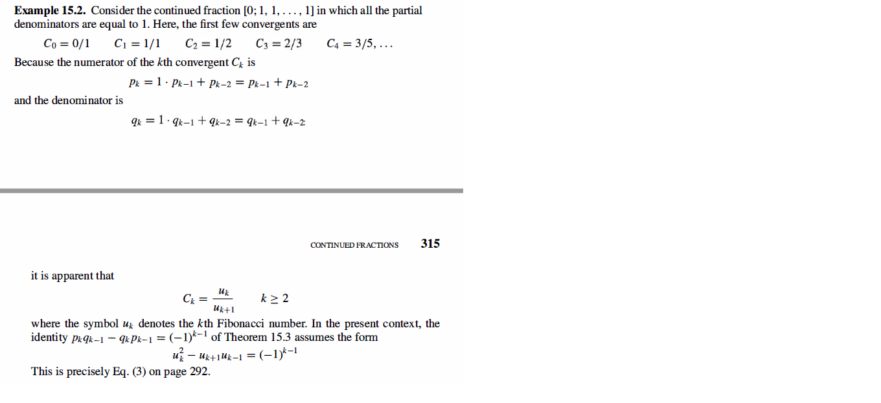

Example 15.3 – Codable

Example 15.4 – Non-Codable (Reason: Integration of variables has been performed resulting in a variable expression as the final solution)

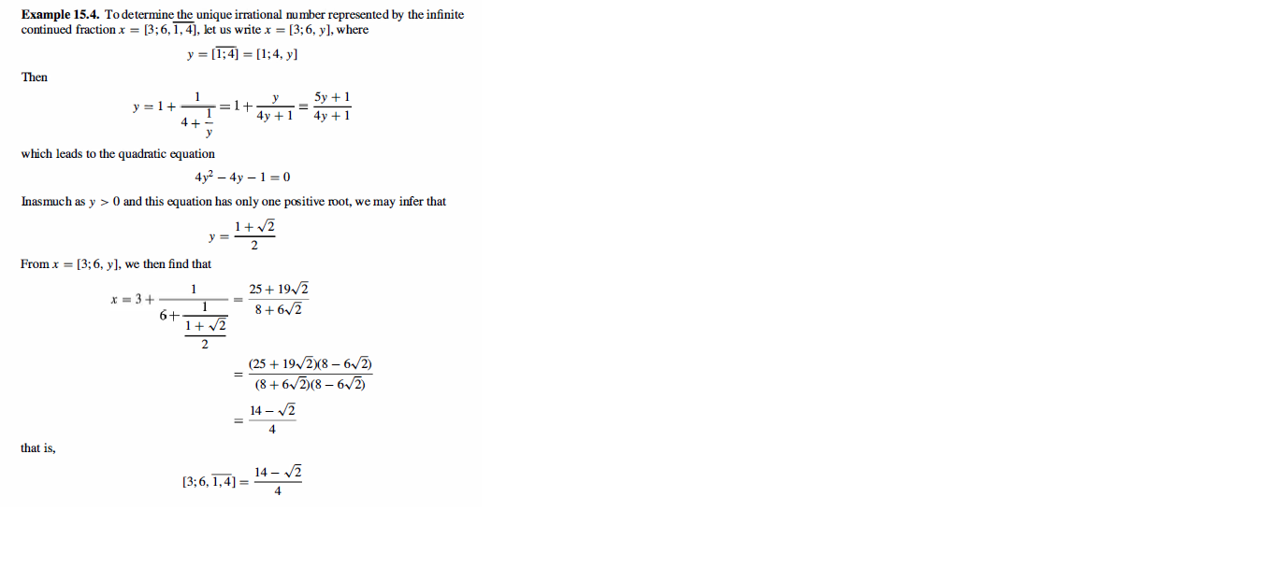

Example 15.5 – Codable

Example 15.6 – Codable

Example 15.7 – Codable

Example 15.8 – Codable

Example 15.9 – Codable

**Chapter 16: Some modern developments**

Example 16.1 – Codable

Example 16.2 – Codable

Example 16.3 – Codable

Example 16.4 – Codable

Example 16.5 – Codable

Example 16.6 – Codable

Example 16.7 – Codable

Example 16.8 – Codable