**Contributor name:** Ayush Kumar Nayak

**Book Proposed:** Introduction to time series and forecasting

**Total Chapters:** 11

**Total Examples:** 10

**Codable Examples:**

**Chapter 1: Introduction**

Example 1.1.1 – Codable

Example 1.1.2 – Non-Codable (Reason: Data not available)

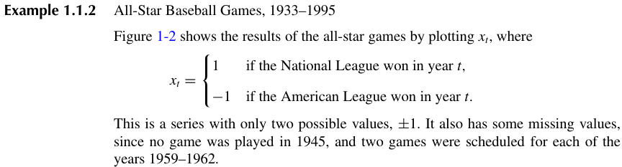

Example 1.1.3 – Codable

Example 1.1.4 – Codable

Example 1.1.5 – Codable

Example 1.1.6 – Codable

Example 1.3.1 – Non-Codable (Reason: A realization of iid Noise)

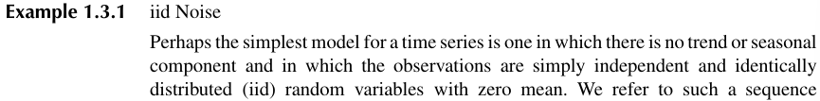

Example 1.3.2 – Non-Codable (Reason: A realization of binary process and data not available)

Example 1.3.3 – Codable

Example 1.3.4 – Codable

Example 1.3.5 – Codable

Example 1.3.6 – Codable

Example 1.4.1 – Non-Codable (Reason: Mathematical definition of iid noise)

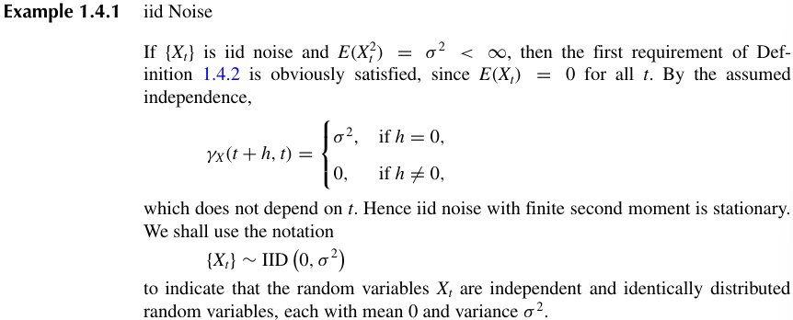

Example 1.4.2 – Non-Codable (Reason: Mathematical definition of white noise)

Example 1.4.3 – Non-Codable (Reason: Mathematical definition of random walk)

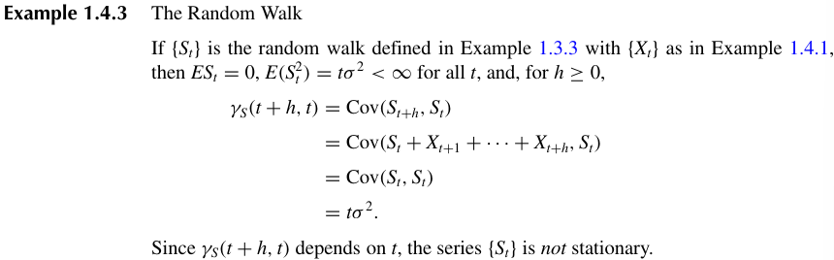

Example 1.4.4 – Non-Codable (Reason: Mathematical definition of MA(1) process)

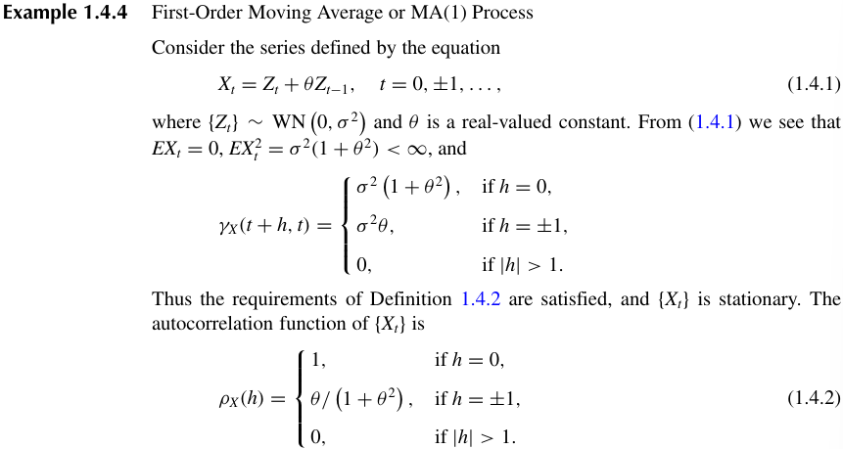

Example 1.4.5 – Non-Codable (Reason: Mathematical definition of AR(1) process)

Example 1.4.6 – Codable

Example 1.3.3 – Codable

Example 1.5.1 – Codable

Example 1.5.2 – Codable

Example 1.5.3 – Codable

Example 1.5.4 – Codable

Example 1.5.5 – Codable

Example 1.6.1 – Codable

**Chapter 2: Stationary processes**

Example 2.1.1 – Non-Codable (Reason: Mathematical proof for stationary process)

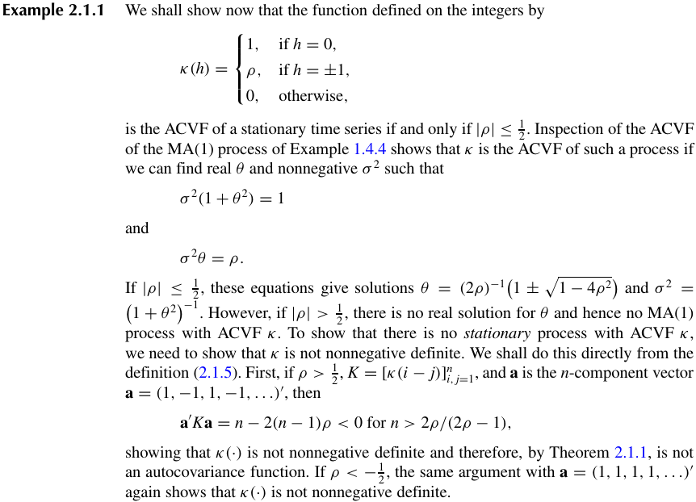

Example 2.2.1 – Non-Codable (Reason: Mathematical definition and proofs for AR(1) process.

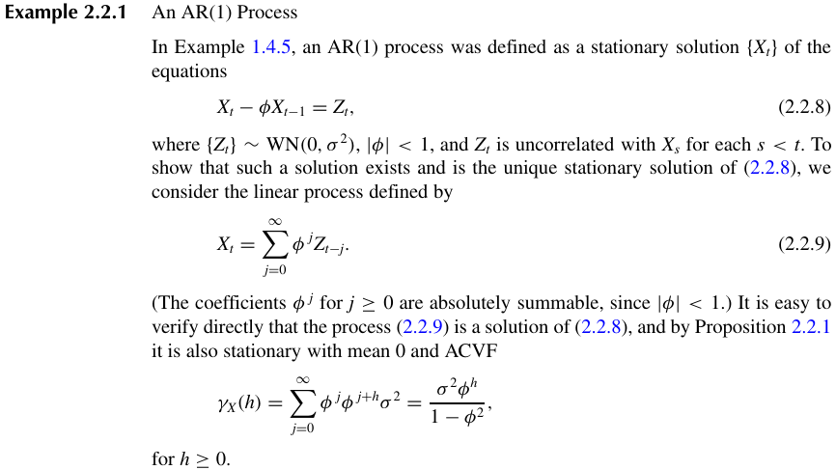

Example 2.4.1 – Non-Codable (Reason: AR(1) model parameters mathematical explanation)

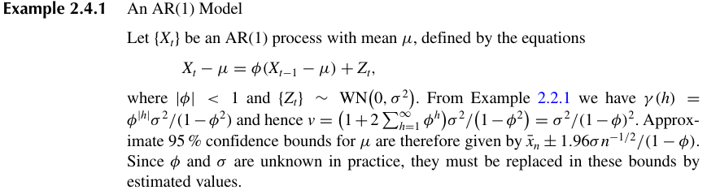

Example 2.4.2 – Non-Codable (Reason: Mathematical explanation of iid Noise

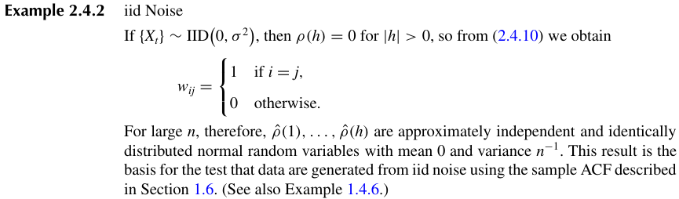

Example 2.4.1 – Codable

Example 2.4.2 – Codable

Example 2.4.3 – Codable

Example 2.4.4 – Codable

Example 2.5.1 – Non-Codable (Reason: Mathematical explanation for one step predictions)

Example 2.5.2 – Non-Codable (Reason: Mathematical procedure for missing value estimation)

Example 2.5.3 – Non-Codable (Reason: Mathematical explanation for one step prediction in AR(p))

Example 2.5.4 – Non-Codable (Reason: Explanation for AR(1) series with non-zero mean)

Example 2.5.5 – Codable

Example 2.5.6 – Non-Codable (Reason: Mathematical definition of causal invertible ARMA(1,1))

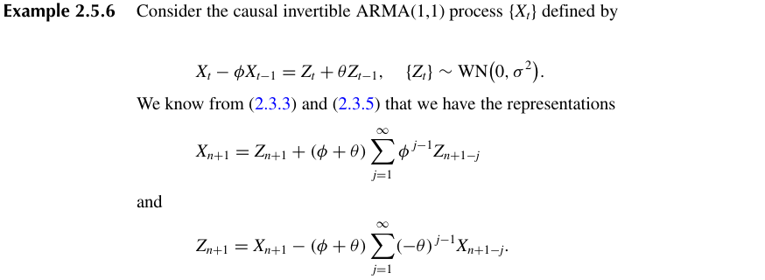

Example 2.6.1 – Non-Codable (Reason: Mathematical example of Wold decomposition)

**Chapter 3: ARMA Models**

Example 3.1.1 – Codable

Example 3.1.2 – Codable

Example 3.1.3 – Codable

Example 3.2.1 – Non-Codable (Reason: Mathematical process for finding autocovariances)

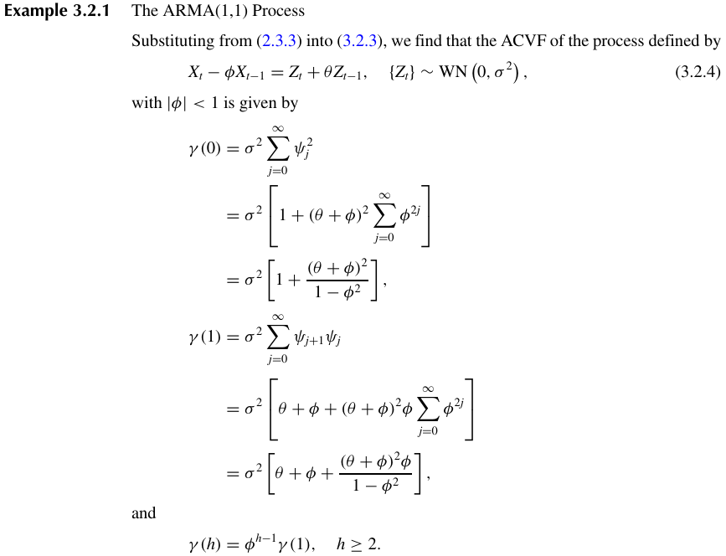

Example 3.2.2 – Non-Codable (Reason: Mathematical process for finding autocovariances in MA(q))

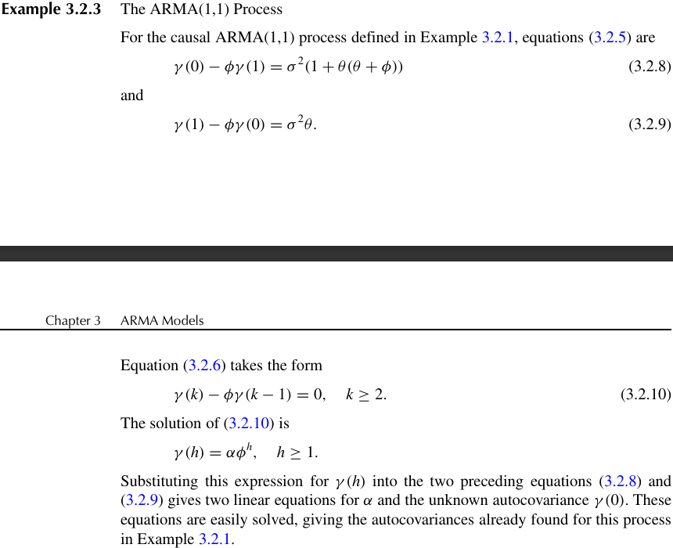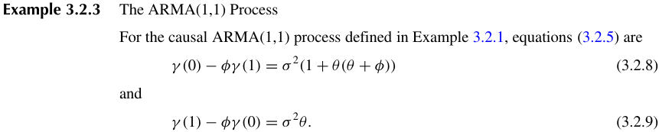Example 3.2.3 – Non-Codable (Reason: Mathematical process for finding autocovariance in ARMA)

Example 3.2.4 – Codable

Example 3.2.5 – Codable

Example 3.2.6 – Non-Codable (Reason: Explanation for PACF of an AR(p) process)

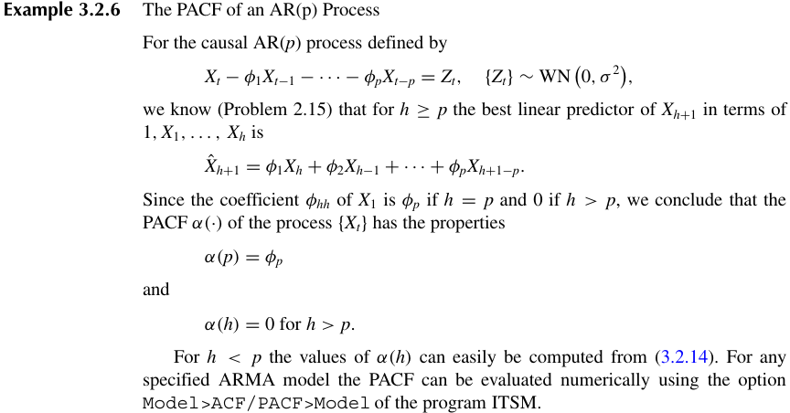

Example 3.2.7 – Non-Codable (Reason: Explanation for PACF of an MA(1) process)

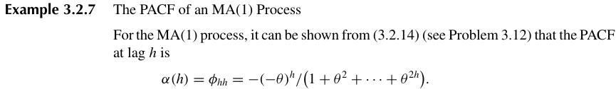

Example 3.2.8 – Codable

Example 3.2.9 – Codable

Example 3.3.1 – Non-Codable (Reason: Procedure for prediction of AR(p) process)

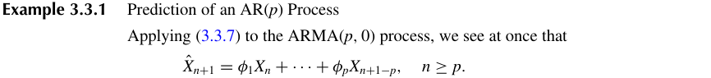

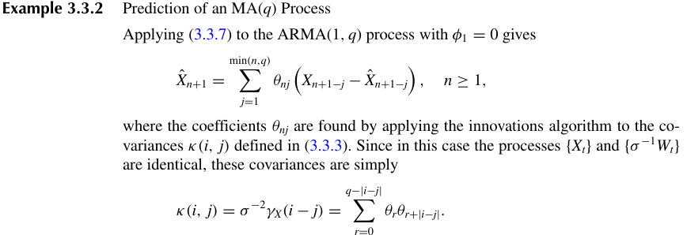Example 3.3.2 – Non-Codable (Reason: Procedure for prediction of MA(q) process)

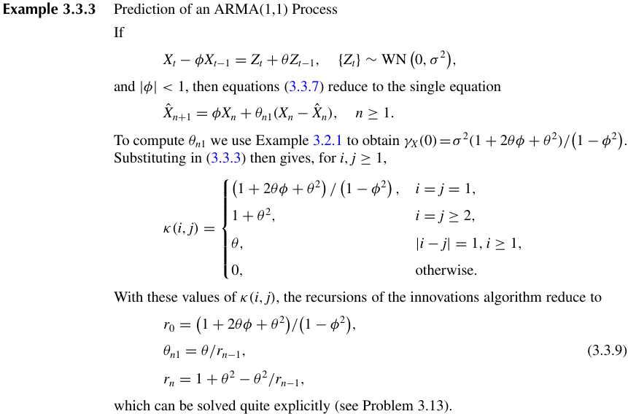Example 3.3.3 – Non-Codable (Reason: Procedure for prediction of ARMA(1,1) process)

Example 3.3.4 – Codable

Example 3.3.5 – Codable

**Chapter 4: Spectral Analysis**

Example 4.1.1 – Non-Codable (Reason: Mathematical explanation of spectral density)

Example 4.1.2 – Codable

Example 4.1.3 – Non-Codable (Reason: Explanation of spectral density for white noise)

Example 4.1.4 – Codable

Example 4.1.5 – Codable

Example 4.2.1 – Codable

Example 4.2.2 – Codable

Example 4.3.1 – Non-Codable (Reason: Definition of filter)

Example 4.3.2 – Non-Codable (Reason: Definition of simple moving average filter)

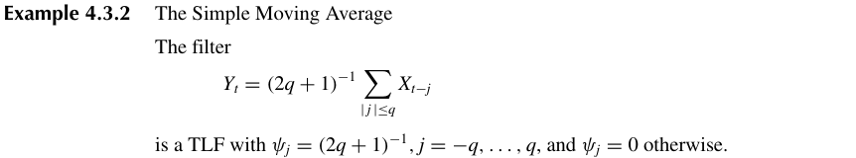

Example 4.4.1 – Codable

Example 4.4.2 – Non-Codable (Reason: Expression of spectral density for ARMA(1,1))

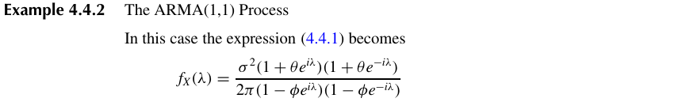

**Chapter 5: Modeling and Forecasting with ARMA Processes**

Example 5.1.1 – Codable

Example 5.1.2 – Codable

Example 5.1.3 – Codable

Example 5.1.4 – Codable

Example 5.1.5 – Codable

Example 5.1.6 – Codable

Example 5.1.7 – Codable

Example 5.2.1 – Non-Codable (Reason: Covariance matrix for Yule walker model)

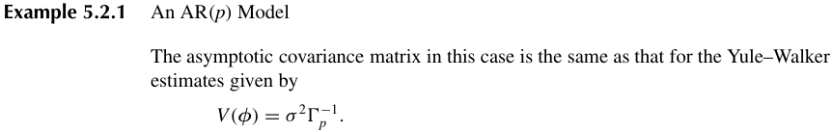

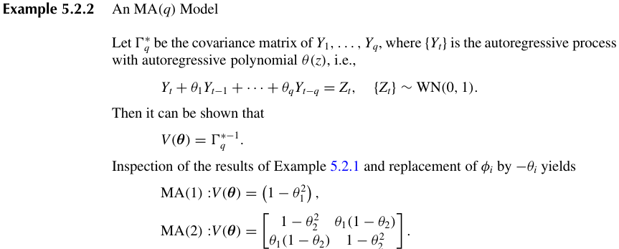Example 5.2.2 – Non-Codable (Reason: Covariance matrix for MA(q) model)

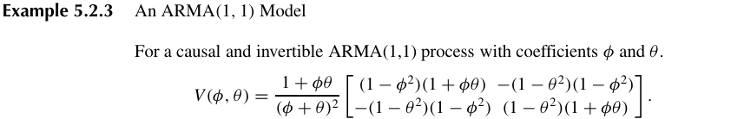Example 5.2.3 – Non-Codable (Reason: Covariance matrix for ARMA(1,1) model)

Example 5.2.4 – Codable

Example 5.2.5 – Codable

Example 5.4.1 – Codable

Example 5.5.1 – Codable

Example 5.5.2 – Codable

**Chapter 6: Nonstationary and Seasonal Time Series Models**

Example 6.1.1 – Codable

Example 6.2.1 – Codable

Example 6.2.2 – Codable

Example 6.3.1 – Codable

Example 6.3.2 – Codable

Example 6.4.1 – Codable

Example 6.5.1 – Non-Codable (Reason: Mathematical explanation of seasonal ARMA)

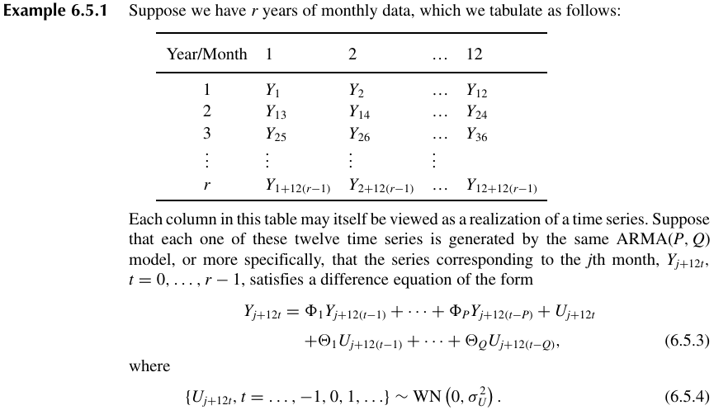

Example 6.5.2 – Codable

Example 6.5.3 – Codable

Example 6.5.4 – Codable

Example 6.5.5 – Codable

Example 6.6.1 – Codable*

Example 6.6.2 – Codable*

Example 6.6.3 – Codable*

**Chapter 7: Time Series Models for Financial Data**

Example 7.2.1 – Codable

Example 7.2.2 – Codable

Example 7.2.3 – Codable

Example 7.3.1 – Non-Codable (Reason: Mathematical definition of EGARCH(1,1) model)

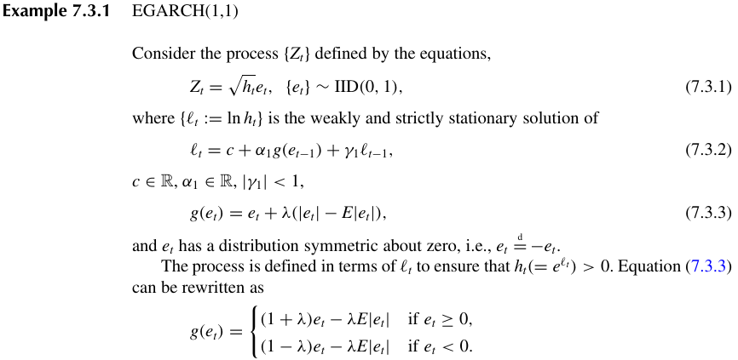

Example 7.5.1 – Codable

Example 7.5.2 – Codable

Example 7.5.3 – Codable

Example 7.5.4 – Non-Codable (Reason: Explanation of the Ornstein-Uhlenbeck SV Model)

**Chapter 8: Multivariate Time series**

Example 8.1.1 – Codable

Example 8.1.2 – Codable

Example 8.2.1 – Codable

Example 8.3.1 – Codable

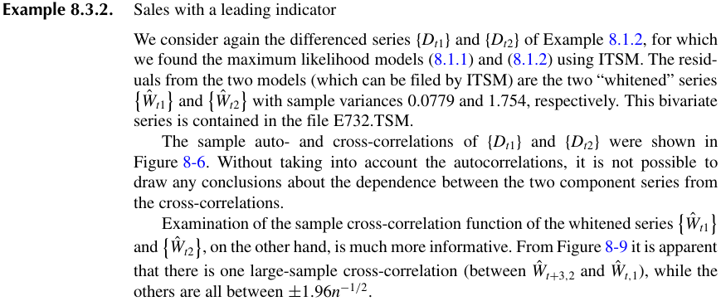Example 8.3.2 – Non-Codable (Reason: A conclusion of the observations in Example 8.1.2)

Example 8.4.1 – Non-Codable (Reason: Mathematical explanation of multivariate AR(1))

Example 8.4.2 – Non-Codable (Reason: Mathematical procedure for recursions of AR(1))

Example 8.6.1 – Codable

Example 8.6.2 – Codable

Example 8.6.3 – Codable

Example 8.6.4 – Codable

Example 8.7.1 – Non-Codable

Example 8.7.2 – Non-Codable

**Chapter 9: State-Space Models**

Example 9.1.1 – Non-Codable (Reason: Mathematical definition of causal AR(1))

Example 9.1.2 – Non-Codable (Reason: Mathematical definition of causal ARMA(1,1))

Example 9.2.1 – Codable

Example 9.2.2 – Non-Codable (Reason: Mathematical explanation of seasonal series with noise)

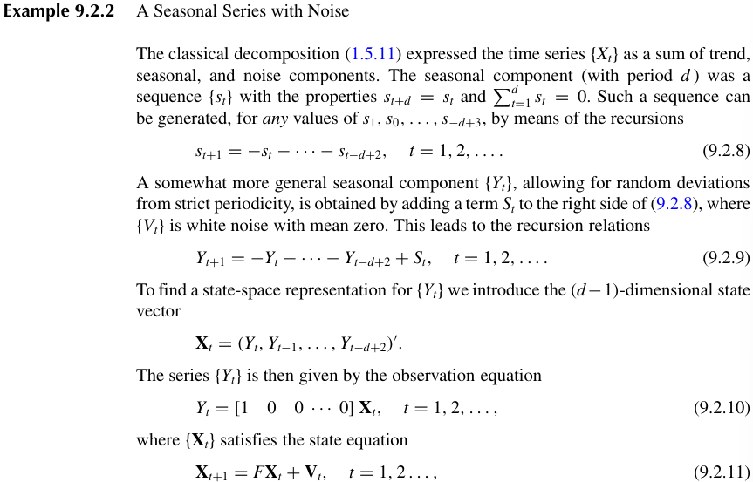

Example 9.2.3 – Non-Codable (Reason: Representation of randomly varying trend with seasonality, noise)

Example 9.3.1 – Non-Codable (Reason: State space representation of causal AR(p))

Example 9.3.2 – Non-Codable (Reason: Mathematical expression for state space form of causal ARMA(p,q) process

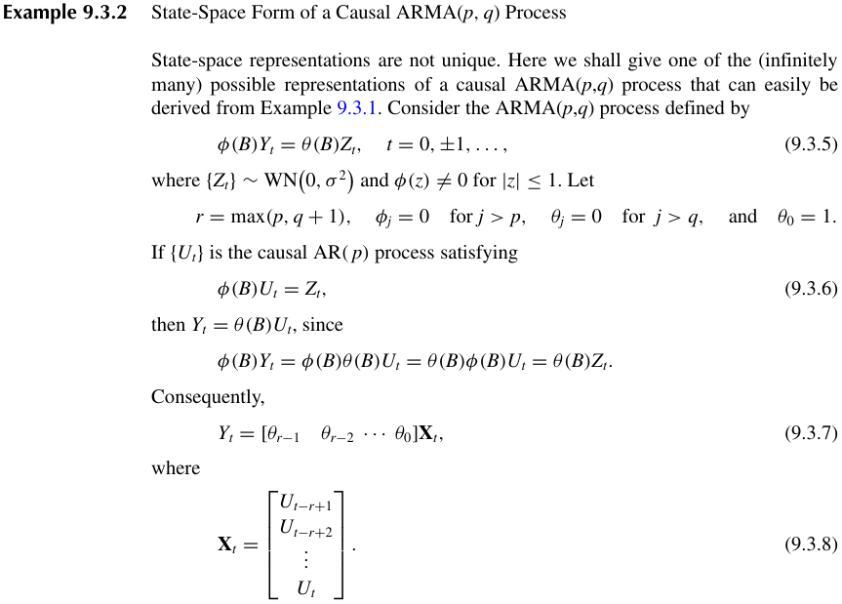

Example 9.3.3 – Non-Codable (Reason: State space representation of ARIMA(p,d,q) process)

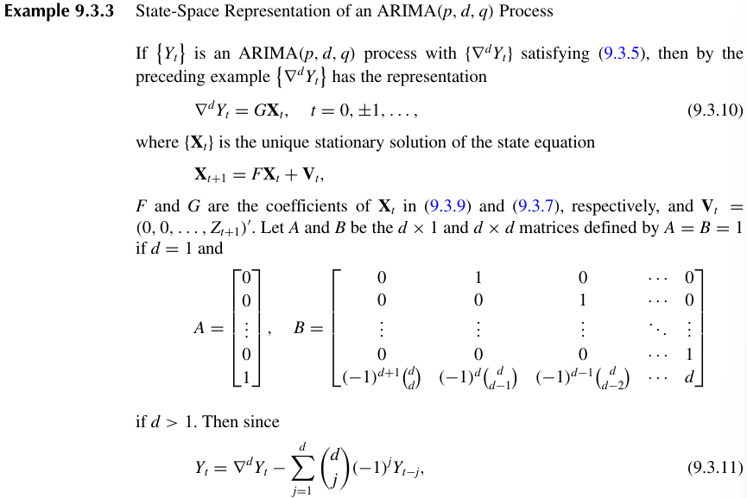

Example 9.4.1 – Non-Codable (Reason: State-space representation of a random walk)

Example 9.4.2 – Non-Codable (Reason: Mathematical explanation of lognormal stochastic volatility model)

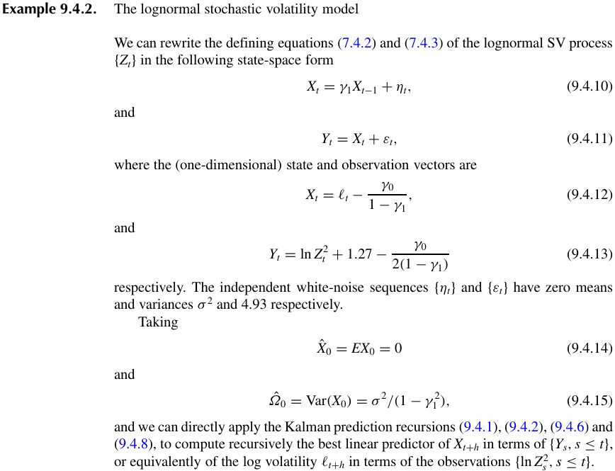

Example 9.5.1 – Codable

Example 9.5.2 – Codable

Example 9.6.1 – Non-Codable (Reason: Procedure for one missing observation in AR(1) Series)

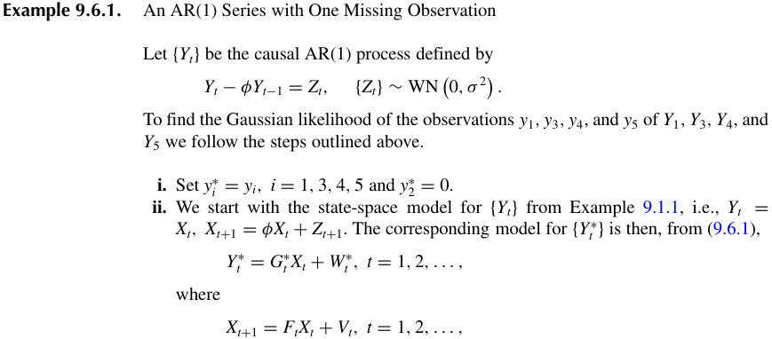

Example 9.6.2 – Non-Codable (Reason: Procedure for one missing observation in AR(1) Series)

Example 9.6.3 – Non-Codable (Reason: Procedure to estimate missing observations in AR)

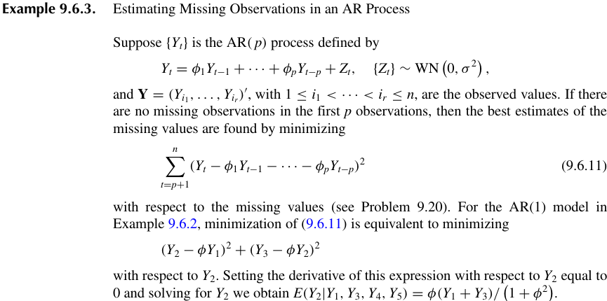

Example 9.7.1 – Codable

Example 9.8.1 – Non-Codable (Reason: Mathematical expression for linear state-space model)

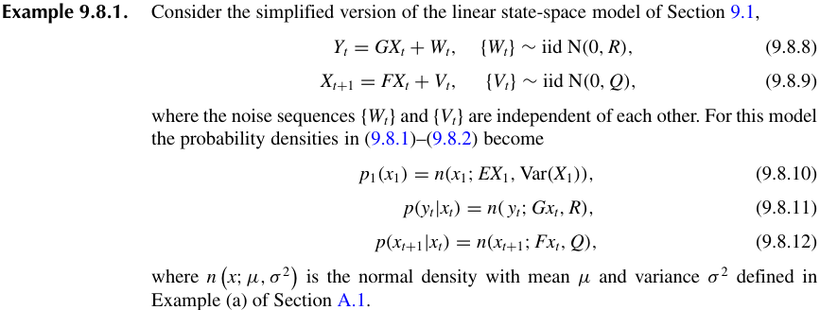

Example 9.8.2 – Non-Codable (Reason: Non gaussian example procedure)

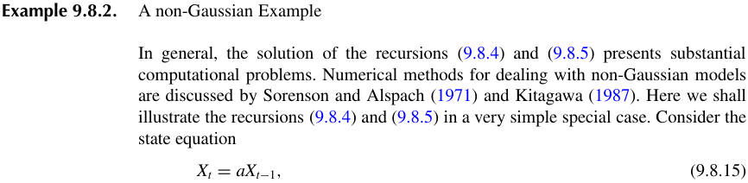

Example 9.8.3 – Codable

Example 9.8.4 – Non-Codable (Reason: AR(1) process representation in state-space model)

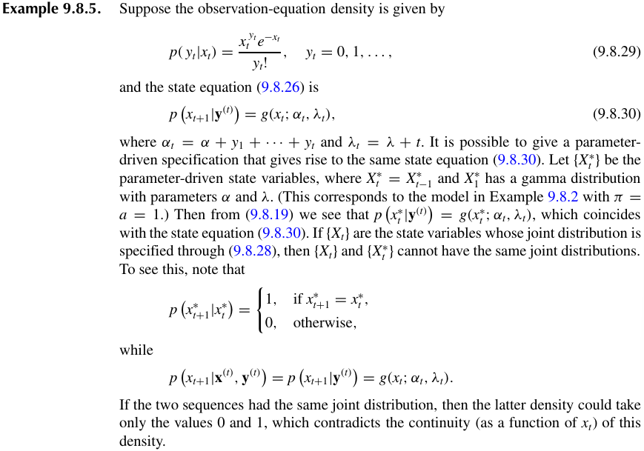Example 9.8.5 – Non-Codable (Reason: Observation density equation explanation)

Example 9.8.6 – Non-Codable (Reason: Poisson observation density equations explanation)

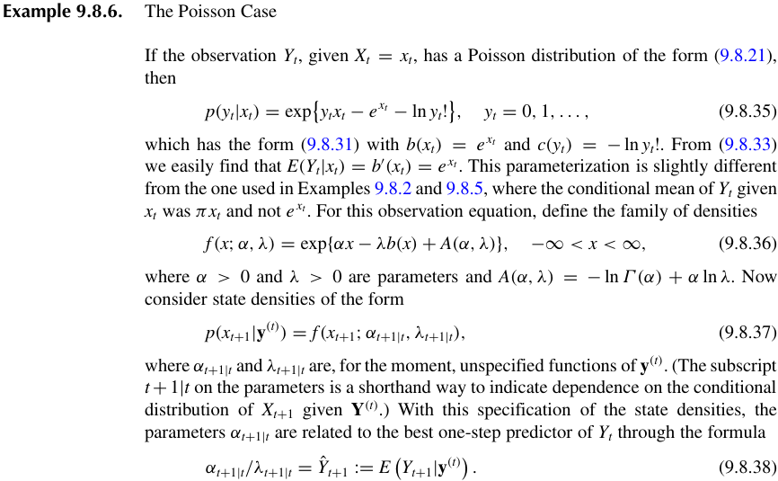

Example 9.8.7 – Codable

Example 9.8.8 – Codable

**Chapter 10: Forecasting Techniques**

Example 10.1.1 – Codable

Example 10.2.1 – Codable

Example 10.3.1 – Codable

**Chapter 11: Further Topics**

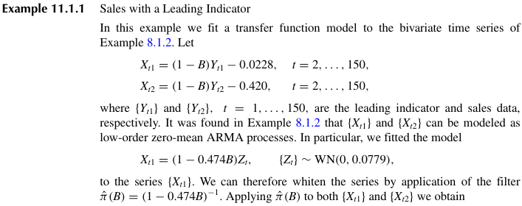Example 11.1.1 – Non Codable (Reason: specific whitening filter used, expression not provided)

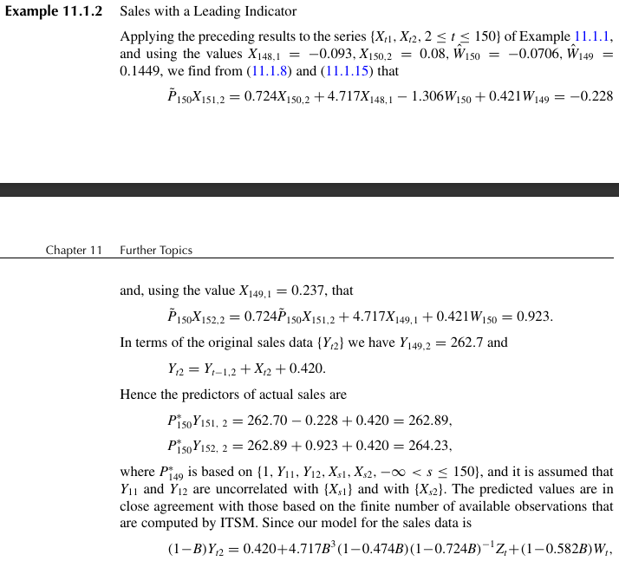Example 11.1.2 – Non Codable (Reason: Continuation from 11.1.1)

Example 11.2.1 – Non Codable (Reason: Example 6.6.3 redone)

Example 11.4.1 – Codable

Example 11.5.1 – Non-Codable (Reason: Stochastic volatility equation representation)

