**Contributor name:** Nitesh Sharma

**Book Proposed:** Modern Physics By G. Aruldhas and P. Rajagopal

**Total Chapters:** 21

**Total Examples:** 120

**Codable Examples:** 98

**Note :** From Chapter 3 I Can’t Provide The Snapshot Because of the absence of Book I search all over the internet and its not found and hard copy of book is available at collage due to covid-19 I can’t go to the collage for the issue of book.

**Chapter 1: The Special Theory of Relativity**

Example 1.1– Non-Codable (Reason: Theoretical example with the purpose of proving a concept)

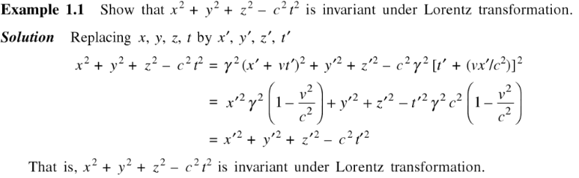

Example 1.2 – Codable

Example 1.3 – Codable

Example1.4– Codable

Example 1.5 – Codable

Example 1.6 – Codable

Example 1.7 – Codable

Example 1.8 – Codable

Example 1.9 – Non-Codable (Reason: Theoretical example with the purpose of proving a concept)

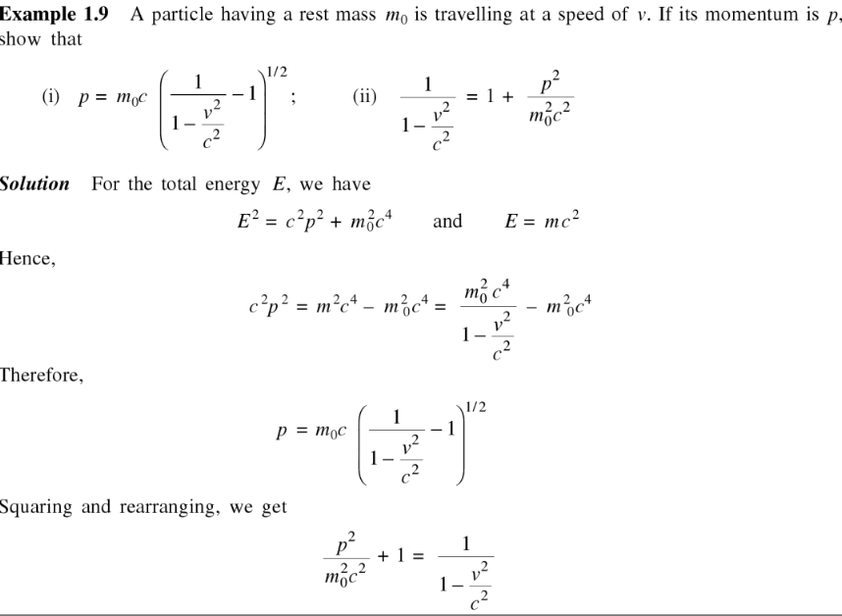

Example 1.10– Non-Codable (Reason: Theoretical example with the purpose of proving a concept)

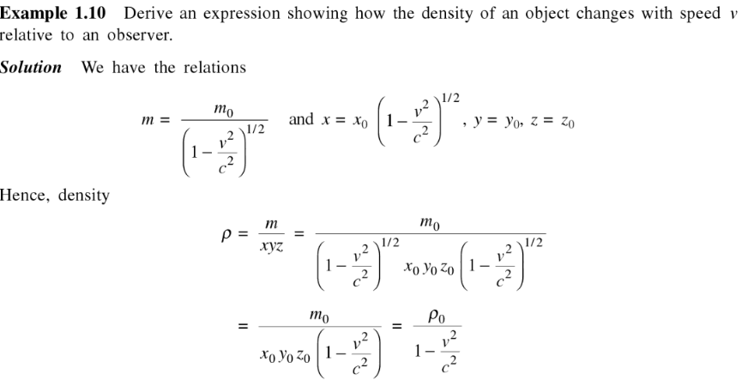

**Chapter 2: Particle Nature of Radiation**

Example 2.1 – Codable

Example 2.2 – Codable

Example 2.3 – Codable

Example 2.4 – Codable

Example 2.5 – Codable

Example 2.6 – Codable

**Chapter 3: Atomic Models**

Example 3.1 – Codable

Example 3.2 –Non- Codable (Reason: Theoretical example with the purpose of proving a concept)

Example 3.3 – Codable

Example 3.4 – Codable

Example 3.5 –Non- Codable (Reason: Theoretical example with the purpose of proving a concept)

Example 3.6 – Codable

**Chapter 4: Wave Mechanical Concepts**

Example 4.1 – Codable

Example 4.2 – Codable

Example 4.3 – Codable

Example 4.4 – Codable

**Chapter 6: Quantum Mechanics of Simple Systems**

Example 6.1 – Codable

Example 6.2 – Codable

Example 6.3 –Non- Codable (Reason: Theoretical example with the purpose of proving a concept)

Example 6.4 –Non- Codable (Reason: Theoretical example with the purpose of proving a concept)

Example 6.5 –Non- Codable (Reason: Theoretical example with the purpose of proving a concept)

Example 6.6 – Codable

Example 6.7 – Codable

**Chapter 7: Atomic Physics**

Example 7.1 – Codable

Example 7.2 –Non- Codable (Reason: Theoretical example with the purpose of proving a concept)

Example 7.3 – Codable

Example 7.4 –Non- Codable (Reason: Theoretical example with the purpose of proving a concept)

Example 7.5 –Non- Codable (Reason: Theoretical example with the purpose of proving a concept)

Example 7.6 – Codable

Example 7.7 –Non- Codable (Reason: Theoretical example with the purpose of proving a concept)

Example 7.8 –Non- Codable (Reason: Theoretical example with the purpose of proving a concept)

Example 7.9 –Non- Codable (Reason: Theoretical example with the purpose of proving a concept)

Example 7.10 – Codable

Example 7.11 –Non- Codable (Reason: Theoretical example with the purpose of proving a concept)

Example 7.12 – Codable

Example 7.13 – Codable

**Chapter 8: Statistical Physics**

Example 8.1– Non-Codable (Reason: Theoretical example with the purpose of proving a concept)

Example 8.2 – Codable

Example 8.3 – Codable

**Chapter 9: Molecular Spectra**

Example 9.1 – Codable

Example 9.2 – Codable

Example 9.3 – Codable

Example 9.4 – Codable

Example 9.5 – Codable

Example 9.6 – Codable

Example 9.7 – Codable

Example 9.8 – Codable

Example 9.9– Non-Codable (Reason: Theoretical example with the purpose of proving a concept)

Example 9.10 – Codable

**Chapter 10: Crystal Structure and Bonding**

Example 10.1 – Codable

Example 10.2 – Codable

Example 10.3– Non-Codable (Reason: Theoretical example with the purpose of proving a concept)

Example 10.4– Non-Codable (Reason: Theoretical example with the purpose of proving a concept)

Example 10.5 – Codable

Example 10.6 – Codable

Example 10.7 – Codable

Example 10.8 – Codable

Example 10.9 – Codable

Example 10.10 – Codable

Example 10.11 – Codable

Example 10.12 – Codable

Example 10.13 – Codable

**Chapter 11: Lattice Dynamics**

Example 11.1 – Codable

Example 11.2 – Codable

**Chapter 12: Band Theory of Solids**

Example 12.1 – Codable

Example 12.2 – Codable

Example 12.3 – Codable

Example 12.4 – Codable

Example 12.5 – Codable

Example 12.6 – Codable

**Chapter 13: Magnetic Properties of Solids**

Example 13.1 – Codable

Example 13.2 – Codable

Example 13.3 – Codable

Example 13.4 – Codable

Example 13.5 – Codable

**Chapter 14: Superconductivity**

Example 14.1 – Codable

Example 14.2 – Codable

**Chapter 15: Lasers**

Example 15.1 – Codable

Example 15.2 – Codable

Example 15.3 – Codable

Example 15.4 – Codable

**Chapter 16: Fibre Optics and Holography**

Example 16.1 – Codable

Example 16.2– Non-Codable (Reason: Theoretical example with the purpose of proving a concept)

Example 16.3 – Codable

**Chapter 17: Nuclear Properties**

Example 17.1 – Codable

Example 17.2 – Codable

Example 17.3 – Codable

Example 17.4 – Codable

Example 17.6 – Codable

Example 17.7 – Codable

**Chapter 18: Radioactive Decay**

Example 18.1 – Codable

Example 18.2 – Codable

Example 18.3 – Codable

Example 18.4– Non-Codable (Reason: Theoretical example with the purpose of proving a concept)

Example 18.5 – Codable

Example 18.6 – Codable

Example 18.7 – Codable

Example 18.8 – Codable

Example 18.9 – Codable

**Chapter 19: Nuclear Reactions**

Example 19.1 – Codable

Example 19.2 – Codable

Example 19.3 – Codable

Example 19.4 – Codable

Example 19.5 – Codable

Example 19.6 – Codable

**Chapter 20: Nuclear Radiation Detectors and Particle Accelerators**

Example 20.1 – Codable

Example 20.2 – Codable

**Chapter 21: Elementary Particles**

Example 21.1 – Codable

Example 21.2 – Codable