**Contributor name:** Saurabh Sanjay Agrawal

**Book Proposed:** Semiconductor Physics And Devices Basic Principles

**Total Chapters:** 11

**Total Examples:** 91

**Codable Examples:** 82

**Chapter 1: The Crystal Structure of Solids.**

Example 1.1 – Codable

Example 1.2 – Non-Codable (Reason: Theoretical example with no scope of computation)

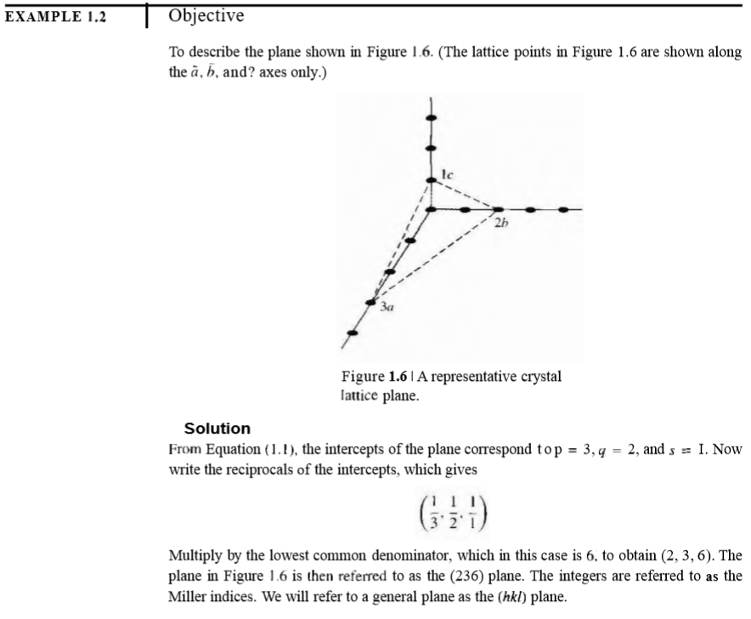

Example 1.3 – Codable

**Chapter 2: Introduction to Quantum Mechanics.**

Example 2.1 – Codable

Example 2.2 – Codable

Example 2.3 – Codable

Example 2.4 – Codable

Example 2.5 – Codable

**Chapter 3: Introduction to Quantum Theory of Solids.**

Example 3.1 – Codable

Example 3.2 – Codable

Example 3.3 – Codable

Example 3.4 – Codable

Example 3.5 – Codable

Example 3.6 – Codable

Example 3.7 – Codable

Example 3.8 – Non-Codable (Reason: Theoretical example with no scope of computation)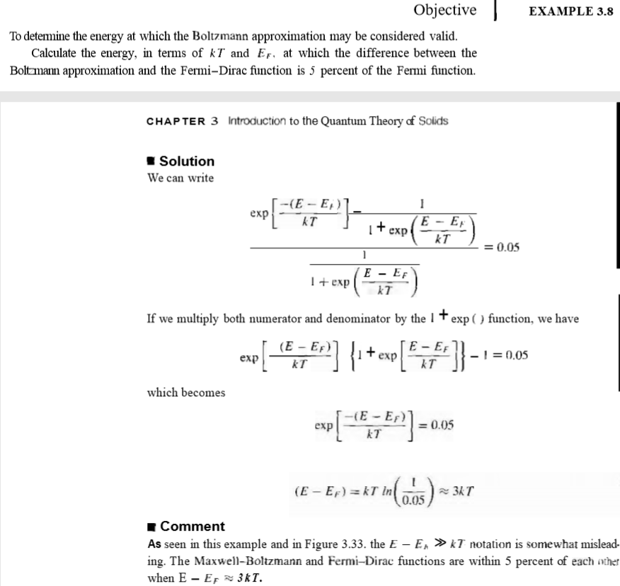

**Chapter 4: The semiconductor in equilibrium.**

Example 4.1 – Codable

Example 4.2 – Codable

Example 4.3 – Codable

Example 4.4 – Codable

Example 4.5 – Codable

Example 4.6 – Codable

Example 4.7 – Codable

Example 4.8 – Non-Codable (Reason : Not Codable uses trial and error method)

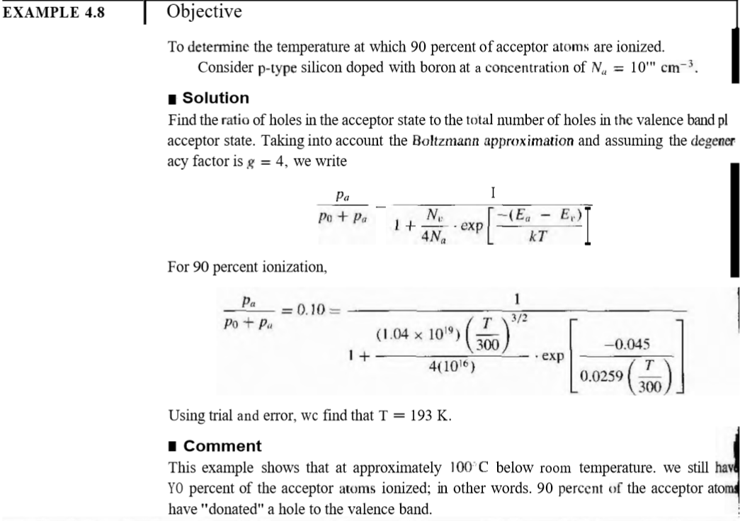

Example 4.9 – Codable

Example 4.10 – Codable

Example 4.11 – Codable

Example 4.12 – Codable

Example 4.13 – Codable

Example 4.14 – Codable

**Chapter 5: Carrier Transport Phenomena.**

Example 5.1 – Codable

Example 5.2 – Codable

Example 5.3 – Codable

Example 5.4 – Codable

Example 5.5 – Codable

Example 5.6 – Codable

Example 5.7 – Codable

**Chapter 6: Nonequilibrium Excess Carriers in Semiconductors.**

Example 6.1 – Non-Codable (Reason: Theoretical example with no scope of computation)

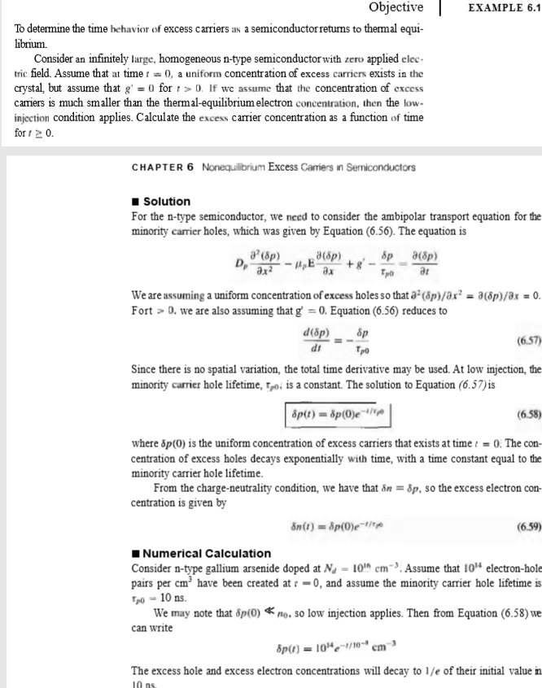

Example 6.2 – Codable

Example 6.3 – Codable

Example 6.4 – Non-Codable (Reason: Theoretical example with no scope of computation)

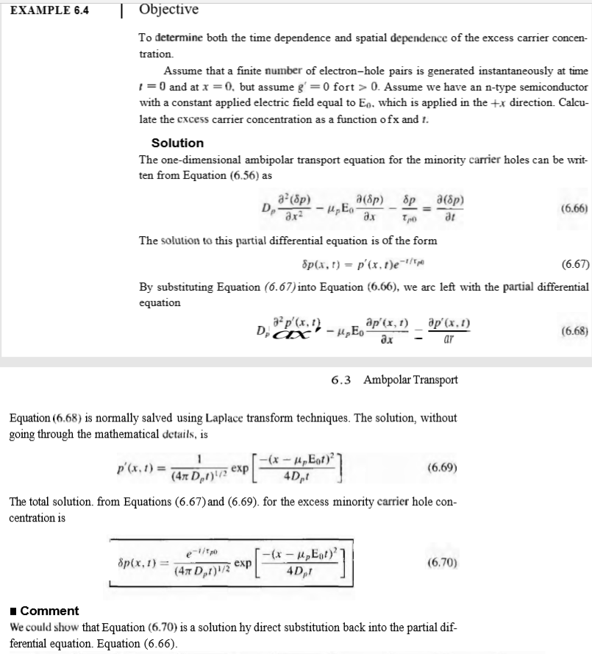

Example 6.5 – Codable

Example 6.6 – Codable

Example 6.7 – Non-Codable (Reason: Theoretical example with no scope of computation)

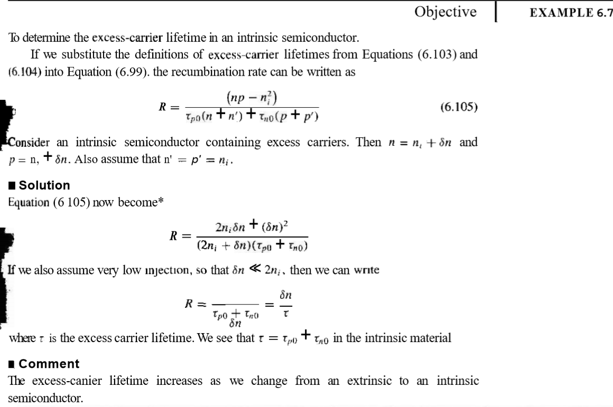

Example 6.8 – Codable

Example 6.9 – Non-Codable (Reason: Theoretical example with no scope of computation)

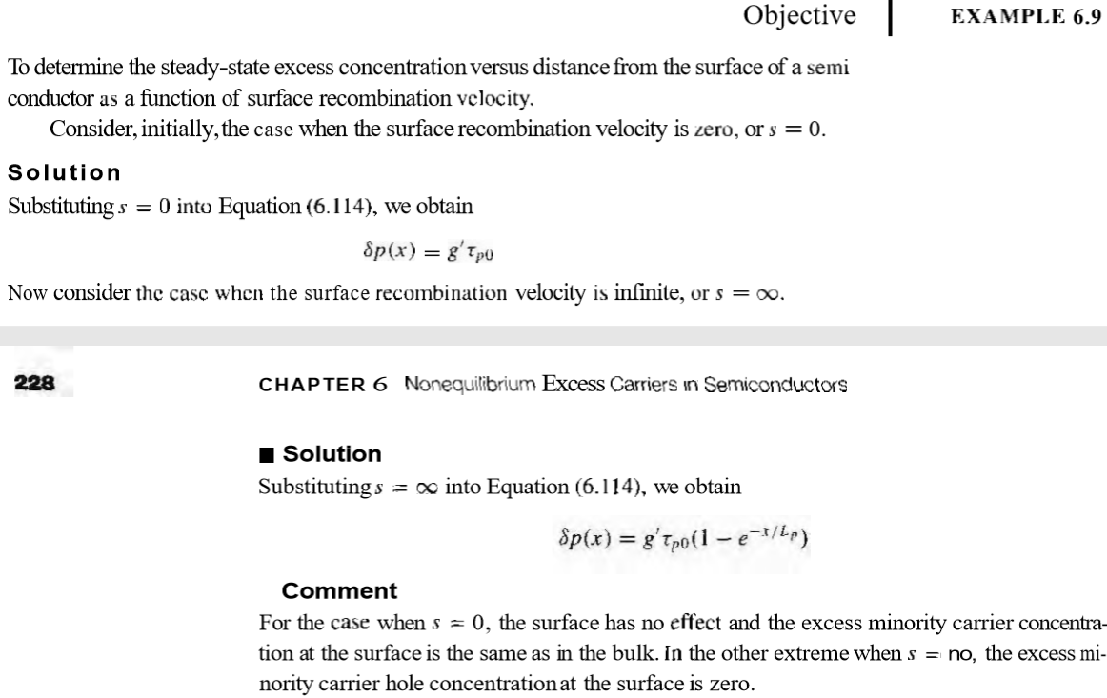

Example 6.10 – Codable

**Chapter 7: The pn Junction.**

Example 7.1 – Codable

Example 7.2 – Codable

Example 7.3 – Codable

Example 7.4 – Codable

Example 7.5 – Codable

Example 7.6 – Codable

**Chapter 8: The pn Junction Diode.**

Example 8.1 – Codable

Example 8.2 – Codable

Example 8.3 – Codable

Example 8.4 – Codable

Example 8.5 – Codable

Example 8.6 – Codable

Example 8.7 – Codable

Example 8.8 – Non-Codable (Reason: Theoretical example with no scope of computation)

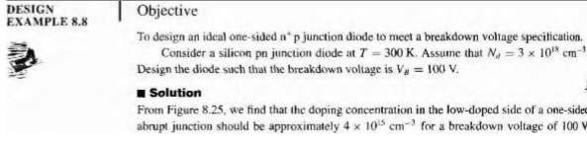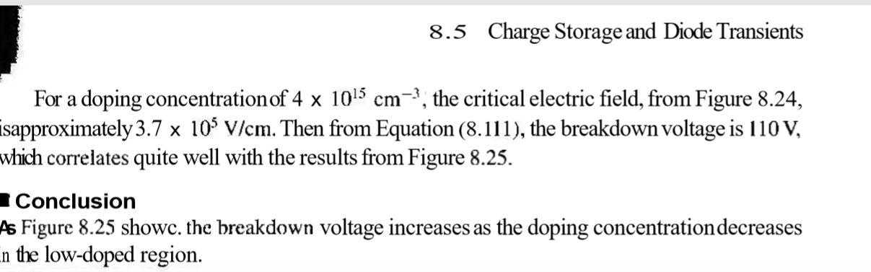

**Chapter 9: Metal Semiconductor and Semiconductor Heterojunctions.**

Example 9.1 – Codable

Example 9.2 – Codable

Example 9.3 – Codable

Example 9.4 – Codable

Example 9.5 – Codable

Example 9.6 – Codable

Example 9.7 – Codable

Example 9.8 – Codable

**Chapter 10: The Biopolar Transistors.**

Example 10.1 – Codable

Example 10.2 – Codable

Example 10.3 – Codable

Example 10.4 – Codable

Example 10.5 – Codable

Example 10.6 – Non-Codable (Reason: Theoretical example with no scope of computation)

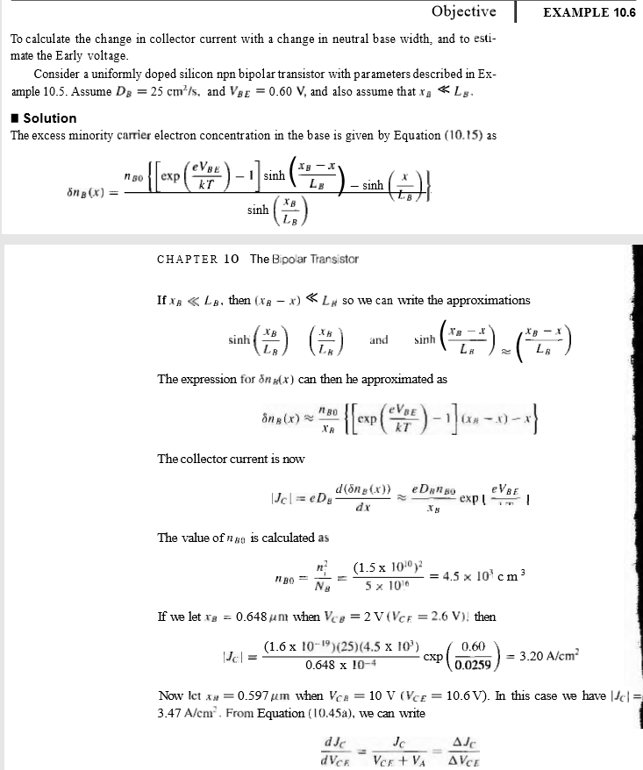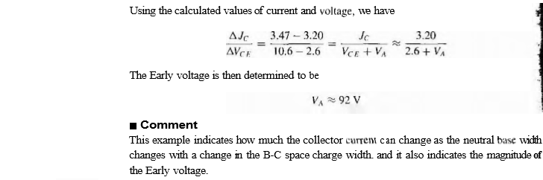

Example 10.7 – Codable

Example 10.8 – Codable

Example 10.9 – Codable

Example 10.10 – Codable

Example 10.11 – Codable

**Chapter 11: Fundamentals of the Metal Oxide Semiconductor Field Effect Transistor.**

Example 11.1 – Codable

Example 11.2 – Codable

Example 11.3 – Codable

Example 11.4 – Codable

Example 11.5 – Codable

Example 11.6 – Codable

Example 11.7 – Codable

Example 11.8 – Codable

Example 11.9 – Codable

Example 11.10 – Codable

Example 11.11 – Codable