**Contributor name:** M. Sai Anand

**Book Proposed:** Statistics Concepts and Applications

**Total Chapters:** 18

**Total Examples:** 103

**Codable Examples:** 84

**Chapter 1: Basic concepts of statistical studies**

Example 1.1 – Non-Codable (Reason: Theoretical example with the purpose of proving a concept)

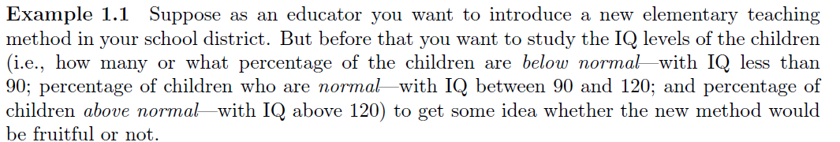

Example 1.2 – Non-Codable (Reason: Theoretical example with the purpose of proving a concept)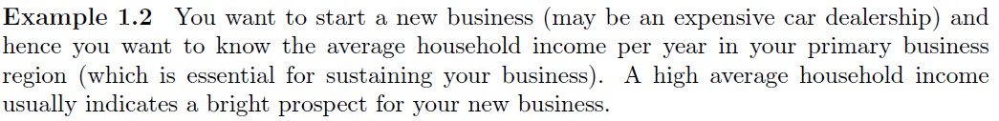

Example 1.3 – Non-Codable (Reason: Theoretical example with the purpose of proving a concept)

Example 1.4 – Non-Codable (Reason: Theoretical example with the purpose of proving a concept)

Example 1.5 – Non-Codable (Reason: Theoretical example with the purpose of proving a concept)

Example 1.6 – Non-Codable (Reason: Theoretical example with the purpose of proving a concept)

**Chapter 2: Organizing a quantitative dataset**

Example 2.1 – Codable

Example 2.2 – Codable

Example 2.3 – Codable

Example 2.4 – Codable

**Chapter 3: Pictorial representation of dataset**

Example 3.1 – Codable

Example 3.2 – Codable

**Chapter 4: Summarizing a raw dataset**

Example 4.1 – Codable

Example 4.2 – Codable

Example 4.3 – Codable

Example 4.4 – Codable

Example 4.5 – Codable

Example 4.6 – Codable

Example 4.7 – Codable

Example 4.8.i – Codable

Example 4.8.ii– Codable

Example 4.8.iii – Codable

Example 4.8.iv – Codable

Example 4.9 – Codable

Example 4.10 – Codable

Example 4.11 – Codable

Example 4.12 – Codable

Example 4.13 – Codable

**Chapter 5: Summarizing an organized dataset**

Example 5.1 – Codable

Example 5.2 – Codable

**Chapter 6: Concepts of Probability**

Example 6.1 – Codable

Example 6.2 – Non-Codable (Reason: Theoretical example with the purpose of proving a concept)

 

Example 6.3 – Codable

Example 6.4 – Non-Codable (Reason: Theoretical example with the purpose of proving a concept)



Example 6.5 – Non-Codable (Reason: Theoretical example with the purpose of proving a concept)



Example 6.6 – Codable

Example 6.7 – Codable

Example 6.8 – Codable

Example 6.9.a – Codable

Example 6.9.b –Non- Codable (Reason: Unknown composition of trials)

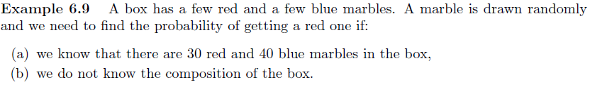 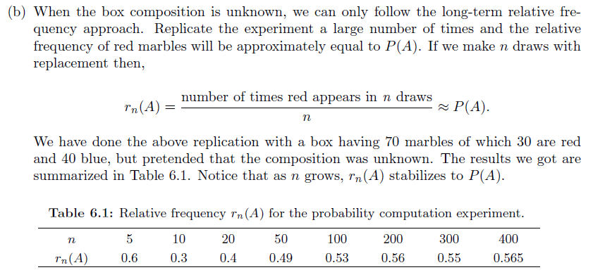

Example 6.10 – Codable

Example 6.11.a – Codable

Example 6.11.b – Codable

Example 6.11.c – Codable

Example 6.12 – Codable

Example 6.13 – Codable

Example 6.14 – Codable

Example 6.15 – Codable

Example 6.16 – Codable

Example 6.17 – Codable

Example 6.18 – Codable

**Chapter 7: Random Variable**

Example 7.1 – Codable

Example 7.2 – Codable

Example 7.3 – Codable

Example 7.4 – Codable

Example 7.5 – Non- Codable (Reason: Theoretical example with the purpose of proving a concept)

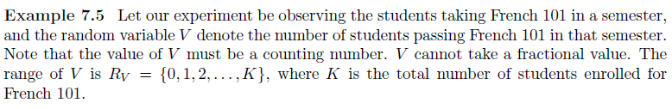

Example 7.6 – Non- Codable (Reason: Theoretical example with the purpose of proving a concept)

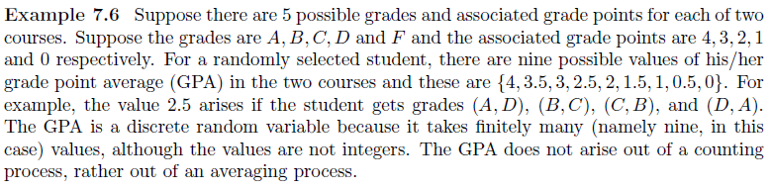

Example 7.7 – Non- Codable (Reason: Theoretical example with the purpose of proving a concept)

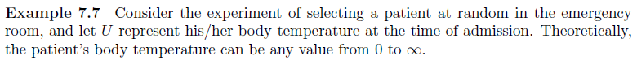

**Chapter 8: Binomial Experiments**

Example 8.1 – Codable

Example 8.2 – Codable

Example 8.3 – Codable

Example 8.4 – Codable

Example 8.5 – Codable

Example 8.6 – Non- Codable (Reason: Theoretical example with the purpose of proving a concept)

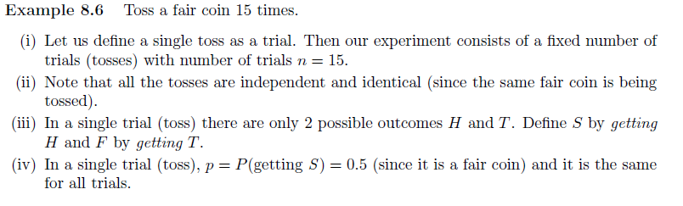

**Chapter 9: Normal Curve and Normal Distribution**

Example 9.1 – Codable

Example 9.2.a – Codable

Example 9.2.b – Codable

Example 9.2.c – Codable

Example 9.2.d– Codable

Example 9.3 – Codable

**Chapter 10: Application of the Normal Distribution**

Example 10.1 – Codable

Example 10.2 – Codable

Example 10.3.a – Codable

Example 10.3.b – Codable

Example 10.3.c – Codable

Example 10.3.d – Codable

Example 10.4 – Codable

Example 10.5.a – Codable

Example 10.5.b – Codable

Example 10.5.c – Non- Codable (Reason: Theoretical example with nothing to find/prove)

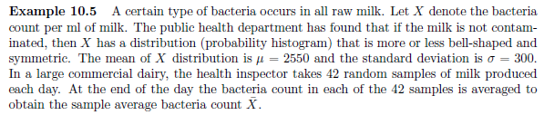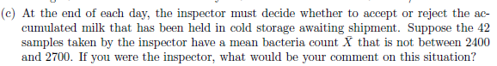 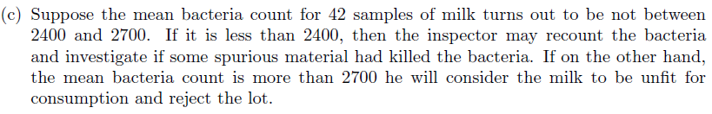

**Chapter 11: Estimation of Population Parameters**

Example 11.1 – Non- Codable (Reason: Theoretical example with the purpose of proving a concept)

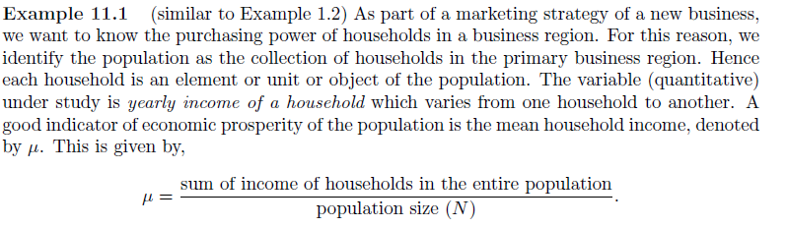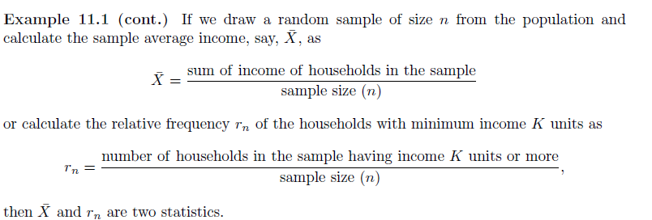

Example 11.2 – Codable

Example 11.3 – Codable

Example 11.4– Codable

**Chapter 12: Hypothesis Testing for a Single Population**

Example 12.1 – Non- Codable (Reason: Theoretical example with the purpose of proving a concept)

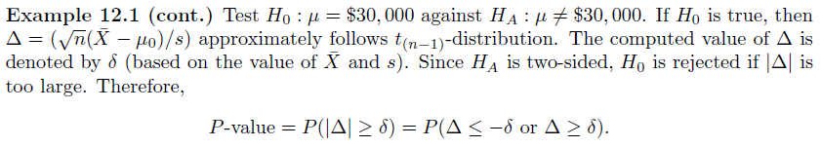

Example 12.2 – Codable

Example 12.3 – Codable

Example 12.4 – Codable

Example 12.5 – Codable

Example 12.6 – Codable

Example 12.7 – Codable

**Chapter 13: Hypothesis testing to compare for two populations**

Example 13.1 – Non- Codable (Reason: Theoretical example with the purpose of proving a concept)

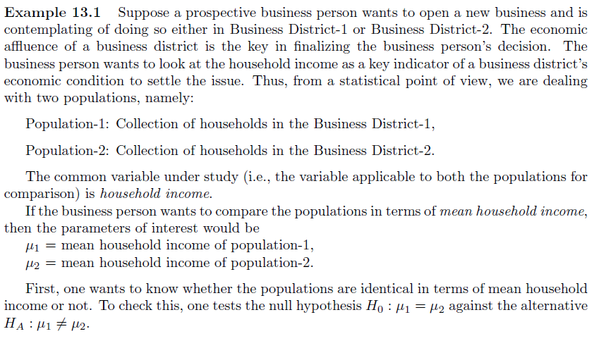

Example 13.2 – Codable

Example 13.3 – Codable

Example 13.4 – Codable

Example 13.5 – Codable

Example 13.6 – Codable

**Chapter 14: Bivariate Quantitative Data: Correlation and Regression**

Example 14.1 – Codable

Example 14.2 – Codable

**Chapter 15: Bivariate categorical data: Contingency table**

Example 15.1 – Codable

Example 15.2 – Codable

Example 15.3 – Codable

**Chapter 16: Multinomial experiments: Goodness of fit test**

Example 16.1 – Non- Codable (Reason: Theoretical example with the purpose of proving a concept)

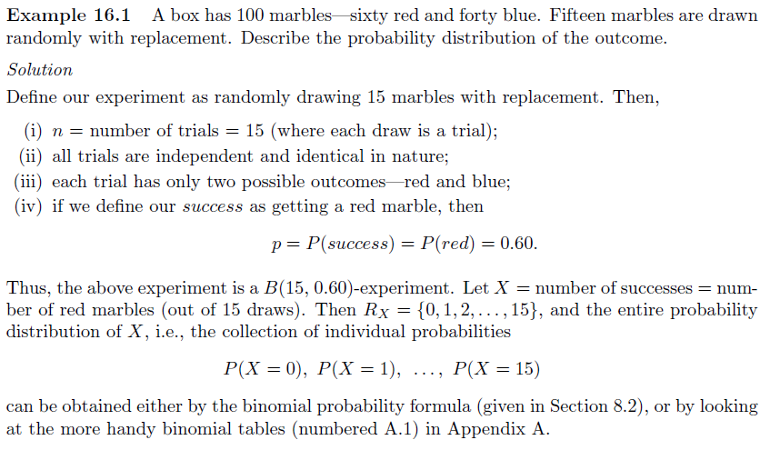

Example 16.2 – Non- Codable (Reason: Theoretical example with the purpose of proving a concept)

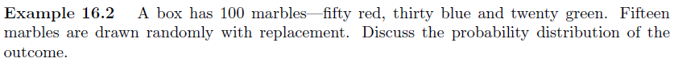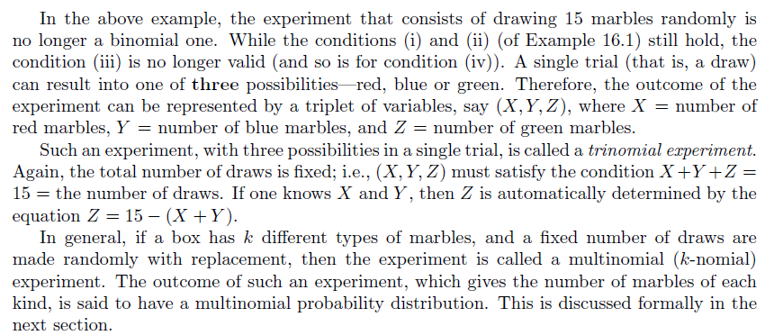

Example 16.3 – Codable

Example 16.4 – Codable

Example 16.5 – Codable

Example 16.6 – Codable

Example 16.7 – Codable

Example 16.8 – Codable

**Chapter 17: Hypothesis testing to compare multiple populations**

Example 17.1 – Codable

Example 17.2 – Codable

**Chapter 18: Quality management using statistics**

Example 18.1 – Codable

Example 18.2 – Codable

Example 18.3 – Codable

Example 18.4 – Codable