Following are the test case plots

(1)Random Gaussian signal

> ve=idinput(1000,type='rgs',band=c(0.4,0.8), c(-2,2))

> uspec<-SDF(ve)

> plot(uspec)

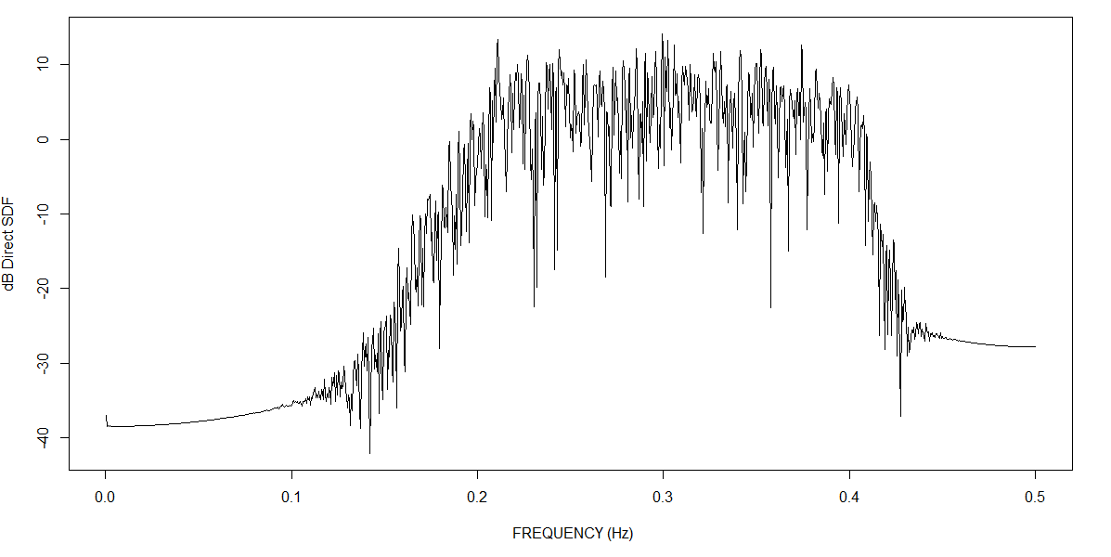

(2) Random Binary signal

> ve=idinput(1000,type='rbs',band=c(0.1,0.5), c(0,1))

> uspec<-SDF(ve)

> plot(uspec)

