Task 7
PCB Design using eSim
555 Timer Based Servo Motor PWM Controller
Name | Sridhar
Registration No. | 24VL0054
Program | B.E. Electronics Engineering (VLSI Design & Technology)
Institution | Chennai Institute of Technology
Internship | FOSSEE eSim Semester Long Internship – IIT Bombay
Submission | eSim Semester Long Internship – Autumn 2026 – Task 7
EDA Tool | eSim (KiCad-based), Version 2.3 / 2.5

1. Project Overview
This project presents the complete PCB design of a 555 Timer Based Servo Motor PWM Controller, developed as part of Task 7 (PCB Design using eSim) of the FOSSEE eSim Semester Long Internship. The objective of the task was to demonstrate the full PCB design workflow in the eSim (KiCad-based) environment — from schematic capture through footprint assignment, PCB layout, routing, Design Rule Checking (DRC), and 3D visualization.
The circuit chosen is a compact, low-component-count pulse generator built around the NE555/LM555 timer IC, configured as an astable multivibrator with an adjustable duty cycle. A potentiometer and steering diode allow the charge and discharge time constants to be set independently, so the output pulse width (and hence the control signal fed to a servo motor or motor driver) can be tuned by hand. This makes the circuit suitable as a low-cost, microcontroller-free servo/motor test driver, position-sweep demonstrator, or PWM signal source for lab use.
Key project attributes:
- Complete schematic-to-PCB flow executed entirely within eSim (KiCad) Version 2.3/2.5.
- Two-copper-layer (F.Cu / B.Cu) PCB design with through-hole components for easy hand assembly.
- Fully routed board with zero unrouted nets and a clean Design Rule Check (0 errors, 0 warnings).
- 3D-rendered board view generated directly from the eSim PCB editor for physical verification.

2. Circuit Description
The design is built around the classic 555 timer astable multivibrator topology, adapted as a variable-duty-cycle pulse generator for driving a servo motor / motor control input. The 555 (X1) is wired with resistor R1 (10 kΩ) between VCC and the DISCHARGE pin, and a duty-cycle network — resistor R2 (220 kΩ), potentiometer R3 (47 kΩ) and steering diode D1 — between DISCHARGE and the tied THRESHOLD/TRIGGER pins. Timing capacitor C1 (0.1 µF) sets the oscillation period at the THR/TR node. The OUT pin (pin 3) drives a 3-pin header (J1) carrying VCC, OUT (signal) and GND, ready to be connected to a servo motor, motor driver, or oscilloscope. A 2-pin terminal block (J2) accepts the DC battery/supply input.

2.1 Pin Functions Used
Pin(s) | Name | Function
1 | VCC | Positive supply voltage from the battery terminal block J2, 4.5–15 V (typical NE555 range).
2, 6 | TR / THR | Trigger and Threshold, tied together at the timing node with C1; sets the astable switching points.
3 | OUT | Timer output — the generated pulse/PWM waveform, routed to the signal pin of header J1.
4 | GND | Ground reference for the IC and the rest of the circuit.
7 | DISC | Discharge pin — connects through R1 to VCC and through R2/R3/D1 to the timing node, forming the RC charge/discharge paths that set the duty cycle.
Table 1 – 555 timer pin functions as used in this design.

2.2 Signal Path and Component Roles
- R1 (10 kΩ): Connects VCC to the DISCHARGE pin and forms the primary charging path for timing capacitor C1.
- R2 (220 kΩ) / R3 (47 kΩ potentiometer): Form the adjustable discharge (and, via diode D1, an alternate charge) path — turning the potentiometer changes the ON/OFF time ratio of the output, i.e. the duty cycle of the generated pulse.
- D1 (steering diode): Placed across part of the RC network so that the charge and discharge paths can be set independently, allowing the duty cycle to be adjusted well below and above 50% rather than being fixed by the classic 555 astable topology.
- C1 (0.1 µF): Timing capacitor at the TR/THR node; together with R1/R2/R3 it sets the oscillation frequency of the astable output.
- J1 (3-pin header — VCC, OUT, GND): Output connector for driving a servo motor, small motor driver, or LED/relay load with the generated pulse train.
- J2 (2-pin terminal block, +Bat−): Supply input for the battery/DC source powering the board.

3. Schematic Capture (eSchema)
The schematic was captured in eSim's eSchema editor. The 555 timer (X1), timing resistors (R1, R2), duty-cycle potentiometer (R3), steering diode (D1), timing capacitor (C1), the servo/output header (J1) and the battery terminal block (J2) were placed and wired to form the astable pulse-generator circuit. Global VCC/GND net labels and PWR_FLAG symbols were added at the power nets so the schematic is ERC-clean and ready for the Sch-to-PCB update.
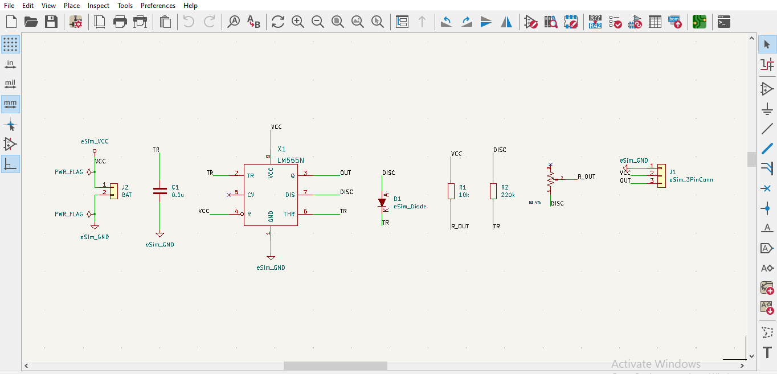
Fig. 1 – Complete schematic of the 555 timer based servo motor PWM controller, captured in eSim eSchema.
Net labels (eSim_VCC, eSim_GND) and PWR_FLAG symbols were used to define the power nets explicitly, ensuring the schematic is electrically complete before generating the PCB via the Sch-to-PCB update flow.

4. Footprint Assignment
Each schematic symbol was mapped to a physical, through-hole footprint suited for hand assembly, using the Footprint Assignment tool. A Phoenix-style terminal block (2.54 mm pitch) was used for the battery input, a 3-pin 2.54 mm pin header was used for the servo/output connector, axial resistor footprints were matched to R1/R2, a Bourns 3296W trimmer footprint was used for potentiometer R3, and the 555 timer was assigned a standard 8-pin DIP-8 package.
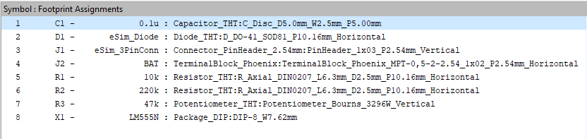
Fig. 2 – Symbol-to-footprint assignment table generated in eSim.
Ref | Value / Part | Assigned Footprint
C1 | 0.1 µF | Capacitor_THT: C_Disc_D5.0mm_W2.5mm_P5.00mm
D1 | eSim_Diode | Diode_THT: D_DO-41_SOD81_P10.16mm_Horizontal
J1 | eSim_3PinConn | Connector_PinHeader_2.54mm: PinHeader_1x03_P2.54mm_Vertical
J2 | BAT | TerminalBlock_Phoenix_MPT-0,5-2-2.54_1x02_P2.54mm_Horizontal
R1 | 10 kΩ | Resistor_THT: R_Axial_DIN0207_L6.3mm_D2.5mm_P10.16mm_Horizontal
R2 | 220 kΩ | Resistor_THT: R_Axial_DIN0207_L6.3mm_D2.5mm_P10.16mm_Horizontal
R3 | 47 kΩ (Potentiometer) | Potentiometer_THT: Potentiometer_Bourns_3296W_Vertical
X1 | LM555N | Package_DIP: DIP-8_W7.62mm
Table 2 – Component-to-footprint mapping used for this design.

5. PCB Layout and Routing Methodology
After footprint assignment, the netlist was transferred to the PCB editor using the Sch-to-PCB Update function. Footprints were arranged with the connector-based components (output header, battery terminal block, potentiometer) placed toward the board edges for easy external wiring, and the LM555N IC placed centrally to minimize average track length to its surrounding passive components.
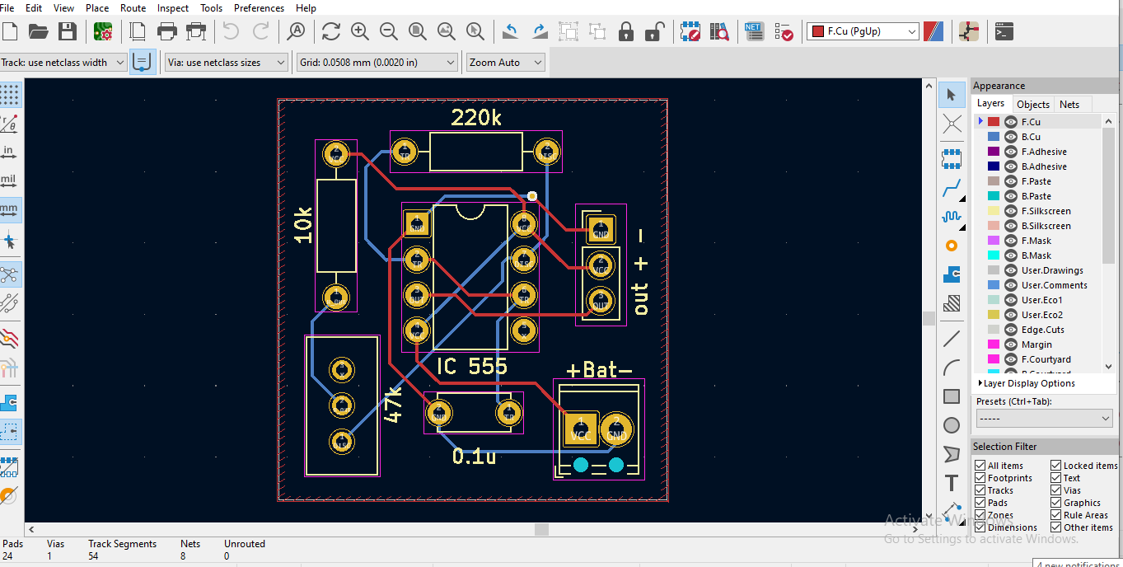
Fig. 3 – Routed PCB layout (top copper view) showing component placement and track routing.

5.1 Routing Methodology
- A two-copper-layer board (F.Cu / B.Cu) was used. Signal tracks were primarily routed on the front copper layer, with the back copper layer and a via used to resolve crossovers.Layer strategy:
- Manual interactive routing was used for all 8 nets, following the schematic connectivity and keeping the timing (R1/R2/R3/C1/D1) traces short to minimize parasitic coupling that could shift the oscillator frequency and duty cycle.
- Power and ground nets (VCC/BAT and GND) were routed with short, direct paths between the battery terminal block, the IC supply pins, and the output header.
- Track widths and clearances followed the default eSim/KiCad netclass rules, keeping the design compatible with standard PCB fabrication tolerances.
- Component placement kept the potentiometer (R3) and the output header (J1) accessible at the board edge for easy field adjustment and connection to the servo motor / driver.

6. Design Rule Check (DRC) Results
A full Design Rule Check was run in the eSim PCB editor after routing was completed, covering clearances, track widths, via annular rings/diameters, board outline, silkscreen overlap, and length-constrained connections.
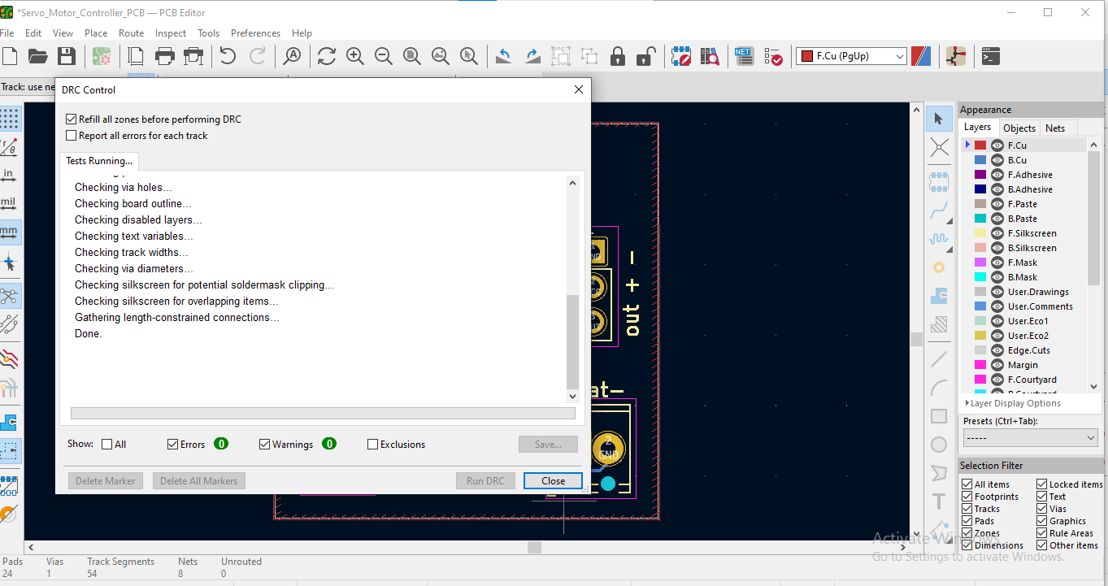
Fig. 4 – DRC Control dialog showing a completed run with 0 errors and 0 warnings.
Parameter | Result
Errors | 0
Warnings | 0
Pads | 24
Vias | 1
Track segments | 54
Nets | 8
Unrouted nets | 0
Table 3 – Summary of DRC results.
The DRC run completed with zero critical errors and zero warnings, with all 8 nets fully routed (0 unrouted), confirming the board meets basic manufacturability requirements for clearance, track width, and via geometry.

7. 3D Visualization
The completed board was verified visually using eSim's built-in 3D Viewer, which renders the populated PCB from the assigned footprints and layer stack-up. This step confirms correct component orientation, footprint scale, and overall board layout before physical fabrication.
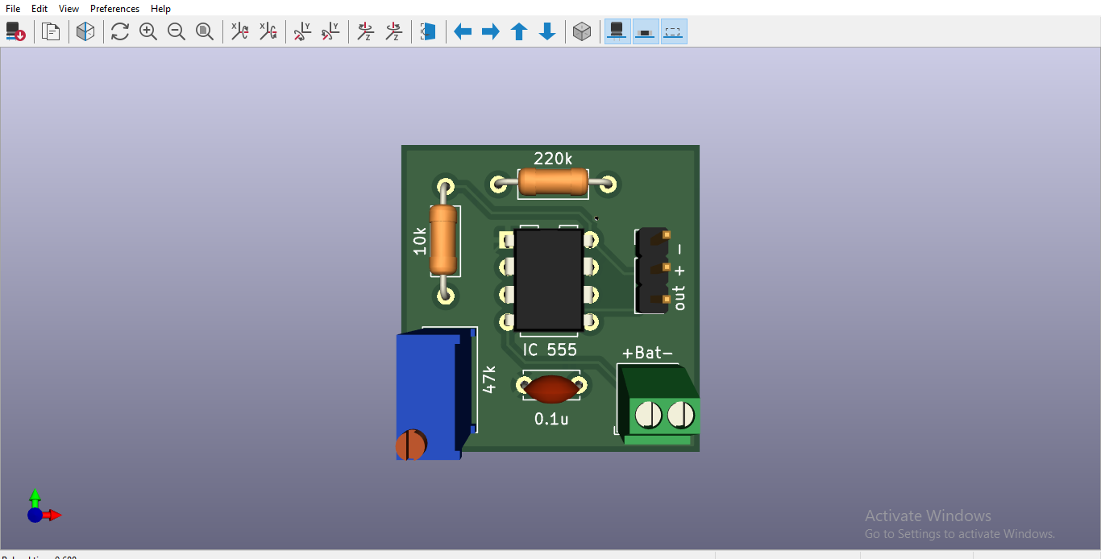
Fig. 5 – 3D top-down render of the PCB, showing the LM555N IC, R1/R2 resistors, potentiometer R3, diode D1, output header J1 and battery terminal block J2.
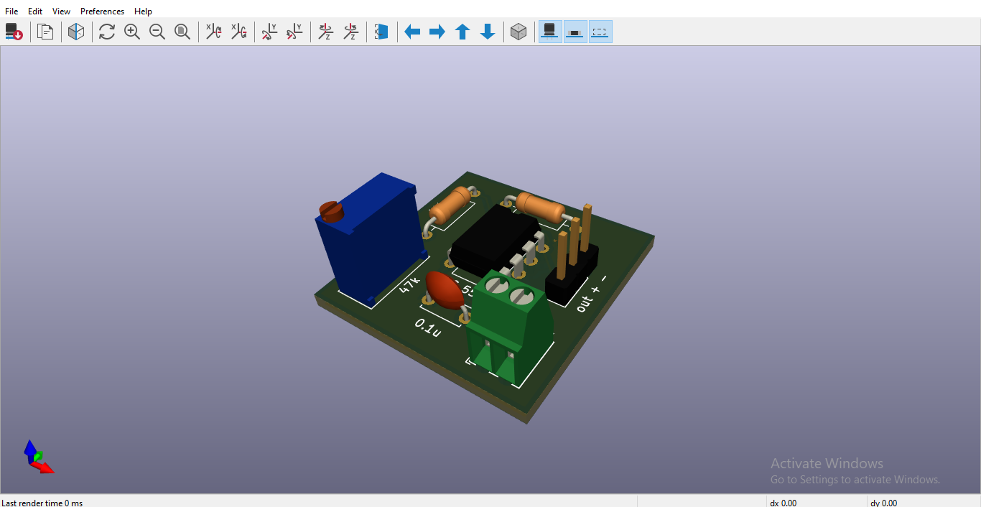
Fig. 6 – 3D isometric render of the populated "Servo_Motor_Controller_PCB", confirming component placement and silkscreen labelling.

8. Design Considerations and Conclusions

8.1 Design Considerations
- Diode D1 in combination with R2 and potentiometer R3 separates the charge and discharge paths of the astable network, allowing the output pulse width (servo control signal) to be tuned continuously via the potentiometer rather than being fixed by R1/R2 alone.Adjustable duty cycle:
- R1, R2, R3 and C1 were kept close to the 555 IC and routed with short traces to minimize stray capacitance and resistance that could otherwise shift the oscillation frequency and duty cycle.Timing stability:
- A terminal-block connector was chosen for the battery input and a pin header for the output, allowing easy field wiring to a servo motor, motor driver, or test equipment; the potentiometer was placed at the board edge for easy hand adjustment.Serviceability:
- Standard through-hole footprints and a two-copper-layer stack-up were used throughout, keeping the design compatible with low-cost PCB fabrication and hand assembly.Manufacturability:
- A zero-error / zero-warning DRC result and a fully routed netlist (0 unrouted connections) confirm the layout is electrically and geometrically sound.Verification:

8.2 Conclusion
This task successfully demonstrates the complete PCB design workflow in eSim — from schematic capture in eSchema, through footprint assignment, PCB layout generation via Sch-to-PCB update, interactive routing, Design Rule Checking, and 3D visualization. The resulting 555 timer based servo motor PWM controller PCB is fully routed across 8 nets with zero DRC errors or warnings, validating both the correctness of the schematic and the manufacturability of the final board layout. The project confirms proficiency with the eSim (KiCad-based) PCB design environment and good PCB design practices such as short timing-critical traces, accessible adjustment/connector placement, and clean DRC verification.

