eSim Semester Long Internship
AUTUMN 2026

Smart Line-Following and
Object-Detection Robot Controller PCB
SCREENING TASK 7 | PCB DESIGN USING eSIM
FINAL TECHNICAL DESIGN REPORT

Candidate Name | BrajBhushan Sah
University Roll No. | 13000324009
College | Techno Main Salt Lake
Department | Electronics & Communication Engineering
Academic Year | 3rd Year
Email Address | bjbhushansah64@gmail.com
Software: eSim 2.5 with integrated KiCad schematic and PCB tools
Project validation: ERC, complete two-layer routing, DRC, and 3D Viewer

Declaration and Scope

This report documents the design and digital verification of a two-layer controller PCB for a smart line-following and object-detection robot. The work was completed as Screening Task 7 for the eSim Semester Long Internship - Autumn 2026.
Scope statement
The PCB was designed and validated digitally using schematic ERC, PCB routing checks, DRC, and KiCad 3D visualization. Physical fabrication, assembly, and hardware testing were outside the scope of this screening submission.

Abstract
The proposed controller PCB combines six independent IR line-sensor inputs with ultrasonic object detection, servo-based directional scanning, Arduino Nano processing, and two external L298N motor-driver interfaces. The design also includes protected battery input, an external 5 V buck-converter interface, separate servo-supply filtering, three indicators, five electrical test points, and four mechanical mounting holes. The final PCB uses F.Cu and B.Cu, contains 124 pads, 30 vias, 320 track segments, and 37 electrical nets, and reports zero unrouted connections. Final ERC and DRC results show zero reported errors, warnings, violations, and unconnected items.

Key outcomes
Metric | Final result
Schematic ERC | 0 errors, 0 warnings, 0 violations
Footprint assignments | 38 physical schematic-derived components
PCB copper layers | 2: F.Cu and B.Cu
Pads / vias | 124 pads / 30 vias
Track segments / nets | 320 segments / 37 nets
Routing completion | 0 unrouted connections
Final DRC | 0 violations, 0 unconnected items, 0 errors, 0 warnings
Mechanical features | 4 corner mounting holes

Contents

Section | Title | Page
1 | Project Overview and Objectives | 5
2 | System Architecture and Pin Allocation | 6
3 | Schematic Development | 8
4 | Electrical Rules Check | 10
5 | Footprint Assignment and BOM | 11
6 | PCB Component Placement | 13
7 | Two-Layer Routing Methodology | 14
8 | Design Verification | 18
9 | 3D Visualization | 21
10 | Design Considerations and Limitations | 24
11 | Conclusion and Submission Package | 25
Note: Page numbers are intended as a navigation guide for the exported report. Figure captions and section headings provide the authoritative structure.

List of Figures
Figure | Title
1 | Initial control schematic
2 | Final annotated schematic
3 | Final ERC result
4 | Complete footprint assignment
5 | Final component placement
6 | Back-copper routing
7 | Front-copper routing
8 | Complete two-layer routing
9 | Final DRC result
10 | Final routing completion status
11 | Edge.Cuts board outline
12 | Angled 3D board view
13 | Bottom 3D board view
14 | Top 3D board view

1. Project Overview and Objectives

1.1 Project objective
The objective is to design a complete two-layer controller PCB that organizes the electrical interfaces required by a line-following and object-detection robot. The controller must acquire six line-sensor signals, measure obstacle distance using an HC-SR04 interface, drive a scanning servo, and provide control outputs for two external L298N motor-driver modules.

1.2 System functions
- Six individually labelled IR sensor inputs improve line-position resolution compared with a basic two-sensor design.
- An HC-SR04 interface provides distance measurement for object detection.
- A servo interface permits directional scanning of the ultrasonic sensor.
- The Arduino Nano processes sensor signals and generates motor-control outputs.
- Two external L298N interfaces control the left and right motor groups.
- Protected input power, regulated logic power, status indication, test points, and mounting holes support practical integration.

1.3 Final deliverables
Deliverable | Status
Complete schematic | Completed
ERC evidence | Completed
Footprint assignment | Completed
Two-layer PCB routing | Completed
Edge.Cuts and mounting holes | Completed
Final DRC evidence | Completed
3D Viewer evidence | Completed
BOM in Excel and CSV | Completed
Physical fabrication and testing | Not included in screening scope

2. System Architecture and Pin Allocation

2.1 Functional architecture
Signal flow
Six IR sensors -> Arduino Nano -> left/right motor-control decisions -> two L298N interfaces -> four DC motors. In parallel, HC-SR04 distance data and servo scanning support object-detection and avoidance decisions.

2.2 Arduino Nano signal allocation
Arduino pin | Assigned function
A0 | IR1_OUT
A1 | IR2_OUT
A2 | IR3_OUT
A3 | IR4_OUT
A4 | IR5_OUT
A5 | IR6_OUT
D2 | US_TRIG
D3 | US_ECHO
D4 | SERVO_PWM
D5 | LEFT_PWM
D6 | RIGHT_PWM
D7 | LEFT_FORWARD
D8 | LEFT_REVERSE
D9 | RIGHT_FORWARD
D10 | RIGHT_REVERSE
D11 | STATUS_LED
D12 | OBJECT_LED

2.3 Power rails
Net | Role
BAT_RAW | Protected battery-pack input before the fuse
BAT_FUSED | Battery voltage after resettable polyfuse
BAT_SWITCHED | Battery voltage after the external main switch
VIN_PROTECTED | Reverse-polarity-protected buck input
+5V | Regulated logic, sensor, and controller supply
SERVO_5V | Servo supply after the zero-ohm isolation link
GND | Common reference for controller and external modules

Each external L298N module controls the two motors on one side of the robot. The enable inputs of both channels share one PWM signal, and the paired direction inputs receive the same forward and reverse commands. This allows both motors on one side to operate together while the left and right sides remain independently controllable.
The battery connector is intended for a properly assembled and protected battery pack. Individual 18650 cells must not be connected directly without an appropriate BMS, cell-balancing arrangement, short-circuit protection, and compatible charging system. The external buck converter must be adjusted to 5.0 V before connecting the Arduino Nano, sensors, or servo branch.

3. Schematic Development

3.1 Control-interface development
The design was first divided into functional blocks so that the controller, sensing, servo, and motor-driver interfaces could be verified independently. Named nets were used instead of long wires to preserve readability.
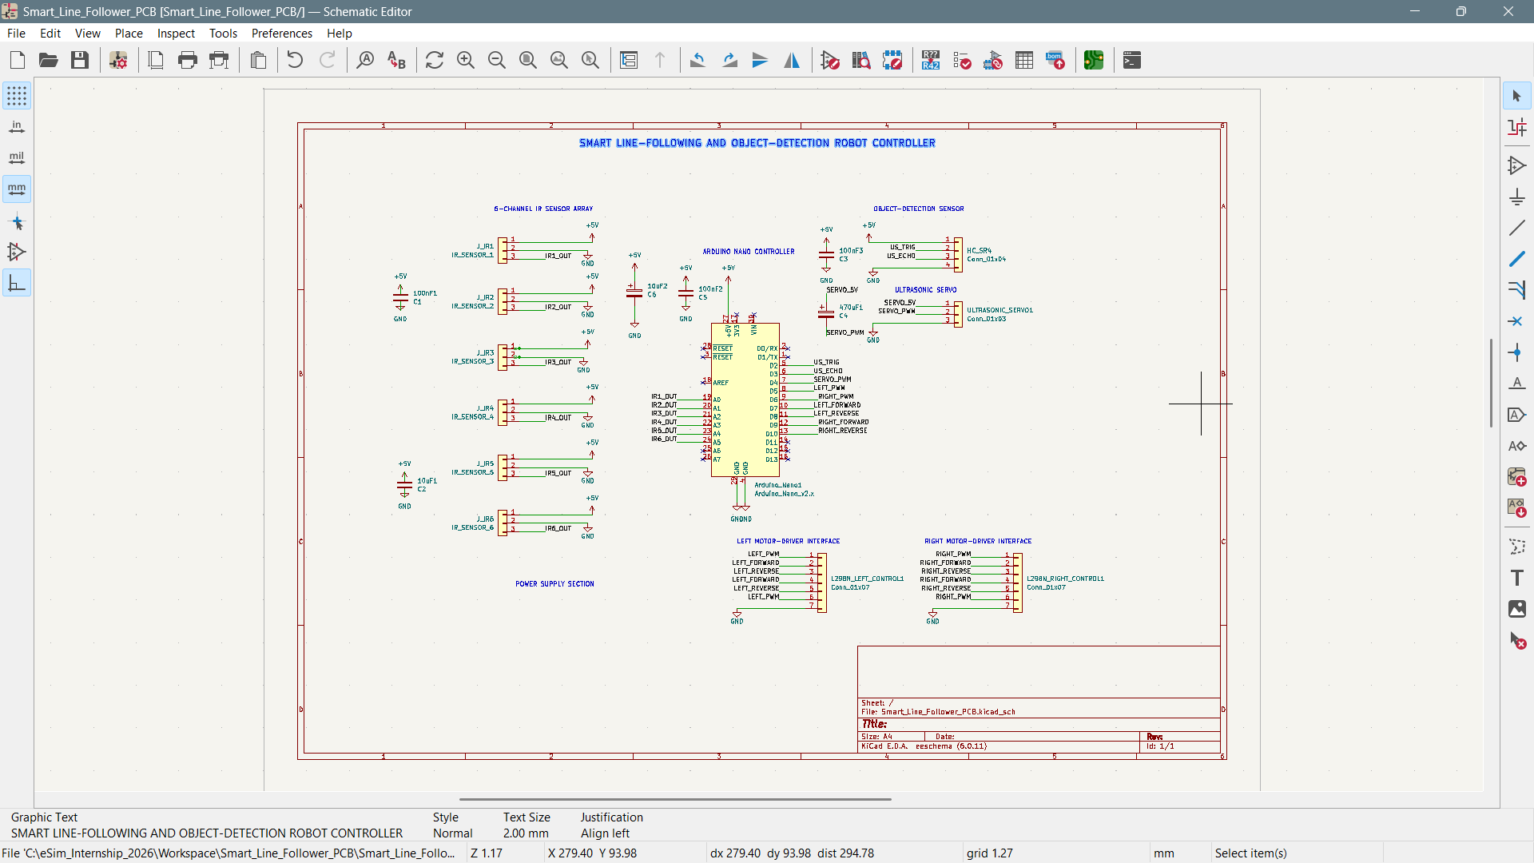
Figure 1: Initial control schematic containing the Arduino Nano, six IR sensor interfaces, HC-SR04 interface, servo interface, and two L298N control interfaces.

3.2 Final annotated schematic
The final schematic adds battery input, overcurrent and reverse-polarity protection, the external buck-module interface, power filtering, three indicators, and five test points. The schematic is annotated and organized into clearly labelled functional regions.
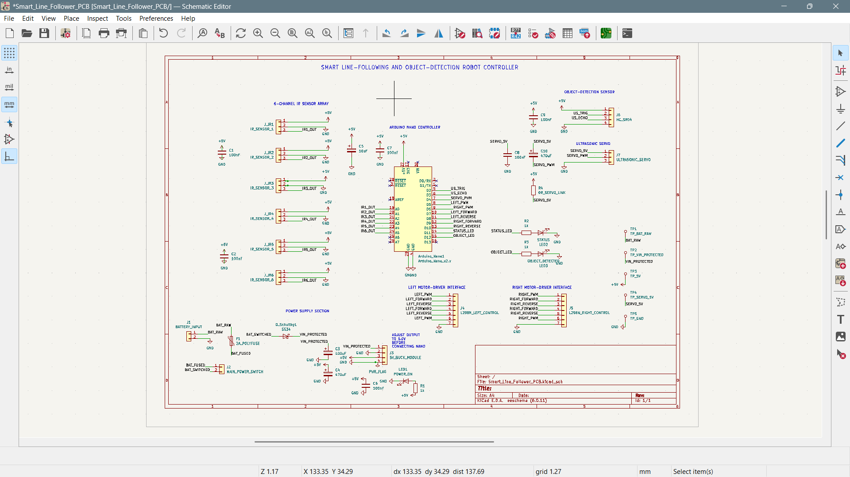
Figure 2: Final annotated schematic of the smart line-following and object-detection robot controller PCB.

3.3 Circuit-block notes
- C1-C2 support IR-sensor supply decoupling.
- C5 and C7 provide local Arduino Nano supply filtering.
- C8-C10 support ultrasonic and servo supply stability.
- F1 limits battery-input fault current, and the SS34 provides reverse-polarity protection.
- R4 creates an isolatable +5 V to SERVO_5V connection.
- TP1-TP5 provide measurement access to the principal power nets.

4. Electrical Rules Check

The annotated schematic was evaluated with KiCad Electrical Rules Checker. Intentional unused pins were marked using no-connect symbols, and the power definitions were corrected before the final check.
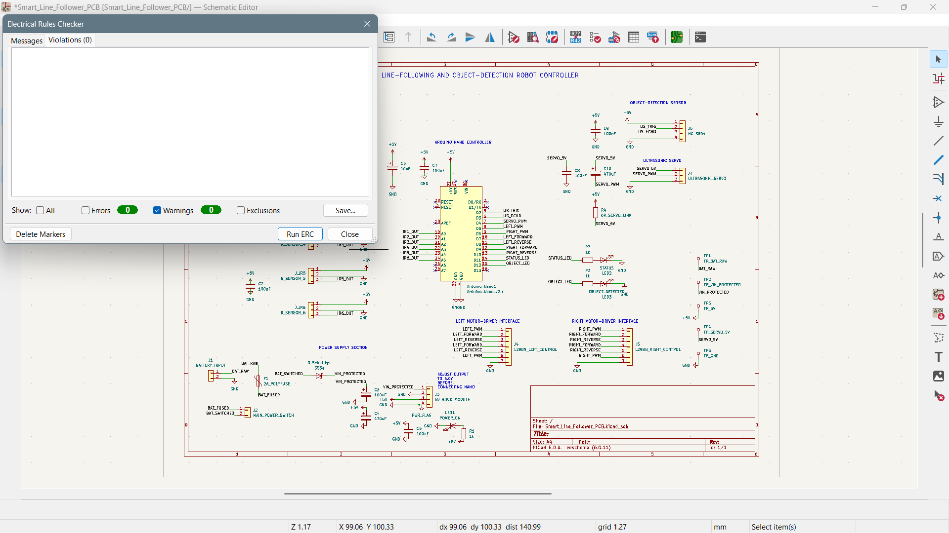
Figure 3: Final ERC result showing zero errors, zero warnings, and zero schematic violations.
Verification result
ERC Errors: 0 | ERC Warnings: 0 | ERC Violations: 0

5. Footprint Assignment and Bill of Materials

5.1 Footprint assignment
Every annotated physical component was mapped to a PCB footprint before forward annotation. Through-hole parts were selected for most connectors, indicators, resistors, and capacitors, while the SS34 diode uses an SMA surface-mount footprint.
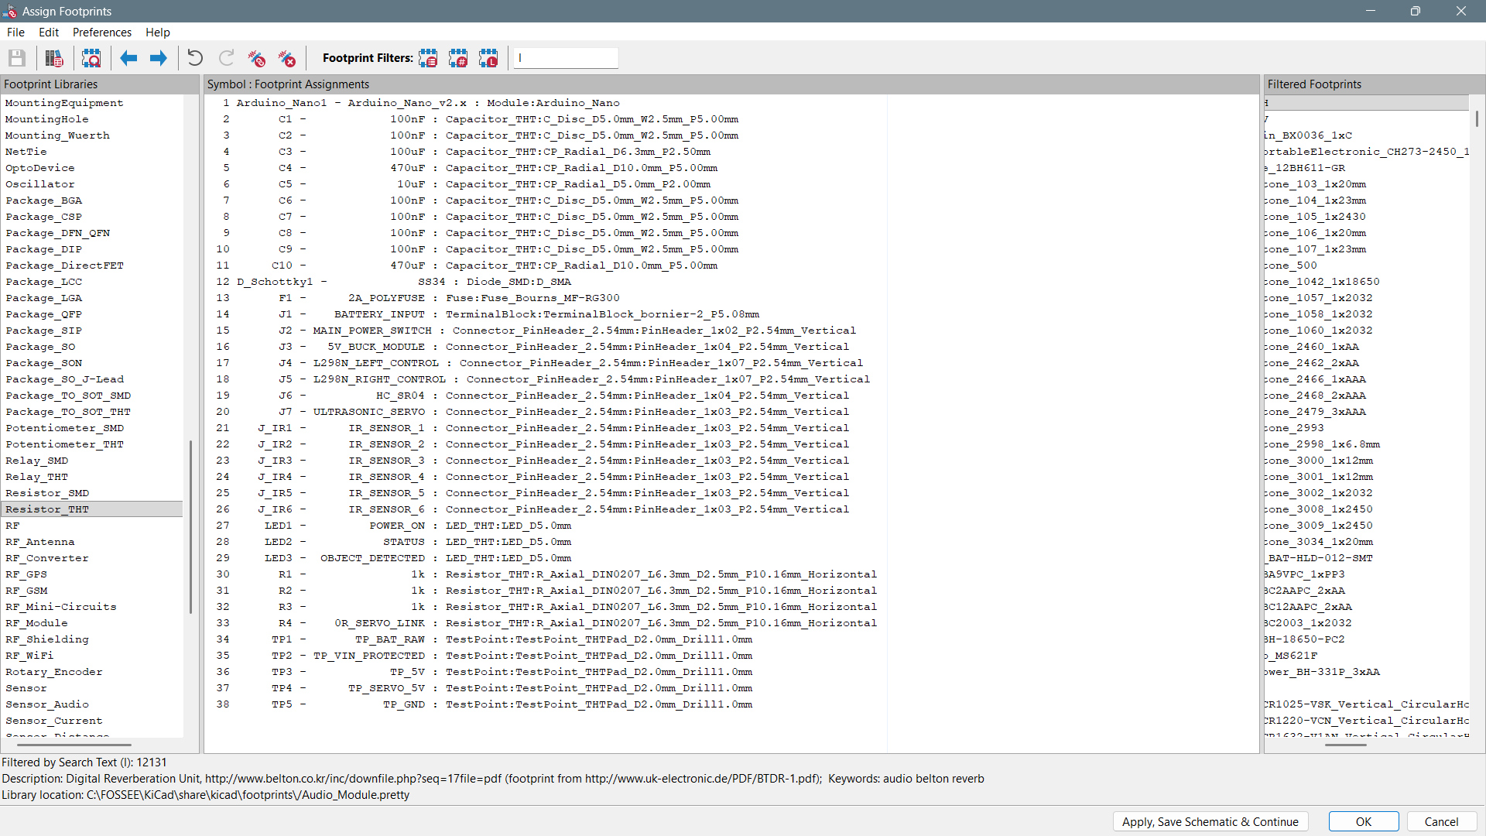
Figure 4: Complete footprint assignment for all 38 schematic-derived physical components.

5.2 Footprint strategy
Category | Selected implementation
Controller | Module:Arduino_Nano
IR and servo interfaces | 2.54 mm vertical pin headers
L298N interfaces | 1x07, 2.54 mm vertical pin headers
Battery input | 2-pin, 5.08 mm terminal block
Resistors | DIN0207 horizontal through-hole
Ceramic capacitors | 5.00 mm pitch disc footprints
Bulk capacitors | Radial polarized footprints sized by capacitance
SS34 diode | SMA surface-mount package
Test points | 2.0 mm through-hole pads

5.3 BOM summary
Component category | Quantity
Arduino Nano module | 1
Capacitors | 10
Schottky diode | 1
Resettable polyfuse | 1
Main power and module connectors | 7
IR sensor connectors | 6
Indicator LEDs | 3
Resistors and servo link | 4
Test points | 5
Total schematic-derived physical components | 38
The complete 38-row BOM is supplied separately as Smart_Line_Follower_BOM.xlsx and Smart_Line_Follower_BOM.csv. Four board-only mounting-hole footprints are not included in the schematic-derived component total.

6. PCB Component Placement

Placement was organized by function. The Arduino Nano occupies the central controller region; external interfaces remain accessible from the board perimeter; power components are grouped; indicator circuits are separated; and test points remain reachable.
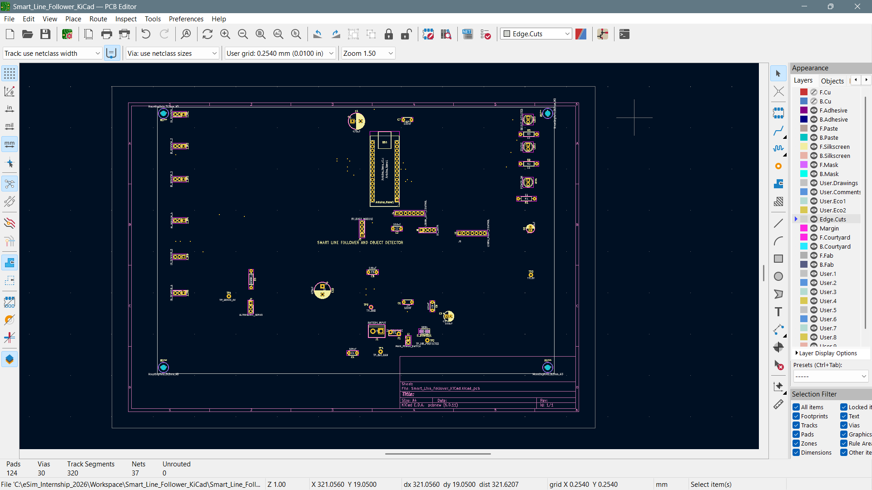
Figure 5: Final component placement with all footprints inside the Edge.Cuts boundary, four mounting holes, and zero unrouted connections.

6.1 Placement rationale
- Arduino Nano USB orientation remains accessible.
- Six identical IR headers support consistent external sensor wiring.
- Battery protection and regulation components are grouped away from sensor interfaces.
- LEDs are positioned as a clearly identifiable bank.
- Servo filtering components remain local to the servo branch.
- Four corner mounting holes support mechanical installation.
Placement trade-off
The layout prioritizes functional separation, cable accessibility, and visually traceable routing over minimum board area.

7. Two-Layer Routing Methodology

7.1 Back copper
B.Cu was used to resolve crossings and complete long control paths. Layer transitions occur through plated vias, preventing unrelated same-layer copper from intersecting.
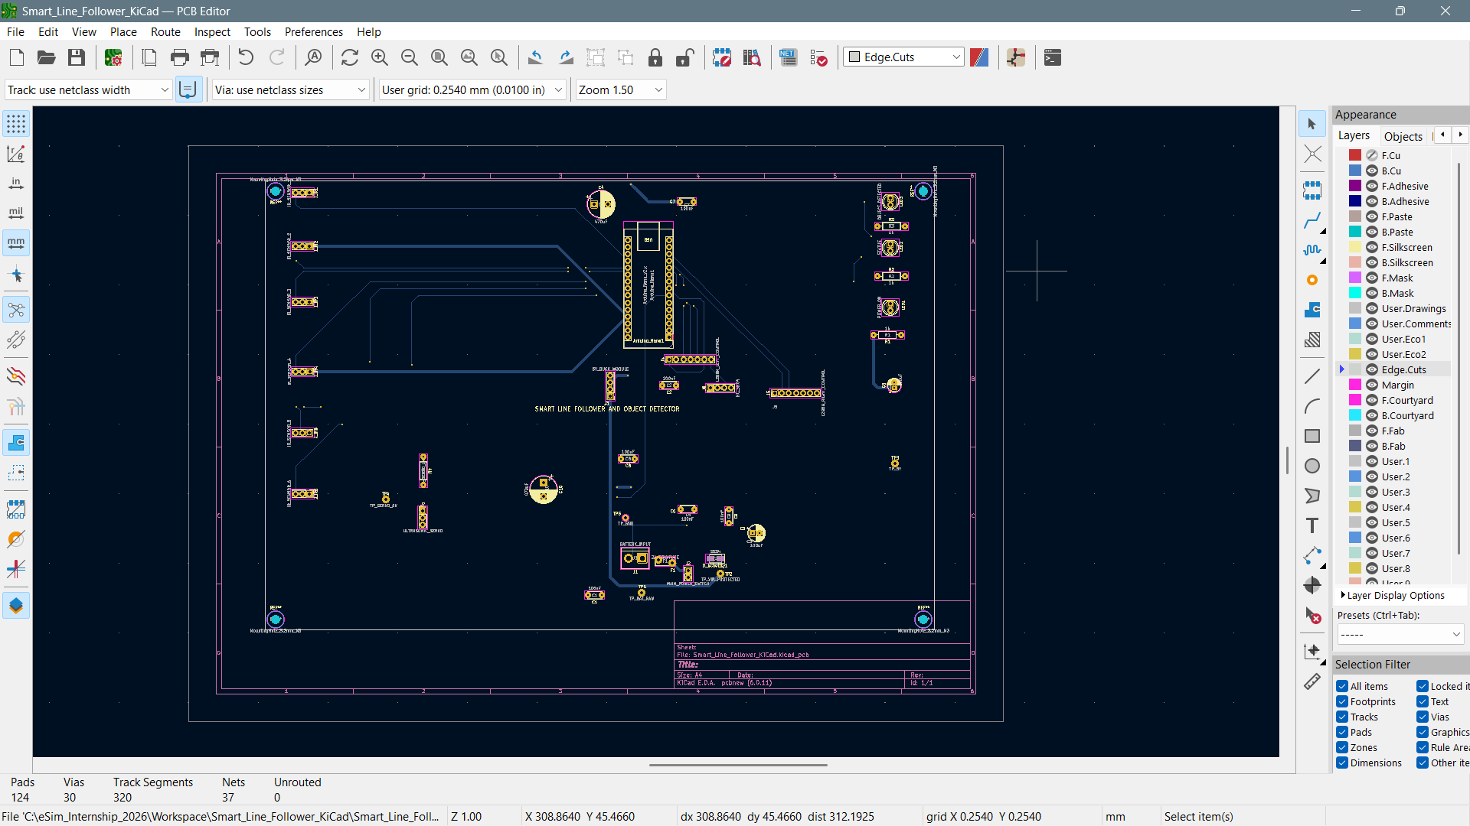
Figure 6: Back-copper routing on B.Cu, used for long control connections, crossing resolution, and selected power paths.

7.2 Front copper
F.Cu carries most of the power distribution, local component branches, sensor connections, and motor-control signals. Wider routing is visible on the main power and servo-supply paths.
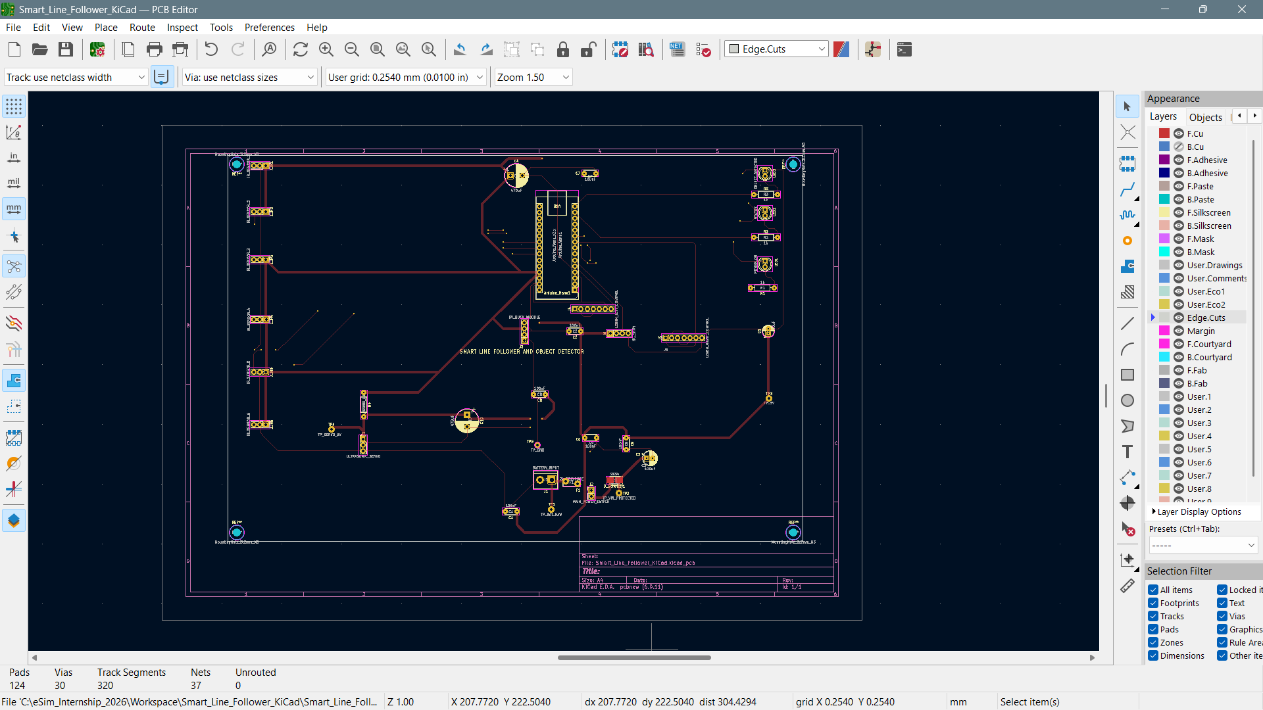
Figure 7: Front-copper routing on F.Cu, including power distribution, sensor interfaces, motor-control signals, and local branches.

7.3 Complete two-layer routing
The combined view shows F.Cu in red and B.Cu in blue. A red track may cross a blue track without electrical contact because the copper layers are separated by the PCB substrate. Electrical transition between layers occurs only at plated vias or plated through-holes assigned to the same net.
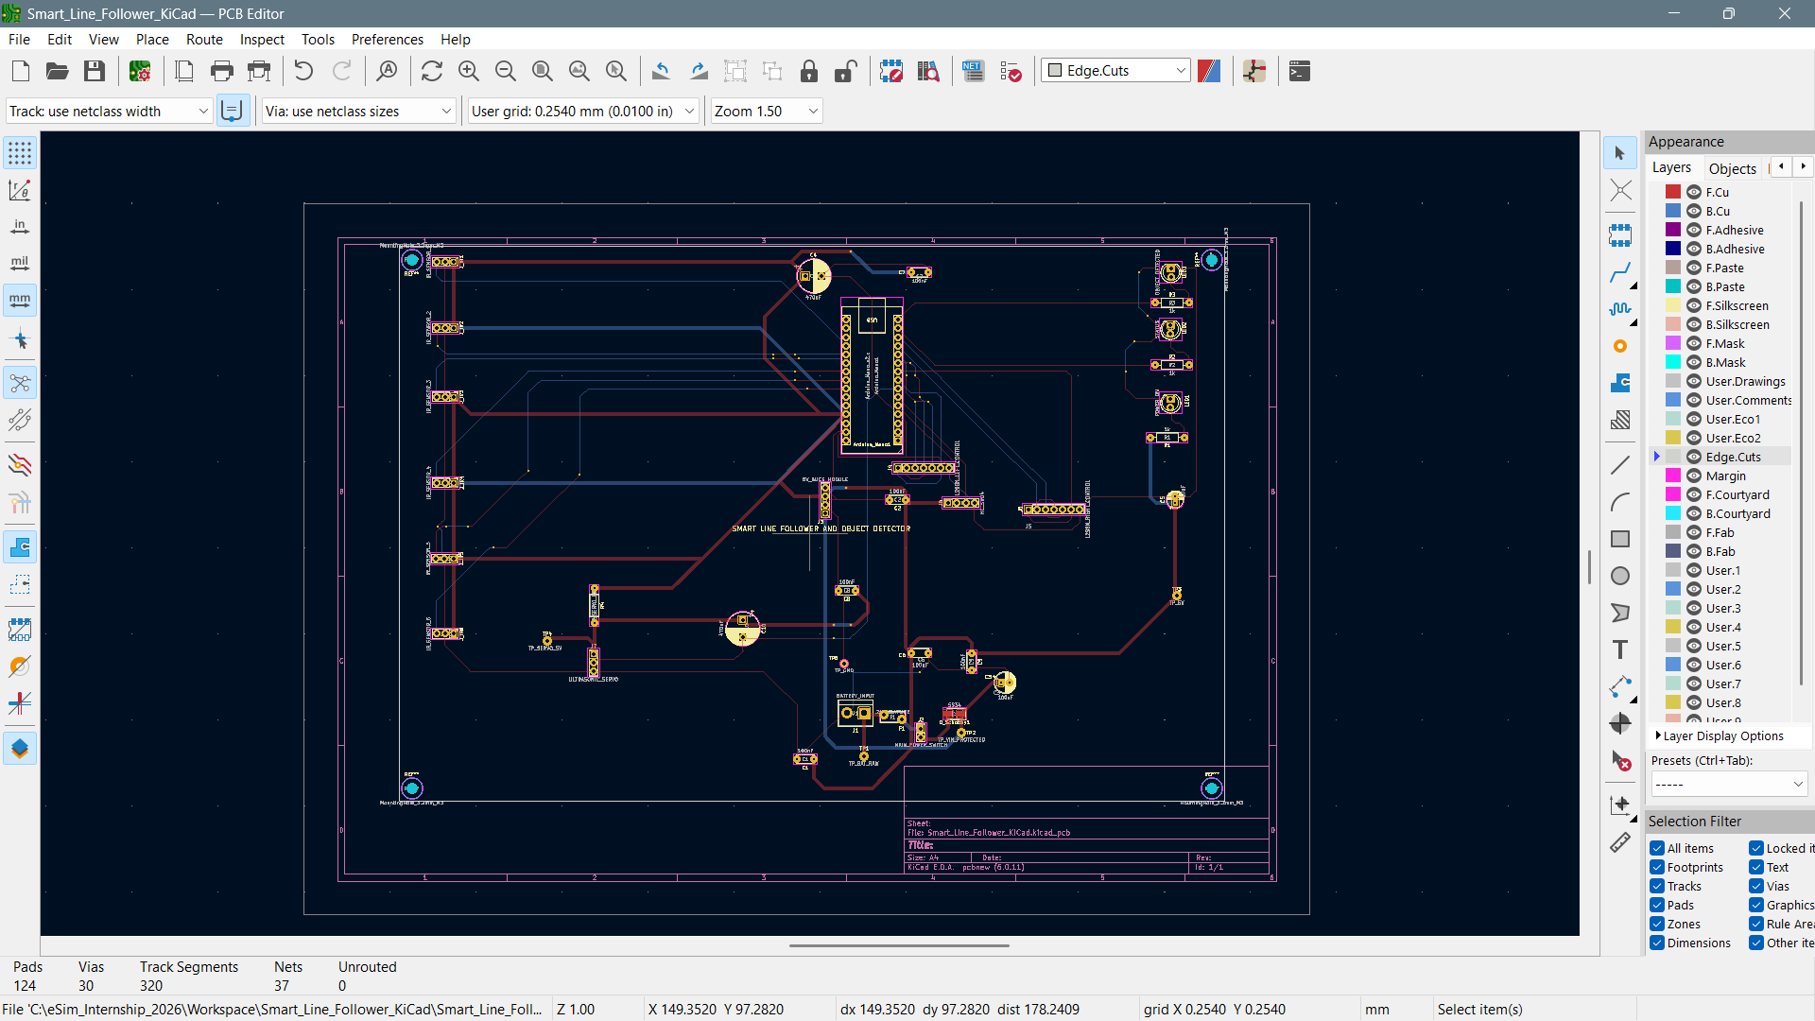
Figure 8: Complete two-layer routing showing F.Cu in red, B.Cu in blue, 30 vias, 37 nets, and zero unrouted connections.
Routing metric | Final value
Pads | 124
Vias | 30
Track segments | 320
Electrical nets | 37
Unrouted connections | 0

7.4 Routing design practices
- Power-related nets use visibly wider copper than logic and sensor nets.
- The majority of direction changes use 45-degree bends.
- Vias are used only where layer changes are required to resolve crossings.
- Shared supply nets branch locally to nearby capacitors and interfaces.
- Ground is completed through routed copper paths on the available layers.
- All routing remains inside the physical Edge.Cuts boundary.

7.5 Deviation from the original proposal
The original proposal considered a bottom-layer ground plane. During final implementation, the ground network was completed through routed copper paths across the two available layers. The final approach achieved zero unrouted connections and passed the configured DRC. The report therefore does not claim that a continuous bottom-layer ground plane was implemented.

8. PCB Design Verification

8.1 Final Design Rules Check
The routed board was checked after correction of the earlier co-located mounting-hole warning. The final DRC includes separate zero counts for violations and unconnected items.
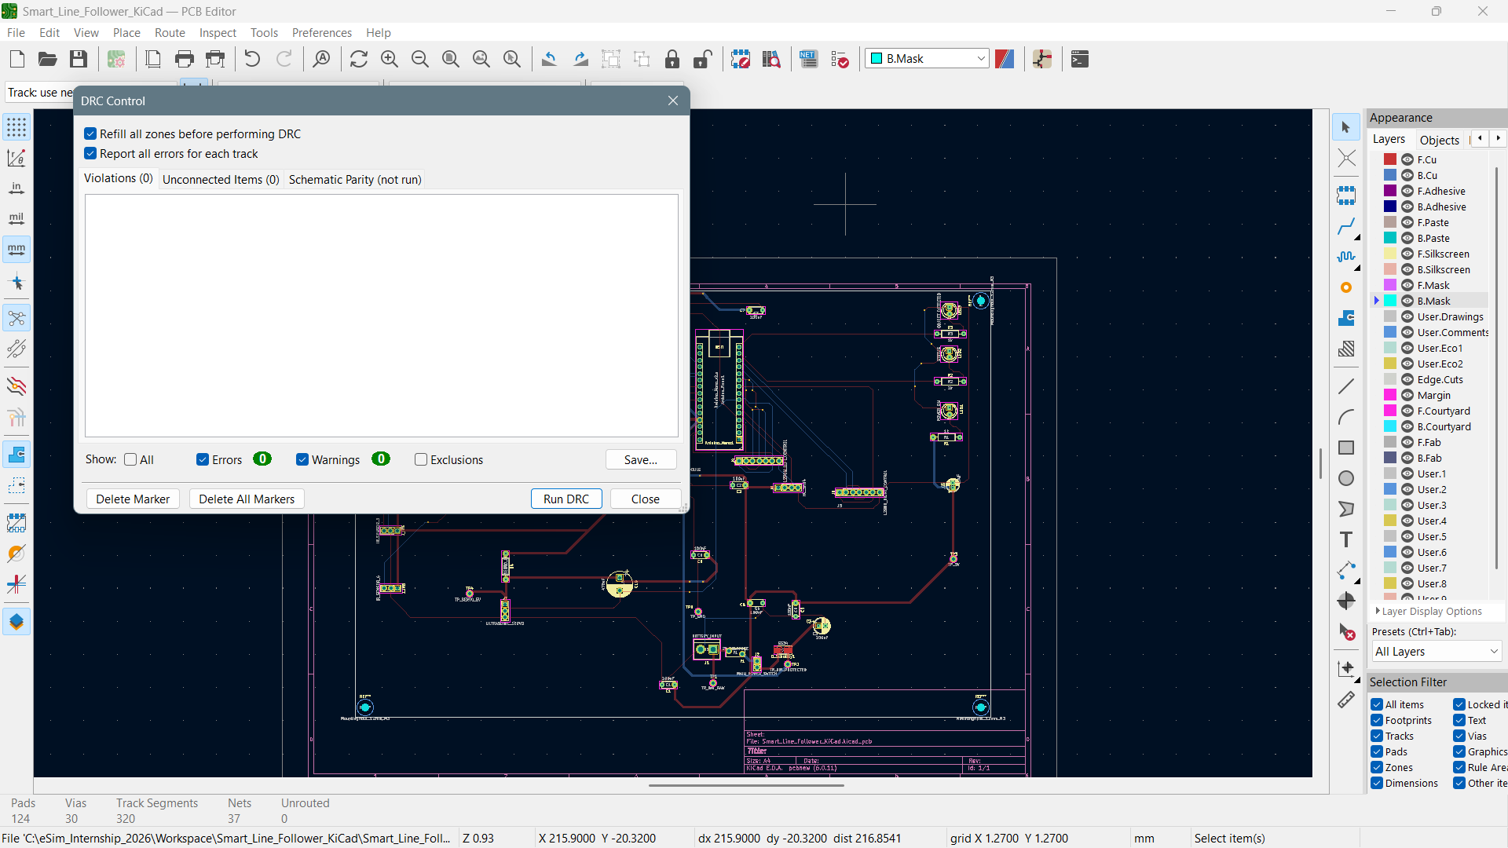
Figure 9: Final DRC result showing zero violations, zero unconnected items, zero errors, and zero warnings.
Final PCB verification
DRC Violations: 0 | Unconnected Items: 0 | Errors: 0 | Warnings: 0

The Schematic Parity tab was not run in the captured DRC session and is not claimed as completed.

8.2 Routing completion status
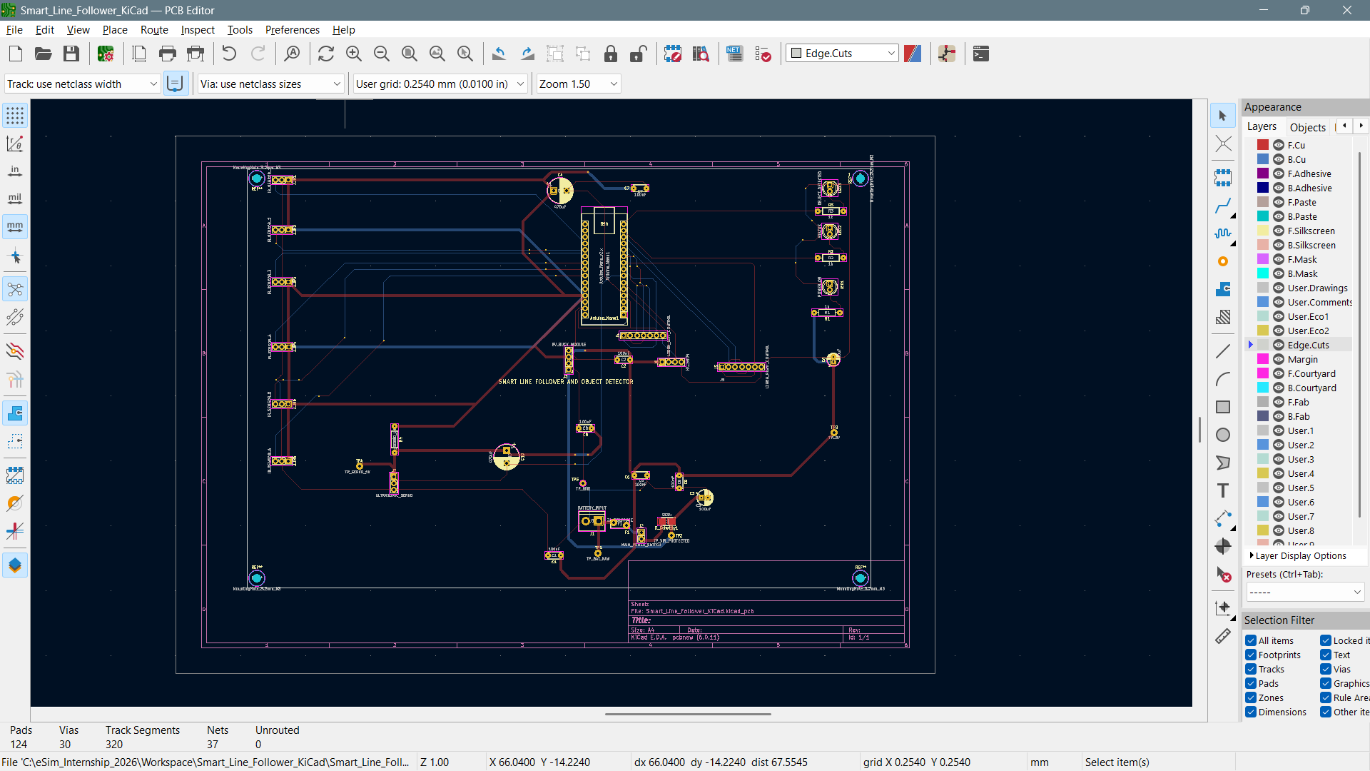
Figure 10: Final routed PCB with both copper layers and a completion status of 124 pads, 30 vias, 320 track segments, 37 nets, and zero unrouted connections.

8.3 Board outline
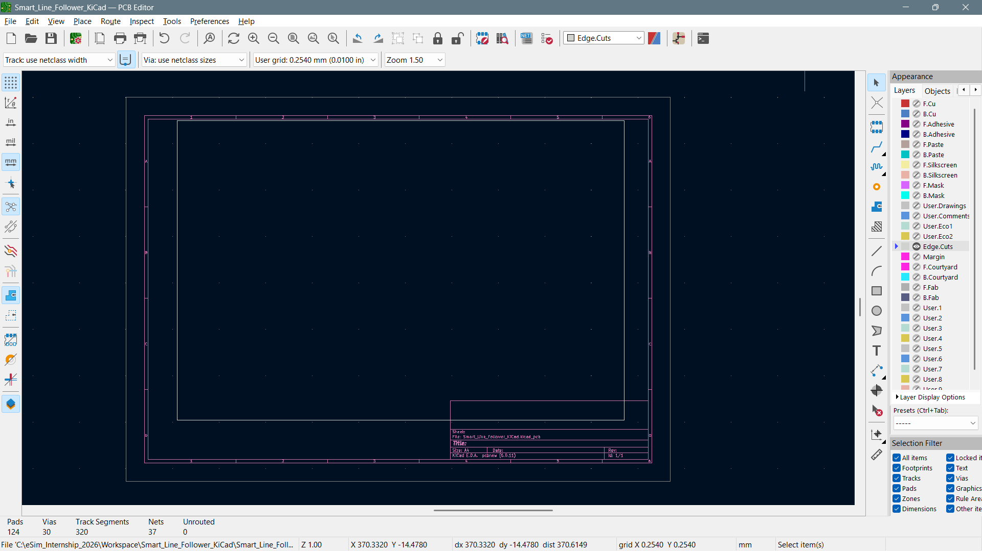
Figure 11: Isolated Edge.Cuts view showing the closed rectangular physical PCB boundary.
The inner white rectangle is the physical board outline. The larger magenta frame and title block are KiCad worksheet graphics and are not part of the manufactured PCB.

9. 3D Visualization

9.1 Angled board view
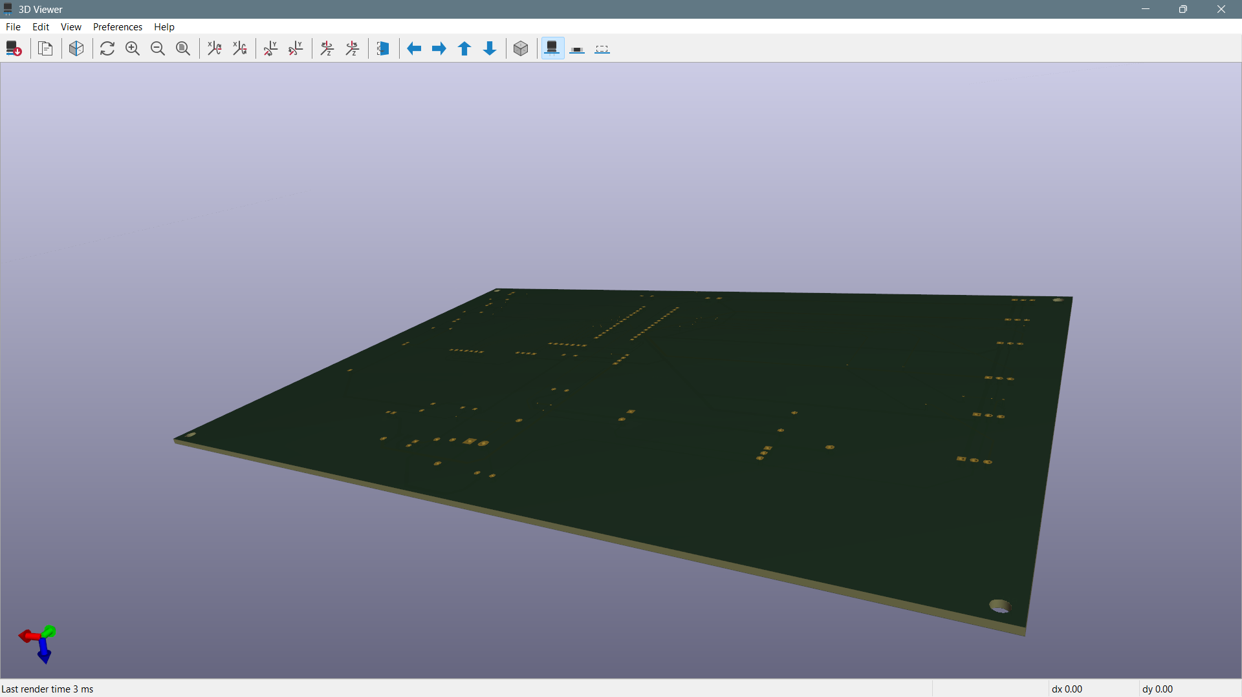
Figure 12: Angled 3D visualization showing the rectangular substrate, finite board thickness, plated pads, drilled holes, routing, and four mounting holes.
The angled view confirms that KiCad recognized the closed Edge.Cuts path and generated a valid rectangular board body with physical thickness.

9.2 Bottom board view
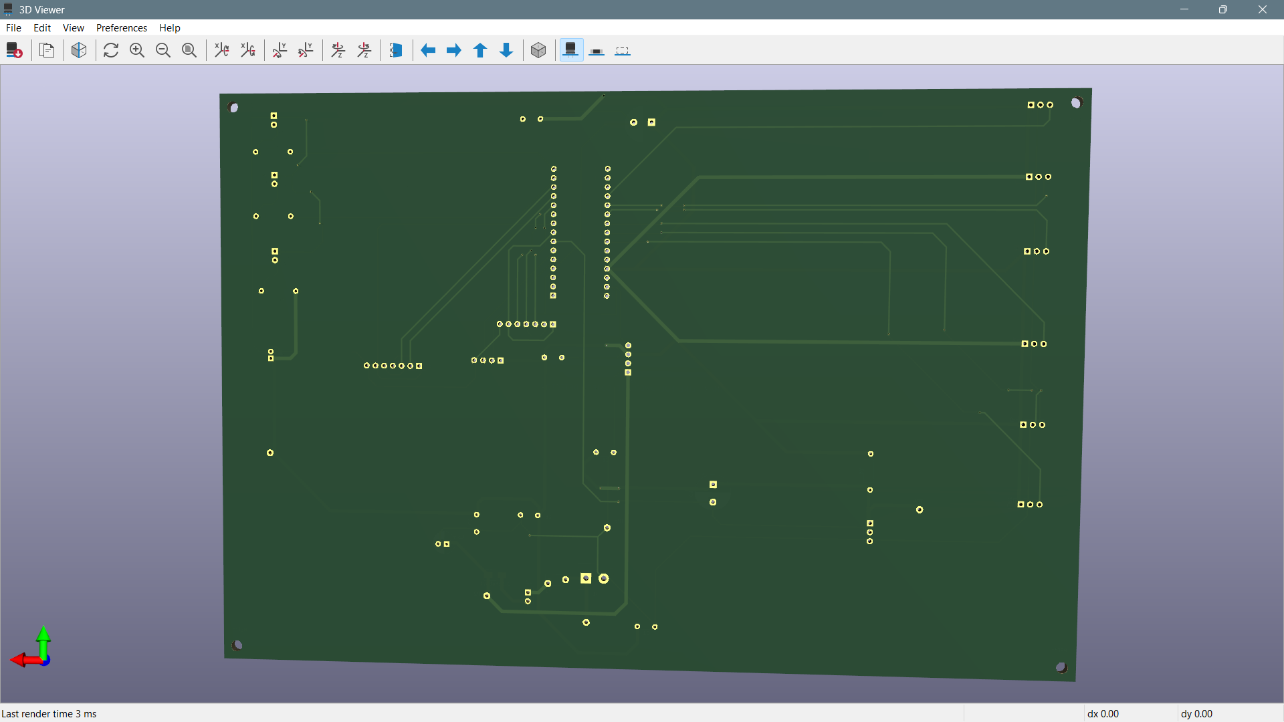
Figure 13: Bottom 3D view showing back-layer routing, through-hole pads, Arduino Nano header rows, connector footprints, vias, and mounting holes.
The underside makes the B.Cu routing and plated through-hole structure clearly visible. The two long Arduino Nano header rows and the repeated external connector patterns are identifiable.

9.3 Top board view
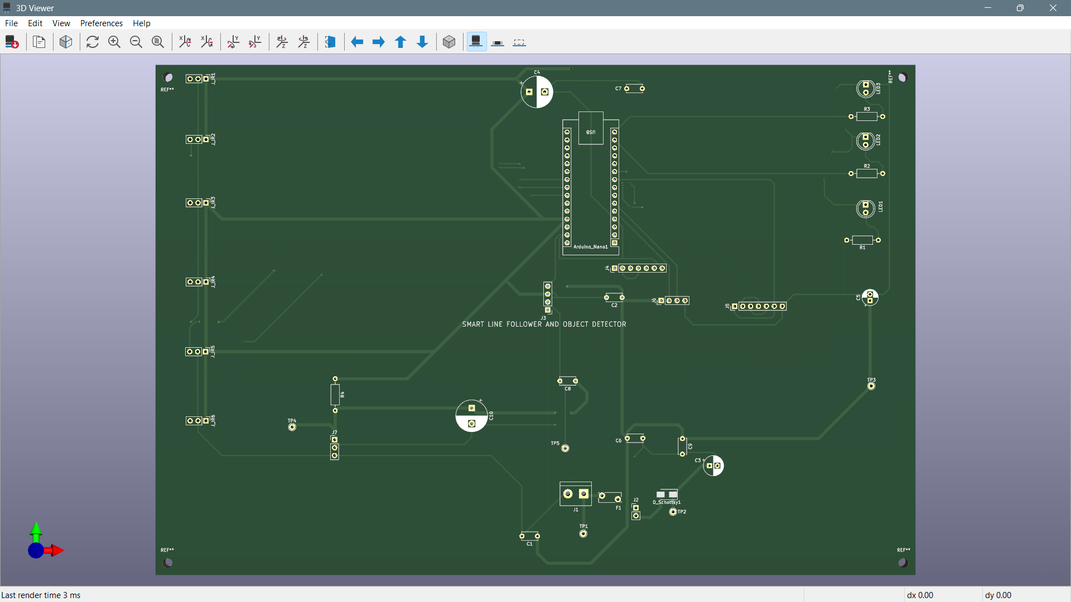
Figure 14: Top 3D view showing the Arduino Nano footprint, IR interfaces, indicator circuits, power section, module connectors, test points, title, and mounting holes.

9.4 3D model limitation
Model-library limitation
KiCad generated the board substrate, pads, drills, traces, solder-mask appearance, silkscreen, and mounting holes. Several footprint libraries did not have locally accessible 3D model associations, so complete solid component bodies are not rendered. This does not affect schematic connectivity, routing completion, ERC, or DRC.

10. Design Considerations, Limitations, and Future Work

10.1 Design considerations
- Six independent IR inputs support finer line-position estimation.
- Sensor, motor-control, power, and indication functions are divided into clear blocks.
- A resettable polyfuse and SS34 provide input protection.
- The external 5 V buck interface avoids routing raw battery voltage directly to the Nano 5 V pin.
- The servo branch includes a zero-ohm isolation link, local 470 uF bulk capacitance, and 100 nF bypassing.
- Common ground is provided to external controller and motor-driver interfaces.
- Five test points support systematic voltage measurement.
- Board-edge connector placement supports cable access.

10.2 Limitations
- The PCB was not fabricated or physically tested during the screening task.
- The board area is larger than a production-optimized revision because placement emphasizes visibility and routing access.
- Several external-interface traces are long due to perimeter connector placement.
- A continuous bottom-layer ground plane was planned but not implemented; ground was routed explicitly.
- Complete component bodies are not visible in the 3D Viewer because some footprint model associations are unavailable locally.
- The L298N modules and 5 V buck converter remain external modules rather than integrated circuitry.

10.3 Future improvements
- Reduce board dimensions through denser placement and revised connector grouping.
- Implement a continuous ground plane with optimized bottom-layer signal allocation.
- Integrate modern high-efficiency motor-driver ICs.
- Add battery-voltage monitoring and current sensing.
- Create a dedicated six-sensor daughterboard with a keyed connection.
- Link verified 3D models for every footprint.
- Fabricate, assemble, and validate the design under motor and servo load.

11. Conclusion and Submission Package

11.1 Conclusion
A complete two-layer PCB was developed for a smart line-following and object-detection robot controller. The schematic integrates an Arduino Nano, six IR sensor interfaces, an HC-SR04 interface, servo control, two L298N interfaces, protected and regulated power distribution, three indicators, and five test points. All 38 schematic-derived physical components received footprints, and four mechanical mounting holes were added in PCB Editor. The final board uses 124 pads, 30 vias, 320 track segments, and 37 electrical nets. Routing was completed with zero unrouted connections. Final ERC and DRC evidence reports zero errors, warnings, violations, and unconnected items. The board was also demonstrated in KiCad’s 3D Viewer.
Final outcome
The mandatory schematic-to-PCB workflow was completed successfully: schematic capture -> annotation -> ERC -> footprint assignment -> component placement -> two-layer routing -> Edge.Cuts -> mounting holes -> DRC -> 3D visualization.

11.2 Submitted supporting files
File / folder | Purpose
Final report PDF | Primary technical documentation
Smart_Line_Follower_BOM.xlsx | Formatted component list
Smart_Line_Follower_BOM.csv | Machine-readable component list
Task_7_PCB_Proposal.txt | Project objective and planned features
KiCad project folder | Schematic, PCB, project, and configuration files
Screenshot folders | ERC, footprint, routing, DRC, outline, and 3D evidence

11.3 Candidate completion fields
Candidate Name: ______________________________________________________________
Roll / Enrollment No.: ______________________________________________________________
Signature: ______________________________________________________________
Date: ______________________________________________________________

References and Design Inputs

Reference | Use in this report
eSim Semester Long Internship - Autumn 2026 Task 7 brief | Mandatory PCB workflow and deliverables
Task_7_PCB_Proposal.txt | Project scope, objectives, and planned features
Final KiCad schematic and PCB project | Technical source of connectivity, placement, and routing
ERC and DRC screenshots | Verification evidence
Footprint-assignment screenshot | Package and footprint evidence
Smart_Line_Follower_BOM.xlsx / .csv | Component list and purpose mapping
KiCad 3D Viewer screenshots | Board geometry and visualization evidence
Accuracy note
All performance claims in this report are limited to digital design verification. No fabricated-board measurements or physical robot test results are claimed.

