Outlines

Section A:

What are the basic gameplay design issues for an MMORPG, Social Game and Virtual World. Compare and contrast them.

Introduction
  - Generally, MMORPG development is more complex than Virtual World Game development, which is in turn more complex than Social Network Game development.

Design issues common to Persistent World Games (see sections 2.x of essay)
  - Player Identity: Usually embodied by an “avatar” or “character”, a virtual representation of the player.
  - Player Growth: The capacity for an avatar to change and improve, according to the wishes of its player/owner.
  - Tasks: Activities within the game world that the player can accomplish for some sort of virtual reward or for pure entertainment.
  - Communication: Methods and systems through which players and cooperate or compete with other players, creating the foundation for the community of the game.
  - Statistic Tracking: A tally of various statistics so players can track their progress through the world.
  - Economy: An emergent property of player interaction in games, particularly with regards to the exchange of virtual currency and/or goods.
    - Closed economies are under the strict control of developers, who dictate the total amount of resources present in the system at any given time. Resistant against inflation and predictable, but difficult to balance and easily exploited.
    - Open economies utilize a faucet/drain system, where developers give players the means to acquire and spend resources, but does not interfere with the flow. Natural and intuitive, but prone to inflation if the money sinks are not large enough.
  - GUI: The interface which serves as a bridge between the players and the game/game mechanics
  - Visual Design: A unified “look and feel” to the game, ensuring consistency across all artistic assets.
  - Accessibility: Barriers of entry to the game, including lack of accommodations for disabilities, monetary barriers, or punishment-heavy gameplay.
  - Monetization: How the game plans to recoup the cost of development and turn a profit, as well as maintain the hosting the players and worlds.
    - Subscriptions are monthly/annual payment from the players in order to play on the game servers.
    - Microtransactions are a one time purchase of some virtual good or service that enhances the player’s experience.

Design issues in MMORPGs (see Section 3.x of esay)
  - Player versus Environment (PvE): PvE pits the players against autonomous entities in the game world.
  - Player versus Player (PvP): PvP pits the players against each other.
  - Classes: An extension of player identity that descends from pen and paper games such as D&D.
    - Classes define what a player avatar is capable of in the game’s primary modes of entertainment, PvE and PvP, as well as outline how the player may grow.
    - In Classed design designers create a complete package of skills and paths of improvement known as a class, and gives the player a choice between one or more classes during character creation, and possibly additional classes as their character progresses.
    - In Classless design, designers create a hierarchy of skills that are accessible to all players, provided they meet whatever prerequisites a given skill may have. Essentially the player creates his or her own class out of the pool of available skills.
  - Combat: Systems and subsystems that define how players resolve conflict against AI controlled enemies or other players.
  - Storytelling: An evolving narrative that serves to give players motive or direction in the game, and aids in establishing the identity of the game itself relative to other games.
  - Real Money Trading (RMT): Real money trading is the conversion between real world money and in-game assets.

Design Issues in Virtual Worlds
  - Virtual Land Ownership: Section of the game world that belongs to or is rented by the player, analogous to the concept of “land” and “property” in real life.
  - User Generated Content: Additional content that is designed and developed by players rather than by developers, made available to other players within the game.
- Design Issues in Social Games
  - Social Gameplay: Intentional encouragement of cooperation and communication between players.
  - Social Network Integration: Relationship between the social game and both in game and external social networks, allowing the game to spread through a given player’s personal network of friends and family.

Section B, C:

User-generated content in MMORPGs and the challenge of its inclusion

- Benefits of UGC
  - Overcome the used-games market
  - Reduce attractiveness of piracy
  - Greatly enhanced gameplay
  - Add another aspect to the game
- UGC in MMORPGs
  - Rare, because MMORPGs rely on balance and structure
  - Must be contained and/or parameterized
    - Aesthetic customizations (custom names, custom colors, styles)
    - Instanced locations
    - Item augmentations (via gems or enchantments, for example)
  - Current implementations
    - RuneScape has instanced, player-owned houses
    - City of Heroes includes Mission Architect
    - Wurm Online features a world completely moldable by players via their avatars’ skills
- True UGC
  - Includes new graphics/models, sounds, game rules, and avatar abilities
    - Customization and modding, like is seen in the Steam Workshop and Second Life
  - Not a part of an MMORPG
    - Changing in-game appearances and tweaking the rules of the game breaks it; it is no longer an MMORPG
  - Seen with MMORPGs in the form of add-on/plugin capability, as seen in World of Warcraft
    - Allows players to contribute to the game without forcing their modifications on others, or allowing those modifications to negatively affect others
    - Creates an entirely new community of players focused on writing plugins for the game
    - Examples
      - UI enhancements
      - Game macros
      - Local graphics/sound changes (only “seen” by the user running the add-on)
- Logistics
  - Server costs
  - Ownership of content (creator? developers? users?)
- Potential uses in our project
  - External contributions could translate into resources for crafting in-game, or for external design of UGC
  - A rating system could be implemented to self-control the content
    - Certain plugins could be “approved” by the development team, marking them as bug-free and not game-breaking
  - Users could actually develop new sections of the game using programming expertise and open-source tools used by the Fedora project and the open-source community
    - This would be easiest to implement if our game’s world was modularly constructed (this is a good thing to do, regardless)
- Benefits of UGC
  - Overcome the used-games market
  - Reduce attractiveness of piracy
  - Greatly enhanced gameplay
  - Add another aspect to the game
- UGC in MMORPGs
  - Rare, because MMORPGs rely on balance and structure
  - Must be contained and/or parameterized
    - Aesthetic customizations (custom names, custom colors, styles)
    - Instanced locations
    - Item augmentations (via gems or enchantments, for example)
  - Current implementations
    - RuneScape has instanced, player-owned houses
    - City of Heroes includes Mission Architect
    - Wurm Online features a world completely moldable by players via their avatars’ skills
- True UGC
  - Includes new graphics/models, sounds, game rules, and avatar abilities
    - Customization and modding, like is seen in the Steam Workshop and Second Life
  - Not a part of an MMORPG
    - Changing in-game appearances and tweaking the rules of the game breaks it; it is no longer an MMORPG
  - Seen with MMORPGs in the form of add-on/plugin capability, as seen in World of Warcraft
    - Allows players to contribute to the game without forcing their modifications on others, or allowing those modifications to negatively affect others
    - Creates an entirely new community of players focused on writing plugins for the game
    - Examples
      - UI enhancements
      - Game macros
      - Local graphics/sound changes (only “seen” by the user running the add-on)
- Logistics
  - Server costs
  - Ownership of content (creator? developers? users?)
- Potential uses in our project
  - External contributions could translate into resources for crafting in-game, or for external design of UGC
  - A rating system could be implemented to self-control the content
    - Certain plugins could be “approved” by the development team, marking them as bug-free and not game-breaking
  - Users could actually develop new sections of the game using programming expertise and open-source tools used by the Fedora project and the open-source community
    - This would be easiest to implement if our game’s world was modularly constructed (this is a good thing to do, regardless)

Section D:

Analysis of “leveling up” systems found in Social Network and Alternate Reality Games.

- Alternate Reality Games (ARGs)
  - Strengths
    - Creates a direct incentive to keep progressing through the story
    - Unites a wide and broad community to reach common goal
    - Known for interesting and innovative new gameplay elements
  - Weaknesses
    - No actual “levels” just progression forward to the next element of the experience
    - Can’t level up without the next clue or piece to the story
    - Can create a dormant state for the player and dulls the experience
    - Providing clues can prove difficult

- Social Network Games
  - Strengths
    - Quick leveling, hooks the player into more game time
    - Achievement systems outline clear goals for players to pursue
    - Can put the game down and still earn experience and points
  - Weaknesses
    - Leveling doesn’t necessarily have direct effect on hero like an RPG would
    - Sometimes a badge or ribbon is the reward, trivial aesthetic award
    - Not as challenging

Section E:

Analysis of player driven events versus server events, and notable examples.

- Server Events
  - Connecting Real World to Game World
    - Holidays
      - World of Warcraft ‘Winter Festival’
    - Intense Real World Events
      - National Tragedies
      - Death of a guildmember
      - Date important to fans of another media(TV Show, Movie,etc)
  - Game Event
    - New Story
    - New Mechanics
      - Classes
      - Abilities
      - Items
    - New “Limited time offers”
      - Quests
      - Items
      - Ways to customize avatars
- Player Events
  - In Outrage
    - Broken in Game System
    - Real world issues
  - Cause It’s Broke
    - Exploitation
    - Hilarity
  - Boredom with Game
    - Griefing
    - Social Players

- How to Combat the Shortcomings of Events
  - Be in Constant communication with players
    - Forums
    - Mailing Lists
  - Let them break your world, fill in holes slowly and loudly
  - Give Events to enhance droughts in gameplay and story
    - Special “Limited Time” Events
    - Hide ‘n Seek
  - Can’t combat them all

Section F:

What balance issues are created when a game can be played with or without boosts from external activities?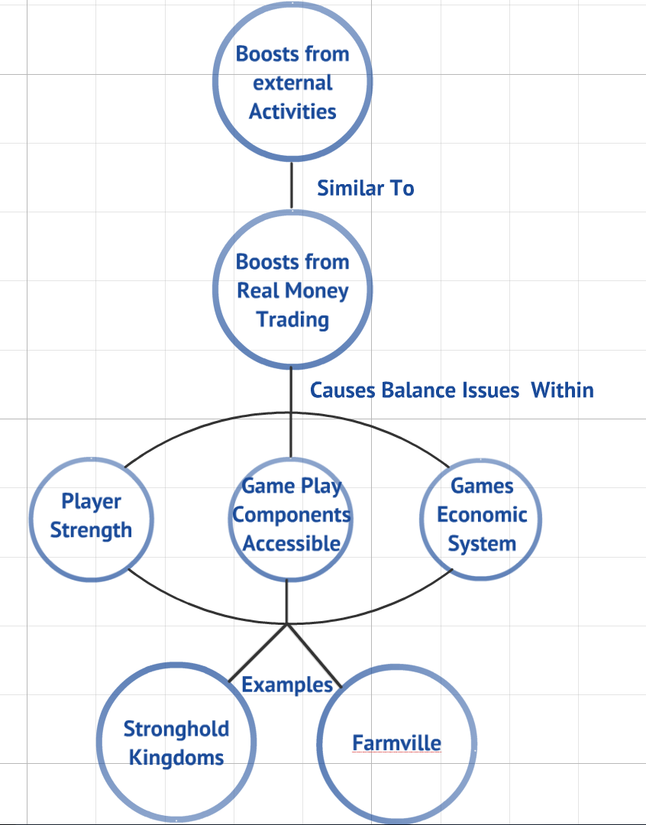

- Balance issues with overpowering players

- Money payers unbalancing the game by controlling the in-game experience.
- Long-term or permanent boosts can make players more powerful for long periods of time and can lead to players stacking boosts.
- Boosts that increase attack rather than defense can cause major imbalances within a games since a player can overwhelm another player with boosts.
- Boosts that allow for extra powers or abilities can lead to imbalance.

- Balance issues with access to in-game components

- Players want to be able to experience everything a game has to offer.
- Boosts within a game can provide access to special items, game components, or game environments.
- These extra game components and the effects of these game components can unbalance a player’s experience. It can also lead to balance issues based on unexpected results of these items in the game.

- Balance issues with a games economic system

- A games economy functions like a capitalist economy in which players improve through in-game advancement and trade.
- When boosts are added it can affect this capitalist economy dramatically since it is adding value and increased means of attaining value.
- This can cause balance issues. It is essentially taking a closed bubble, popping it, and exposing it to extra material. The results can be chaotic and destructive.

- Examples with balance issues created from real money purchases
  - Stronghold Kingdoms: Online resource and military building game in which money can buy premium access, powerful cards, and auto creation/planning. These features totally put the game in the hands of these money lenders which can raze anyone in their way.
  - Farmville: Online farm and money gathering game. Some players have spent over $2,000 on in-game purchases to allow them to reach level 111, 40 levels above the rank where leveling unlocks new game features.

Related reading:
- Forum post and accompanying thread regarding user-created content in D&D computer games
  - http://forums.ddo.com/showthread.php?t=254304
- Discussion on UGC
  - http://www.mpog.com/gamelist.cfm/game/447/view/forums/thread/338004/page/1
- Article on UGC in MMOs
  - http://www.theinquirer.net/inquirer/feature/1727926/mmo-games-user-generated-content
- Forum thread on UGC in MMOs, touching on CoH’s failure to prevent users from abusing the Mission Architect
  - http://www.mmorpg.com/discussion2.cfm/post/4910932/thread/347526#4910932
- MMORPG.com community spotlight on UGC in MMOs
  - http://www.mmorpg.com/blogs/staffblog/042012/23032_Community-Spotlight-User-Generated-Content-Yea-or-Nay
- Article on UGC in games and meaning to players
  - GDC: Chris Hecker Discusses User-Generated Content, Etcetera

