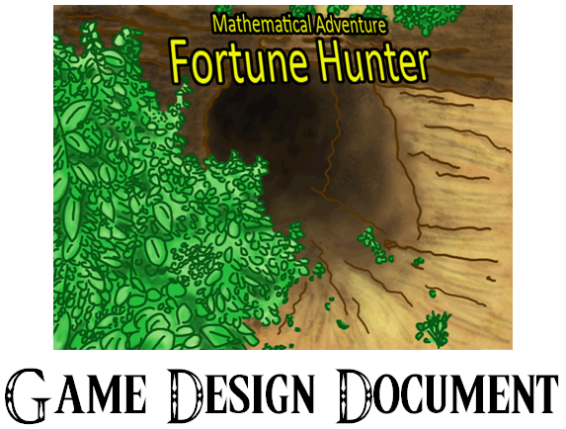

Fortune Hunter™ Game Design Document

Design Team

*Jonathan Meschino Eric Kenvin Mike DeVine*

*David Silverman Preston Johnson*

*Justin Lewis Kevin Hockey*

Table of Contents

[Introduction 6](#_Toc253773651)

[Objectives 7](#_Toc253773652)

[Terminology 8](#_Toc253773653)

[Game Mechanics 9](#_Toc253773654)

[Controls 9](#_Toc253773655)

[Console Input (default) 10](#_Toc253773656)

[Console Input (optional) 10](#_Toc253773657)

[Menu Systems 11](#_Toc253773658)

[Title Menu 11](#_Toc253773659)

[Pause Menu 14](#_Toc253773660)

[Character Select 14](#_Toc253773661)

[Game Over 15](#_Toc253773662)

[Stats / Inventory 15](#_Toc253773663)

[Combat Menu 15](#_Toc253773664)

[Shop Menu 16](#_Toc253773665)

[Player Perspective 17](#_Toc253773666)

[Dungeons 17](#_Toc253773667)

[Levels 17](#_Toc253773668)

[Elemental Dungeons 17](#_Toc253773669)

[Travel System 18](#_Toc253773670)

[Combat System 18](#_Toc253773671)

[Environment Interaction 19](#_Toc253773672)

[Cutscenes 20](#_Toc253773673)

[FMCs (Full Motion Comics) 20](#_Toc253773674)

[Amulet Search 21](#_Toc253773675)

[Combat 21](#_Toc253773676)

[Items 21](#_Toc253773677)

[Puzzles 21](#_Toc253773678)

[Shop 22](#_Toc253773679)

[Inventory 24](#_Toc253773680)

[Equipping / Using Items 24](#_Toc253773681)

[Equipping a Weapon / Armor / Accessory 24](#_Toc253773682)

[HUD – Heads Up Display 25](#_Toc253773683)

[Solving Puzzles 26](#_Toc253773684)

[Game Elements 26](#_Toc253773685)

[Main Characters 26](#_Toc253773686)

[Arith 26](#_Toc253773687)

[Lytic 26](#_Toc253773688)

[Feren 27](#_Toc253773689)

[Merchant 27](#_Toc253773690)

[Enemies (Bestiary) 27](#_Toc253773691)

[Bonesprout 27](#_Toc253773692)

[Boom Shroom 28](#_Toc253773693)

[Cave Yeti 28](#_Toc253773694)

[Cave Yeti (Juvenile) 28](#_Toc253773695)

[Dark Knight 28](#_Toc253773696)

[Dire Wolf 29](#_Toc253773697)

[Dire Wolf Lord 29](#_Toc253773698)

[Dragon Slug 29](#_Toc253773699)

[Flame Elemental 29](#_Toc253773700)

[Frost Giant 29](#_Toc253773701)

[Goblin 30](#_Toc253773702)

[Necromancer 30](#_Toc253773703)

[Orc 30](#_Toc253773704)

[Roseweaver 30](#_Toc253773705)

[Sacateran 31](#_Toc253773706)

[Stone Golem 31](#_Toc253773707)

[Undead Insurgent 31](#_Toc253773708)

[Volcanaboar 31](#_Toc253773709)

[Wake Angel 32](#_Toc253773710)

[Wind Elemental 32](#_Toc253773711)

[Wizard (Adept) 32](#_Toc253773712)

[Wizard (Master) 32](#_Toc253773713)

[Boss Enemies 33](#_Toc253773714)

[Beast King 33](#_Toc253773715)

[Bitter Biter 33](#_Toc253773716)

[Cave Yeti (Adult) 33](#_Toc253773717)

[Celestial Dragon 33](#_Toc253773718)

[Feren 34](#_Toc253773719)

[Feren (Akhalite) 34](#_Toc253773720)

[Great Skua 34](#_Toc253773721)

[Ice Golem 34](#_Toc253773722)

[Root Golem 35](#_Toc253773723)

[Sacatetra 35](#_Toc253773724)

[Serratula 35](#_Toc253773725)

[Undead Scourge 36](#_Toc253773726)

[Weapons 36](#_Toc253773727)

[Rusted Blade 36](#_Toc253773728)

[Great Sword 36](#_Toc253773729)

[Falcatta 36](#_Toc253773730)

[Sun & Moon Daggers 37](#_Toc253773731)

[Crescent Sword 37](#_Toc253773732)

[Cardinal 37](#_Toc253773733)

[Solar & Lunar Blades 37](#_Toc253773734)

[Armor 37](#_Toc253773735)

[Earth Vest 38](#_Toc253773736)

[Wind Breaker 38](#_Toc253773737)

[Flame Leggings 38](#_Toc253773738)

[Dark Cowl 38](#_Toc253773739)

[Celestial Armor 38](#_Toc253773740)

[Accessories 38](#_Toc253773741)

[Jewel Shard 39](#_Toc253773742)

[Broken Hourglass 39](#_Toc253773743)

[Radiant Vial 39](#_Toc253773744)

[Tome of Honor 39](#_Toc253773745)

[Tome of Valor 39](#_Toc253773746)

[Items 40](#_Toc253773747)

[Remedy 40](#_Toc253773748)

[Elixir 40](#_Toc253773749)

[High Elixir 40](#_Toc253773750)

[Panacea 40](#_Toc253773751)

[Nostrum 41](#_Toc253773752)

[Ruby 41](#_Toc253773753)

[Sapphire 41](#_Toc253773754)

[Emerald 41](#_Toc253773755)

[Diamond 41](#_Toc253773756)

[Key Items 42](#_Toc253773757)

[Ancient Amulet 42](#_Toc253773758)

[Room Key 42](#_Toc253773759)

[Dungeon Key 42](#_Toc253773760)

[Currency 43](#_Toc253773761)

[Akhal 43](#_Toc253773762)

[Akhal (small) 43](#_Toc253773763)

[Akhal (large) 43](#_Toc253773764)

[Akhal (chest) 43](#_Toc253773765)

[Features 43](#_Toc253773766)

[LAN Cooperative Play 43](#_Toc253773767)

[Region Based Game Progression 44](#_Toc253773768)

[Explorer’s League – Networking Around the World 44](#_Toc253773769)

[XOME™ – Avatar Customization Feature 45](#_Toc253773770)

[Fortune Maker™ (Custom User Game Creation Feature) 45](#_Toc253773771)

[Developer Dungeon Creation 46](#_Toc253773772)

[Education 48](#_Toc253773773)

[Classroom Application 48](#_Toc253773774)

[Curriculum Elements 49](#_Toc253773775)

[Dungeon Guide 50](#_Toc253773776)

[Storyline 50](#_Toc253773777)

[Game Progression 51](#_Toc253773778)

[Main Menu –> New Game 52](#_Toc253773779)

[Dungeon 1 –> Level 1, Temple Main Hall 52](#_Toc253773780)

[Dungeon 1 –> Level 2, Transference Center 56](#_Toc253773781)

[Dungeon 1 –> Level 3, The Gauntlet 58](#_Toc253773782)

[Dungeon 1 –> Level 4, Nerve Block 58](#_Toc253773783)

[Dungeon 1 –> Level 5, Chamber of Trials 58](#_Toc253773784)

[Critical Path 58](#_Toc253773785)

[Main Menu 58](#_Toc253773786)

[Dungeon 1 –> Level 1, Temple Main Hall 59](#_Toc253773787)

[Dungeon 1 –> Level 2, Transference Center 61](#_Toc253773788)

[Dungeon 1 –> Level 3, The Gauntlet 63](#_Toc253773789)

[Dungeon 1 –> Level 4, Nerve Block 63](#_Toc253773790)

[Dungeon 1 –> Level 5, Chamber of Trials 64](#_Toc253773791)

# Introduction

Mathematical Adventure: Fortune Hunter™ draws on teaching children of a global scale fourth grade mathematics through the guise of a dungeon styled adventure game. Players will be able to explore dungeons and fight fearsome battles with various monsters, each pertaining to a unique mathematical concept. The player controls a protagonist that must progress through maze-like dungeons, solve puzzles / problems, and defeat enemies in a two dimensional world. It is a single player adventure with room for ad hoc cooperative play in the future.

MAFH™ follows the story of Arith, a determined young researcher dedicated to finding all of the world’s best hidden secrets. One day she stumbled across a piece of blank papyrus during the time she spent studying in Egypt on a dig site. She quickly brought it to her best friend and colleague, Lytic. They were determined to find out more about this strange paper, but the two could not unearth its secrets in such a short time. To them, it was just a blank piece of ancient material.

Two months later, the dig ever deeper into the earth, Arith noticed a faint glow emanating from a random pile of dirt. “What’s that over there?” she asked Lytic, who was standing nearby with his shovel. Digging it out, Lytic noticed that it was a small amulet. It let off the strangest beautiful teal glow. “Strange,” he remarked. Lytic stared deep into the light, his eyes widening as if in a trance. "Just what are you?" he questioned. The glow got even brighter and then went dim again. Now the amulet appeared to be as plain as any other stone. Confused, the two left the site to turn in for the night.

Upon bringing this find to back to their living quarters, Lytic tossed it lightly on the table. It landed near the old blank papyrus that Arith had found months earlier. The amulet began to glow again. This time, the papyrus wasn't blank. The light appeared to be the key and filled the papyrus with teal characters and symbols. The two stared amazed at the sight. Nothing made sense. It was no language they’d ever come across before. Upon closer inspection, only one thing was certain. The image of a giant pile of treasure, larger than anything you could imagine. The other familiar image was of a human mind with mathematical symbols surrounding it. Apparently, those who desired this treasure must be intelligent and versed in the ways of mathematics. There was one other hint on the old Egyptian paper. It was extremely cold to the touch. The two agreed this meant it must be somewhere on Earth in a very cold or dark place. At last, a massive treasure hunt was underway.

Four days after, Arith and Lytic found themselves in a strange place face to face with a mysterious and ancient building, relics in hand. “You wait here. I’ll go take a look around,” Arith told Lytic. “Okay. Good luck.”

Arith entered the chilly, dark structure alone; unaware of what lay in wait…

## Objectives

The objective of this game is to reiterate teachings of fourth grade mathematics to students in a fun and unique way, primarily through the use of creative interactive software. The project is intended to be used as supplemental material to classroom education. See the section labeled ‘Curriculum Elements’ for incorporated curriculum topics and a lesson plan to use in the classroom.

# Terminology

There are many vocabulary terms used throughout this document and the game. They are listed here for clarification and understanding.

* **Accessory**: An item that can be equipped for bonus affects.
* **Akhal**: The in-game currency units.
* **Amulet Search**: A search executed by using the amulet to uncover hidden secrets.
* **Armor**: An item that can be equipped for additional defense.
* **Attack**: What the player uses to deal damage to enemies.
* **Attack Power**: The strength of an attack. The higher the attack, the more damage dealt.
* **Basic Attack**: A very basic attack that deals a minimal amount of damage to enemies and is ineffective to most.
* **Bonus Power**: Additional affects added to the basic statistics of the player.
* **Boss**: This is a rather powerful enemy which requires completion of specialized problems found within the dungeon.
* **Combat**: A sequence in which the player must fight enemies.
* **Combat Timer**: This bar is found within battles and is a bonus effect timer for your current attack. It starts out full and slowly diminishes, decreasing the bonus effect over time.
* **Critical Attack**: An effective attack that gives the player the chance to deal additional damage to enemies providing the player solves a multiplication problem.
* **Cutscene**: A halt during game play to provide story elements and hints to the player.
* **Defense Power**: The ability to minimize damage dealt. The higher the defense, the less damage is received.
* **Damage / dmg**: The amount of health points lost during a successful attack.
* **Dungeon**: A series of levels connected to one another following the same theme, ending with a boss fight.
* **Enemy**: A hostile opponent faced in the game.
* **Equipment**: Refers to items that are currently equipped to the player for use.
* **FMC (Full Motion Comic)**: A video that interrupts game play to show story progression. This video is in the style of a motion comic.
* **FMV (Full Motion Video)**: A video that interrupts game play to show story progression. This video is in the style of a typical movie.
* **GB Mode**: Setup the XO monitor so it is raised and rotated 180\* and fold it back down into the XO. Use the directional pad and four buttons located on either side of the monitor for game input.
* **Health Meter**: This meter shows the current health status.
* **HP**: Health points. The player’s game is over when their health points reach zero.
* **HUD (Heads Up Display)**: Refers to the graphical elements presented on screen.
* **Inventory**: All of the items and equipment that the player is currently holding.
* **Item**: Usable items that can be used at any time and have various affects.
* **Key Item**: Important items found in the game required for progression.
* **Level**: A map consisting of multiple rooms which the player must explore in order to find the exit.
* **Macro Map**: A larger version of the mini map. It allows players to see a greater area.
* **Magic Attack**: This type of attack requires the player to solve geometry and graphing related problems.
* **Mini Map**: A small on-screen map used for navigational purposes.
* **PC Mode**: Setup the XO monitor so it is open, with the keyboard to its front. Use the keyboard and touchpad for game input.
* **Shop**: In-game shop. The player can travel to the shop to purchase or sell items or equipment.
* **Special Attack**: This type of attack requires the player to solve fraction related problems.
* **Weapon**: An item that can be equipped for additional attack power.

# Game Mechanics

## Controls

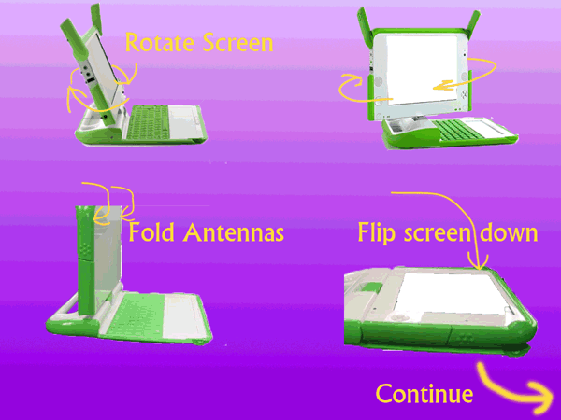

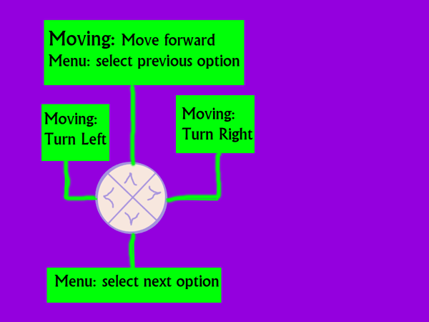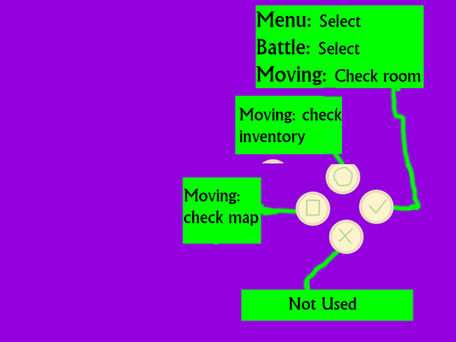

### Console Input (default)

Setup the XO monitor so it is raised and rotated 180 degrees and fold it back down into the XO. Players will then utilize the directional pad and four buttons located on either side of the monitor for game input. This configuration is known as GB mode. The directional pad on the left of the monitor is used for movement and to change the cursor position when player input is necessary. Left and right will rotate the player’s orientation, while up will move the player in the faced direction. To the right of the monitor, buttonV.gif acts as a select tool in menus. While traveling around, buttonV.gif is used to activate the amulet and reveal hidden items within a room. buttonO.gif, buttonL.gif, and buttonX.gif vary depending on the activity / situation at hand and will be defined during. While traveling in the dungeon, buttonL.gif will show and hide the macro map, buttonX.gif will explain details of the current room, and buttonO.gif will bring up the game’s statistics menu.

### Console Input (optional)

Setup the XO monitor so it is open, with the keyboard to its front. Players will then utilize the keyboard and touch pad for game input. This configuration is known as PC mode. The touch pad, up, right, down, left keys, and W, A, S, D keys are used for movement. Players can point and click on on-screen elements to interact using the touch pad or simply move using the above-mentioned keys. The full keyboard is used when player input is necessary. The enter / return key acts as a select tool. Other keyboard functions will vary depending on the activity / situation at hand and will be defined during.

## Menu Systems

This game is primarily menu driven. As such there are many different available options.

### Title Menu

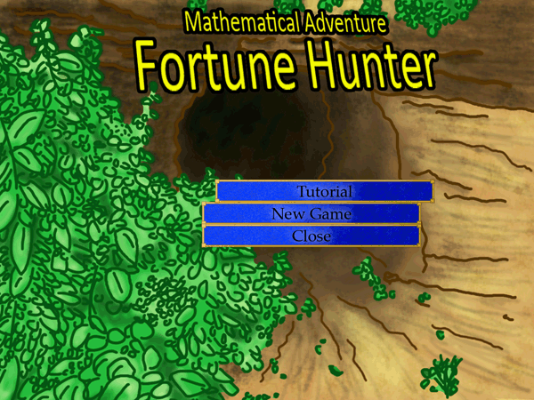

The title menu is the first screen you will be brought to after starting Fortune Hunter™. Here, you can change options, start game play, or exit Fortune Hunter™.

#### Adventure Play

Selecting *adventure play* will bring you to the adventure menu.

Select *continue* to resume game play from your most current save status.

Select *level select* to begin a game in any previously completed levels.

Select *load game* to load a different saved game profile.

Select *new game* to begin a new save profile and start the game from the beginning.

Select *return to title* to go back to the title menu screen.

#### Creative Play

Selecting *creative play* will bring you to the creative menu.

Select *play custom map* to play a map created using Fortune Maker™.

Select *new custom map* to quit Fortune Hunter™ in order to load Fortune Maker™.

Select *share map* to give or receive custom maps to friends.

Select *return to title* to go back to the title menu screen.

#### Network

Selecting *network* will bring you to the network menu.

Select *local treasure trekkers play* to launch a time trial version of Fortune Hunter™ with a friend.

Select *view scoreboard* to see the statistics and rankings of yourself and friends.

Select *return to title* to go back to the title menu screen.

#### Extras

Selecting *extras* will bring you to the extras menu.

Select *view bestiary* to see details of all the monsters encountered during your playthroughs.

Select *view awards* to see awards unlocked during your playthroughs.

Select *view statistics* to see your profile statistics.

Select *return to title* to go back to the title menu screen.

#### Options

Selecting *controls* launches an input setup guide to change or view your control scheme.

Selecting *options* will bring you to the options menu.

Highlight *language* to change the language settings.

Select *audio* to change audio volume or turn it off altogether.

Highlight *FMCs* to change the FMC settings on or off.

Highlight *subtitles* to change the subtitles settings on or off.

Highlight *cooperative play* to change cooperative settings on or off.

Select *credits* to roll the credits reel.

Select *about* to learn more about Fortune Hunter™ and see which version of the game you are running.

#### Exit Game

Selecting *exit game* closes the activity on the XO, returning the user to their home screen.

### Pause Menu

(update remaining menu systems)

The purpose of the pause menu is to allow the player to halt game play and save and/or exit the game.

The save option saves the game’s current progress and continues game play.

The save and quit option saves the game’s current progress and exits the game.

The quit without save option exits the game without saving the game’s progress.

#### Continue

The purpose of the continue menu is to allow the player to choose whether or not they wish to restart from where they left off last time or begin a previously completed dungeon over again.

The continue option begins a game from the most recent continue point.

The level select option begins a game from the beginning of the selected level.

The quit to title screen option will return the player to the game’s main title menu.

### Character Select

The character select screen is accessed any time a game is initiated. It allows the current player to choose between Arith or Lytic as the playable character. If a second player wishes to join a friend, they will assume control of the player not in use. The screen is split in two with an image representation of each character and their name. The player can then highlight and select the chosen character.

### Game Over

The game over screen will merely inform the player that their game has ended, should they choose to quit after being asked whether or not to continue.

### Stats / Inventory

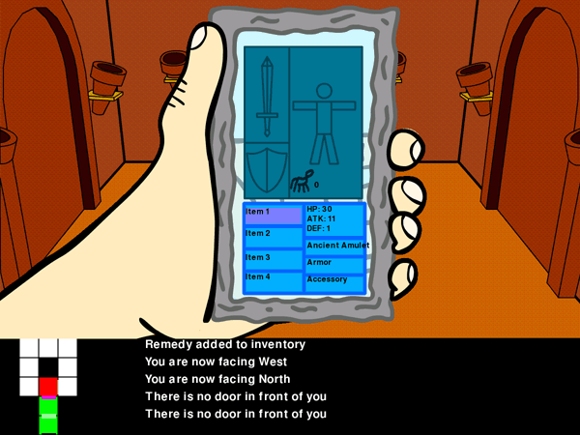

The purpose of the stats / inventory menu is to view the player’s current game statistics. This includes items such as money, items equipped, inventory, health points, or any other stat tied to the character.

The player may browse the inventory in order to use or equip items, armor, and weapons.

### Combat Menu

The combat menu gives the player many options when in a battle. It is subdivided further into smaller combat menus.

The main battle menu appears when the battle begins. From this menu, the player can choose to perform an attack, use an equipped item, or flee the battle. Choosing the basic attack option will launch a simple attack on the enemy. If the player gets a critical hit, they will be taken to the critical hit screen. The special attack option will launch a division based attack against the enemy. The magic attack will launch a geometry based attack. Choosing the use item option will take the player to the list of available items to choose from and use. Finally, the flee battle option will give the player a chance to flee the battle.

The critical hit screen also has some components to it. This screen is where a player is brought when they have a chance to get a critical hit. They are given a basic math problem (add, subtract, divide, multiply) and must solve it to gain additional damage to their attack. From this screen, an on-screen number pad will be available. Using this pad for input, players can input and submit their answer.

The use item screen will have all available items in battle listed so the player can choose which item to use. Afterwards and depending on the type of item, it will be removed from this list or faded out as items may only be used once per battle.

The special attack screen will have a selectable list of five fractions on screen. The player will then choose one and it will be replaced with another. Adding fractions with the chosen choices will result in the right or wrong answer. There will also be an undo option to backtrack the last few selections. There will also be a goal display. This has the target number or fraction the player is trying to reach and displays the chosen answers chronologically.

The magic attack screen will pose a geometry based problem utilizing geometry transformations with shapes as answer input. There will be a display with a graph for input use and a shapes pad with selectable shapes on it in addition to transformation buttons, such as move right, to transform the shape on the graph. The finish button can be selected once the player is happy with their answer and decides on being done.

### Shop Menu

The shop menu is comprised of a couple smaller menus. This is the menu the player will see while being in the shop. There is a buy menu, sell menu, and an exit option. If buy is chosen, a list of available purchases will be presented and the player can choose an item to add to their inventory in exchange for a fee (in-game currency).

If sell is chosen, a list of available sales (the player’s inventory) will be shown and the player can choose items to get rid of in exchange for money. Selecting the exit option will close out the shop and return the player to what they were previously doing.

## Player Perspective

The game follows a traditional first person perspective in a two dimensional world. Graphics have limited animation, thus each scene is a 'still' screen with minor animation. The player will be able to see the protagonists hand as well as the room and enemies that are currently present. FMCs feature a third person perspective of the characters and their interactions.

## Dungeons

A dungeon is just a fancy word we use to refer to a group of levels. You can think of each dungeon as its own story entity. Each dungeon consists of five or more levels and a boss type enemy. It is the player’s job to make it to the end of a dungeon to claim its treasure and be guided to the next dungeon. Each dungeon will be in a different geographical location on the globe as well.

### Levels

A level is a series of rooms that are strung together. You can think of levels as separate floors within a dungeon. Each room will have plenty of tasks for the player to complete such as combating an enemy, find hidden treasures, or solve puzzles. It is up to the player to find the exit for each level within the dungeon in order to get to the next one.

### Elemental Dungeons

Each dungeon will also have a natural element to tie it together with a nice theme. These elements are ice, fire, desert, jungle, and astral. Aside from the looks, enemies will also follow the theme. There may even be certain effects, limiting or changing game play in some manner.

## Travel System

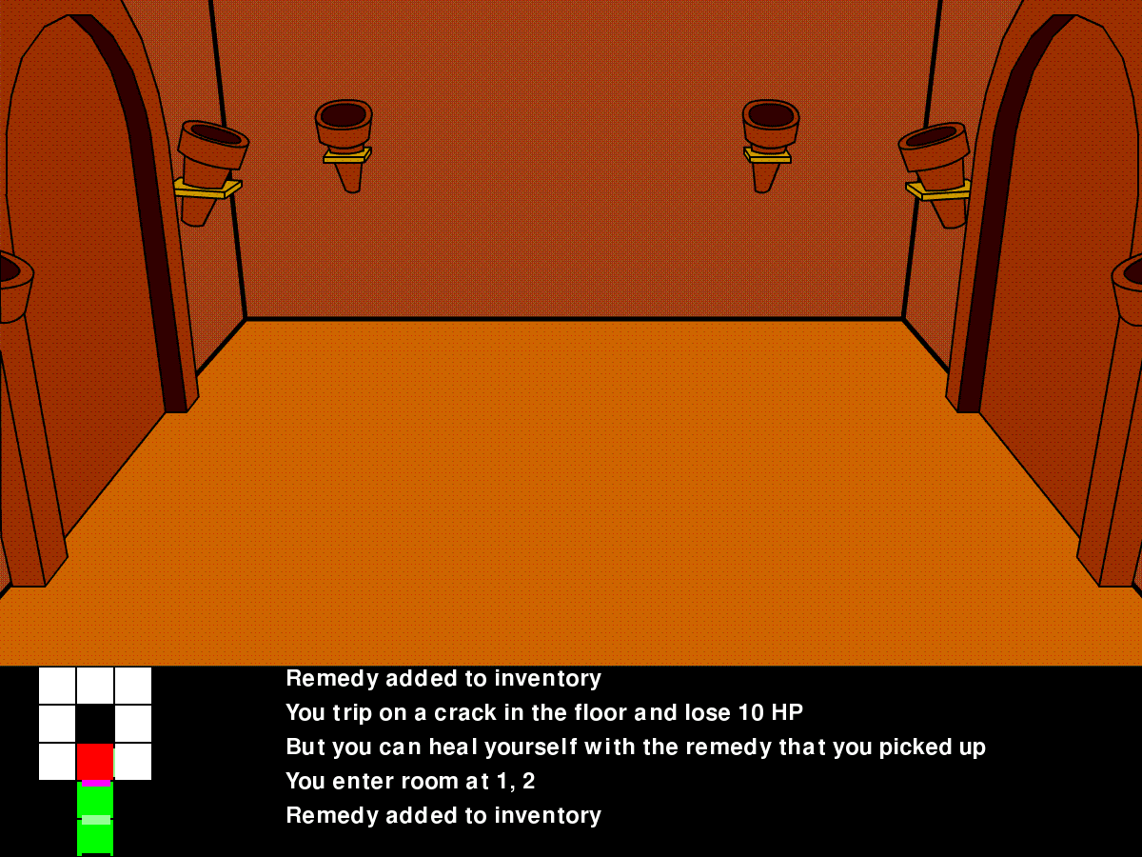

While in a room, players can change the direction they are facing (orientation) and choose the direction in which to travel. Players can move freely from room to room provided there are no locked doors along the way. These will require keys to be obtained first before continuing. Once they are unlocked the player may travel freely through them. Entering a room with enemies in it will automatically launch a battle (see Combat System). Otherwise, if there are items in the room, they can be collected. Sometimes there will be special events that will automatically occur upon entering a room. Players will end at a specially marked door, which will complete the level and take them to a new one.

## Combat System

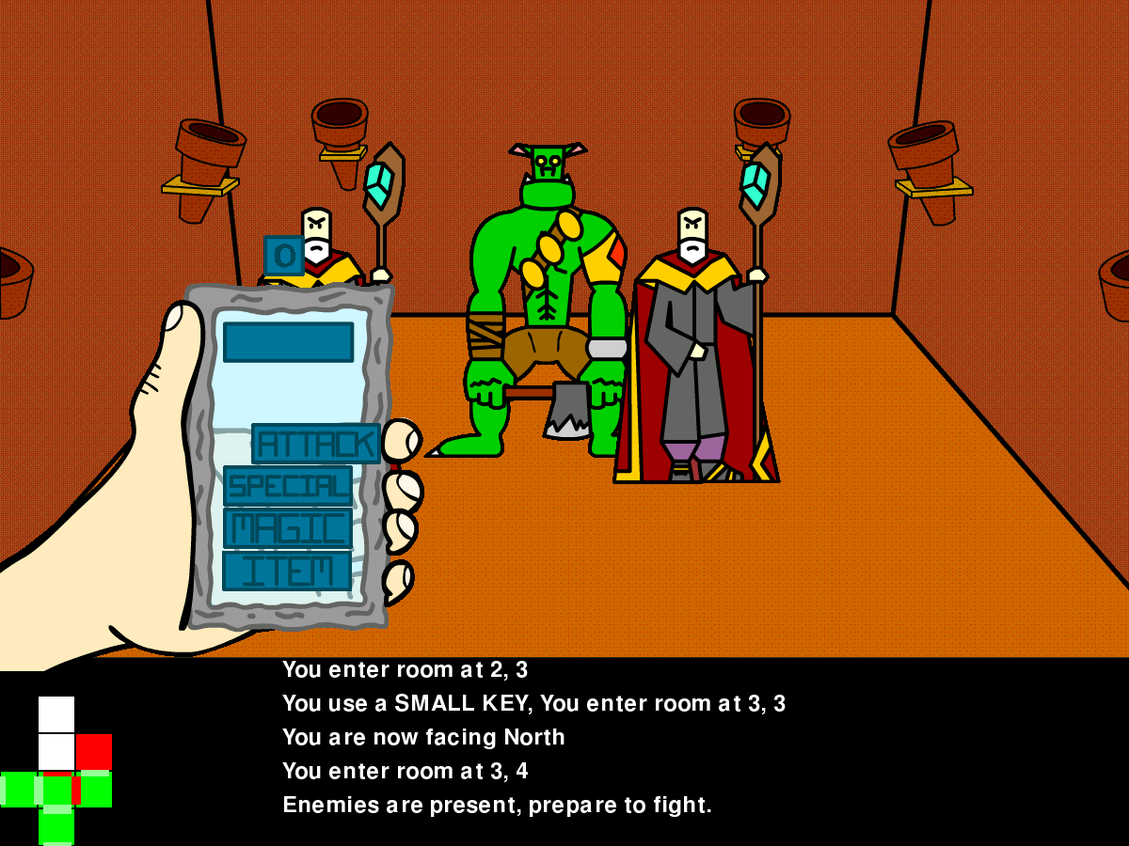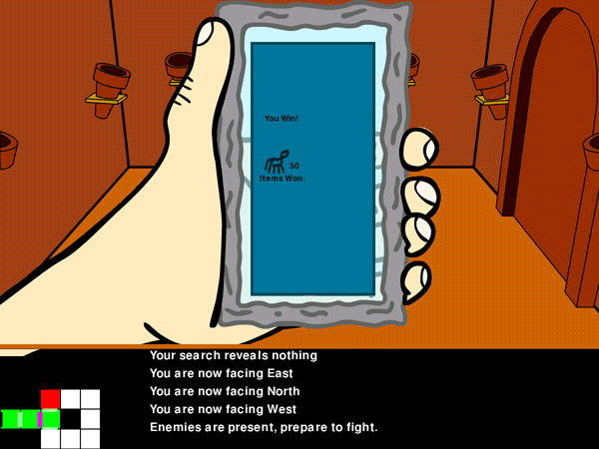

As soon as the player enters a room containing enemies, they will be forced into combat. Combat consists of a turn based attack system in which the player is able to choose an attack type (math topic) and execute it. Different attack types will do different actions, having the player solve various types of mathematics. The game’s input may change depending on the type of answer that is needed. The faster the player correctly answers, the more damage they will deal. The remaining time left on the timer at the end of a successful attack is directly added to the attack damage dealt to the enemy. This makes the player want to act faster in order to be more skillful at the game. Providing a wrong answer or running out of time allows the enemy to attack the player instead.

Time is determined by the player’s battle timer. A blue timer will appear on screen while an attack is active and constantly decrease. Time is up when this timer reaches zero. Enemies will also attack the player and diminish their HP. When their HP reaches zero, the player’s game will be over. Losing a battle will reset the player to the latest checkpoint position (usually the start of the current level), and force them to backtrack a little.

Defeating all opponents on screen will cause the battle to be over and the player will be deemed victorious. The victory screen will then open showing the player the spoils they have won for the battle, usually items and akhal (money). This will help the player in various ways to survive throughout the game. There are many types of enemies found within the various dungeons and it is up to the player to figure out how to most effectively defeat each one.

## Environment Interaction

### Cutscenes

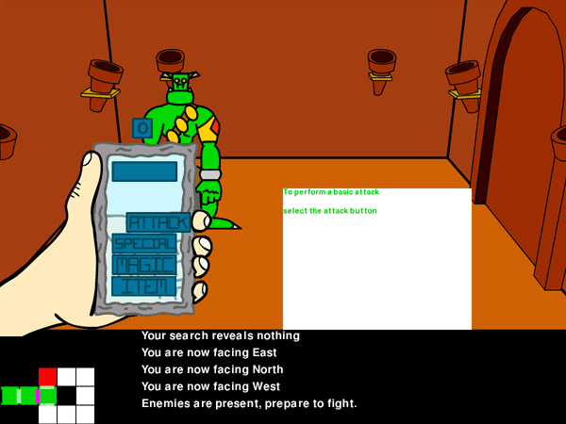

Cutscenes interrupt the game in order to explain something to the player. They often contain hints as to where to go or what to do next and are very helpful. They also progress the story arc. Cutscenes merely ‘pause’ movement while a message or action happens. The player then resumes control afterward.

### FMCs (Full Motion Comics)

Full motion comics are videos that interrupt the game to solely progress the story arc and generally handle more important events that are happening. Most games have full motion videos (FMV), which do the same in a more cinematic format. Fortune Hunter™ utilizes a comic book style cinematic sequence for a few reasons; it is a renowned art form and looks fantastic (especially on the XOs), it aids in reading skills and makes reading a more pleasant task, it drastically cuts down on the game’s required hard disk space, and the FMCs can remain within the scope of the art style of the game. The full motion comics also have voice over, so the player is essentially being read to while the words are presented in speech bubbles. On top of all of this, they are fun to watch and offer a brief break from game play.

### Amulet Search

In each room, the player may use the amulet to search for hidden items or clues. They do this by using the ancient amulet’s glow, which can be toggled on or off using the appropriate button for input. This allows them to further investigate rooms, even after they have already visited one. It is good practice to use this search often as the player will gain a great deal of collectibles to aid them through dungeons.

### Combat

Upon entering a room, there is a chance that enemies reside there. If enemies do exist in the room, the player will be forced into a skirmish in which they will have to answer and solve inherent math problems in order to deal damage. For more information regarding combat, please refer to the Combat System section.

### Items

In addition to purchasing items at the shop, items can be collected by being found among the rooms. Players can see visible items in the room if they exist and add those items to their inventory. In many rooms, there are also hidden items. These cannot readily be seen and the player must use the ancient amulet to reveal them. There are also key (important) items that are required to progress in the story. For instance, keys are needed to progress through locked doors. Players may also be asked to bring special items to certain areas. Finally, items may be obtained from combat victories. Winning battles will force the defeated enemies into handing over their possessions.

### Puzzles

Some rooms may contain puzzles. There are two forms of puzzles in Fortune Hunter™. The first is a puzzle door. Puzzle doors require the player to make an attempt at solving a puzzle in order to progress through that door. The player gets no penalties for inputting an incorrect answer and the puzzles primarily consist of those that can continue until solved properly (such as slider puzzles). The second form of puzzle in Fortune Hunter™ is a puzzle room. Puzzle rooms are more accurately represented as traps. The player is temporarily stuck in the room while trying to solve a usually timed puzzle. If the player does not succeed, they lose their game and must restart from the previous checkpoint. If they do succeed, they gain unlimited access to the room. Usually puzzles are in the way blocking shortcuts through a dungeon or rooms filled with rewards. In any case, keep your wits about you and solve those puzzles!

### Shop

Players can have access to an in-game shop by finding our friend, the merchant. He will be located in random rooms throughout the game. When the player encounters him, they will be able to open up a shop menu. From here, they may choose to buy or sell items. The merchant accepts akhals, which is fortunate because these coins are the available currency picked up in the dungeons. Use akhals to purchase various items or sell collectibles in exchange for more akhals. Upon selecting a desired item to buy or sell, the player can then input how many of the item he or she wishes to include in the deal. The merchant’s store will keep updating as the game progresses so be sure to keep an eye for new arrivals.

There is a trick to shopping with this merchant, however. He will attempt to confuse the players into being cheated out of their hard earned money. Everything available in the shop for purchase as well as selling has a suggested akhal value associated with it. The players are responsible for calculating their own deals with the merchant. He or the player can get the better end of things, so exercise caution when dealing with this slippery fellow. Don’t become a victim!

The shop may be set to different modes in Fortune Hunter™ through the title menu before game play starts. There are three primary behaviors of the merchant depending on which mode is selected.

*Consumer* mode is the easiest setting, virtually turning off the merchant’s ability to confuse the player. This will cause the shop interactions to be normal and fair representations of a store. They player will still be responsible for solving the mathematical aspects, but the merchant will aid the player through the process, not allowing for an incorrect input. Thus, the player will learn how to very accurately count their fortune. In a scenario, the player wishes to purchase four remedies at a suggested 20 akhal a piece. The merchant will ask for input from the player, who believes that the inherent problem of “4 x 20” is “100.” He inputs “100” as the answer. The merchant then says, “That will be 80 akhal please. Hey, wait a second. You gave me too much here. Could you count that again?” The merchant will ensure the player is accurate with the transaction so the deal is not tipped in anyone’s favor. The deal is always exactly what is stated.

*Trader* mode is a normal difficulty setting for the shop and set by default. This mode will cause the merchant to confuse players, attempting to elicit money from them. He will cloud their judgment in their calculations and attempt to cause the players to accept a corrupt deal. Players may also seek to do the same to the merchant while selling stock as well. In a scenario, if a player wishes to purchase four remedies, which are marked at a suggested 20 akhal a piece, they must inherently solve the multiplication problem “4 x 20”. The player knows that to be “80” and tells the merchant. Being a crafty individual, the merchant says to the player, “I don’t think so! You sure you know how to calculate math? 90 please. What do you think?” Well our player is no slump, so he offers “80” again. The merchant then retorts with, “Fine. I can see there’s no tricking you today. Here.” In this scenario, the player stuck to their roots to make a proper deal with the merchant. Things get rather tricky when the player is wrong. In this case, the merchant will (after the deal has been made) mention it to the player. “Ha ha, I just made an extra 20 akhal profit! Better luck next time.” The deal in this difficulty can go in anyone’s favor. The merchant is open to more types of trade and thus, the player can potentially take advantage of a more beneficial deal.

*Merchant* mode is a hard difficulty setting. The main difference here is that you may only encounter the merchant a limited number of times. After you reach this amount, he will no longer pay mind to you. This forces the players to make larger deals at a single time since they may no longer visit him as freely as they may need. In a scenario, the player wishes to purchase four remedies at a suggested 20 akhal a piece. Knowing the merchant is going no longer be available in the future, the player also figures he may as well purchase two elixirs at a suggested 30 akhal a piece. Rather than the inherent math being a simple multiplication problem (4 x 20), it has been forced to become a complex one (4 x 20 + 2 x 30). The same sort of dialogue transpires between the merchant and player as mentioned above in Trader mode. This time, though, the deals are more complex so there is more at stake. The merchant is more apt to accept deals that can heavily benefit the player. (more so than in Trader mode)

Happy shopping!

## Inventory

The player’s inventory is the place where they can store and view everything they have collected during their journey. The inventory menu houses your items, weapons, armor, and accessories to be equipped or used as well as any special story-sensitive items you pick up along the way. You can find out more information about each item and see what they do for you. It will help you familiarize yourself with the various treasures of Fortune Hunter™.

### Equipping / Using Items

It’s no secret that a well used item will keep the game going and the player performs all item actions in the inventory. While not engaged in a battle, the player may use as many items as desired. Simply highlight the desired item from the inventory list and select use from the menu. The player does not have full access to the inventory while in battle, however. In order to use an item while in combat, the player must have equipped it prior to the battle. This is done by, again, highlighting the item and selecting equip from the menu. Equipped items are available via the battle menu while in combat. Using an item in either scenario will cause the affects of the item to activate followed by the item being deleted or removed from the list. Certain items may be allowed to be used in combat without being depleted, but may only be utilized once per battle.

### Equipping a Weapon / Armor / Accessory

Similarly to equipping items, weapon, armor, and accessories must also be equipped in order to take advantage of the effects they grant to the player. To equip a weapon, armor, or accessory the player must first enter the inventory screen, highlight the item of choice, and select equip from the menu. Only one weapon, one armor piece, and one accessory may be equipped at any given time and they differ in effects so it is wise to switch them around as needed. While in combat, the effects of the weapons, armor, or accessory will be given to the player automatically. They will remain equipped until the player equips different equipment in their place or highlights the weapon, armor, or accessory from the equipment screen and selects unequip from the menu, sending the equipment back into the inventory list.

## HUD – Heads Up Display

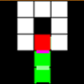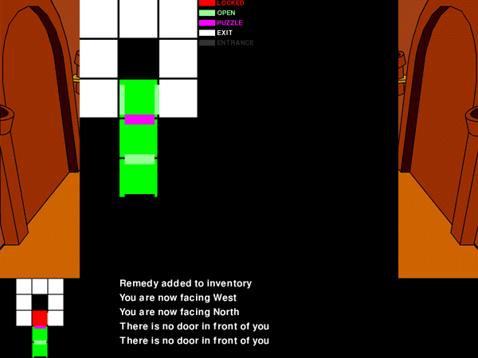

The heads up display in this game consist of few, simple elements. While in the world travelling from room to room, the player will have a travel indicator. This is a mini map on the lower left screen showing the players current location and orientation as well as rooms that were previously visited. The player also has the ability to view a larger scaled visual of this map so they may see a larger area of play. The player is represented by an arrowhead within the room and the door in which they came from has a light blue rectangular marker. Also, while travelling, the player has a vitality indicator. This shows the player’s current health status as either danger (red), fine (yellow), or good (green). This lets the player know what shape they are in just in case of another enemy encounter. Finally, there is a text feed of the area on the bottom of the screen, telling the player of any abnormalities or hinting them in the right direction for any given room.

While in a battle the heads up display differs. There is a more detailed vitality bar, showing the exact health of the player as well as the color indicators. There is also a battle indicator, which shows the battle timer while answering / solving a problem. The less this gauge depletes the more damage the player may deal to the enemy. It will begin to diminish as soon as the problem is presented to the player. When it fully empties, the player is out of the allotted time for inputting an answer and will take a hit from the enemy. The same will happen if the player inputs an incorrect solution. There will be text feed for the enemies as well, letting the player know information about them and possibly hints for defeating them.

## Solving Puzzles

In addition to the questions that must be completed in order to defeat enemies, there will also be an assortment of puzzles spread throughout a dungeon. These puzzles will be utilized in order to gain access to keys for passing through locked doors or even the solution of the puzzle itself will be the method for unlocking the door. Solving some will be optional while others will be required to progress.

# Game Elements

## lockedchar.gifMain Characters

### lockedchar.gifArith

Arith is the protagonist of the game. Her name comes from the root of the word arithmetic. She is curious by nature and a natural explorer. Her best friend and colleague, Lytic, also accompanies her on her journey. Together, they seek to find fortune and glory and put the evil Feren out of commission.

### lockedchar.gifLytic

Lytic is Arith’s best friend and partner. His name is derived from the word analytic. He is very adventuresome, however more cautious than his female counterpart. Feren causes plenty of trouble for these two during their journey and Lytic will stop at nothing to ensure he and Arith both make it out unscathed and richer.

### feren.gifFeren

Feren is the antagonist of the game. Little is known about Feren, including age and gender. Feren’s name is derived from the word differential. It is believed that Feren may know Arith or Lytic, as Feren seems to recall personal information regarding their pasts. Feren aims to stop the two from discovering the fabled treasure and hoarding it. Dark natured, Feren is a very dangerous and devious foe. There is lots to learn about this mysterious, shady character.

### lockedchar.gifMerchant

The merchant has no allegiance to anyone. The only thing he cares about is increasing the weight of his pockets. He enjoys bumping in to weary travelers and jumps and the opportunity to make a beneficial sale. He loves to cheat people who are off their game and will take advantage of many situations. Although he is a sneak, he is very handy for the protagonists, providing them with items, weapons, armor, and advice during their journey… for a substantial fee, of course!

## lockedbeast.gifEnemies (Bestiary)

Standard enemies are commonly found throughout the game and vary in difficulty.

### lockedbeast.gifBonesprout

It is unknown whether bonesprouts are animals or plants, as they grow from the ground and have the appearance of human skeletons. They cannot stand on those feet of theirs, but their body is fully functional and powerful. Bonesprouts also have a hardened exterior, making it difficult to inflict much damage.

### lockedbeast.gifBoom Shroom

They may look like harmless fungi but boom shrooms can attack at a distance, firing a cloud of fast-flying spores into their target. Once enough spores make contact, it’s only a matter of time before paralysis sets in and they move in for the kill. They are also noted for their disgruntled representation of a human face.

### lockedbeast.gifCave Yeti

Ranging in size from that of a chicken to a bear, cave yetis have a lot of potential for power. Smaller ones aren’t as dangerous, but the larger ones are. When threatened, these yetis stand on their hind quarters to appear larger and use their very long and heavy claws for hammering opponents. It is said that the original abominable snow yeti was just one of these creatures defending a nest. It scared the unknowing traveler senseless.

### lockedbeast.gifCave Yeti (Juvenile)

Same in appearance as the normal cave yetis, these yetis are much larger and a whole lot more dangerous! As intimidating as their size is, they have still not reached adulthood yet.

### lockedbeast.gifDark Knight

Ancient protectors of the dungeons, knights were once heralded as champions of the lands. Dark knights are spawned of every fallen knight who met an untimely end. They seek to destroy everything in their path.

### lockedbeast.gifDire Wolf

An ancient and extinct wolf species with a ravenous appetite. Remember wolves always travel in packs.

### lockedbeast.gifDire Wolf Lord

The alpha of the dire wolves. More vicious than the dire wolves, this wolf is stronger and faster.

### lockedbeast.gifDragon Slug

Gorgeous to look at, yes, but very dangerous to unsuspecting travelers. They aren’t terribly strong, but don’t let their size fool you. They pack quite a bit of energy in every bite and sting and should be handled with extreme caution.

### lockedbeast.gifFlame Elemental

Born from the flames of scorched earth, these elementals are defenders of the world. Wherever they go, the temperature will rise by hundreds of degrees. Be warned, they have the ability to ignite almost everything.

### frost_giant.gifFrost Giant

Cold by nature, these giants are very dangerous. They can use the power of ice to slow their enemies, making it easier for them to crush them.

### goblin.gifGoblin

Goblins are very old inhabitants of this dungeon. They are from the ancient world and survive in secret away from the prying eyes of the world. They have evolved slightly in intelligence as they are usually depicted, but are still ruthless and primitive. They are strong in numbers, but are normally weak creatures of habit.

### lockedbeast.gifNecromancer

These dark mages have the ability to call forth the dead to do their bidding. They are quite a sight, but keep in mind their real power lies within their minions. Defeat them as quickly as possible to stop the endless onslaught of undead they summon.

### orc.gifOrc

Orcs have existed for a very long time. They live with the goblins of this dungeon and their primary asset is brute strength. They lack in intelligence and are easily tricked or deceived.

### lockedbeast.gifRoseweaver

These feisty, intelligent creatures trick their enemies by luring them with a beautiful rose-like flower sprouting from their side. Primarily targeting smaller creatures, they will not stop at the chance of larger prey. Once the roseweaver’s target is close enough, they ensnare them with razor sharp thorns mounted on strong, thick vines, constricting the life out of their prisoner.

### lockedbeast.gifSacateran

These enormous insects generally travel in swarms, however it isn’t uncommon to come across one straggler in combat. They are excellent at picking away at their prey’s health as they are parasitic in nature. Their real strength lies in their adulthood when they mature into Sacatetras.

### lockedbeast.gifStone Golem

Extremely large in size, they appear to be made of unique stones with engraved symbols on them. They are very strong and have a high defense as well. Their weakness lies in their speed and agility.

### lockedbeast.gifUndead Insurgent

These rogues are simply skeletons with armor, making them harder to defeat. They have a wider range of attacks than most enemies, making them unpredictable. Be on your guard in all fronts when facing undead insurgents. They used to work for the undead scourge, but have since fled and survive on their own.

### lockedbeast.gifVolcanaboar

They appear harmless and are usually passive, but do not like unknown foreign invaders into their habitat. They will defend their homes in numbers, though they are generally on the weaker side.

### lockedbeast.gifWake Angel

These invisible enemies are masses of free forming energy that slightly resemble human shapes. They exist riding the wake of balanced energy that flows throughout all life and become enraged when this balance of energy is upset, taking more physical manifestations. In this state, they can be quite dangerous.

### lockedbeast.gifWind Elemental

The essence of wind, they are very strong. Wind elementals resemble tornadoes and can cause enormous pressure changes in nearby areas. They have a temper to match their erratic behavior.

### wizard.gifWizard (Adept)

The order of wizardry consisted of masters of magic and the elements, allowing them to communicate with their surroundings and cast magical based attacks. They are skilled at their craft and extremely knowledgeable. These wizards, however, have been cut off from the growing world for far too long and have lost touch with the foundation for their order, causing them to lash out at whatever creatures they encounter. They conjure up their own food for survival while stuck in this dungeon for all eternity.

### lockedbeast.gifWizard (Master)

Wizard masters are even strong than adepts with more powerful attacks and boast defensive magic as well. They are distinguished by their colorful, new robes.

## lockedboss.gifBoss Enemies

Boss enemies are usually very rare encounters in the game and offer larger rewards for defeating them. However, they are much tougher and more difficult in discovering and exploiting their weaknesses. Their mathematical principals serve as a unit overview.

### lockedboss.gifBeast King

The king of all beasts found within the dungeon. It has the ability to summon lesser beasts to attack with it. The beast king is exceedingly strong and has lightning fast reflexes. It only shows itself when it absolutely must accomplish tasks itself, when minions simply will not do.

### lockedboss.gifBitter Biter

A large creature with an angry personality. It is extremely powerful offensively. Try not to give it a chance to attack and keep an eye on those horns and teeth.

### lockedboss.gifCave Yeti (Adult)

These fully matured cave yetis are extremely powerful and massive in size. Approach them with the utmost caution. They also have the tendency to lure cave yetis from a nearby distance to reconcile and intrusions into their habitat.

### lockedboss.gifCelestial Dragon

As beautiful as this creature is, it is still a danger to travelers. This dragon holds power over the cosmos, protecting both time and space on the planet. It will only fight in self defense. It cannot be killed, but it is said defeating a celestial dragon in battle will yield an unimaginable reward that would protect anyone that happened survive the encounter. It also may grant the victor a small touch of its magical power.

### feren.gifFeren

Feren is a seemingly old foe of Arith and Lytic, having knowledge of their lives. Feren is very mysterious and dark and works to oppose the two adventurers and stops at nothing to make things difficult for them, even if that means many battles first-hand. What’s he hiding?

### lockedboss.gifFeren (Akhalite)

At last Feren reveals his true identity! He is truly fearsome. Absolute master of both magical and physical attacks, he deals massive blows to those who oppose him. Fed up with the events of story, he is ready to fight to the death. Good thing our heroes are also ready to end this, once and for all! It will take a true master of mathematics to defeat this king of destruction.

### lockedboss.gifGreat Skua

A gigantic skua with an extra bad temper. Watch out you don't take a 'beaking' from this bird! It is rather fast and difficult to fight.

### lockedboss.gifIce Golem

This ice behemoth is treacherous, freezing everything in its path and fighting with relentless ice attacks. It is made of solid, thick ice, causing most physical attacks to be virtually useless. As you can imagine, this will be one very cold fight.

### lockedboss.gifRoot Golem

Another behemoth, this time comprised of the earth. This golem is made entirely out of roots. It is generally passive by nature, but something’s not right in this dungeon. The root golem will ensnare any that seek to pass through its grotto. It can also sap the life from enemies, regenerating its own health over time.

### lockedboss.gifSacatetra

Only one queen to the sacaterans may be active at one time. Should multiple queens emerge, they must fight to the death. It is only the victor that can reap the benefits of ruling the sacaterans. Being a queen, sacatetra has the ability to summon minions to fight alongside her. She has many insect-oriented attacks that will leave her enemies weak and vulnerable. Her giant rock arms are heavy, sharp, piercing blades. As with all sacaterans though, the heaviness of her leaf wings make it impossible for them to be efficient fliers or make it very long distances without walking.

### lockedboss.gifSerratula

Serratula is a giant spider mutant. Her many eyes gives her the ability to foresee attacks and her many legs makes her powerful and fast. She is very dangerous and will fight with every ounce of energy once she has a fresh meal in her sights. Maybe it’s best to try and avoid her lair altogether.

### lockedboss.gifUndead Scourge

The scourge is nothing short of a small, precision army of undead. Once protectors of this realm, they were outlawed for reasons unknown and desire to take revenge on all living things that they encounter. Led by a royal undead, the most dangerous type, they all fight together simultaneously to make living difficult for their enemies.

## lockedweap.gifWeapons

Weapons are found or purchased in the game. They are solely responsible for improving the player’s attack power.

### lockedweap.gifRusted Blade

A rusty, very old blade. Adds +5 attack power.

### lockedweap.gifGreat Sword

A large, two handed sword with lots of power. Adds +15 attack power.

### falcatta.gifFalcatta

An ancient sword used by warriors. Adds +20 attack power.

### lockedweap.gifSun & Moon Daggers

These daggers are imbued with the power of the cosmos. +20 attack power. +5 defense. +5 combat timer.

### lockedweap.gifCrescent Sword

A strong and fast sword with a curved blade. +25 attack power.

### lockedweap.gifCardinal

A very well built blade that is both quick and extremely powerful. It also provides a small amount of defense. +35 attack power. +5 defense.

### lockedweap.gifSolar & Lunar Blades

The shape of these blades resembles something familiar. They are of unknown original and have massive strength and good defensive capabilities. +50 attack power. +15 defense.

## lockedarm.gifArmor

Armor is found or purchased in the game. It is solely responsible for improving the player’s defensive capabilities.

### lockedarm.gifEarth Vest

A ratty old vest made of natural materials. +5 defense.

### lockedarm.gifWind Breaker

Thick armor made from durable material. +15 defense.

### lockedarm.gifFlame Leggings

Strong, durable leggings imbued with the essence of fire. +25 defense.

### lockedarm.gifDark Cowl

A dark, gloomy cowl. It appears to have some sort of power. +35 defense. +5 HP.

### lockedarm.gifCelestial Armor

An incredibly strong armor set made from the essence of the stars. +50 defense. +20 HP. +5 BT.

## lockedaccs.gifAccessories

Accessories are found or purchased in the game. They generally add additional or unusual affects to help the player and are more rare than weapons or armor.

### lockedaccs.gifJewel Shard

A broken jewel piece with unnatural powers. +10 special attack.

### lockedaccs.gifBroken Hourglass

A cracked hourglass. Time itself seems to have been altered. +10 BT.

### lockedaccs.gifRadiant Vial

An empty, shimmering vial with unnatural healing powers. +20 HP.

### lockedaccs.gifTome of Honor

A large book filled with useful fighting knowledge. It is said that it grants the user better offense in battle. +20% attack power.

### lockedaccs.gifTome of Valor

A large book filled with useful fighting knowledge. It is said that it grants the user better defense in battle. +20% defense.

## lockeditem.gifItems

Items are objects found in the game that grant the user a one-time effect such as regaining lost health points. They are generally consumed after use.

### lockeditem.gifRemedy

A remedy is used to regain lost health points. They are fairly common on your quest. Restores 5% max health points. Buy for 20\*. Sell for 2\*. Max carried 20 remedies.

### lockeditem.gifElixir

An elixir is used to regain lost health points. They refill more health points than a remedy and are less common on your quest. Restores 15% max health points. Buy for 60\*. Sell for 10\*. Max carried 20 elixirs.

### lockeditem.gifHigh Elixir

A high elixir is used to regain lost health points. They refill more health points than an elixir and are rare on your quest. Restores 40% max health points. Buy for 100\*. Sell for 20\*. Max carried 20 high elixirs.

### lockeditem.gifPanacea

An panacea is used to regain lost health points. They refill more health points than a high elixir and are very rare on your quest. Restores 80% max health points. Buy for 150\*. Sell for 50\*. Max carried 20 panaceas.

### lockeditem.gifNostrum

They said the merchant was crazy, but look at what he’s concocted now! A nostrum is used to regain lost health points after being defeated. It is automatically used on those who are about to give up their ambitions. Extremely rare to find on your quest. Restores 50% max health points when health points reach 0. Auto-use. Buy for 250\*. Sell for 100\*. Max carried 5 nostrums.

### lockeditem.gifRuby

A large, beautiful ruby… Sells for 500\*. Also grants the barer a magic flame attack.

### lockeditem.gifSapphire

A large, deep sapphire… Sells for 500\*. Also grants the barer a magic water attack.

### lockeditem.gifEmerald

A large, radiant emerald… Sells for 500\*. Also grants the barer a magic earth attack.

### lockeditem.gifDiamond

A large, shimmering diamond… Sells for 500\*. Also grants the barer a magic ice attack.

## lockedkey.gifKey Items

Key Items are items that are found in the game that will not be removed from the inventory after use. These items are important and usually involved in the main story line and necessary for game completion.

### lockedkey.gifAncient Amulet

This is the very same amulet Arith stumbled across during her initial dig at the start of her journey. It possesses untold energy and makes for a great reading light, as it has the ability to uncover hidden secret texts if shone on the right surface.

### lockedkey.gifRoom Key

A room key is important for passing through locked doors. They are hidden and scattered throughout the dungeons and must be found in order to progress to locked or hidden areas. One room key is expelled for each lock that requires one.

### dungeon_key.gifDungeon Key

A dungeon key is important for exiting a dungeon. They are hidden in each dungeon and must be found in order to progress to the next level. They are usually guarded by tougher enemies.

## lockedakh.gifCurrency

### akhal.pngAkhal

Akhal are the in-game currency units. They most closely resemble golden coins with engravings of a horse and unknown language in them. They are named for a special breed of horse, known as the 'golden horse'.

### lockedakh.gifAkhal (small)

Akhal (small) is worth one akhal. They are found everywhere on your journey. +1 \*.

### lockedakh.gifAkhal (large)

Akhal (large) is worth ten akhal. They are found everywhere on your journey. +10 \*.

### lockedakh.gifAkhal (chest)

Akhal (chest) is worth one hundred akhal. They are uncommon on your journey. +100 \*.

# Features

## LAN Cooperative Play

Tired of exploring alone? Share the Fortune Hunter™ activity running on your XO with a friend and let them take control of your legendary partner, Lytic. Together, players can explore the dungeons and face challenging foes, doubling the odds for survival. Players may also help each other out and work together to solve problems and find the hidden treasures. Two is better than one.

This feature is coming at some point in the future and as such, details are currently unavailable. More information will be presented when development is further along.

## Region Based Game Progression

Choosing a region at the start of a game play through will change the progression of the game. Depending on which region is chosen, the game will take the player down different paths, altering the natural order of dungeon progression. Regardless of the region, however, the player will always end up at the same final dungeon. The player will be able to travel to all of the regions during a game and visit many areas around the world. Regions are also divided into very large areas, as to not cause any tensions among countries or areas where being specific may prove offensive. The entire earth is covered in the game. Regions will be described in the game during selection so the player knows which region they belong to, should they want to choose it.

## Explorer’s League – Networking Around the World

The Explorer’s League is a term referring to the online network database for Fortune Hunter™. Players can connect online to see how other classrooms and schools are progressing in Fortune Hunter™ and may also talk about the game with people from all over the world! The more we share, the more fun we have.

This is a future development goal and is not currently implemented. More information and details will become available upon progression of this feature.

## XOME™ – Avatar Customization Feature

XOME™ (pronounced as English ‘home’) is an avatar customization feature that lets the player have a customized avatar to represent them in the game. The avatar is comprised of the XO logo symbol, but can be dressed up with various costumes and paraphernalia to add a personal touch to the player’s persona. These avatars will also be shown online in the Explorer’s League as well as be visible to friends when playing together.

It is planned that there will be a light version of this feature so that it does not expand the game’s physical memory size too drastically. The light version will have fewer choices of customizable parts and the heavier version of this feature is always an option, providing there is enough room on the hard disk drive where the game directory is installed to.

More information and details will become available when this feature is in production.

## Fortune Maker™ (Custom User Game Creation Feature)

Make your own fortune with Fortune Maker™! This feature is a separate XO activity and will give teachers and students the ability to create and manipulate their own version of the game, choosing such things as level layout, problem enemy types, and game difficulty. This activity is an easy to use graphical interface creation tool that works hand in hand with the game to inspire creativity in all users up for the task.

When opening Fortune Maker™, you will come to the main screen. Fill out the form with a dungeon name, width and height, and description. Then click on the ‘create’ button. The next screen will show a grid layout of the dungeon. From here, you will be able to specify room conditions by dragging and dropping items from the toolbar. You can add doors, enemies, and items to each room as well as specify any special conditions for the room such as puzzles or adding a shop. Once you are happy with the room, you can back out and do the same with every other room. From here, you can edit the properties of each element. When you are happy with your dungeon, you can click on the ‘save dungeon’ button. Fortune Maker™ will then generate an output file that the game itself can read and interpret. You will then be able to play your own custom maps or stories!

## Developer Dungeon Creation

This work-in-progress feature allows developers to easily create custom maps using a flagged input string method into a text (.txt) document. Each dungeon is represented by a separate file. The 21 digit per room string is broken up into input flags and are labeled as follows. Also note that quotation marks “” are not used in the actual input file.

In order to explain the string, it will be broken up into segments. The final string will have no indicators of these different segments and will be written as one continuous entity.

Segment A – Door declaration: *01234567*

Doors locations and conditions are declared here. They are always handled in the order of North, South, West, and East, and are defined in specific string character positions. Position 0, 2, 4, and 6 can either be a value of ‘0’ for “no door” or ‘N’, ‘S’, ‘W’, or ‘E’, respectively for “a door” at the given direction. A string with a basic door on each wall would look like “N0S0W0E0”. The flags for each door are specified to give the door special properties. These flags fill the remaining positions of the string in positions 1, 3, 5, and 7. Each flag pertains only to the door preceding it. A door must always be specified with a following flag. The flags are as follows. Use ‘u’ for an unlocked door (this is the default), ‘l’ for a locked door, ‘p’ for a puzzle door, ‘b’ for a locked puzzle door, ‘e’ for a dungeon entrance door, or ‘x’ for a dungeon exit door. A basic unlocked door on each wall would look like “NuSuWuEu”. Note that rooms must be capitalized and flags must be lower cased.

Segment B – Special conditions: *8*

Special conditions for the room are specified with this character. Use ‘M’ to have a merchant present in the room or ‘P’ for a puzzle room. Note that this character must be capitalized.

Segment C – Enemy declaration: *9ABC*

Enemies will be declared in this portion of the string using given identification numbers to represent each one. Each character represents an enemy position in the battle, with a maximum of four enemies. To have an enemy in positions A and B, the string would look like “0110”. The list of enemy identification numbers will be available in the future.

Segment D – Item declaration: *DEFGHIJK*

Item declaration is noted in the last 8 characters of the room input string. The items will also have identification numbers (like the enemies). There may be a maximum of four items in a room and they are declared in positions D, F, H, and J of the string. The remaining positions of E, G, I, and K are flags for whether or not the preceding item is visible or a hidden item. This is done with a ‘v’ for visible or a ‘h’ for hidden. Note that these flags must be lower cased. A string with two visible items and one hidden item would look like “1v1v1h00”.

The full string compiles as follows: “0123456789ABCDEFGHIJK”

Sample null string, also used for an empty room: “000000000000000000000”

The very first line of the text file is the name of the level. This can be anything.

The second line is the level ID number. (found in XO metadata, auto-generated by Fortune Maker™)

The third line of the text file is where the room dimensions are written in the format of column by row (CxR).

The fourth line is the theme ID number. ‘0’ is the default level theme type.

The fifth line is the next-level ID number. The exit to this level will link to the entrance of the next level.

Finally, each additional line represents the rooms contained in the level. Each room will be listed in the text file on a separate line. Rooms are represented from left to right, top to bottom in order.

Here is a quick reference for writing these strings. ‘( )’ indicates one string element as each option is contained within. Remember that ‘0’ is used as a default and placeholder and ‘#’ represents an enemy / item ID tag.s

“(N) (ulpbex) (S) (ulpbex) (W) (ulpbex) (E) (ulpbex) (MP) (#) (#) (#) (#) (#) (vh) (#) (vh) (#) (vh) (#) (vh)”

**To see what a full dungeon input text file looks like, here is the input to Dungeon 1, Level 1 of Fortune Hunter™.**

“My Level Name

ae27872adf6123e023f89a650a6b3c7b96e85fca

3x5

0

edee9402d198b04ac77dcf5dc9cc3dac44573782

Nx0000Eu000001v000000

0000WuEu0110000000000

00Su00Eu000001h000000

00Su0000000001v000000

000000000000000000000

NuSb0000000001h1h0000

Nu0000Eu0100000000000

00SpWuEu000001v000000

Nb00Wu000000000000000

000000000000000000000

NpSu0000000001v000000

000000000000000000000

000000000000000000000

NuSe00000000000000000

000000000000000000000”

# Education

## Classroom Application

This game will be used to assist with math topics taught in the classroom and will be excellent reinforcement material. The lesson plan can be found at <http://wiki.sugarlabs.org/go/MPG/LessonPlan>.

## Curriculum Elements

This game covers elements of the fourth grade math curriculum currently in use at Boston, MA, USA. The complete listing of the curriculum can be found at <http://wiki.sugarlabs.org/go/Math4Team/Resources/Curriculum_Chart>. The following topics are covered in this game activity.

|  |  |
| --- | --- |
| NUMBER SENSE AND OPERATIONS |  |
| **4.N.3** | Demonstrate an understanding of fractions as parts of unit wholes, as parts of a collection, and as locations on the number line. |
| **4.N.4** | Select, use, and explain models to relate common fractions and mixed numbers (1/2, 1/3, 1/4, 1/5, 1/6, 1/8, 1/10, 1/12, and 11/2), find equivalent fractions, mixed numbers, and decimals, and order fractions. |
| **4.N.5** | Identify and generate equivalent forms of common decimals and fractions less than one whole (halves, quarters, fifths, and tenths). |
| **4.N.6** | Exhibit an understanding of the base ten number system by reading, naming, and writing decimals between 0 and 1 up to the hundredths. |
| **4.N.9** | Select, use, and explain the commutative, associative, and identity properties of operations on whole numbers in problem situations, e.g., 37 x 46 = 46 x 37, (5 x 7) x 2 = 5 x (7 x 2). |
| **4.N.11** | Know multiplication facts through 12 x 12 and related division facts. Use these facts to solve related multiplication problems and compute related problems, e.g., 3 x 5 is related to 30 x 50, 300 x 5, and 30 x 500. |
| **4.N.12** | Add and subtract (up to five-digit numbers) and multiply (up to three digits by two digits) accurately and efficiently. |
| **4.N.14** | Demonstrate in the classroom an understanding of and the ability to use the conventional algorithms for addition and subtraction (up to five-digit numbers), and multiplication (up to three digits by two digits). |

|  |  |
| --- | --- |
| GEOMETRY |  |
| **4.G.1** | Compare and analyze attributes and other features (e.g., number of sides, faces, corners, right angles, diagonals, and symmetry) of two- and three-dimensional geometric shapes. |
| **4.G.3** | Recognize similar figures. |
| **4.G.4** | Identify angles as acute, right, or obtuse. |
| **4.G.7** | Describe and apply techniques such as reflections (flips), rotations (turns), and translations (slides) for determining if two shapes are congruent. |
| **4.G.9** | Predict and validate the results of partitioning, folding, and combining two- and three-dimensional shapes. |

|  |  |
| --- | --- |
| MEASUREMENT |  |
| **4.M.2** | Carry out simple unit conversions within a system of measurement, e.g., hours to minutes, cents to dollars, yards to feet or inches, etc. |

# Dungeon Guide

## Storyline

MAFH™ follows the story of Arith, a determined young researcher dedicated to finding all of the world’s best hidden secrets. One day she stumbled across a piece of blank papyrus during the time she spent studying in Egypt on a dig site. She quickly brought it to her best friend and colleague, Lytic. They were determined to find out more about this strange paper, but the two could not unearth its secrets in such a short time. To them, it was just a blank piece of ancient material.

Two months later, the dig ever deeper into the earth, Arith noticed a faint glow emanating from a random pile of dirt. “What’s that over there?” she asked Lytic, who was standing nearby with his shovel. Digging it out, Lytic noticed that it was a small amulet. It let off the strangest beautiful teal glow. “Strange,” he remarked. Lytic stared deep into the light, his eyes widening as if in a trance. "Just what are you?" he questioned. The glow got even brighter and then went dim again. Now the amulet appeared to be as plain as any other stone. Confused, the two left the site to turn in for the night.

Upon bringing this find to back to their living quarters, Lytic tossed it lightly on the table. It landed near the old blank papyrus that Arith had found months earlier. The amulet began to glow again. This time, the papyrus wasn't blank. The light appeared to be the key and filled the papyrus with teal characters and symbols. The two stared amazed at the sight. Nothing made sense. It was no language they’d ever come across before. Upon closer inspection, only one thing was certain. The image of a giant pile of treasure, larger than anything you could imagine. The other familiar image was of a human mind with mathematical symbols surrounding it. Apparently, those who desired this treasure must be intelligent and versed in the ways of mathematics. There was one other hint on the old Egyptian paper. It was extremely cold to the touch. The two agreed this meant it must be somewhere on Earth in a very cold or dark place. At last, a massive treasure hunt was underway.

Four days after, Arith and Lytic found themselves in a strange place face to face with a mysterious and ancient building, relics in hand. “You wait here. I’ll go take a look around,” Arith told Lytic. “Okay. Good luck.”

Arith entered the chilly, dark structure alone; unaware of what lay in wait…

## Game Progression

Each dungeon will introduce a distinct mathematical concept, and each dungeon will be comprised of several levels of increasing difficulty.

At the beginning of each level the player will face the entrance of the dungeon. In each room if there are no enemies left, the player will have a decision as to where to go next based on what room in the dungeon they are in and how many exit doors they have available.

As the player moves through the dungeon, they will face enemies which they will have to fight by solving math problems. If the player answers enough questions correctly in a battle, they will win the battle. However, if they continue to answer questions wrong, they will be damaged and eventually die. When the player dies, they will be given the option to quit to the main screen or to restart the level. Once the player answers enough math problems correctly or defeats enough enemies, they will be granted access to the dungeons key, which will let them move on to the next level.

When the player reaches the end of most dungeons, they will encounter a boss that will confront them with numerous timed math problems to ensure mastery of the dungeon's concepts.

A player's game is completed when they find all of the fortune hidden within each dungeon level and defeats the main game boss.

### Main Menu –> New Game

#### FMV I – Feels Like Adventure

Having found the amulet, Arith and Lytic find the temple and a way in. They both have a bad feeling about entering and are freezing cold.

### Dungeon 1 –> Level 1, Temple Main Hall

#### Cutscene I – Crash Course (Dungeons)

Our player gets an explanation of dungeon systems.

#### FMV II – Where Do You Put the Batteries?

A legendary, ancient calculator is found by our legendary, not-so ancient heroes.

#### Cutscene II – Crash Course (Menu Screen)

Our player gets an explanation of the menu screen and its available options.

#### Cutscene III – Crash Course (Room Changing)

Our player gets an explanation of changing rooms.

#### Cutscene IV – Crash Course (Inventory)

Our player gets an explanation of items and the inventory screen.

#### Cutscene V – Crash Course (Health Points)

Our player gets an explanation of how health points work.

#### Cutscene VI – Crash Course (Puzzle Doors)

Our player gets an explanation of puzzle doors.

#### Cutscene VII – Crash Course (Orientation)

Our player gets an explanation of changing directions (orientation).

#### Cutscene VIII – Crash Course (Equipment)

Our player gets an explanation of using equipment.

#### Cutscene IX – Crash Course (Combat)

Our player gets an explanation of combating enemies.

#### Cutscene X – Crash Course (Room Keys)

Our player gets an explanation of room keys.

#### Cutscene XI – Crash Course (Locked Doors)

Our player gets an explanation of locked doors.

#### Cutscene XII – Crash Course (Hidden Secrets)

Our player gets an explanation of using the amulet to uncover hidden secrets.

#### FMV III – On the Right Track

Arith and Lytic find clues that let them know they are on the right track to the treasure they seek.

#### Cutscene XIII – Crash Course (Dungeon Keys)

Our player gets an explanation of dungeon keys.

#### Cutscene XIV – Crash Course (Dungeon Completion)

Our player gets an explanation of completing dungeons.

### Dungeon 1 –> Level 2, Transference Center

#### Cutscene XV – Crash Course (Currency)

Our player gets an explanation of how the in-game currency system works.

#### Cutscene XVI – Crash Course (Boss Battles)

Our player gets an explanation of boss battles.

#### Cutscene XVII – Crash Course (Puzzle Rooms)

Our player gets an explanation of how puzzle rooms work.

#### FMV IV – Almost Isn’t Good Enough

Arith and Lytic meet the strange travelling merchant.

### Dungeon 1 –> Level 3, The Gauntlet

Being updated…

### Dungeon 1 –> Level 4, Nerve Block

Being updated…

### Dungeon 1 –> Level 5, Chamber of Trials

Being updated…

Multiple endings / extended story line ending?

## Critical Path

### Main Menu

Once the title screen appears, scroll to the 'NEW GAME' option and push the select button to begin your quest.

**FMV I – Feels Like Adventure**

### Dungeon 1 –> Level 1, Temple Main Hall

The main door closes behind Arith and Lytic as they begin their trek into the temple.

As they enter the first room, room 1, an explanation of dungeons interrupts the game to explain how the levels will work.

**Cutscene I – Crash Course (Dungeons)**

Afterward, a FMV sequence will begin in which the heroes find the calculator.

**FMV II – Where Do You Put the Batteries?**

Following the FMV, a cutscene will occur explaining the menu screen.

**Cutscene II – Crash Course (Menu Screen)**

Immediately after, an explanation of traveling between rooms occurs.

**Cutscene III – Crash Course (Room Changing)**

When the explanations are over, walk into the north room to continue.

In room 2, the protagonists trip and fall on a crack in the floor, losing health. Fear not. There is a potion just sitting on the floor, free to take. Upon receiving the item, an explanation of items and their usage will occur.

**Cutscene IV – Crash Course (Inventory)**

A freebie potion will be given to you to use and replenish your missing health, followed by an explanation of how health points work.

**Cutscene V – Crash Course (Health Points)**

When you try to enter the next room, an explanation of puzzle doors will happen.

**Cutscene VI – Crash Course (Puzzle Doors)**

After it is over, you will have to solve the game’s first puzzle in order to progress to the north room.

Room 3 is the first room with two exit options as there is a door to the west and east. An explanation of changing directions (your orientation) will occur.

**Cutscene VII – Crash Course (Orientation)**

After the explanation ends, you will notice the game’s first weapon item sitting in the room. An explanation of equipping weapons and armor will occur.

**Cutscene VIII – Crash Course (Equipment)**

Having your newly acquired weapon equipped, enter the west room first.

The first thing you will notice about room 4 is an odd and hostile creature dancing about. You will automatically be engaged in your first combat, along with an explanation of how to. Follow the prompts and defeat the enemy.

**Cutscene IX – Crash Course (Combat)**

Continue to the north for the next room.

Room 5 houses a silver key. Grab it.

**Cutscene X – Crash Course (Room Keys)**

Backtrack to room 3. This time, exit room 3 via the east door.

Upon entering room 6, an explanation of locked doors will happen.

**Cutscene XI – Crash Course (Locked Doors)**

You will be asked to unlock the north door and solve another puzzle to gain entryway to room 7.

In room 7, you will be on the receiving end of another lesson, explaining how to explore and find hidden items with your amulet.

**Cutscene XII – Crash Course (Hidden Secrets)**

Continue to the north.

**FMV III – On the Right Track**

There’s not much going on in room 8 aside from an FMV sequence, but take a deeper look around with your amulet before continuing to the next room to the west.

Room 9 may look familiar, but these enemies are just the welcoming party. Defeat them both to progress. Exit via the west room.

The final room, number 10, will explain how levels are completed and how to obtain and use level keys.

**Cutscene XIII – Crash Course (Dungeon Keys)**

**Cutscene XIV – Crash Course (Dungeon Completion)**

After obtaining your first level access key, exit the dungeon via the north door to enter dungeon 2.

### Dungeon 1 –> Level 2, Transference Center

This dungeon is filled with more choices of movement than the first. Upon entering the first room, you will notice a puzzle door to the west and another unlocked door to the north. The player has a choice of which door to choose, but for now let’s take the easy road and head north.

Once in room 2, you will yet again be presented with another two doors. The north door has another puzzle and the west door is open and looking friendly. Snag the potion on the ground and use that amulet of yours to check around. Then head west.

In the third room of this dungeon, the player will have to fight an enemy. Conquer it as you’ve done before and head south. Note that there’s a door to the north as well.

Room four grants you access to a key. Solving that first puzzle would have given you a direct line to this room, but it’s still good to explore as much as possible. Solve the puzzle and get back into the first room.

Now head north by one room and solve the puzzle on the north door.

This is a great example of why exploring is the smart thing to do. Solving this puzzle and heading north into room 5 will find you in possession of some new armor. You will be happy later on. Ignore the lock on the eastern door for now and head back out the south door.

Travel west. This time, enter the northern door.

**Cutscene XV – Crash Course (Currency)**

Entering room 6, you notice a treasure chest filled with shiny gold pieces, henceforth known and referred to as Akhal. Grab the 200\* and listen to the explanation introducing you to your in-game currency system. Head west.

A tougher battle ensues in room 7 with two enemies to defeat. Do this. Before exiting this room, be sure to look around with your amulet. Unlock the northern door and get ready.

**Cutscene XVI – Crash Course (Boss Battles)**

Room 8 features your very first full-on boss fight! Bosses are much tougher than your standard enemies and require more finesse to defeat. Always think strategy when coming into a boss fight and remember what you have learned up until that point. A tutorial will occur, so don’t be too afraid. Defeat this beast and head east.

More keys! Pick them up, no surprise one of them is a dungeon key. Exit room 9 the way you came and find your way back to the room where we collected your new armor. (Told you it was a good idea to explore)

Do this by leaving room 9 and travelling west, south, east, south, east, and north. This time, use that key and gain entry to the east room.

**Cutscene XVII – Crash Course (Puzzle Rooms)**

This is your first puzzle room challenge, all the way in room 10! You must solve the puzzle presented in puzzle rooms before the timer click away to zero. Read the explanation for how this all works and then solve away! Now exit via the north door.

**FMV IV – Almost Isn’t Good Enough**

The exit to dungeon 2 is in sight. However, first you notice a strange being lingering about the room. It’s a merchant! This guy has no allegiance to anyone but money. At least you can now purchase or sell items or other pick-ups during that you find during the game. Remain on your toes, as he is apt to cheat you out of a few coins here or there. It’s up to you to stop this. After learning about shopping via the cutscene, you may now exit the dungeon and continue your journey.

### Dungeon 1 –> Level 3, The Gauntlet

Being updated…

### Dungeon 1 –> Level 4, Nerve Block

Being updated…

### Dungeon 1 –> Level 5, Chamber of Trials

Being updated…