http://www.findjar.com/index.x

https://mvnrepository.com/

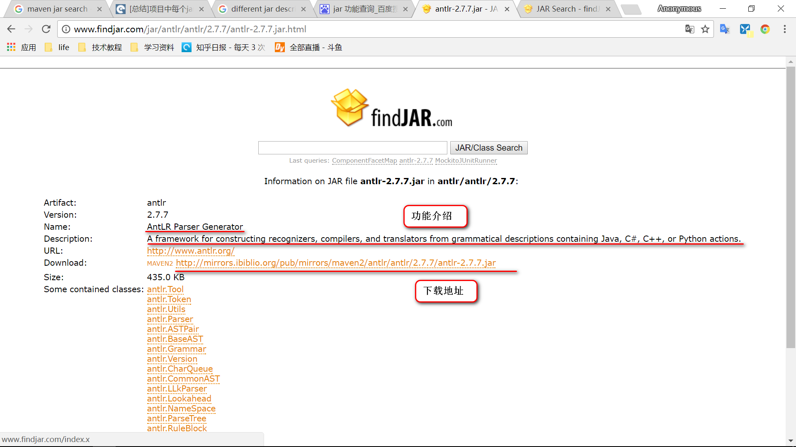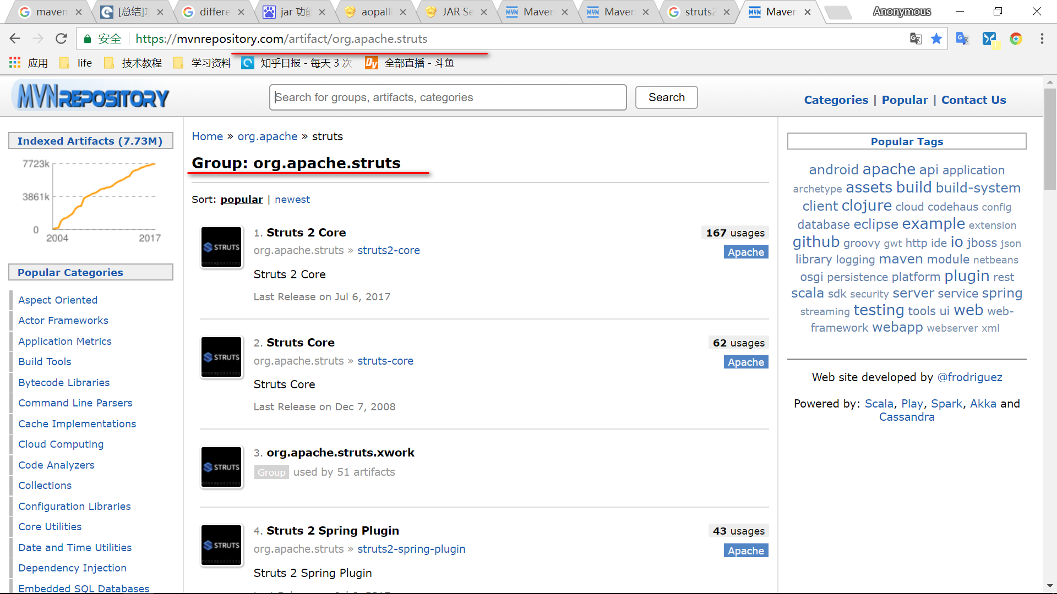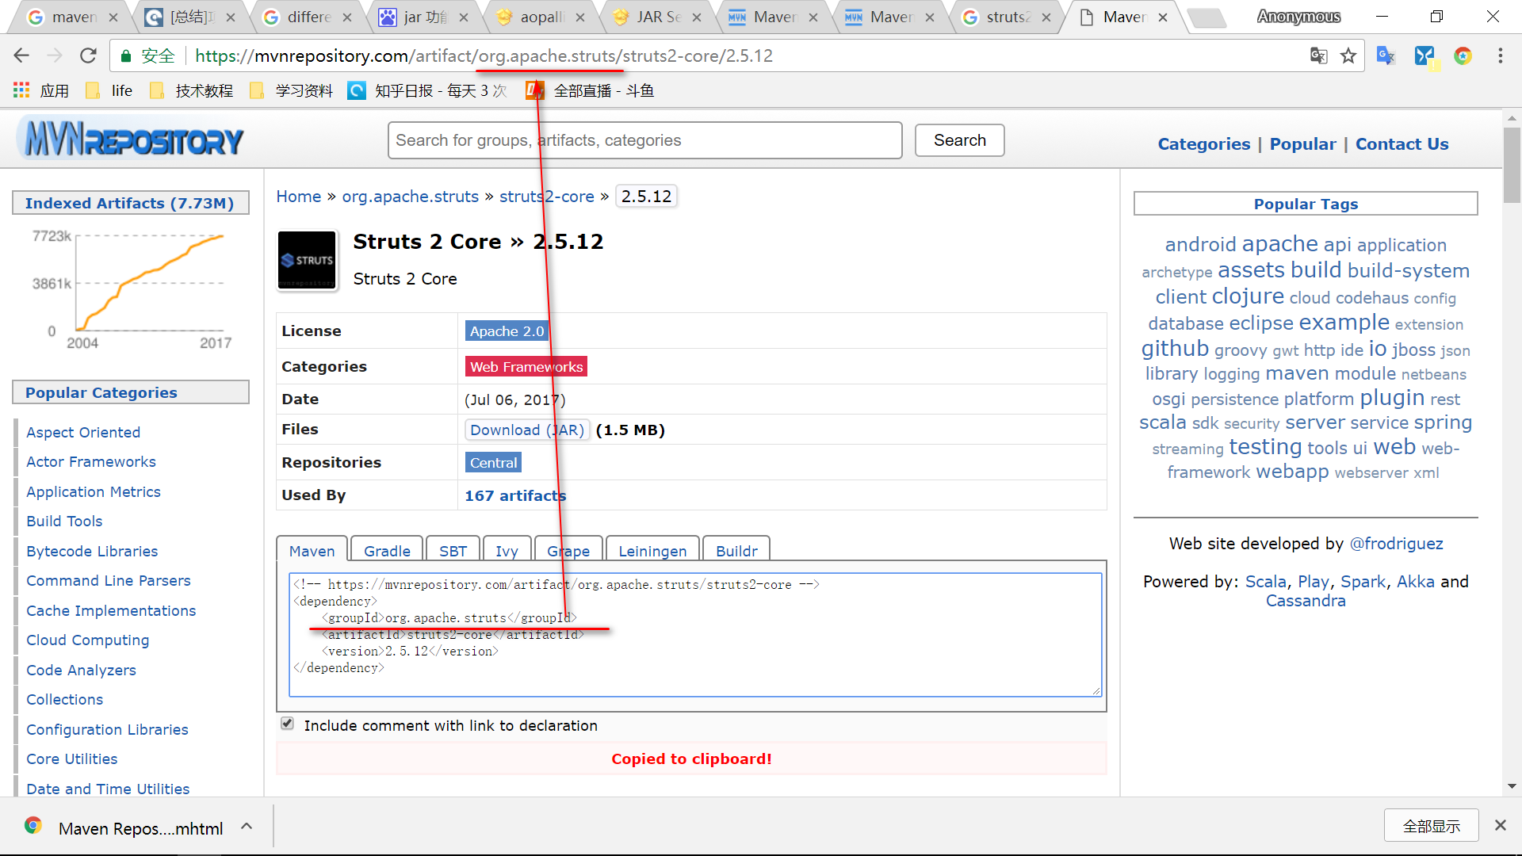

## antlr-2.7.7.jar

Artifact: antlr

Version: 2.7.7

Name: AntLR Parser Generator

Description: A framework for constructing recognizers, compilers, and translators from grammatical descriptions containing Java, C#, C++, or Python actions.

URL: http://www.antlr.org/

Download: MAVEN2 http://mirrors.ibiblio.org/pub/mirrors/maven2/antlr/antlr/2.7.7/antlr-2.7.7.jar

Size: 435.0 KB

## aopalliance-.jar

Artifact: aopalliance

Version: 1.0

Name: AOP alliance

Description: AOP Alliance

URL: http://aopalliance.sourceforge.net

Download: MAVEN2 http://mirrors.ibiblio.org/pub/mirrors/maven2/aopalliance/aopalliance/1.0/aopalliance-1.0.jar

Size: 5.0 KB

## aspectjweaver-1.8.10.jar

Vendor: aspectj.org

Title: org.aspectj.weaver

Artifact: aspectjweaver

Version: 1.5.0

Name: AspectJ weaver

Description: The AspectJ weaver introduces advices to java classes

URL: http://www.aspectj.org

Download: MAVEN2 http://mirrors.ibiblio.org/pub/mirrors/maven2/aspectj/aspectjweaver/1.5.0/aspectjweaver-1.5.0.jar

Size: 1.67 MB

## commons-fileupload-1.3.2.jar

Vendor: Apache Software Foundation

Version: 11

Name: Oracle Containers for Java

URL: http://www.oracle.com/technology/tech/java/oc4j/index.html

Size: 22.0 KB

## commons-io-2.2.jar

Vendor: Apache Software Foundation

Title: Commons IO

Artifact: commons-io

Version: 1.0

Name: IO

Description: Commons-IO contains utility classes, stream implementations, file filters, and endian classes.

URL: http://jakarta.apache.org/commons/io/

Download: MAVEN http://mirrors.ibiblio.org/pub/mirrors/maven/commons-io/jars/commons-io-1.2.jar

Size: 65.0 KB

## commons-lang3-3.2.jar

Vendor: Apache Software Foundation

Title: org.apache.commons.lang

Artifact: commons-lang

Version: 3.7

Name: Lang

Description: Commons.Lang, a package of Java utility classes for the classes that are in java.lang's hierarchy, or are considered to be so standard as to justify existence in java.lang.

URL: http://jakarta.apache.org/commons/lang/

Download: MAVEN http://mirrors.ibiblio.org/pub/mirrors/maven/commons-lang/jars/commons-lang-2.0.jar

Size: 166.0 KB

## commons-logging-1.1.1.jar

Vendor: Apache Software Foundation

Version: 11

Name: Oracle Containers for Java

URL: http://www.oracle.com/technology/tech/java/oc4j/index.html

Size: 38.0 KB

## dom4j-1.6.1.jar

Vendor: MetaStuff Ltd.

Title: org.dom4j

Artifact: jaxme-api

Version: 0.3

Name: dom4j

Description: dom4j: the flexible XML framework for Java

URL: http://sourceforge.net/projects/dom4j

Download: MAVEN http://mirrors.ibiblio.org/pub/mirrors/maven/dom4j/jars/dom4j-1.5.1.jar

Size: 371.0 KB

## freemarker-2.3.22.jar

Vendor: Visigoth Software Society

Artifact: freemarker

Version: 1.5.3

Name: BSD-style license

Description: FreeMarker is a "template engine"; a generic tool to generate text output based on templates.

URL: http://freemarker.org/

Download: MAVEN2 http://mirrors.ibiblio.org/pub/mirrors/maven2/freemarker/freemarker/1.5.3/freemarker-1.5.3.jar

Size: 97.0 KB

## hibernate-commons-annotations-4.0.5.Final.jar

Vendor: hibernate.org

Artifact: hibernate-commons-annotations

Version: 3.0.0.ga

Name: Hibernate Commons Annotations

Description: Hibernate Commons Annotations is a utility project used by annotations based Hibernate sub-projects.

Download: MAVEN2 http://mirrors.ibiblio.org/pub/mirrors/maven2/org/hibernate/hibernate-commons-annotations/3.0.0.ga/hibernate-commons-annotations-3.0.0.ga.jar

Size: 65.0 KB

## hibernate-core-4.3.11.Final.jar

Vendor: Hibernate.org

Title: Hibernate Core

Artifact: hibernate-core

Version: 3.3.0.CR1

Name: Hibernate Core

Description: The core functionality of Hibernate

Download: MAVEN2 http://mirrors.ibiblio.org/pub/mirrors/maven2/org/hibernate/hibernate-core/3.3.0.CR1/hibernate-core-3.3.0.CR1.jar

Size: 2.15 MB

## hibernate-jpa-2.1-api-1.0.0.Final.jar

Vendor: hibernate.org

Description:Clean-room definition of JPA APIs intended for use in developing Hibernate JPA implementation.

## jandex-1.1.0.Final.jar

Description: Java Annotation Indexer

## javassist-3.18.1-GA.jar

Description: Javassist (JAVA programming ASSISTant) makes Java bytecode manipulation simple. It is a class library for editing bytecodes in Java.

## jboss-logging-3.1.3.GA.jar

Description: Apache Commons Logging is a thin adapter allowing configurable bridging to other, well known logging systems.

## jboss-logging-annotations-1.2.0.Beta1.jar

Description: Apache Commons Logging is a thin adapter allowing configurable bridging to other, well known logging systems.

## jboss-transaction-api_1.2_spec-1.0.0.Final.jar

Description: The Java Transaction 1.2 API classes

## json.org.jar

Description: JSON is a light-weight, language independent, data interchange format. See http://www.JSON.org/ The files in this package implement JSON encoders/decoders in Java. It also includes the capability to convert between JSON and XML, HTTP headers, Cookies, and CDL. This is a reference implementation. There is a large number of JSON packages in Java. Perhaps someday the Java community will standardize on one. Until then, choose carefully.

## junit-4.7.jar

Description: JUnit is a unit testing framework for Java, created by Erich Gamma and Kent Beck.

## log4j-api-2.8.2.jar

Description: The Apache Log4j Implementation

## log4j-core-2.8.2.jar

Description: The Apache Log4j Implementation

## mysql-connector-java-5.1.42-bin.jar

Description: MySQL JDBC Type 4 driver

## ognl-3.0.19.jar

Description: OGNL - Object Graph Navigation Library

## ojdbc14.jar

Description: Oracle JDBC driver classes for use with JDK1.4

## servlet-api.jar

Description: Java Servlet API

## spring-aop-3.2.4.RELEASE.jar

Description: Spring AOP

## spring-beans-3.2.4.RELEASE.jar

Description: Spring Beans

## spring-context-3.2.4.RELEASE.jar

Description: Spring Context

## spring-context-support-3.2.4.RELEASE-javadoc.jar

Description: Spring Context Support

## spring-core-3.2.4.RELEASE.jar

Description: Spring Core

## spring-expression-3.2.4.RELEASE.jar

Description: Spring Context

## spring-web-3.2.1.RELEASE.jar

Description: Spring Web

## struts2-core-2.3.33.jar

Description: Core Jackson processing abstractions (aka Streaming API), implementation for JSON

## struts2-spring-plugin-2.3.4.1.jar

Description: Struts 2 Spring Plugin

## xwork-core-2.3.33.jar

Description: Core Jackson processing abstractions (aka Streaming API), implementation for JSON