FPC Research Summary Template Guidelines (2026)
- Meta Data: At the top of the template there is a place for title, author(s), etc. Please replace the bracketed text after each field label (e.g., [Full Title]) with your information. Do not remove or rename the field labels (Title:, Author:, etc.). This information will be added to the filterable table where members can search for reports.
  - For “RW Studies Used,” make sure you list the full name of each study and if multiple studies are used, separate them by commas. EX. 284501, 280601
- Header Styles: The auto-publication tool uses the style classes to sort the reports out into appropriate html formatting, so keeping styles consistently used is very important.
  - Header: Use “FPC-Header” Style
  - Body Text: Use “Normal” Style
  - Sub header: Use “FPC-Sub” Style
  - Figure/Table Captions: Use “FPC-Caption” Style
- Figures and Tables: For the auto-publication tool to identify figures/tables and be able to associate them with their captions, they must be embedded within tables.
  - In-text references: Ensure that you spell out Table or Figure and close it in parentheses. EX. “There are trees in the forest canopy (Figure 1)”
  - Figures: Ensure figures are placed in either 1x2, 2x2, or 2x3 tables with the image in each top cell and the caption(s) in the bottom. Ensure the caption starts with Figure X. Using 2x2 and 2x3 will display your figures horizontally beside each other. If you prefer them stacked vertically, put them in separate 1x2 tables
  - Tables:
    - For tables that are already images, follow the same process as figures, but ensure your caption starts with Table X instead of Figure X.
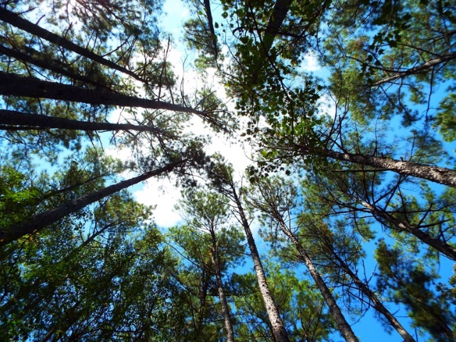
Figure 1: The green canopy is the basis for stand volume growth.

    - If you’re inserting an actual table into the word doc, follow the below example where a merged first row cell contains the caption
Table 1: If tables are added as figures follow the figure rules, but insure you caption starts with Table X. If you are instead inserting an actual table. Use this format where there is a merged cell with caption above your table
Header | Header | Header | Header
Record | Data | Data | Data
Record | Data | Data | Data

