Title: [Full Title]
Author: [First and Last Name. If multiple, separate by commas]
New or Updated: [Brand new report or just an updated report? Type “New” or “Updated”]
Species: [Primary Species studied. Type “Pine” “Eucalyptus” “Other” or “NA”]
RW Studies Used: [Type the full names regionwide studies used separated by commas]
-----------------------------------------------------------------------------------------------------------------

Introduction or Background {optional}
Lorem ipsum dolor sit amet, consectetur adipiscing elit, sed do eiusmod tempor incididunt ut labore et dolore magna aliqua. Ut enim ad minim veniam, quis nostrud exercitation ullamco laboris nisi ut aliquip ex ea commodo consequat.

Sub header {optional}
 | 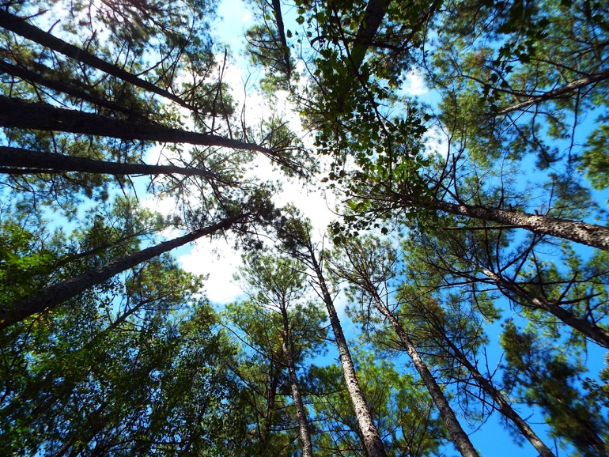
 | Figure 1: The green canopy is the basis for stand volume growth.
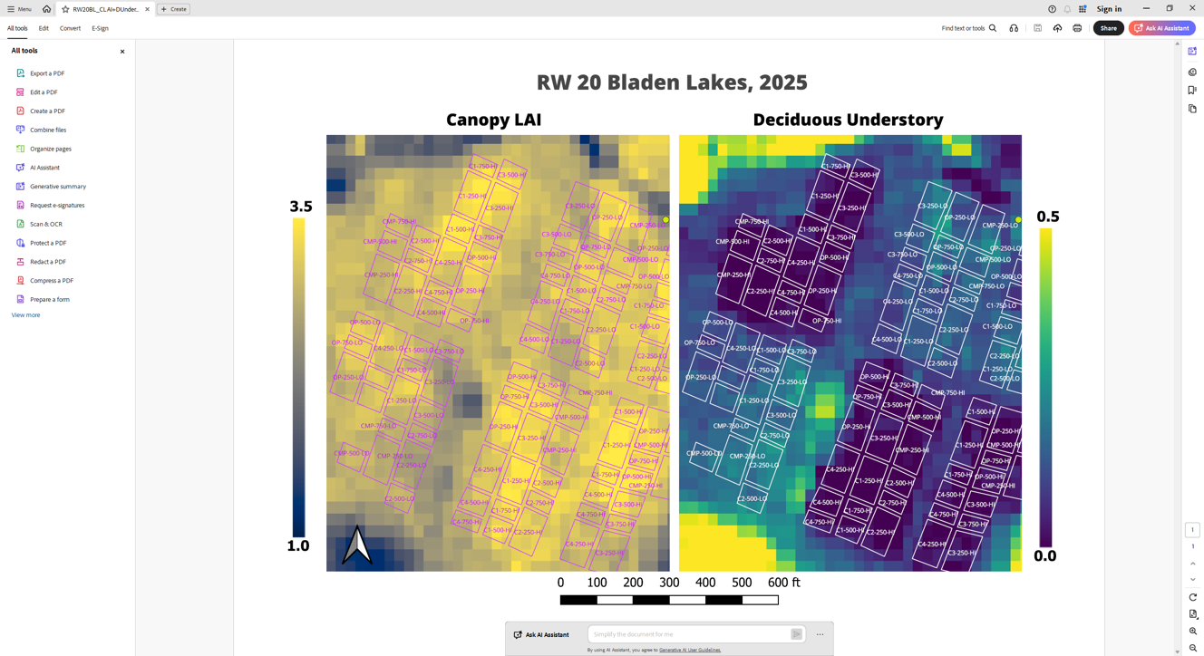 |  | 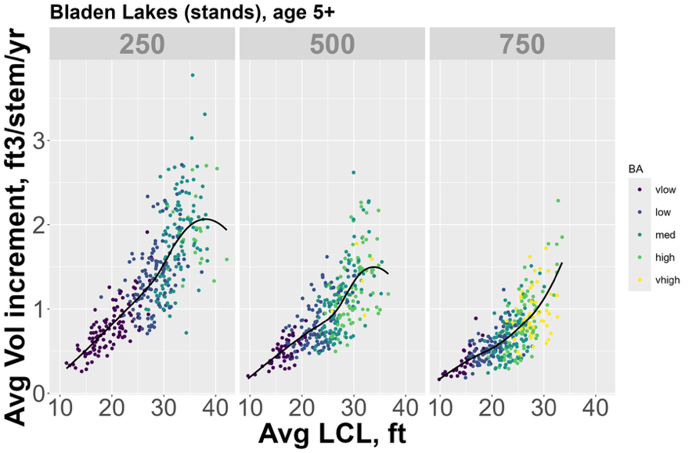
Figure 2: Example of canopy LAI (left) and deciduous understory index (right) based on Sentinel-2 imagery. |  | Figure 3: Stem annual productivity vs. live crown length, split by planting density (250/500/750 trees per acre, TPA). Black lines show local regression smooth fit to the point data.

Table 1: If tables are added as figures follow the figure rules, but insure you caption starts with Table X. If you are instead inserting an actual table. Use this format where there is a merged cell with caption above your table
Header | Header | Header | Header
Record | Data | Data | Data
Record | Data | Data | Data

Study Objectives

Paragraph or bullet/numbered format

Treatments and Experimental Design or Methods

Paragraph or bullet/numbered format

Results
Paragraph format

Conclusions or Future Direction
Paragraph format

Acknowledgements (if appropriate)

Paragraph or bullet/numbered format

Additional Resources (if appropriate) or References (optional)
Bullet/numbered format. If report is published, make sure to include the full citation here.

