# Sunrise Rafting

Name: Felipe Corral

## Branding

### Logo

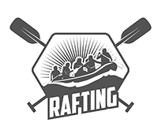

## Style Guide

### Color Schema

Color palette URL: <https://coolors.co/2d5200-ebc77e-6a320c-f5f5f5>

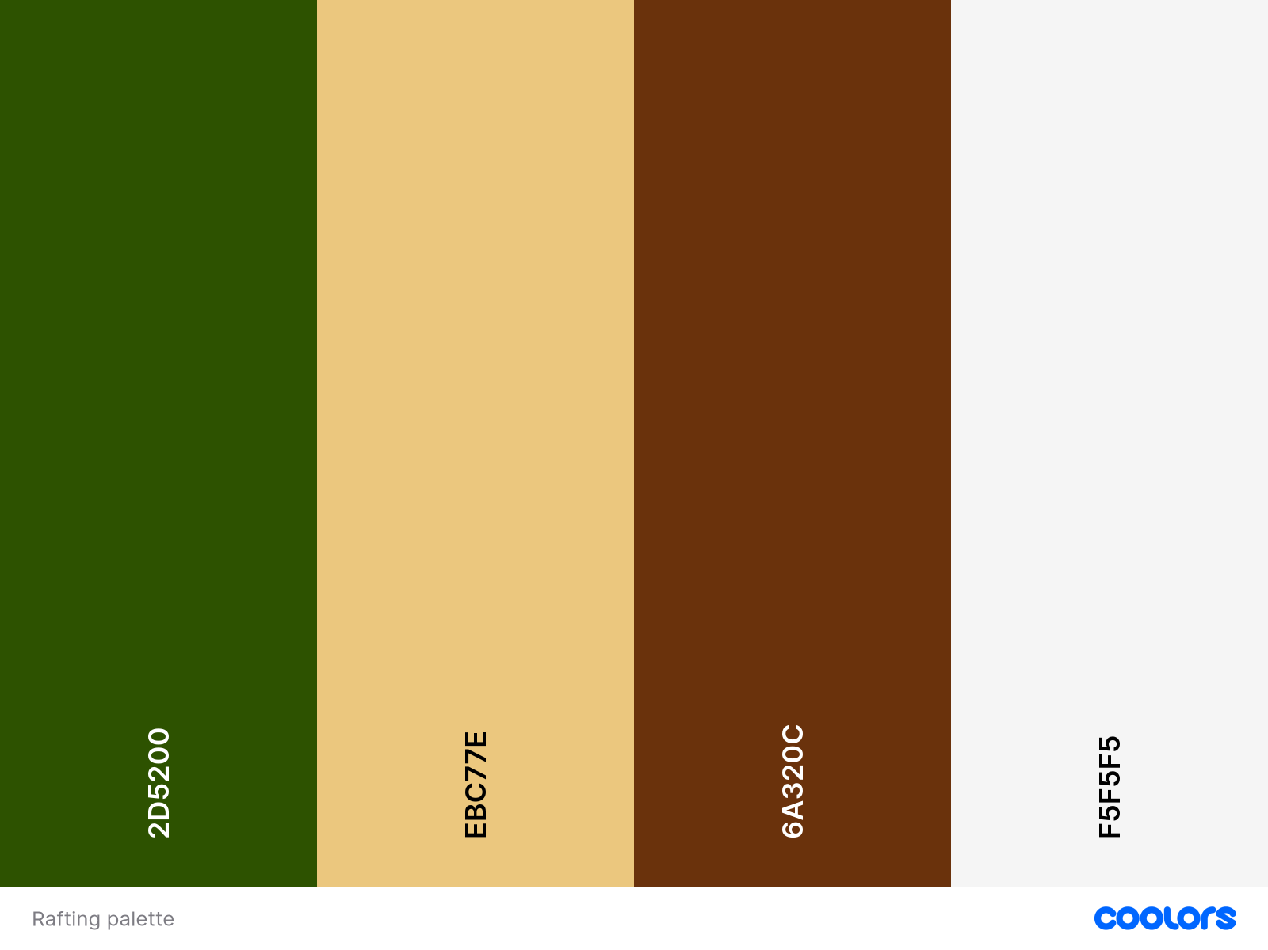

* **Primary Color:** #2D5200
* **Secondary Color:** #EBC77E
* **Accent1 Color:** #6A320C
* **Accent2 Color:** #F5F5F5

### Typography

**Heading 1:** [Rock Salt 400 Static](https://fonts.google.com/specimen/Rock+Salt?preview.text=Rock Salt 400 Static)

**Heading 2:** [Acme Regular 400](https://fonts.google.com/specimen/Acme?preview.text=Acme Regular 400)

**Body:** Noto Sans 400 and 700