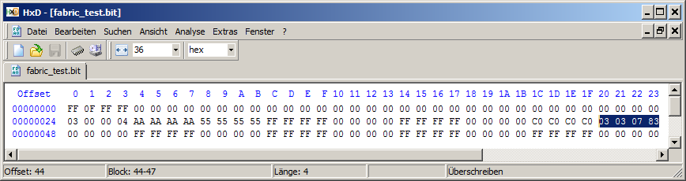

frame2,2,32,1111_1111_1111_1111_0001_0001_0011_0011,
36:51,52,53,515:514,517:516,#,J_l_CD_BEG0,J_l_CD_BEG1
36:51 is the LUT value

The LSBs in a frame are the top row (1 in my case as row 0 are the U-turn tiles

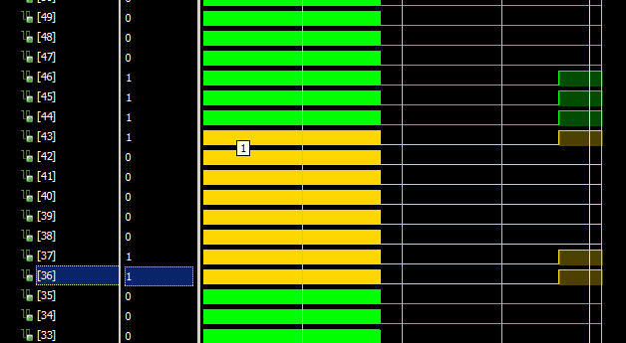

frame0,0,12,0000_1111_0000_1111_0000_0011_0000_0011,3:0,9:6,5:4,11:10,#A_I,B_I,A_T,B_T

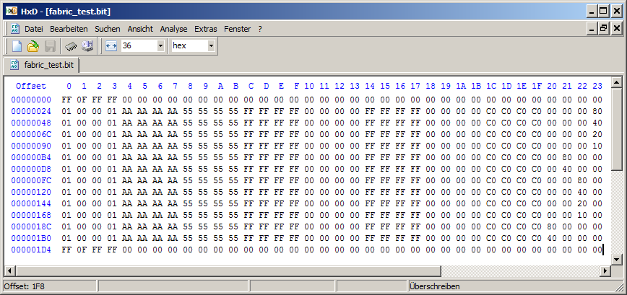

The waveform below is for bytes 20..23

31.30.29.28.27.26.25.24|23.22.21.20.19.18.17.16|15.14.13.12.11.10.09.08|07.06.05.04.03.02.01.00
10.11. . . . . . |04.05. . . . . . |06.07.08.09. . . . |00.01.02.03. . . .

