Implementation of a Field-Oriented Control (FOC) System for a BLDC Motor on an FPGA
[Author Name]
[Department, Organization]
[City, Country]
[email address]

Abstract—Field-oriented control (FOC) gives decoupled control of torque and flux for brushless DC (BLDC) motor drives, with smooth torque and fast dynamic response over a wide speed range — properties that are particularly valuable for real-time electromechanical actuation in aerospace and defense systems, where the control loop must meet strict, deterministic timing regardless of operating condition. This paper describes the design and FPGA implementation of a complete FOC system for a BLDC motor: cascaded position, velocity and d–q current loops, the Clarke/Park transform pair and its inverse, a CORDIC-based sine/cosine generator, PID control with anti-windup, min–max space vector modulation, an initial rotor-alignment routine, and encoder-based velocity estimation with a moving-average filter. The fixed-point scaling used to connect the ADC, angle, current, encoder and PWM signals is derived, and the datapath is pipelined for deterministic timing. Simulation verifies the transform chain and the scaling blocks, and hardware results are reported for the velocity and position loops, including operation under an 80 N·m load. At 10 kHz, FOC and trapezoidal commutation give comparable rise times for 10° and 20° position steps, with FOC achieving lower steady-state error. The post-implementation design uses 15.5 % of the FPGA’s LUTs and 45.4 % of its DSP slices, with a total on-chip power of 0.238 W.
Index Terms—Aerospace actuation, BLDC motor, CORDIC, field-oriented control, FPGA, PID anti-windup, real-time control, servo control, space vector modulation, vector control.

Introduction
Field-oriented control (FOC), or vector control, treats the stator currents of a brushless DC (BLDC) machine as a rotating vector rather than three independent phase quantities. Once the motor equations are expressed in a rotating d–q frame, torque and flux can be controlled independently, the current loops respond quickly, and the same controller structure applies from standstill through high speed. Compared with trapezoidal commutation, FOC also gives lower torque ripple, reduced current harmonics and a better power factor, at the cost of the extra computation needed for the coordinate transforms and trigonometric functions [1], [2]. These properties make FOC the preferred choice for real-time electromechanical actuators in aerospace and defense applications — for example, flight-control-surface and gimbal actuators — where the drive must track fast, high-authority commands with guaranteed control-loop latency and without the jitter of a software-scheduled processor.
Because the transform, trigonometric and control stages of FOC can be pipelined, a field-programmable gate array (FPGA) is well suited to implementing the controller with deterministic, sample-accurate timing — the same property that makes FPGA-based FOC attractive for real-time aerospace actuation, where a microprocessor’s variable interrupt latency is difficult to certify against hard real-time requirements. We describe the design and FPGA implementation of a complete FOC system for a BLDC motor: cascaded position, velocity and d–q current loops; the Clarke, Park, inverse Park and inverse Clarke transforms [3], [4]; a CORDIC-based sine/cosine generator; PID control with anti-windup; min–max space vector modulation; an initial rotor-alignment routine; and encoder-based velocity estimation with a moving-average filter. We also derive the fixed-point scaling that connects these blocks to the ADC, encoder and PWM hardware, and report simulation and hardware results, together with the resource utilization and power drawn by the implementation.

FOC Architecture
The controller (Fig. 1) consists of a position loop, a velocity loop, d- and q-axis current loops, the Clarke/Park transform pair and its inverse, a CORDIC sine/cosine block, and min–max space vector modulation. Phase currents are measured with current sensors biased at 2.5 V for 0 A, and rotor position is measured with an incremental encoder. The position loop converts a position command and feedback into a speed command for the velocity loop, which sets the q-axis current command; the d-axis command is held at zero away from start-up. The measured phase currents and the electrical angle are transformed into the d–q frame, regulated by the current-loop PI controllers, transformed back to the three-phase domain, and shaped by the space-vector block into six duty cycles for the MOSFET driver. Until the initial-alignment routine (Section VII) completes, a multiplexer substitutes fixed alignment values for the current-loop outputs. The datapath is fully pipelined, with a 10 µs register stage between each major block, so the control loop runs with fixed, predictable latency. This position–velocity–current cascade is the standard architecture of a precision servo drive, and the same structure underlies flight-control-surface, gimbal and antenna-positioner actuators in aerospace and defense systems.
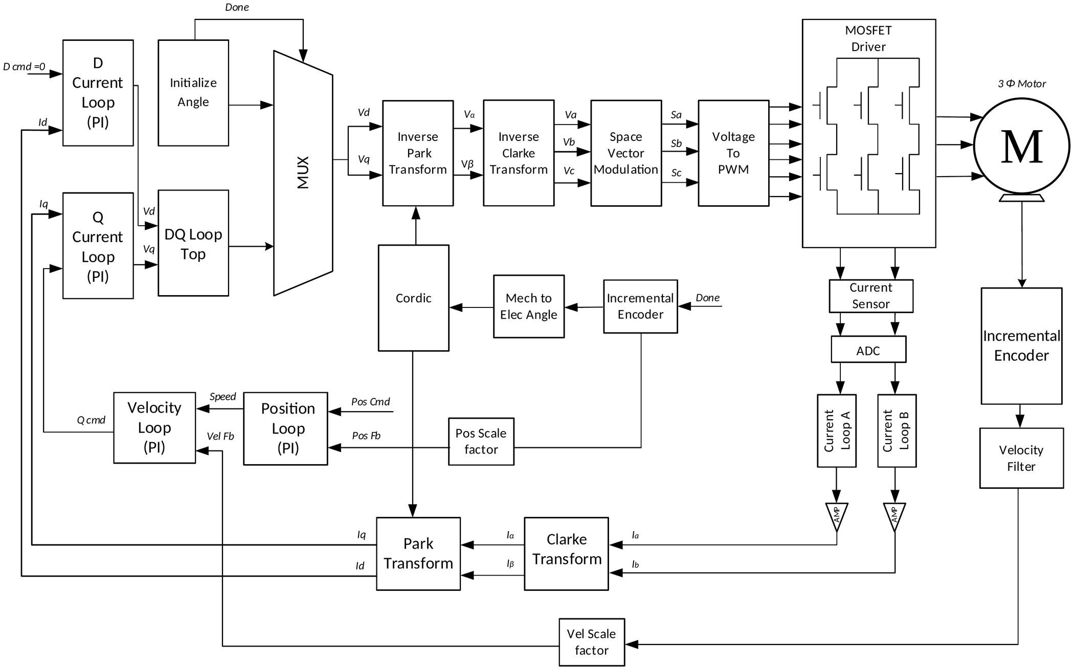
Fig. 1. Top-level architecture of the FPGA-based FOC system.
TABLE I
Key design parameters
Parameter | Value
PWM switching frequency | 10 kHz
PWM dead band | 1 µs
PWM full-scale count (100 % duty) | 6400 (bias 3200)
Pipeline stage interval | 10 µs
ADC | 8 channels, 14-bit, ±10 V
Current sensor | 20 mV/A, 2.5 V bias at 0 A
Incremental encoder | 512 PPR, ×4 = 2048 CPR
Alignment command / duration | I_{d} = 10 A, I_{q} = 0 A / 200 ms
Velocity window T_{duration} | 10 µs
PID gains (Fig. 5) | K_{p1} = 6, K_{p2} = 8, K_{i1} = 20, K_{i2} = 15

Reference-Frame Transformations

Clarke Transform
The Clarke, or αβ, transform converts the three stator currents (a, b, c) into two orthogonal stationary-frame components (α, β), with the α-axis aligned to the a-axis (Fig. 2(a)). In amplitude-invariant form,
$α=\frac{2}{3}\left(a−\frac{1}{2}b−\frac{1}{2}c\right)$ (1)
$β=\frac{1}{\sqrt{3}}\left(b−c\right)$ (2)
For a balanced three-phase system a + b + c = 0, and (1)–(2) reduce to
$α=a$ (3)
$β=\frac{a+2b}{\sqrt{3}}$ (4)
where a and b are the measured phase currents.

Park Transform
The Park transform rotates the stationary frame onto the rotating d–q frame,
$d=α\cos{θ}+β\sin{θ}$ (5)
$q=−α\sin{θ}+β\cos{θ}$ (6)
with the d-axis aligned to the rotor flux (Fig. 2(b)). In the rotating frame the current and voltage quantities are time-invariant, which is what lets a linear PI controller regulate them with zero steady-state error. The angle θ in (5)–(6) is the rotor electrical position obtained from the CORDIC block of Section IV.
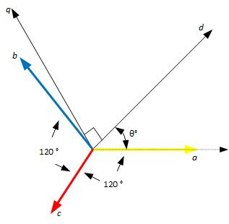  (a) | 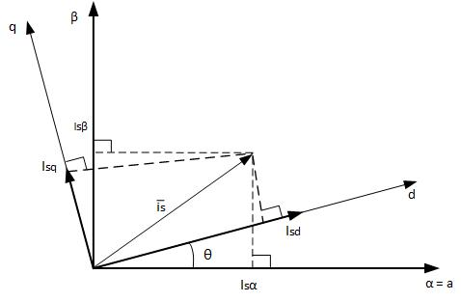  (b)
Fig. 2. Reference-frame transformations: (a) abc to αβ; (b) αβ to dq.

Inverse Park and Inverse Clarke Transforms
Equations (7)–(8) recover the stationary-frame quantities from the current-loop outputs,
$α=d\cos{θ}−q\sin{θ}$ (7)
$β=d\sin{θ}+q\cos{θ}$ (8)
and (9)–(11) project the result back onto the three physical phase axes, 120° apart, before it is passed to space vector modulation:
$a=α$ (9)
$b=−\frac{1}{2}α+\frac{\sqrt{3}}{2}β$ (10)
$c=−\frac{1}{2}α−\frac{\sqrt{3}}{2}β$ (11)

CORDIC-Based Sine/Cosine Generation
CORDIC (Coordinate Rotation Digital Computer) computes sine and cosine through a sequence of small, predetermined vector rotations, using only additions, subtractions and bit shifts [5]. Because it needs neither a multiplier nor a divider, it is a natural fit for FPGA logic, and is used here to supply the sin θ and cos θ values consumed by the Park and inverse Park transforms [6]. Fig. 3 shows the simulated response for an electrical angle ramping over several cycles: the sine and cosine outputs track the angle with the expected quarter-cycle offset, cosine leading sine by 90°.
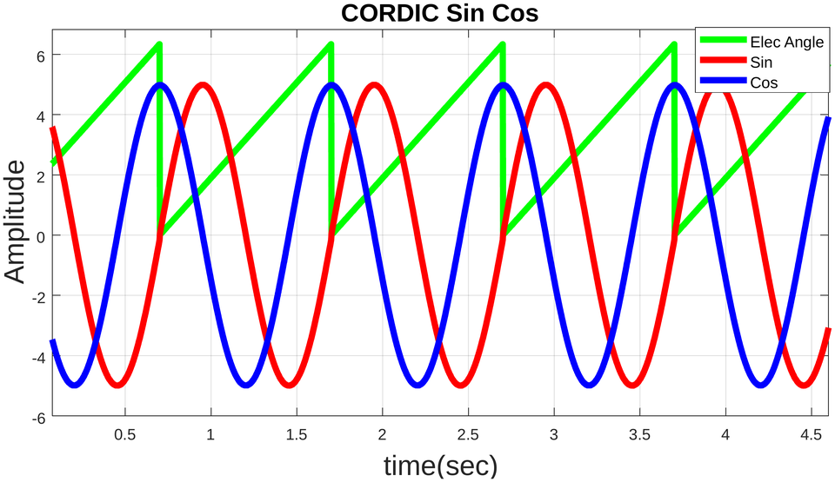
Fig. 3. MATLAB waveforms of electrical angle, sine and cosine from the CORDIC block.

PID Control with Anti-Windup
Each control loop uses a PID controller (Fig. 4). Because the output is limited by the current or voltage rating of the drive, the integral term can keep accumulating error after the controller saturates, producing overshoot and a slow, oscillatory recovery once the loop leaves saturation [7], [8]. The integrator is disabled only when the output has actually been clipped by the saturation block and the sign of the tracking error still matches the sign of the unsaturated PID output, which keeps the anti-windup logic from interfering with normal operation. Fig. 5 shows the simulated cascaded-loop response with K_{p1}=6, K_{p2}=8, K_{i1}=20, K_{i2}=15 and K_{d1}=K_{d2}=0: the anti-windup terms are active only briefly around the command transitions, and the loop settles quickly with no sustained oscillation.
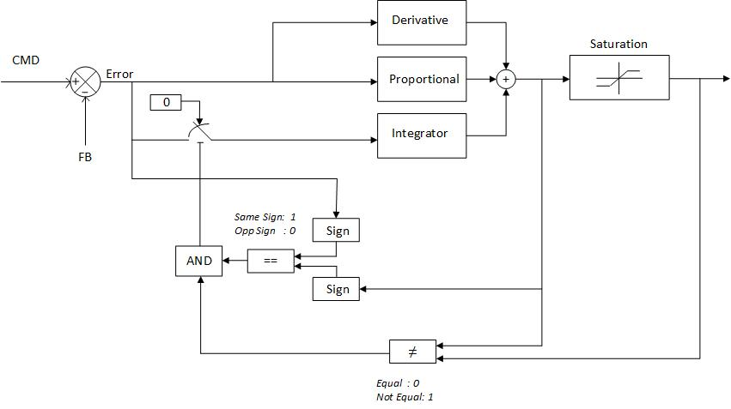
Fig. 4. Block diagram of the PID controller with anti-windup.
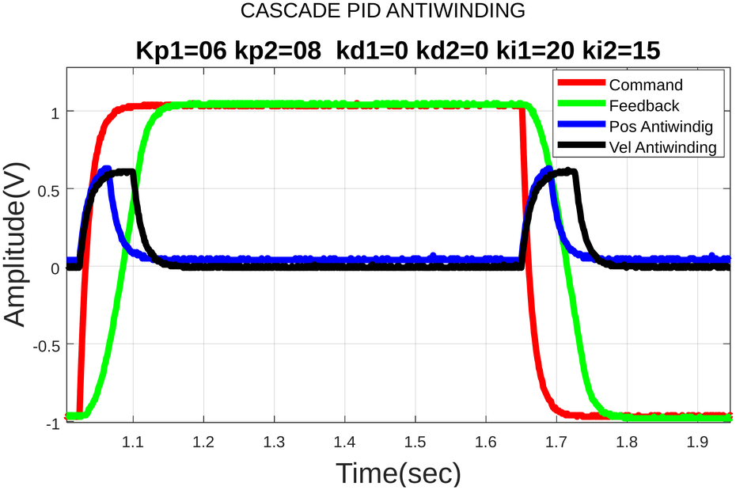
Fig. 5. Simulated response of the cascaded PID controller with anti-windup.

Space Vector Modulation
Space vector PWM improves DC-bus utilization by roughly 15 % over sinusoidal PWM and reduces harmonic distortion [9]. We use the min–max method, a low-complexity equivalent of conventional SVPWM that avoids explicit sector identification [10]:
$x=\max\left(A,B,C\right)$ (12)
$y=\min\left(A,B,C\right)$ (13)
$z=\frac{x+y}{2}$ (14)
$A_{SVM}=A−z$ (15)
$B_{SVM}=B−z$ (16)
$C_{SVM}=C−z$ (17)
where A, B and C are three-phase reference signals 120° apart. Fig. 6 shows the resulting SVM waveforms.
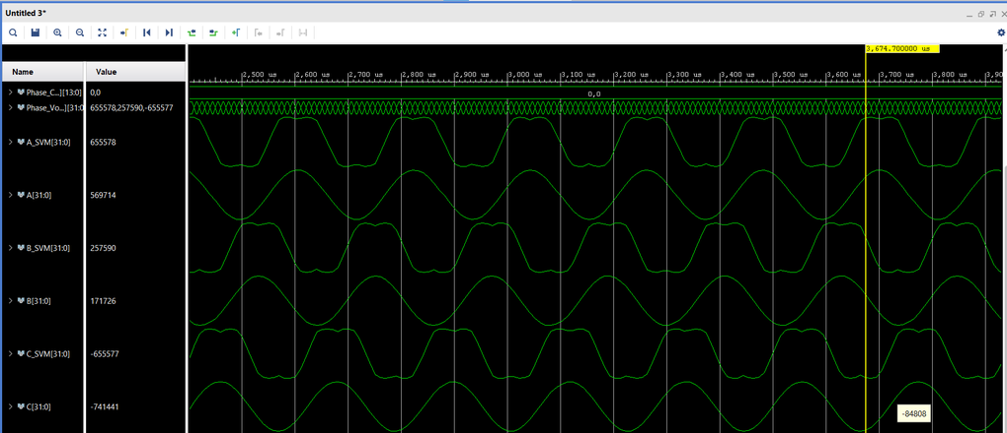
Fig. 6. Simulated space vector modulation waveforms.

Initial Rotor-Position Alignment
An incremental encoder reports only relative position, so the rotor must first be aligned to a known reference. At power-up, a counter runs for 200 ms (2,000,000 cycles of a 10 MHz clock) while the multiplexer of Fig. 7(b) holds a fixed alignment command — I_{d}=10 A, I_{q}=0 A, θ=0° — as shown in the timing diagram of Fig. 7(a), which locks the rotor onto the nearest d-axis. At the exact end of the 200 ms window the encoder count is reset to zero, marking this position as the 0° reference and asserting the “done” flag, after which control switches to the normal current-loop path. For a motor with multiple pole pairs there is more than one d-axis position per mechanical revolution; the rotor settles at whichever one is closest to its position at start-up. Fast, deterministic alignment of this kind is essential in servo actuators that must reach a known reference position within a bounded time after power-up, as required of many aerospace and defense drive systems.
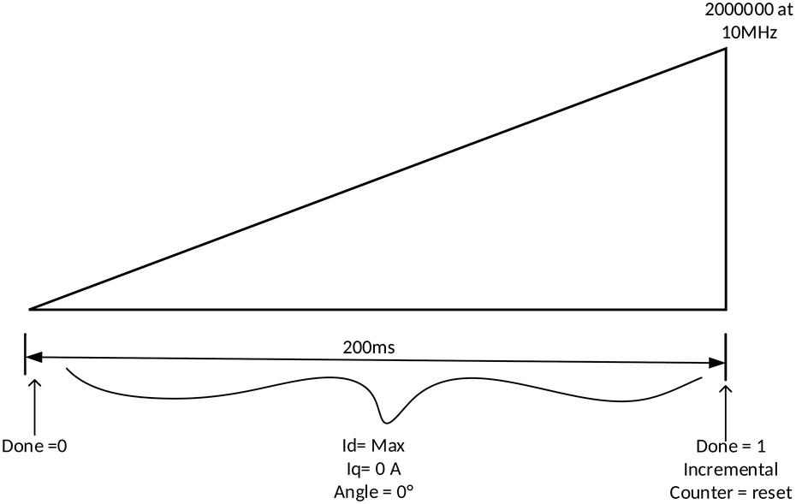  (a) | 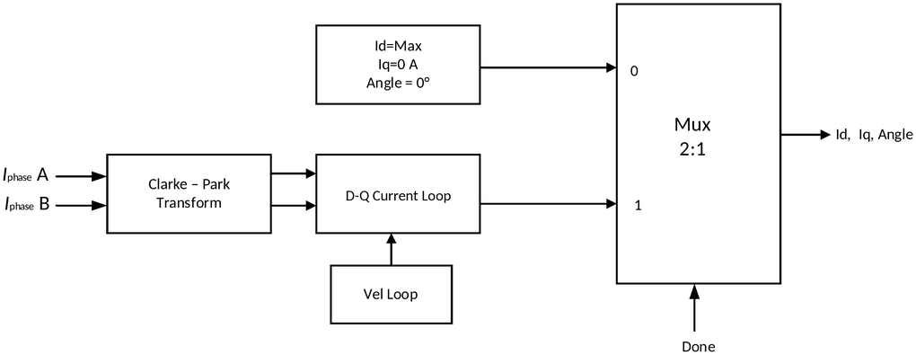  (b)
Fig. 7. Initial rotor-position alignment: (a) timing diagram; (b) block diagram.

Velocity Estimation

Encoder Decoding and Velocity Calculation
The incremental encoder outputs two quadrature channels; their relative phase gives the direction of rotation, and four-fold edge decoding gives a resolution four times the base pulse count. With a 512 pulse-per-revolution (PPR) encoder this gives 2048 counts per revolution (CPR). Velocity is obtained by counting pulses N_{p} over a fixed window T_{duration} and converting to RPM,
$RPM=\frac{N_{p}×60}{T_{duration}×CPR}$ (18)
with T_{duration} = 10 µs in this design. As shown in Fig. 8, the rotation direction follows from the relative phase of the two quadrature channels: if channel B lags channel A the encoder is turning clockwise, otherwise counter-clockwise.
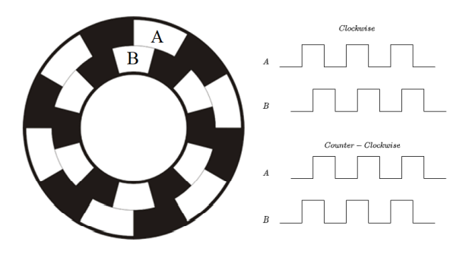
Fig. 8. Incremental encoder and its quadrature output channels.

Velocity Filter
Because encoder pulses are discrete and, at low speed, infrequent, the raw δθ/δt estimate is noisy; feeding it directly to the speed loop causes torque ripple and audible noise. A moving-average filter over the last N samples removes the quantization noise at the cost of a small, fixed phase lag; too long a window trades this lag for slower disturbance rejection.

Fixed-Point Scaling

ADC Resolution
The FPGA board has an 8-channel, 14-bit ADC with a ±10 V (20 V dynamic) range, giving a resolution
$Δ=\frac{20 V}{2^{14}}≈1.22 mV$ (19)
Scaled by 2¹⁶ for the sfix32_En16 fixed-point format used downstream, this gives an integer gain of 79 (Fig. 9).
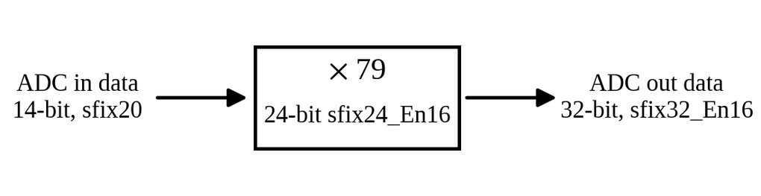
Fig. 9. ADC scaling block.

Mechanical-to-Electrical Angle Scaling
For a motor with P pole pairs, the electrical angle completes P cycles per mechanical revolution,
$θ_{e}=Pθ_{m}$ (20)
The encoder gives 2048 counts per mechanical revolution; one electrical revolution (2π) is represented in the controller as 5145 counts, from the same ADC-derived scale factor, so
$K=\frac{5145}{2048}≈2.512$ (21)
converts between the two representations (Fig. 10). The current sensor (20 mV/A) and the encoder count are scaled by the same ADC- and angle-derived factors to recover amperes and the electrical angle, respectively.
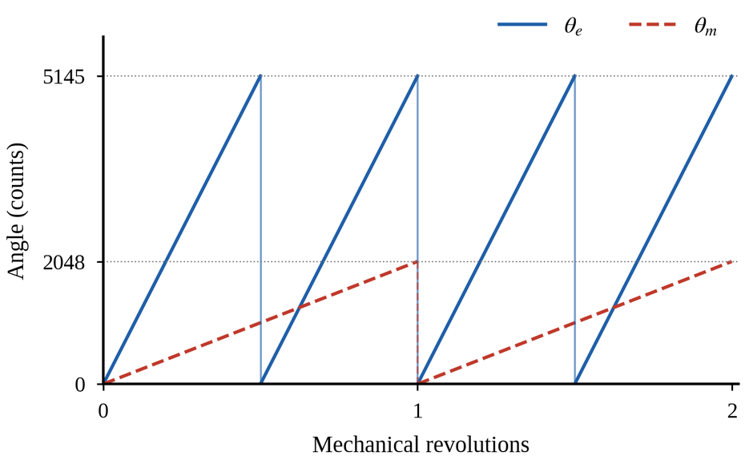
Fig. 10. Relationship between mechanical angle θ_{m} and electrical angle θ_{e} for two pole pairs.

Voltage-to-PWM Scaling
The linear-modulation limit of the SVM output is
$V_{lim}=\frac{2}{3}V_{dc}\cos\left(\frac{π}{6}\right)=\frac{V_{dc}}{\sqrt{3}}$ (22)
giving ±45.068 V, so the PWM count scale is
$K=\frac{3200}{45.068}≈71$ (23)
The SVM output spans ±3200, and a 3200 bias gives a duty count of 0–6400 (100 % duty at 6400), with a 1 µs dead band applied at the 10 kHz switching frequency, as verified by the open-loop PWM simulation of Fig. 11.
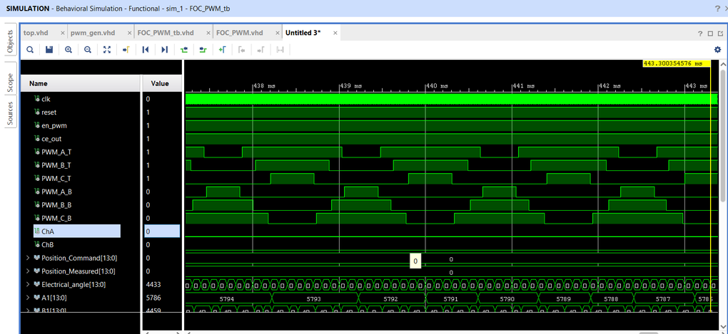
Fig. 11. Simulated open-loop FOC PWM outputs with a 1 µs dead band.

BLDC Motor Electrical Model

Three-Phase Voltage Equations
Each stator phase couples to the other two through mutual inductance. With self-inductance L and mutual inductance M, the phase-a terminal voltage is
$v_{a}=Ri_{a}+L\frac{di_{a}}{dt}+M\frac{di_{b}}{dt}+M\frac{di_{c}}{dt}+e_{a}$ (24)
with b and c identical by symmetry, and e_{a} the back-EMF induced by the rotating magnet flux. For a balanced, wye-connected winding the phase currents sum to zero at every instant, i_{a}+i_{b}+i_{c}=0, so di_{b}/dt+di_{c}/dt=−di_{a}/dt and the mutual terms collapse into a single effective inductance L_{s}=L−M. Writing L_{s} simply as L, the three coupled phase equations reduce to the single-inductance equivalent circuit of Fig. 12,
$v_{a}=Ri_{a}+L\frac{di_{a}}{dt}+e_{a}$ (25)
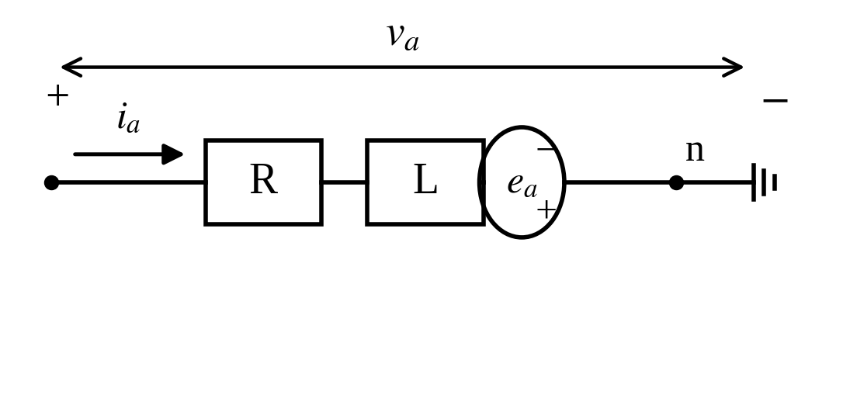
Fig. 12. Per-phase equivalent circuit of the motor winding.
For a sinusoidally-wound machine the three back-EMFs are themselves sinusoidal functions of the rotor electrical angle,
$e_{a}=λ_{m}ω_{e}\sin{θ_{e}}$ (26)
with e_{b} and e_{c} identical but phase-shifted by ∓120°, ω_{e}=Pω_{m} the electrical angular speed and λ_{m} the permanent-magnet flux linkage.

Stationary- and Rotating-Frame Equations
Applying the Clarke transform of Section III-A to the phase equations gives the equivalent stationary-frame (α, β) equations,
$v_{α,β}=Ri_{α,β}+L\frac{di_{α,β}}{dt}+e_{α,β}$ (27)
with e_{α,β} obtained by transforming e_{a,b,c} in the same way. Defining the d- and q-axis flux linkages
$λ_{d}=L_{d}i_{d}+λ_{m}$ (28)
$λ_{q}=L_{q}i_{q}$ (29)
the Park transform of Section III-B turns the stationary-frame equations into the standard flux-linkage form of the rotating-frame voltage equations,
$v_{d}=Ri_{d}+\frac{dλ_{d}}{dt}−ω_{e}λ_{q}$ (30)
$v_{q}=Ri_{q}+\frac{dλ_{q}}{dt}+ω_{e}λ_{d}$ (31)
For the constant inductances assumed here (L_{d}=L_{q}=L), dλ_{d}/dt=Ldi_{d}/dt and dλ_{q}/dt=Ldi_{q}/dt, so the flux-linkage equations reduce to the current-based form used by the current-loop design,
$v_{d}=Ri_{d}+L\frac{di_{d}}{dt}−ω_{e}Li_{q}$ (32)
$v_{q}=Ri_{q}+L\frac{di_{q}}{dt}+ω_{e}Li_{d}+ω_{e}λ_{m}$ (33)
The cross-coupling terms ω_{e}Li_{q} and ω_{e}Li_{d}, together with the speed-proportional back-EMF ω_{e}λ_{m}, are exactly the disturbances that the d- and q-axis current loops of Fig. 1 must reject at every sample.

Electromagnetic Torque
In terms of the flux linkages, the electromagnetic torque of a P-pole-pair machine is
$T_{e}=\frac{3}{2}\frac{P}{2}\left(λ_{d}i_{q}−λ_{q}i_{d}\right)$ (34)
Substituting (28)–(29) gives the equivalent current-based expression,
$T_{e}=\frac{3}{2}\frac{P}{2}\left(λ_{m}i_{q}+\left(L_{d}−L_{q}\right)i_{d}i_{q}\right)$ (35)
For the surface-mounted rotor assumed here, L_{d}=L_{q}=L, and this reduces to
$T_{e}=\frac{3}{2}\frac{P}{2}λ_{m}i_{q}$ (36)
so torque is proportional to i_{q} alone — the reason the controller holds i_{d} at zero and regulates speed and position entirely through the q-axis current command.

Mechanical Dynamics
The electromagnetic torque drives the rotor inertia against load torque and friction,
$J\frac{dω_{m}}{dt}=T_{e}−T_{L}−Bω_{m}$ (37)
where T_{L} is the load torque, J the rotor inertia and B the viscous-friction coefficient, closing the loop back to the velocity and position controllers of Section II.

Results and Discussion

Transform Verification
Fig. 13 shows the full Clarke → Park → inverse Park → inverse Clarke chain: the reconstructed three-phase currents reproduce the original inputs, and the three phases sum to approximately zero, confirming that the forward and inverse transforms are consistent.
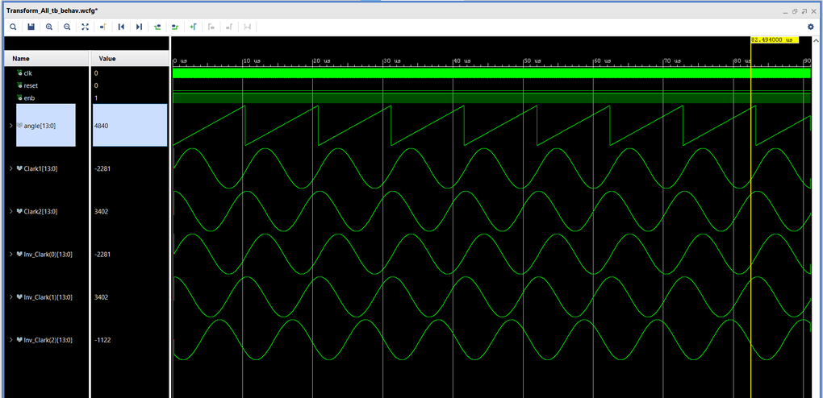
Fig. 13. Simulated Clarke–Park–inverse-Park–inverse-Clarke transform chain.

Hardware Results
The velocity loop (Fig. 14) tracks a step command with no visible overshoot. The position loop (Fig. 15) tracks repeated position steps, with the feedback closely following the command. Under an 80 N·m load (Fig. 16) the position and q-axis current loops remain stable through step and step-plus-sinusoid commands. Fig. 17 compares the phase currents at 80 N·m before and after loop tuning: the pre-tuning currents show visible chatter near the current-loop bandwidth, which tuning removes, giving smooth, sinusoidal phase currents. The 80 N·m step is representative of the intermittent, high-torque duty cycles demanded of real-time aerospace electromechanical actuators, for which this deterministic, FPGA-timed control loop is well suited. These step responses are the standard way of characterizing servo-loop bandwidth and settling behavior, and the same test methodology applies directly to qualifying aerospace and defense actuators.
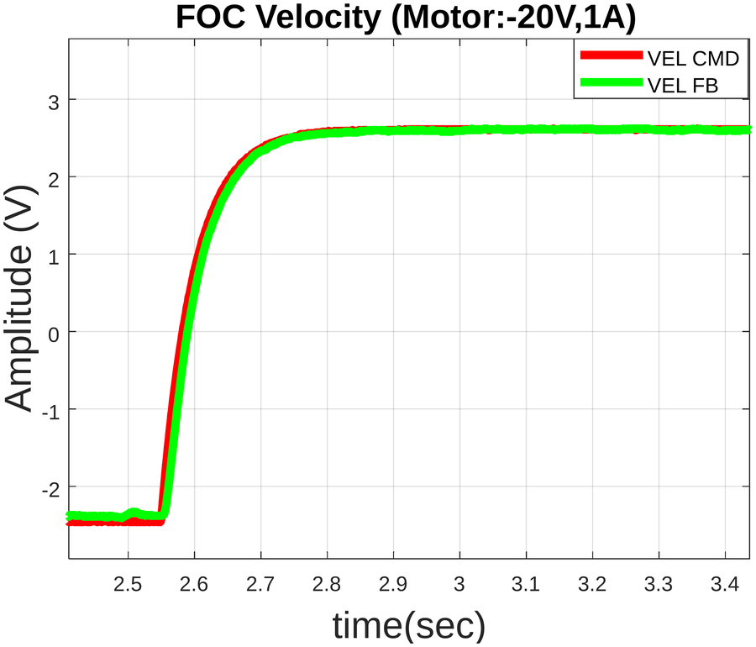
Fig. 14. Velocity-loop step response (VEL CMD: command; VEL FB: feedback).
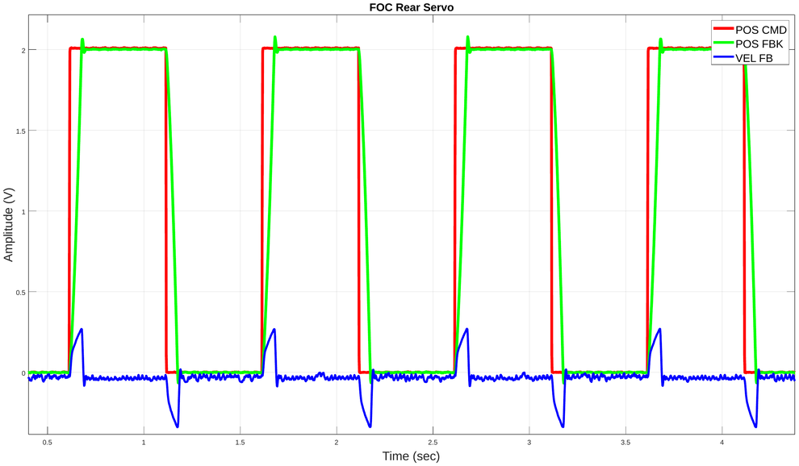
Fig. 15. Position-loop response for repeated position steps (POS CMD: command; POS FBK: feedback).
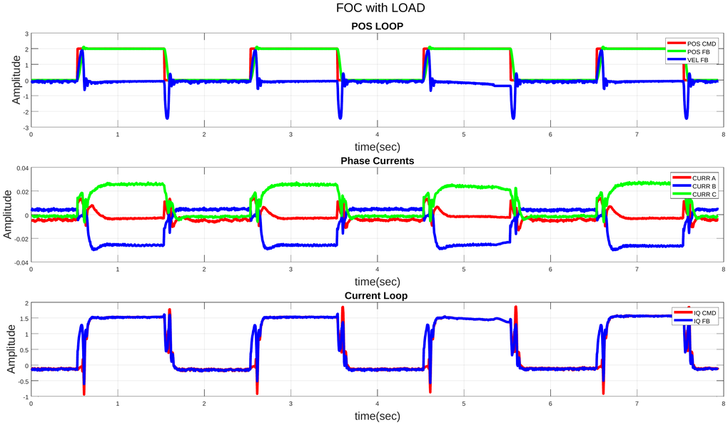
Fig. 16. Position loop, phase currents and q-axis current loop under an 80 N·m load.
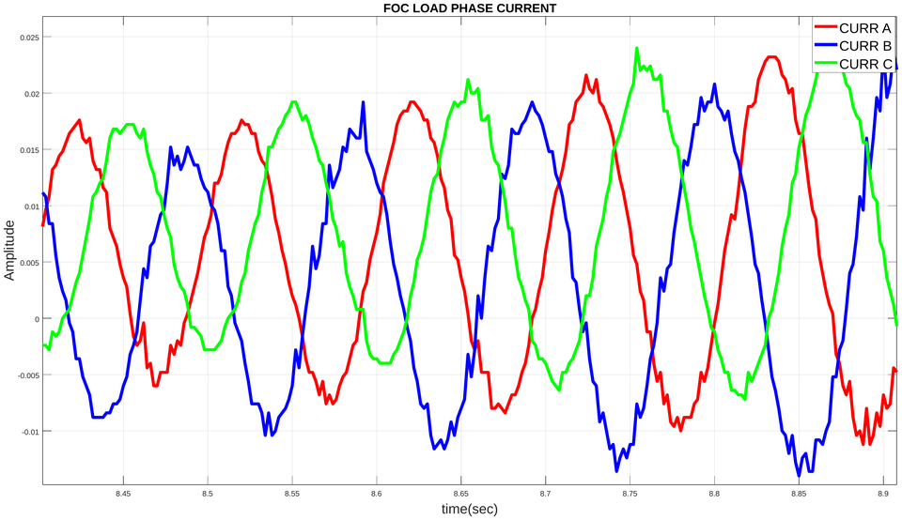  (a) | 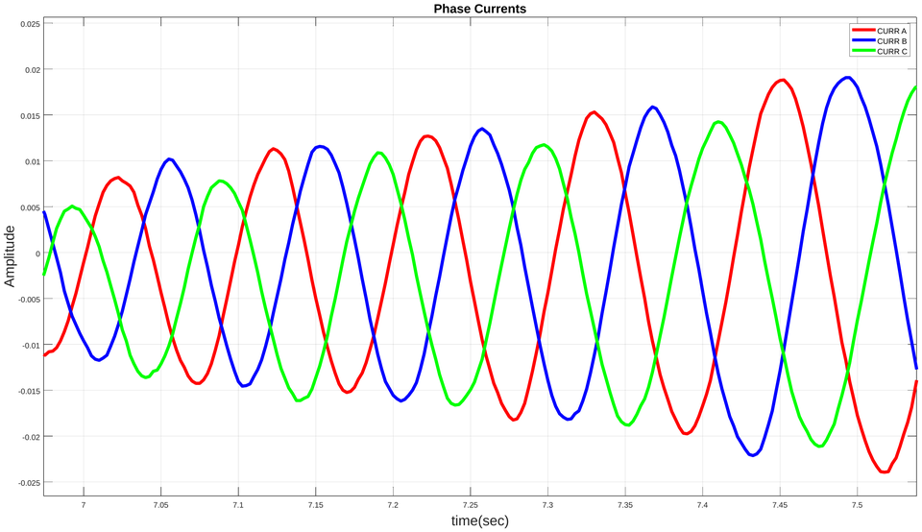  (b)
Fig. 17. Phase currents at 80 N·m load: (a) before and (b) after tuning.

Comparison with Commutation Control
Table II compares FOC and trapezoidal commutation, both running at 10 kHz, for 10° and 20° position steps. The two controllers give comparable rise times (47 ms vs. 48 ms at 10°; 83 ms vs. 78 ms at 20°). FOC gives lower steady-state error at both step sizes (0.399 % vs. 0.599 % at 10°; 0.35 % vs. 0.373 % at 20°) and no overshoot at 20°, against 1.117 % for commutation, while the 10° overshoot is similar for both (0.17 % vs. 0.163 %).
TABLE II
Comparison of FOC and commutation control
Controller | Step | Rise (ms) | Speed (°/s) | Settle (ms) | SS error | Overshoot
FOC (10 kHz) | 10° | 47 | 170 | 83 | 0.399 % | 0.17 %
FOC (10 kHz) | 20° | 83 | 192 | 112 | 0.35 % | 0
Commutation (10 kHz) | 10° | 48 | 168 | 84 | 0.599 % | 0.163 %
Commutation (10 kHz) | 20° | 78 | 204 | 136 | 0.373 % | 1.117 %

FPGA Utilization and Power
Table III lists the post-implementation resource utilization. The design uses 15.5 % of the LUTs, 5.9 % of the flip-flops, 5.9 % of the block RAMs and 45.4 % of the DSP slices of the target device, with DSP usage — driven mainly by the transform and CORDIC arithmetic — the most heavily loaded resource. This modest footprint, together with the 0.238 W total power of Table IV, leaves headroom on size-, weight- and power-constrained (SWaP) platforms such as aerospace actuators.
TABLE III
Post-implementation FPGA resource utilization
Resource | Used | Available | Util. (%)
LUT | 9824 | 63400 | 15.50
LUTRAM | 243 | 19000 | 1.28
FF | 7497 | 126800 | 5.91
BRAM | 8 | 135 | 5.93
DSP | 109 | 240 | 45.42
IO | 44 | 210 | 20.95
BUFG | 8 | 32 | 25.00
MMCM | 1 | 6 | 16.67

Table IV breaks down the on-chip power. Total power is 0.238 W, split between 0.140 W (59 %) of dynamic power, dominated by the PLL (0.089 W), and 0.098 W (41 %) of static power.
TABLE IV
On-chip power consumption
Component | Power (W) | Share (%)
Dynamic | 0.140 | 59
Clocks | 0.016 | 11
Signals | 0.012 | 9
Logic | 0.009 | 6
BRAM | 0.001 | 1
DSP | 0.008 | 5
PLL | 0.089 | 64
I/O | 0.006 | 4
Static (PL) | 0.098 | 41
Total on-chip | 0.238 | 100

Conclusion
We implemented a complete FOC system for a BLDC motor on an FPGA, including the Clarke/Park transform pair, a CORDIC sine/cosine generator, anti-windup PID control, min–max space vector modulation, initial rotor alignment, and encoder-based velocity estimation, together with the fixed-point scaling that ties these blocks to the ADC, encoder and PWM hardware. The design was verified in simulation and validated on hardware, including velocity- and position-loop step responses and operation under an 80 N·m load. At 10 kHz, FOC matched the rise time of trapezoidal commutation while giving lower steady-state error and less overshoot at larger steps. The implementation is compact, using under half of the FPGA’s DSP slices and a total of 0.238 W, leaving headroom for additional axes or a faster PWM update rate in future work. Its deterministic, sample-accurate timing and low SWaP footprint make it well suited to real-time electromechanical actuation in aerospace and defense applications, where guaranteed control-loop latency is as important as steady-state accuracy. The cascaded position–velocity–current architecture, in particular, maps directly onto the servo drives used for flight-control surfaces, gimbals and other real-time aerospace and defense actuation systems.
References
[1] P. Vas, Sensorless Vector and Direct Torque Control. Oxford, U.K.: Oxford Univ. Press, 1998.
[2] B. K. Bose, Modern Power Electronics and AC Drives. Upper Saddle River, NJ, USA: Prentice-Hall, 2002.
[3] E. Clarke, Circuit Analysis of A-C Power Systems, vol. I. New York, NY, USA: Wiley, 1943.
[4] R. H. Park, “Two-reaction theory of synchronous machines—Generalized method of analysis—Part I,” Trans. AIEE, vol. 48, no. 3, pp. 716–727, Jul. 1929.
[5] J. E. Volder, “The CORDIC trigonometric computing technique,” IRE Trans. Electron. Comput., vol. EC-8, no. 3, pp. 330–334, Sep. 1959.
[6] R. Andraka, “A survey of CORDIC algorithms for FPGA based computers,” in Proc. ACM/SIGDA Int. Symp. Field Programmable Gate Arrays, Monterey, CA, USA, 1998, pp. 191–200.
[7] K. J. Åström and T. Hägglund, PID Controllers: Theory, Design, and Tuning, 2nd ed. Research Triangle Park, NC, USA: ISA, 1995.
[8] C. Bohn and D. P. Atherton, “An analysis package comparing PID anti-windup strategies,” IEEE Control Syst. Mag., vol. 15, no. 2, pp. 34–40, Apr. 1995.
[9] H. W. van der Broeck, H.-C. Skudelny, and G. V. Stanke, “Analysis and realization of a pulsewidth modulator based on voltage space vectors,” IEEE Trans. Ind. Appl., vol. 24, no. 1, pp. 142–150, Jan./Feb. 1988.
[10] D.-W. Chung, J.-S. Kim, and S.-K. Sul, “Unified voltage modulation technique for real-time three-phase power conversion,” IEEE Trans. Ind. Appl., vol. 34, no. 2, pp. 374–380, Mar./Apr. 1998.

