**Question 1:**  Đề Su23

In this circumstance, I recommend using **Agile** methodology for the following reasons:

***- In terms of requirements characteristics:***

+ **Reliability:** The requirements of customer are defined quite clearly and just for the begining of the project, not enough and not too detailed. Maybe there are some missing points that will be discovered later in the development process. So, when applying Agile, after each sprint, the requirements will be more detailed thanks to the collaboration between customer and the development team.

**+ How often the requirements can change:** As mentioned above, the requirements are not 100% clear, they are still missing some points or some details because there are for the begining of the project. It is the reason why we are not sure that the requirements will remain unchanged throughout the development process. With the help of the organization, using Agile is a good option because one of the principles of Agile is "Welcome changes", so we can adapt quickly to changes in user requirements after discussing them with the customer.

+ **Can the requirements be defined at an early stage:**  The requirements are defined quite clearly, but still have some vague points needed to be discovered by the collaboration between the team and customer.

***- In terms of the development team:***

**+ Team size:** From this situation, our team includes 6 developers and 2 QA. It mean our team have 8 members, and the number of members in our team is very small. Thus, it is very suitable to apply Agile methods because the number of members of a team working in Agile methods is quite small. And the appropriate number of members for the Agile method is between 3 and 9 members, so 8 members in this case will help the team operate in the most effective way.

**+  Level of understanding of user requirements by the developers**: From requirements defined quite clearly, which are listed by the customer, our developers are expected to have a pretty good understanding of requirements. This makes the development process become easier and easier. And with the help of customer to clarify the requirements and their needs, after each sprint, customer requirements become clearer and more detailed. That lead to developers' understanding of the requirements improves.

***- In terms of user involvement in the project:***

+ In this case, the customer is expected to contact with our company to provide additional resources. It is a good condition to choose Agile because, in Agile, the customer participation will be throughout the product development process, helping to provide feedbacks as well as additional resources to help to improve the quality of the product.

* Because of the detailed reasons mentioned above about the characteristics of the requirements, the development team, and user involvement in the project. I suggest using **Agile** methodology for the above situation.

**Question 2:**

As we know, functional testing is a type of testing that aims to check whether the features of the product match the customer's expectations. It involves black box testing and has nothing to do with the source code inside. In contrast, non-functional testing is a type of testing that checks aspects such as performance, reliability, security, usability,…. Non-functional testing improves the user experience.

**From the characteristics of functional testing and non-functional testing, in this case, I suggest using functional testing (black box testing) for the team because of two main reasons:**

+ Functional testing helps to check whether the product's features meet the needs of the customer or not. And if something goes wrong, they will be fixed quickly to avoid huge damage later.

+ Because defects are detected and fixed early, functional testing not only helps customer reduce the time it takes to fix bugs but also saves money in the long run.

**Question 3:**

4 test cases for what you expect the testing team to use when testing this product:

+ Test case 1:

Input: Upload a photo describe body of user.

Output expect: clothes which suitable with user.

+ Test case 2:

Input: Upload a photo describe something.

Output expect: Send notification “Not recognize!”.

+ Test case 3:

Input: User rate a product which he bought.

Output expect: Change the average rating of this product.

+ Test case 4:

Input: User rate a product which he did not buy.

Output expect: Send notification “You must buy this product to review or rate it!”.

**Question 4:**

**- The list of 4 functional requirements for the given project:**

+ Users could review and rate to feedback on products and share their experiences with others.

+ Users could see how a garment looks on their body, enabling them to make more informed purchasing decisions with AR or VR technologies.

+ Users could share products or their purchases on social platforms.

+ Customer could send notifications or email alerts to users about order confirmations, shipment updates, discounts, or new product arrivals.

**- The list of 2 non-functional requirements for the given project:**

+ The mobile application compatible with all of operating systems such as: IOS, Android,… and all of the brand in the world.

+ The mobile application should be able to handle a growing number of users and orders without degrading performance or reliability.

**Question 5:**

- The list of 2 user stories based on my answer in question 4:

+ As a user, I want to share products or my purchases on social platforms so that I can share it with my friends or my family to we can buy together.

+ As a user, I want to review and rate to feedback on products and share my experiences with others so that I can provide more information for the next buyers with the real experiences.

**Question 6:**

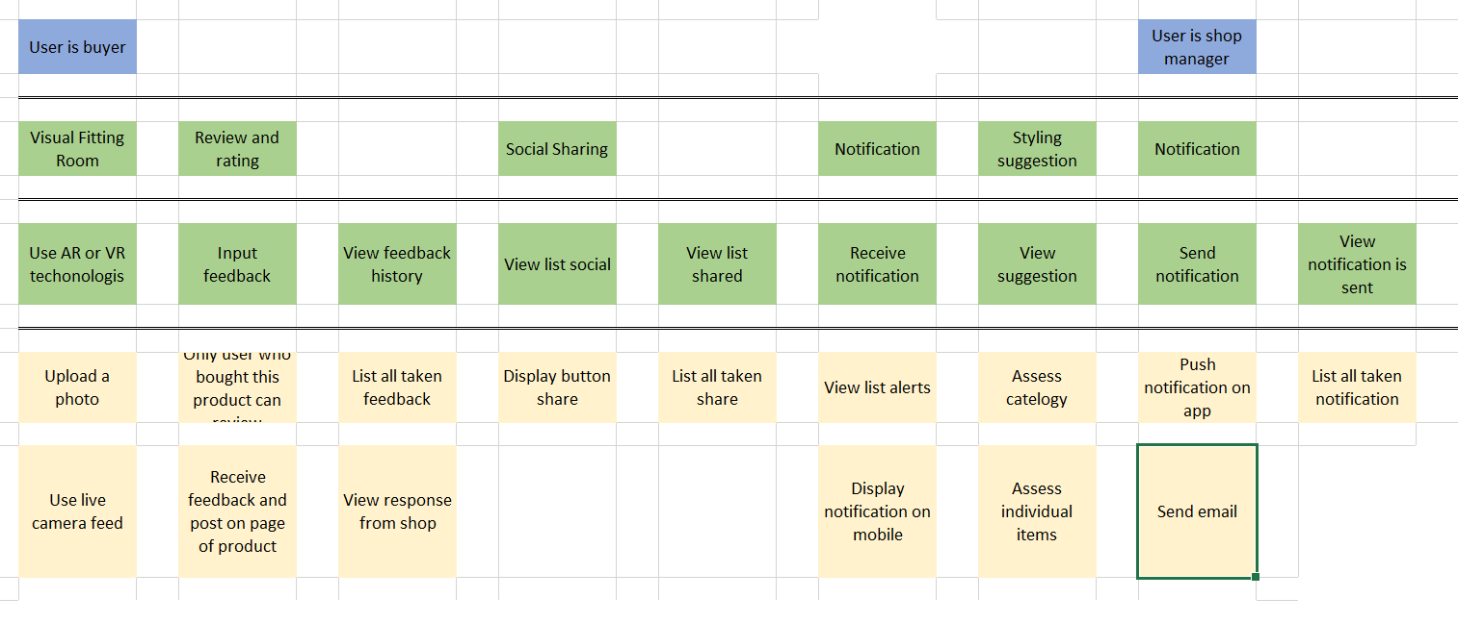

**Question 7:**

The list of 3 assumptions regarding the Virtual Fitting Room feature:

+ High impact if wrong, high probability of configuration of user’s device does not adapt. (1)

+ High impact if wrong, low probability of recognize person being wrong. (2)

+ Low impact if wrong, low probability of can not use camera. (3)

Explain:

(1): This is because users are using a different device but existing some device with low configuration. May be Virtual Fitting Room feature can not available or response slowly. And if it happens, the user’s experiences will not satisfied and can not choose a suitable product .

(2): This is because nowadays, camera recorgnization is becoming more modern than ever before, so tracking are easy tasks. But if it happens, the impact of it will be high because system can give wrong suggestion, the user’s experiences will not satisfied .

(3): This is because in some situation, the device does not allow to use live camera so can not use camera to recorgize. But system allow upload picture so it is low impart.