**For the submission of your work:**

- Create a folder named **RollNo_Name_DBI202_PaperNo**, e.g. se01245_LongNT_DBI202_01. **Do not** create any subfolder in this folder. All file created will be located in the above folder.

- For each question, you are required to write a database script. Create a file with the name corresponding to the index of the question. For example, **for question 1**, we will create a file named **Q1.sql** and create a file **Q2.sql for question 2**. So, if you do 10 questions, your folder must contain **only** 10 files Q1.sql, Q2.sql, Q3.sql, Q4.sql, Q5.sql, Q6.sql, Q7.sql, Q8.sql, Q9.sql and Q10.sql.

- Do not use any commands having the database name such as create database, alter database, use [database name], GO, EXEC, *etc*.

- Your response must contain only necessary commands for answering the question. Do not include any other command. For example, if you are required to create a trigger/procedure, then your response should contain only commands for creating the corresponding trigger/procedure; all commands for testing the created trigger/procedure are forbidden.

- On completion, import your work by browsing to the above folder.

**- Note that:**

**+ You could use only SQL Server, SQL Server Management Studio, Window explorer, Winrar, Winzip**

**+ If any of the previous requirements is not respected, your mark will be 0.**

**From the 2nd question**, you should use the database provided in the .sql file which has the following database diagram. Please, run the provided script to create tables and insert data into your database.

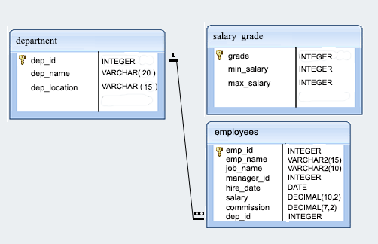

**Question 2:**

write a SQL query to find those employees who do not belong to the department 2001. Return complete information about the employees

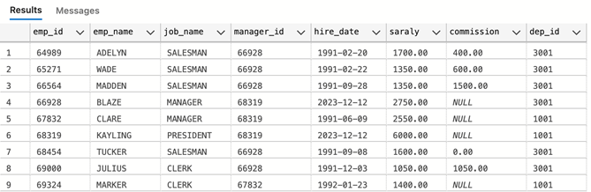

Picture 2.1

**Question 3:**

write a SQL query to calculate the average salary of employees who work as analysts. Return average salary

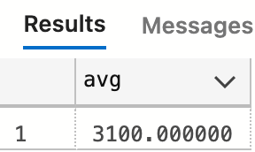

Picture 3.1

**Question 4:**

Write a SQL query to find the employee ID, salary, and commission of all the employees

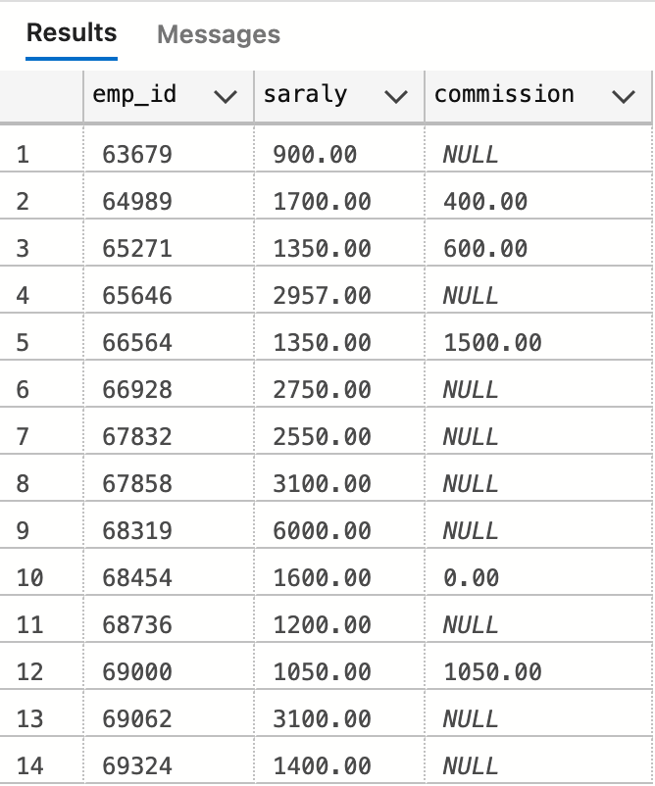

Picture 4.1

**Question 5:**

write a SQL query to identify employees whose commissions exceed their salaries. Return complete information about the employees

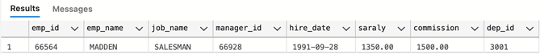

Picture 5.1

**Question 6:**

write a SQL query to find those employees who joined before 1st April 1991. Return employee ID, employee name, hire date and salary

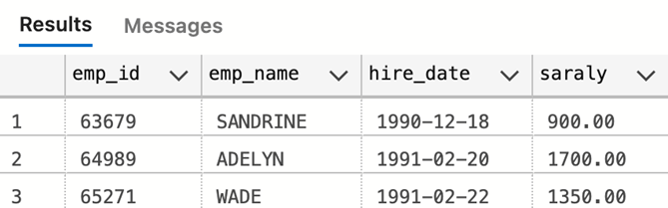

Picture 6.1

**Question 7:**

write a SQL query to identify the employees who joined the company in June 1991. Return complete information about the employees

**Question 8:**

Wirte a SQL to udpate commission of emp_id is 66928 to 500.00

**Question 9:**

Create stored procedure with named psm_list_all_of_department to list all information of department

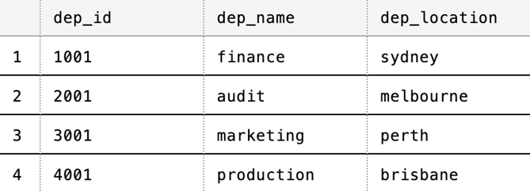

Picture 9.1

**Question 10:**

Create a trigger named Tr_Employee_Update_Under18 for the update statement on table Employees so that refuses all under-18-year-old employee’s updating the table Employees.

For example :

update employees

set hire_date='2022-2-2'

where emp_id = 63679

The system will display the error results because employee's age is less than 18 years old.