**NWC203c**

**1,** Explain the difference between connectionless unacknowledged service and connectionless acknowledged service. How do the protocols that provide these services differ?

Unacknowledged Connectionless Service :  
Unacknowledged connectionless service simply provides datagram styles delivery without any error, issue, or flow control. In this service, source machine generally transmits independent frames to destination machine without having destination machine to acknowledge these frames.This service is called as connectionless service because there is no connection established among sending or source machine and destination or receiving machine before data transfer or release after data transfer.In Data Link Layer, if anyhow frame is lost due to noise, there will be no attempt made just to detect or determine loss or recovery from it. This simply means that there will be no error or flow control. An example can be Ethernet.

Acknowledged Connectionless Service :  
This service simply provides acknowledged connectionless service i.e. packet delivery is simply acknowledged, with help of stop and wait for protocol.In this service, each frame that is transmitted by Data Link Layer is simply acknowledged individually and then sender usually knows whether or not these transmitted data frames received safely. There is no logical connection established and each frame that is transmitted is acknowledged individually.This mode simply provides means by which user of data link can just send or transfer data and request return of data at the same time. It also uses particular time period that if it has passed frame without getting acknowledgment, then it will resend data frame on time period.This service is more reliable than unacknowledged connectionless service. This service is generally useful over several unreliable channels, like wireless systems, Wi-Fi services, etc.

| **Unacknowledged Connectionless Service** | **Acknowledged Connectionless Service** |
| --- | --- |
| Unacknowledged connectionless service simply provides datagram styles delivery without any error, issue, or flow control. | This service simply provides acknowledged connectionless service i.e. packet delivery is simply acknowledged, with help of stop and wait for protocol |
| In this service, source machine generally transmits independent frames to destination machine without having destination machine to acknowledge these frames | In this service, each frame that is transmitted by Data Link Layer is simply acknowledged individually and then sender usually knows whether or not these transmitted data frames received safely. |
| This service is called as connectionless service because there is no connection established among sending or source machine and destination or receiving machine before data transfer or release after data transfer. | There is no logical connection established and each frame that is transmitted is acknowledged individually.This mode simply provides means by which user of data link can just send or transfer data and request return of data at the same time. |
| there will be no error or flow control. | This service is more reliable than unacknowledged connectionless service. |
| An example can be Ethernet. | This service is generally useful over several unreliable channels, like wireless systems, Wi-Fi services |

**2**, Explain the difference between connection-oriented acknowledged service and connectionless acknowledged service. How do the protocols that provide these services differ?

Acknowledged Connection-Oriented Service :  
In this type of service, connection is established first among sender and receiver or source and destination before data is transferred.Then data is transferred or transmitted along with this established connection. In this service, each of frames that are transmitted is provided individual numbers first, so as to confirm and guarantee that each of frames is received only once that too in an appropriate order and sequence.

| **Connection-oriented acknowledged service** | **Connectionless acknowledged service** |
| --- | --- |
| In this type of service, connection is established first among sender and receiver or source and destination before data is transferred. | This service simply provides acknowledged connectionless service i.e. packet delivery is simply acknowledged, with help of stop and wait for protocol. |
| data is transferred or transmitted along with this established connection. | This mode simply provides means by which user of data link can just send or transfer data and request return of data at the same time. |
| In this service, each of frames that are transmitted is provided individual numbers first, so as to confirm and guarantee that each of frames is received only once that too in an appropriate order and sequence. | IT uses particular time period that if it has passed frame without getting acknowledgment, then it will resend data frame on time period. |

**3,**

| **HDLC** | **PPP** |
| --- | --- |
| HDLC stands for High-Level data link control | PPP stands for Point-To-Point protocol |
| It is a Bit-oriented protocol | It is a Byte-oriented protocol |
| The HDLC protocol is only used for the synchronous media | The PPP protocol is used for both the asynchronous media as well as synchronous media |
| It is an older protocol as compared to PPP protocol so it does not provide any kind of authentication | It is the newer protocol as compared to HDLC protocol which means that it does provide the authentication. |
| In this, the addressing is not dynamic which means that the addressing is purely static. | In this, the addressing is dynamic which makes it quite more reliable than the HDLC protocol. |
| As the HDLC protocol is quite old school which purely signifies that it does not support non-cisco devices at all. | The PPP protocol is relatively newer than the HDLC protocol which signifies that it does support the non-cisco devices. |
| It is more costlier than PPP | It is less costlier than HDLC |

**4.** A 1.5 Mbps communications link is to use HDLC to transmit information to the moon. What is the smallest possible frame size that allows continuous transmission? The distance between earth and the moon is approximately 375,000 km, and the speed of light is 3 x 108 meters/second.

**Solution:**

For continuous transmission: Use Go-Back-N or Selective Repeat ARQ

|  | Maximum Send Window Size in Default HDLC Frame | Maximum Send Window Size in Extended HDLC Frame |
| --- | --- | --- |
| Go-Back-N | 7 | 2^7 - 1 = 127 |
| Selective ARQ | 4 | 64 |

The round trip propagation delay is

Round-Trip Propagation Delay = 2 $t_{prop}=$ $\frac{2 * Distance}{Light Speed} =\frac{2 * (375 * 10^{6})}{3 * 10^{8}}=2.5s$

Call $n_{f}$ is the smallest possible frame size, so that we got

$\frac{N * n_{f}}{Transmission Rate} = 2t_{prop}$

Go-Back-N

If N = 7: $\frac{7 n_{f}}{1.5 Mbps} = 2.5 s =>n_{f }=535714,3 bits$

If N = 127: $\frac{127 n_{f}}{1.5 Mbps} = 2.5 s =>n_{f }=29527,5 bits$

Selective Repeat

If N = 4: $\frac{4 n_{f}}{1.5 Mbps} = 2.5 s =>n_{f }= 973500 bits$

If N=64: $\frac{64 n_{f}}{1.5 Mbps} = 2.5 s =>n_{f }=58593,75 bits$

**5.** Suppose HDLC is used over a 1.5 Mbps geostationary satellite link. Suppose that 250-byte frames are used in the data link control. What is the maximum rate at which information can be transmitted over the link?

**Solution:**

We have  
R = 1,5 Mbps or R = $1,5 × 10^{6} bps$, and $n_{f}$ = 2000 bits = 250 bytes * 8

The distance that the information must travel is the Earth-to-Satellite Distance, or

D ≈ 36000 km = $3,6 × 10^{7} m$

The speed of light is c = $3× 10^{8} m$

We can calculate the propagation delay and processing rate as follows

$t_{prop}$ = $\frac{D}{c}$ = $\frac{3,6 × 10^{7}}{3 × 10^{8}}$ = 0,12 s = 120 ms

$t_{f}$ = $\frac{n_{f}}{R}$ = $\frac{2000}{1,5 × 10^{6}}$ = 0,00133s = 1,33 ms

In which, $t_{prop}$ is propagation rate, $t_{f}$ is processing rate.

We can use either Go-Back-N or Selective Repeat ARQ.

|  | Maximum Send Window Size in Default HDLC Frame | Maximum Send Window Size in Extended HDLC Frame |
| --- | --- | --- |
| Go-Back-N | 7 | 2^7 - 1 = 127 |
| Selective ARQ | 4 | 64 |

If using Go-Back-N which default HDLC Frame, then N = 7.

The maximum information rate is achieved with no error, and hence, no retransmission

$t_{cycle} = t_{f } + 2t_{prop} = 1,33 + 2×120 = 241,33 ms$

In which, $t_{cycle}$ is the minimum time to transmit a group of N packets.

n = N × nf =7 × 2000=14000 bits

Then

$R_{max} = n / t_{cycle}=14000 / 241,33 ms = 14000 / ( 241,33 × 10^{-3}) s$

$= 58011,85 bps$

In which, n is number of bits transmitted in a cycle, $R_{max}$ is the number of bits sent in a cycle / minimum cycle time.

If using Go-Back-N which extended HDLC Frame,, then N = 127.

n = N × nf =127 × 2000= 254000 bits

Then

$R_{max} = n / t_{cycle}=254000 / 241,33 ms = 254000 / ( 241,33 × 10^{-3}) s$

$= 1052500,725 bps$

If using Selective Repeat which default HDLC Frame, then N = 4.

n = N × nf =4 × 2000= 8000 bits

Then

$R_{max} = n / t_{cycle}=8000 / 241,33 ms = 8000 / ( 241,33 × 10^{-3}) s$

$= 33149,63 bps$

If using Selective Repeat which extended HDLC Frame, then N = 64.

n = N × nf =64 × 2000= 128000 bits

Then

$R_{max} = n / t_{cycle}=128000 / 241,33 ms = 128000 / ( 241,33 × 10^{-3}) s$

$= 530394,07 bps$

# 6: Suppose that a multiplexer receives constant-length packet from N = 60 data sources. Each data source has a probability p = 0.1 of having a packet in a given T-second period. Suppose that the multiplexer has one line in which it can transmit eight packets every T seconds. It also has a second line where it directs any packets that cannot be transmitted in the first line in a T-second period. Find the average number of packets that are transmitted on the first line and the average number of packets that are transmitted in the second line.

**Solution:**

First, find out the probability of the k packets that have reached the T- second. It can be computed with the help of binomial distribution that has parameters as N=60 and shows the probability of p=0.1.

The average number for the arrivals of the packets can be given as Np=6. Now, calculate the average number of packets received through the first line as below:

$\sum_{0}^{8}{}k ×60Ck ×{\left(0.1\right)}^{k}{\left(1-0.1\right)}^{60-k}=4.59$

Now, the average number of packets received is 4.59 that gets transmitted through the first line. The remaining will get transmitted by the second line. Now, the average number of packets transmitted through the second line per T second can be obtained as below:

6 – 4.59 = 1.41

Therefore, it will transmit 1.41 packets on average per T second from the second line.

# 

**7,**

Consider the transfer of a single real-time telephone voice signal across a packet network. Suppose that each voice sample should not be delayed by more than 20 ms.

a. Discuss which of the following adaptation functions are relevant to meeting the requirements of this transfer: handling of arbitrary message size; reliability and sequencing; pacing and flow control; timing; addressing; and privacy, integrity and authentication.

b. Compare a hop-by-hop approach to an end-to-end approach to meeting the requirements of the voice signal.

Packets:

In networking, a packet is a small segment of a larger message.

Data sent over computer networks, such as the Internet, is divided into packets.

These packets are then recombined by the computer or device that receives them.

a)

Adaptation functions are relevant to meeting the requirements:

Message size is important because in real-time signals of voice, it is necessary to transfer a fixed packet size that holds no more than 20 ms of the speech signal. The handling of arbitrary message size is not as important as long as the desired packet size for voice can be handled.

Sequencing is essential because each packet needs to arrive in the same sequence that it was generated. Reliability is moderately important since voice transmission can tolerate a certain level of loss and error.

Pacing and flow control are not as important because the synchronous nature of the voice signal implies that the end systems will be matched in speed.

Timing, for real-time voice transfer, is important because this adaptation function helps to control the jitter in the delivered signal.

Addressing is only during the connection setup phase if we assume some form of virtual circuit packet switching method.

Privacy, integrity, and authentication have traditionally not been as important as the other issues discussed above.

b)

Comparing a hop-by-hop approach to an end-to-end approach:

If the underlying network is reliable then the end-to-end approach is better because the probability of error is very low so processing at the edge suffices to provide acceptable performance.

If the underlying network is unreliable then the hop-by-hop approach may be required. For example, if the probability of error is very high, as in a wireless channel, then error recovery at each hop may be necessary to make effective communication possible.

Therefore, the adaptation functions are relevant to meeting the requirements and the comparison of hop-by-hop approach to an end-to-end approach is provided.

**8.** Consider the Stop-and-Wait protocol as described. Suppose that the protocol is modified so that each time a frame is found in error at either the sender or receiver, the last transmitted frame is immediately resent.

|  |  |
| --- | --- |

a. Show that the protocol still operates correctly.

b. Does the state transition diagram need to be modified to describe the new operation?

c. What is the main effect of introducing the immediate-retransmission feature?

a.

The Stop-and-Wait protocol works by sending a frame, waiting for an acknowledgement, and then sending the next frame. If the acknowledgement is not received, the frame is resent.

The immediate-retransmission feature modifies the protocol so that the frame is resent as soon as an error is detected. This means that the sender does not have to wait for the acknowledgement before resending the frame.

The protocol will still operate correctly with the immediate-retransmission feature. If a frame is received in error, the receiver will send a negative acknowledgement. The sender will then immediately resent the frame.

b.

The state transition diagram does not need to be modified to describe the new operation. The only difference is that the sender will now enter the "Resend frame" state as soon as an error is detected.

c.

The main effect of introducing the immediate-retransmission feature is to reduce the number of frames that are lost. This is because the frame is resent as soon as an error is detected, so there is less time for the frame to be lost in the network.

The immediate-retransmission feature also improves the throughput of the protocol. This is because the sender does not have to wait for the acknowledgement before resending the frame, so the sender can send more frames in a given period of time.

**9,**

Suppose that two peer-to-peer processes provide a service that involves the transfer of discrete messages. Suppose that the peer processes are allowed to exchange PDUs that have a maximum size of M bytes including H bytes of header. Suppose that a PDU is not allowed to carry information from more than one message.

a. Develop an approach that allows the peer processes to exchange messages of arbitrary size.

b. What essential control information needs to be exchanged between the peer processes?

c. Now suppose that the message transfer service provided by the peer processes is shared by several message source-destination pairs. Is additional control information required, and if so, where should it be placed?

a,

To exchange messages of arbitrary size, large messages must be segmented into parts of M-H bytes

each in length to be transmitted in multiple PDUs.

Small messages must be placed in a single PDU.

b.

The peer processes need to communicate information that allows for the reassembly of messages at

the receiver.

For example, the first PDU may contain the message length.

The last PDU may contain

and end-of-message marker.

Sequence numbers may also be useful to detect loss in connection

oriented networks and to help in reconstruction of the messages in connectionless networks.

Lastly,

since variable size PDUs are permitted, the size of the PDU payload must be transmitted in the PDU

header.

c.

In this case, in addition to all of the header information mentioned in b, each PDU must be labeled

with a stream ID, so that the receiver can treat each stream independently when reassembling

messages.

This stream ID may be avoided if the source and destination operate so that they handle

the transfer of a single message at a time.

For example, this approach is used by AAL5 in ATM.

**10.** A 1 Mbyte file is to be transmitted over a 1 Mbps communication line that has a bit error rate of p = 10-6.

* 1. What is the probability that the entire file is transmitted without errors? Note for n large and p very small, (1 − p)n ≈ e-np.
  2. The file is broken up into N equal-sized blocks that are transmitted separately. What is the probability that all the blocks arrive correctly without error? Does dividing the file into blocks help?
  3. Suppose the propagation delay is negligible, explain how Stop-and-Wait ARQ can help deliver the file in error-free form. On the average how long does it take to deliver the file if the ARQ transmits the entire file each time?

**Solution:**

The file length n = 8 $×{10}^{6}$ bits, the transmission rate R = 1 Mbps, and

p = ${10}^{-6}.$

a. What is the probability that the entire file is transmitted without errors? Note for n large and p very small, ${\left(1-p\right)}^{n} ≈{ e}^{-np}$

P[no error in the entire file] = ${\left(1-p\right)}^{n} ≈{ e}^{-np}$, for n >> 1, p << 1

= $e^{-8}=3.35 × {10}^{-4}$

We conclude that it is extremely unlikely that the file will arrive error free.

b. A subblock of length n/N is received without error with probability:

P[no error in subblock] = ${(1-p)}^{n/N}$

A block has no error if all subblocks have no errors, so

P[no error in block] = ${P\left[no error in subblock\right]}^{N}$

$={\left({\left(1-p\right)}^{\frac{n}{N}}\right)}^{N}={\left(1-p\right)}^{n}$

So simply dividing the blocks does not help.

c.

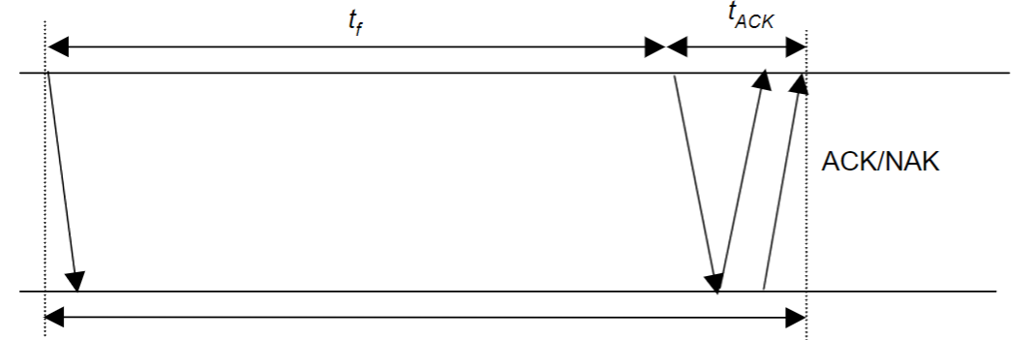

$t_{0}$ = basic time to send a frame and receive the ACK/NAK ≈ $t_{timeout}$

$t_{total}$ = total transmission time until success

$n_{f}$ = number of bits/frame

$n_{a}$ = number of bits per ACK

$n_{t}$ = number of transmissions

$P_{t}$ = probability of frame transmission error

$t_{0}$ = $t_{f}$ + $t_{ACK}$ = $n_{f}$/ R+ $n_{a}$/ R (prop ≈ 0).

P[ $n_{t}$ = i ] = P[one success after i - 1 failure] = (1 – )

| i transmissions = i . $t_{0}$

E[$t_{total}$] = $\sum_{i=1}^{∞}{}it_{0}P\left[n_{t}=i\right]=t_{o}(1-P_{f})\sum_{i=1}^{∞}{}iP_{f}^{i-1}=\frac{t_{0}\left(1-P_{f}\right)}{{\left(1-P_{f}\right)}^{2}}=\frac{t_{0}}{(1-P_{f})}$

Here, $n_{f}$ = n >> ${ n}_{a}$, thus $t_{0}≈$ $t_{f}$ = n / R ; and $P_{f}$ = 1 - P[ no error]

= 1 – $e^{-np}$

E[total] = n/R (1 - ${ P}_{f}$) = n/[R $e^{-np}$]= 8 / (3.35 x $10^{4}$) =23,847 seconds = 6.62 hours!

The file gets through, but only after many retransmissions.

**11.**

In this activity, you are given the network address of 192.168.1.0/24 to subnet and provide the IP addressing for the Packet Tracer network. Each LAN in the network requires at least 25 addresses for end devices, the switch and the router. The connection between R1 to R2 will require an IP address for each end of the link.

1. Based on the topology, how many subnets are needed?
2. How many bits must be borrowed to support the number of subnets in the topology table?
3. How many subnets does this create?
4. How many usable hosts does this create per subnet?

**Solution:**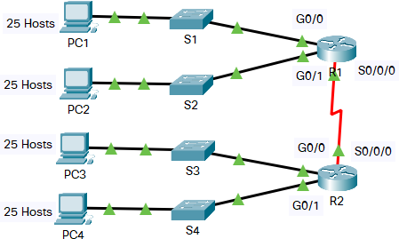

a. The answer is 5. Four for the LANs (S and R), and one for the link between the routers (R and R).

b. To support 5 subnets, we need to borrow three bits from the host portion of the IP address.

Explaination:  
We have 5 networks in total, so that if we call N (N > 0) is the number of bits borrowed, then N is the least number that sastifies

$2^{N}≥5$

Then N = 3.

c. Borrowing three bits creates $2^{3}$ = 8 subnets.

Since we have borrowed 3 bits, then the subnet mask becomes

$/27 : 11111111.11111111.11111111.11100000$

(We can understand that the initial subnet mask is /24, after borrowing 3 bits, the subnet mask becomes /27)

All the network addresses are listed below

| **Network Address** | **Usable Host Range** | **Broadcast Address:** |
| --- | --- | --- |
| 192.168.1.0 | 192.168.1.1 - 192.168.1.30 | 192.168.1.31 |
| 192.168.1.32 | 192.168.1.33 - 192.168.1.62 | 192.168.1.63 |
| 192.168.1.64 | 192.168.1.65 - 192.168.1.94 | 192.168.1.95 |
| 192.168.1.96 | 192.168.1.97 - 192.168.1.126 | 192.168.1.127 |
| 192.168.1.128 | 192.168.1.129 - 192.168.1.158 | 192.168.1.159 |
| 192.168.1.160 | 192.168.1.161 - 192.168.1.190 | 192.168.1.191 |
| 192.168.1.192 | 192.168.1.193 - 192.168.1.222 | 192.168.1.223 |
| 192.168.1.224 | 192.168.1.225 - 192.168.1.254 | 192.168.1.255 |

d. The last octet of an IP address has 8 bits, since we have borrowed 3 bits, so that the answer is

$2^{8-3}-2=30$

So that each subnet can create 30 usable hosts.

**12.** Five stations (S1-S5) are connected to an extended LAN through transparent bridges (B1- B2), as shown in the following figure. Initially, the forwarding tables are empty. Suppose the following stations transmit frames: S1 transmits to S5, S3 transmit to S2, S4 transmits to S3, S2 transmits to S1, and S5 transmits to S4. Fill in the forwarding tables with appropriate entries after the frames have been completely transmitted.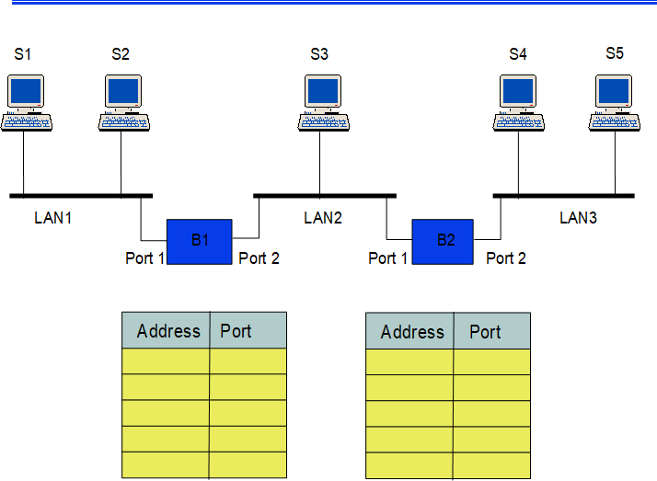

**Solution:**

| B1 | |
| --- | --- |
| Station | Port |
| S1 | 1 |
| S3 | 2 |
| S4 | 2 |
| S2 | 1 |
| S5 | 2 |

| B2 | |
| --- | --- |
| Station | Port |
| S1 | 2 |
| S3 | 1 |
| S4 | 1 |
| S2 | 1 |
| S5 | 2 |

S1 transmits to S5

S3 transmits to S2

S4 transmits to S3

S2 transmits to S1

S5 transmits to S4

**13.**

Consider the network in Figure.

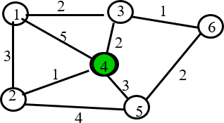

* 1. Use the Dijkstra algorithm to find the set of shortest paths from node 4 to other nodes.

| Iteration | N | D1 | D2 | D3 | D5 | D6 |
| --- | --- | --- | --- | --- | --- | --- |
| Initial |  |  |  |  |  |  |
|  |  |  |  |  |  |  |
|  |  |  |  |  |  |  |
|  |  |  |  |  |  |  |
|  |  |  |  |  |  |  |
|  |  |  |  |  |  |  |

* 1. Find the set of associated routing table entries (Destination, Next Hop, Cost)

**Solution:**

a, We define N is the node 4, D1, D2, D3, D5, D6 is the node 1,2,3,5,6.

| Iteration | N | D1 | D2 | D3 | D5 | D6 |
| --- | --- | --- | --- | --- | --- | --- |
| Initial | {N} | 5 | **1** | 2 | 3 | ~ |
| 1 | {N, D2} | 4, D2 |  | **2** | 3 | ~ |
| 2 | {N, D2, D3} | 4, D2 |  | - | **3** | **3, D3** |
| 3 | {N, D2, D3, D5, D6} | 4, D2 |  |  |  |  |
| 4 | {N, D2, D3, D5, D6, D1} | - | - | - | - | - |

So that, we can conclude that

+ The shortest part from N to D1 is 4, and pass D2.

+ The shortest part from N to D2 is 1.

+ The shortest part from N to D3 is 2.

+ The shortest part from N to D5 is 3.

+ The shortest part from N to D6 is 3, and pass D3.

b, Find the set of associated routing table entries (Destination, Next Hop, Cost)

| Destination | Cost | Next Hop |
| --- | --- | --- |
| D1 | 4 | D2 |
| D2 | 1 | D2 |
| D3 | 3 | D3 |
| D5 | 3 | D5 |
| D6 | 3 | D3 |

**14.**

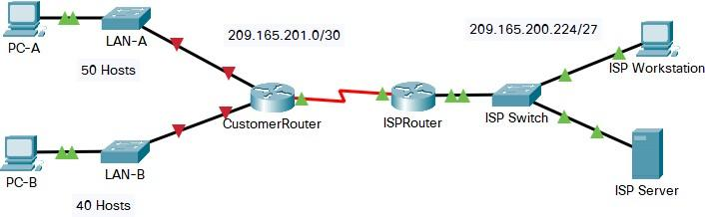

You are a network technician assigned to install a new network for a customer. You must create multiple subnets out of the 192.168.1.0/24 network address space to meet the following requirements:

- The first subnet is the LAN-A network. You need a minimum of 50 host IP addresses.

- The second subnet is the LAN-B network. You need a minimum of 40 host IP addresses.

- You also need at least two additional unused subnets for future network expansion.

Note: Variable length subnet masks will not be used. All of the device subnet masks should be the same length.

Answer the following questions to help create a subnetting scheme that meets the stated network requirements:

a. How many host addresses are needed in the largest required subnet?

b. What is the minimum number of subnets required?

c. The network that you are tasked to subnet is 192.168.1.0/24. What is the /24 subnet mask in binary?

d. The subnet mask is made up of two portions, the network portion, and the host portion. This is represented in the binary by the ones and the zeros in the subnet mask.

In the network mask, what do the ones and zeros represent?

e. When you have determined which subnet mask meets all of the stated network requirements, derive each of the subnets. List the subnets from first to last in the table. Remember that the first subnet is 192.168.0.0 with the chosen subnet mask.

a. The largest required subnet is LAN-A, which needs a minimum of 50 host IP addresses (since LAN-B needs a minimum of 40 host IP addresses, which is lower than 50).

b. We need a minimum of 4 subnets - 2 for the required LANs and 2 additional unused subnets for future network expansion.

c. The /24 subnet mask in binary is 11111111 11111111 11111111 00000000.

d. In the subnet mask, the ones represent the network portion, and the zeros represent the host portion. The network portion identifies the network address, while the host portion identifies individual hosts within the network.

e. LAN-A needs at minimum 50 host IP addresses, so that we need a subnet mask /26 since

/26 in binary: 11111111.11111111.11111111.**11**000000

There are 2 ones at the beginning of the last octet so that /26 provide $2^{2} = 4$ subnets as required

/26 provides $2^{6}-2=62$ host per subnet, which is the smallest number that is larger than 50.

| **Subnet Address** | **Prefix** | **Subnet Mask** |
| --- | --- | --- |
| **192.168.0.0** | **/26** | **255.255.255.192** |
| **192.168.0.64** | **/26** | **255.255.255.192** |
| **192.168.0.128** | **/26** | **255.255.255.192** |
| **192.168.0.192** | **/26** | **255.255.255.192** |

# 15,

# Suppose that Selective Repeat ARQ is modified so that ACK messages contain a list of the next m frames that it expects to receive.

# Solutions follow questions:

# a. How does the protocol need to be modified to accommodate this change?

# b. What is the effect of the change on protocol performance?

# a,

# 2 things are needed to be changed:

# The frame header needs to be modified to receive the list of frames and Since the receiver explicitly indicates which frames are needed to be transmitted.

# Change in transmitter operation is needed. If the received list contains the oldest frames that are yet to be received , then it can be used to skip retransmission of frames that have already been received.

# b,

# Performance will surely increase if the error rate is high or delay is high. A single frame can ask for the retransmission of several frames.

# The complexity of the protocol will surely increase relative to the unchanged Selective repeat ARQ.

# 16. Suppose the size of an uncompressed text file is 1 megabyte

***Note: Explain your answer in details.***

1. How long does it take to download the file over a 32 kilobit/second modem?
2. How long does it take to take to download the file over a 1 megabit/second modem?
3. Suppose data compression is applied to the text file. How much do the transmission times in parts (a) and (b) change?
4. $T_{32k}$ = 8 (1024) (1024) / 32000 = 262.144 seconds
5. $T_{1M}$ = 8 (1024) (1024) bits / 1x106 bits/sec = 8.38 seconds

$T_{32k}$ = 8 (1024) (1024) / (32000 x 6) = 43.69 sec

$T_{1M}$ = 8 (1024) (1024) / (1x106 x 6) = 1.4 sec

**17.** Let g(x)=x3+x+1. Consider the information sequence 1001. Find the codeword corresponding to the preceding information sequence. Using polynomial arithmetic we obtain

Let $g\left(x\right)=x^{3}+x+1$. Consider the information sequence 1001. Find the codeword corresponding to the preceding information sequence. Using polynomial arithmetic we obtain

Given an information polynomial code is $g\left(x\right)=x^{3}+x+1$

Now we rewrite the polynomial code as ${1 ×x}^{3}+{0× x}^{2}+1× x+1×1$  as 1011

Since polynomial is of order  (3 is the higest power of g(x))

So, we add three zeros in the information sequence.

Therefore, the new polynomial code is $1001000$

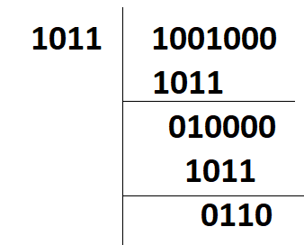

Then, we add 110 to the information sequence 1001 to get the codeword: 1001110.

**18,**

A router has the following CIDR entries in its routing table:

Address/mask Next hop

135.46.56.0/22 Interface 0

135.46.60.0/22 Interface 1

192.53.40.0 /23 Router 1

default Router 2

(a) What does the router do if a packet with an IP address 135.46.63.10 arrives?

(b) What does the router do if a packet with an IP address 135.46.57.14 arrives?

a, 135.46.63.10

When converted into binary, we have

10000111.00101110.00111111.00001010

Taking the first 22 bits of 135.46.63.10 as network address, we have

10000111.00101110.00111100.00000000 or 135.46.60.0.

The bit pattern of 135.46.63.10 is 10000111.00101110.00111111.00001010

When we perform the bit and operation with 22 leading bit 1s and 10 bit 0s, it is equivalent of making the last 10 bit zero. We get the following network address bit pattern: 10000111.00101110.00111100.00000000. The first two bytes are not changed. The 3rd type changes from 63 to 60 while the 4th byte become zero.

Match with network address in the routing table. The 2rd row matches. The router will forward the packet to Interface 1.

(b) 135.46.57.14

Taking the first 22 bits of the above IP address as network address, we have 135.45.56.0. It matches the network address of the first row. The packet will be forwarded to Interface 0.

**19,**

A Large number of consecutive IP address are available starting at 198.16.0.0. Suppose four organizations, A, B, C, D request 4000, 2000, 4000, and 8000 addresses, respectively. For each of these organizations, give:

1. the first IP address assigned

2. the last IP address assigned

3. the mask in the w.x.y.z/s notation

The start address, the ending address, and the mask are as follows:

**Case 1: Organization A, 4000 request**

In this case, the first address = starting address = 198.16.0.0.

Starting address 198.16.0.0 can be written as 11000110.00010000.00000000.00000000

We note that $n=12$ is the smallest number that satisfy $2^{n} >= 4000.$ Replace the last 12 bits of first IP Address with 1, then we have the last IP Address is

11000110.00010000.00001111.11111111 or 198.16.15.255

The subnet mask is derived by subtracting 12 from 32, resulting in a value of 20, which is equivalent to using a subnet mask of /20.

So in this case, the result is 198.16.0.0 - 198.16.15.255 or can be written as 197.16.0.0/20

**Case 2: Organization B, 2000 request**

Remember that, the last IP assigned to A is 198.16.15.255, so that the first IP address of B is that IP + 1, or

First IP = 198.16.15.255 + 1 = 198.16.16.0

(Bạn đọc tự thực hiện phép cộng 2 IP để có được kết quả này)

We note that $n=11$ is the smallest number that satisfy $2^{n} >= 2000.$ Replace the last 11 bits of first IP Address with 1, then we have the last IP Address is

11000110.00010000.00010111.11111111 or 198.16.23.255

The subnet mask is derived by subtracting 11 from 32, resulting in a value of 21, which is equivalent to using a subnet mask of /21.

So in this case, the result is 198.16.16.0 - 198.16.23.255 or can be written as 197.16.16.0/21

**Case 3: Organization C, 4000 request**

Remember that, the last IP assigned to B is 198.16.23.255, so that the first IP address of C is that IP + 1, or

First IP = 198.16.23.255 + 1 = 198.16.24.0 (11000110.00010000.00011000.00000000)

(Bạn đọc tự thực hiện phép cộng 2 IP để có được kết quả này)

We note that $n=12$ is the smallest number that satisfy $2^{n} >= 4000.$ But, the 12 last bits of the first IP are not all zeros, so we have to find the nearest IP that is higher than the first IP and satisfy that the last 12 bits are zeros. Particularly, it is

$11000110.00010000.00100000.00000000$ or 198.16.32.0

(Bạn đọc tự thấy cái màu xanh lá là cái nhỏ nhất mà lớn hơn màu xanh dương và thỏa mãn điều kiện 12 bits cuối đều là 0, xanh lá xanh dương chỉ để nhận biết, đi thi nhớ điền các dòng xanh lá xanh dương vào và mặc kệ dòng màu đỏ này).

Replace the last 12 bits of first IP Address with 1, then we have the last IP Address is

11000110.00010000.00101111.11111111 or 198.16.47.255.

The subnet mask is derived by subtracting 12 from 32, resulting in a value of 20, which is equivalent to using a subnet mask of /20.

So in this case, the result is 198.16.32.0 - 198.16.47.255 or can be written as 197.16.32.0/20

**Case 4: Organization D, 8000 request**

Remember that, the last IP assigned to B is 198.16.47.255, so that the first IP address of C is that IP + 1, or

First IP = 198.16.47.255 + 1 =198.16.48.0 (11000110.00010000.00110000.00000000)

(Bạn đọc tự thực hiện phép cộng 2 IP để có được kết quả này)

We note that $n=13$ is the smallest number that satisfy $2^{n} >= 8000.$ But, the 13 last bits of the first IP are not all zeros, so we have to find the nearest IP that is higher than the first IP and satisfy that the last 13 bits are zeros. Particularly, it is

$11000110.00010000.01000000.00000000$ or 198.16.64.0

(Bạn đọc tự thấy cái màu xanh lá là cái nhỏ nhất mà lớn hơn màu xanh dương và thỏa mãn điều kiện 13 bits cuối đều là 0, xanh lá xanh dương chỉ để nhận biết, đi thi nhớ điền các dòng xanh lá xanh dương vào và mặc kệ dòng màu đỏ này).

Replace the last 13 bits of first IP Address with 1, then we have the last IP Address is

11000110.00010000.01011111.11111111 or 198.16.95.255.

The subnet mask is derived by subtracting 13 from 32, resulting in a value of 19, which is equivalent to using a subnet mask of /19.

So in this case, the result is 198.16.64.0 - 198.16.95.255 or can be written as 198.16.64.0/19

**20,**

Suppose an application layer entity wants to send an L-byte message to its peer process, using an existing TCP connection. The TCP segment consists of the message plus 20 bytes of header. The segment is encapsulated into an IP packet that has an additional 20 bytes of header. The IP packet in turn goes inside an Ethernet frame that has 18 bytes of header and trailer. What percentage of the transmitted bits in the physical layer correspond to message information, if L = 100 bytes, 500 bytes, 1000 bytes.

The packet in turn goes inside an Ethernet frame that has 18 bytes of header and trailer.

TCP/IP over Ethernet allows data frames with a payload size up to 1460 bytes.

Therefore, L = 100, 500 and 1000 bytes are within this limit.

The message overhead includes:

TCP: 20 bytes of header

IP: 20 bytes of header

Ethernet: total 18 bytes of header and trailer.

The efficiency formula is

$Efficiency = L/ (L + TCP Header + IP Header + Ethernet header and trailer)$

Therefore

L = 100 bytes, 100/158 = 63,29% efficiency.

L = 500 bytes, 500/558 = 89,6% efficiency.

L = 1000 bytes, 1000/1058 = 94,51% efficiency.

**21,**

Consider the three-way handshake in TCP connection setup.

(a) Suppose that an old SYN segment from station A arrives at station B, requesting a TCP connection. Explain how the three-way handshake procedure ensures that the connection is rejected.

(b) Now suppose that an old SYN segment from station A arrives at station B, followed a bit later by an old ACK segment from A to a SYN segment from B. Is this connection request also rejected?

a,

In three-way handshake, there are three messages transmitted by TCP to establish connection between computer.

1. SYN: Client sets the segment sequence number to a random value (say X) and send SYN message to server.

2. SYN-ACK: Server sends SYN-ACK in response to client. Set acknowledgment number to one more than the recieved sequence number (X+1) and sequence number of the packet to another random value (say Y)

3. ACK- Finally, Client sends an ACK back to the server and set sequence number to the recieved acknowledgment number (X+1) and acknowledgment number to one more than recieved sequence number (Y+1).

In this process, one must ensure that first sequence number(i.e. X) is always unique.

Now, if station B recieves an old SYN segment from station A, station B will acknowledge request based on old sequence number and send acknowledgment to station A by adding one more to the recieved old sequence number. A will find out that B had recieved wrong sequence number. Hence, A will discard the acknowledgment and reject the connection.

b,

Yes, the connection will get rejected if an old SYN segment from station A arrives at station B followed a bit later by an old ACK segment from A to a SYN segment from B. Initially when B recieves an old SYN segment from A, B will send a SYN segment with its own unique sequence number. Now, if B recieves an old ACK from A, B will identify that the old ACK sequence number doesnot match with the sequence number send by B previously and notify A that the connection is invalid. That is why the connection will be rejected.

**22,** Suppose a header consists of four 16-bit words: (11111111 11111111, 11111111 00000000, 11110000 11110000, 11000000 11000000). Find the Internet

checksum for this code.

$b_{0}$ = 11111111 11111111 = ${2^{16}}_{}$– 1 = 65535

$b_{1}$ = 11111111 00000000 = 65280

$b_{2}$ = 11110000 11110000 = 61680

$b_{3}$ = 11000000 11000000 = 49344

x = $b_{0}$ + $b_{1}$ + $b_{2}$ + $b_{3}$ modulo 65535 = 241839 modulo 65535 = 45234

$b_{4}$ = − x modulo 65535 = 20301

So the Internet checksum = 01001111 01001101

**23,** Consider the 7-bit generator, G=10011, , and suppose that D has the value 1001010101. What is the value of R? Show your all steps to have result.

Given data

G = 10011

D = 1001010101

The polynomial expression of G

${G = x}^{4} * 1 + x^{3 }* 0 + x^{2} * 0 + x * 1 + 1 * 1$

$=x^{4 } + x + 1$

Hence the degree of the expression is 4, so that r = 4.

Add 4 zeros to the end D to obtain D’ = 100101010000

Calculating the value of R

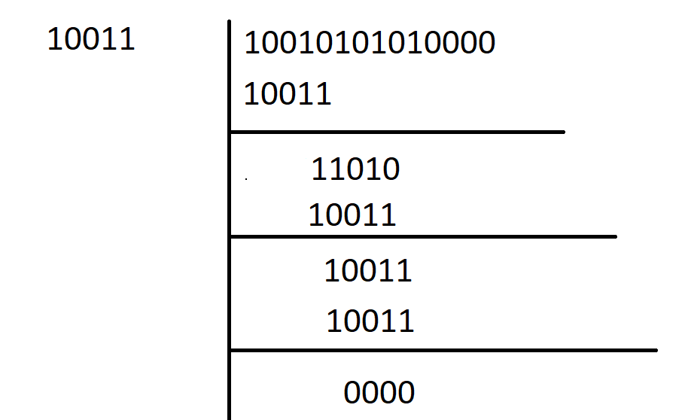

Thus, R = 0000

**24,** Suppose two hosts, A and B, are separated by 20,000 kilometers and are connected by a direct link of R = 2 Mbps. Suppose the propagation speed over the link is 2.5 x 108 meters/sec.

a. Calculate the bandwidth-delay product, $R_{ dprop}$

b. Consider sending a file of 800,000 bits from Host A to Host B. Suppose the file is sent continuously as one large message. What is the maximum number of bits that will be in the link at any given time?

a, The distance (Distance) between two hosts A and B = 20,000 km

= $2 ⨯$ 10^7 m (since 1 km = 10^3 m)

Trasmission rate(R) of the direct link between A and B = 2Mbps

= 2 $10^{6} bps (1Mbps = 10^{6} bps)$

*

Propagation Speed(S) of the link between A and B = $2.5 *10^{8} m/s$

Calculate the propagation delay:

$d_{prog }= Distance / Speed = (2 * 10^{7})/ (2.5 * 10^{8}) = 0.08$ s

Calculate the band-width delay product:

R $d_{prog }= 2 * 10^{6} * 0.08 = 16 * 10^{4 }bits$

*

Therefore, band-with delay product is 160000bits

b, Size of the file = 800000 bits $= 8 * 10^{5} bits$

Trasmission rate(R) of the direct link between A and B = 2Mbps

$= 2 * 10^{6} bits (1 Mpbs = 10^{6} bps)$

The band-width delay product:

R $d_{prog }= 2 * 10^{6} * 0.08 = 16 * 10^{4 }bits$

*

Therefore, the maximum number of bits at a given time will be 160000bits.