**EX2: Using data input and output functions**

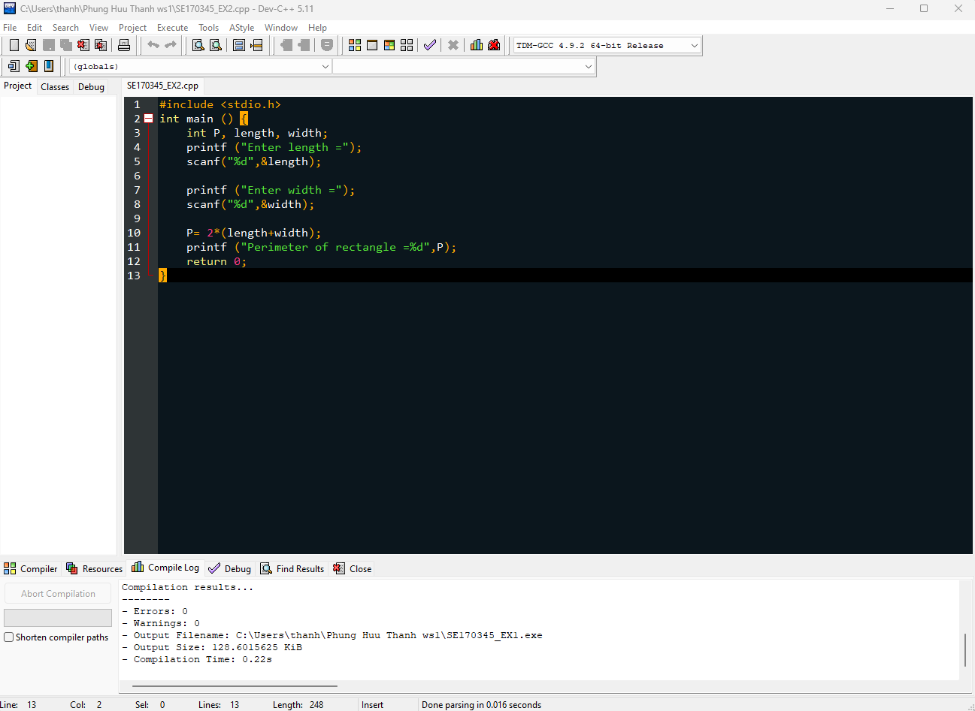

**EX3: Using data input and output functions**

