**Lab 3 – Working with EMG Signal**

Aim: Develop a working muscle sensor to measure and illustrate levels of muscle contraction through indicators and an electromyogram.

With your group members you will,

1.Understand how to use a functional muscle sensor using the Myoware sensor and Arduino.

* Begin by researching the Myoware sensor and set-up instructions at the following website: <https://www.sparkfun.com/products/21265> .

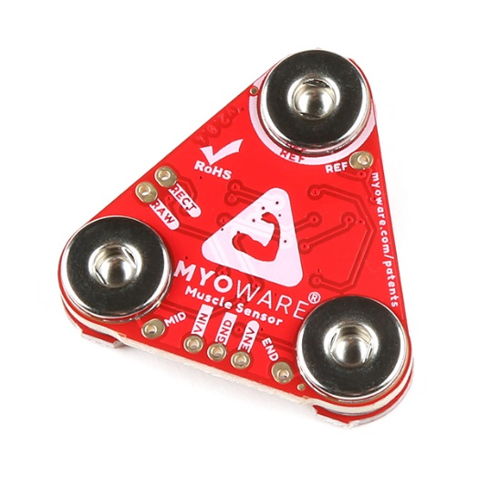

Fig 1: **MyoWare Muscle sensor**

* Once the sensor is connected to your Arduino, attach the electrodes in your kit to the Myoware sensor. Then, place the sensor on a volunteering student’s forearm. Make sure your reference electrode is placed accordingly on a stable location.

2. Implement a system to detect and quantify different levels of muscle contraction (strong, weak, and at rest). You can use any component in your kit to demonstrate three different states of muscle contraction i.e. LEDs, buzzer, etc.

* Test the sensor by plotting your raw signal over time. As the volunteering student forms a tight fist, you should see a spike in your plot. If not, your set up or your sensor is faulty. Please reach out to the TA if this occurs.

4. Collect and analyze electromyogram (EMG) data.

5. Document your findings through a plot of the EMG data and a video demonstration of the muscle sensor and indicators in action.

**Submission Requirements**

1. A lab report on this experience
2. Well-documented Matlab code in *.m format (NO MxL) that includes a description for all the tasks mentioned in the assignment.
3. Data in *.mat format.
4. A video of the experiment showing the board.
5. All members of the group must participate and contribute to the assignment.
6. Submission of the acquired plot and data included in your written 1-3 page lab report.
7. Upload your experimental data.

**Plagiarism**

Please note that plagiarism of any form is unacceptable, including using ChatGPT to create the code. Turnitin can now detect this type of issue, and I will have to follow FIU requirements on plagiarism if it is detected.

**Format:** The assignment must be submitted via [Turnitin](https://fiu.instructure.com/courses/203928/pages/how-to-submit-a-turnitin-assignment) in .m format with the following naming format:

* Group#BME4503CLab3.m
* Group#BME4503CLab3.mat
* The video should be loaded on youtube and the link clearly written in the .m code.