**E-Scooter Requirements**

Use Cases

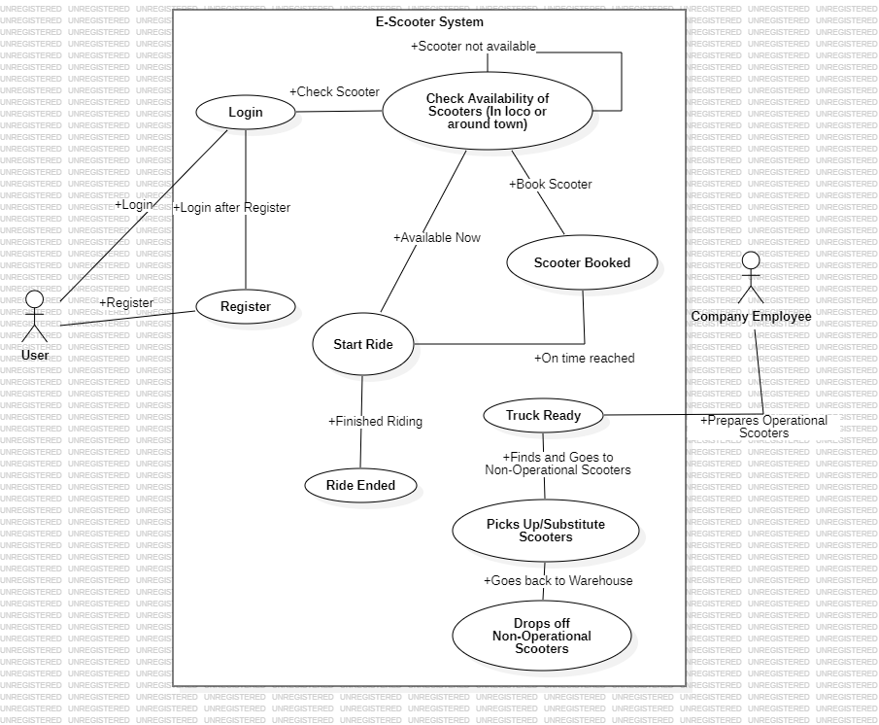

Use Stories

Story: User wants to use Scooter

As a User

I want to make use of a Scooter

So that I can make use of it to travel to my destination

Scenario 1: User wants to use a Scooter now

Given user is registered

And the user has logged in

When the User checks if a Scooter is available

Then the System should show where the nearest available Scooter is to the User

And the designated Scooter is now unavailable

Scenario 2: User wants to book a Scooter for later use

Given user is registered

And the user has logged in

When the User checks if a Scooter is available to book it

Then the System should book a Scooter for later use to the user

And the designated Scooter is now unavailable

And at the booked time, the System should show where the nearest available Scooter is

Scenario 3: User is not registered/fails login

Given the User is not registered/has failed login

When the User tries to access the System

Then the System should not let the User in

And the System should ask the User to re-enter his credentials

Scenario 4: System doesn’t have a Scooter available to use/book

Given user is registered

And the user has logged in

When the User checks if a Scooter is available to book it

Then the System should inform the User that no Scooters are available

And the System will the notify the User as soon as a Scooter is available to use or book

Domain Storytelling

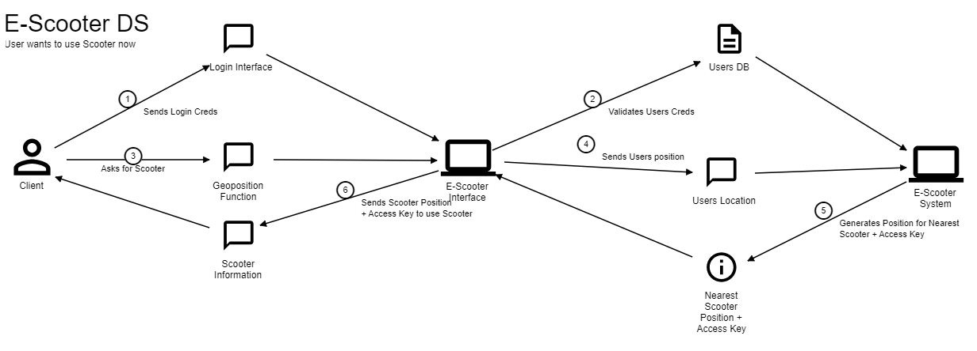

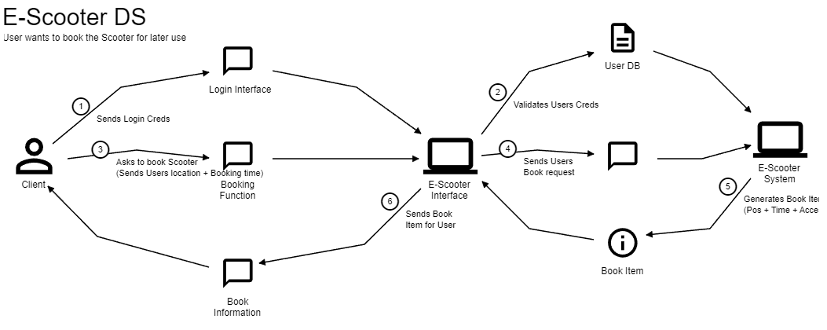

Quality Attribute Scenarios

Examples:

Feature: Small Latency in the case of overload

when multiple requests initiated in k seconds interval cause overload

caused by n users

occur in the system

operating in normal operation

then the system processes all requests

so that the average latency < m seconds

Feature: Latency in geographical operations when searching Scooters

when geopositioning services are slowed down

occur during scooter search/track

operating under normal conditions

then the system warns the user and slows down processing

so that the average latency < n seconds

Feature: Basic fault-tolerance

when a server fails

operating in normal operation

then the Server informs operator and continues to operate

so that there is no downtime