Computational model for premce
Computational models after reading (Kreis et al., 2021)⁠.

In order to quantify latent cognitive processes, several cognitive-computational models were fitted independently to participants’ choices (predicting the categories for each murks) and choice outcome (murkse presented or not).

Note that for all the models, the reward (or feedback) when participants correctly predict the trial is 0, instead than -1. the reason is that parameter recovery has been tried with -1 for incorrect prediction, but recoverability for those models was not good.

Model 1: win-stay-lose-shift model
This model assumes that participants contined to choose an option if it was rewarded on the previous trials, while changing it when they were not rewarded.
With the four possibilities of the present task, the win choice is calculated as:

So the values for the categories that are not displayed become -1.

Model2: choice-dependent
In this model, the agent constantly learns by uptating the value of the current choice through a fixed learning rate. The value of the current choice s defined by the value of the prediction eror delta, which represents the difference between the “reward” and the expected value, of the previous trial, weighted by the learning rate

the prediction error ᵟ is computed as following;

Rewards are defined as correct predictions and are assigned a value of 1, while incorrect predictions are assigned a value of 0.

Model Pearce-Hall
In the pearce hall mode, the learning rate is left free to vary at the trial level. The updating is similar to the Rescorla Wagner model, but the learning rate alpha varied depending on the previous prediction error.

where delta is given by

Hidden Markov Model
The HMM assumes that participants select a choice based on their belief about the current task state, which in turn depends by the probability of those state to reverse (or change) (Keris, Zhang, et al., 2021: Schla- genhauf et al., 2014).
An hidden markov model thoery was delined in a series of papers by Baum and his colleagues in the late 60s early 70s. However, widespread understanding of HMM and their applications have occurred only in the late 90s.
The HMM consider the learner a system that can be in a set of N distinct states Ss. The stystem can undergo a state change. A full probabilistic description of the sustem would require specificatio nof the state at timet ,as well as all the predecessor states. For the special case of a discrete, first order, Markov change, this porbabilitist description is truncated to just represent the current and the predecessor state (rabiner, 1989).
Participants are assumed to ingere the belief distribution over the different states form their observations of action-reward pairs, . The estimation of this acton-outcome pair is represented by the hidden state variable S_{t .} The prior belief over the current state is calculated based on the posterior belief from the previous trial, modulated by the transition proability ɣ, a gree paramter betwwin 0 and 1:

The posterior probability of state S is calculated as following:

After the outcome has been observed, the posterior probability of is updated based on the prior and the outcome :

# Notebook
Applying the Peace-Hall and the HMM to the task structure from PREMCE did not work (parameter recovery was not good.
For this reason, a function (“simulate_data/taskSim2.R”) was created, to allow to run the parameter recovery at different trial n and change points, and characters.
Considering the gamma parameter as fixed to 1, the HMM recovered (28/10/2021). The next goal would be to find out how to implement the gamma.
For the PH, it worked reasonably good for the beta, k, and eta. For the alpha, the correlation between fit and simulated was not that high. One possibility would be to run at fixed k.
Tried transition matrix as in Rabiner, 1989, for the HMM model and gamma, but it did not work.

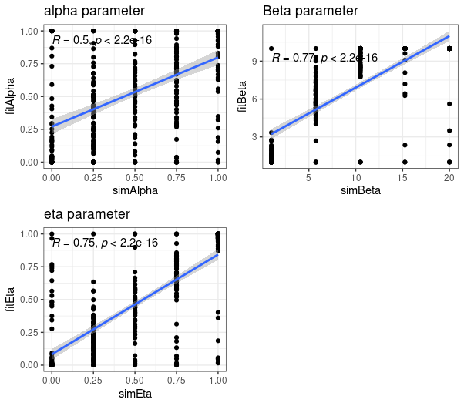
Parameter recovery for the PH, fixing the gamma to 0.1
Parameter recovery for the HMM (simulated structure)
(simulated structure)

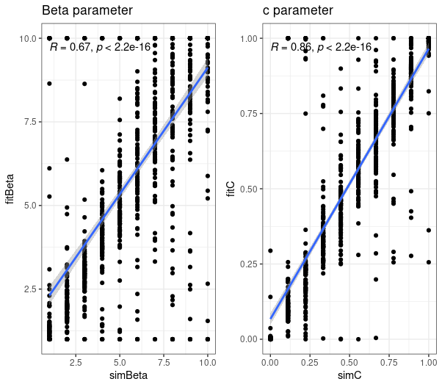

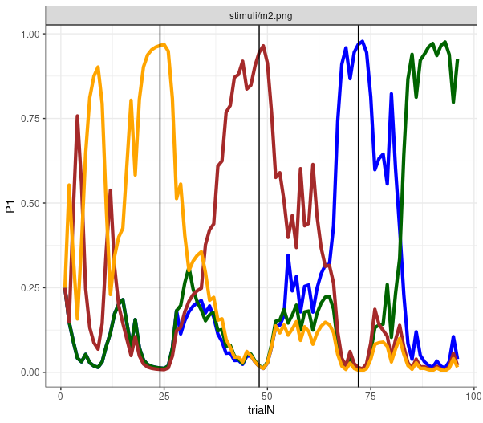
Probabilities, learning rate, and PE for PH model simualted at initial alpha = 0.5, beta = 7, k = 0.5, eta =0.5.

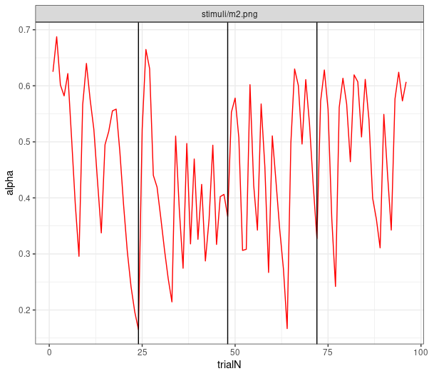

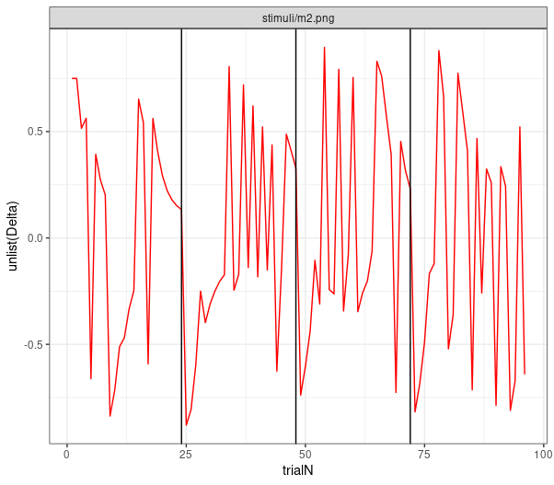

Probabilities, surprise, and other for simulated model HMM, c =0.5, beta =7, gamma=0.1

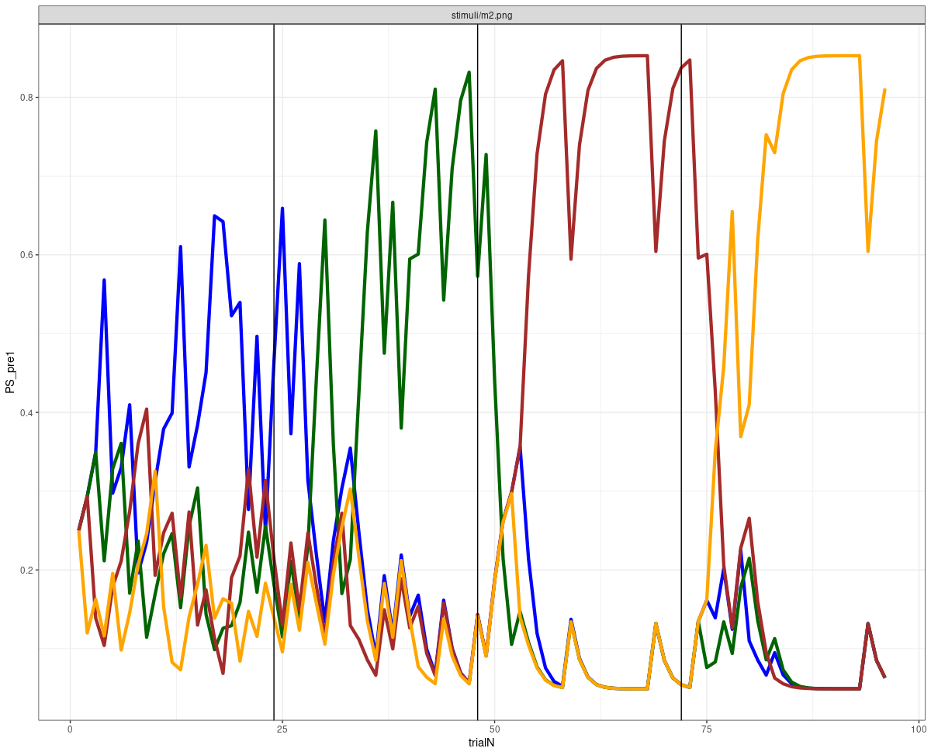

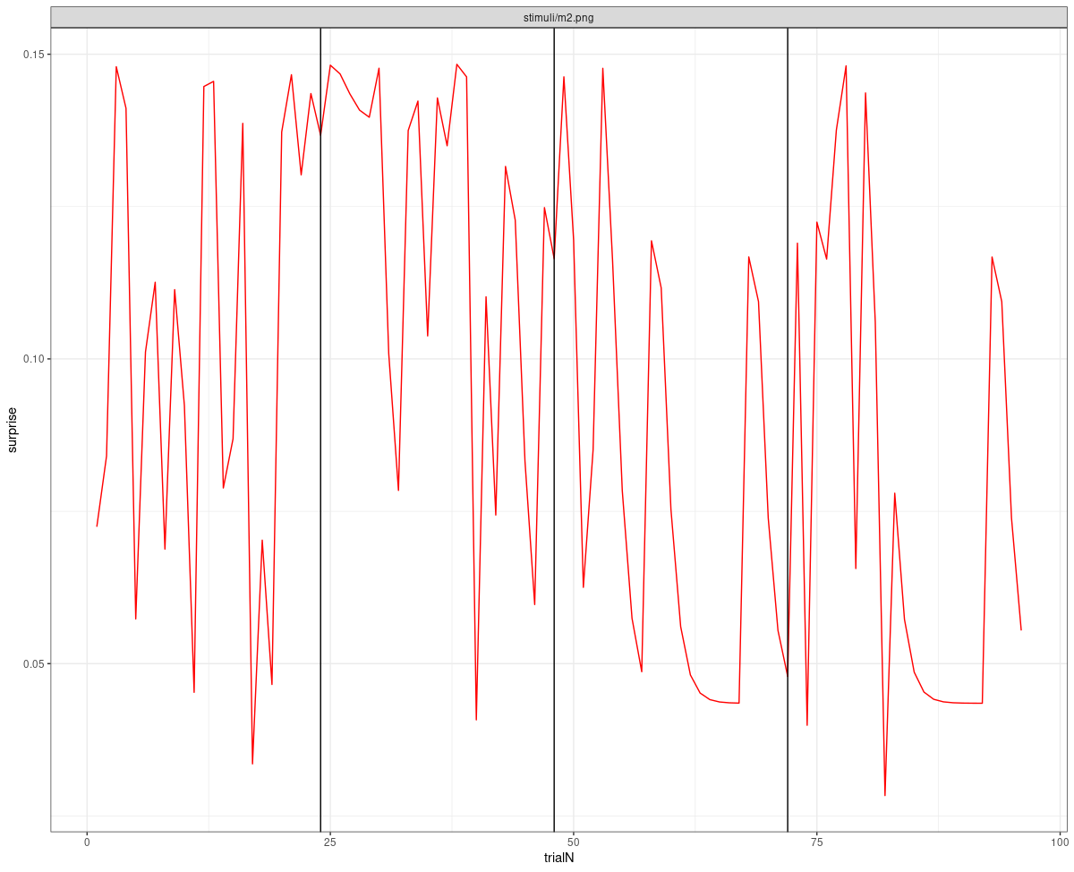

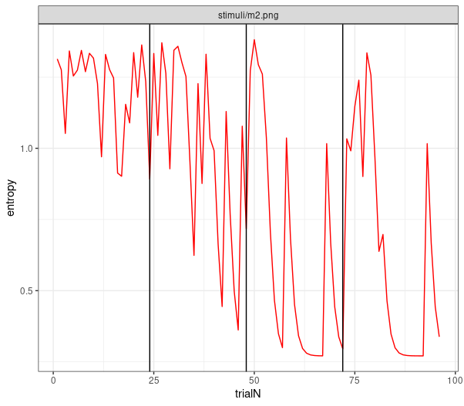

References
Rabiner, L. R. (1989). A tutorial on hidden Markov models and selected applications in speech recognition. Proceedings of the IEEE, 77(2), 257-286.

