Table of Contents
Prediction Error and Episodic Memory: Insights from Computational Models 1
Results 5
Learning performance 6
Recognition memory as a function of PE condition 6
Recognition memory as a function of model-derived PE 6
The role of prediction outcome 7
Discussion 9
References 10
Supplementary material 19
Model Comparison 19
Model Validation 20
Analysis parameters 21

Prediction Error and Episodic Memory: Insights from Computational Models
Francesco Pupillo, Javier Ortiz-Tudela, Rasmus Bruckner, Yee Lee Shing
Abstract
Predictive processing accounts suggest that our brain constantly tries to match top-down internal representations with bottom-up incoming information from the environment. Through the extraction of regularities, prior expectations of varying strength are formed and later used to make predictions. Information encountered in the environment can either match or violate these predictions, leading to varying degrees of prediction error. Theoretical and computational models assume significant, beneficial effects of prediction error on learning and memory. Nevertheless, very little is know on the effects of prediction error on memory encoding. Therefore, the aim of the present investigation is to examine how prediction error at encoding influences subsequent episodic memory. We first used a contingency-learning paradigm to establish different levels of priors for context-object category associations. In the encoding phase that followed, participants were asked to predict the category of the object that will be presented as cued by the context. The objects that were then shown could either match or violate their previously learned expectations. Finally, participants were asked to complete a surprise recognition test. We used a reinforcement learning model to derive subject-specific trial-to-trial estimates of prediction error. Results showed that prediction error at encoding influenced subsequent memory as a function of the outcome of participants’ predictions (correct vs incorrect). Precisely, when participants correctly predicted the object category, stronger prediction error (as an outcome of weak prior) led to enhanced memory. In contrast, when participants incorrectly predicted the object category, stronger prediction error (as an outcome of strong prior) led to impaired memory. These results suggests a computationally specific influence of prediction error on memory formation, revealing the important moderating role of prediction accuracy.

In our daily interaction with the environment we are confronted with a great amount of information which cannot be all processed in detail, given the limited resources of our cognitive systems. In order to simplify the complexity of the world, our brain tries to extract the regularities in order to be able to react to environmental stimuli in advantageous ways. One way of extracting regularities is to rely on repetitions and associations, which guide behavior creating schemas on top of which it is possible to build increasingly more complex knowledge (Ghosh & Gilboa, 2014; Tse et al., 2007; Van Kesteren et al., 2012)⁠. For example, we can learn that in the bar where we usually have our morning coffee the espresso is really good while the cappuccino tends to be too hot. Repeated exposure to this situation will guide us to preferably order an expresso, rather than a cappuccino.
Events can sometimes deviate from our expectations. We may order a burnt espresso in our familiar coffee shop, or a very good one in a shop in which we did not have a strong expectations. These schema-deviant events are thought to generate a prediction error (PE) and are assumed to be represented differently from schema-congruent events (Henson & Gagnepain, 2010; Van Kesteren et al., 2012)⁠. While it is well know that PE promotes learning by enhancing updating of prior knowledge (Ergo et al., 2020; Friston, 2018)⁠, its effects on the formation of new memories are still not fully understood.
According to theoretical and computational accounts, events that violate prior expectations should improve encoding by promoting the formation of more distinct memory traces, in order to better guide future behaviour and avoid catastrophic interference (McClelland et al., 1995; Van Kesteren et al., 2012). However, studies investigating the interplay of memory encoding and PE show contrasting results. In fact, some studies have found that information that is congruent with prior knowledge tends to be better remembered than incongruent (Bein et al., 2015; Brod, Garvin, Shing, Yee, 2019)⁠, while other studies have found that unpredicted events may be better remembered that predicted ones (Greve et al., 2017; Kafkas & Montaldi, 2018).
The study of the relationship between prior expectations and learning has also benefitted from computational models. Investigations on the neural mechanisms underlying learning have shown that brain activity reflects values used in computational reinforcement learning models (Sutton & Barto, 2018)⁠. In particular, it has been shown that firing patterns of mesencephalic dopamine neurons and also BOLD signal in the striatum resemble a PE signal used in reinforcement learning models (Daw, 2011; McClure et al., 2003; Schultz et al., 1997)⁠. This dopaminergic-dependent PE is thought to promote plasticity in the striatum, encouraging the repetition of actions that are better than expected (positive PE) and discouraging the repetition of actions that are worse than expected (negative PE, Schultz, 2016; Steinberg et al., 2013).
Reinforcement learning models have also being use to link trial-level, model-derived PE to memory encoding. Several studies have manipulate the amount of the reward participants expected and received, liking the obtained reward PE experienced at the time of item presentation or immediately after presentation to subsequent recognition of the items (Jang et al., 2019; Loof et al., 2018; Rouhani, N., Norman, K., Niv, 2018; Rouhani & Niv, 2021). Some studies found that better-than-expected outcomes, compared to worse-than-expected ones, led to improved later recognition (Jang et al., 2019; Loof et al., 2018)⁠. By contrast, other studies have found improved memory for surprising items, namely items associated to both better- and worse-than-expected outcomes (Rouhani, N., Norman, K., Niv, 2018; Rouhani & Niv, 2021). Therefore, results are divided among effects due to signed PE, in which there is a contrast between the positive and negative valence of PE, and effects related to unsigned prediction error, in which the unexpectedness of the events, independently of the valence, influenced memory encoding.
One element that can be a good candidate for explaining these mixed findings is the outcome of participants’ predictions. In fact, while in the studies finding a positive, linear relationship between signed PE and encoding participants were receiving an outcome that was related to their choice, in the studies finding memory benefits for all surprising events (both better- and worse-than-expected), a passive Pavlovian paradigm was used, with outcome being independent of participants’ choice (Rouhani et al., 2018; Rouhani & Niv, 2021). It is thus possible that prediction outcome modulates the effects of PE on encoding. In addition, because the studies aforementioned manipulated PE by using rewards, the mechanistic effects of PE per se, regardless of the reward, are still far to be fully understood.
We designed a task in which participants were presented with different contexts and had to predict the category of trial-unique objects that appeared at the end of each trial. In order to generate different amounts of PE strengths, we quantified expectations by using gradually different contingencies. The probability of a certain category following a context was systematically manipulated so that for some contexts expectations were higher than for others. We then use a reinforcement learning model to derive trial-level PE experienced during the presentation of the images and relate it to the likelihood of subsequently recognizing the items in a following surprise recognition test. PE reflected how unexpected to participants was the presentation of one object category following a context. The procedure thus allowed to test whether episodic memory for the objects was related to PE experienced during their presentation. We reasoned that if surprising events improve memory encoding, we would observe a positive relationship between PE and memory encoding, so that the more surprising the events, the better the memory for those events. Contrarily, if choice outcome makes a difference, we would expect an interaction between PE and choice outcome in a way that PE improves memory for better than expected outcome, while impairing memory for worse than expected outcome. In a first experiment, we designed a strong prior and a flat prior scene, leading to high and low PE, and medium PE, respectively. We then designed a second experiment in which the contingencies of the context-category pairs were more graded.

Results
In both experiments, participants performed a paired-associate task in which they were asked to predict the category of the trial-unique objects that would follow a context (see Methods). Unbeknownst to participants, each context was predictive of an object category with a fixed contingency (see Fig X). Participants could learn the association between a context and an object category during a learning phase (phase 1), in which they received feedback. In a subsequent phase (phase 2), participants were asked to do the same task as in phase 1, with the only difference that they no longer received feedback. Finally, they had to do a recognition memory test, were they were asked to recognize the objects presented in phase 2 among some distractors.
In experiment 1, participants were presented with six contexts, each of them was predictive of the object categories following specific contingencies: three contexts were related to a strong prior condition, in which one of the three objects categories was presented 80 % of the times, and the remaining two object categories 10% of the times; three contexts were related to a flat prior condition, in which all the three object categories were equally likely. Trials that matched expectations in the strong prior conditions were considered low PE trials, while those who mismatched the expectations high PE trials. Trials in the flat prior conditions were considered medium PE trials. In experiment 2, two instead of three object categories were used. The strong and the flat prior conditions were maintained, although with 90-10 and 50-50 contingencies, and a weak prior condition was introduced, with 70-30 contingencies. This manipulation allowed to sample more points along the PE continuum.

Learning performance
Results of the paired-associate task show that participants understood the task correctly and were able to learn to predict the object category that was more likely to be presented for each context, in both experiment 1 and experiment 2. Participants’ cumulative accuracy tended to approximate true probability for each context and experiment.

Recognition memory as a function of PE condition
To test whether matching or violating expectations affected subsequent recognition of the objects, we analyzed hit rate as a function of PE level (high, low, medium). Participants were overall able to discriminate previously presented old items from new distractors (d’ = 0.93, t(26) = 13.7, p < .001, experiment 1; d’ = 0.90, t(34) = 16.8, p < .001, experiment 2). We used a generalized linear mixed-effects model to test the effect of PE level on recognition memory accuracy, including PE level as fixed effect and testing both linear and quadratic trends. Random slopes for PE level and random intercepts for participants were also estimated in the model. Results showed that there was a main effect of PE level (χ²(1) = 9.39, p = .003, experiment 1; χ²(1) = 12.67, p = .013, experiment 2; Figures 1 and 2). The relationship between PE level and recognition memory was characterized by a significant quadratic component component (β = - 0.30, p < .001, experiment 1; β = - 0.30, p = .005, experiment 2), revealing higher memory for intermediate levels of PE. The linear component was not significant (β = - 0.031, p = .726, experiment 1; β = - 0.19, p = .060, experiment 2).

Recognition memory as a function of model-derived PE
A computational model was used to derive trial-level PE at encoding. Specifically, we used a standard reinforcement learning model (Sutton & Barto, 1998) in order to capture the process of learning the category probability for the different contexts and establishing prior expectations (see Methods). In this model, the expected values reflected the value of context – category associations, and were updated on each trial by adding the current expected value to a learning rate multiplied by the PE.
The PE was calculated as the difference between whether or not an object category was presented and its estimated value. A high PE was generated when a category presented was not expected, as reflected in its expected value close to zero. By contrast, a low PE was generated by trials in which the category presented was characterized by a high expected value.
The learning rate represents the extent to which the evidence from the current trial was used to update the expectations: Higher learning rate weights more the present evidence and the extend to which it deviates from the value estimates, while lower learning rate weights more the estimated values, and thus the past trials. The learning rate was left as a free parameter and estimated at the participant level. In order to model participants’ choice, an inverse temperature parameter was also estimated for each participant. Simulations showed that the model could successfully recover the parameters, and data validation showed that choice data simulated from the model did not differ significantly from participants’ actual choice data (see Figure X). Model comparison showed that this simple model better fitted the data compared to a reduced, optimal, model with a decaying learning rate, and to more complex models taking into account more parameters (see Table x).
The model with the parameters of best fit was then fit to participants’ data and used to estimate the trial-level PE at encoding.
To test whether model-derived PE was related to recognition memory we used a generalized linear-mixed model, with PE added as fixed effect as both linear and quadratic effect, including random slopes of PE and random intercepts for participants.
Results are shown in Figures 3 and 4. There was an effect of PE (χ²(2) = 7.87, p = .020, experiment 1; χ²(2) = 18.0, p < .001, experiment 2). This effect was driven by the quadratic trend in both experiments (β = - 6.50, p = .005, experiment 1; β = - 7.75, p < .001, experiment 2). The linear effect was not significant in experiment 1 (β = 0.48, p = .822), while a significant negative linear effect was present in experiment 2 (β = -4.34, p = .046).

The role of prediction outcome
Results from experimentally manipulated and model-derived PE showed that when PE is high or low, items are remembered worse compared to when PE is of medium strength. As in the task participants were making a prediction, the outcome of this prediction may have plaied a role. To test whether prediction outcome modulated the effect of PE on memory encoding, we added the interaction between prediction outcome and model-derived PE in the generalized linear mixed-effects model. Random slopes for the interaction between PE and prediction outcome were also added. Results are shown in Figure 5. Analysis revealed a significant interaction between PE and prediction outcome ( χ²(1) = 10.48, p = .001, experiment 1; χ²(1) = 13.09, p < .001, experiment 2). To break down the interaction, we analyzed accurate and inaccurate predictions separately. For experiment 1, there was a positive linear relationship between PE and recognition memory when prediction outcome was correct, β = 7.80, p = .002, while a negative linear trend when prediction outcome was incorrect which did not reach significance, β = 3.31, p = .080. For experiment 2, a positive linear trend between PE and recognition memory when predictions were correct did not reach significance, β = 7.80, p = .143, while there was a significant negative relationship for incorrect predictions, β = -0.774, p < .001.
As a next step, we analyzed data from both experiments in the same model. In order to compare memory at different levels of the model-derived PE, PE was binned to created four PE quantiles for the dependent variable for each participant, separately for trials with correct and incorrect prediction outcome. The average recognition memory performance within each quantile was the response variable in the model. A graph with the data obtained is shown in Figure 8.
We tested for a three-way interaction between binned PE, prediction outcome, and experiment, in a linear mixed-effects model. The three-way interaction was not significant, χ²(3) = 3.63, p = 0.304. In addition, the interactions between PE and experiment, and the interaction between prediction outcome and experiment were not significant (χ²(3) = 2.22, p = 0.528, χ²(1) = 0.66, p = 0.415, respectively). These results suggest that there were not substantial differences in the effects of PE and in the interaction between PE and prediction outcome between the two experiments. By contrast, there was a main effect of experiment, χ²(3) = 7.70, β = -0.12, .p = .005, showing that overall participants’ performance was significantly worse in experiment 2, compared to experiment 1. Importantly, there was also a significant interaction between PE and prediction outcome, χ²(3) = 14.09, p = .003. To break down the interaction, the effect of PE on recognition was analyzed separately for correct and incorrect prediction outcomes. We compared each quantile with the first one, to test whether increasingly higher PE significantly affected memory encoding. Results showed that for incorrect prediction outcomes, the difference between the first and the second quantile did not reach significant, β = -0.05, .p_{corr} = .060. Contrarily, the comparisons between the third and the first, and the fourth and the first, were both significant, (ps_{corr} < .001). For correct prediction outcomes, the comparison between first and second quantile, and first and third quantile did not reach significance (ps_{corr} >.133), whereas the comparison between the fourth and the first quantile was significant, β = 0.075, .p_{corr} = .015. These results suggest that while a PE error generated by incorrect prediction impairs memory even when prior expectations are not very strong, for correct predictions a high PE is needed in order to observe benefits for memory encoding.

Discussion
Previous literature have provided mixed evidence on the effects of prior expectations on memory formation (Bein et al., 2015; Brod, Garvin, Shing, Yee, 2019,Greve et al., 2017; Kafkas & Montaldi, 2018). First studies on reward PE using reinforcement learning models have also produced contrasting results (Jang et al., 2019; De Loof et al., 2018, Rouhani et al.,2018; 2021). In two experiments, we analyzed the effects of PE generated by unexpected events on memory encoding, by quantifying PE as deviation from experimentally manipulated contingencies, and using computational models to derive trial-by-trial PE levels. We showed that prediction outcome was a strong modulator of the effects of PE on memory encoding so that when unexpected events were successfully predicted PE was beneficial to memory encoding, while it was detrimental when expected event where unsuccessfully predicted. There results reveal a computationally specific effect of PE, highlighting the crucial modulating role of prediction accuracy.
Results showing worse memory for events eliciting PE as a result of incorrect predictions are in line with studies showing benefits of matching expectations (Bein et al., 2015; Brod, Garvin, Shing, Yee, 2019; van Kesteren et al., 2013)⁠. In fact, findings from the current study suggest that the higher the prediction error caused by strong prior expectations, the worse the memory. However, results also suggest that PE can be beneficial to memory in conditions when prior expectations are low and the events are correctly predicted. These findings are in line with studies on reward PE showing better memory for better than expected outcomes (De Loof et al., 2017; Jang et al., 2019), a pattern suggested to be related to dopaminergic activity promoting hippocampal plasticity and memory formation (Bethus et al., 2010; Rosen et al., 2015)⁠.
Results are in contrast with previous findings exploring effects of unsigned reward PE (Rouhani et al., 2018, 2021). One possible explanation for this discrepancy is the task used. While Rouhani and colleagues (2018, 2021) have used a Pavlovian task in which participants’ predictions did not affect the outcome, in the present study it was emphasized that participants’ task was to correctly predict the object category in relation to each context. Therefore, even if encoding was incidental, participants’ choice was still relevant.
Another potential explanation for the effects observed is related to the utility of the information that can match or mismatch expectations. Events can be processed differently depending on whether they are useful in the future to correctly predict events in similar contexts. In fact, while positive feedback when prior expectations are weak may inform individuals that the choice is important for future similar contexts, negative feedback in contexts where prior expectations are strong may inform participants that that event is not useful for future predictions. Therefore, events that might be useful to guide future behaviour are remembered better, while those that are deviant from established expectations may be discarded as exceptions. Results are thus in line with views considering reinforcement learning as both a reward-seeking and an information-seeking system (ES Bromberg-Martin, 2011; Niv & Chan, 2011)⁠, emphasizing the utility of information in modifying behaviour and optimizing outcomes.
It is important to note that mismatched information might have been discarded as not helpful for the future because the task used in both experiments used contingencies that were established before encoding of the events and never changed during the course of the task. As a consequence, deviant information was quite expected from participants. It is possible that mismatched information would be more valued during the learning of the priors or in tasks that implements changes in the environment, leading to unexpected outcomes. There is evidence that expected and unexpected uncertainty might have different behavioural and neurophysiological correlates (Yu & Dayan, 2005)⁠.
In conclusion, the current study provides robust evidence on the effects of PE on memory encoding, highlighting the crucial modulating role of prediction outcomes.

References
Bein, O., Livneh, N., Reggev, N., Gilead, M., Goshen-Gottstein, Y., & Maril, A. (2015). Delineating the Effect of Semantic Congruency on Episodic Memory: The Role of Integration and Relatedness. PLOS ONE, 10(2), e0115624. https://doi.org/10.1371/JOURNAL.PONE.0115624
Bethus, I., Tse, D., & Morris, R. G. M. (2010). Dopamine and Memory: Modulation of the Persistence of Memory for Novel Hippocampal NMDA Receptor-Dependent Paired Associates. Journal of Neuroscience, 30(5), 1610–1618. https://doi.org/10.1523/JNEUROSCI.2721-09.2010
Brod, Garvin, Shing, Yee, L. (2019). A Boon and a Bane: Comparing the Effects of Prior Knowledge on Memory Across the Lifespan. https://www.researchgate.net/publication/330440758
Daw, N. D. (2011). Trial-by-trial data analysis using computational models. Decision Making, Affect, and Learning: Attention and Performance XXIII, 1–26. https://doi.org/10.1093/acprof:oso/9780199600434.003.0001
Ergo, K., Loof, E. De, & Verguts, T. (2020). Reward Prediction Error and Declarative Memory. Trends in Cognitive Sciences, 24(5), 388–397. https://doi.org/10.1016/J.TICS.2020.02.009
ES Bromberg-Martin, O. H. (2011). Lateral habenula neurons signal errors in the prediction of reward information. Nat. Neurosci., 14(9), 1209–1216. https://doi.org/10.1038/nn.2902
Friston, K. (2018). Does predictive coding have a future? Nature Neuroscience, 21(8), 1019–1021. https://doi.org/10.1038/s41593-018-0200-7
Ghosh, V. E., & Gilboa, A. (2014). What is a memory schema? A historical perspective on current neuroscience literature. Neuropsychologia, 53(1), 104–114. https://doi.org/10.1016/j.neuropsychologia.2013.11.010
Greve, A., Cooper, E., Kaula, A., Anderson, M. C., & Henson, R. (2017). Does prediction error drive one-shot declarative learning? Journal of Memory and Language, 94, 149–165. https://doi.org/10.1016/j.jml.2016.11.001
Henson, R. N., & Gagnepain, P. (2010). Predictive, interactive multiple memory systems. Hippocampus, 20(11), 1315–1326. https://doi.org/10.1002/hipo.20857
Jang, A. I., Nassar, M. R., Dillon, D. G., & Frank, M. J. (2019). Positive reward prediction errors during decision making strengthen memory encoding. Nature Human Behaviour, 3(July), 719–732. https://doi.org/10.1038/s41562-019-0597-3.Positive
Kafkas, A., & Montaldi, D. (2018). How do memory systems detect and respond to novelty? In Neuroscience Letters (Vol. 680, pp. 60–68). Elsevier Ireland Ltd. https://doi.org/10.1016/j.neulet.2018.01.053
Loof, E. De, Ergo, K., Naert, L., Janssens, C., Talsma, D., Opstal, F. Van, & Verguts, T. (2018). Signed reward prediction errors drive declarative learning. PLOS ONE, 13(1), e0189212. https://doi.org/10.1371/JOURNAL.PONE.0189212
McClelland, J. L., McNaughton, B. L., & O’Reilly, R. C. (1995). Why there are complementary learning systems in the hippocampus and neocortex: Insights from the successes and failures of connectionist models of learning and memory. Psychological Review, 102(3), 419–457. https://doi.org/10.1037/0033-295X.102.3.419
McClure, S. M., Berns, G. S., & Montague, P. R. (2003). Temporal Prediction Errors in a Passive Learning Task Activate Human Striatum. Neuron, 38(2), 339–346. https://doi.org/10.1016/S0896-6273(03)00154-5
Niv, Y., & Chan, S. (2011). On the value of information and other rewards. Nature Neuroscience 2011 14:9, 14(9), 1095–1097. https://doi.org/10.1038/nn.2918
Rosen, Z. B., Cheung, S., & Siegelbaum, S. A. (2015). Midbrain dopamine neurons bidirectionally regulate CA3-CA1 synaptic drive. Nature Neuroscience 2015 18:12, 18(12), 1763–1771. https://doi.org/10.1038/nn.4152
Rouhani, N., Norman, K., Niv, Y. (2018). Dissociable effects of surprising rewards on learning and memory. J Exp Psychol Learn Mem Cogn., 176(3), 139–148. https://doi.org/10.1037/xlm0000518.Dissociable
Rouhani, N., & Niv, Y. (2021). Signed and unsigned reward prediction errors dynamically enhance learning and memory. ELife, 10(Lc), 1–28. https://doi.org/10.7554/eLife.61077
Schultz, W. (2016). Dopamine reward prediction error coding. Dialogues in Clinical Neuroscience, 18(1), 23–32. https://doi.org/10.31887/dcns.2016.18.1/wschultz
Schultz, W., Dayan, P., & Montague, P. R. (1997). A neural substrate of prediction and reward. Science (New York, N.Y.), 275(5306), 1593–1599. https://doi.org/10.1126/SCIENCE.275.5306.1593
Steinberg, E. E., Keiflin, R., Boivin, J. R., Witten, I. B., Deisseroth, K., & Janak, P. H. (2013). A causal link between prediction errors, dopamine neurons and learning. Nature Neuroscience 2013 16:7, 16(7), 966–973. https://doi.org/10.1038/nn.3413
Sutton, R. S., & Barto, A. G. (2018). Reinforcement Learning: An Introduction, Second Edition. In The Lancet (Vol. 258, Issue 6685). https://doi.org/10.1016/S0140-6736(51)92942-X
Tse, D., Langston, R. F., Kakeyama, M., Bethus, I., Spooner, P. A., Wood, E. R., Witter, M. P., & Morris, R. G. M. (2007). Schemas and memory consolidation. Science, 316(5821), 76–82. https://doi.org/10.1126/science.1135935
van Kesteren, M. T. R., Rijpkema, M., Ruiter, D. J., & Fernández, G. (2013). Consolidation Differentially Modulates Schema Effects on Memory for Items and Associations. PLoS ONE, 8(2). https://doi.org/10.1371/journal.pone.0056155
Van Kesteren, M. T. R., Ruiter, D. J., Fernández, G., & Henson, R. N. (2012). How schema and novelty augment memory formation. Trends in Neurosciences, 35(4), 211–219. https://doi.org/10.1016/j.tins.2012.02.001
Yu, A. J., & Dayan, P. (2005). Uncertainty, Neuromodulation, and Attention. Neuron, 46(4), 681–692. https://doi.org/10.1016/J.NEURON.2005.04.026

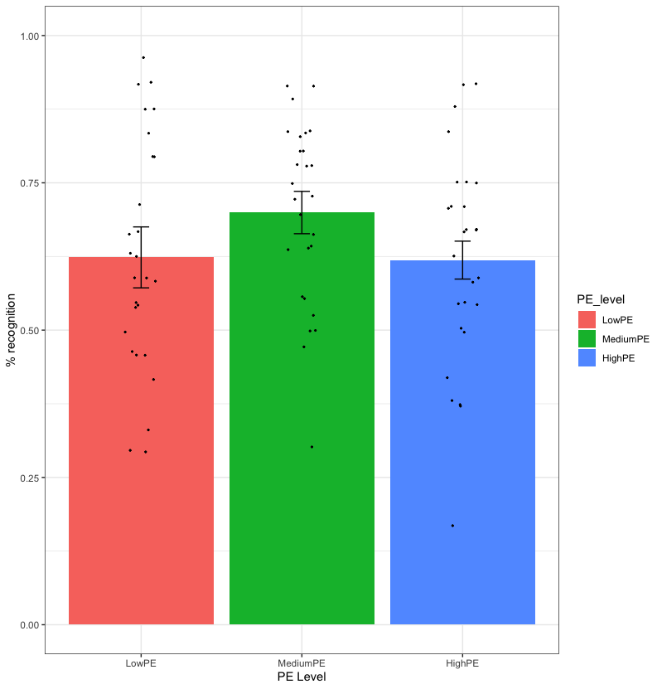Figure 1: Effect of PE level on memory recognition, experiment 1. Error bars represent standard errors.

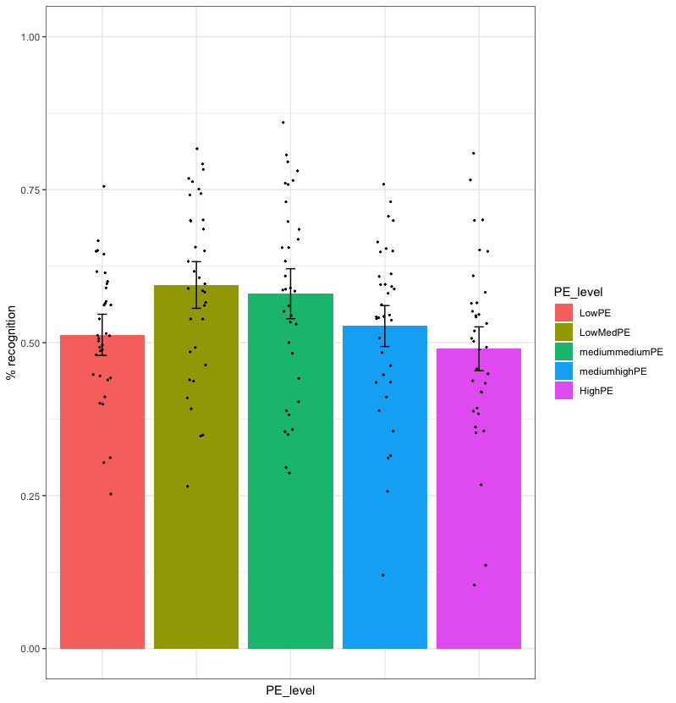
Figure 2: Effect of PE level on recognition memory, experiment 2. Error bars represent standard errors.

Figure 3: Effect of computationally-derived PE on recognition memory, experiment 1.
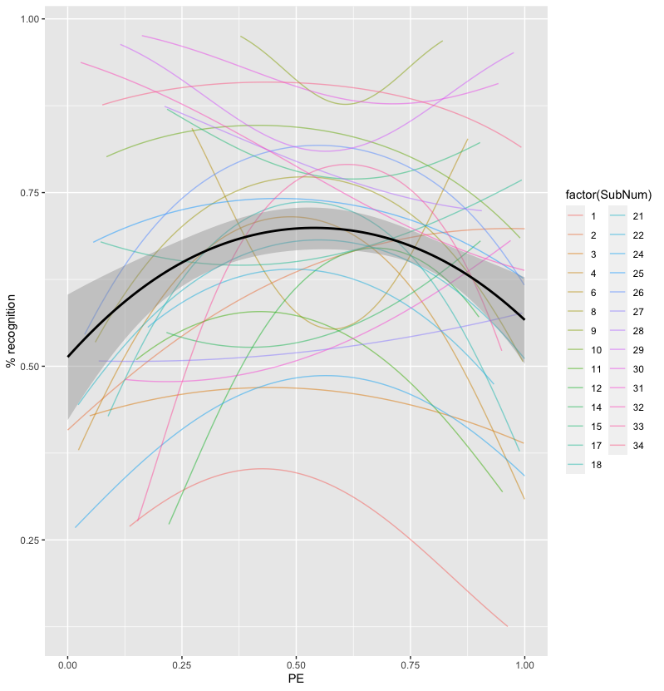

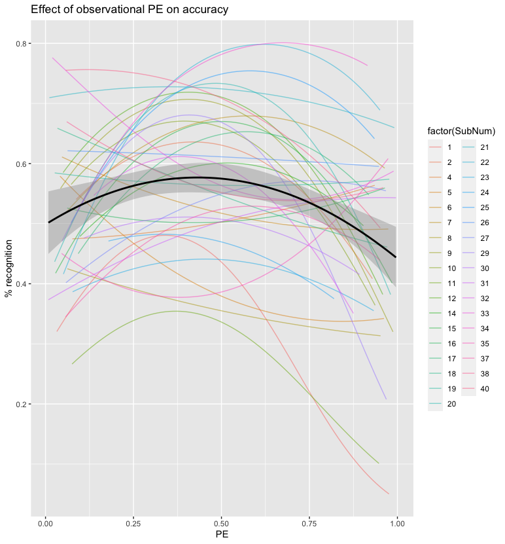Figure 4: Effect of computationally-derived PE on recognition memory, experiment 2

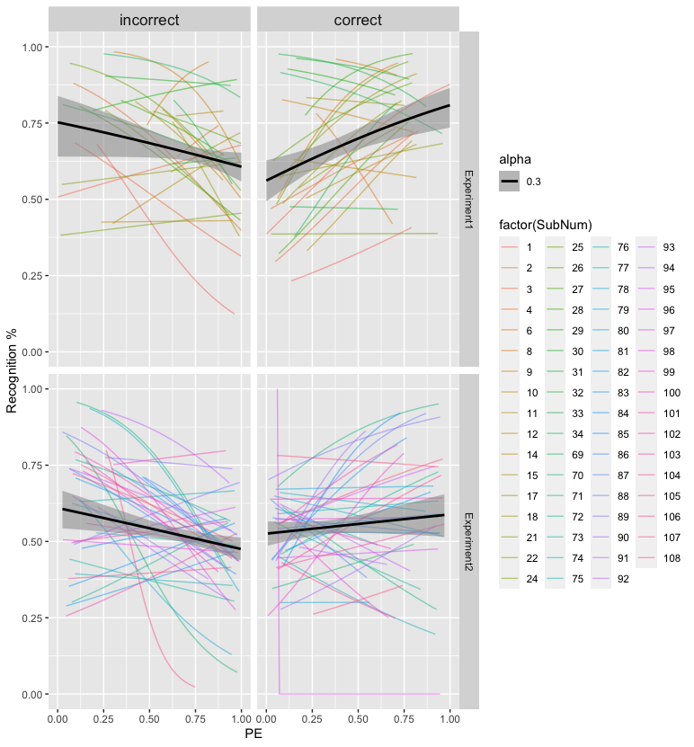Figure 5: Recognition accuracy as a function of computationally-derived PE and prediction outcome

#
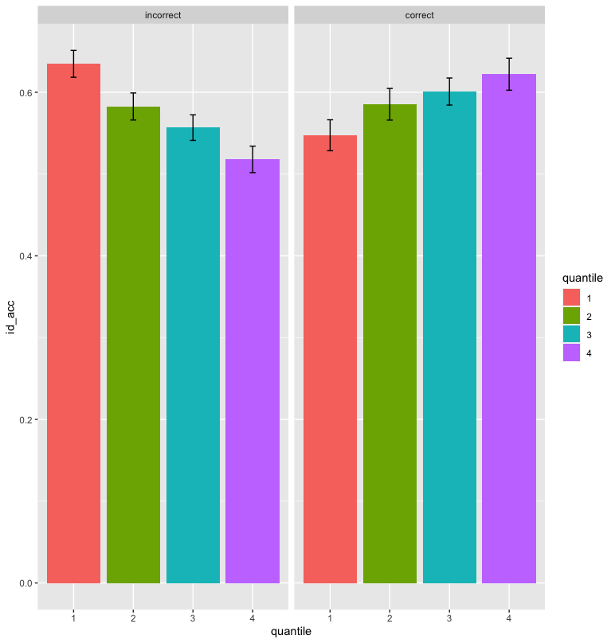Figure 6: Recognition memory as a function of PE and prediction outcome, experiment 1 and 2

Supplementary material

Parameter recovery
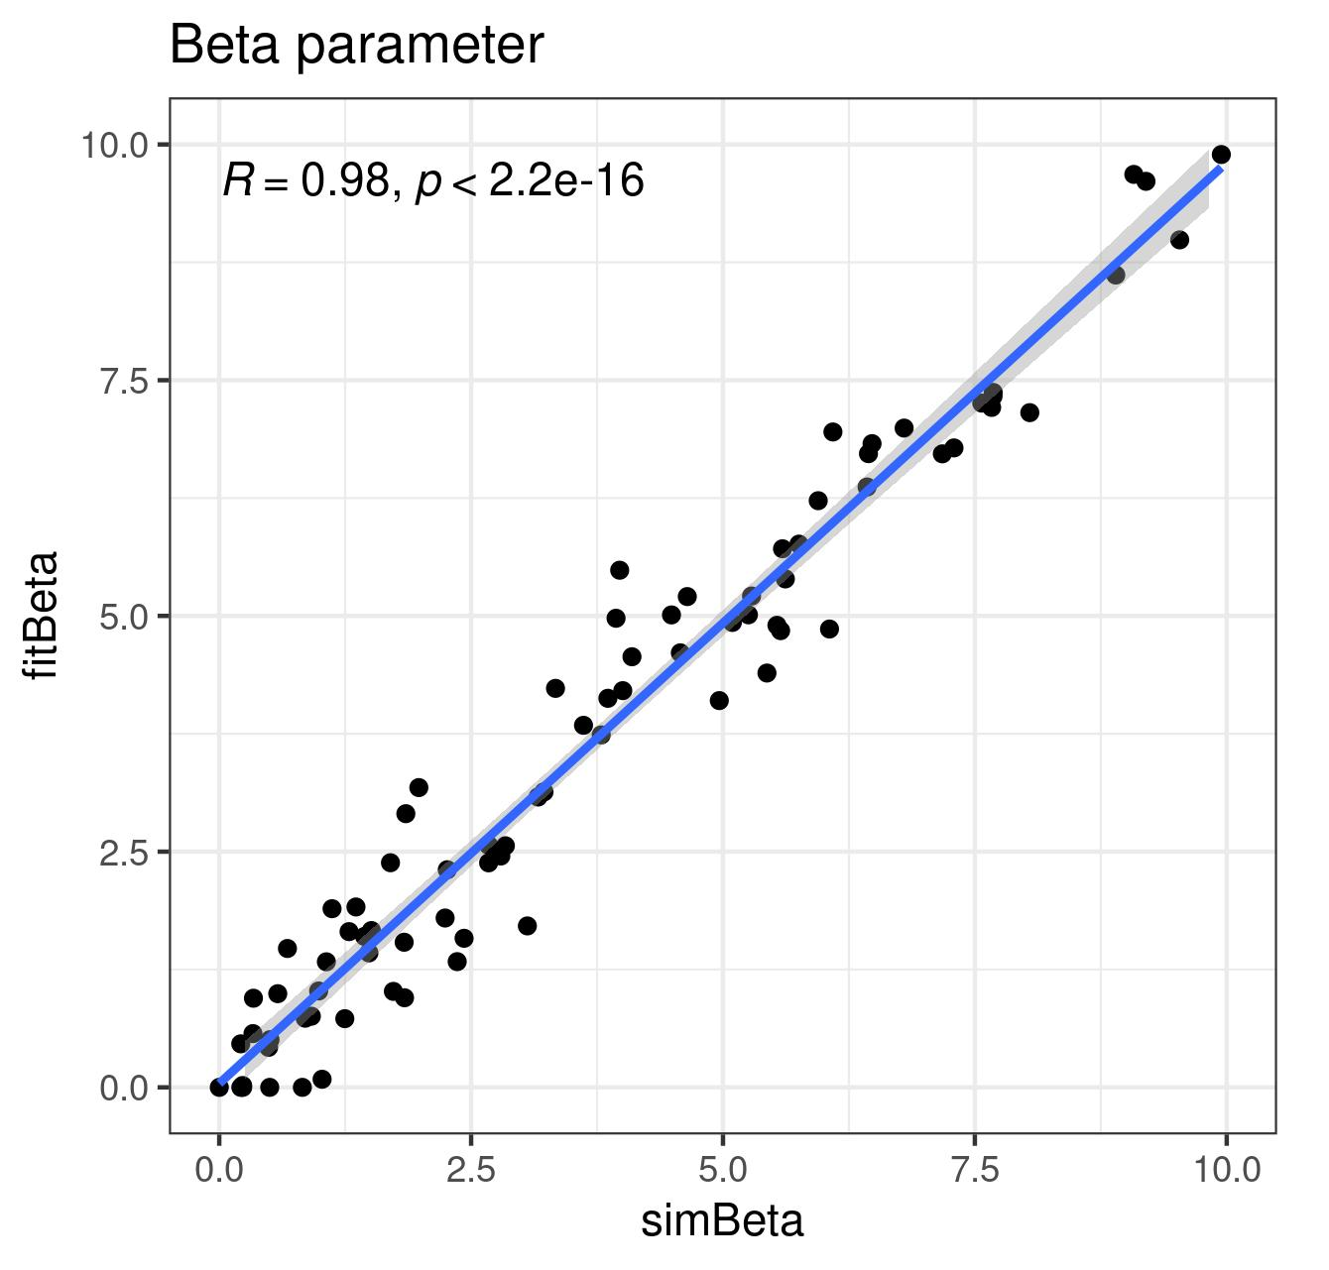Figure 7: Parameter recovery Optimal Bayesian model beta parameter experiment 1
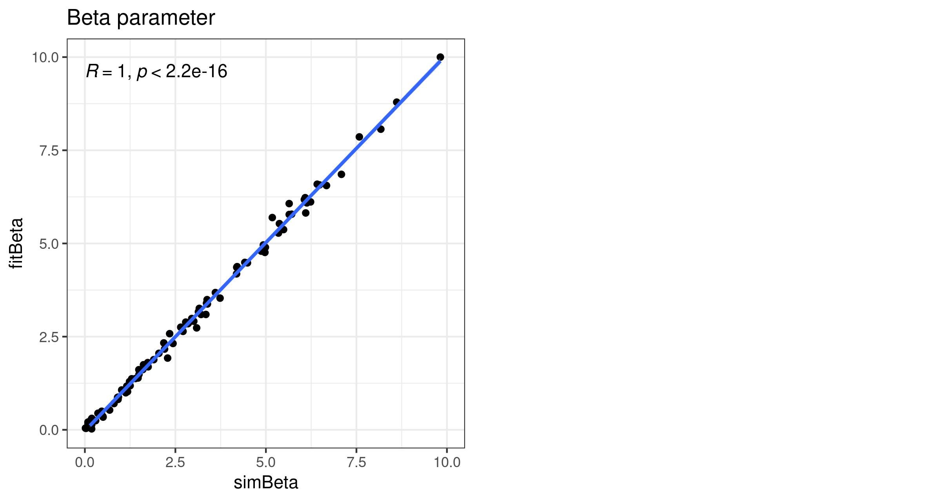Figure 8: Parameter recovery Optimal Bayesian model beta parameter experiment 2
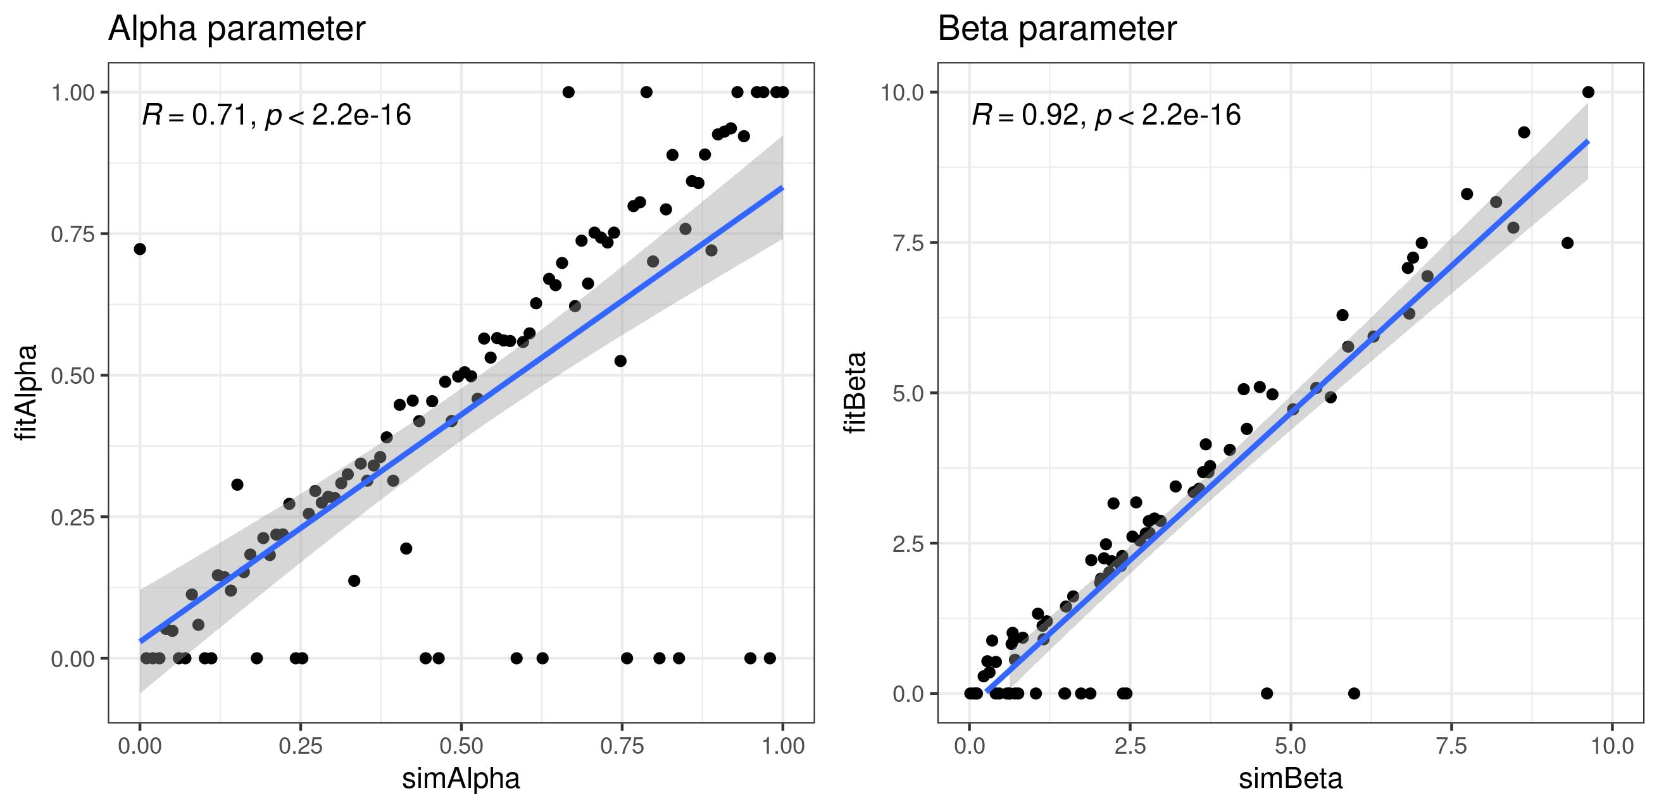Figure 9: Parameter recovery RW model free LR experiment 1

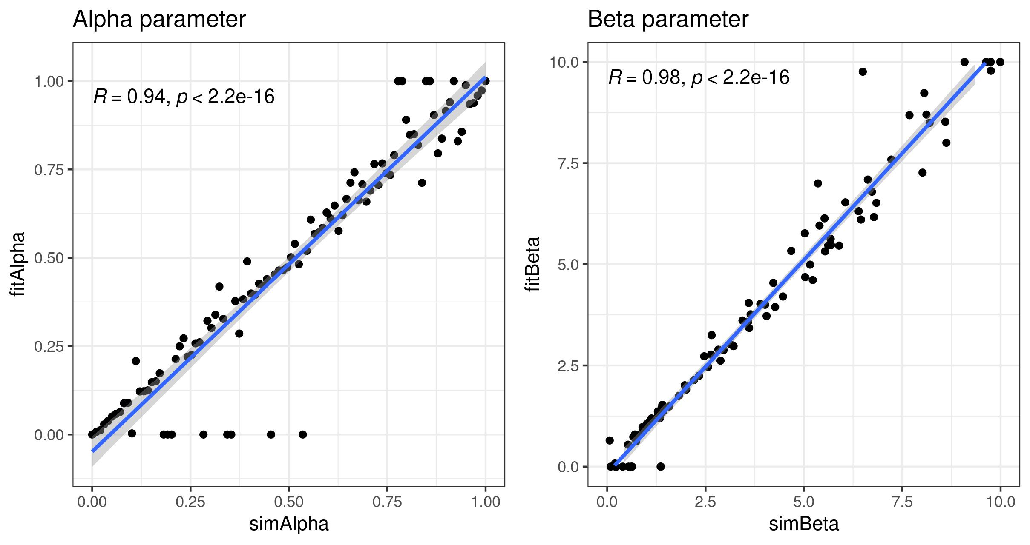Figure 10: Parameter recovery RW model free LR experiment 2
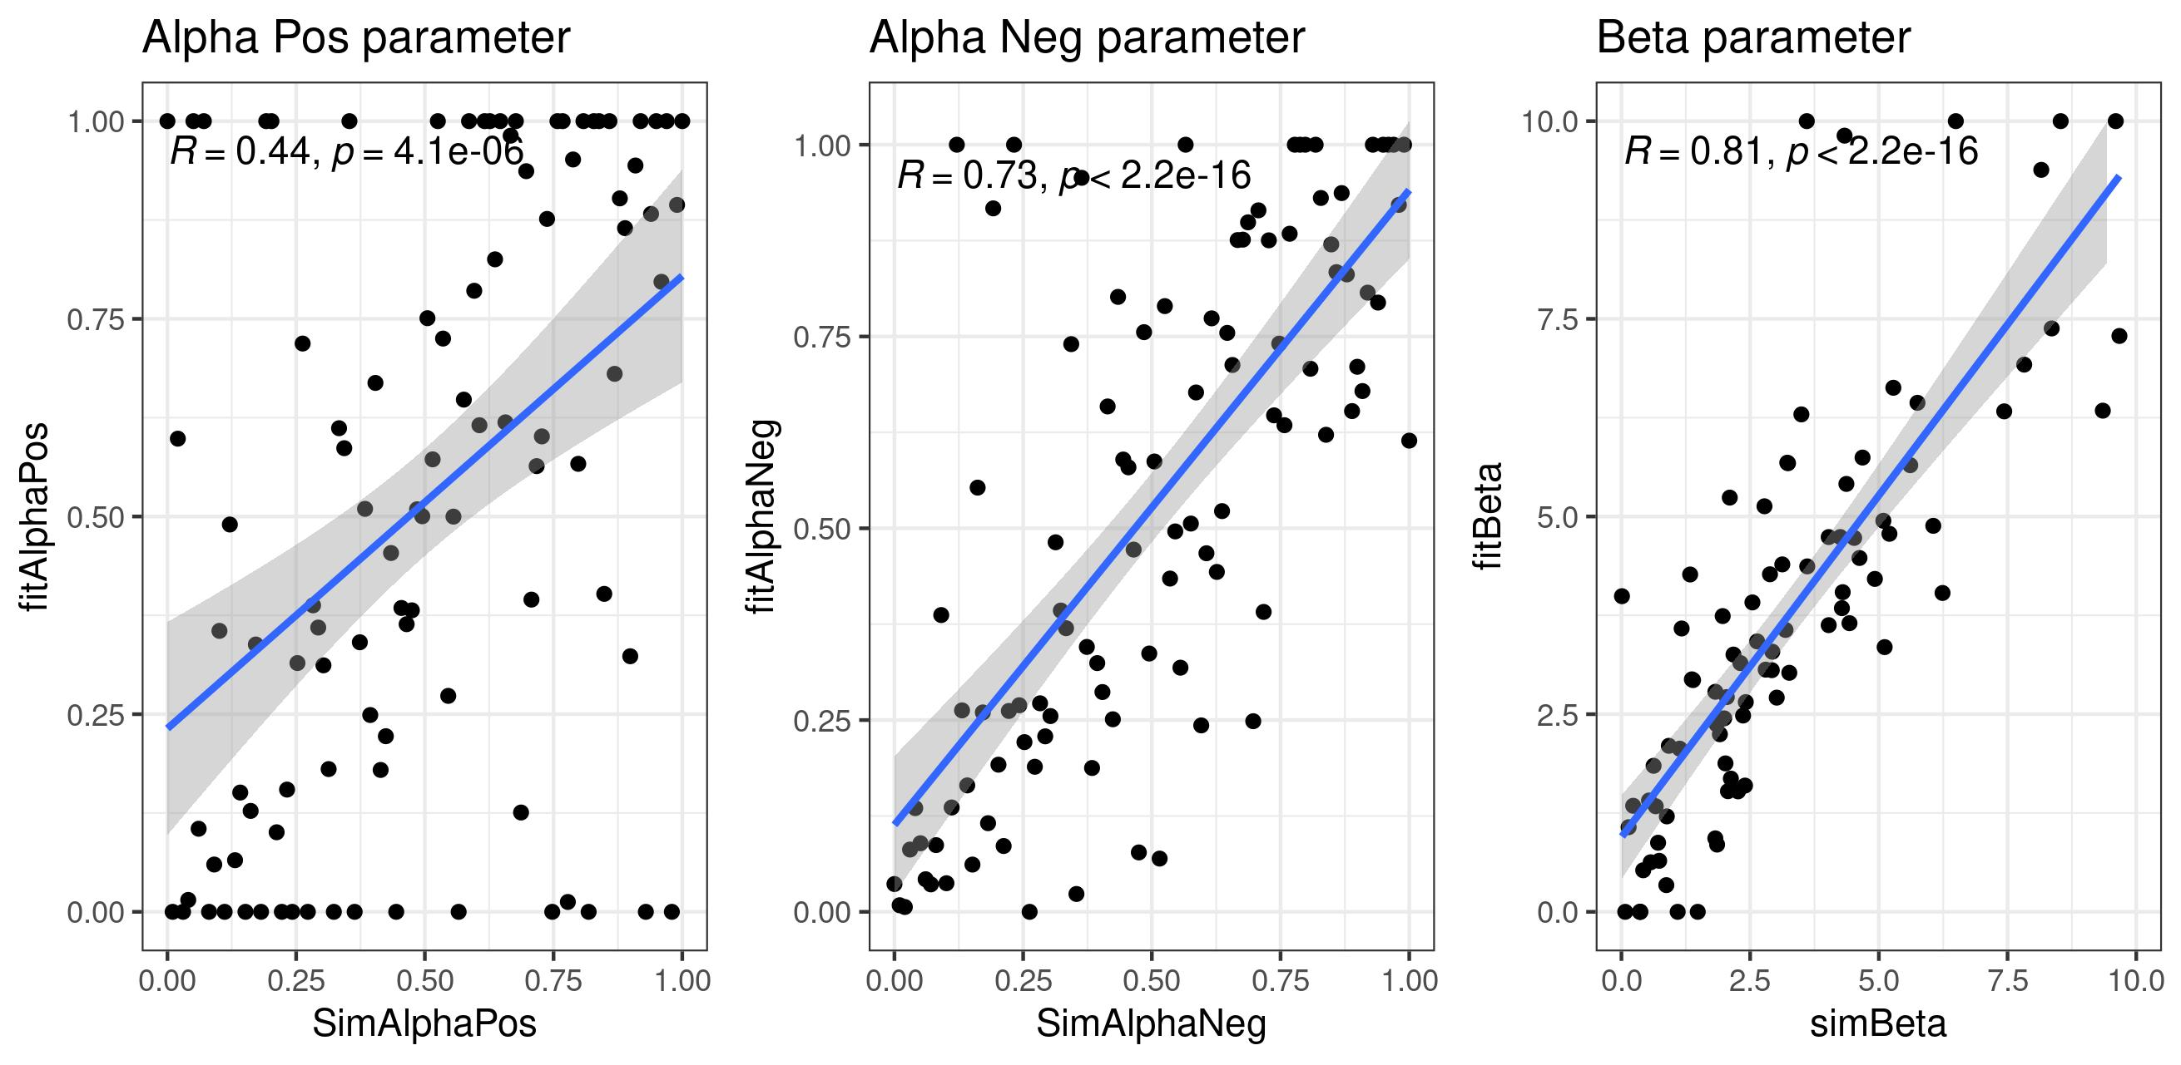Figure 11: Parameter recovery RW dual lr. Experiment 1

Model recovery
Figure 12: Parameter recovery RW dual lr. Experiment 2
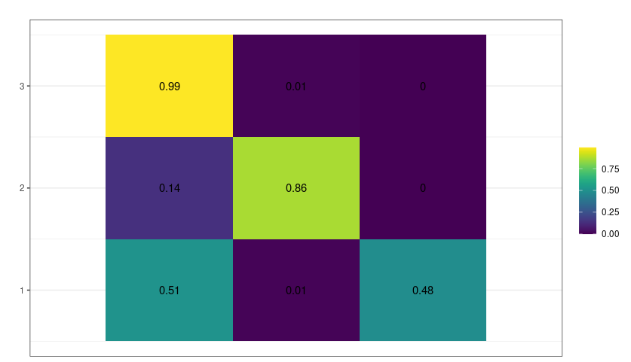Figure 13: Confusion matrix experiment 2.
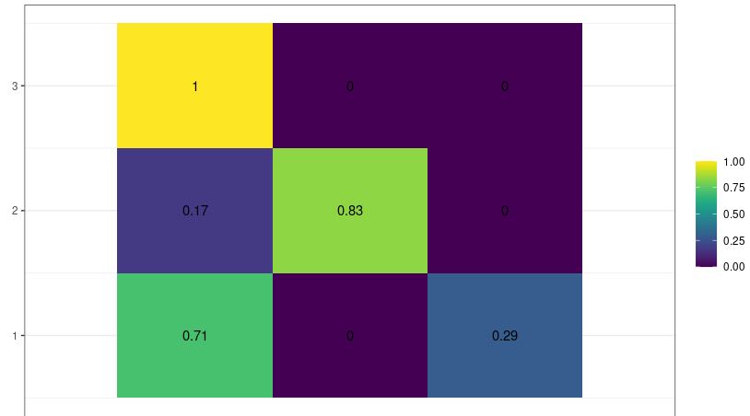Figure 14: Confusion matrix experiment 1.

Model Comparison
In order to compare the models’ fit, the BIC was used:

We report the model evidence of the best model within each participant (Gluth et al., 2017; Raftery, 1995). We defined the model evidence as “weak”, “positive”, “strong”, or “very strong” when the BIC difference between the best and the second best model is x < 2, 2 < x < 6, 6 < x < 10, or x > 10, respectively.
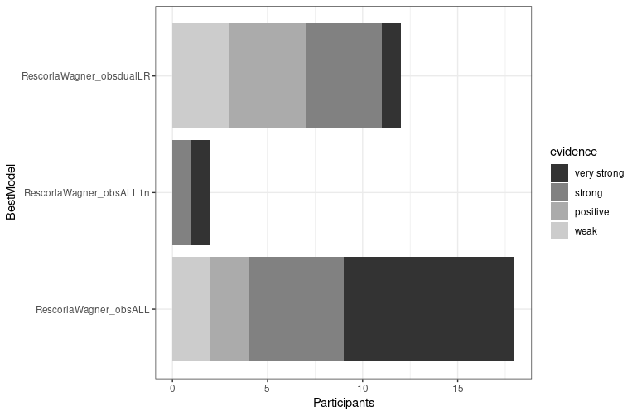
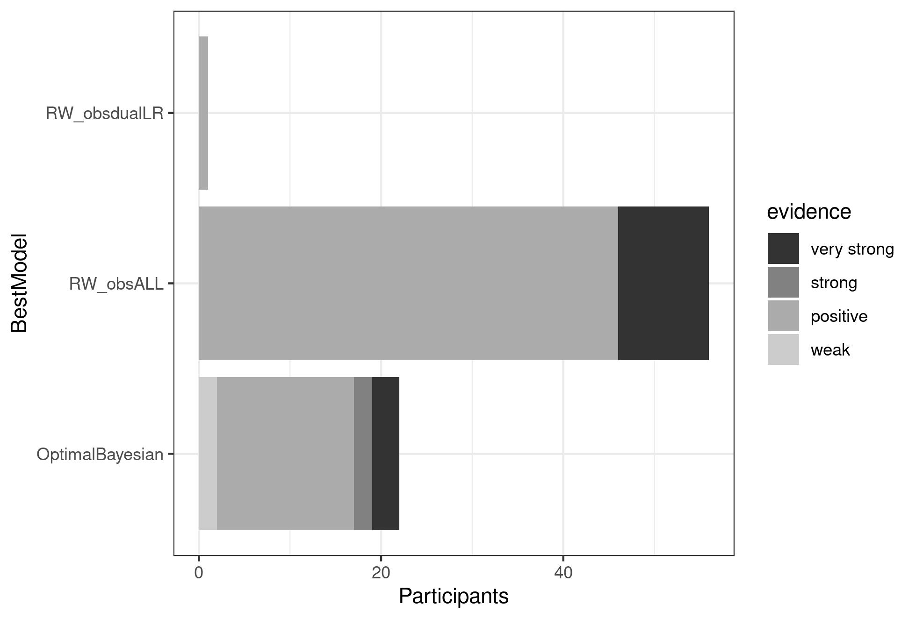

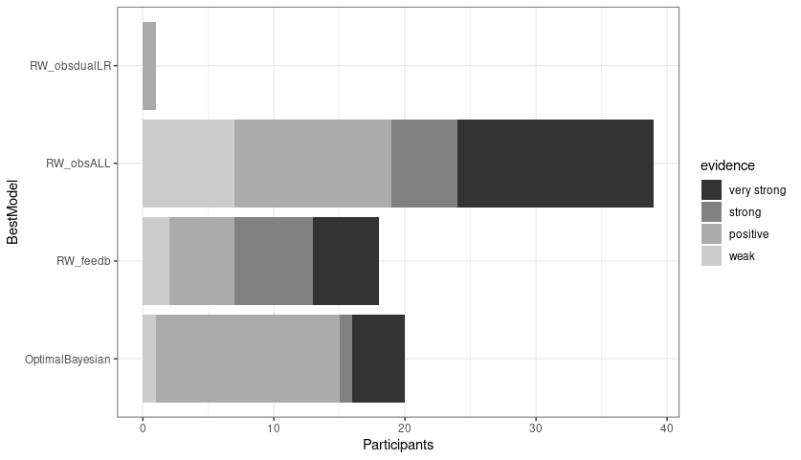

Model Validation
In order to validate the model, accuracy of simulated and empirical data on the probabilistic task were compared. Figure 6 shows the difference in performance between empirical and simulated data, for early and late trials, respectively. The alpha parameter variable was binned.

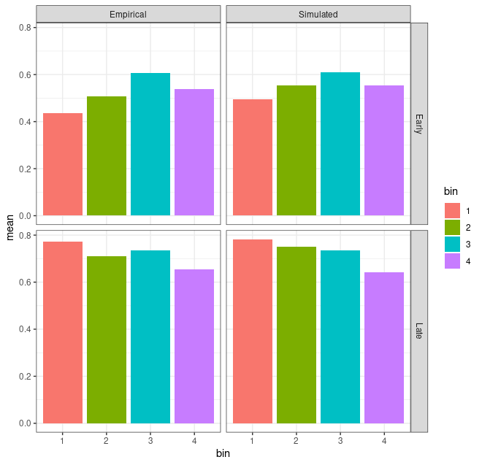Figure 16: Binned Alpha parameter and cumulative accuracy for simulated vs empirical data. Experiment 1.
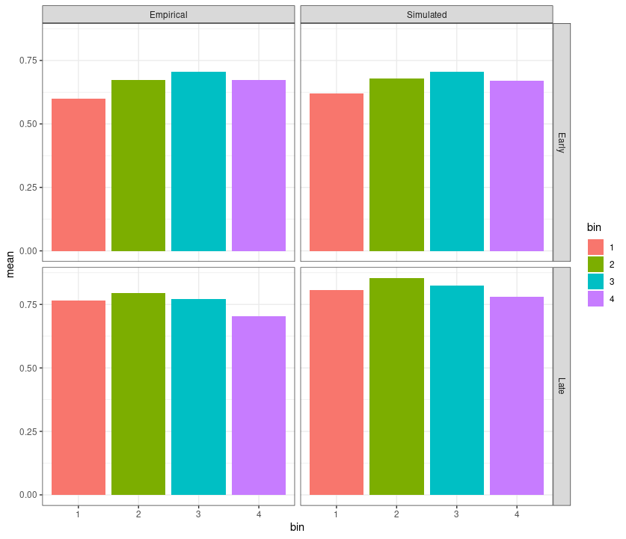Figure 15: Binned Alpha parameter and cumulative accuracy for simulated vs empirical data. Experiment 2.

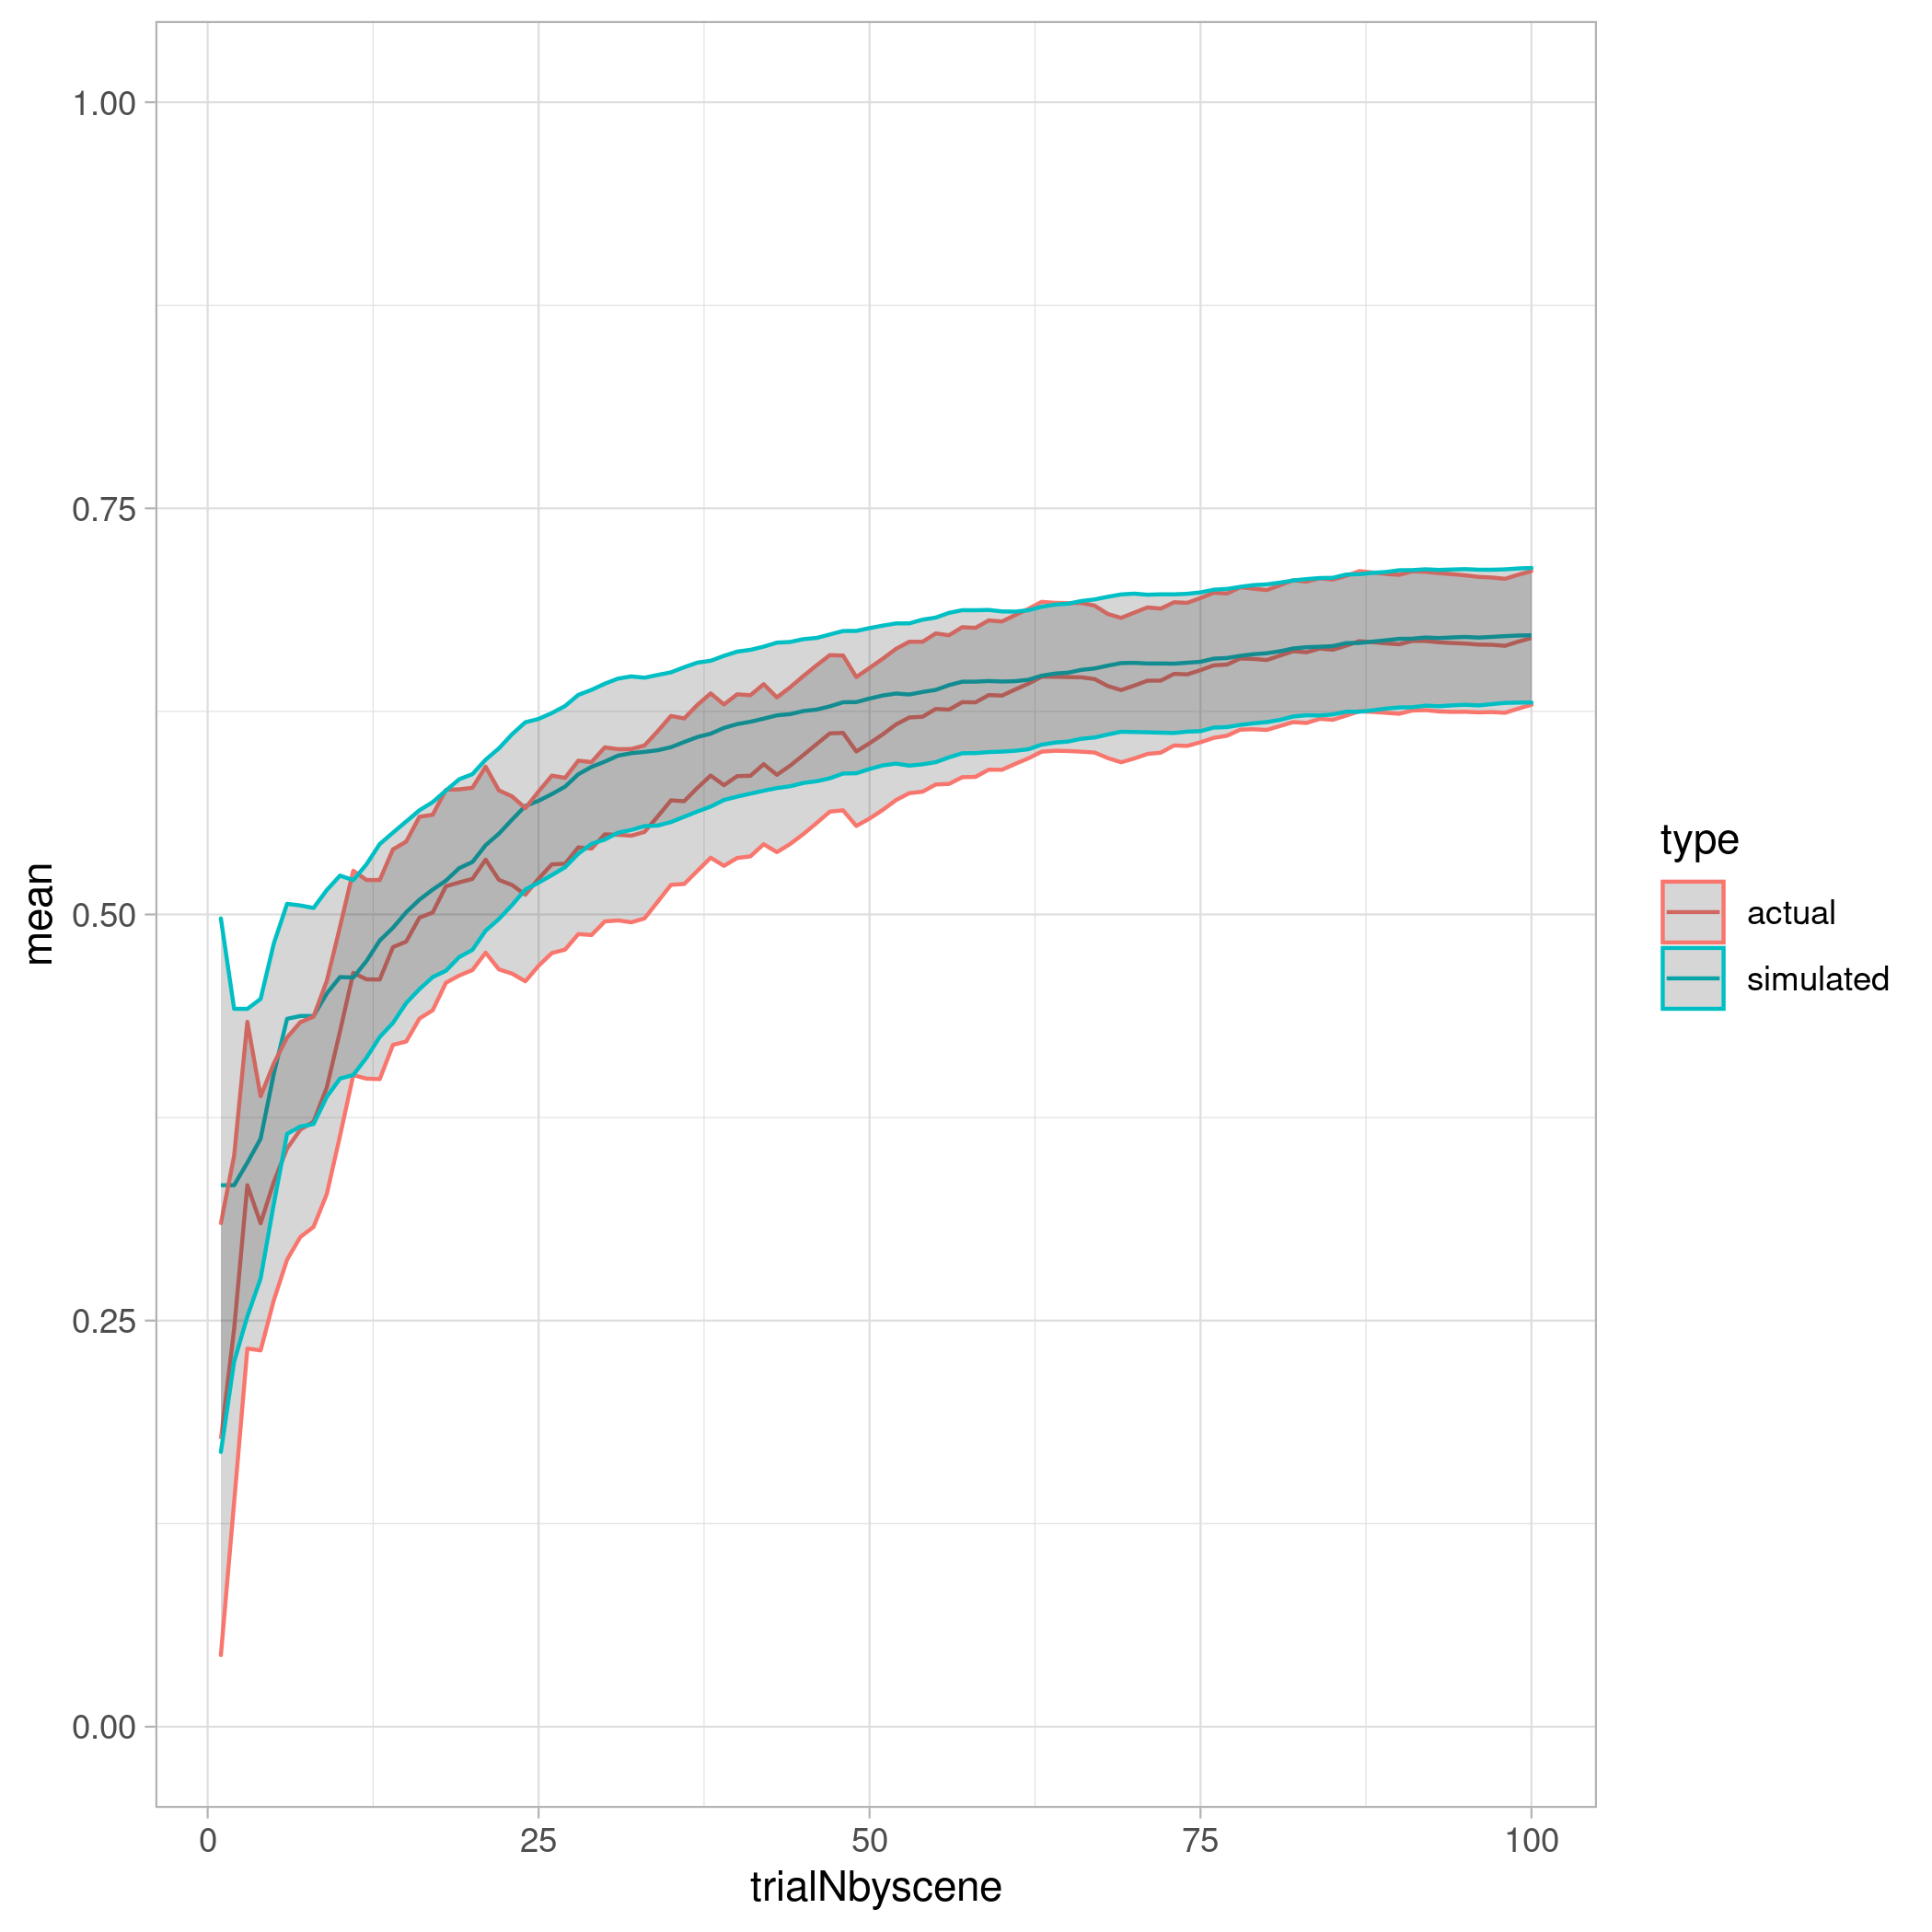Figure 17: Simulated vs Empirical, RW model free learning rate. Experiment 1.
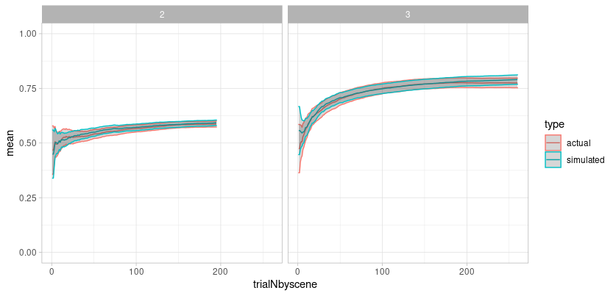
Figure 18: Simulated vs Empirical for the RW model with the free learning rate parameter. Experiment 2.

Analysis parameters
Descriptive statistics for the parameters of best fit for both experiments is presented on Table 1.
Experiment 1
Parameter | Mean (SD)
Learning rate | 0.09 (0.1)
beta | 6.03 (2.61)
Experiment 2
Parameter | Mean (SD)
Learning rate (pos) | 0.18 (0.30)
Learning rate (neg) | 0.04 (0.17)
beta | 6.22 (2.93)

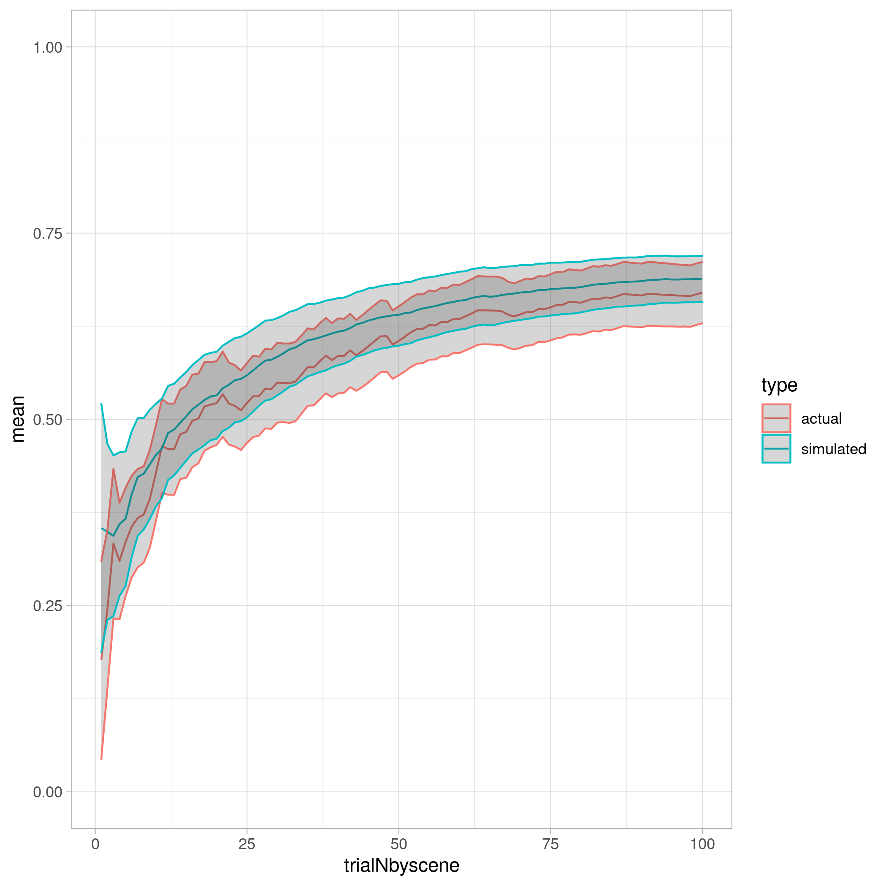Figure 19: Simulated vs Empirical, dual LR model

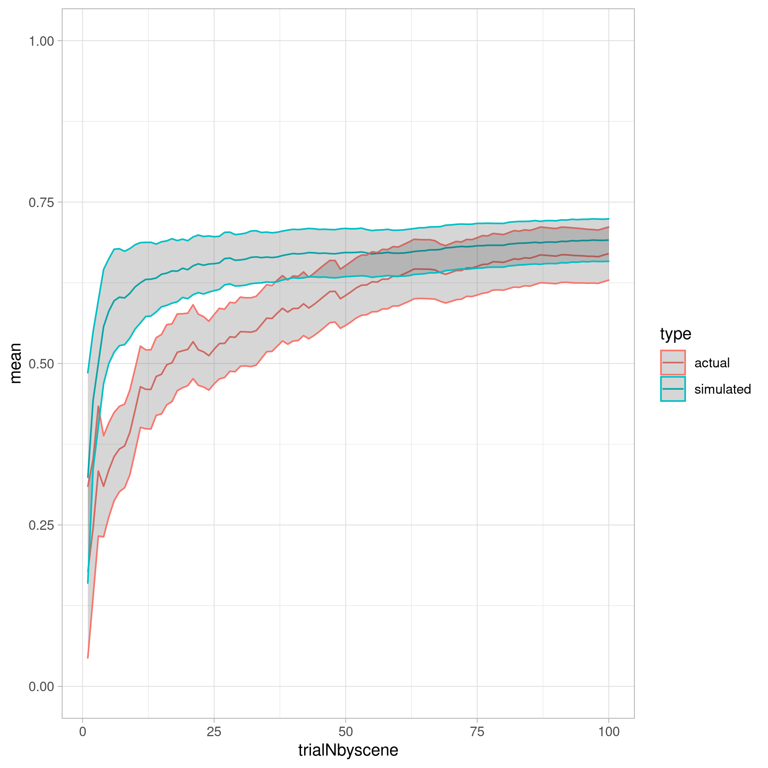Figure 20: Simulated vs Actual, Optimal Bayesian model

