**Template task**

In a similar setting as in the encoding phase (see Figure 1) participants had to think about one of the four categories on each trial. There were 16 trials for each of the 4 categories. In the timewindow in which participants were thinking about the categories, we measured brain activity. We then looked at whether patterns of brain activation in areas we selected was more similar in trials that belonged to the same object category were more similar to pattern of activation in trials that did not belonged to the same category. In other words, we tested whether the representational dissimilarity was lower for within-category trials compared to between-category ones.

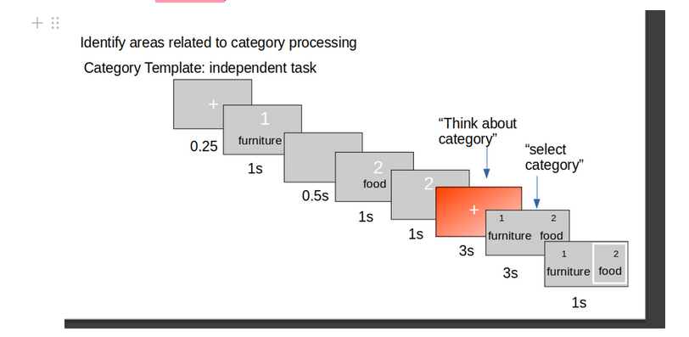Figure 1: Template structure

**Analysis steps**

In order to run the analysis only on selected ROIs, we had to first extract masks where only the ROIs was segmented. Then, we had to transform those segmentation to participants’ functional scans. We obtained brain segmentation on MNI space (Manera et al., 2020) and then got the transformation matrix to participants’ anatomical native space (T1). As a second step, we transformed participants’ functional space to T1. After that, we inverted the last transformation to get from native to functional. Finally, the transformations from MNI to native space, and from native to functional were concatenated. The mask (segmentation) was then transformed to participants’ functional space by applying the concatenation.

Drawing 1: Trasformations of the Brain Masks to functional space

MNI space

Native Space

Functional Space

a.

b.

c.

d.

Mask

MNI space

Native Space

Functional Space

a.

b.

c.

d.

Mask

1.After data have been preprocessed, the masks (lateral, temporal) are extracted on MNI space.

2. Then the mask is transformed from atlas space (MNI) into functional – native space.

In order to do this, 4 steps were performed:

a. The transformation matrix from atlas to native anatomical space is obtained.

In this way, we get how to go from the MNI map with the segmentation to the native participants space (T1). But we have to report the functional to the native and get the transformation matrix.

b. transformation matrix from native functional to native anatomical is obtained

Now we can invert the matrix to go from native to functional

c. the last transformation is inverted, to go from native anatomical to functional.

d. Concatenate the so obtained matrix with the transformation from atlas to native, to get the functional to the MNI space. Apply concatenated matrix to atlas (for visualization) and mask. The mask is now into functional space.

**RDA**

In order to compute the RDA, beta maps for each trial were first obtained through Least Square Unitary estimation (see, e.g., Abdulrahman & Henson, 2016). The trials were then ordered according to the event (i.e., the category participants were supposed to think about), and the dissimilarity between each trial and all the 63 remaining ones was computed to obtain the Representation Dissimilarity Matrix (see Figure 2). The similarity within same-category trials and the similarity between different-category trials was computed for each participant by averaging the single pairs.

Figure 2 shows in yellow the cases in the RDA matrix that were averaged for different-category and same-category trials, respectively. Multidimensional scaling shows that trials belonging to the same category showed clustering.

Figure 2: RSA for one participant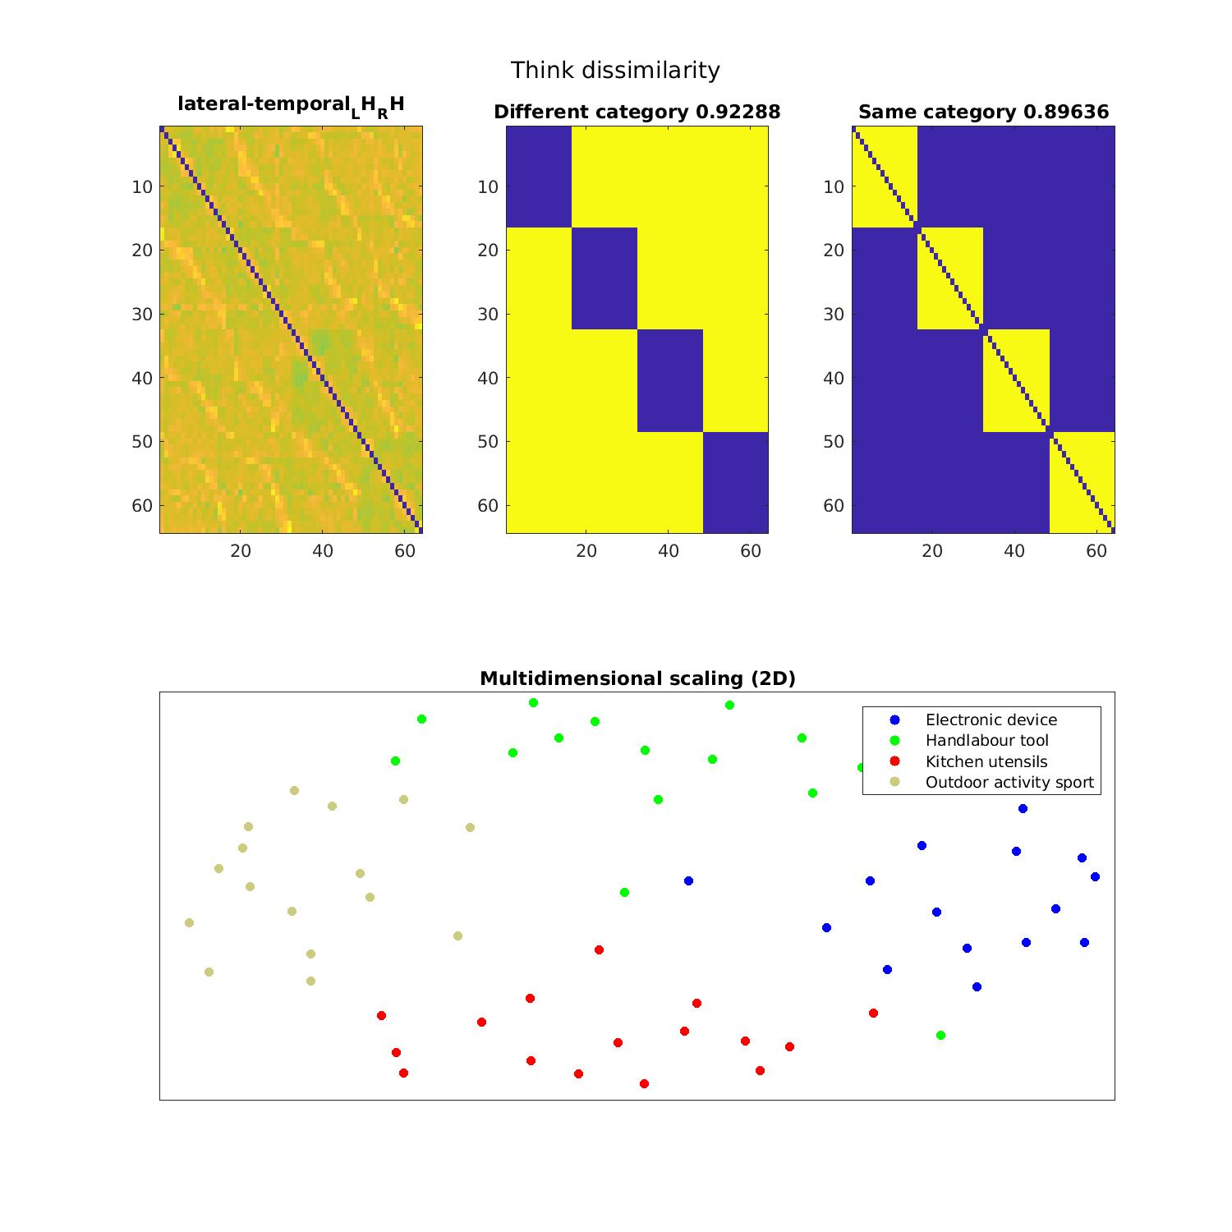

3. glm lss and lsu are computed for both prediction (“think about category”) and response.

4. RDM matrix is computed ordering the events (category – prediciton, category – response).

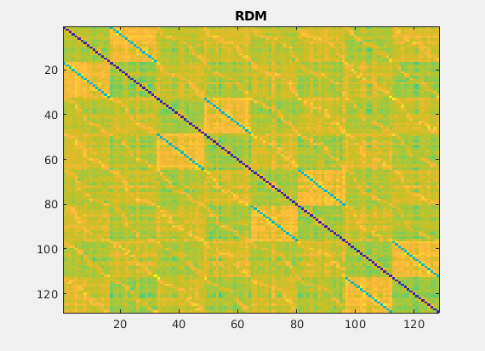The first 16 trials are from the same cateogry -prediction. Then the as the previous category – response, and so on. There are 16 (trial per category) * 4 (categories) * 2( thinking vs response) trials = 128 trials.

**Control checks**

**- remembered vs forgottone**

**-response vs all**In responsevsall contrast, we are checking whether we can have increased activation for the motor response, compared to the prediction condition (in which participant think about the condition) and the target image (when participants see the image).   
In the ‘respvsall.m’ script, the events, the confound, the contrasts are computed for this condition.   
Then the contrast is tested at the group level. For four participants, we set the p value to .01 and 10 voxel cluster corrected.

Show on canonical brain – overlays – section – canonical – navigate to spm12/canonical

**References**

Abdulrahman, H., & Henson, R. N. (2016). Effect of trial-to-trial variability on optimal event-related fMRI design: Implications for Beta-series correlation and multi-voxel pattern analysis. NeuroImage, 125, 756-766.

Manera, A. L., Dadar, M., Fonov, V., & Collins, D. L. (2020). CerebrA, registration and manual label correction of Mindboggle-101 atlas for MNI-ICBM152 template. *Scientific Data*, *7*(1), 237.