Eviden SafeKit

Technical Overview

Reference: EVD/BR/190226

Table of contents
1. Technical Overview 3
1.1 Generalities, solutions, architectures 3
1.1.1 Introduction to SafeKit 3
1.1.2 SafeKit solutions 4
1.1.3 SafeKit architectures 4
1.1.4 SafeKit cluster definition 5
1.1.5 SafeKit module definition 5
1.1.6 SafeKit limitations 7
1.2 The SafeKit mirror cluster 8
1.2.1 Real time file replication and application failover 8
1.2.2 Step 1. Normal operation 8
1.2.3 Step 2. Failover 9
1.2.4 Step 3. Failback and automatic resynchronization 9
1.2.5 Step 4. Return to normal operation 9
1.2.6 Synchronous replication versus asynchronous replication 10
1.2.7 Behavior in case of network isolation 10
1.2.8 3-node replication 11
1.2.9 SafeKit on a single node to protect against software failures 11
1.3 The SafeKit farm cluster 12
1.3.1 Network load balancing and application failover 12
1.3.2 Principle of a virtual IP address with network load balancing 12
1.3.3 Load balancing for stateful or stateless web services 12
1.3.4 Chain high availability solution in a farm 13
1.4 Clusters running several modules 13
1.4.1 The SafeKit farm+mirror cluster 13
1.4.2 The SafeKit active/active cluster with replication 14
1.4.3 The SafeKit N-1 cluster 15
1.5 The SafeKit Hyper-V or KVM cluster 15
1.5.1 Load balancing, replication, failover of entire virtual machines 15
1.6 SafeKit clusters in the cloud 16
1.6.1 Mirror cluster in Azure, AWS and GCP 16
1.6.2 Farm cluster in Azure, AWS and GCP 18

Technical Overview
- Section 1.1 “Generalities, solutions, architectures”
- Section 1.2 “The SafeKit mirror cluster”
- Section 1.3 “The SafeKit farm cluster”
- Section 1.4 “Clusters running several modules”
- Section 1.5 “The SafeKit Hyper-V or KVM cluster”
- Section 1.6 “SafeKit clusters in the cloud”

Generalities, solutions, architectures

Introduction to SafeKit
SafeKit, developed by Eviden, is a high availability software solution designed to ensure 24/7 uptime for business-critical applications. It supports both Windows and Linux platforms and eliminates the need for shared disks, enterprise editions of databases, or advanced technical skills, making it a cost-effective alternative to traditional clustering solutions.
Key Features:
- Real-Time Synchronous Replication: Continuous data replication across nodes to prevent data loss.
- Automatic Failover and Failback: Seamless switch to a secondary system during failures and reversion once the original system is operational.
- Load Balancing: Optimizes resource use by distributing workloads across multiple servers.
- Platform Agnostic: Compatible with physical machines, virtual machines, and public cloud infrastructures.
Key Advantages:
- Zero Specific Skills: No specialized IT skills required for deployment.
- Zero Hardware Overhead: No need for specific hardware like shared disks or load balancers.
- Zero Software Overhead: Works with standard editions of Windows and Linux.
Key Solutions:
- Application Level: High availability with restart scripts per application.
- Hypervisor Level: High availability without restart scripts per application.
- Container or Pod Level: High availability without restart scripts per application.
SafeKit is ideal for software publishers, resellers, and distributors looking to enhance their products with high availability features. It also offers an OEM opportunity for partners to integrate SafeKit into their own applications.

SafeKit solutions
See here for a list of SafeKit solutions.
Application-level HA  In this type of solution, only application data is replicated. And only the application is restarted in case of a failure.  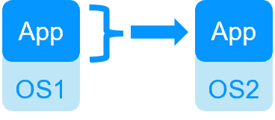  Integration tasks must be implemented, including defining the list of services to restart in case of failover, specifying data folders for replication, configuring software checkers, and setting up a virtual IP address.  This solution is platform-independent and works with applications inside physical machines, virtual machines, in the cloud. Any hypervisor is supported (e.g., VMware, Hyper-V, etc.). | Virtual machine-level HA  In this type of solution, the entire virtual machine (VM) is replicated, including the application and OS. The complete virtual machine is restarted in case of a failure.  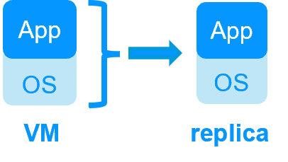  The advantage is that there is no need to have in-depth knowledge of the application (services to restart, location of application data to replicate), and no virtual IP address needs to be configured.  This solution works with Windows/Hyper-V and Linux/KVM but not with VMware. This is an active/active solution with multiple virtual machines replicated and restarted between the two nodes.
Note: Applications running in containers or pods also do not require dedicated restart scripts. SafeKit provides generic restarts and real-time replication of persistent data for these environments (see the list of SafeKit solutions).

SafeKit architectures
SafeKit offers two basic high availability clusters for Windows and Linux:
- the mirror cluster, with real-time file replication and failover, built by deploying a mirror module on 2 servers,
- the farm cluster, with network load balancing and failover, built by deploying a farm module on 2 servers or more.
Several modules can be deployed on the same cluster. Thus, advanced clustering architectures can be implemented:
- the farm+mirror cluster built by deploying a farm module and a mirror module on the same cluster,
- the active/active cluster built by deploying several mirror modules on 2 servers,
- the N-1 cluster built by deploying N mirror module on N+1 servers.
Specific clusters are also interesting to consider with SafeKit:
- the Hyper-V or KVM cluster with real-time replication and failover of entire virtual machines between 2 active hypervisors,
- mirror or farm clusters in the Cloud.

SafeKit cluster definition
A SafeKit cluster is a set of servers where SafeKit is installed and running.
All servers within a given SafeKit cluster share the same cluster configuration, which includes the list of servers and networks used. These servers communicate with each other to maintain a global view of the configurations of the SafeKit modules. A server cannot belong to multiple SafeKit clusters simultaneously.
Configuring the cluster is a prerequisite before the installation and configuration of SafeKit modules. This can be done using the SafeKit web console or through online commands.

SafeKit module definition
A module is a customization of SafeKit for a specific application or hypervisor. See here for a list of modules and their quick installation guides.
Types of Modules
- Generic farm and mirror modules for new applications,
- Preconfigured application modules for databases, web servers…,
- Hypervisors modules (hyperv.safe, kvm.safe) for real-time replication and restart of entire virtual machines.
Module Contents
In practice, a module is a “.safe” file (zip type) that includes:
- The configuration file userconfig.xml, which contains:
- The virtual IP address (not necessary for a hypervisor module),
- File directories to replicate in real time (for a mirror module),
- Network load balancing criteria (for a farm module),
- Configuration of software and hardware failures detectors,
- The scripts to start and stop an application or a virtual machine.
Deployment Steps
Once a module is configured and tested, deployment requires no specific IT skills:
- Install the application or the hypervisor on 2 standard servers,
- Install the SafeKit software on both servers,
- Install the module on both servers.
Configuring, deploying, and monitoring modules can be done using the SafeKit web console or through online commands.

SafeKit limitations
Typical usage with SafeKit
Replication of a few Tera-bytes | Replication < 1 million files | Replication <= 32 virtual machines | 1 or 10 G/s LAN or extended LAN
Limitation
Resynchronization after a failure takes too long.  On a 1 Gb/s network, 3 Hours for 1 Tera-bytes.  On a 10 Gb/s network, 1 hour or less for 1 Tera-bytes (depends on write disk IO performances). | Resynchronization after a failure takes too long.  Time to check each file between both nodes. | In full virtual machine replication mode, and with one virtual machine in a mirror module, the limit is 32 modules per cluster. | Failover of the virtual IP address is built-in when in the same subnet.  A LAN provides adequate bandwidth for resynchronization.  A LAN provides adequate latency (typically a round-trip of less than 2ms) for synchronous replication.
Alternative
Use shared storage. | Put files in a virtual hard disk replicated by SafeKit. | Use another HA solution with shared storage. | Use backup solutions with asynchronous replication.

The SafeKit mirror cluster

Real time file replication and application failover
The mirror cluster is an active-passive high-availability solution, built by deploying a mirror module within a two-node cluster. The application runs on a primary server and is restarted automatically on a secondary server if the primary server fails.
With its real-time file replication function, this architecture is particularly suited to providing high availability for back-end applications with critical data to protect against failure.
Microsoft SQL Server, PostgreSQL, MariaDB, Oracle, Milestone, Nedap, Docker, Podman, Hyper-V, and KVM solutions are examples of mirror modules. You can create your own mirror module for your application based on the generic mirror.safe module. See here for a list of modules.
Note that Hyper-V and KVM mirror modules replicate entire virtual machines, including applications and operating systems. They do not require a virtual IP, as the VM restart handles the failover of the VM physical IP address.
The mirror cluster works as follows.

Step 1. Normal operation
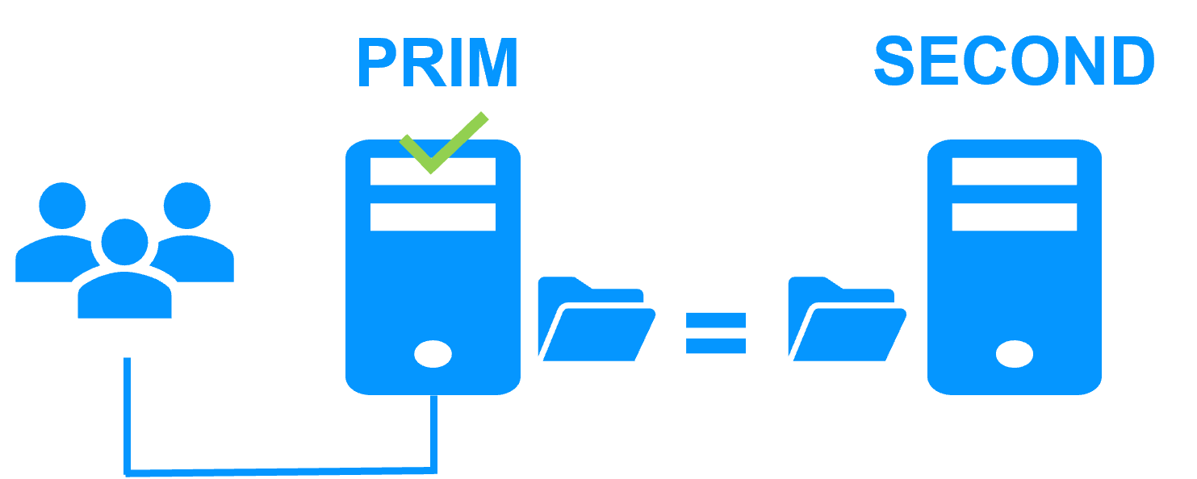
Server 1 (PRIM) runs the application.
SafeKit replicates files opened by the application. Only changes made by the application in the files are replicated in real time across the network, thus limiting traffic.
For replication, only names of file directories to replicate are configured in SafeKit. There are no pre-requisites on disk organization for the two servers. Directories to replicate may be located in the system disk.

Step 2. Failover
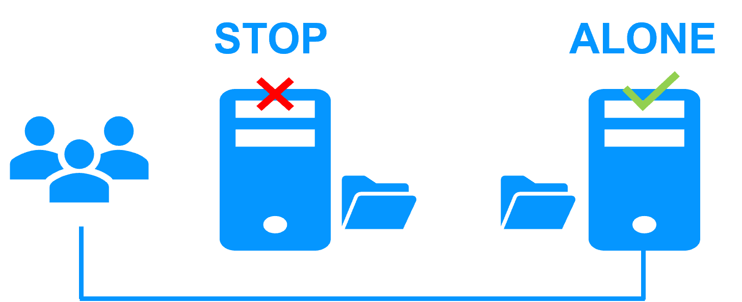
When Server 1 fails, Server 2 takes over. SafeKit switches the virtual IP address and restarts the application automatically on Server 2. The application finds the files replicated by SafeKit up-to-date on Server 2, thanks to the synchronous replication between Server 1 and Server 2. The application continues to run on Server 2 by locally modifying its files that are no longer replicated to Server 1.
The switch-over time is equal to the fault-detection time (set to 30 seconds by default) plus the application start-up time. Unlike disk replication solutions, there is no delay for remounting file systems and running recovery procedures.

Step 3. Failback and automatic resynchronization
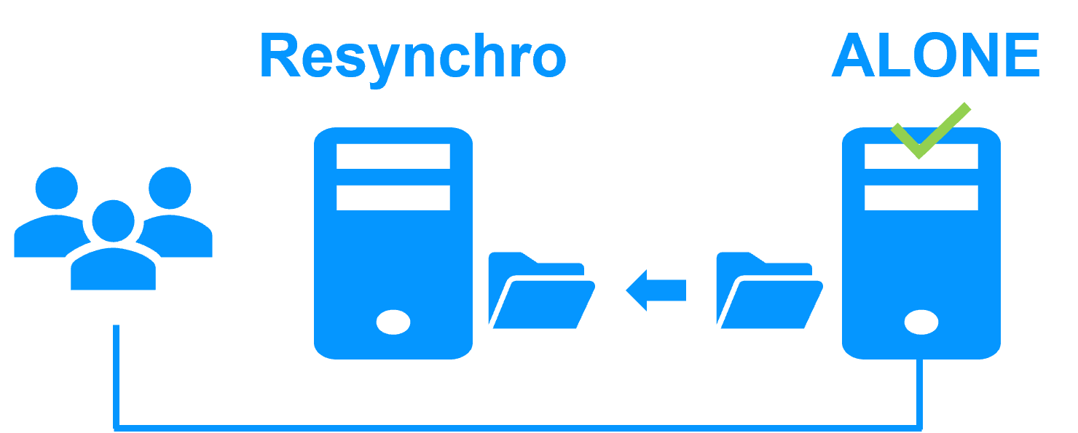
Failback involves restarting Server 1 after fixing the problem that caused it to fail. SafeKit automatically resynchronizes the files, updating only the files modified on Server 2 while Server 1 was halted.
This automatic reintegration takes place without stopping the application, which can continue running on Server 2. This is a major feature that differentiates SafeKit from other solutions, which require manual operations to reintegrate Server 1 in the cluster.

Step 4. Return to normal operation
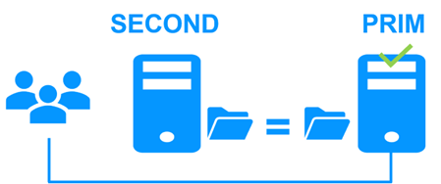
After reintegration, the files are once again in mirror mode, as in step 1. The system is back in high-availability mode, with the application running on Server 2 and SafeKit replicating file updates to Server 1.
If administrators want the application to run on Server 1, they can execute a ‘Stop/Start’ command on the PRIM server either through the console at the appropriate time or automatically by configuring a default primary server.

Synchronous replication versus asynchronous replication
There is a significant difference between synchronous replication, as offered by the SafeKit mirror solution, and asynchronous replication traditionally offered by other file replication solutions.
With synchronous replication, when a disk IO is performed by the application on the primary server inside a replicated file, SafeKit waits for the IO acknowledgement from the local disk and from the secondary server, before sending the IO acknowledgement to the application. This mechanism is essential for recovery of transactional applications.
The latency of a LAN (typically a round-trip of less than 2ms) between the servers is required to implement synchronous data replication, possibly with an extended LAN in two geographically remote computer rooms.
With asynchronous replication implemented by other solutions, the IOs are placed in a log on the primary server but the primary server does not wait for the IO acknowledgments of the secondary server. Thus, all data that has not been copied over the network to the second server is lost in the event of a failure of the first server.
In particular, a transactional application may lose committed data in the event of a failure. Asynchronous replication can be used for data replication over a low-speed WAN to back up data remotely, but it is not suitable for high availability with automatic failover.
SafeKit provides a semi-synchronous solution, implementing the asynchrony not on the primary server but on the secondary one. In this solution, SafeKit always waits for the acknowledgement of the two servers before sending the acknowledgement to the application. But on the secondary, there are 2 options asynchronous or synchronous. In the asynchronous case, the secondary sends the acknowledgement to the primary upon receipt of the IO and writes to disk after. In the synchronous case, the secondary writes the IO to disk and then sends the acknowledgement to the primary. The synchronous mode is required if we consider a simultaneous double power outage of two servers, with inability to restart the former primary server and requirement to re-start on the secondary.

Behavior in case of network isolation
A heartbeat is a mechanism for synchronizing two servers and detecting failures by exchanging data over a shared network. If one server loses all heartbeats, it assumes the other is down and runs the application ALONE.
SafeKit supports multiple heartbeats across shared networks. A dedicated network with a second heartbeat can prevent network isolation and also be used as the replication network.
Network Isolation:
- Upon losing all heartbeats, both servers transition to the ALONE state, running the application independently.
- After the isolation, one server stops and resynchronizes data from the other server.
- The cluster returns to PRIM-SECOND state.
Splitbrain Checker:
- Uses a witness IP (usually a router) to avoid double execution during isolation.
- Only the server with witness access goes ALONE; the other waits.
- After isolation, the WAIT server resynchronizes and becomes SECOND.

3-node replication
SafeKit only supports replication between two nodes. However, it is possible to implement 3-node replication by combining SafeKit with a backup solution.
An application is made highly available between 2 nodes thanks to SafeKit with its synchronous real-time replication (no data loss) and automatic failover. Additionally, a backup solution is implemented for asynchronous replication to a third node in a disaster recovery site. Since there is data loss with an asynchronous backup solution, the failover to the third node is manual and decided by an administrator.
Note that the real-time replication of SafeKit does not eliminate the need for a backup solution. For example, a ransomware attack encrypting replicated data on the primary server will also encrypt data on the secondary server in real-time with SafeKit. Only a backup solution with a retention policy can resolve a ransomware attack. The administrator must restore the backup from before the ransomware attack.

SafeKit on a single node to protect against software failures
You can configure a module in "light" mode, which corresponds to a module running on a single node without synchronizing with other nodes (unlike mirror or farm modules). A light module includes the start and stop of an application, as well as SafeKit checkers that detect software errors and perform automatic restarts on a single node.
The light module interfaces with the SafeKit console, allowing an administrator to view the status of the application module and manually trigger application restarts using a button-click interface.
There is no need to define a virtual IP address or replicated directories in a light module. Note that this can also serve as a first step before transitioning to a mirror module or a farm module.

The SafeKit farm cluster

Network load balancing and application failover
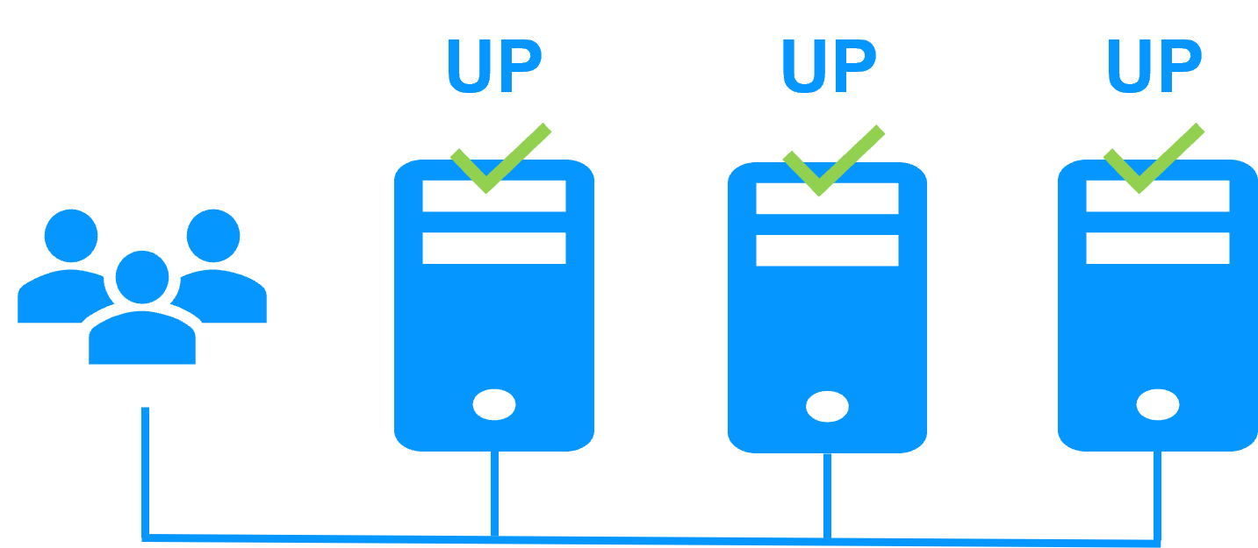
The farm cluster is an active-active high-availability solution, built by deploying a farm module within a cluster of two or more nodes. The farm cluster provides both network load balancing, through transparent distribution of network traffic, and software and hardware failover. This architecture offers a simple solution to support the increase in system load.
The same application runs on each server, and the load is balanced by the distribution of network activity on the different servers of the farm.
Farm clusters are suited to front-end applications like web services.
Apache, Microsoft IIS, NGINX solutions are examples of farm modules. You can write your own farm module for your application, based on the generic farm.safe module. See here for a list of modules.

Principle of a virtual IP address with network load balancing
The virtual IP address is configured locally on each server in the farm. Input traffic for this address is distributed among all servers by a filter within each server’s kernel.
The load balancing algorithm inside the filter is based on the identity of the client packets (client IP address, client TCP port). Depending on the identity of the client packet, only one filter on a server accepts the packet. Once a packet is accepted by the filter on a server, only the CPU and memory of that server are used by the application responding to the client’s request. The output messages are sent directly from the application server to the client.
If a server fails, the SafeKit heartbeat protocol in a farm reconfigures the filters to re-balance the traffic among the remaining available servers.

Load balancing for stateful or stateless web services
With a stateful server, session affinity is required. The same client must connect to the same server across multiple TCP sessions to retrieve its context. In this scenario, the SafeKit load balancing rule is configured on the client IP address. This ensures that the same client always connects to the same server for multiple TCP sessions, while different clients are distributed across various servers in the farm. This configuration is used when session affinity is required.
With a stateless server, there is no session affinity. The same client can connect to different servers in the farm across multiple TCP sessions, as no context is stored locally on a server from one session to another. In this case, the SafeKit load balancing rule is configured on the TCP client session identity. This configuration is optimal for distributing sessions between servers but requires a TCP service without session affinity.

Chain high availability solution in a farm
What is a chain HA solution (also known as a cascading HA solution)?
- Multiple servers are linked in a sequence: If one server fails, the next one in the chain takes over.
- Priority-based management: A single server, the one with the highest priority in the chain and which is available, manages all requests from clients.
- Failover process: If the server with the highest priority fails, the next available server with the highest priority takes over.
- Reintegration: When a server comes back online and has the highest priority, it resumes handling all client requests.
- Quick recovery time: This solution has a quick recovery time, as the application is pre-started on all servers. The recovery time is essentially the time needed to reconfigure the priorities among the servers in the farm (a few seconds).
- Replication limitations: This solution does not support real-time replication, which is limited to mirror architecture. However, a combined farm+mirror architecture is available.
To implement a chain high availability solution, SafeKit offers a "power" variable in the load balancing rules, which is set at the level of each server in the cluster. The power variable allows you to allocate more or less traffic to a server. When the power variable is set as a multiple of 64 between servers (e.g., 1, 64, 64*64, 64*64*64, ...), the chain high availability solution is implemented.

Clusters running several modules

The SafeKit farm+mirror cluster
Network load balancing, file replication and application failover
You can mix farm and mirror modules on the same cluster.
This option allows you to implement a multi-tier application architecture, such as apache_farm.safe (farm architecture with load balancing and failover) and postgresql.safe (mirror architecture with file replication and failover) on the same servers.
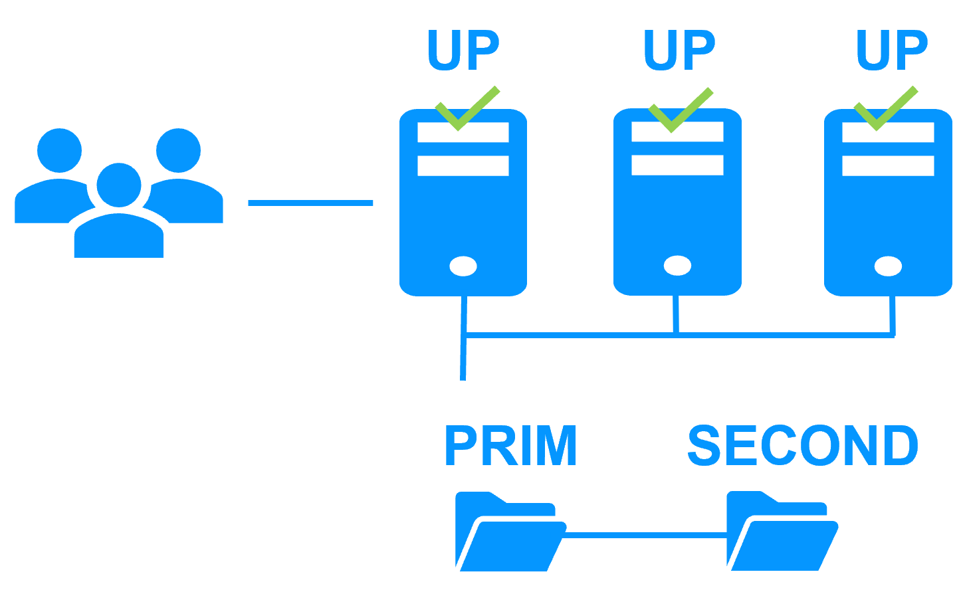
As a result, load balancing, file replication and failover are managed coherently on the same servers.

The SafeKit active/active cluster with replication
Crossed replication and mutual failover
In an active / active cluster with replication, there are two servers and two mirror modules in mutual failover (appli1.safe and appli2.safe). Each application server is backup of the other server.
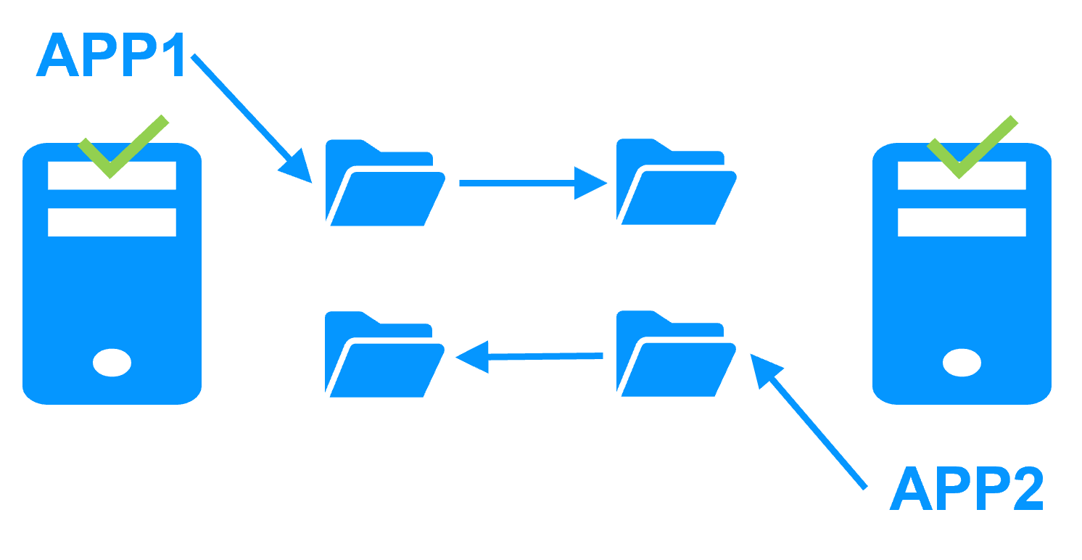
If one application server fails, both applications will run on the same physical server. Once the failed server is restarted, its application will return to its default primary server.
A mutual failover cluster is more cost-effective than two separate mirror clusters, as it eliminates the need for backup servers that remain idle most of the time, waiting for a primary server to fail. However, in the event of a server failure, the remaining server must be capable of handling the combined workload of both applications.
Note that:
- Both applications, Appli1 and Appli2, must be installed on each server to enable application failover.
- This architecture is not limited to just two applications; N application modules can be deployed across two servers.
- Each mirror module will have its own virtual IP address, its own replicated file directories, and its own restart scripts.

The SafeKit N-1 cluster
Replication and application failover from N servers to 1
In an N-1 cluster, N mirror application modules are deployed across N primary servers and a single backup server.
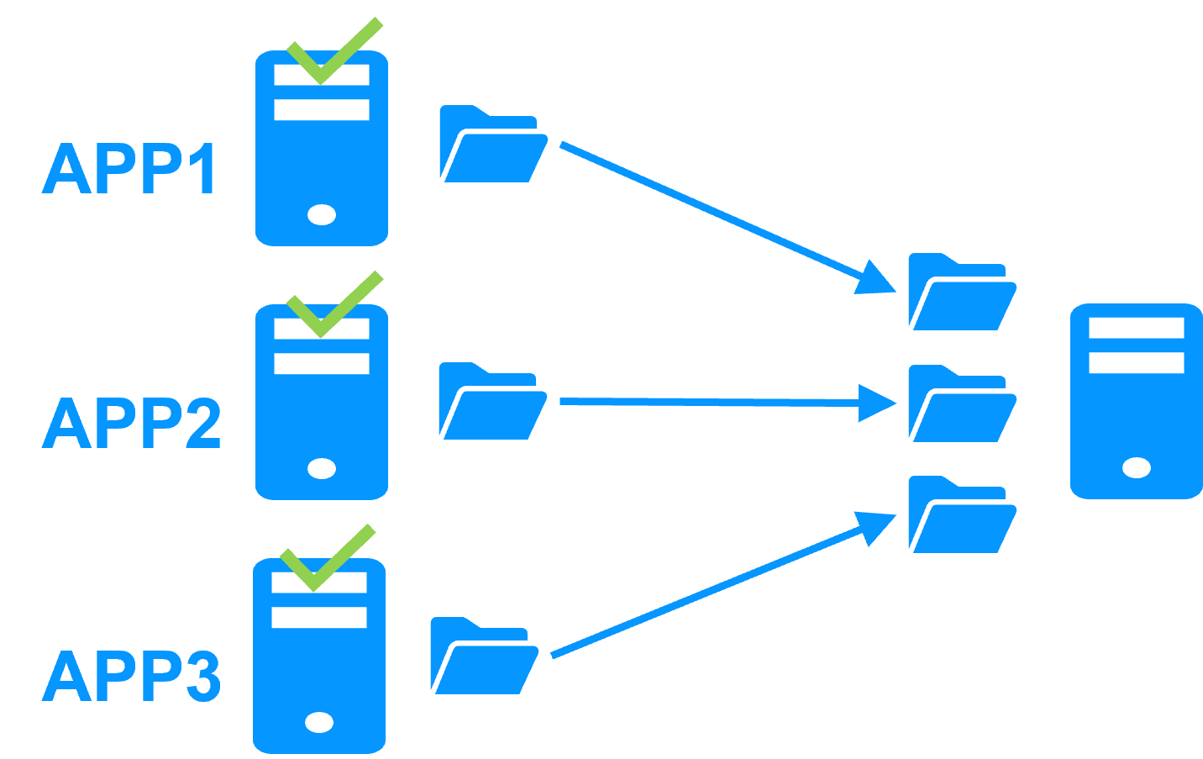
In the event of a failure, unlike in an active/active cluster, the backup server does not need to manage a double workload when a primary server fails. This assumes only one failure occurs at a time. While the solution can support multiple primary server failures simultaneously, in such cases, the single backup server will need to handle the combined workload of all the failed servers. In a N-1 cluster, there are N mirror application modules installed between N primary servers and one backup server.
Note that:
- All applications (Appli1, Appli2, Appli3) must be installed on the single backup server to enable application failover.
- Each mirror module will have its own virtual IP address, its own replicated file directories, and its own restart scripts.

The SafeKit Hyper-V or KVM cluster

Load balancing, replication, failover of entire virtual machines
The Hyper-V or KVM cluster is an example of an active-active cluster. Multiple applications can be hosted in various virtual machines, which are replicated and restarted by SafeKit. Each virtual machine is managed by SafeKit within its own mirror module.
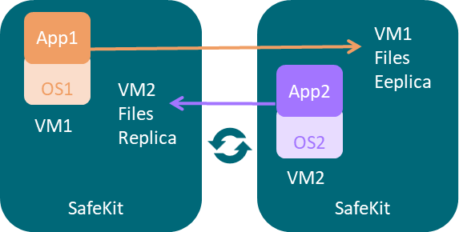
The solution has the following features:
- Real-time synchronous replication of entire virtual machines with failover capabilities.
- A centralized, user-friendly SafeKit console for managing all VMs, including the ability to migrate VMs between servers to optimize load distribution.
- A Hyper-V checker for each VM to detect if it has locked up, crashed, or ceased to function, and to restart the VM if necessary.
- An attractive solution that requires no application integration.
- A robust architecture suitable for high-availability solutions that cannot be integrated at the application level.
A free trial of the Hyper-V cluster with SafeKit is available here.
A free trial of the KVM cluster with SafeKit is available here.

SafeKit clusters in the cloud

Mirror cluster in Azure, AWS and GCP
SafeKit delivers high-availability clusters with real-time replication and failover in Azure, AWS, and GCP through the deployment of a mirror module.
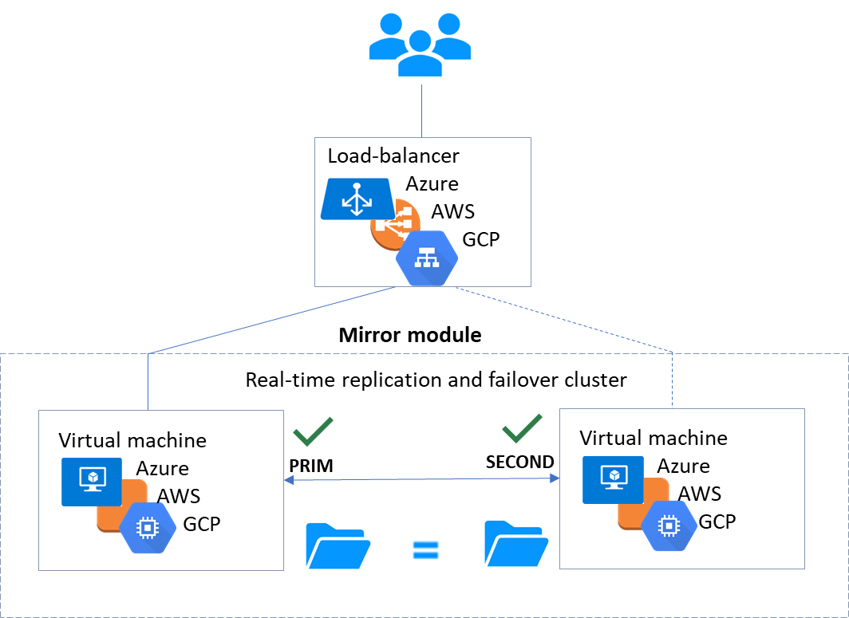
The mirror solution in the cloud is similar to the on-premise one, except that the virtual IP address must be configured at the load balancer level:
- Virtual machines are placed in different availability zones, which are in different subnets.
- The critical application runs on the primary server.
- Users connect to a primary/secondary virtual IP address managed by the cloud load balancer.
- SafeKit provides a health check configured in the load balancer. On the primary server, the health check returns OK to the load balancer, while it returns nothing on the secondary server. Thus, all requests to the virtual IP address are routed to the primary server.
- If the primary server fails or is stopped, the secondary server automatically becomes the primary one and returns OK to the health check. Thus, all requests to the virtual IP address are rerouted to the new primary server.
- SafeKit monitors the critical application on the primary server using SafeKit checkers.
- SafeKit automatically restarts the critical application in the event of software or hardware failure, thanks to restart scripts.
- SafeKit performs synchronous real-time replication of files containing critical data.
For more information, refer to mirror cluster in Azure, mirror cluster in AWS or mirror cluster in GCP.

Farm cluster in Azure, AWS and GCP
SafeKit delivers high-availability clusters with network load balancing and failover in Azure, AWS, and GCP through the deployment of a farm module.
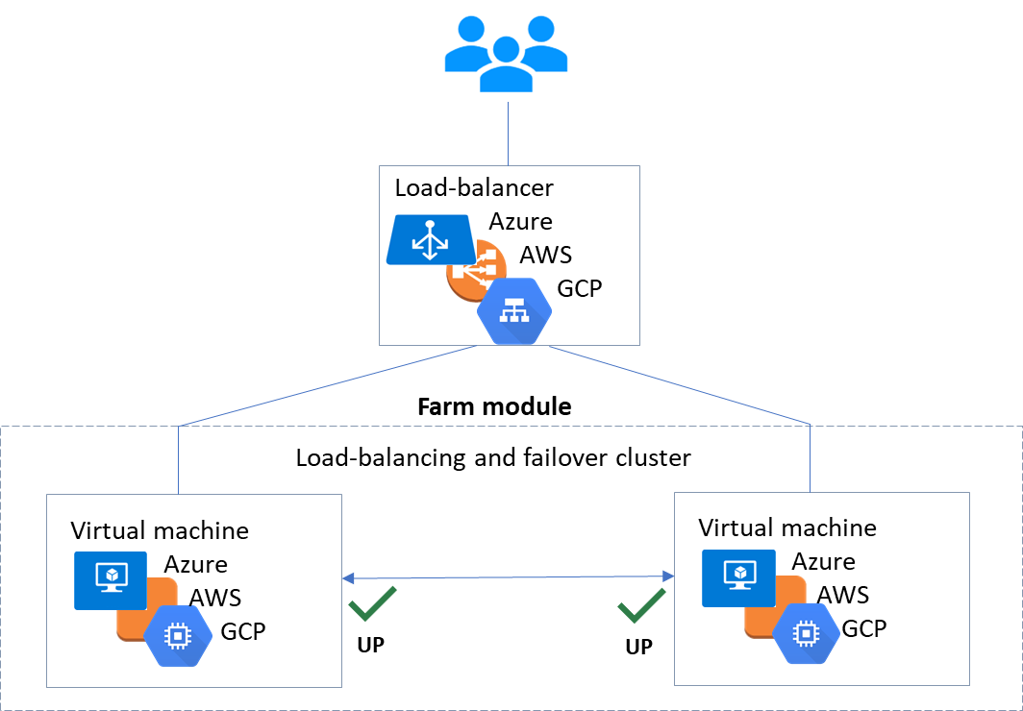
The farm solution in the cloud is similar to the on-premise one, except that the virtual IP address must be configured at the load balancer level:
- Virtual machines are placed in different availability zones, which are in different subnets.
- The critical application runs on all servers.
- Users are connected to a virtual IP address managed by the cloud load balancer.
- SafeKit provides a health check configured in the load balancer. The health check returns OK on all servers running the application.
- If a server fails or is stopped, the checker returns nothing to the load balancer, which then stops routing requests to that server.
- SafeKit monitors the critical application on all servers using SafeKit checkers.
- SafeKit automatically restarts the critical application on a server when there is a software failure, thanks to restart scripts.
For more information, refer to farm cluster in Azure, farm cluster in AWS or farm cluster in GCP.

