Surrogate CWT indicator stock selection for Elwha Chinook

Pete McHugh, Eco Logical Research, December 2015

# Background and problem Statement

Management applications of the Chinook Fishery Regulation Assessment Model (FRAM) involving Puget Sound Chinook necessitate that an Elwha/Dungeness summer Chinook model stock be included in base period development. However, the Elwha Hatchery (ELW) CWT releases that occurred during the proposed brood years (2005-2008) were not adipose clipped and therefore cannot be used for cohort analysis/calibration purposes (i.e., due to the lack of CWT recoveries, not impacts, in many northern fisheries for which catch is sampled visually only). Further, due to poor CWT survival and limited ocean recovery data, relatively few ‘out-of-base’ (OOB) AD+CWT code options exist that could inform stock inclusion via existing OOB procedures. Accordingly, here we consider the potential for using another CWT indicator stock as a surrogate for Elwha summer Chinook.

# ANALYSIS APPROACH

To identify candidate stocks, we examined the harvest distribution patterns of 17 Salish Sea (Canada and US; Table 1) CWT indicator stocks, based on the stocks and codes used in ongoing Pacific Salmon Commission Chinook Technical Committee analyses. We focused specifically on data from the early 1990s (1990, 1992, 1993 broods), as this was a period during which large numbers of AD+CWT fingerling Chinook were released from the Elwha Hatchery, and a sufficiently large number (n > 30 estimated recs; Elwha codes 212015, 212324, 212451) occurred for Elwha Chinook in outside (non-Salish Sea) fisheries. We focused our attention on patterns of harvest in outside fisheries because we expected a priori that different Salish Sea stocks would have different harvest patterns on the inside (i.e., within Salish Sea) given their respective ‘turn off’ locations. We expected that such differences could be addressed through run reconstruction- or other rule-based modifications to a surrogate stock’s CWT dataset. Our analysis thus proceeded according to the following steps:

1. We screened the CWT indicator stock dataset for evidence of a ‘natural’ or ‘obvious’ surrogate.
2. For potential candidates, we examined harvest patterns more closely and compared the average recovery distribution (frequency by coarse fishery strata) and average exploitation rates; we additionally compared the age structure of mature returns, approximated by escapement-at-age composition across years.
3. Given findings from 1 and 2, we devised a method to create a surrogate calibration CWT input file that could be used to approximate the harvest patterns for ELW Chinook.

# Findings

Using multivariate statistical methods, we identified potential surrogate stocks by exploring similarity in the harvest distribution patterns for individual stock-brood year observations. Specifically, we used principal components analysis (PCA) and cluster analysis to identify the stock groups with harvest patterns most similar to those of ELW for the three brood years in question (**Figures 1 and 2**). Visualizing patterns based on PCA (**Figure 1**) illustrated that ELW are indeed unique among the stocks considered, reflecting a variable presence in both NBC, SEAK, and WCVI fisheries. However, PCA results also suggested, and cluster analysis results further confirmed (**Figure 2**) that among Salish Sea stocks the Stillaguamish (STL) indicator stock lies the closest in multidimensional ‘harvest space’.

Given the patterns emerging from the multivariate harvest distribution analysis, we further assessed the similarities between the STL and ELW indicator stocks for the brood years in question, as well as based on a more extended dataset, in order to further vet STL’s promise as a surrogate. We conducted three analyses:

(1) We examined the average recovery distribution pattern across finer-scaled FRAM fishery groupings (i.e., within the coarse groupings used in the multivariate analyses), which generally show concordance for the two stocks (**Table 2**). In general, there is a higher fraction of mortality in NBC net and WCVI sport for STL than ELW and a *These findings, in conjunction with the multivariate analyses described above, suggest the distribution of mortalities across fisheries is similar for the two stocks.*

(2) Using the entire time series of brood year ERs produced through cohort analysis by the PSC-CTC (CTC 2015) for the two indicator stocks, we assessed whether ocean ERs differed for the two stocks. Although we find a strong correlation in BYER for the two stocks (**Figure 3**), on average the two had BYERs that were virtually identical. In fact, the average ratio of Elwha to Stillaguamish ocean BYER for the three BYs used in the harvest distribution analysis was 0.99. Additionally, the slope and intercept of the regression displayed in Figure 1 did not differ from 1 and 0, respectively (P > 0.20 for simultaneous test). *These results suggest the magnitude of total ocean ER is quite similar for the two stocks; differences may exist within the Salish Sea and can be addressed through surrogate dataset modification/adjustment.*

(3) To determine whether STL’s maturation pattern reasonably approximates that of ELW, we evaluated whether or not the mature age structure, indexed based on the CWT escapement age distribution, differed for the two stocks. Generally, ELW Chinook appear to have a lower percentage of age 2s and 3s and higher percentage of age 5s compared to the STL Chinook indicator stock (**Table 3**). *These data suggest that using STL as a surrogate may yield a slightly earlier maturation schedule than a true ELW-origin CWT dataset would; should STL be used as a surrogate, the sensitivity to this departure may warrant some consideration/accommodation.*

Overall, these analyses corroborate previous assertions suggesting that no perfect surrogate stock exists for the ELW stock. More importantly, however, they also suggest that the STL stock may be a viable option, depending on the willingness of parties involved to make a few assumptions and modifications (i.e., to adjust in order to accommodate expected inside fishery differences for the two stocks) in order to create a STL-to-ELW surrogate CWT dataset for the contemporary (2005-2008) base period brood years. An possible approach towards developing this surrogate dataset is described below.

# Creating a surrogate CWT calibration dataset

Using STL as a surrogate for ELW assumes that the overall harvest distribution and maturation pattern for the two CWT indicator stocks is comparable and/or that suitable modifications can be made to the surrogate dataset to account for known, suspected, or assumed differences. As discussed above, we have attempted to establish that the two stocks have similar *outside* harvest distribution pattern and overall ocean ERs; however, we *a priori* expected there to be *inside* (i.e., within US and Canadian Salish Sea net and sport fisheries) fishery impact differences (and by extension, possibly total ER differences) given that STL and ELW originate and return to different portions of the Salish Sea. Accordingly, to use STL CWT data as surrogate for ELW in the FRAM calibration process, it is necessary to account for this differential, and here we propose an approach for creating a modified surrogate CWT dataset:

1. Generate a duplicate mapped STL FRAM calibration dataset.
2. Use the recovery data for *outside* fisheries in this cloned surrogate dataset ‘as is’ for calibration.
3. Modify STL recoveries for *inside* fisheries to reflect the expected ELW equivalents. This can be achieved using a combination of (1) the historic/OOB relationship between ELW and STL (i.e., estimated from the same broods reviewed above, 90, 92-93 brood years) tag recoveries in inside fisheries, and/or (2) based on simple run reconstruction-type rules (e.g., we don’t expect there to be ELW tags in Tulalip Bay fisheries targeting mature returns, whereas STL tags may be abundant). The first approach is facilitated by computing the average ratio (e.g., *R*F = ELW *N*F / STL *N*F) of ELW to STL CWTs, by fishery[1], in the historic data and subsequently applying these values to contemporary STL recoveries (e.g., ELW *N* FAT = STL *N* FAT * *R*F). Importantly, for the ratio adjustments to work properly in a surrogate context, OOB ELW CWTs must first be re-scaled so that the total ELW fishery+escapement CWT abundance is on equal footing with the OOB STL dataset. The second type of modification (i.e., run reconstruction rule-based adjustments) are also worth considering if evidence/logic support such a dataset alteration. For example, in the Tulalip Bay case described above, we may opt to zero out all STL CWTs for these sport and net fisheries (i.e., *R*F = 0).
4. [*For discussion, I’m not sure about this just yet*] Where appropriate, alterations to *inside* fishery recoveries in the surrogate STL dataset should be mirrored by a commensurate alteration to surrogate CWT escapement. Given the challenges and further assumptions that this type of data alteration introduces into the surrogate dataset preparation, it should only be supported where a fishery recovery alteration would absolutely be expected to result in a significant escapement response, e.g., in the case of an extreme terminal fishery targeting the mature run.

Upon completing these steps, a complete and modified STL CWT dataset is available for surrogate use in producing BPER, maturation rates, sublegal encounter rates, etc. for the Elwha/Dungeness FRAM model stock. It can be used in FRAM modelling with the knowledge that the best CWT proxy dataset available at the present time is guiding management decisions in mixed-stock fisheries for Elwha/Dungeness summer Chinook. However, such applications will implicitly accept that the base period parameters for Elwha Chinook at best reflect a hypothesis about the distribution and ocean life history of this stock under current conditions. The assumptions behind this approach should be further assessed as recovery data for recent (BY 2012+) AD+CWT releases from Elwha Hatchery become available in the coming years.

# Tables & FIGURES

**Table 1.** List of indicator stocks considered, with abbreviations.

|  |  |
| --- | --- |
| **Abbreviation** | **Stock Name** |
| BQR | Big Qualicum River (Strait of Geo.) |
| CHI | Chilliwack (Fraser) |
| COW | Cowichan (Strait of Geo.) |
| ELW | Elwha River (Juan de Fuca) |
| GAD | George Adams (Hood Canal) |
| GRN | Green River (Puget Sound) |
| GRO | Grovers (Puget Sound) |
| HOK | Hoko (Juan de Fuca) |
| NAN | Nanaimo (Strait of Geo.) |
| NIC | Nicola (Fraser) |
| NIS | Nisqually (Puget Sound) |
| PPS | Puntledge (Strait of Geo.) |
| QUI | Quinsam (Strait of Geo.) |
| SAM | Samish (Puget Sound) |
| SHU | Shuswap (Fraser) |
| SPY | Puget Sound Yearling (Puget Sound) |
| STL | Stillaguamish (Puget Sound) |

**Table 2.** Frequency of estimated recoveries across ‘outside’ (i.e., non-Salish Sea) fisheries for the Elwha and Stillaguamish indicator stocks. The fishery WA NOF corresponds to all PFMC fisheries in Washington waters; pooling was necessitated for the comparison given low expected value for some fisheries.

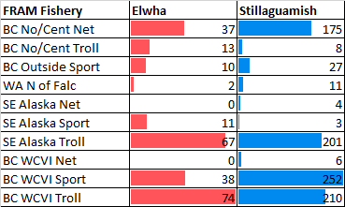

**Table 3.** Age composition of total estimated recoveries in escapement for the Elwha (ELW) and Stillaguamish (STL) indicator stocks.

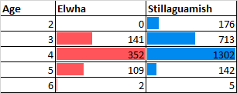

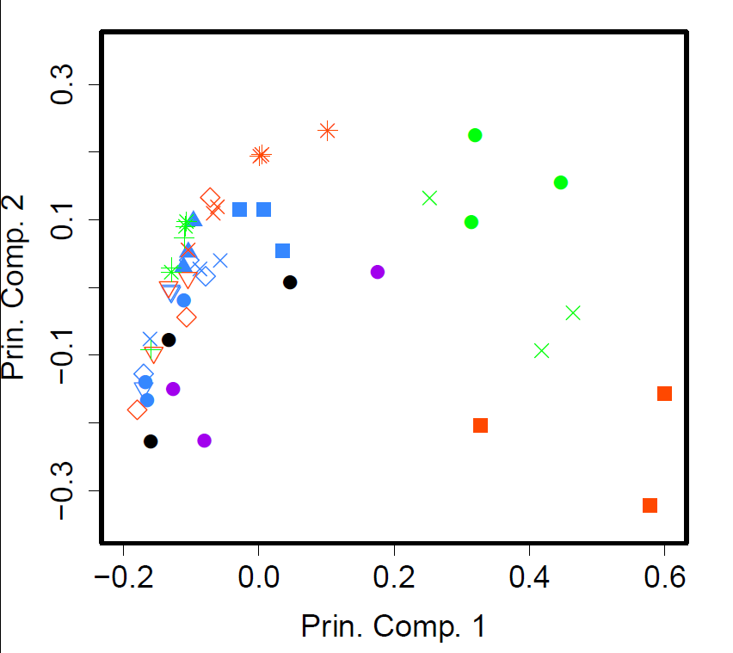

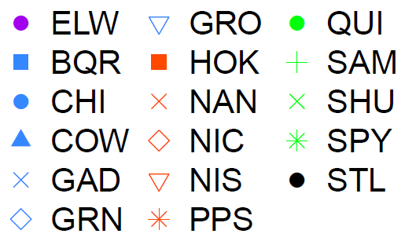

**Figure 1.** Principal components analysis plot of the outside (non-Salish Sea fisheries) harvest distribution data for Salish Sea CWT indicator stocks for brood years 1990, 1992-3. See Table 1 for stock abbreviations. For reference, separation along the PC1 relates primarily to relative abundance in SEAK (increasing values = higher SEAK fraction of mortality distribution), whereas positive PC2 values are associated with a strong NBC presence and *vice versa* a WCVI presence.

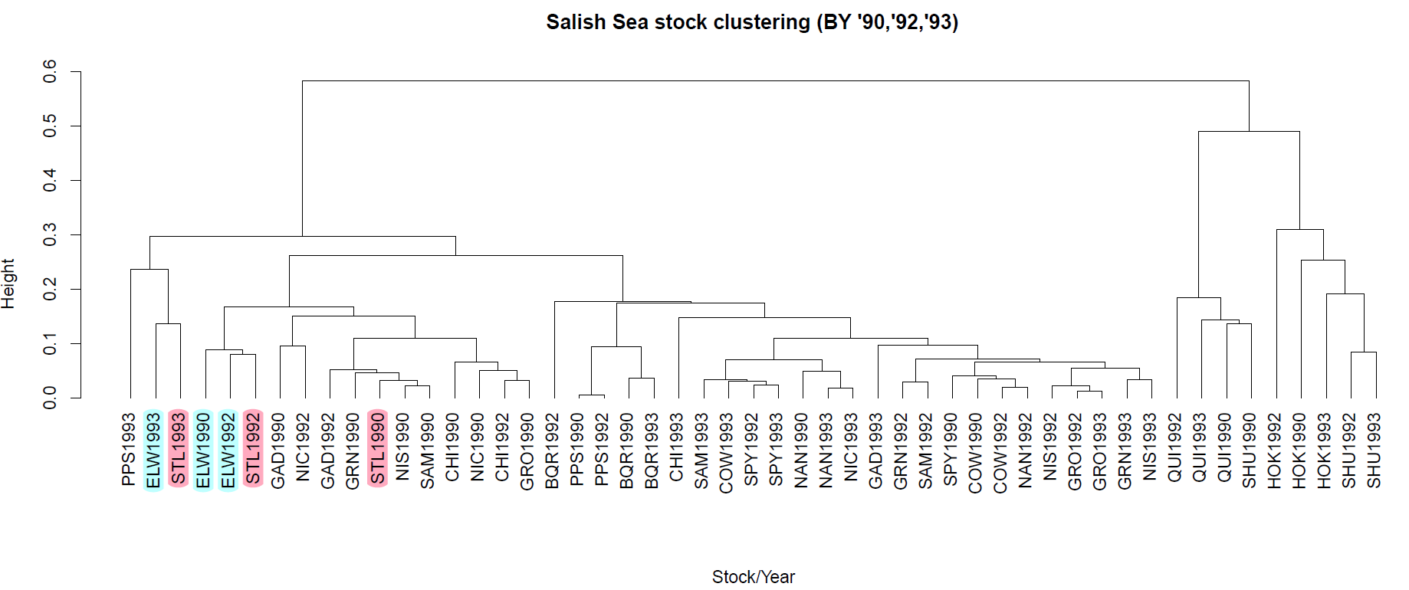

**Figure 2.** Clustering of stock-year observations based on their outside (non-Salish Sea) harvest distribution during the 1990, 1992-1993 brood years. The displayed clustering is based on a dissimilarity matrix computed on Euclidean distance and uses the UPGMA (unweighted pair group method with arithmetic mean) linkage method. Harvest distribution data were collapsed into four regional fishery categories prior to computing the distance matrix and conducting the cluster analysis (SEAK, NBC, WCVI, PFMC-North of Falcon). Note: The ELW nodes and proposed candidate STL stock nodes are highlighted for ease of visualization. See Table 1 for abbreviations for all stocks.

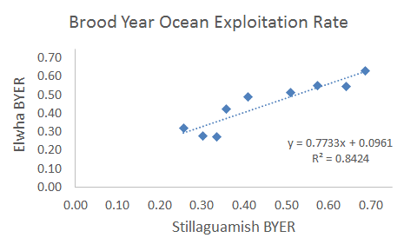

**Figure 3.** Relationship between ELW and STL indicator stock brood year exploitation rates (BYER) based on the PSC-CTC cohort analysis results for all available contemporaneous ELW and STL broods. A joint test of slope = 1 and intercept = 0 could not be rejected (*F* = 0.17, *P* = 0.84) suggesting that equality of stock BYERs may be a reasonable assumption.

1. The ratios can be computed by as fine of strata as desired, e.g., by age and time step; however, given the modest sample sizes and subsequent volatility of CWT data, a fishery-specific but pooled ages/time steps estimator may be the most appropriate way to proceed.