Chinook FRAM Base Period Documentation: Growth Functions

Pete McHugh (Eco Logical Research), Galen Johnson (Northwest Indian Fisheries Commission), and Jason Schaffler (Muckleshoot Indian Tribe-Fisheries)

October 5, 2015

# Background

To model fisheries with minimum size limit regulations, the Chinook Fishery Regulation Assessment Model (FRAM) is parameterized with growth functions for computing mean length (fork length, FL, in mm) by age and model time step, as well as supplementary inputs (coefficients of variation, CVs) for characterizing variability around these predictions. This report summarizes the data and analysis details associated with the growth parameters that were estimated in support of the 2015 Chinook FRAM Base Period Project. The objectives of this effort were to: (1) Estimate parameters for stock-specific von Bertalanffy growth functions (VBGFs), inclusive of an assessment of model fit diagnostics, etc.; and (2) Estimate stock-specific CVs associated with VBGF mean length-at-age predictions.

The approach taken differs from what has been done for prior base period (BP) calibrations in two important ways. Firstly, whereas past BPs included separate ‘mature’ (~terminal) and ‘mixed-maturity’ (~pre-terminal) VBGFs, a single pre-terminal model was deemed appropriate for contemporary modeling due to the lack of minimum size limits in terminal fisheries. Secondly, the estimation approach employed here addressed the fact that the data used to fit VBGFs (i.e., fishery recoveries) may be positively biased due to the release of sublegal/undersized (i.e., smaller than the minimum size limit) fish in fisheries with minimum size limit regulations.

# data description

This analysis is based on length observations associated with the coded-wire tag (CWT) recovery dataset selected for general base period calibration (i.e., exploitation rate estimation/cohort reconstruction) purposes, which is documented in other base period documents (i.e., stock profiles). Dataset details include:

* CWT recoveries for brood years 2005-2008 were included for all stocks. Additional CWT data were added to expand the sample size used to estimate VBGFs for the Washington Coast regional aggregate, as well as for the Sacramento/Central Valley stock; broods 2001-2004 were included for these two groups, as well as additional facilities for Washington Coast (Grays Harbor, Quinault, and Tsoo-Yess).
* Length data for CWTs processed via the CAS loading and FRAMBuilder mapping process were included in the analysis; ‘anomalous’ length data, such as from high-seas fisheries and/or research trawls, were excluded.
* Data collected in freshwater or extreme terminal fisheries, within which maturation-related changes in morphometry were expected to be well under way, were excluded from all analyses. Thus, although >90% of the dataset used here consists of pre-terminal recoveries, some terminal marine net recoveries were used in the final analysis.
* For cases in which CWT lengths were not reported in fork length (FL), conversions were made using the conversion equations of Conrad and Gutman (1996; total length) and Pahlke (1989; other length types).
* Data were combined across brood years and grouped into coarser regional aggregates (Table 1) in order to facilitate VBGF estimation (described below); aggregates were selected based on those used during the estimation of growth parameters during the last Chinook FRAM calibration groupings and based on knowledge of stock relationships.
* The final analysis used data from 658 CWT codes and N = 27,535 marine recoveries (25,606 pre-terminal; 1,929 marine terminal net).

# Estimating growth curve parameters

We used a two-stage approach to estimate growth functions for the Chinook FRAM Base Period project. In the first step, we estimated mean ($μ_{sm}$) and SD ($σ_{sm}$) length-at-age individual stock aggregate–month (*sm*) combinations using the method of Satterthwaite et al. (2012). In brief, this approach treats individual length observations as samples from a truncated normal distribution, wherein the truncation point is governed by the minimum size limit of a fishery; accordingly, it returns mean/SD maximum likelihood estimates (MLEs) consistent with both the observed and unobserved portions of the underlying probability distribution. Thus, the probability of observing an individual length *li* in a fishery with minimum length limit *msli* is

Equation 1. $p\left(l_{i} | μ_{sm},σ_{sm},{msl}_{i}\right)=\frac{\text{}(l_{i}|μ_{sm},σ_{sm}^{2})}{\text{1-}\text{}(msl_{i}|μ_{sm},σ_{sm}^{2})}$

and the probability for observing the length dataset as a whole ($\tilde{l}$) given the collective of size regulations ($\tilde{msl}$) is simply the product of individual likelihoods, i.e.,

Equation 2. $p\left(\tilde{l} | μ_{sm},σ_{sm},\tilde{msl}\right)=\prod_{i=1}^{N}{p\left(l_{i} | μ_{sm},σ_{sm},{msl}_{i}\right)}$

MLEs ($μ_{sm},σ_{sm}$) were generated using this joint likelihood function and the ‘bbmle’ package in R. For estimation purposes, we pooled data across brood years and did not attempt to estimate $μ_{sm}$ and $σ_{sm}$ unless there were at least 20 observations per month–stock aggregate estimation stratum. The $μ_{sm}$ and $σ_{sm}$ estimates generated through analysis stage 1 are provided in Appendix A. With the exception of two suspected outliers, the MLEs were consistent with the expected growth pattern for Chinook salmon and differed in the manner expected relative to values estimated in the absence of size limit considerations.

In our second estimation stage, we estimated the parameters of stock-specific von Bertalanffy growth functions (VBGFs) that best described variation in mean length-at-age estimates generated during stage one (i.e., $μ_{sm}$). To do this, we employed an approach wherein VGBF parameters were modeled to be stock-varying realizations from a common distribution of VBGF parameters (i.e., , *k*, *t0*):

Equation 3. $μ_{sm}=L_{∞_{s}}{[1-e}^{(-k_{s}[t-t_{0s}])}]+ε_{sm}$

Parameters were estimated using Bayesian methods in WinBUGS with uniformative priors (see Appendix B for code, priors, and initial values). The final values proposed for inclusion in the Chinook FRAM BP are medians from a 1-in-50 sample of N = 31,000 MCMC iterations on each of three chains, less an N = 5,000 iteration burn-in period (i.e., N = 26K total per chain; Table 2). The fitted curves appear to describe well the variability in MLEs (stage 1 results), as well as raw length observations, on both a stock-by-stock (Figure 1) and overall (Figure 2) basis. Finally, we explored the sensitivity of stock-specific VBGF parameters to the inclusion/exclusion of two outliers (i.e., mean FL at age 21 and 29 months was lower than anticipated for Sacramento/CV stock; Appendix A). The omission of these points caused a small increase in the length-at-age prediction (fitted curve) for young Sacramento/Central Valley fish and negligibly affected other stocks (Figure 1); the final VBGF parameters recommended for use in base period development exclude these two points.

In addition to mean length-at-age predictions, FRAM’s size limit algorithm requires an estimate of distributional spread around means. We considered two approaches towards fulfilling this BP information need: (1) a constant CV approach, or (2) an age-varying CV approach. An inspection of stage 1 results (i.e., $μ_{sm},σ_{sm}$) revealed that the latter method best captured patterns in the data (Figure 3). Thus, we used ANCOVA to assess the relationship between CV(FL) and age (in months) and then used the resulting model to compute CV(FL) on January 1 for age-2 to age-5 Chinook for use in modeling. ANCOVA results indicated that CV decreased significantly with increasing age overall (P < 0.001) and offered strong support for stock-specific intercepts (P < 0.001) but not slopes (P > 0.05). Thus, CV(FL) was computed, by age, for each regional aggregate based on an ‘equal slopes’ ANCOVA model (Appendix A).

# Future work

While the inputs proposed here for use in Chinook FRAM BP calibration are robust descriptors of length-at-age patterns for Chinook FRAM’s model stocks, future work may consider improving on the present analysis in at least three ways. First, the estimation framework employed here necessitated that we group related stocks into larger regional aggregates, as was the case for previous base period calibrations. Although groupings were made with some consideration of stock relationships, a more objective approach guided by evidence in the length-at-age dataset may be preferable. This may, however, require an approach that avoids the two-stage analysis that introduced data restrictions here. Secondly, it may be possible to improve model accuracy, precision, and/or realism through the use of an alternative growth curve parameterization (e.g., with seasonally varying growth; O’Farrell et al. 2012). Although this may necessitate minor changes to FRAM algorithms, it may be beneficial, particularly if future changes alter FRAM’s temporal structure. Lastly, whereas the curves reported here describe well the length-at-age patterns Chinook ages relevant to FRAM (i.e., ages 2 to 5), their utility in describing growth patterns for younger fish remains uncertain. If future FRAM applications necessitate prediction for younger ages, other length observations (e.g., length at release, for age-1 research trawl recoveries, etc.) should either be included in the analysis or used to corroborate predictions. We suggest that improvements such as these be given consideration during the phase II of the Chinook FRAM base period calibration.

# References

Conrad, R., Gutmann, J. (1996). Conversion equations between fork length and total length for Chinook Salmon (*Oncorhynchus tshawytscha*). Northwest Indian Fisheries Commission. Project Report Series No. 5. Olympia, WA. 32 pp.

O’Farrell, M.R., M.S. Mohr, A.M. Grover, and W.H. Satterthwaite. 2012. Sacramento River winter Chinook cohort reconstruction: analysis of ocean fishery impacts. NOAA Tech. Memo. NOAA-TM-NMFS-SWFSC-491. Santa Cruz, CA. 74 pp.

Pahlke, K. 1989. Length conversion equations for sockeye, chinook, chum, and coho salmon in southeast Alaska. Juneau, AK: Alaska Department of Fish and Game, Division of Commercial Fisheries. 15 pp.

Satterthwaite, W. H., M. S. Mohr, M. R. O’Farrell, B. K. Wells, and C. Walters. 2012. A Bayesian hierarchical model of size-at-age in ocean-harvested stocks—quantifying effects of climate and temporal variability. Canadian Journal of Fisheries and Aquatic Sciences 69(5):942-954.

**Table 1.** Summary of data used to fit growth functions for FRAM model stock aggregates. Counts are based on marine fishery recoveries for brood years 2005-2008 for all stocks except for Washington Coast and Sacramento/Central Valley, which include additional recoveries, and non-model stock CWT codes, for brood years 2001-2004.

|  |  |  |  |  |  |  |
| --- | --- | --- | --- | --- | --- | --- |
| **Regional Aggregate** | **Region**  **Abbreviation** | **N observations by age** | | | | **Stocks included** |
| **Age 2** | **Age 3** | **Age 4** | **Age 5+** |
| Columbia River tule stocks | ColRTule | 102 | 1,037 | 265 | 26 | Lower River hatchery and natural tules, Bonneville Pool tules |
| Columbia River bright stocks | ColRUpriver | 36 | 1,307 | 2,883 | 590 | All Columbia River bright stocks (URB, upper Col. R summers, Lower R. wild) |
| Fraser Early | FraserEarly | 1 | 225 | 385 | 7 | Fraser Early all |
| Fraser Late | FraserLate | 33 | 729 | 321 | 5 | Fraser Late all |
| Lower Columbia R. spring | LColRSpr | 5 | 192 | 580 | 156 | Lower Columbia (Cowlitz, Kalama, Lewis) and Willamette spring stocks |
| Lower Georgia Strait | LGS | 51 | 315 | 220 | 9 | Lower Georgia Strait hatchery/natural fall stocks |
| North Puget Sound spring | NPSSprng | 14 | 265 | 229 | 21 | Skagit, Nooksack spring stocks |
| Oregon Coast | ORCoast | 3 | 215 | 992 | 407 | Oregon Coast fall stocks (NOC/MOC) |
| Puget Sound/Hood Canal summer/fall fingerling | PSHCfng | 156 | 3,024 | 2,196 | 74 | All Puget Sound/Hood Canal summer/fall fingerling stocks |
| Puget Sound/Hood Canal summer/fall yearling | PSHCyrl | 4 | 226 | 349 | 24 | All Puget Sound/Hood Canal summer/fall yearling stocks |
| Sacramento/Central Valley | Sacramento | 234 | 3,313 | 296 | 2 | Sacramento/Central Valley stocks |
| Washington Coast | WACoast | 13 | 229 | 2,901 | 2,253 | Willapa Bay, Grays Harbor, WA North Coast, etc. |
| West Coast Vancouver Island | WCVI | 7 | 79 | 414 | 115 | West Coast Vancouver Island hatchery/natural (Robertson stock) |

**Table 2.** Estimates of VBGF parameters by regional stock aggregate. Estimates are median values (95% credible intervals in parentheses) from a 1-in-50 sample of N = 26K MCMC iterations (i.e., 31K less 5K burn-in period) on each of three chains. Final parameter estimates are based on an analysis that excludes Sacramento outliers (See App A).

|  |  |  |  |
| --- | --- | --- | --- |
| **Regional**  **Aggregate** |  | ***k*** | ***t*0** |
| ColRTule | 942  (845-1101) | 0.049  (0.031-0.077) | 6.5  (1.3-10.8) |
| ColRUpriver | 966  (881-1121) | 0.036  (0.024-0.051) | 6.9  (1.3-12.8) |
| FraserEarly | 934  (832-1109) | 0.048  (0.029-0.072) | 5.3  (-2-10.7) |
| FraserLate | 1072  (949-1300) | 0.038  (0.024-0.058) | 6.5  (1.1-12) |
| LColRSpr | 945  (853-1106) | 0.053  (0.032-0.082) | 3.9  (-2.4-8.7) |
| LGS | 920  (839-1056) | 0.048  (0.031-0.068) | 4.9  (-0.9-9.2) |
| NPSSprng | 978  (853-1219) | 0.038  (0.024-0.058) | 6.9  (1.7-12.6) |
| ORCoast | 940  (878-1042) | 0.043  (0.03-0.059) | 6.1  (-0.3-11.6) |
| PSHCfng | 952  (859-1079) | 0.04  (0.029-0.057) | 5.3  (1.6-8.7) |
| PSHCyrl | 1013  (857-1485) | 0.035  (0.018-0.055) | 7.4  (2-14.6) |
| Sacramento | 1010  (923-1170) | 0.047  (0.03-0.068) | 5.3  (0.3-9.1) |
| WACoast | 988  (923-1100) | 0.041  (0.028-0.057) | 6.6  (0.4-12.7) |
| WCVI | 934  (849-1071) | 0.045  (0.03-0.066) | 5.6  (-1.5-11.1) |

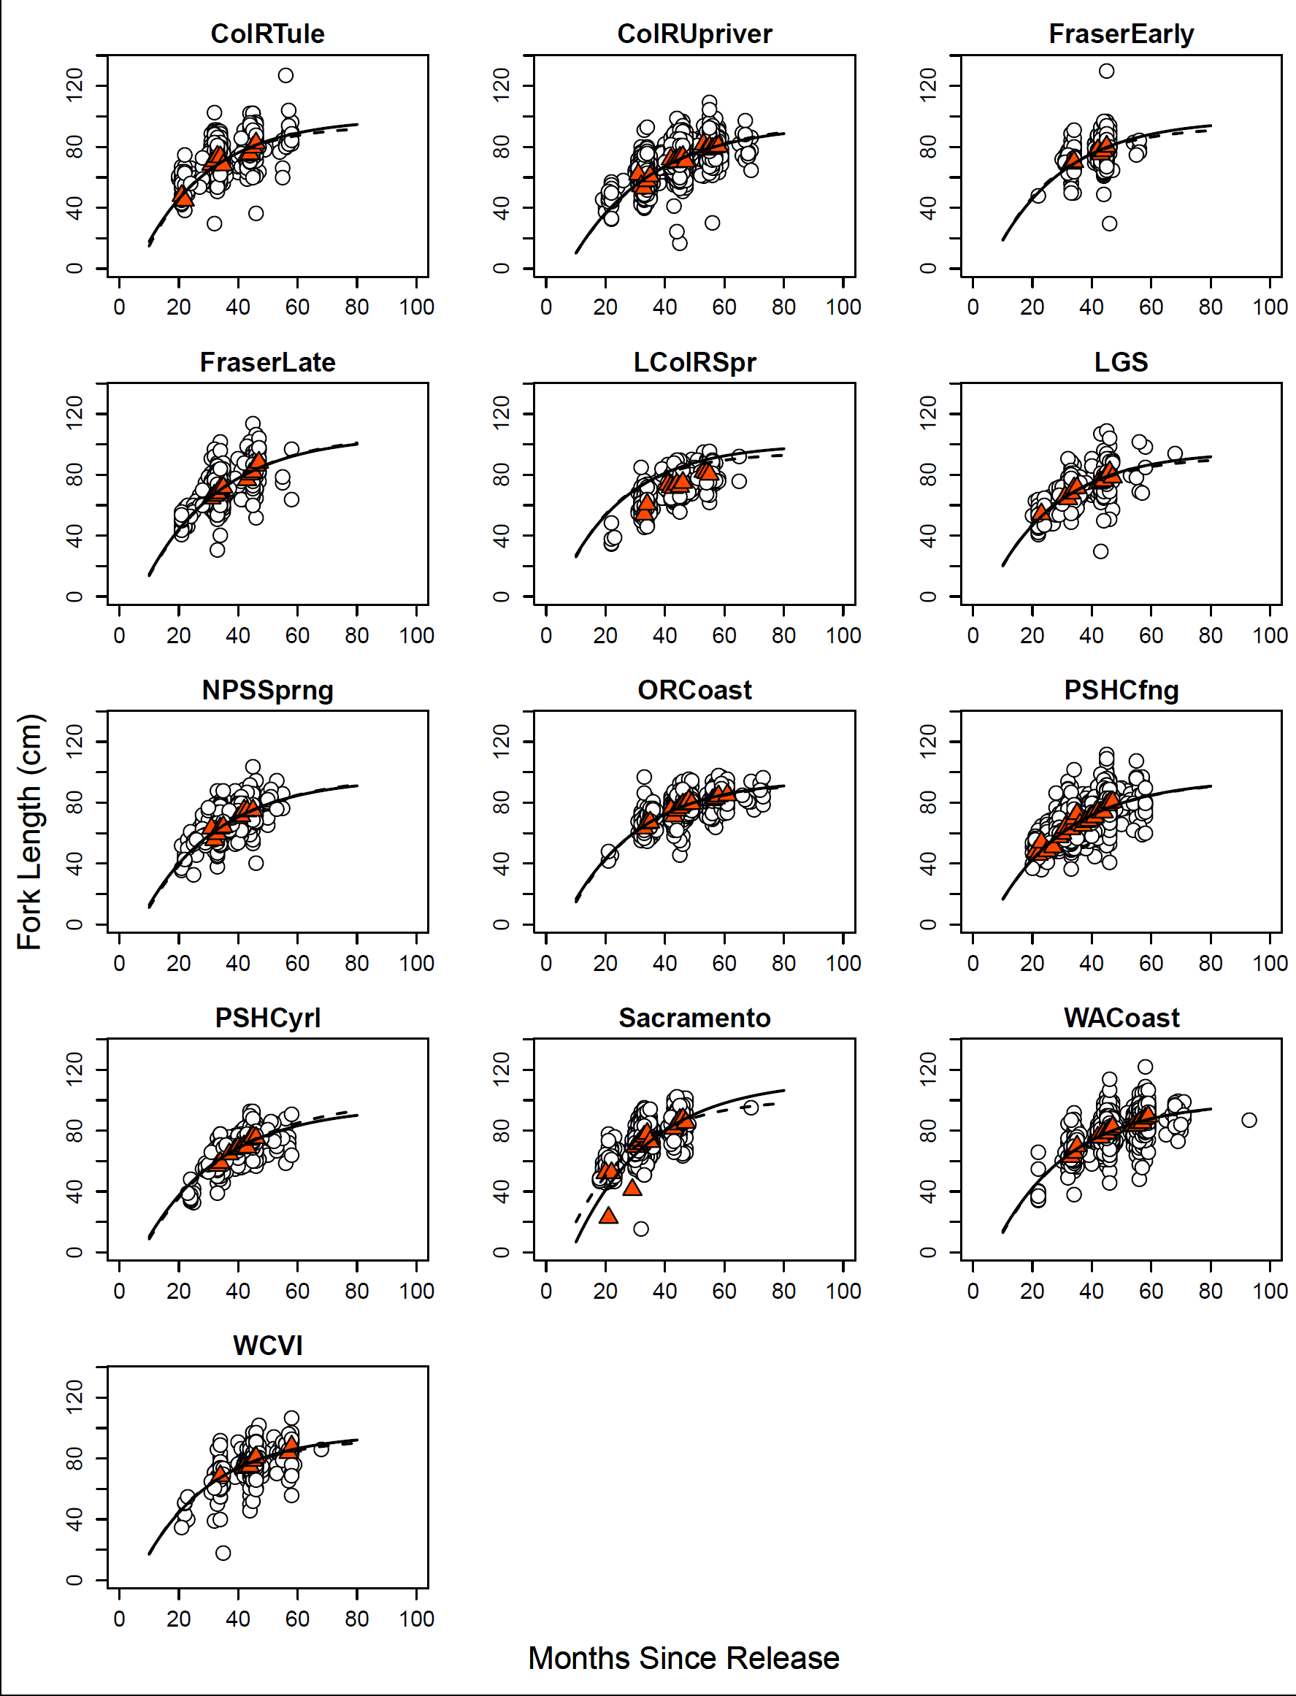

**Figure 1.** Growth functions for regional aggregates of FRAM model stocks. In each figure, white circles represent individual observations whereas red triangles are monthly means for (min. month N = 20). Note, monthly means were estimated via maximum likelihood assuming that tags recovered in fisheries with minimum size restrictions are a truncated sample (see ‘Stage 1 analysis’ in text for details). The dashed line in each figure reflects the VBGF parameterization resulting from withholding two Sacramento outliers.

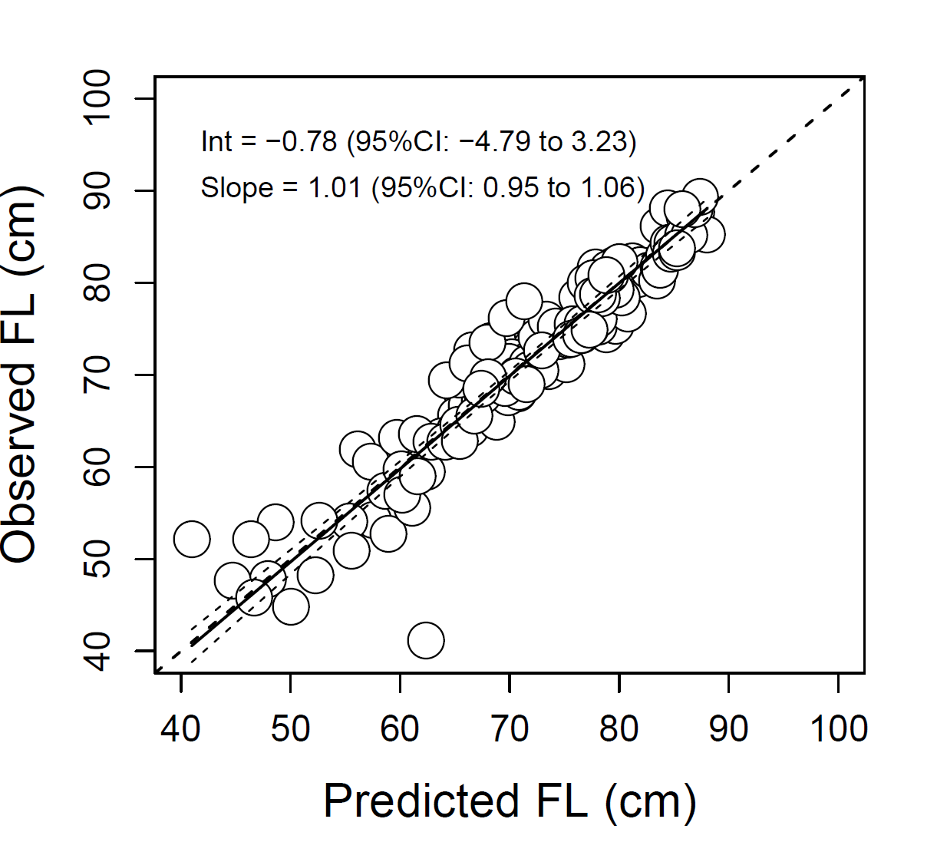

**Figure 2.** VBGF-predicted vs. observed fork length by stock-month observation. A posterior predictive check indicated good correspondence between the model and data (Bayesian P-value = 0.52).

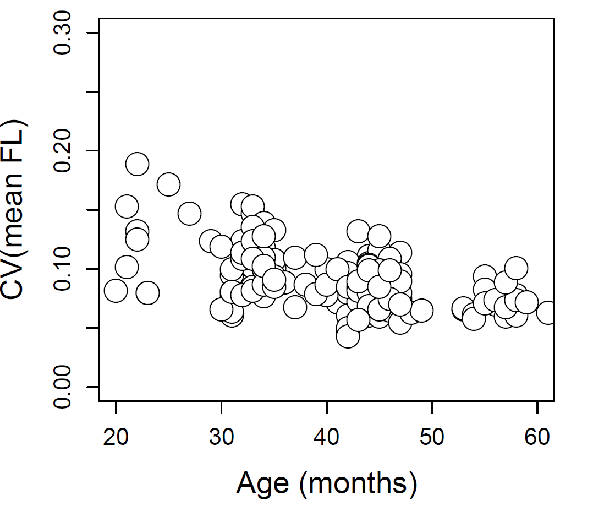

**Figure 3.** Coefficient of variation associated with monthly length-at-age estimates.

# Appendix A. length-at-age distribution parameters

**Table A1.** Stage 1 analysis results. Maximum likelihood estimates of the mean, SD, and CV of fork length (FL, mm) by age (in months) for stock-time estimation strata for which sufficient records occurred to estimate distributional parameters (N = 20). Note, the two suspected outliers that were included in VBGF estimation but not in the CV function analysis are denoted by ‘**’; columns ‘Age’ and ‘Mean FL (cm)’ are the values used for fitting VBGFs.

| **Region** | **Age (months)** | **N** | **Mean**  **FL (cm)** | **SD** | **CV(FL)** |  |
| --- | --- | --- | --- | --- | --- | --- |
| ColRTule | 21 | 23 | 47.9 | 7.3 | 15.3% |  |
| ColRTule | 22 | 48 | 44.9 | 8.5 | 18.9% |  |
| ColRTule | 31 | 170 | 68.3 | 6.5 | 9.5% |  |
| ColRTule | 32 | 423 | 70.8 | 7.8 | 11.1% |  |
| ColRTule | 33 | 206 | 73.7 | 7.5 | 10.2% |  |
| ColRTule | 34 | 154 | 73.3 | 7.5 | 10.3% |  |
| ColRTule | 35 | 23 | 68.0 | 6.9 | 10.2% |  |
| ColRTule | 43 | 44 | 74.5 | 6.1 | 8.2% |  |
| ColRTule | 44 | 70 | 75.4 | 8.4 | 11.1% |  |
| ColRTule | 45 | 81 | 79.7 | 8.7 | 10.9% |  |
| ColRTule | 46 | 38 | 82.4 | 7.3 | 8.8% |  |
| ColRUpriver | 31 | 41 | 61.9 | 4.8 | 7.7% |  |
| ColRUpriver | 32 | 194 | 54.3 | 8.4 | 15.5% |  |
| ColRUpriver | 33 | 338 | 52.8 | 7.7 | 14.7% |  |
| ColRUpriver | 34 | 461 | 57.5 | 8.0 | 13.9% |  |
| ColRUpriver | 35 | 65 | 60.8 | 6.1 | 10.0% |  |
| ColRUpriver | 42 | 95 | 71.9 | 6.7 | 9.3% |  |
| ColRUpriver | 43 | 555 | 69.9 | 5.6 | 8.0% |  |
| ColRUpriver | 44 | 806 | 70.3 | 6.3 | 9.0% |  |
| ColRUpriver | 45 | 595 | 73.0 | 6.1 | 8.4% |  |
| ColRUpriver | 46 | 599 | 73.6 | 6.2 | 8.5% |  |
| ColRUpriver | 47 | 74 | 70.4 | 8.0 | 11.4% |  |
| ColRUpriver | 53 | 31 | 81.7 | 5.4 | 6.6% |  |
| ColRUpriver | 54 | 58 | 78.3 | 4.9 | 6.3% |  |
| ColRUpriver | 55 | 133 | 79.9 | 7.5 | 9.4% |  |
| ColRUpriver | 56 | 154 | 78.9 | 6.2 | 7.9% |  |
| ColRUpriver | 57 | 97 | 79.9 | 6.0 | 7.5% |  |
| ColRUpriver | 58 | 49 | 80.4 | 6.3 | 7.8% |  |
| FraserEarly | 33 | 141 | 69.2 | 5.9 | 8.5% |  |
| FraserEarly | 34 | 41 | 70.3 | 7.7 | 10.9% |  |
| FraserEarly | 42 | 40 | 77.9 | 5.5 | 7.1% |  |
| FraserEarly | 43 | 47 | 75.3 | 7.6 | 10.1% |  |
| FraserEarly | 44 | 127 | 77.3 | 7.8 | 10.0% |  |
| FraserEarly | 45 | 142 | 80.3 | 7.7 | 9.6% |  |
| FraserLate | 31 | 72 | 64.7 | 6.5 | 10.0% |  |
| FraserLate | 32 | 194 | 66.5 | 7.2 | 10.9% |  |
| FraserLate | 33 | 184 | 68.0 | 8.4 | 12.4% |  |
| FraserLate | 34 | 147 | 70.9 | 8.3 | 11.8% |  |
| FraserLate | 35 | 90 | 71.7 | 7.7 | 10.8% |  |
| FraserLate | 43 | 56 | 76.7 | 6.5 | 8.4% |  |
| FraserLate | 44 | 67 | 80.5 | 7.4 | 9.2% |  |
| FraserLate | 45 | 88 | 81.9 | 8.8 | 10.7% |  |
| FraserLate | 46 | 63 | 86.2 | 8.3 | 9.6% |  |
| FraserLate | 47 | 21 | 88.1 | 6.6 | 7.5% |  |
| LColRSpr | 21 | 56 | 54.1 | 6.9 | 12.8% |  |
| LColRSpr | 22 | 73 | 60.7 | 5.2 | 8.5% |  |
| LColRSpr | 29 | 26 | 73.8 | 5.3 | 7.2% |  |
| LColRSpr | 30 | 53 | 72.0 | 3.5 | 4.9% |  |
| LColRSpr | 31 | 113 | 71.5 | 5.9 | 8.3% |  |
| LColRSpr | 32 | 130 | 73.8 | 6.0 | 8.2% |  |
| LColRSpr | 33 | 99 | 72.3 | 5.7 | 7.9% |  |
| LColRSpr | 34 | 106 | 74.9 | 4.9 | 6.5% |  |
| LColRSpr | 41 | 22 | 82.0 | 5.5 | 6.7% |  |
| LColRSpr | 42 | 30 | 81.4 | 5.1 | 6.2% |  |
| LColRSpr | 43 | 35 | 80.3 | 6.6 | 8.3% |  |
| LGS | 23 | 29 | 54.2 | 4.3 | 8.0% |  |
| LGS | 31 | 40 | 65.6 | 4.0 | 6.1% |  |
| LGS | 32 | 72 | 64.2 | 7.6 | 11.8% |  |
| LGS | 33 | 67 | 67.8 | 8.4 | 12.5% |  |
| LGS | 34 | 52 | 71.2 | 6.1 | 8.6% |  |
| LGS | 35 | 42 | 71.5 | 6.2 | 8.7% |  |
| LGS | 42 | 20 | 74.4 | 7.9 | 10.6% |  |
| LGS | 43 | 26 | 75.0 | 9.9 | 13.2% |  |
| LGS | 44 | 43 | 76.1 | 8.0 | 10.5% |  |
| LGS | 45 | 32 | 79.8 | 9.3 | 11.6% |  |
| LGS | 46 | 36 | 81.9 | 8.9 | 10.9% |  |
| LGS | 47 | 22 | 78.5 | 7.5 | 9.6% |  |
| NPSSprng | 31 | 33 | 63.2 | 4.0 | 6.4% |  |
| NPSSprng | 32 | 48 | 55.6 | 6.9 | 12.4% |  |
| NPSSprng | 33 | 51 | 59.6 | 9.1 | 15.3% |  |
| NPSSprng | 34 | 47 | 63.3 | 8.8 | 13.9% |  |
| NPSSprng | 35 | 24 | 64.1 | 8.5 | 13.3% |  |
| NPSSprng | 40 | 46 | 70.1 | 7.0 | 10.0% |  |
| NPSSprng | 41 | 25 | 71.3 | 6.7 | 9.4% |  |
| NPSSprng | 42 | 24 | 75.0 | 6.0 | 8.0% |  |
| NPSSprng | 43 | 20 | 74.4 | 6.2 | 8.4% |  |
| NPSSprng | 45 | 23 | 75.0 | 9.6 | 12.8% |  |
| ORCoast | 33 | 57 | 63.3 | 7.3 | 11.6% |  |
| ORCoast | 34 | 101 | 66.7 | 5.2 | 7.7% |  |
| ORCoast | 35 | 33 | 67.2 | 6.3 | 9.4% |  |
| ORCoast | 42 | 22 | 75.4 | 4.6 | 6.1% |  |
| ORCoast | 43 | 51 | 71.2 | 5.9 | 8.3% |  |
| ORCoast | 44 | 137 | 75.0 | 4.6 | 6.1% |  |
| ORCoast | 45 | 366 | 76.8 | 4.6 | 6.0% |  |
| ORCoast | 46 | 331 | 78.9 | 5.1 | 6.5% |  |
| ORCoast | 47 | 46 | 79.3 | 4.3 | 5.5% |  |
| ORCoast | 48 | 57 | 81.5 | 5.1 | 6.3% |  |
| ORCoast | 49 | 30 | 79.3 | 5.1 | 6.5% |  |
| ORCoast | 56 | 48 | 81.8 | 5.8 | 7.0% |  |
| ORCoast | 57 | 111 | 82.9 | 4.9 | 6.0% |  |
| ORCoast | 58 | 75 | 84.4 | 5.1 | 6.1% |  |
| ORCoast | 61 | 24 | 85.0 | 5.4 | 6.3% |  |
| PSHCfng | 21 | 25 | 47.7 | 4.9 | 10.2% |  |
| PSHCfng | 22 | 36 | 45.8 | 6.1 | 13.2% |  |
| PSHCfng | 23 | 48 | 54.0 | 4.3 | 8.0% |  |
| PSHCfng | 25 | 20 | 48.3 | 8.3 | 17.2% |  |
| PSHCfng | 27 | 20 | 51.0 | 7.5 | 14.7% |  |
| PSHCfng | 29 | 46 | 57.5 | 7.1 | 12.4% |  |
| PSHCfng | 30 | 25 | 59.8 | 7.1 | 11.9% |  |
| PSHCfng | 31 | 165 | 63.7 | 5.2 | 8.1% |  |
| PSHCfng | 32 | 469 | 62.8 | 7.2 | 11.4% |  |
| PSHCfng | 33 | 627 | 62.8 | 8.5 | 13.6% |  |
| PSHCfng | 34 | 1,038 | 69.6 | 7.0 | 10.0% |  |
| PSHCfng | 35 | 427 | 72.7 | 6.5 | 9.0% |  |
| PSHCfng | 36 | 43 | 65.9 | 5.9 | 8.9% |  |
| PSHCfng | 37 | 53 | 65.0 | 7.1 | 11.0% |  |
| PSHCfng | 38 | 40 | 67.6 | 5.9 | 8.7% |  |
| PSHCfng | 39 | 54 | 68.2 | 7.6 | 11.2% |  |
| PSHCfng | 40 | 112 | 70.7 | 5.5 | 7.8% |  |
| PSHCfng | 41 | 87 | 70.6 | 6.5 | 9.1% |  |
| PSHCfng | 42 | 65 | 74.1 | 7.2 | 9.7% |  |
| PSHCfng | 43 | 225 | 73.7 | 5.4 | 7.3% |  |
| PSHCfng | 44 | 317 | 73.9 | 7.7 | 10.4% |  |
| PSHCfng | 45 | 346 | 78.5 | 7.8 | 9.9% |  |
| PSHCfng | 46 | 616 | 80.1 | 6.8 | 8.5% |  |
| PSHCfng | 47 | 215 | 80.5 | 6.4 | 8.0% |  |
| PSHCyrl | 33 | 65 | 57.0 | 7.0 | 12.4% |  |
| PSHCyrl | 34 | 100 | 59.0 | 6.5 | 11.0% |  |
| PSHCyrl | 37 | 22 | 64.6 | 4.4 | 6.8% |  |
| PSHCyrl | 39 | 20 | 67.8 | 5.3 | 7.9% |  |
| PSHCyrl | 40 | 36 | 69.0 | 6.0 | 8.7% |  |
| PSHCyrl | 41 | 21 | 68.7 | 6.9 | 10.0% |  |
| PSHCyrl | 42 | 20 | 69.8 | 6.0 | 8.5% |  |
| PSHCyrl | 43 | 22 | 69.1 | 5.9 | 8.5% |  |
| PSHCyrl | 44 | 39 | 74.1 | 7.6 | 10.3% |  |
| PSHCyrl | 45 | 84 | 76.1 | 7.6 | 9.9% |  |
| PSHCyrl | 46 | 57 | 75.3 | 6.9 | 9.2% |  |
| Sacramento | 20 | 29 | 52.2 | 4.3 | 8.2% |  |
| Sacramento | 21 | 76 | 22.8 | 14.2 | 62.1% | ** |
| Sacramento | 22 | 62 | 52.2 | 6.5 | 12.5% |  |
| Sacramento | 29 | 42 | 41.2 | 9.9 | 24.1% | ** |
| Sacramento | 30 | 276 | 69.5 | 4.6 | 6.6% |  |
| Sacramento | 31 | 760 | 71.3 | 5.8 | 8.1% |  |
| Sacramento | 32 | 772 | 73.6 | 5.7 | 7.8% |  |
| Sacramento | 33 | 786 | 76.2 | 6.3 | 8.2% |  |
| Sacramento | 34 | 454 | 78.0 | 6.8 | 8.7% |  |
| Sacramento | 35 | 140 | 72.7 | 6.2 | 8.5% |  |
| Sacramento | 43 | 90 | 81.5 | 6.7 | 8.2% |  |
| Sacramento | 44 | 53 | 84.4 | 6.7 | 8.0% |  |
| Sacramento | 45 | 67 | 87.2 | 5.9 | 6.7% |  |
| Sacramento | 46 | 29 | 87.7 | 7.7 | 8.8% |  |
| Sacramento | 47 | 29 | 85.3 | 7.7 | 9.0% |  |
| WACoast | 33 | 42 | 62.8 | 6.8 | 10.9% |  |
| WACoast | 34 | 134 | 65.7 | 6.7 | 10.3% |  |
| WACoast | 35 | 20 | 69.8 | 6.3 | 9.1% |  |
| WACoast | 42 | 57 | 75.6 | 3.8 | 5.0% |  |
| WACoast | 43 | 66 | 75.6 | 6.8 | 9.0% |  |
| WACoast | 44 | 397 | 78.6 | 5.4 | 6.9% |  |
| WACoast | 45 | 1,276 | 78.4 | 5.2 | 6.6% |  |
| WACoast | 46 | 965 | 80.9 | 6.1 | 7.5% |  |
| WACoast | 47 | 116 | 82.3 | 5.8 | 7.0% |  |
| WACoast | 54 | 102 | 83.2 | 4.8 | 5.8% |  |
| WACoast | 55 | 58 | 83.4 | 6.0 | 7.1% |  |
| WACoast | 56 | 369 | 85.2 | 6.3 | 7.4% |  |
| WACoast | 57 | 936 | 85.2 | 5.8 | 6.8% |  |
| WACoast | 58 | 615 | 88.0 | 6.5 | 7.4% |  |
| WACoast | 59 | 74 | 89.4 | 6.5 | 7.2% |  |
| WCVI | 34 | 38 | 68.6 | 8.8 | 12.8% |  |
| WCVI | 42 | 41 | 74.0 | 3.2 | 4.3% |  |
| WCVI | 43 | 21 | 74.4 | 4.3 | 5.7% |  |
| WCVI | 44 | 103 | 75.0 | 7.4 | 9.9% |  |
| WCVI | 45 | 110 | 78.8 | 6.7 | 8.5% |  |
| WCVI | 46 | 113 | 80.9 | 8.0 | 9.9% |  |
| WCVI | 57 | 24 | 83.8 | 7.4 | 8.9% |  |
| WCVI | 58 | 20 | 88.0 | 8.9 | 10.1% |  |

# Appendix B. WINBUGS CODE FOR FITTING GROWTH FUNCTIONS

##WinBUGS code for VB Growth fxn #####

### Specs for FRAM VBGF parameter estimation:

## N = 3 chains, thinned to 1 in 50

## N = 31k total interations (1k initial, 30k thereafter, summarize 5001+)

model

{

# priors

mu.a0~dnorm(0, 0.001) # Mean hyperparameter for a0

mu.Linf~dnorm(0, 0.001) # Mean hyperparameter for Linf

mu.k~dnorm(0, 0.001) # Mean hyperparameter for k

sigma.a0~dunif(0, 10000) # SD hyperparameter for a0

sigma.Linf~dunif(0, 10000) # SD hyperparameter for Linf

sigma.k~dunif(0, 10000) # SD hyperparameter for k

sigma~dunif(0, 10000) # Residual standard deviation

tau.a0 <- 1/(sigma.a0*sigma.a0)

tau.Linf <- 1/(sigma.Linf*sigma.Linf)

tau.k <- 1/(sigma.k*sigma.k)

tau <- 1/(sigma*sigma) # Residual precision

# hierarchical parmeters

for (i in 1:P) {

Linf[i]~dnorm(mu.Linf, tau.Linf)

k[i]~dnorm(mu.k, tau.k)#I(0,)

a0[i]~dnorm(mu.a0, tau.a0)

}

# likelihood

for (i in 1:N) {

li[i] ~ dnorm(Lai[i],tau)

Lai[i]<-Linf[pop[i]]*(1-exp(-k[pop[i]]*(ai[i]-a0[pop[i]])))

# Observation-level GOF calcs

pred[i] <- Lai[i]

rep_li[i] ~ dnorm(pred[i], tau) #simulate perfect dataset

rep_resid[i] <- rep_li[i]-pred[i] #calc resid for simulated data

resid[i] <- li[i] - pred[i] #calc resid for actual data

sq[i] <- pow(resid[i],2) #calc squared resids for actual data sq_new[i] <- pow(rep_resid[i],2) #calc squared resids for simulated data

}

# Dataset-level GOF calcs

fit<-sum(sq[]) #sum squared resids for actual data

fit_new<-sum(sq_new[]) #sum squared resids for simulated data

test<-step(fit_new-fit) #determine which is greater (0s and 1s)

bpvalue<-mean(test) #mean of 0,1 gives Bayesian P-value

}

# inits

list(a0=c(-5,-5,-5,-5,-5,-5,-5,-5,-5,-5,-5,-5,-5), k=c(0.03,0.03,0.03,0.03,0.03,0.03,0.03,0.03,0.03,0.03,0.03,0.03,0.03), Linf=c(950,950,950,950,950,950,950,950,950,950,950,950,950),mu.a0=-5,mu.k=0.03,mu.Linf=950,sigma.a0=1,sigma.Linf=1,sigma.k=1,sigma=1)

#data -- also must load secondary data file (Appendix A) with stock-month means

list(N=164, P=13) #n is 165 observations (0 indexed) and 13 stock aggregates