Rprop (Resilient Backpropagation) :

- Initialize the weights and biases in the neural network randomly.
- Set the initial update value for each weight to a small positive constant (e.g., 0.1).
- While the stopping criteria have not been met:
a. Compute the gradients of the error function with respect to the weights and biases.
b. For each weight:
i. If the sign of the gradient has not changed since the last iteration, multiply the update value by a constant factor (e.g., 1.2).
ii. If the sign of the gradient has changed since the last iteration, reset the update value to a small positive constant (e.g., 0.1).
iii. Update the weight by subtracting the sign of the gradient times the update value.
c. Evaluate the performance of the network on a validation set, and update the stopping criteria if necessary.
Pros : robust to noisy data, less sensitive to initial weights values
Cons : It falls in local minima if this is sparse (but so it is robust?)

RMSprop (Root mean square backpropagation) :
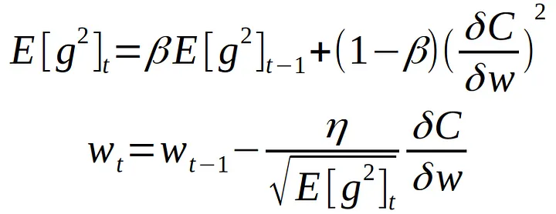
E[g] — moving average of squared gradients. dC/dw — gradient of the cost function with respect to the weight. n — learning rate. Beta — moving average parameter (good default value — 0.9)

= Adagrad with memory

Adam :
Mix of RMSprop and AdaGrad
