A Project Report on

RentSphere - Smart Property and Rental Management System

Submitted for partial fulfillment of the requirement of the Mini Project (3MCA7) for

MASTER OF COMPUTER APPLICATIONS

Submitted by

FRANKLIN S(P18IW24S126004)
ANTONY JOY R (P18IW24S126001)

Name of Guide

Ms. Lakshmi Devi C (Ph. D)
Assistant Professor
Project Coordinator



ST. FRANCIS COLLEGE

MCA DEPARTMENT

Permanently Affiliated to Dr. Manmohan Singh Bengaluru City University
3rd Block, 8th Main, Koramangala
Bengaluru-560034
ST. FRANCIS COLLEGE



CERTIFICATE

This is to certify that the report entitled “RentSphere - Smart Property and Rental Management System” embodies the original work FRANKLIN S(P18IW24S126004), ANTONY JOY R (P18IW24S126001) in the partial fulfilment of the requirements for Mini Project (3MCA7) for MCA, IIIrd Semester course during the academic semester from December 2025 to March 2026 as prescribed by Dr. Manmohan Singh Bengaluru City University.

Project Guide Head of the Department

Ms. Lakshmi Devi C Dr. Nazura Javed Kutty

Place: Bengaluru
Date:

ST. FRANCIS COLLEGE

CERTIFICATE

This is to certify that the report entitled “RentSphere - Smart Property and Rental Management System” embodies the original work FRANKLIN S(P18IW24S126004), ANTONY JOY R (P18IW24S126001) in the partial fulfilment of the requirements for Mini Project (3MCA7) for MCA, IIIrd Semester course during the academic semester from December 2025 to March 2026 as prescribed by Dr. Manmohan Singh Bengaluru City University.

External Examiner

Place: Bengaluru
Date:

ACKNOWLEDGEMENT

We would like to express our gratitude and appreciation to all those who gave us the possibility to complete this report. We take pleasure in expressing gratitude towards our institution for providing us the opportunity to work on this project as a part of our course. We would like to express our gratitude and sincere thanks to our management, Dr. Brother Titus Anto, Director for providing us with a congenial environment for studies. We would like to express our gratitude to Principal, Dr. R N Subba Rao for providing the right atmosphere at the institute. We express our heartfelt thanks to Dr. Nazura Javed Kutty, Head of the Department, for being helpful throughout the project. We express our deep sense of gratitude to our project guide Ms. Lakshmi Devi C (Ph. D), Assistant Professor for her unfailing encouragement, valuable guidance, and suggestions to us during project work. We also express our heartfelt thanks to our parents for being supportive in all our activities without whom it would not have been possible for us to complete our project.

TABLE OF CONTENTS
ACKNOWLEDGEMENT 6
TABLE OF CONTENTS 8
1. ABSTRACT 12
2. PROBLEM DEFINITION 13
2.1 Objective 13
2.2 Advantages of the Proposed System 14
2.3 Limitations: Scope and Boundary 14
3. REQUIREMENT ANALYSIS 16
3.1 Data Flow Diagram 16
Level 0: Context Diagram 16
Level 1: Major Processes 17
Level 2: Payment Process 18
3.2 ER Diagram 19
3.3 Requirement Specification 23
Functional Requirements 23
Non-Functional Requirements 24
Role Permission Matrix 24
3.4 Hardware and Software Requirements 25
Development Hardware 25
Client Hardware 25
Software 26
4. SYSTEM DESIGN 27
4.1 Architectural Design 27
Component Responsibilities 27
4.2 UML Diagrams 28
4.2.1 Class Diagram 28
Backend Layer Class Diagram 30
4.2.2 Sequence Diagrams 30
4.2.3 Use Case Diagram 35
4.3 Database Design 35
Normalization Decisions 36
Data Integrity Rules 36
4.4 Input Design 36
4.5 Output Design 37
5. SYSTEM IMPLEMENTATION OVERVIEW 38
5.1 Main Modules 38
Authentication and Profile 38
Organization and User Administration 38
Property, Building and Unit Management 38
Tenant and Agreement Management 38
Invoice and Payment Management 38
Apartment Booking and Approvals 39
Complaints and Maintenance 39
Deposit Disputes 39
Rent Increase Management 39
Notifications 39
AI Assistant 39
User Interface Features 40
5.2 Screenshots 40
6. TESTING 42
6.1 Test Case 1: FORM VALIDATION 42
6.2 Test Case 2: Authentication and Authorization 42
6.3 Test Case 3: Payment Processing 43
6.4 Test Case 4: Tenant Data Isolation 44
6.5 Test Case 5: Approval Workflow 44
Test Summary 44
7. APPENDICES 46
Appendix A: Important API Routes 46
Appendix B: Status Enumerations 46
Appendix C: Environment Variables 46
Appendix D: Local Execution 47
Appendix E: Suggested Future Enhancements 47
8. REFERENCES 48
Conclusion 48

1. ABSTRACT
RentSphere is a role-based web application designed to centralize property administration and tenant self-service. Conventional rental management often depends on spreadsheets, messaging applications, paper agreements and disconnected payment records. This fragmentation makes it difficult to determine which unit is occupied, which invoice is outstanding, whether a maintenance request has been resolved, or who approved a rental decision. RentSphere addresses these problems through one secured platform for administrators, owners and tenants.
The system provides organization, user, property, building, unit, tenant, agreement, invoice, payment, complaint, deposit-dispute, rent-increase, booking, approval, notification and profile workflows. Administrators and owners manage portfolio records. Tenants browse apartments, request visits, review approval status, pay invoices, submit complaints, raise deposit disputes and respond to rent-increase notices. Razorpay test-mode integration provides hosted payment checkout and cryptographic verification. Real-time notifications use Server-Sent Events with a polling fallback. A contextual AI assistant can answer user questions using the records visible to the authenticated user.
The client is implemented using React, TypeScript, Vite and Material UI. The API uses Java 21, Spring Boot, Spring Security, Spring Data JPA and PostgreSQL. JSON Web Tokens identify the current user, while method-level authorization and tenant-owned /me endpoints protect personal data. Audit fields and soft deletion preserve record history. Automated integration tests cover module access, payment verification, invalid signatures, tenant isolation and application startup. The resulting system demonstrates a modular, secure and extensible approach to rental portfolio management.
Keywords: rental management, property management, tenant portal, Spring Boot, React, PostgreSQL, Supabase, Razorpay, JWT, role-based access control.

2. PROBLEM DEFINITION
Rental operations involve many connected records: organizations own portfolios; properties contain buildings; buildings contain units; tenants occupy units through agreements; agreements generate invoices; invoices produce payment attempts; and disputes or maintenance requests refer back to tenants and units. When these records are maintained separately, users experience duplicated data, inconsistent status values and slow communication.
The core problem is the absence of a unified and secure information flow between property managers and tenants. Owners require portfolio-wide visibility and controlled administrative operations. Tenants require a simple interface limited to their own payments, complaints, disputes and notices. A shared application must therefore support both broad management access and strict personal-data isolation.
RentSphere solves this problem through a relational domain model, REST API, role-aware frontend and event-driven notifications. It replaces informal status tracking with explicit states such as AVAILABLE, OCCUPIED, PENDING, PAID, OPEN, RESOLVED, APPROVED and REJECTED.

2.1 Objective
The primary objective is to design and implement a secure, usable and maintainable rental-management platform. Specific objectives are:
- Centralize properties, buildings, units, tenants and agreements.
- Provide separate experiences for administrator, owner and tenant roles.
- Ensure tenants can retrieve only records associated with their authenticated identity.
- Support apartment browsing and visit-request approval workflows.
- Generate and track invoices and verified online payments.
- Prevent completed invoices from continuing to appear as unpaid.
- Support maintenance complaints, deposit disputes and rent-increase responses.
- Deliver persistent, near-real-time notifications.
- Maintain audit information and use soft deletion for recoverable history.
- Provide responsive presentation, theme selection, language selection and accessible navigation.
- Validate critical workflows using automated tests.
- Keep the architecture modular enough for future mobile clients and additional integrations.

2.2 Advantages of the Proposed System
- Single source of truth: Related rental data is maintained in a structured relational database.
- Role-based experience: Users see only relevant modules and actions.
- Tenant privacy: Personal records are obtained through authenticated ownership mappings rather than user-supplied tenant identifiers.
- Reduced duplication: Dedicated apartment browsing replaces raw property/unit screens for tenants; the payment page combines invoices and transaction history.
- Verified payments: Razorpay order creation and signature verification reduce false success records.
- Correct payment history: Superseded pending attempts are hidden once the same invoice has a successful payment.
- Traceability: Creation, update and deletion metadata supports operational audits.
- Recoverability: Soft deletion avoids immediate physical removal of important records.
- Timely communication: Notifications update through Server-Sent Events and remain stored for later viewing.
- Maintainability: Controllers, services, repositories, DTOs and entities have distinct responsibilities.
- Responsive UI: The navigation and record views support desktop and smaller screens.
- Extensibility: New modules can follow the existing configuration-driven frontend and layered backend pattern.

2.3 Limitations: Scope and Boundary
The present version is a project implementation, not a complete commercial property-management suite. Its boundaries are:
- Razorpay is configured for test-mode demonstration unless production credentials and webhooks are supplied.
- Uploaded images are represented by URLs or data previews; a production deployment should use Supabase Storage or another object-storage service with signed URLs.
- Language selection is implemented at application level, but complete translation coverage depends on the available translation dictionary.
- Email delivery depends on external SMTP configuration.
- Server-Sent Events provide server-to-client updates; collaborative editing and bidirectional live messaging would require WebSockets or another channel.
- Legal rules for deposits, notices and agreements vary by jurisdiction and remain the responsibility of the property operator.
- The application does not perform bank settlement, tax filing, accounting reconciliation or credit assessment.
- AI answers are supportive and must not be treated as legal, financial or emergency advice.
- Database schema updates should be managed through versioned migrations in production instead of relying only on Hibernate ddl-auto=update.
- Performance testing at very large portfolio scale is outside the current evaluation.

3. REQUIREMENT ANALYSIS
Requirement analysis identifies users, data, external services, functional behavior and quality constraints. RentSphere has three primary actors:
- Administrator: manages the complete platform and organization-level records; the only role that can create, modify or delete ADMIN accounts.
- Owner: performs operational management for properties, tenants, finance and workflows inside their own organization; cannot grant or take over the ADMIN role.
- Tenant: uses apartment discovery and personal self-service functions.
External actors are Razorpay, the configured email provider, the AI provider and the PostgreSQL/Supabase database.

3.1 Data Flow Diagram

Level 0: Context Diagram
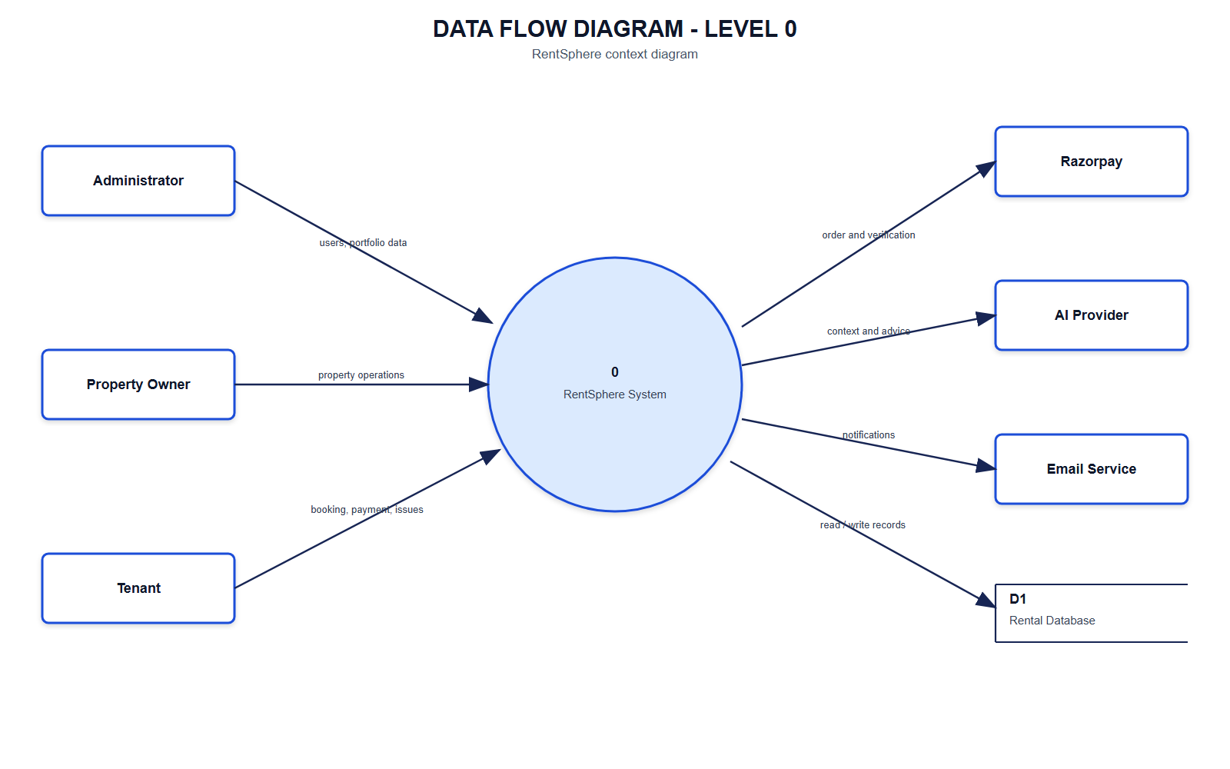
Figure 3.1 - Level 0 Context Diagram

Level 1: Major Processes
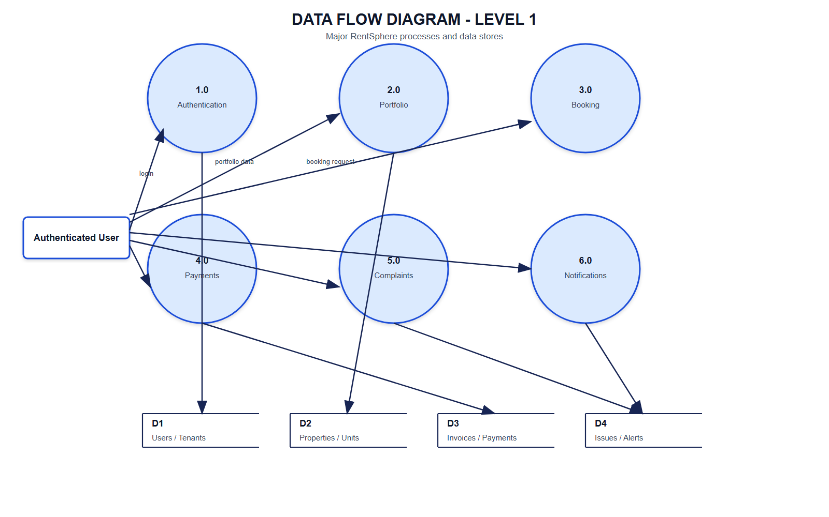
Figure 3.2 - Level 1 Data Flow Diagram

Level 2: Payment Process
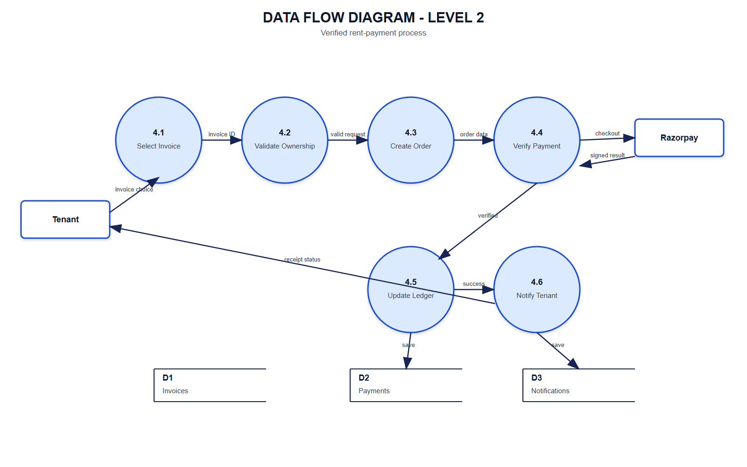
Figure 3.3 - Level 2 Payment Data Flow

3.2 ER Diagram
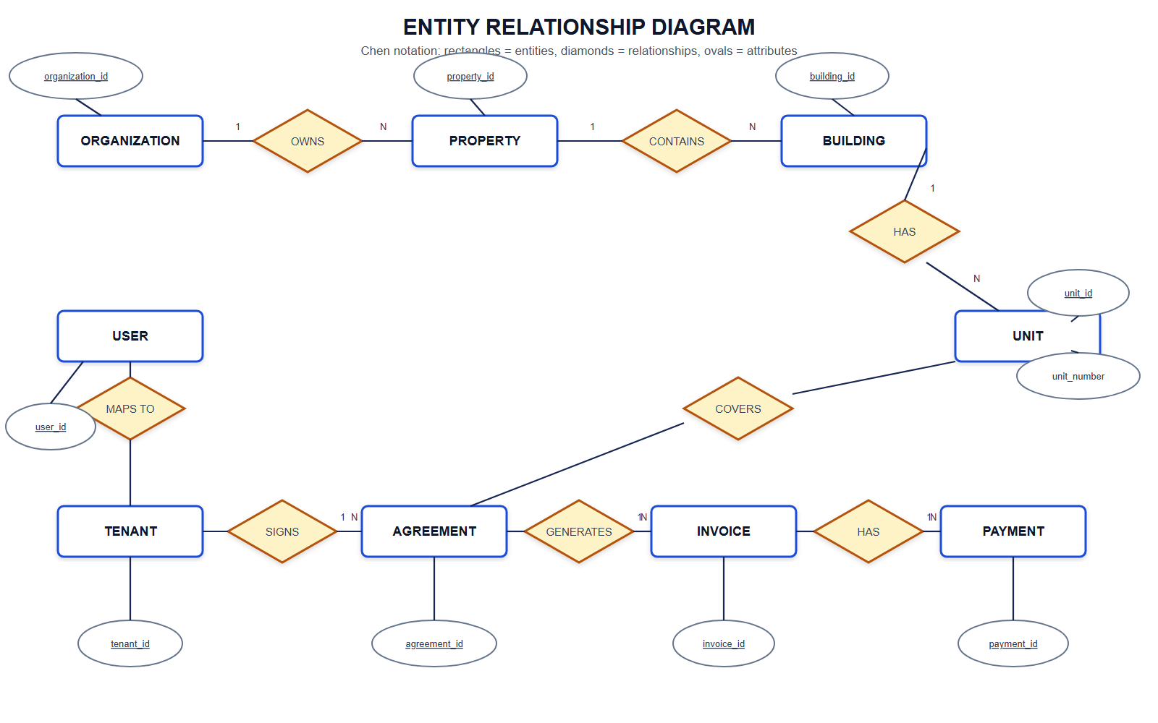
Figure 3.4 - Entity Relationship Diagram

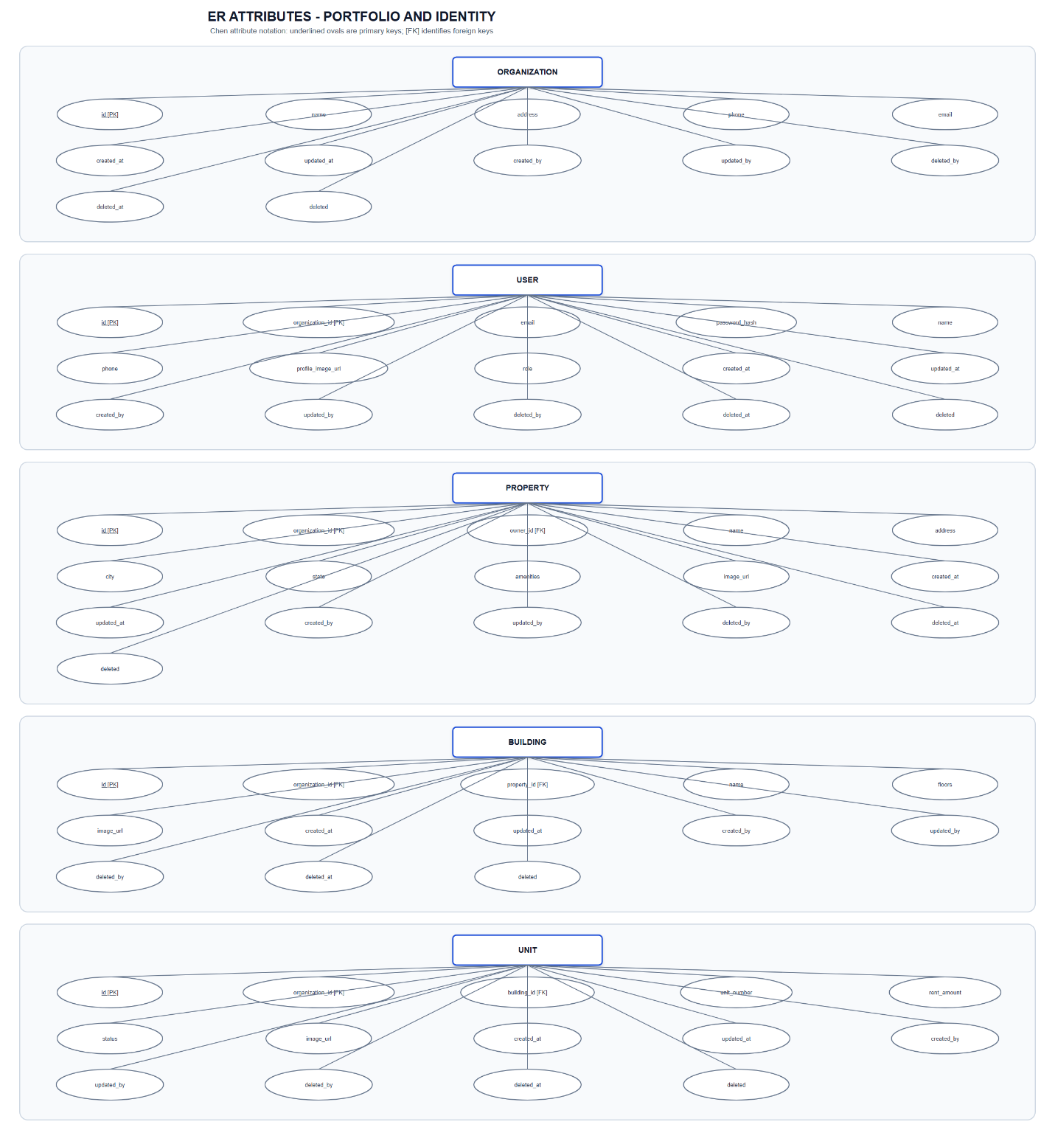
Figure 3.5 - ER Attributes: Portfolio and Identity

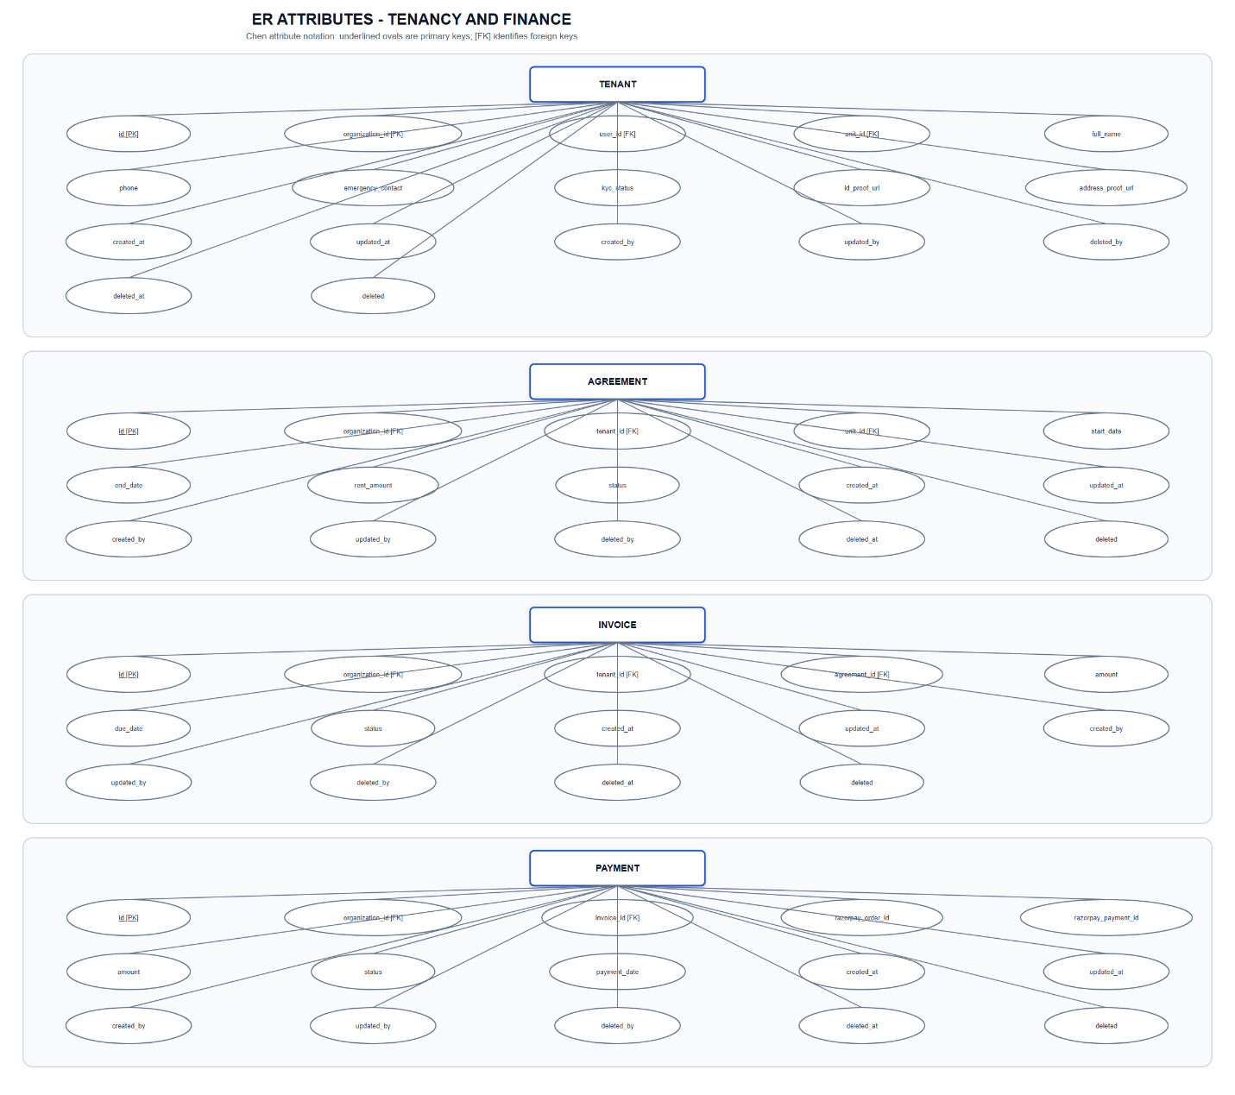
Figure 3.6 - ER Attributes: Tenancy and Finance

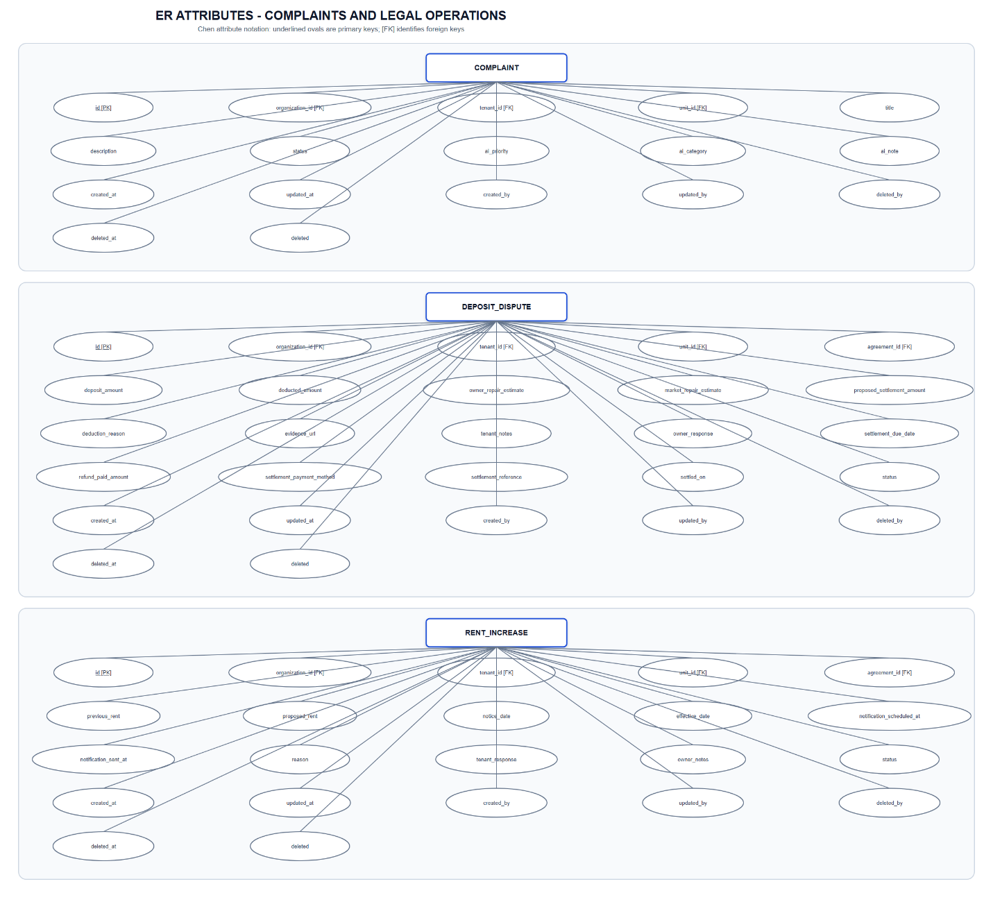
Figure 3.7 - ER Attributes: Complaints and Legal Operations

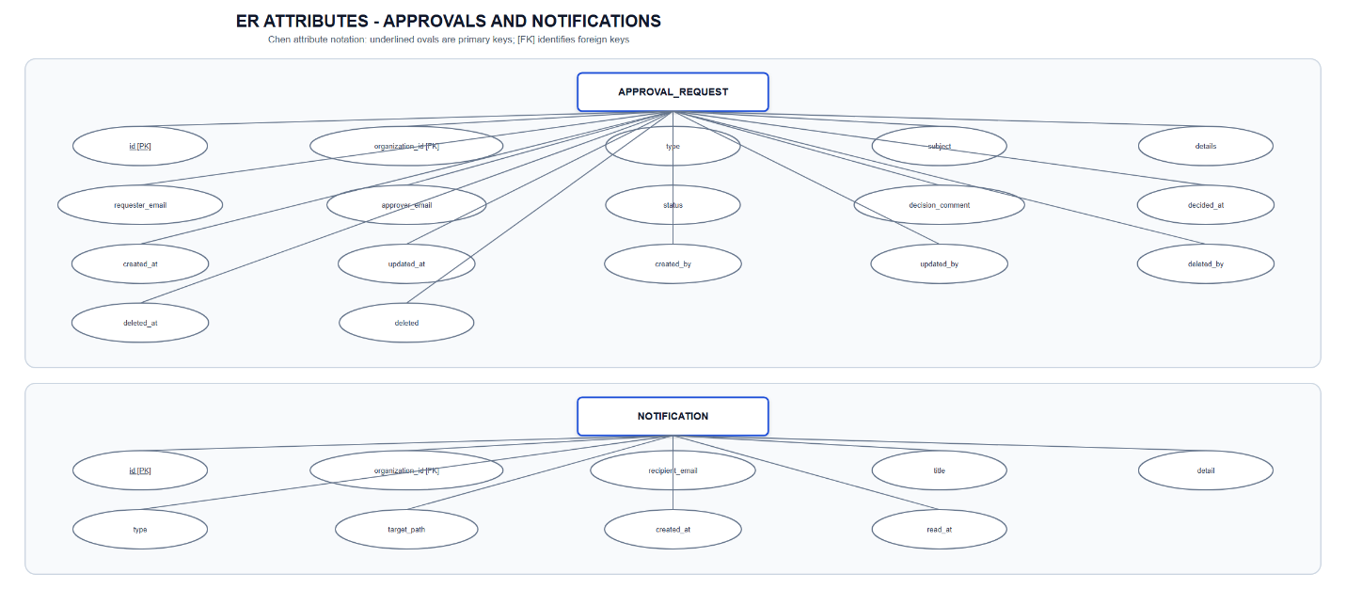
Figure 3.8 - ER Attributes: Approvals and Notifications

3.3 Requirement Specification

Functional Requirements
ID | Requirement | Priority
FR-01 | Register and authenticate users using email and password | High
FR-02 | Issue a signed JWT and secure protected routes | High
FR-03 | Allow users to view/update their profile and change password | High
FR-04 | Manage organizations and role-bearing users | High
FR-05 | Manage properties, buildings and units with images and availability | High
FR-06 | Manage tenant profiles, unit assignment and KYC references | High
FR-07 | Manage rental agreements, dates, rent and status | High
FR-08 | Create invoices and show tenant-owned outstanding invoices | High
FR-09 | Create and verify Razorpay payment orders | High
FR-10 | Mark an invoice paid only after successful verification | High
FR-11 | Prevent successful invoices from showing obsolete pending attempts | High
FR-12 | Allow tenants to browse apartments and request visits | High
FR-13 | Allow managers to approve or reject requests | High
FR-14 | Allow tenants to submit complaints and deposit disputes | High
FR-15 | Allow owners to issue rent increases and tenants to respond | High
FR-16 | Deliver and persist notifications with read status | Medium
FR-17 | Provide a role-aware dashboard and navigation | High
FR-18 | Provide theme and language selection | Medium
FR-19 | Provide contextual AI assistance within authorized scope | Medium
FR-20 | Support soft deletion and audit metadata | High

Non-Functional Requirements
Category | Requirement
Security | Passwords must be BCrypt encoded; protected endpoints require valid authentication; method authorization enforces roles.
Privacy | Tenant-owned endpoints must derive tenant identity from the authenticated user.
Integrity | Payment success requires Razorpay signature verification; derived rent values are not redundantly persisted.
Usability | Interfaces use clear labels, status chips, validation feedback, empty states and responsive layouts.
Reliability | API errors use consistent responses; notifications persist even when live delivery is unavailable.
Maintainability | Layered backend and configuration-driven frontend reduce duplication.
Portability | Docker configuration and environment variables support local and deployed environments.
Performance | Repository filtering, pagination, caching and compact responses reduce avoidable work.
Accessibility | Semantic controls, keyboard-accessible menus, contrast-aware themes and responsive presentation are required.

Role Permission Matrix
Capability | Admin | Owner | Tenant
Self-registration | First bootstrap user only | No (provisioned via /users) | Yes
Manage organizations/users | Yes (all roles) | Yes (own org, except ADMIN accounts) | No
Create/modify ADMIN accounts | Yes | No | No
Manage property inventory | All organizations | Own organization | Browse available
Manage tenants/agreements | Yes | Yes (own organization) | No
Manage invoices | Yes | Yes (own organization) | No
Pay own invoice | Yes | Yes | Yes
View personal payment history | N/A | N/A | Yes
Submit complaint | Yes | Yes | Yes
Update complaint status | Yes | Yes (own organization) | No
Submit deposit dispute | Yes | Yes | Yes
Decide approvals | Yes | Yes (own organization) | No
View own approval status | Yes | Yes | Yes
Issue rent increase | Yes | Yes (own organization) | No
Respond to own rent increase | No | No | Yes
Cross-organization record access | Allowed | Blocked (403) | N/A

Organization isolation is enforced in the service layer: collection endpoints filter by the authenticated user's organizationId, single-record reads and mutations assert organization membership, and shared caches key entries by caller scope. Only administrators may create, update or delete ADMIN-role users, which removes every privilege-escalation path from the OWNER role.

3.4 Hardware and Software Requirements

Development Hardware
- 64-bit computer with a modern dual-core or better processor.
- Minimum 8 GB RAM; 16 GB recommended.
- At least 5 GB free disk space for source, dependencies, database and generated assets.
- Reliable internet connection for Maven/npm dependencies and external test services.

Client Hardware
- Desktop, laptop, tablet or modern smartphone.
- Display resolution of at least 360 pixels width.
- Internet connection and a current standards-compliant browser.

Software
Layer | Requirement
Operating system | Windows, Linux or macOS
Backend | Java 21, Maven, Spring Boot 3.5.16
Frontend | Node.js, npm, React 19, TypeScript 6, Vite 8
UI | Material UI, Emotion, OverlayScrollbars
Database | PostgreSQL/Supabase; H2 PostgreSQL mode for tests
Security | Spring Security, JWT, BCrypt
Payment | Razorpay test or live account
API documentation | Springdoc OpenAPI/Swagger UI
Deployment | Docker and Docker Compose (optional)

4. SYSTEM DESIGN

4.1 Architectural Design
RentSphere follows a client-server and layered service architecture. The browser renders the React single-page application. Axios sends JSON requests to Spring Boot. The security filter validates the JWT and constructs the authenticated principal. Controllers enforce endpoint permissions and delegate business operations to services. Services apply rules and transaction boundaries. Repositories communicate with PostgreSQL using Spring Data JPA.
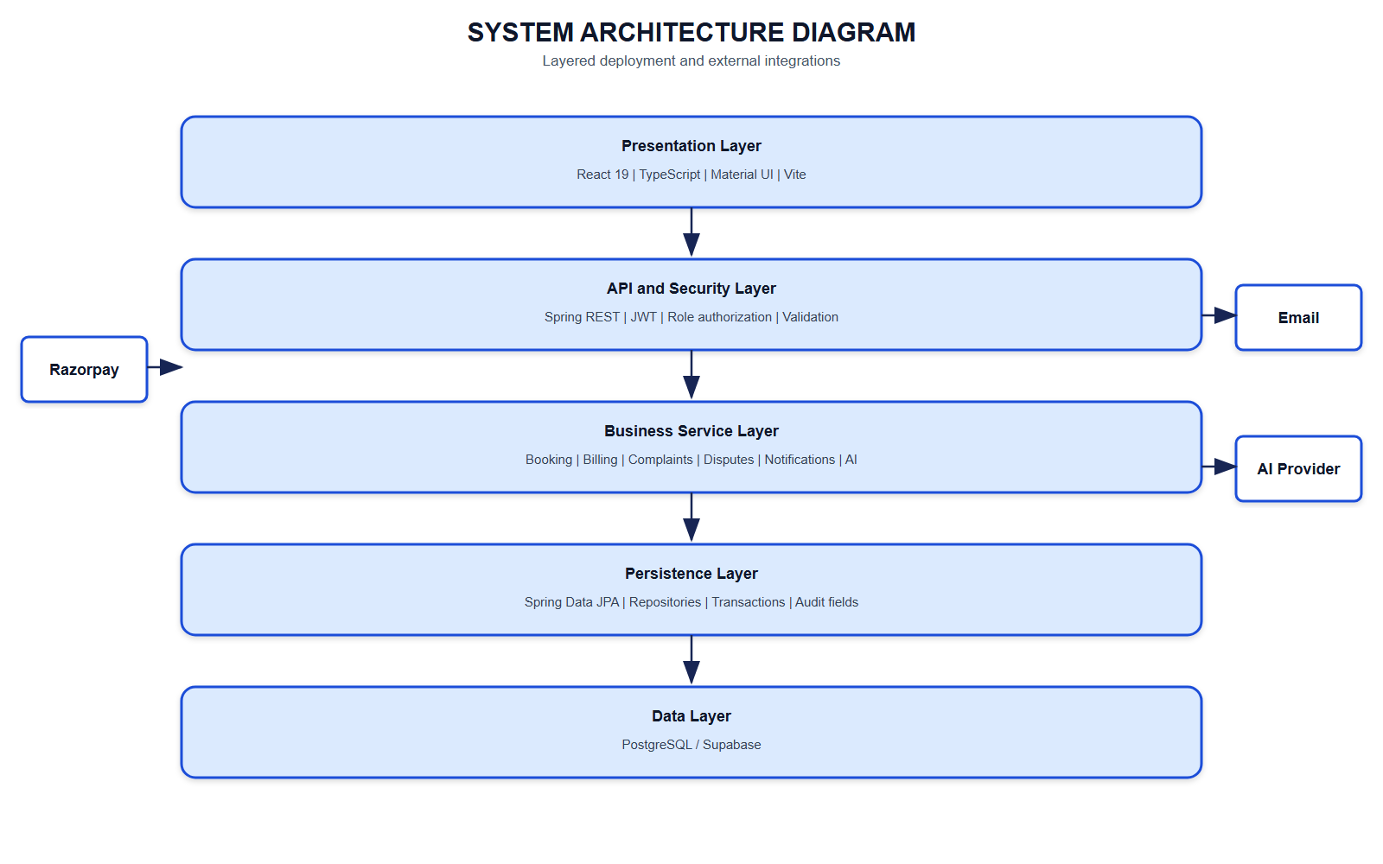
Figure 4.1 - Layered System Architecture

Component Responsibilities
- Pages/components: presentation, user input, loading/error states and navigation.
- Module configuration: fields, columns and labels for reusable CRUD views.
- Authentication context: session lifecycle, decoded role and logout.
- Controllers: request validation, route mapping and role constraints.
- DTO mapper: separates external API structures from persistence entities.
- Services: ownership checks, payment lifecycle, approval state transitions and notifications.
- Repositories: persistence queries including organization and tenant filters.
- Audit listener: creation, update and deletion metadata.
- Database: durable relational state.

4.2 UML Diagrams

4.2.1 Class Diagram
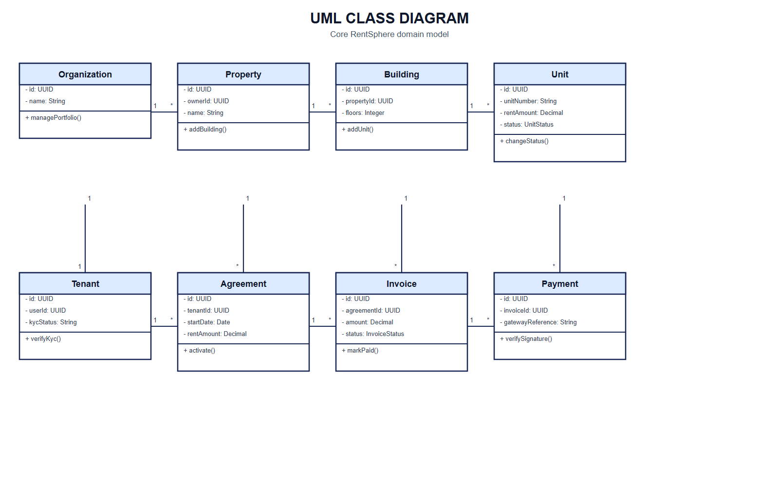
Figure 4.2 - Domain Class Diagram

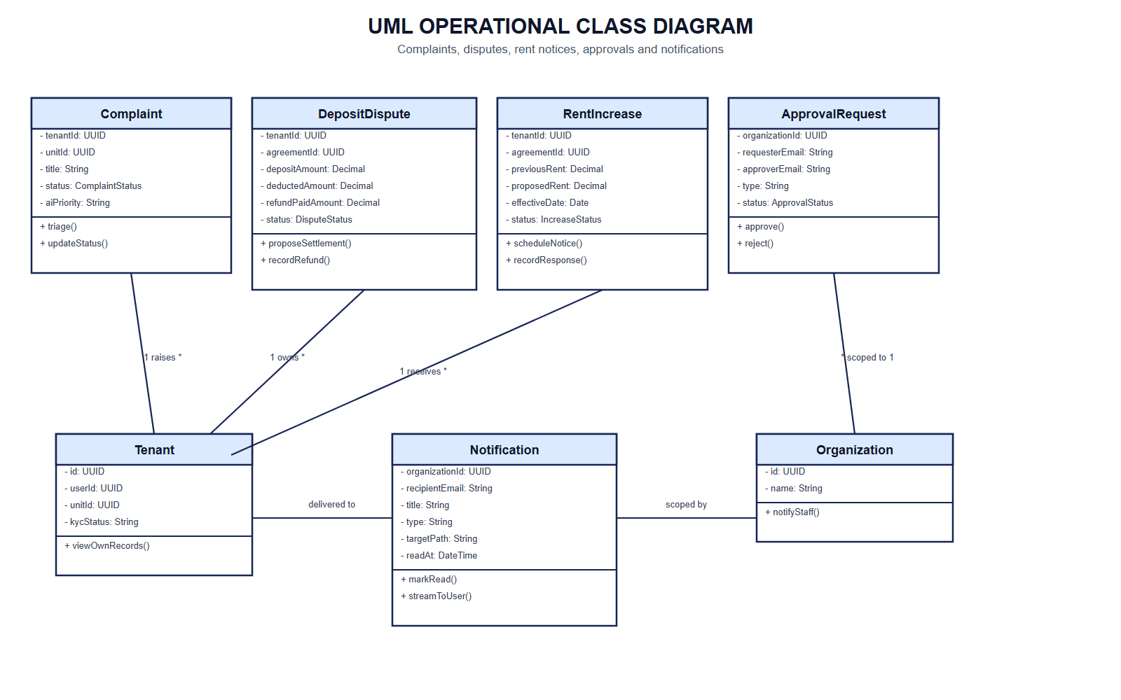
Figure 4.3 - Operational Class Diagram

Backend Layer Class Diagram
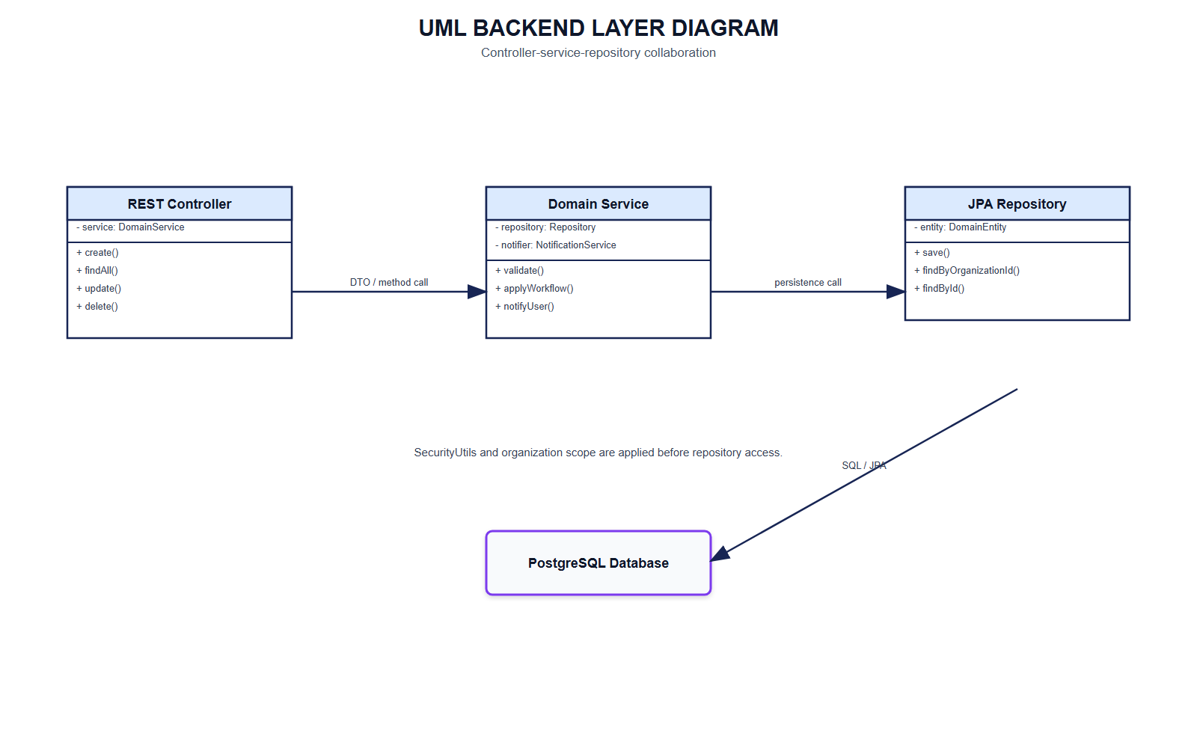
Figure 4.4 - Backend Layer Class Diagram

4.2.2 Sequence Diagrams
#### Login Sequence
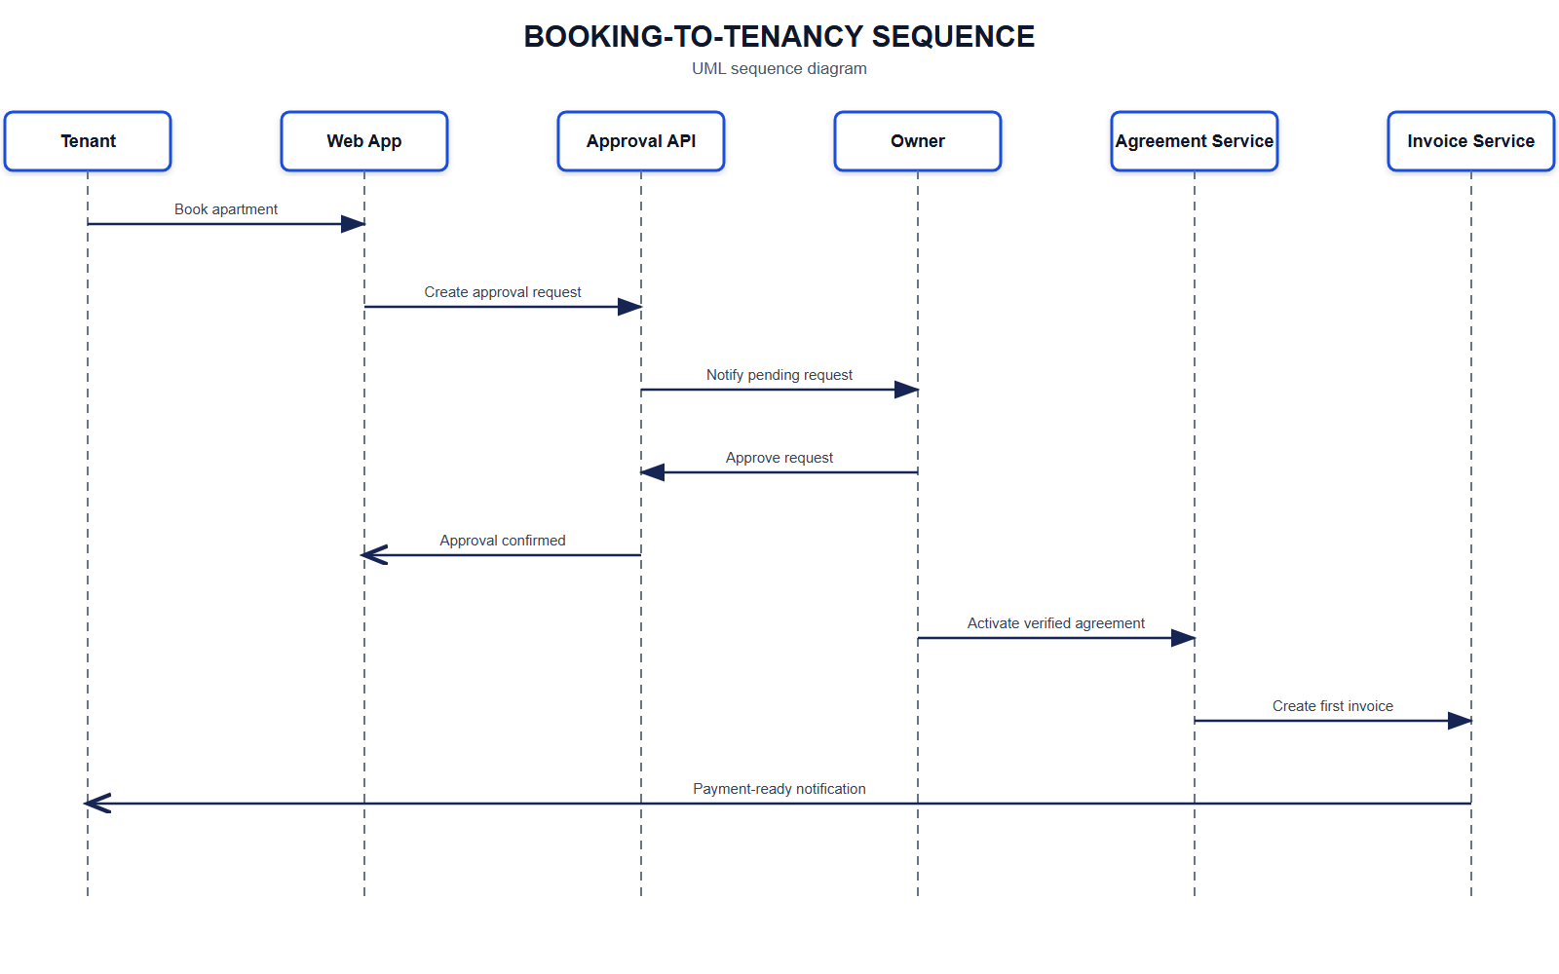
Figure 4.5 - Booking-to-Tenancy Sequence
#### Apartment Booking and Approval Sequence
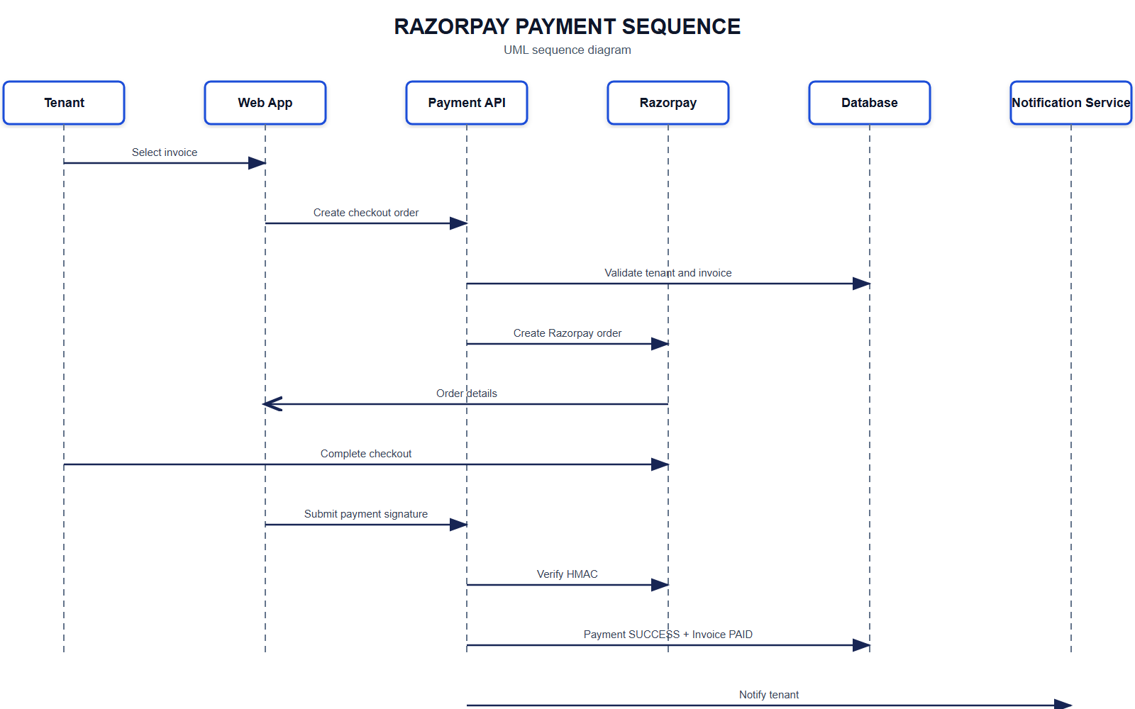
Figure 4.6 - Payment Sequence
#### Verified Payment Sequence
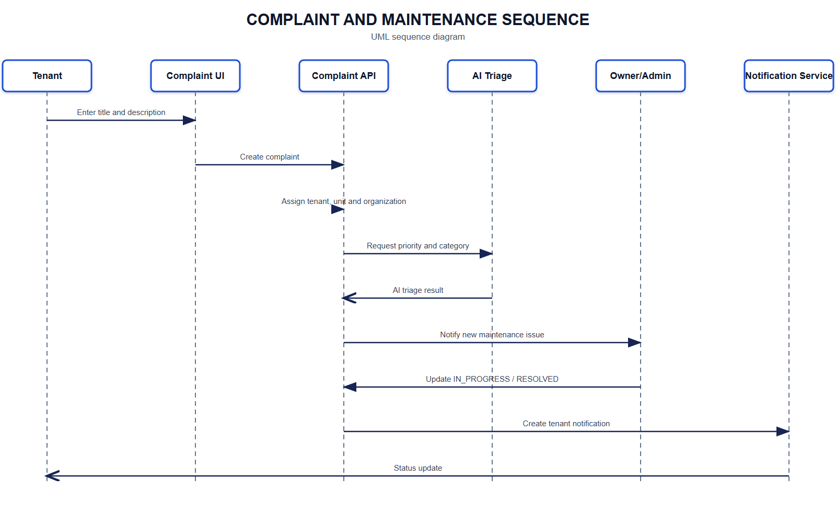
Figure 4.7 - Complaint and Maintenance Sequence
#### Real-Time Notification Sequence
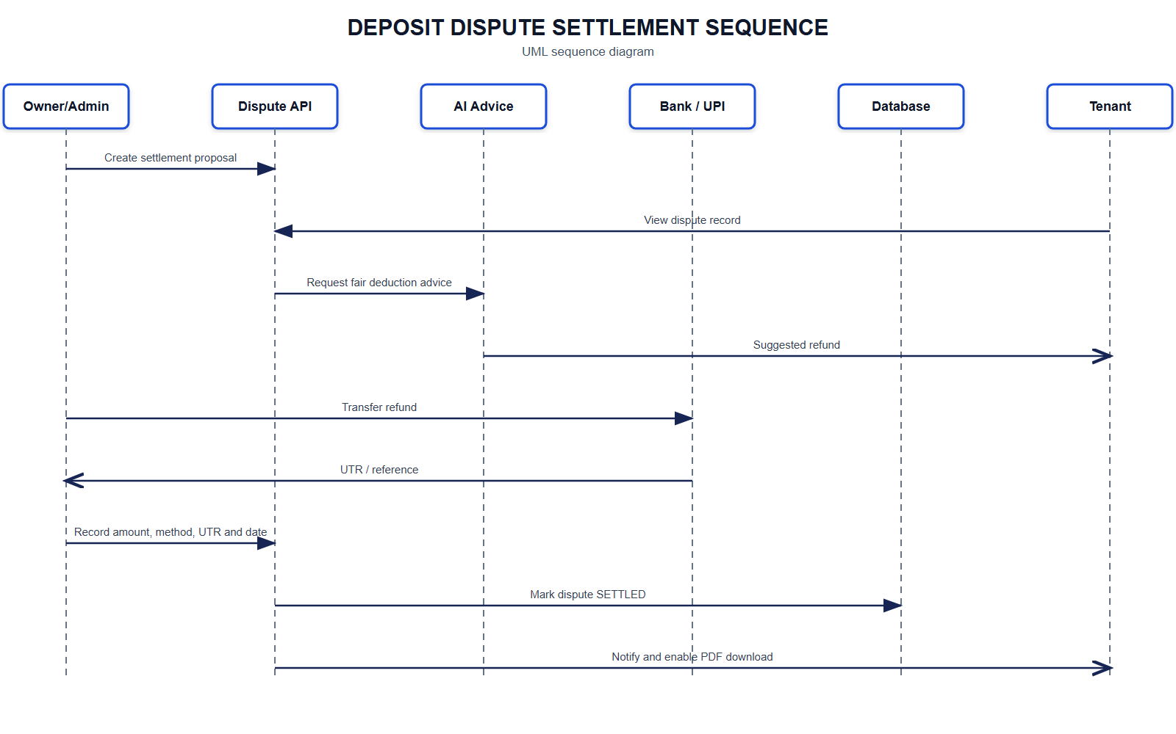
Figure 4.8 - Deposit Dispute Settlement Sequence

4.2.3 Use Case Diagram
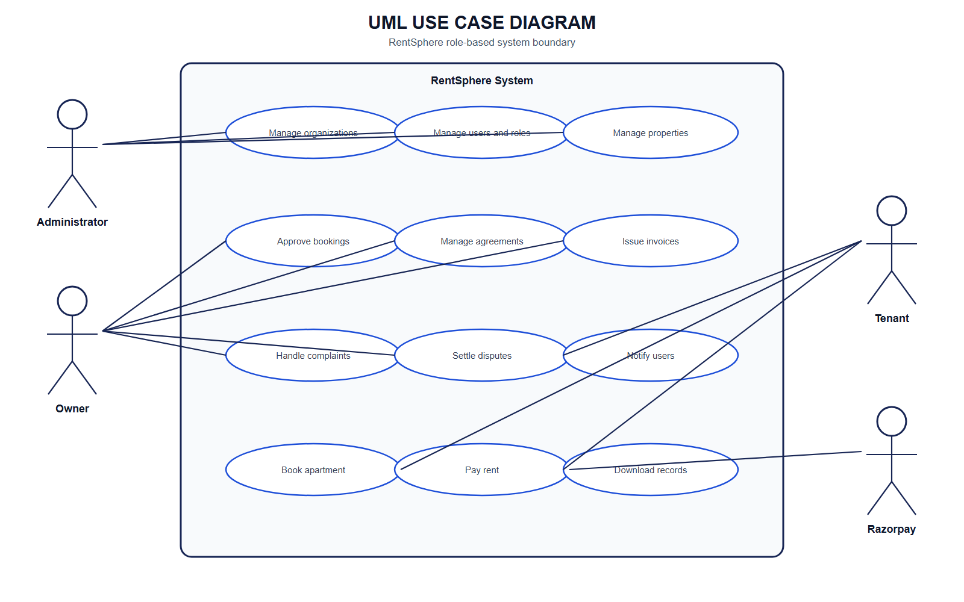
Figure 4.9 - Use Case Diagram

4.3 Database Design
The database uses UUID primary keys. Most business tables include organization_id for portfolio scoping. Soft-deletable entities include deleted, deleted_at, deleted_by, created_at, updated_at, created_by and updated_by. Hibernate restrictions exclude deleted records from ordinary queries.
Table | Important fields | Purpose
organizations | id, name, address, phone, email | Rental operating group
users | organization_id, name, email, password, role | Authentication identity
properties | organization_id, owner_id, name, address, image_url | Property-level record
buildings | property_id, name, floors, image_url | Building within a property
units | building_id, unit_number, rent_amount, status, image_url | Rentable inventory
tenants | user_id, unit_id, contact and KYC fields | Tenant business profile
agreements | tenant_id, unit_id, dates, rent_amount, status | Lease relationship
invoices | tenant_id, agreement_id, amount, due_date, status | Amount due
payments | invoice_id, Razorpay identifiers, amount, status | Payment attempts and results
complaints | tenant_id, unit_id, title, description, status | Maintenance workflow
deposit_disputes | agreement and estimate fields, evidence, status | Deposit settlement workflow
rent_increases | previous/proposed rent, dates, responses, status | Rent revision workflow
approval_requests | type, subject, requester/approver, decision | General approval workflow
notifications | recipient, title, detail, target, read_at | Persistent user alerts

Normalization Decisions
The schema separates each major business concept to reduce repeated values. Payment.amount is retained even though an invoice has an amount because it records the amount associated with an individual payment attempt. previous_rent and proposed_rent are retained for rent-history meaning, while redundant increase_amount and increase_percent columns were removed because they can be derived and could become inconsistent. Organization and tenant identifiers are retained on transactional records to support secure scoping and efficient retrieval.

Data Integrity Rules
- User email is unique and mandatory.
- Tenant user_id is unique, enforcing one tenant profile per login.
- Required monetary fields use decimal types.
- Status values are Java enums persisted as strings.
- Passwords are never returned through response DTOs.
- Payment provider identifiers support reconciliation and idempotent callbacks.
- Successful payment history suppresses older pending attempts for the same invoice.

4.4 Input Design
Input forms follow these principles:
- Labels describe business concepts rather than implementation details.
- Required fields use client-side and Jakarta validation.
- Relationship fields use selectable reference records where possible.
- Dates use date/datetime controls and prevent accidental past values where appropriate.
- Monetary values use numeric inputs and server-side decimal types.
- Status values use controlled selections.
- Images accept a URL or local file preview.
- Password fields are masked and password updates are separated from ordinary profile updates.
- Tenant ownership values are obtained from authentication on protected self-service operations.
- Destructive actions require confirmation.
Major inputs include signup/login, profile update, property inventory, tenant/KYC references, agreement dates, invoice amount and due date, payment checkout, maintenance complaint, deposit evidence, rent response and approval decision.

4.5 Output Design
Outputs are designed for rapid status recognition:
- Dashboard metric cards and charts summarize portfolio or personal activity.
- Module cards display human-readable labels and status chips.
- The apartment browser presents listing images, availability and visit actions.
- Payment summary shows outstanding balance, invoices due and confirmed history.
- Successful payments show a completion date; obsolete pending attempts are not displayed.
- Approval pages show request, approver, decision and comments.
- Notification menu shows unread state, detail, relative time and target navigation.
- Empty, loading and error states prevent blank or ambiguous screens.
- Responsive navigation collapses for smaller displays.
- Light/dark themes derive from centralized color tokens.

5. SYSTEM IMPLEMENTATION OVERVIEW
This chapter describes the implemented modules and workflows. Source-code listings are intentionally omitted in accordance with the prescribed mini-project report format.

5.1 Main Modules

Authentication and Profile
Registration checks duplicate emails, hashes passwords using BCrypt and provisions a tenant profile for tenant accounts. Login applies rate limiting, validates credentials and issues a JWT containing role and organization context. The profile endpoint returns a readable organization name without exposing organization administration to tenants.

Organization and User Administration
Managers create and maintain organizations and users. User roles determine frontend module visibility and backend method authorization. Public registration is limited to TENANT accounts; the first account may bootstrap as ADMIN, while OWNER accounts are always provisioned through user management. Only administrators may create, modify or delete ADMIN-role users, and staff users are scoped to their own organization for reads and mutations. Sensitive password values are excluded from normal responses.

Property, Building and Unit Management
The hierarchy is Organization â†’ Property â†’ Building â†’ Unit. Managers maintain addresses, amenities, images, floor counts, rents and unit status. Tenants use the dedicated apartment browser instead of raw management modules.

Tenant and Agreement Management
Tenant records connect login identities to assigned units and store contact, emergency and KYC references. Agreements connect tenants and units for a defined period and establish rent and agreement status.

Invoice and Payment Management
Managers issue invoices. Tenants see their invoices through /invoices/me. Checkout creation verifies ownership and payable status. Razorpay success is accepted only after signature verification or a valid webhook. Successful payment updates the invoice to PAID. Pending attempts for an already successful invoice are excluded from displayed history.

Apartment Booking and Approvals
Tenants browse available inventory and submit visit requests. The booking service resolves the appropriate organization/owner approver and creates an approval request. Managers approve or reject it, and the tenant sees the current status in the approval workflow.

Complaints and Maintenance
Tenants create complaints using only a title and description; the backend securely assigns their organization, tenant identity, unit and OPEN status. The backend assigns authenticated tenant ownership rather than trusting arbitrary IDs. Owners update status from open to in-progress or resolved.

Deposit Disputes
The workflow records deposit and deduction values, repair estimates, evidence, tenant notes, owner response, proposed settlement and due date. Tenant access is read-only and ownership-checked. Owners record refund amount, method, transaction reference and settlement date; tenants receive notifications, AI settlement advice and a downloadable statement.

Rent Increase Management
Owners create rent notices with old/new rent, notice date, effective date, reason and notes. Tenants may update only their response and an allowed response state. The database does not store redundant increase amount or percentage.

Notifications
Notifications are stored per recipient. The client loads persisted notifications and subscribes to a live event stream. Users can mark one or all notifications read. A fallback refresh maintains usability if the stream is unavailable.

AI Assistant
The assistant receives the authenticated user's question and a server-built personal context. Context construction follows role and ownership rules so that an answer does not require unrestricted frontend data access.

User Interface Features
- Centralized professional blue property-management theme.
- Light and dark color modes.
- OverlayScrollbars integration.
- Hover-accessible compact profile menu.
- Language selector.
- Responsive sidebar and mobile drawer.
- Reusable module forms, cards, searches and empty states.
- Document viewer/download support.

5.2 Screenshots
The following screen list defines the evidence captured during system demonstration. Screenshots should use non-sensitive demonstration data.
Figure | Required screen | Suggested caption
5.1 | Login page | Secure RentSphere authentication screen
5.2 | Admin dashboard | Portfolio metrics and management overview
5.3 | Property module | Property records with image, location and amenities
5.4 | Building module | Buildings associated with selected properties
5.5 | Unit module | Unit rent and availability management
5.6 | Tenant module | Tenant contact, assignment and KYC management
5.7 | Agreement module | Agreement dates, rent and status
5.8 | Tenant apartment browser | Search and visit-request workflow
5.9 | Approval module | Pending and decided requests
5.10 | Payment page | Outstanding invoices and successful transaction history
5.11 | Razorpay checkout | Test-mode hosted payment interface
5.12 | Complaint module | Maintenance request lifecycle
5.13 | Deposit dispute module | Evidence and settlement workflow
5.14 | Rent increase module | Notice and tenant-response workflow
5.15 | Notification menu | Persistent real-time notifications
5.16 | Profile menu/page | Compact identity and organization display
5.17 | Dark mode | Alternate centralized color theme
5.18 | Mobile layout | Responsive tenant navigation

Generated demonstration listing assets are available under frontend/public/demo-images. They may be used to populate records before screenshots are captured.

6. TESTING
Testing combines frontend static validation, production compilation and backend automated tests. The verified backend suite contains 24 passing tests covering DTO mapping, application startup, module APIs, role access, privilege-escalation prevention, organization scoping and Razorpay scenarios. Frontend validation uses ESLint and the TypeScript/Vite production build.

6.1 Test Case 1: FORM VALIDATION
Field | Value
Test ID | TC-FORM-001
Objective | Ensure required and typed fields reject invalid input
Preconditions | User is authenticated and has create permission
Steps | Open a create form; leave required fields blank; enter malformed email or invalid numeric values; submit
Expected result | Submission is blocked or API returns HTTP 400 with field-specific validation errors
Actual result | Validation feedback is displayed and invalid data is not persisted
Status | Pass

Additional form cases:
ID | Input | Expected result
TC-FORM-002 | Duplicate registration email | Clear duplicate-account error; no second user
TC-FORM-003 | Password shorter than policy | Validation error
TC-FORM-004 | Empty property name/address | Required-field error
TC-FORM-005 | Invalid relationship selection | No invalid persistence; reference guidance displayed
TC-FORM-006 | Unsupported status text | Request rejected by enum conversion/validation

6.2 Test Case 2: Authentication and Authorization
Field | Value
Test ID | TC-AUTH-001
Objective | Verify role-based access
Steps | Login as tenant; request a manager-only collection or mutation
Expected result | HTTP 403; no data change
Actual result | Method-level security rejects the operation
Status | Pass

Test ID | Scenario | Expected
TC-AUTH-002 | Correct email/password | JWT issued and dashboard opens
TC-AUTH-003 | Incorrect password | HTTP 401 without revealing which credential failed
TC-AUTH-004 | Missing/invalid token | Protected endpoint rejected
TC-AUTH-005 | Tenant opens hidden module URL | Frontend redirects and backend remains protected
TC-AUTH-006 | Tenant reads another tenant's record | Access denied

6.3 Test Case 3: Payment Processing
Field | Value
Test ID | TC-PAY-001
Objective | Complete a valid Razorpay test payment
Preconditions | Tenant owns a pending invoice; Razorpay test keys configured
Steps | Create order; complete hosted checkout; submit returned payment ID, order ID and signature
Expected result | Payment becomes SUCCESS; invoice becomes PAID; success appears once; obsolete pending attempts are hidden
Status | Pass

Test ID | Scenario | Expected
TC-PAY-002 | Invalid signature | Verification fails and invoice remains unpaid
TC-PAY-003 | Tenant attempts another tenant's invoice | Request denied
TC-PAY-004 | Repeat valid callback | Idempotent success without duplicate success notification
TC-PAY-005 | Failed checkout | Failed/pending attempt does not mark invoice paid
TC-PAY-006 | Success plus older pending attempts | Only authoritative success is displayed for that invoice

6.4 Test Case 4: Tenant Data Isolation
Field | Value
Test ID | TC-TENANT-001
Objective | Confirm personal endpoints return only authenticated tenant data
Steps | Create two tenants with separate invoices, payments and complaints; authenticate as tenant A; call /me endpoints
Expected result | Only tenant A records are returned
Status | Pass

Covered endpoints include /tenants/me, /invoices/me, /payments/me, /complaints/me, /deposit-disputes/me and /rent-increases/me.

6.5 Test Case 5: Approval Workflow
Field | Value
Test ID | TC-APP-001
Objective | Verify apartment visit request lifecycle
Steps | Tenant submits request; owner lists pending approvals; owner approves with comment; tenant refreshes status
Expected result | One pending request is created, then changes to approved with decision time/comment and notification
Status | Pass

Test Summary
Test layer | Command | Result
Frontend lint | npm run lint | Pass
Frontend production build | npm run build | Pass
Backend automated suite | mvn test | 19 tests passed, 0 failures, 0 errors
Database test schema | H2 in PostgreSQL compatibility mode | Pass

7. APPENDICES

Appendix A: Important API Routes
Area | Routes
Authentication | POST /auth/register, POST /auth/login, GET/PUT /auth/me, POST /auth/change-password
Inventory | /organizations, /users, /properties, /buildings, /units
Tenancy | /tenants, /tenants/me, /agreements
Finance | /invoices, /invoices/me, /payments, /payments/me
Razorpay | /payments/razorpay/create-order, /verify, /webhook
Operations | /complaints, /deposit-disputes, /rent-increases and their /me routes
Workflow | /booking-requests, /approvals, /approvals/{id}/approve, /reject
Notifications | /notifications, /stream, /{id}/read, /read-all
Assistant | POST /assistant/chat

Appendix B: Status Enumerations
- User roles: ADMIN, OWNER, TENANT
- Unit: AVAILABLE, OCCUPIED, MAINTENANCE
- Agreement: ACTIVE, EXPIRED, TERMINATED
- Invoice: PENDING, PAID, OVERDUE
- Payment: PENDING, SUCCESS, FAILED, REFUNDED
- Complaint: OPEN, IN_PROGRESS, RESOLVED
- Approval: PENDING, APPROVED, REJECTED
- Deposit dispute: OPEN, EVIDENCE_PENDING, UNDER_REVIEW, SETTLEMENT_PROPOSED, SETTLED, REJECTED
- Rent increase: DRAFT, NOTICE_SCHEDULED, NOTIFIED, TENANT_REVIEW, ACCEPTED, DISPUTED, CANCELLED

Appendix C: Environment Variables
Secrets must be stored in local/deployment environment configuration and must never be committed or included in screenshots.

Appendix D: Local Execution
Swagger UI is available at http://localhost:8080/swagger/index.html when the backend is running. The Vite development client normally runs at http://localhost:5173.

Appendix E: Suggested Future Enhancements
- Supabase Storage-backed multi-image galleries with thumbnails and signed URLs.
- Versioned Flyway migrations for every production schema change.
- Lease PDF generation and digital signatures.
- Recurring invoice scheduler and late-fee policy engine.
- Accounting exports and payment reconciliation.
- Native mobile application and push notifications.
- Maintenance vendor assignment, SLA timers and cost tracking.
- Stronger accessibility evaluation against WCAG 2.2.
- Localization of all interface strings and server messages.
- Load, security and disaster-recovery testing.

8. REFERENCES
- Spring Boot Reference Documentation. https://docs.spring.io/spring-boot/
- Spring Security Reference. https://docs.spring.io/spring-security/reference/
- Spring Data JPA Reference. https://docs.spring.io/spring-data/jpa/reference/
- React Documentation. https://react.dev/
- TypeScript Documentation. https://www.typescriptlang.org/docs/
- Material UI Documentation. https://mui.com/material-ui/
- PostgreSQL Documentation. https://www.postgresql.org/docs/
- Supabase Database Documentation. https://supabase.com/docs/guides/database
- Razorpay Standard Checkout Documentation. https://razorpay.com/docs/payments/payment-gateway/web-integration/standard/
- JSON Web Token, RFC 7519. https://www.rfc-editor.org/rfc/rfc7519
- OWASP Application Security Verification Standard. https://owasp.org/www-project-application-security-verification-standard/
- OpenAPI Specification. https://spec.openapis.org/oas/latest.html
- MDN, Using Server-Sent Events. https://developer.mozilla.org/docs/Web/API/Server-sent_events
- Docker Documentation. https://docs.docker.com/

Conclusion
RentSphere demonstrates how a modern full-stack architecture can organize the complete rental lifecycle while respecting the different responsibilities of administrators, owners and tenants. Its strongest design characteristics are the relational domain model, layered API, tenant-owned access paths, verified payment lifecycle, explicit workflow states and consistent user interface. The automated test suite confirms the principal access and payment scenarios. With production storage, versioned migrations, expanded testing and operational monitoring, the system provides a strong foundation for a deployable property-management platform.

